- Plug your iPad into the MacBook laptop using the USB cable
- If iTunes does not start automatically, find it in the dock and click on it.
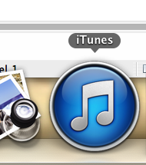
- When iTunes comes up, you should see your iPad showing in the side panel. Mine is called “IPad Mini 6” under devices.
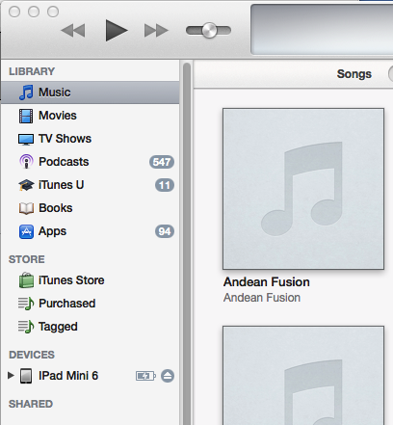
- Click on that iPad. The device view screen will show.
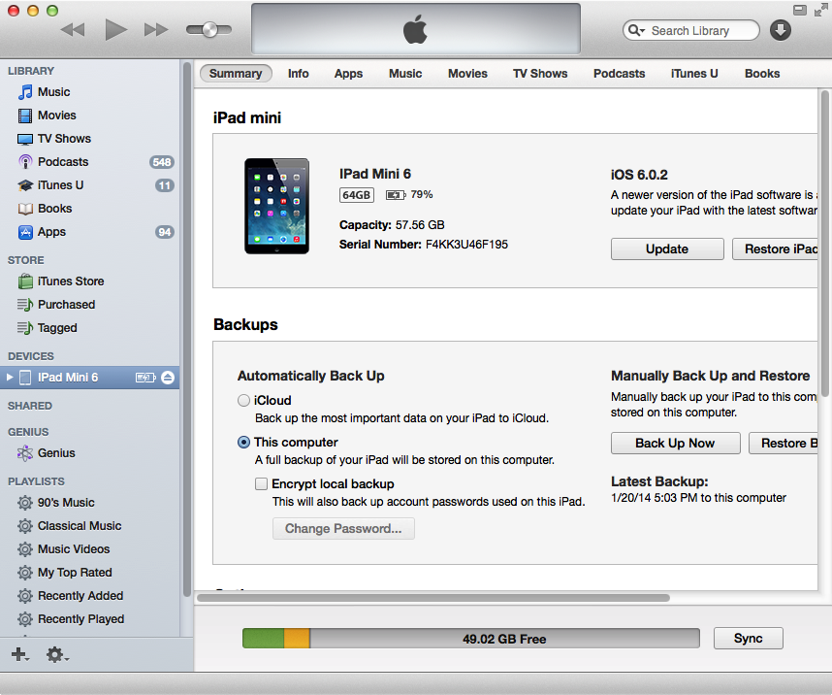
- Click on the “Apps” heading just over the iPad picture on the right panel. You will then see something like this. You may have to scroll down to see “CWP Teacher.” Click on that icon.
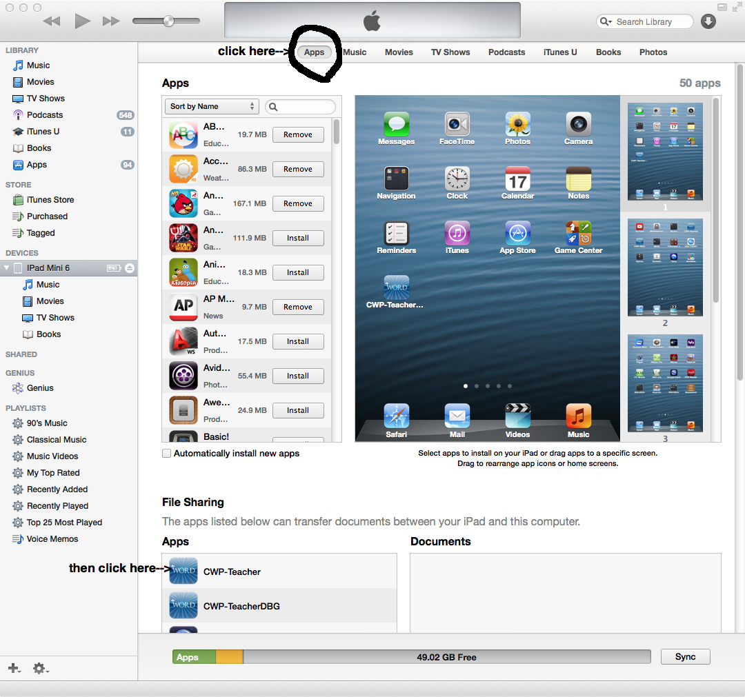

- Then find the Tagalog.bbl and Ilonggo.bbl files and drag them one at a time into the “Documents” section of the “File Sharing” area. The border around the CWP-Teacher Documents will turn blue to let you know it will copy.
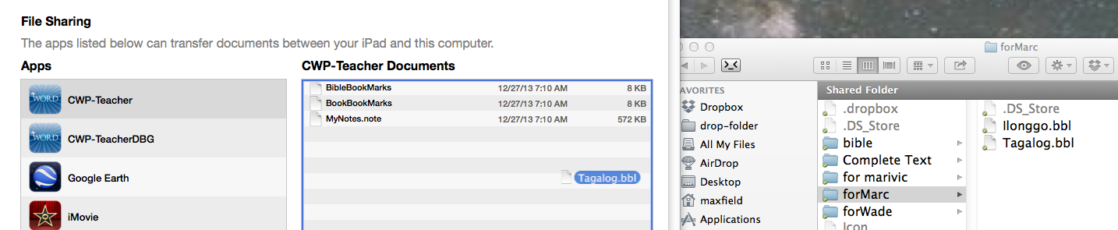
- If the file already exists, it will ask you if you want to replace the file. Click on the “Replace” button.
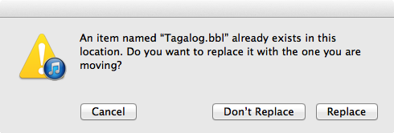
- It will take a few seconds to copy over. Once it copies over, it will show up in the Documents list.
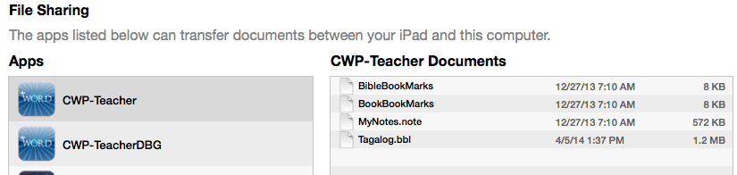
- After this, you can unplug and use the file in the Bible program.

