

Travel Monkey quick start
Support · Full user guide · Privacy Policy
Last updated: October 2, 2026
Set up your preferences, try a sample trip, and get your first recommendation. You need Travel Monkey installed on an iPhone running iOS 17 or later, a connection, and your own Anthropic API key for concierge questions. The current app is installed with the developer's help.

1. Tell it who is traveling
On first launch, add your household travelers. Rate a few favorite cuisines and activities, and enter dislikes and allergies separately. Leave ratings blank when you have nothing to record; blank does not mean 3.
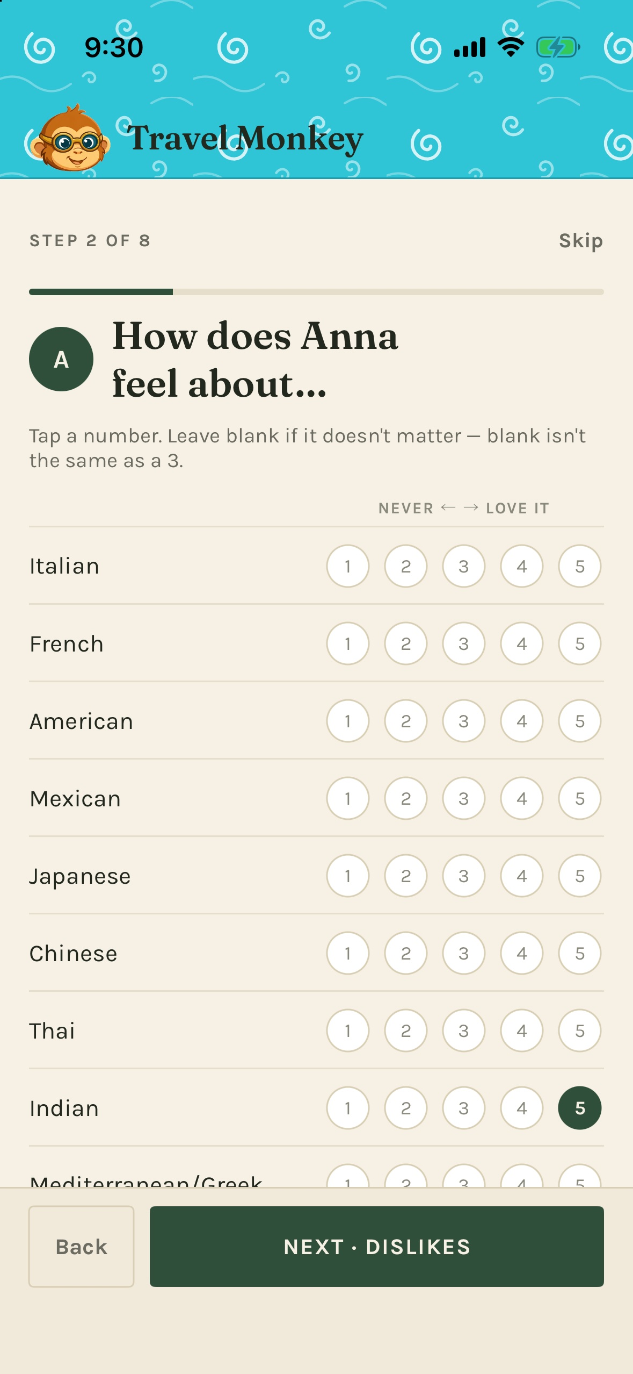
Screenshots use demonstration data. Your travelers and suggestions will differ.
Enter shared logistics such as transport preference, budget, and comfortable walking time. You can skip optional details and edit them later in Profile.

2. Enable the concierge and reminders
During setup:
- Allow location While Using the App for nearby recommendations and travel times.
- Allow notifications if you want leave-by and meal-log reminders.
- Paste your Anthropic API key, then finish with Ask me where to eat.
Get a key through the Claude Console, following Anthropic's key instructions. API usage is billed separately from a Claude chat subscription.
Skipped the key or a permission? Open Profile → Settings to add the key or use Change in iOS Settings. The key is stored in the iOS Keychain.

3. Try the sample trip
Open Profile → Settings → Load sample data. It loads a trip with dates near today and makes it active.
- Open Daily to see the day's plan; use the arrows to browse.
- Open Trip for all days and Reservations for booking details.
- Return to Concierge to see the next hard deadline and weather when available.
The sample does not move your phone's location. To ask about its destination, say “Suggest lunch near the hotel in the sample trip.” Sample deadlines can produce real local reminders. If the sample file is missing, ask the developer for a build that includes it; you can still try the concierge without a trip.
Your own trip: the current app requires the developer's help for the initial import. Once the trip exists, Trip → Add from text lets you paste more bookings, review the proposed details, and tap Confirm. It does not create your first trip.

4. Ask, refine, and choose
Open Concierge and ask “Where should we eat?” or tap a suggestion chip. Wait for the reply to finish, then use the card controls:
- ⓘ expands extra reasoning when available.
- Not for me lets you explain why the option misses.
- Lock it in records your choice and adds it to today's active trip.
- Directions appears on the locked card and opens Apple Maps. Long-press it for Google Maps if installed.
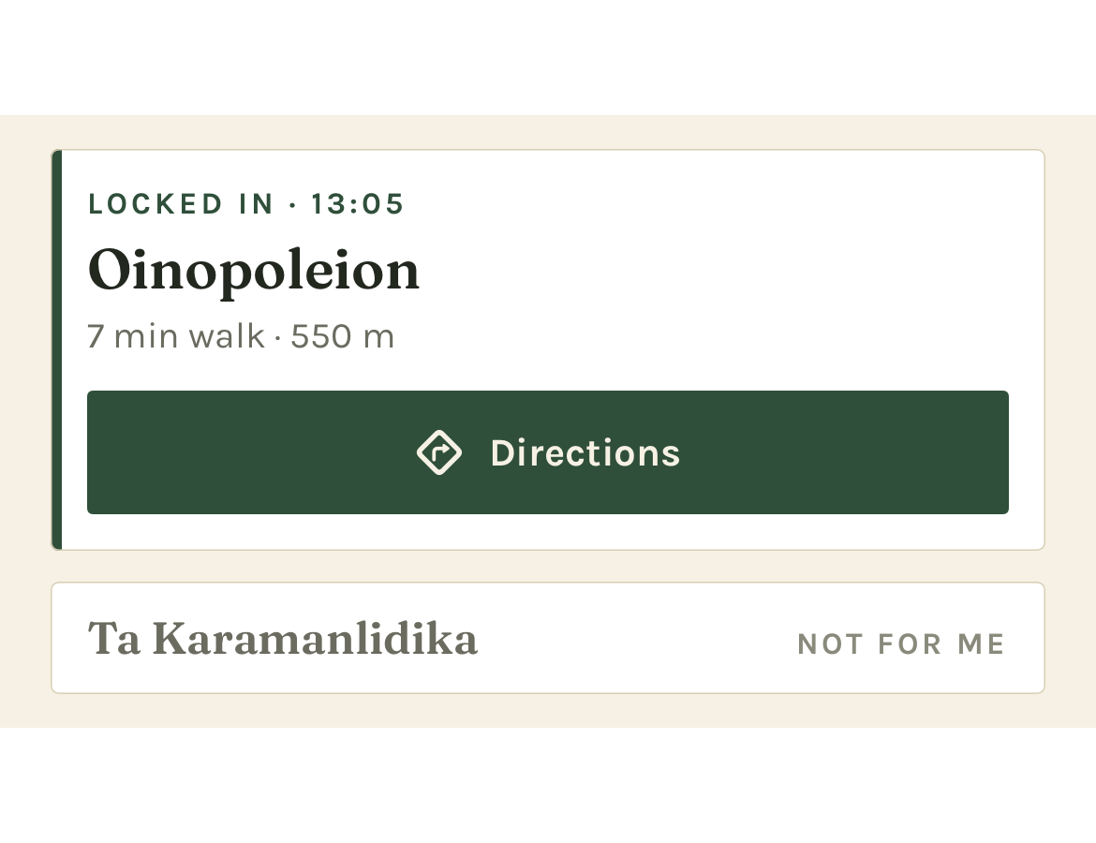
Locking in records a plan; it does not make a booking.
For something easier, tap the Normal pill above the conversation and choose Low-key today. In that same sheet, Who's out right now selects the people joining this outing. The whole-trip roster lives under Trip → Who's coming.

5. Leave on time and remember what worked
Check the deadline strip's Leave by time. With notifications allowed, the app normally reminds you an hour before leave-by and again when it is time to go. These are scheduled phone reminders; the concierge does not monitor travel changes or follow up later on its own.
After a locked-in meal, use Log it when it appears, or the meal reminder. Choose Loved it, Fine, or Not again, add a useful short note, and tap Save to log. Find your entries in Profile → Meal & activity log.
When you finish trying the sample, use Profile → Settings → Remove sample data. This deletes the sample and anything asked or logged on it; your own trips remain.
For the remaining features, see the full user guide. For help, see Support. If something looks wrong, check the key, connection, permissions, and active trip first.

