1. For the controlled vehicle:

* When reasonable acceleration $a_{ni}$ (without violating constraints) is not generated yet by the RL controller, we calculate it according to the CACC model: [The Impact of Cooperative Adaptive Cruise Control on Traffic-Flow Characteristics]

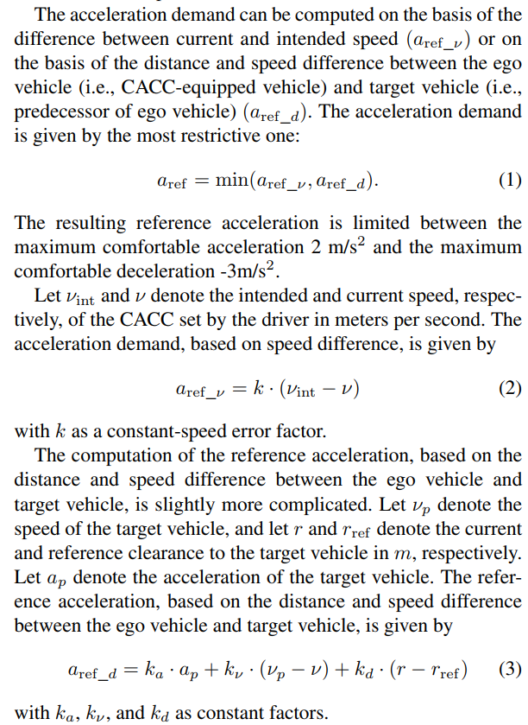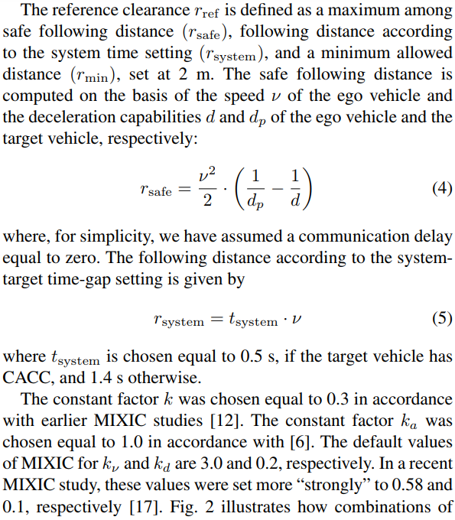

* Otherwise, the acceleration $a_{ni}$ (without violating constraints) is generated by the RL controller.

2. For the following vehicles:

We use Bando OV model: (highway)

3. After that, we use the following vehicle dynamic equations to obtain other state variables:

$$v_{n\left(i+1\right)}=v_{ni}{+a}_{ni}*delta$$

$$x_{n\left(i+1\right)}=x_{ni}{+v}_{ni}*delta{+\frac{1}{2}*a}_{ni}*{delta}^{2}$$

Where delta is the time interval for discretization.