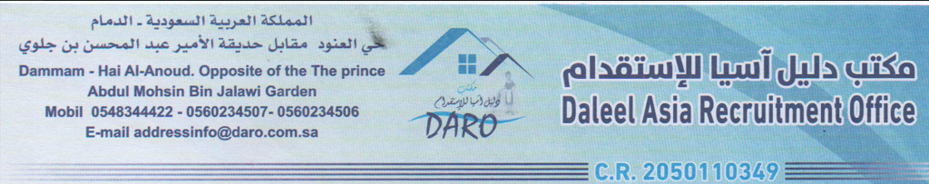

**Code : Q.Cv. 00001**

**Code : Q.Cv. 00002**

**Code : Q.Cv. 000016**

**Code : Q.Cv. 00003**

|  |  |  |  |  |  |  |  |  |  |  |  |  |  |  |  |  |  |  |  |  |  |  |  |  |  |  |  |  |  |  |  |  |
| --- | --- | --- | --- | --- | --- | --- | --- | --- | --- | --- | --- | --- | --- | --- | --- | --- | --- | --- | --- | --- | --- | --- | --- | --- | --- | --- | --- | --- | --- | --- | --- | --- |
| **Bio Data** | | | **Agent Name-** | | | | |  | | | | | | | **تاريخ تقديم الطلب** | | | |  | | --- | |  | | | | | | |  | | | | | | | |
| **Date** | | | Click here to enter a date. | | | | | Destination | | | SAUDI | | | |  | | |  | | | | | |  | | | | | | | |
| **Post Applied For** | | | HOUSE MAID | | | | | | | | | | | | **الوظيفه** | | |  | | | | | |  | | | | | | | |
| **Monthly Salary (REAL)** | | | **SAUDI RIAL 1000** | | | | | | | | | | | | **الراتب** | | |  | | | | | | Per sonal Photo | | | | | | | |
| **Contract Period** | | | TWO YEARS | | | | | | | | | | | | **مده العقد** | | |  | | | | | |  | | | | | | | |
|  | | |  | | | | | | | | |  |  | | |  | | | |  | | |  | | | | | | | | | |
| Full Name | | | **AYSHA KABETE TILAHUN** | | | | | | | | | | | | Applicant’s Mob. | | | +251 0991577414 | | | | | | | | | |
|  | | |  | | | | | | |  | | | | |  | |  | |  | | | | | |  | | | | |
| **Detail of Application** | | | | | | | | | **بيانات مقدم الطلب** | | | | | |  | | **Passport Details** | |  | | **تفاصيل جواز السفر** | | | | | | | | |
| **Nationality** | | | | **ETHIOPIAN** | | | | | | **الجنسيه** | | | | |  | | **Passport No.** | | EP6851967 | | | | | | **رقم جواز السفر** | | | | |
| **Religion** | | | | Muslim | | | | | | **الديانه** | | | | |  | | **Date Issue** | | **19-Dec-2021** | | | | | | **تاريخ الاصدار** | | | | |
| **Birth Date** | | | | 14-Dec-1996 | | | | | | **تاريخ الميلاد** | | | | |  | | **Date Expire** | | **18-Dec-2026** | | | | | | **تاريخ الانتهاء** | | | | |
| **Birth Place** | | | | WOLISO | | | | | | **مكان الميلاد** | | | | |  | | **Place of Issued** | | Addis Ababa | | | | | | **مكان الاصدار** | | | | |
| **Mother Name** | | | | - | | | | | | **اسم الام** | | | | |  | | |  | | --- | |  | | |  | | | | | |  | | | | |
| **Age** | | | | 28 | | | | | | **العمر** | | | | |  | |  | |  | | | | | |  | | | | |
| **Height (cm)** | | | | 165 | | | | | | **الطول** | | | | |  | |  | |  | | | | | |  | | | | |
| **Weight (Kg)** | | | | 64 | | | | | | **الوزن** | | | | |  | |  | |  | | | | | |  | | | | |
| **Marital Status** | | | | **Single** | | | | | | **الحاله الاجتماعيه** | | | | |  | |  | |  | | | | | |  | | | | |
| **No. of Children** | | | | **0** | | | | | | **عدد الاطفال** | | | | |  | |  | |  | | | | | |  | | | | |
| **Education** | | | | Secondary | | | | | | **التعليم** | | | | |  | |  | |  | | | | | |  | | | | |
| **Phone no.** | | | | **+25** 0991577414 | | | | | | **رقم الهاتف** | | | | |  | |  | |  | | | | | |  | | | | |
| **Cleaning** | **Ironing** | **Washing** | | | | | |  | |  | | | | |  | |  | |  | | | | | |  | | | | |
| **تنظيف** | **كى الملابس** | **غسل الملابس** | | | | | |  | |  | | | | |  | |  | |  | | | | | |  | | | | |
| **YES** |  | **YES** | | | | | |  | |  | | | | |  | |  | |  | | | | | |  | | | | |
| **Knowledge of Languages** | | | | | | | | | | **اللغات المعروفه** | | | | |  | |  | | | | | | | | |  |
|  | | | | | | Arabic/ العربيه\ | | | | English | | | | |  | |  | | | | |  | | | | | | |  | |
| POOR | | | | | | NEW | | | | NEW | | | | |  | |  | | | | |  | | | | | | | **PHOTO**  **FOR THE DH.**  **STANDING** | |
| FAIR | | | | | |  | | | |  | | | | |  | |  | | | | |  | | | | | | |  | |
| FLUENT | | | | | |  | | | |  | | | | |  | |  | | | | |  | | | | | | |  | |
| **WORK EXPERIANCE خبره العمل** | | | | | |  |  | | | | | | |
| **COUNTERY** | | | | | **PERIOD** |  | | | | | | | |
| **NEW** | | | | | **NEW** |  | | | | | | | |
|  | | | | |  |  | | | | | | | |
|  | | | | |  |  | | | | | | | |

