**Code no: SD - 223**

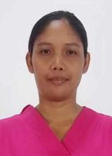

|  |  |  |  |
| --- | --- | --- | --- |
| **POSITION APPLIED** | **DH** | **SALARY** | **$ 400** |
| **COUNTRY APPLIED** | **SAUDI** | | |
| **DATE APPLIED** | **15 FEBRUARY 2024** | | |

|  |  |
| --- | --- |
| **FULL NAME** | **EL MARIE JANE BELARMINO LATOZA** |
| **CONTACT NO.** | **09071208917** |

**DETAILS OF APPLICATION**

|  |  |  |  |
| --- | --- | --- | --- |
| **NATIONALITY** | **FILIPINO** | | |
| **RELIGION** | **CHRISTIAN** | | |
| **DATE OF BIRTH** | **25 NOV 1992** | | |
| **AGE** | **31 YEARS OLD** | | |
| **ADDRESS** | **BACOLOD CITY** | | |
| **MARITAL STATUS** | **MARRIED** | | |
| **SPOUSE NAME - bdate** | **NELMAR LATOZA** | | |
| **NO. OF CHILDREN** | **5 KIDS** | | |
| **WEIGHT** | **65 KG** | | |
| **HEIGHT** | **167.64 CM** | | |
| **FATHER’S NAME-bdate** | **NESTOR BELARMINO** | | |
| **MOTHER’S NAME-bdate** | **GEMMA BELARMINO** | | |
| **LANGUAGE OR DIALECT YOU CAN SPEAK** | **ENGLISH**  **FAIR** | **ARABIC**  **WILLING TO LEARN HOW TO SPEAK ARABIC LANGUAGE** | **OTHER** |

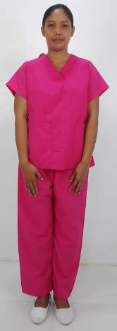

**EDUCATIONAL BACKGROUND**

|  |
| --- |
| **HIGH SCHOOL GRADUATE** |

**EMPLOYMENT RECORD**

|  |  |  |
| --- | --- | --- |
| **POSITION** | **COUNTRY** | **PERIOD** |
| **FIRST TIMER** |  |  |
|  |  |  |
|  |  |  |

|  |  |
| --- | --- |
| **BABYSITTING** | **/** |
| **COOKING** | **/** |
| **CLEANING** | **/** |
| **WASHING** | **/** |
| **ELDERLY CARE** | **/** |
| **DRIVING** |  |
| **COMPUTER** |  |
| **TUTORING** |  |
| **SEWING** |  |
| **IRONING** | **/** |
| **OTHERS** | **/** |

**NEXT OF KIN:**

**PASSPORT COPY**

