Cost Analysis

Assuming:
- no overhead for if statement testing which type of particle we have
- counting power by 2 as two mults
- each particle has approximately M = 13 neighbors

fladds/subs(N, Ni, Nb) = 2 Nb + 3 N2 + 143/156 N + 13 N + 13 N + N
+ 183 Ni + 4 Ni
= 3 N2 + 170/183 N + 187 Ni + 2 Nb
flmults(N, Ni, Nb) = 8 Nb + 3 N2 + 221/195 N + 13 N + 13 N + N
+ 260 Ni + 4 Ni
= 3 N2 + 248/222 N + 264 Ni + 8 Nb
fldiv(N, Ni, Nb) = 3 Nb + + 169 N + (14 N + 2 Nb)
+ 52 Ni
= 183 N + 52 Ni + 5 Nb
flsin/cos(N, Ni, Nb) = 2 Nb
flsqrt(N, Ni, Nb) = N2 + 26 N

C(N, Ni, Nb) = (fladds/subs(N, Ni, Nb), flmults(N, Ni, Nb), fldiv(N, Ni, Nb),
flsin/cos(N, Ni, Nb), flsqrt(N, Ni, Nb))
= (3 N2 + 170/183 N + 187 Ni + 2 Nb, 3 N2 + 248/222 N
+ 264 Ni + 8 Nb, 183 N + 52 Ni + 5 Nb, 2 Nb, N2 + 26 N)
C(N, Ni, Nb) = 7 N2 + 627/614 N + 503 Ni + 17 Nb flops
~ 7 N2 + 620 N + 503 Ni + 17 Nb flops

Derivation:

time loop over all time steps with N particles (Ni interior, Nb boundary (repulsive, ghost))
- Time_Integration_Half
Not used here for explicit Euler
- DisplaceBoundaries
C(Nb) = (fladds/subs(Nb), flmults(Nb), fldiv(Nb), flsin/cos(Nb))
= (2 Nb, 8 Nb, 3 Nb, 2 Nb)
- for i = 1, N
SearchNeighbors
C(N) = (fladds/subs(N), flmults(N), flsqrt(N))
= (3 N2, 3 N2, N2)
- ComputeGlobalKernel
Kernel:
C(M, N) = (fladds/subs(M, N), flmult(M, N), fldivs(M, N), flsqrt(M, N))
= (3 + 2/1, 7/6, 5, 1) M N
= (5/4 M N, 7/6 M N, 5 M N, M N)
KernelGradient:
C(M, N) = (fladds/subs(M, N), flmult(M, N), fldivs(M, N), flsqrt(M, N))
= (3 + 2 + 1/3, 2 + 4 + 4/3, 5 + 2 + 1, 1) M N
= (6/8 M N, 10/9 M N, 8 M N, M N)
C(N) = (fladds/subs(N), flmult(N), fldivs(N), flsqrt(N))
= (11/12 M N, 17/15 M N, 13 M N, 2 M N)
= (143/156 N, 221/195 N, 169 N, 26 N)
- ComputeGlobalDensity
C(N) = (fladds/subs(N), flmults(N))
= (M N, M N)
= (13 N, 13 N)
- DensityAndBCVelocityCorrection
C(N, Nb) = (fladds/subs(N, Nb), flmult(N, Nb), fldivs(N, Nb))
= (M N, M N, M N + N + 2 Nb)
= (13 N, 13 N, 14 N + 2 Nb)
- ComputeGlobalPressure
C(N) = (fladds/subs(N), flmults(N))
= (N, N)
- ComputeInteriorLaminarAcceleration
ComputeSoundSpeed
C(N) = const
C(Ni) = (fladds/subs(Ni), flmult(Ni), fldivs(Ni))
= (14, 3 + 2 + 2 + 7 + 2 + 4, 2 + 1 + 1) M Ni + Ni fladds
= (183 Ni, 260 Ni, 52 Ni)
- AddRepulsiveForce
ComputeSoundSpeed
C(N) = const
C(Ni) = (fladds/subs(Ni), flmult(Ni), fldivs(Ni))
~ const (as only interior particles with repulsive particles in neighborhood)
- Time_Integration
C(Ni) = (fladds(Ni), flmults(Ni))
= (4 Ni, 4 Ni)

New Cost Analysis – 13.05.2020

The only differences with respect to the old cost analysis are new costs for SearchNeighbor and ComputeGlobalKernel. Indeed, the computation of the Kernel is fused into SearchNeighbor.
Assumption: the new analysis is done knowing how the particles are stored (first interior, then repulsive, then ghost).

Cost analysis of SearchNeighbor:
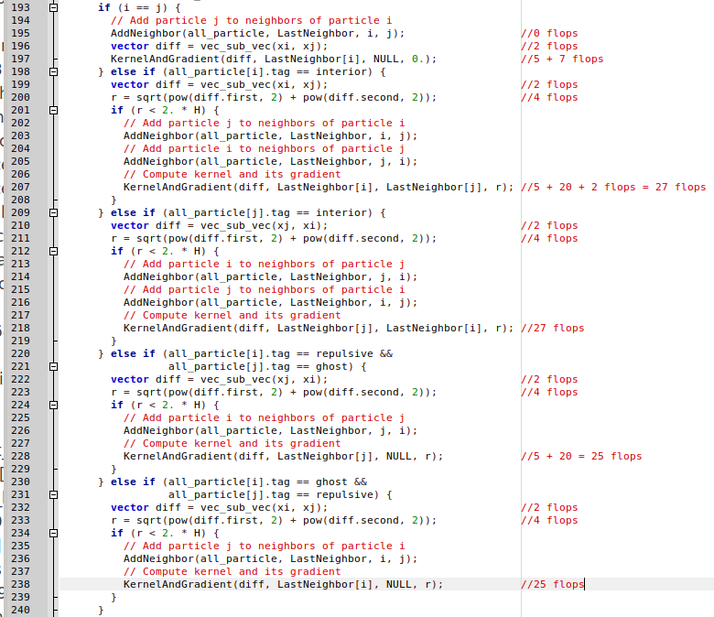
For every i = 0, … N there are:
- 14 flops (j =i is a neighbor)
- 12 * ~26 flops (for the 12 remaining neighbors)
For every interior particle i there are (Ni-1-i)*6 flops + Nb*6 flops (in order to compute diff and r for all the particles j).
For every repulsive particle i there are (Nghost)*6 flops (in order to compute diff and r for all the ghost particles j).

So, the cost of SearchNeighbor is: C(N, Ni, Nb, Nr, Ng) = 14N + 12N*26 + + 6*Nb*Ni + 6*Nr*Ng= 326N + 6Nb*Ni + 6*Nr*Ng + 3(Ni – 3)Ni.
Assuming that Nr ~ Nb/3 and Ng ~ 2Nb/3, the above expression can be simplified:
C(N, Ni, Nb) = 326N + 6Nb*Ni + 4*Nb²/3 + 3Ni² – 9Ni.

The overall cost of our algorithm is therefore:
fladds/subs(N, Ni, Nb) = 2 Nb + 3 N2 + 143/156 N + 13 N + (13 N + 2 Nb) + N
+ 196 Ni + 4 Ni
= 27N + 200Ni + 4Nb
flmults(N, Ni, Nb) = 8 Nb + 3 N2 + 221/195 N + 13 N + 13 N + N
+ 260 Ni + 4 Ni
= 27N + 264 Ni + 8Nb
fldiv(N, Ni, Nb) = 3 Nb + + 169 N + (14 N + 2 Nb)
+ 52 Ni
= 14 N + 52 Ni + 5 Nb
flsin/cos(N, Ni, Nb) = 2 Nb
flsqrt(N, Ni, Nb) = N2 + 26 N

C(N, Ni, Nb) = (fladds/subs(N, Ni, Nb), flmults(N, Ni, Nb), fldiv(N, Ni, Nb),
flsin/cos(N, Ni, Nb))
= (27 N + 200 Ni + 4 Nb, 27 N + 264 Ni + 8 Nb, 14 N + 52 Ni + 5 Nb, 2 Nb )
+ 326N + 6Nb*Ni + 4*Nb²/3 + 3Ni² – 9Ni
C(N, Ni, Nb) = 3Ni² + 4Nb²/3 + 6Nb*Ni + 394N + 507Ni + 19Nb flops

Memory transfer

Assume:
Cold cache
Only capacity miss ---- because the input size is not very big
13 neighbors

Note:
Can’t analyze base version because of struct

- SearchNeighbor
Wij: 13*N*8
Wij_grad: 13*2*N*8
Indices: 13 * N * 4
Positions: 2*N*8

