New Cost Analysis – 04.06.2020

Assumptions:
- no overhead for if statement testing which type of particle we have
- counting power by 2 as two mults
- each particle has approximately M = 13 neighbors

Base version (master branch)
Without considering SearchNeighbors, the cost of our code is:
C(N, Ni, Nb) = (fladds/subs, flmults, fldiv, flsin/cos(N, Ni, Nb))
= (27N + 187Ni + 2Nb, 27N + 264Ni + 8Nb, 14N + 52Ni + 5Nb, 2Nb)
= 68N + 503Ni + 17Nb

Cost Analysis for SearchNeighbors:
In the base version, SearchNeighbors uses the functions AddNeighbor and KernelAndGradient. AddNeighbor doesn’t have any flops, KernelAndGradient instead has flops. In order to count them there must be done a distinction between the calls of KernelAndGradient:
- i == j: KernelAndGradient performs 12 flops
- i != j and neighbor2 == NULL: KernelAndGradient performs 24 flops
- i != j and neighbor2 != NULL: KernelAndGradient performs 24 flops
Now looking at SearchNeighbors:
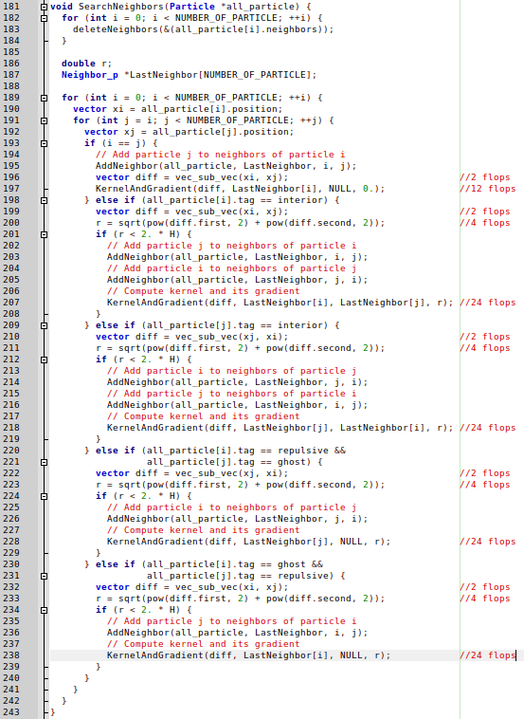
Total number of flops for SearchNeighbors:
- every particle has itself as neighbor → 14N flops
- every particle has other 12 neighbors for which KernelAndGradient is computed but KernelAndGradient is computed only once for every pair of neighbors →12 * 24N flops / 2 = 144N flops
- for every interior particle we compute the distance between the considered particle and the other interior particles with index higher than the index of the considered particle → = 3Ni(Ni – 1) flops
- for every interior particle we compute the distance between the considered particle and every boundary particle → Ni * 6Nb flops
- for every repulsive particle we compute the distance between the considered particle and every ghost particle → Nr * 6Ng = (Nb/3) * 6(2Nb/3) = 4Nb²/3
So, the cost of SearchNeighbors is 14N + 144N + 3Ni² – 3Ni + 6Ni * Nb + 4Nb²/3.
The overall cost of the base version is:
C(N, Ni, Nb) = 68N + 503Ni + 17Nb + 14N + 144N + 3Ni² – 3Ni + 6Ni * Nb + 4Nb²/3
= 226N + 500Ni + 17Nb + 3Ni² + 6Ni*Nb + 4Nb²/3

Optimization1 (optimization1 branch)
With this optimization, we introduced different kind of “KernelAndGradient”:
- KernelAndGradient_zero: 0 flops
- KernelAndGradient_unidirectional: 16 flops
- KernelAndGradient_bidirectional: 16 flops
So, looking at SearchNeighbors:
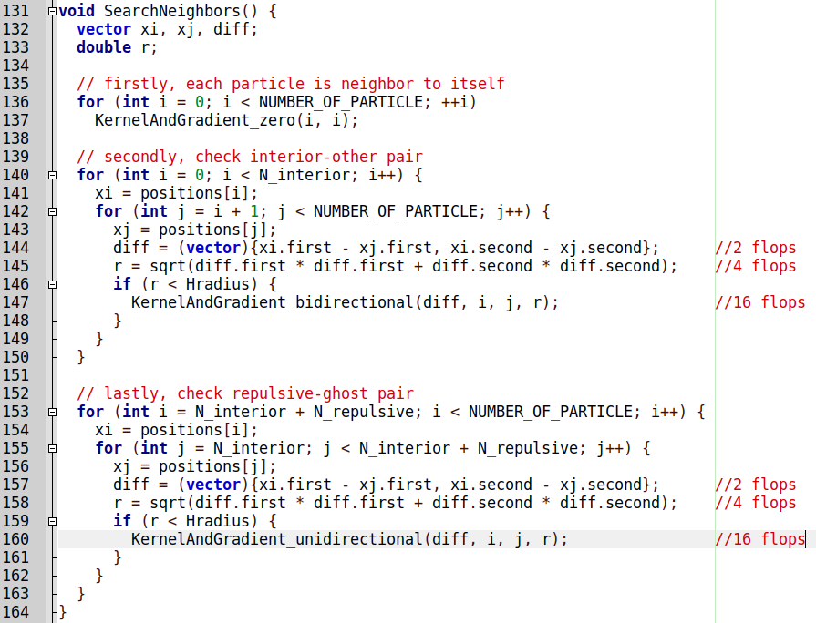
Total number of flops for SearchNeighbors:
- every particle has itself as neighbor → 0 flops
- every particle has other 12 neighbors for which “KernelAndGradient” is computed but it is computed only once for every pair of neighbors →12 * 16N flops / 2 = 96N flops
- for every interior particle we compute the distance between the considered particle and the other interior particles with index higher than the index of the considered particle → = 3Ni(Ni – 1) flops
- for every interior particle we compute the distance between the considered particle and every boundary particle → Ni * 6Nb flops
- for every repulsive particle we compute the distance between the considered particle and every ghost particle → Nr * 6Ng = (Nb/3) * 6(2Nb/3) = 4Nb²/3
So, the cost of SearchNeighbors is 96N + 3Ni² – 3Ni + 6Ni * Nb + 4Nb²/3.
The overall cost of optimization1 is:
C(N, Ni, Nb) = 68N + 503Ni + 17Nb + 96N + 3Ni² – 3Ni + 6Ni * Nb + 4Nb²/3
= 164N + 500Ni + 17Nb + 3Ni² + 6Ni*Nb + 4Nb²/3

Optimization2 (optimization2_unrolling_factor_4 branch)
The number of flops shouldn’t change with respect to optimization1.
C(N, Ni, Nb) = 164N + 500Ni + 17Nb + 3Ni² + 6Ni*Nb + 4Nb²/3

Optimization3 (optimization3_vectorization branch)
The number of flops shouldn’t change with respect to optimization1 and optimization2.
C(N, Ni, Nb) = 164N + 500Ni + 17Nb + 3Ni² + 6Ni*Nb + 4Nb²/3

Optimization4 (optimization4 branch)
Instead of computing for every pair of particles the sqrt, it is computed only when needed in “KernelAndGradient”:
- KernelAndGradient_zero: 0 flops
- KernelAndGradient_unidirectional: 17 flops
- KernelAndGradient_bidirectional: 17 flops
Total number of flops for SearchNeighbors:
- every particle has itself as neighbor → 0 flops
- every particle has other 12 neighbors for which “KernelAndGradient” is computed but it is computed only once for every pair of neighbors →12 * 17N flops / 2 = 102N flops
- for every interior particle we compute the distance squared between the considered particle and the other interior particles with index higher than the index of the considered particle → = (5/2)Ni(Ni – 1) flops
- for every interior particle we compute the distance between the considered particle and every boundary particle → Ni * 5Nb flops
- for every repulsive particle we compute the distance between the considered particle and every ghost particle → Nr * 5Ng = (Nb/3) * 5(2Nb/3) = 10Nb²/9
So, the cost of SearchNeighbors is 102N + (5/2)Ni² – (5/2)Ni + 5Ni * Nb + 10Nb²/9.
The overall cost of optimization4 is:
C(N, Ni, Nb) = 68N + 503Ni + 17Nb + 102N + (5/2)Ni² – (5/2)Ni + 5Ni * Nb + 10Nb²/9
= 170N + (1001/2)Ni + 17Nb + (5/2)Ni² + 5Ni*Nb + 10Nb²/9

Comparison between the number of flops for different versions of our code

~400 particles → Ni = 396, Nb = 497, N = 893
Version | Flops | % wrt base version
Base | ~2388932 | -
Optimization 1, 2, 3 | ~2333566 | 97.68%
Optimization 4 | ~2009011 | 84.10%

~4000 particles → Ni = 3959, Nb = 1529, N = 5488
Version | Flops | % wrt base version
Base | ~89703811 | -
Optimization 1, 2, 3 | ~89363555 | 99.62%
Optimization 4 | ~74988791 | 83.60%

Theoretical Peak Performance for SearchNeighbors

Base version (master branch)
Flops for SearchNeighbors:
- every particle has itself as neighbor → 14N flops: N*(4 add/sub, 5 mul, 5 div)
- every particle has other 12 neighbors for which KernelAndGradient is computed but KernelAndGradient is computed only once for every pair of neighbors →12 * 24N flops / 2 = 144N flops: (12/2)N * (4 add/sub, 12 mul, 8 div)
- for every interior particle we compute the distance between the considered particle and the other interior particles with index higher than the index of the considered particle → = 3Ni(Ni – 1) flops: (1/2Ni(Ni-1))*(3 add/sub, 2 mul, 1 sqrt)
- for every interior particle we compute the distance between the considered particle and every boundary particle → Ni * 6Nb flops: Ni*Nb*(3 add/sub, 2 mul, 1 sqrt)
- for every repulsive particle we compute the distance between the considered particle and every ghost particle → Nr * 6Ng = (Nb/3) * 6(2Nb/3) = 4Nb²/3: 2Nb²/9 * (3 add/sub, 2 mul, 1 sqrt)

For one timestep, the execution of SearchNeighbors requires approximately:
- add/sub = 4N + 24N + 3/2Ni*(Ni-1) + 3*Ni*Nb + 2/3Nb²
= 28N + 3/2Ni*(Ni-1) + 3*Ni*Nb + 2/3Nb²
- mul = 5N + 72N + Ni*(Ni-1) + 2Ni*Nb + 4/9Nb²
= 77N + Ni*(Ni-1) + 2Ni*Nb + 4/9Nb²
- div = 5N + 48N = 53N
- sqrt = 1/2Ni*(Ni-1) + Ni*Nb + 2/9Nb²

Considering also FMA, the operations which would correspond to peak performance are:
Kabylake architecture:
Port 0 | Port 1
FMA → 1 cycle | FMA → 1 cycle
Add/Sub → 1 cycle | Add/Sub → 1 cycle
Mul → 1 cycle | Mul → 1 cycle
Div → 4 cycles | X
Sqrt → 6 cycles | X
The schedule of the operations is the following:
- On Port0 are executed the div and the sqrt, meanwhile on port1 are executed the fma and the add. Since (#div*4 + #sqrt*6) > #add + #fma for every input, the number of cycles here is #cycles = #div*4 + #sqrt*6.
So, the total number of cycles for the base version is given by:
#cycles = #div*4 + #sqrt*6

Given the number of cycles and the flops, the peak performance can be computed:

Optimization1 (optimization1 branch)

