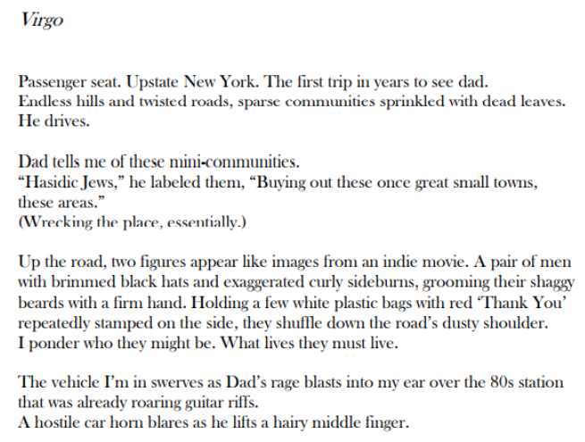

William Lewandowski’s debut book of poetry, *Sometimes the Stars Say*, paints the sometimes beautiful and sometimes gruesome parts of life. This book of poems highlights the struggles of mental health and toxic relationships, as well as the strength of overcoming the hardest parts of life. After I read the rest of “Virgo,” I will share another poem of mine called, “Aries,” which examines the theme of ambient loss—when you’ve lost someone or something although they haven’t physically left.



