# **Head of Business Intelligence, Management Reporting & Insights, Corporate Vice President Assessment**

**Workflow Summary**

Navigating Dashboard

1. Main components: Hover, click, or drag over card variables to render different selections. Cards will render different warnings as risk levels increase.

* Select a Customer
* Filter by Risk
* Total Transactions (Threshold set to show green, yellow, red pending on numeric value)
* Customer Service (counts on when customer reached out, and by count of relationships)
* Sudden Change (value of change from Q1_Q4 for “Yes” Churn customers)
* Heatmap where “Total_Relationship_Count” over “Total_Trans_Ct” is affected by Churn Risk threshold.

2. “Churn Scoring Controls” = allows users to select Customer # (reassigned random #s to CLIENTNUM, provides % of risk in same cell). Reacts entire dashboard according to selection.

3. “Filter by Risk” = user can drag to render Customer selections that fall within desired risk

Data Analysis & Feature Engineering

1. Calculated new metrics, such as the attrition rate, average transaction amount per active month

2. Identified correlations between different variables and attrition.

3. GLMNet, Random_Forest, and XGBoost techniques conducted for risk analysis and predictions.

4. Stacked Ensembles to fine tune and optimize collecting metrics for best performing models.

── A stacked ensemble model ─────────────────────────────────────

Out of 15 possible candidate members, the ensemble retained 2.

Penalty: 0.1.

Mixture: 1.

The 2 highest weighted member classes are:

# A tibble: 2 × 3

member type weight

*<chr>* *<chr>* *<dbl>*

1 .pred_Yes_tune_results_xgb_1_1 boost_tree 2.87

2 .pred_Yes_tune_results_xgb_1_3 boost_tree 1.27

> object.size(model_stack_fit)

44359592 bytes

Key Metrics

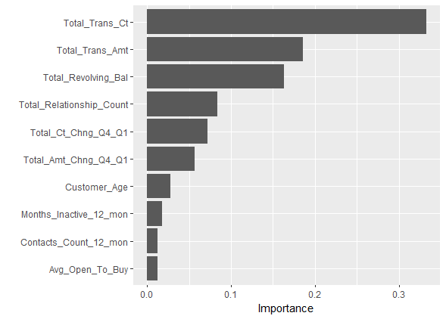

Converted Metrics

1. **Attrition Rate**: Calculated as (Number of customers who left / Total number of customers) * 100

2. **Average Customer Lifetime**: Months on Book / Number of customers

3. **Average Credit Utilization**: Sum of Average Utilization Ratio / Number of customers

4. **Average Transaction Amount per Active Month**: Total trans amount / (Total trans count * Months Inactive)

5. **Customer Interaction Frequency**: Contacts_Count_12_months / Months on Book

Data Dictionary

*\*\*\*were not used on dashboard, only for base level comparisons*

| **Metric Name** | **Description** | **Formula** |
| --- | --- | --- |
| Attrition Rate | Percentage of customers who left the company | (Number of customers who left / Total number of customers) * 100 |
| Average Customer Lifetime | Average number of months a customer stays with the company | Sum of Months on Book / Total Number of Customers |
| Average Credit Utilization | Average ratio of credit used to credit limit | Sum of Average Utilization Ratio / Total Number of Customers |
| Avg. Transaction Amount/Active Month | Average transaction amount per active month | Sum of Total trans amount / (Total trans count * (Months on Book - Months Inactive)) |
| Customer Interaction Frequency | Average frequency at which a customer contacts the company in a month | Sum of Contacts_Count_12_months / Months on Book |

Briefing

* Dataset does not quite capture anything out of the ordinary at first glance.
* With respect to most notable column “Total_Trans_Ct”, LESS transactions, relationship counts, and activity indicated higher probability that a customer left.
  + 96 or less Total_Trans_Ct in dataset shows higher probability for customer to leave.
  + 57 or more Total_Trans_Ct shows higher probability to remain.
* 1627 / 8500 customer have left. Mean tenure in months on book was 35.93.
* Factors like credit limit, dependent count, marital status, or gender did not hold as much weight as initially would have thought.