Industrial Visit Report
On 28th December,2021, 43 students of Second Year Master Of Management Studies along with 2 faculty members of Swayam Siddhi College of Management and Research visited Mumbai Waste Management Limited, Shree Chem Pharmaceuticals Private Limited, Dol Motors Private Limited and Pradeep Metals Limited. We left our college at 8:45 am and reached Navi Mumbai at 10:45 am. We travelled in a comfortable bus with students. First, we headed to Mumbai Waste Management Limited
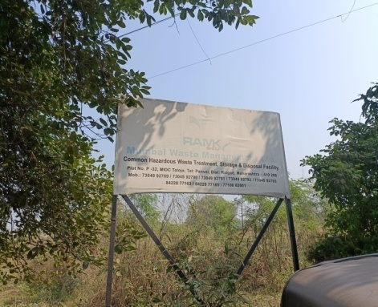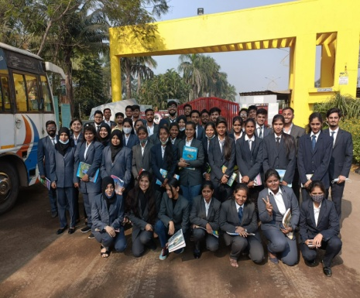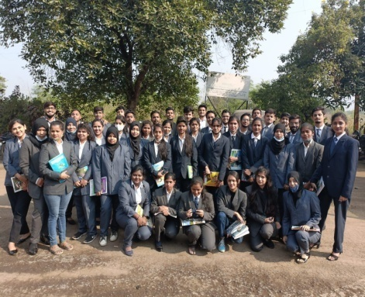
We were welcomed with a presentation followed by site visit where we were given details about how each process works. It was very informative session. It ended by around 1:00 PM. Then we headed towards Shree Chem Pharmaceuticals Private Limited
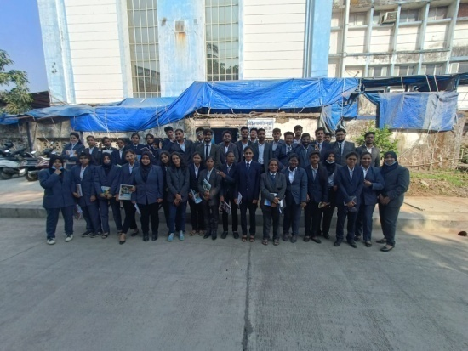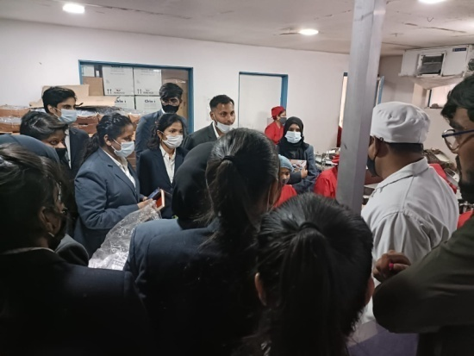
We reached Shree Chem Pharmaceuticals Private Limited at around 2:30 PM. They showed us the entire processes of medicines like tablets, drops and injections. Our third visit of the day was of Dol Motors Private Limited.
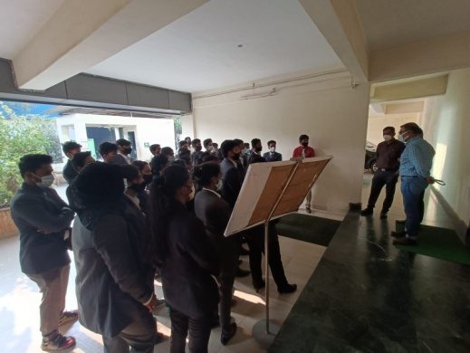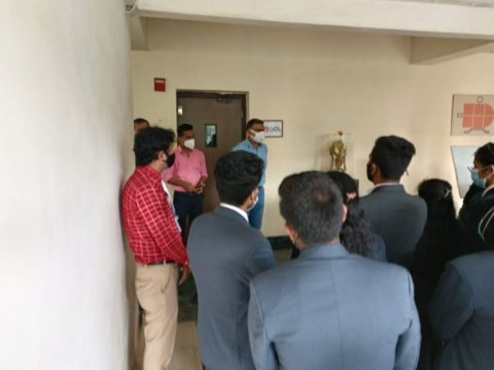
We reached there by 3:45 PM. General Manager of the company welcomed us. Here, the students were divided into two groups and information was provided simultaneously.
Our final destination of the day was Pradeep Metals Limited.
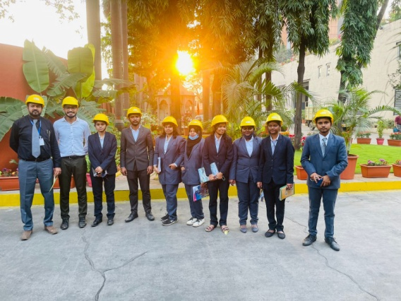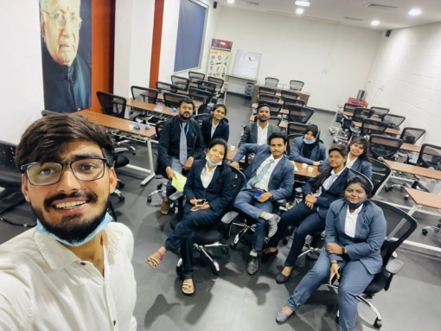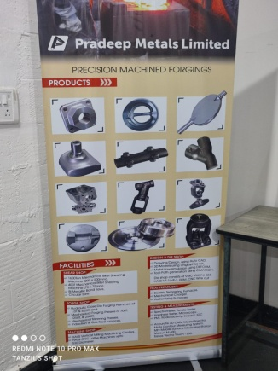
We reached there by 4:40 PM. We were provided helmets for our safety and entire process of manufacturing different products was shown and explained. We left from there at 5:45 PM and reached College Campus by 7:00 PM.
Total four industries were visited in a day of varied products. Students gained lot of practical exposure and understood the operations, fiancé, HR and IT related work carried in Industries. They were very happy and looked forward to more industrial visit in future.

REPORT ON NATIONAL INDUSTRIAL VISIT
Report contains information dated from: 6th January 2022 to 14th January 2022

Total No. of Students: 67
PLACES VISITED:
Chandigarh, Manali and Amritsar

INDUSTRIES VISITED:
Siddhartha Super Mills ltd.
Microturners
Shawl Factory
Pingalwada NGO
Swayam Siddhi College of Management & Research every year organizes International Industrial Visit but due to COVID RESTRICTIONS this year i.e. January 2022 we went to a domestic Industrial Visit to Chandigarh, Manali & Amritsar.
On 8th January after having the breakfast we went for the IV to the first Industry, SIDDHARTHA SUPER MILLS ltd. where strict precautions were taken and we were allowed inside the industry only after following the proper sanitization norms. We were supposed to wear the helmet provided by them and all the students were distributed in a group of 10 before going inside.

SIDDHARTHA SUPER SPINNING MILLS LIMITED is an Indian company incorporated on 13/08/1980 and its registered office address is SIDDHARTHA SUPER SPINNINGMILLS LTD VPO NIHLAKHERA,Nalagarh,Himachal Pradesh,INDIA.
SIDDHARTHA SUPER SPINNING MILLS LIMITED is registered at Registrar of Companies, Himachal Pradesh (RoC- Himachal Pradesh) and is classified as the Indian Non- Government Company. Its authorized share capital is INR 150,000,000 and its paid up capital is INR 127,500,000. The industrial and the SIC code for SIDDHARTHA SUPER SPINNING MILLS LIMITED is 17115.
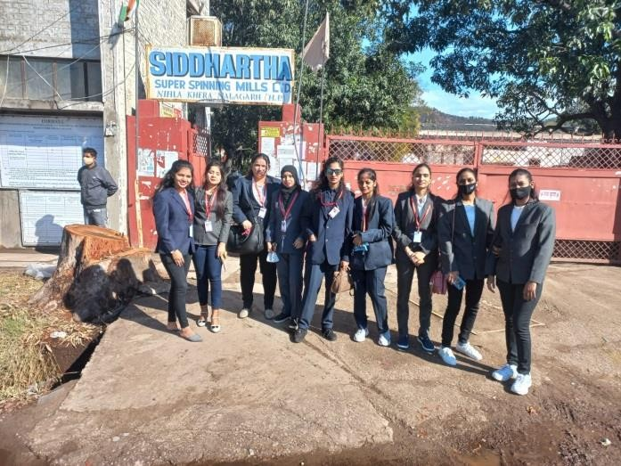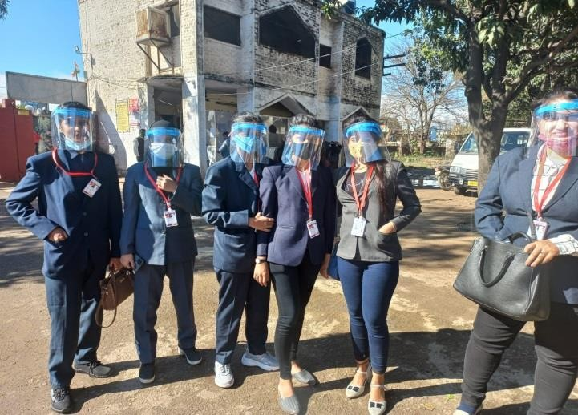It is involved in the business activities related to the industry code such as Cotton fabrics, woven (not handloom),Cotton mixture fabrics, manufacturing (not handloom),Fabrics of cotton mixture, manufacturing (not handloom),Fabrics of cotton, woven (not handloom),Weaving, manufacture of cotton and cotton mixture fabrics. Woven fabrics of cotton (not handloom).
All the process of textiles were explained by the HR manager to all the students after that we went to the second IV to the MICROTURNERS (Automotive Component Manufacturers).
At MICROTURNERS we have been guided about the plant which was spread across 10 km by the HR Manager, Senior Operations Manager and his team.
MICRO TURNERS Group, founded in 1969 (started with name A K Automatics) is one of the largest integrated Automotive component manufacturers in India.
They explained us the work of forging and machining, We also saw their well equipped and modern tool room with CAD/CAM/CAE infrastructure for 3D modeling, employing high-end CAM software, standard room, metallurgical lab and design & process facilities and added to these are our flawless inspection and testing facilities that further take manufacturing standards to levels of excellence.
MICRO LOGISTICS, started its operations in 2016 by combining local know-how and global expertise with the aim to make a mark and take India’s SCM and logistics industry to the next level, offering best in class services and promise fulfillment.
After the visit resource people gave us chocolates and said we were glad to have such bright students like you at our plant. Throughout the visit all the students were very interactive and in return we all got chocolates from them.

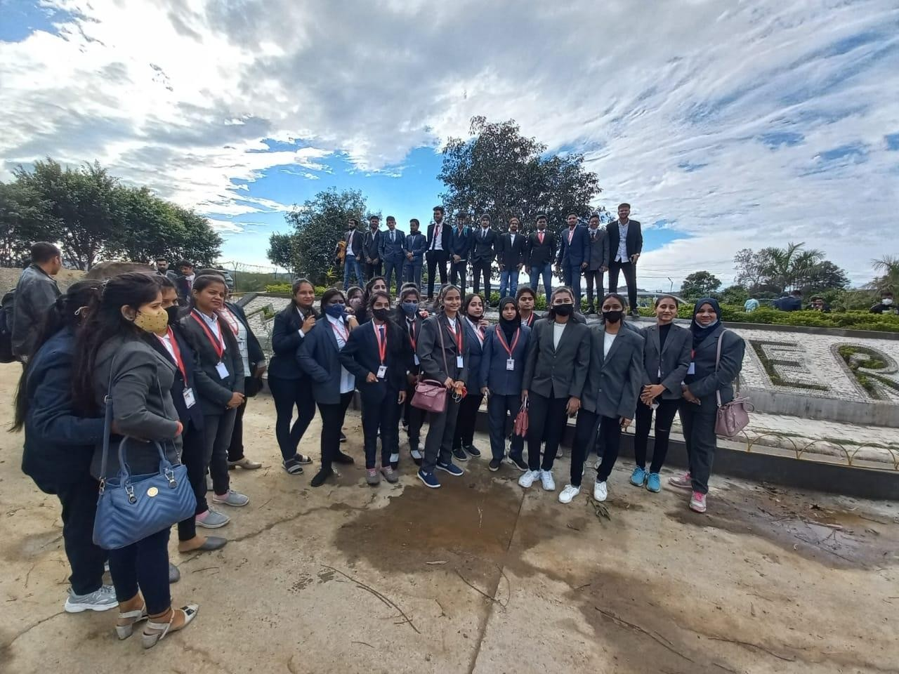

GROUP PICTURE AT METALMAN MICROTURNERS
The next Day i.e. on 10th January our plan as to go to snow camp at solan valley but due to heavy snowfall and rainfall we had no other option than to cancel the plan but we went for shopping in the evening at Mall Road.
On 11th January we left the Grand Krisa hotel and headed towards Kullu where thrilling adventures were waiting us i.e. Paragliding and River Rafting. Many of us had enjoyed either of the two adventure. The students that went for paragliding had to wait for their turn the whole day long and finally had got the chance before the sunset.
The same day we had a visit to the shawl Factory situated at KULLU where we were taught about the relevance and popularity of the shawls made at KULLU and also its manufacturing process: Kullu Shawls are well known all around the world for its simple and elegant designs and its fine woolen fabric and manufacturing quality. Kullu shawls are worn by both: men and women, but men's shawls are usually called "Loi" or "Pattu" and are often plain without any pattern or minimal patterned stripes on two edges.
Typical Kullu shawls have geometrical designs on both ends. The shawls may also have floral designs, which may run all over. Each design may have up to eight colors.
Most traditional colors are often bright colors, used to emphasize the shawl and make it more appealing, however, there are instances where the shawl is made with a more dull color, such as pastel. Kulu shawls are also crafted in yak's wool, sheep wool, Pashmina, and other handcrafted material.
One more day ended and after having the dinner at Dhaba we left KULLU and proceeded the journey towards Amritsar.

The journey was of 11 constant hours and finally on 12th January we arrived at Amritsar, checked in the hotel room had the breakfast and at 11 o’clock we went to an NGO i.e. Pingalwada NGO, every year our college does CSR activities as to make the students learn the dynamics of Society and how to be the better version of yourself. Thus many of us had visited to the NGO where we had an interaction with the Admin Head Mr. Singh who gave us a deep insight about the roles and duties they perform for the society.

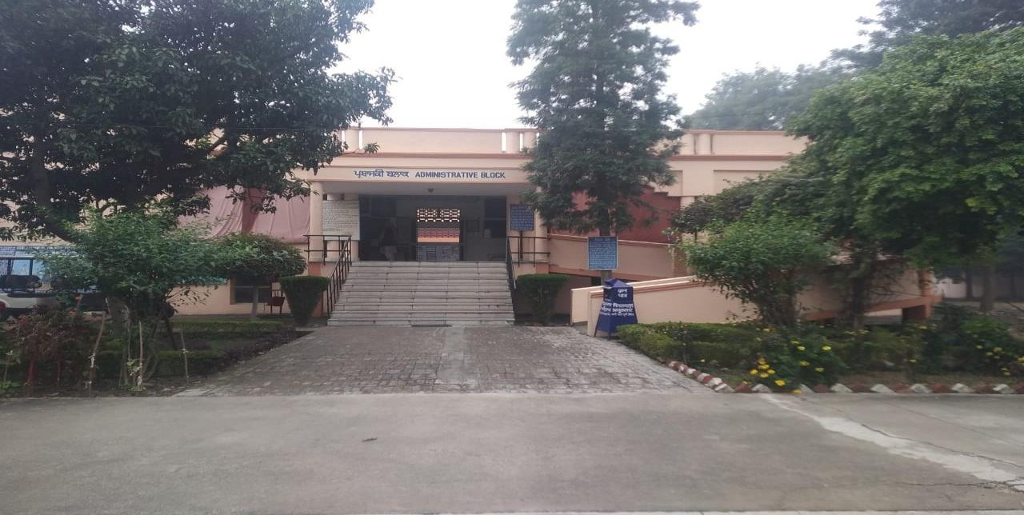
PINGALWADA NGO
Pingalwada is a house for destitutes in Amritsar in northern Indian state of Punjab. It is housed in a three-storey building near the main Amritsar bus stand on the National Highway no. 1, also known as G.T. Road. In this house all the handicapped/diseased people are provided such a shelter that is more like a home. The workers treat all like gifted rather than destitutes. Under the name of this building, there are many other places working selflessly for the same cause that are run by the main organisation. This remarkable institution is the real example of selfless good deeds. Children, widows and old people are able to find that little feeling of love at the most unbearable movements of their lives. The rising number of volunteers show that the people of Amritsar are controlled by the graciousness of the heart.
Currently Pingalwara has facilities for 1080 patients who are fed, housed and looked after thanks to generous support of various philanthropists.
The unclaimed bodies of the deceased are donated to Government Medical College, Amritsar for research and teaching purposes. The main branch houses the Administrative Complex, A Female ward, Children's ward, Rehabilitation Centre, Printing Press, Dispensary, Medical Lab, Dental Centre and the Common Kitchen.
The next day, on 13th January in the morning at 8.45 am we caught the train for returning back to our homes. The journey of train was nearly of 37 hrs and we reached at Kalyan Station on 14th January where our family members came to pick us up.
Although no one can be as caring as parents but throughout the trip all the professors have taken a very good care of all of us and have become a family.
CONCLUSION: It had been an extremely good exposure for all the students to experience the culture of different state, able to understand how MNC’s work at large scale, what are different types of work carried out in different department and last but not the least we have learned to get adapted into a crowd and team up immediately as per the need and requirement by proper utilization of time.

Photos of
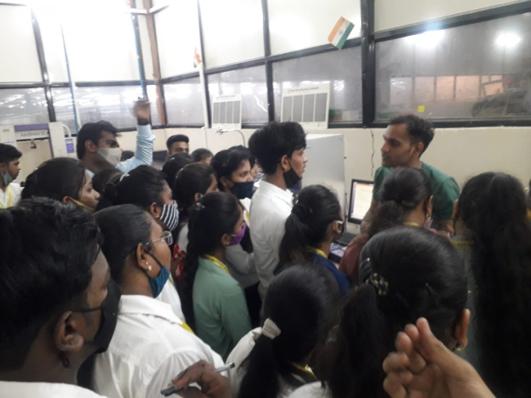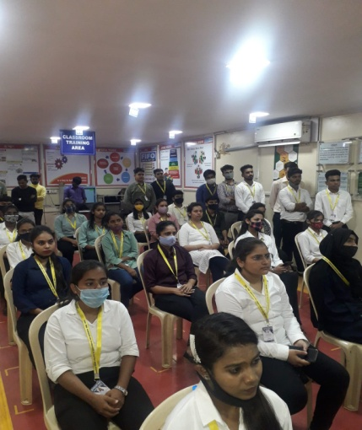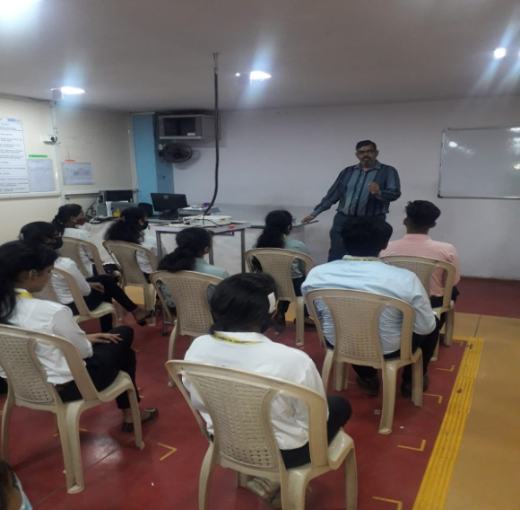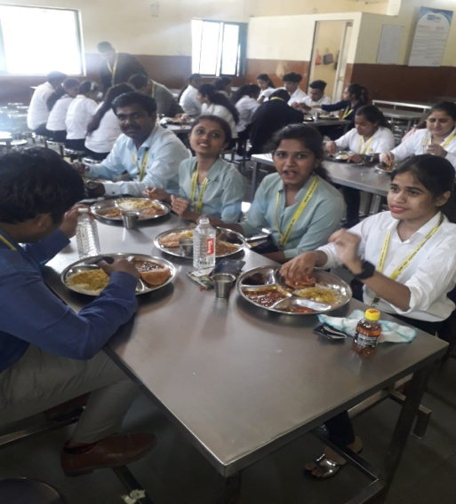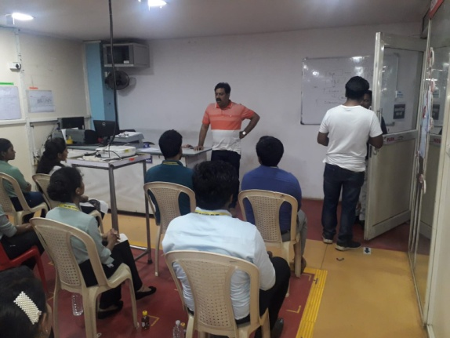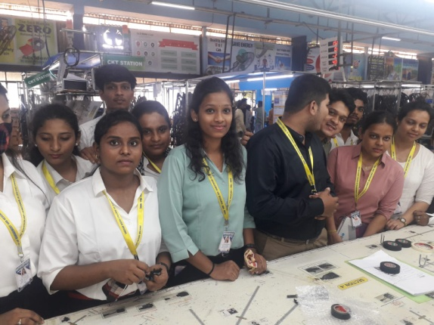
One day local IV was arranged by the college to Ahuja Industries Ltd., Minda Corporation Ltd. On Sat., 16th April, 2022 to provide students an insight regarding internal working of companies.
Total 51 students visited the comp[any along with 2 faculty members. Students did get first hand information about the working of the industry.
They was extremely helpful and informed to our students about our organisation function and its operations. It was really a splendid presentation and Industry visit which provide lots of information to the students in the field visit and it will help to prepare their project report work.

