PHOTOS OF INDUSTRIL VISIT TO JNPT SCHEDULE ON 1st November 2024
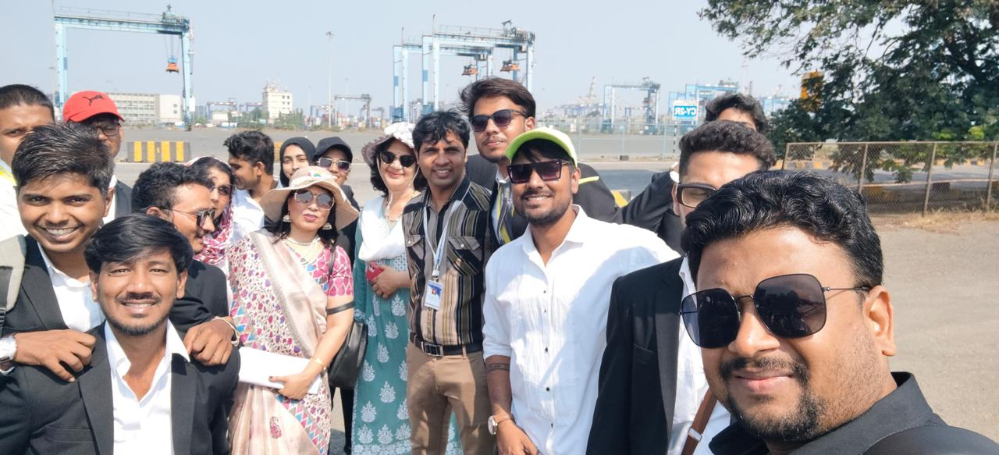
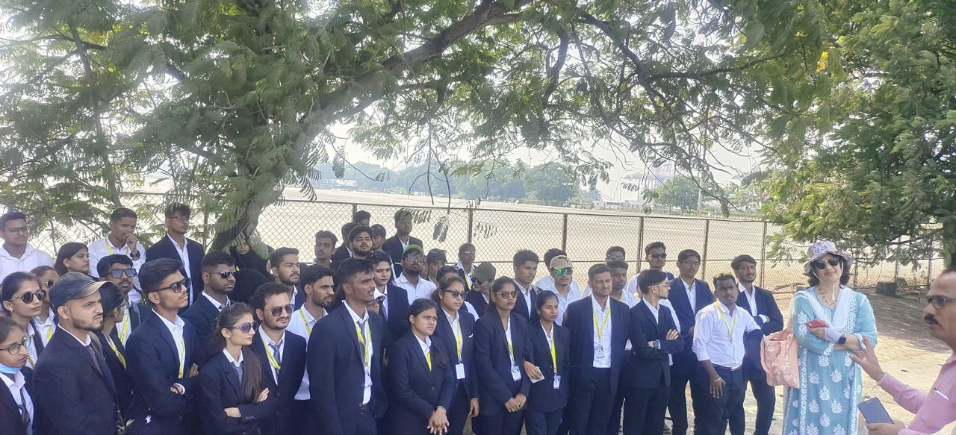
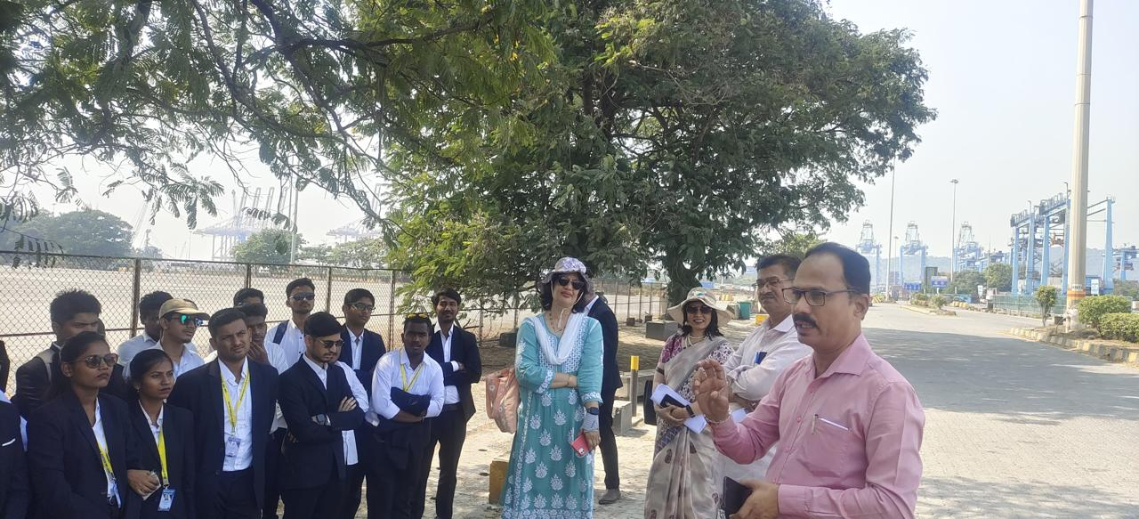
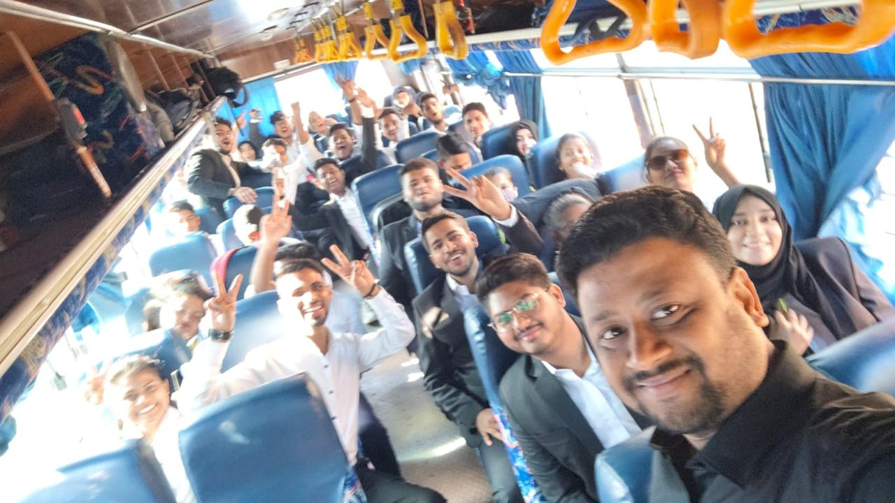
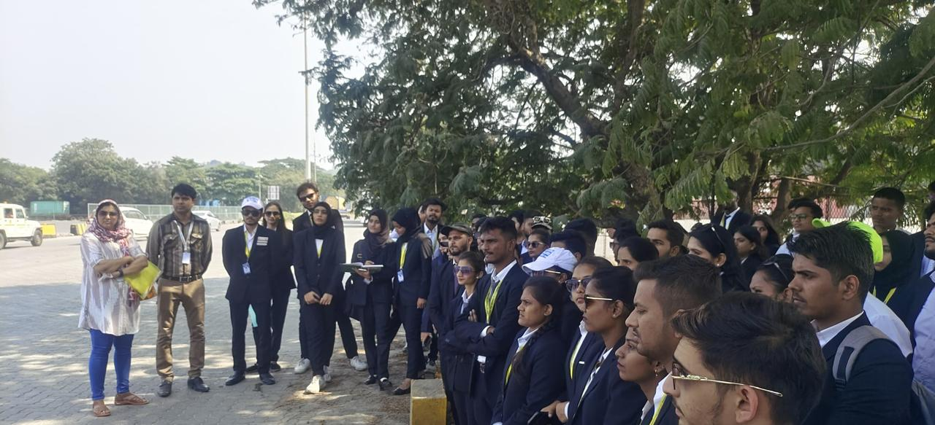
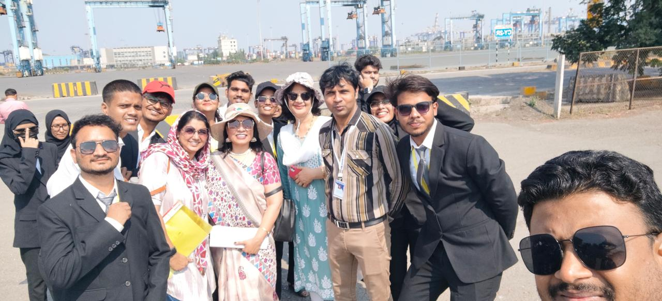
Report of JNPT:
REPORT ON JNPT VISIT SCHEDULED ON 1st NOVEMBER 2023
The report summarizes a study visit to the Jawaharlal Nehru Port Trust (JNPT) in Uran, India. 75 students and four faculty members from Swayam Siddhi Mitra Sangh’s college of Management and Research visited JNPT to learn about port operations. The students toured various areas of the port and learned about container handling and shipping processes. They observed operations like container movement from ships to storage areas and visited administrative and cargo checking facilities. The visit provided students with practical insights into port management and international trade.
College had organized one day study visit to JNPT (Uran) for the MMS students of SEM I and SEM II on 1st November 2024. The main purpose of the visit was to acquaint students with various activities, functioning, etc related to ports. The students experienced operations like how the containers were moved from the shipping vessel to various areas of ports. They personally visited different restricted areas like administration building, container checking area, etc and learned different terminologies used in port areas.
Objectives of the visit:
To see operations at terminals like: - vessel side operation, Yard operations etc.
To understand the functions of an ICD in port
Familiarization of various equipment's used in terminals
To understand the importance of safety at the terminals
To get insights into the operations while loading and unloading the cargo
To understand the Customs formalities
The entire objective was covered and students enjoyed and gain practical application of JNPT port.

Report on International Visit.
Note*****Please take the photo from Meetesh Sir.
Report on Thailand Bangkok:
Management organized “International Industrial Visit to Thailand, Pataya and Bangkok from 12th August 2023 to 16th August 2023”. Total 63 students along with 3 Faculty Members has the opportunity to travel international and gain practical exposure and application.
The main objectives of the visit was:
- Observe and analyze
- Understand practical application
- Gain hands-on experience
- Practical Exposure and Application
- Knowledge Enhancement and Skill Development
- Understanding Organizational Dynamics

The outcome of the visit was:
- Students made details of the observations made during the visit, analyzing the industry environment, processes, and technologies.
- Students were demonstrated how theoretical concepts learned in the classroom are applied in the real-world industrial setting.
- The visit offered a chance to see firsthand how different departments and functions within an organization operate.
- Industrial visits provided opportunities to learn about the latest technologies, equipment, and processes used in the industry.
- The visit contributed in developing skills like observation, analysis, problem-solving and communication.
- Students learned about various business functions like marketing, HR, finance, operations, and logistics.
- Students interacted with industry leaders, professionals, and experts, gaining valuable insights and advice.
The experience helped students develop a better understanding of professional ethics, work culture, and the importance of teamwork. Along with the visit the students did sightseeing at different tourist places and enjoyed a lot. International visit was successful and students gained the practical exposure.

