Alumni Cell – Runanubandh

There is a dedicated Alumni Cell of the Institution titled “Runanubandh” which got registered on April 17,2021. The event saw registrations and attendees of more than 50 distinguished SSCMR Alumni from different parts of Maharashtra like Nagpur, Nandurbar, Pune, etc.
​
Mrs. Rita Khandekar Madam, the Hon’ble Trustee of Swayam Siddhi College, in her address expressed her happiness about Students’ reaction wrt. the Alumni association endorsing and accepting the name “Runanubandh”. She further expressed that the alumni will contribute in a big way in taking this association to the next level by contributing, enhancing the Knowledge and skill domains of current students by conducting guest lectures, webinars, seminars and for providing all the necessary support and direction for the college to move forward. She also took this opportunity to thank the alumni for their active participation.
Mr. Dhammapal Thorat was declared the President of this Alumni Cell with Mr. Navneet Tiwari and Mr. Mayur More being named the Treasurer and Secretary respectively.
An Alumni Cell Committee was also created under the official patronage and support of Mrs.Rita Khandekar, the Hon’ble Managing Trustee of Swayam Siddhi Mitra Sangh Trust, .
Following members will be a part of “Runanubandh” Alumni Cell:
1. Mr. Dhammapal Thorat- President
2. Mr. Navneet Tiwari- Treasurer
3. Mr. Mayur More – Secretary
4. Mrs. Bhagyalaxmi Sevareddy- Member
5. Mr. Bhavik Bhanushali- Member & Industry Connect
6. Mr. Milankumar Jain – Member
7. Mr. Bhushan Ahire – Member
8. Ms. Triveni Sriram Siddhiram – Member

Mr. Dhammapal, Mr. Amit Delikar, Mr. Navneet Tiwari, Mr. Ravindra Shende and Miss. Minu Yadav recalled their college memories & elaborated how Swayam Siddhi College, has changed their life from students to be successful professionals and good human beings.

Some of Testimonials share by Alumni :
MR. MAYUR MORE TESTIMONIAL - Proud Alumni
“Myself Mayur Lilawati Suryakant More( B.E. & MMS)
I have done my MMS from Swayam Siddhi College, Mumbai, It was a great experience and learning from Swayam Siddhi College, , I have learned many skills and grabbed knowledge from college...
About Staff is too much Cooperative, they supported me for various other activities, when I was in SSCMRI have represented 2 time Mumbai university and Maharashtra at Indian student’s parliament and first national student’s parliament Kerala legislative assembly My success story is published in the 10th Indian Student parliament conclave Vighyan Bhavan New Delhi. When I was on campus we organized many skills set programs, annual gathering program we participated. I have learned many management skills and improved my skill set.
My journey with Swayam Siddhi College has been excellent
Thanks.”
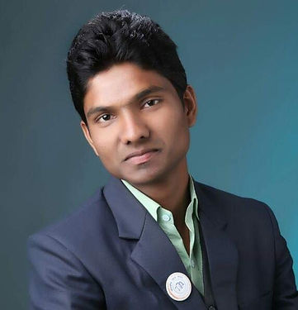

xxxxxx-------------------xxxxx

Mr. Manohar Patil - Proud Alumni
SSCMR is a good institute with better career opportunities and improving placements year by year, Teaching Methodologies and arranging Modern equipment for better understanding of things in practical. This institution has always supported their students for doing something good. Each department of this institute have honest and dedicated faculty.
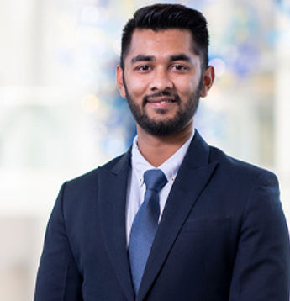

xxxxxx----------------xxxxxxxx

Ms. Priyanka Yadav - Proud Alumni
The expertise and skills that I acquired from my education and experiences have played a significant role in defining my professional path, and I am convinced that they will continue to direct me in my future endeavors. I am incredibly appreciative of the department’s strong foundation as I set out to earn a Master’s degree in Management. It is unimaginable to explain how the department has impacted my journey. My career trajectory has been significantly influenced by their focus on fostering a culture that fosters growth and commitment to excellence.


