College Alumni Meet 2024-25

Event Date: April 27, 2025 Venue: College Auditorium
Organised by: Alumni Committee, Swayam Siddhi College of Management & Research (SSCMR), Bhiwandi

Introduction
The annual alumni meet of SSCMR was held on April 27, 2024, at the college auditorium. The event aimed to reconnect alumni, foster networking opportunities, and celebrate the achievements of past students. It also provided a platform for alumni to engage with current students and contribute to the growth and development of their alma mater.

Registration and Welcome
The event commenced with the registration of alumni at 11:30 AM. Each attendee received a welcome kit containing a program brochure, a token of gratitude and a lunch coupon. The college auditorium was beautifully decorated, and the ambiance was filled with nostalgia and excitement.

Inaugural Ceremony
The inaugural ceremony began at 12:30 PM with a welcome address by the Head of Alumni Committee, Prof. Amit Singh. He expressed his gratitude to the alumni for their continued support and highlighted the importance of their contributions to the college progress.

Keynote Address
The keynote address was delivered by a very distinguished alumni Dr. Sharadkumar Dattatray.
Dr. Sharadkumar D. Shah is a distinguished academician, researcher, and administrator with over 30 years of experience. Currently serving as the Principal of Bakliwal College of Arts, Commerce & Science in Navi Mumbai, he holds a Ph.D. in HRM and a Doctorate in Business Management. His qualifications include dual Master's degrees (Management & Chemistry), PGDBM, and multiple prestigious fellowships (FICC, FICS, FIC, MAMIC [USA], etc.). He is also pursuing an LLB from the University of Mumbai.
He spoke about his journey of over 30 years of his professional carrer and how he achieved these many milestones in his life. He also gave many usful tips and suggestions to the other alumni members for living a balanced and successful life. His inspiring speech resonated with both alumni and current students.

Placement Head Speech

Placement head of the college, Mr. Snjay Kumar offered an inspiring speech to encourage Alumni Members for their support in college placement activities. He also suggested alumni to ask for any support from the college placement cell if required by them.

Networking Lunch
A networking lunch followed the panel discussion, offering alumni the opportunity to reconnect with old friends, make new connections, and exchange ideas. The lunch was held in the college canteen, providing a relaxed and informal setting for conversations.

Campus Tour
Post meet, a campus tour was organized for the alumni. Many attendees were thrilled to revisit their old classrooms, libraries, and hostels. The tour also showcased the recent developments and infrastructural advancements of the college.

Closing Remarks & Vote of Thanks
The event concluded with closing remarks by Prof. Sharique Momin. He thanked the alumni for their participation and encouraged them to stay connected with the college. He also invited them to contribute to the college growth through mentorship programs, guest lectures, and placement support.

Conclusion
The alumni meet was a resounding success, bringing together former students from various batches and fostering a sense of community and belonging. The event not only celebrated the achievements of the alumni but also strengthened their bond with the college. The positive feedback from the attendees underscored the importance of such gatherings in building a vibrant and engaged alumni network.
SSCMR Alumni Committee looks forward to organising more such events in the future to continue this tradition.

Pictures:

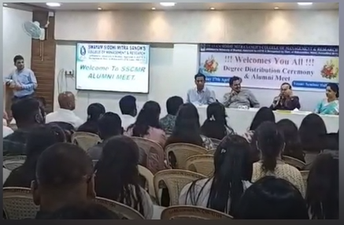

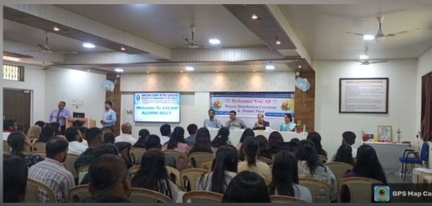

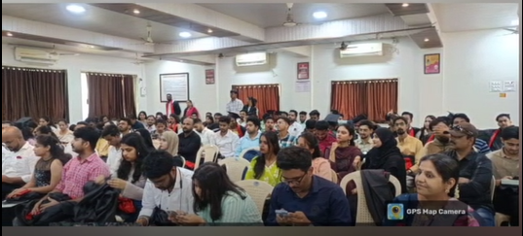

Alumni Video Bites:

