Computations of Rarefied Gas Flows Using Semiclassical Boltzmann-ES-BGK Equation

Jaw-Yen Yang*, Chi-Yen Yan, Manuel Diaz and Juan-Chen Huang
Institute of Applied Mechanics and Center of Advanced Study in Theoretical Science
National Taiwan University, 10764, Taiepi Taiwan *Corresponding author: yangjy@iam.ntu.edu.tw

ABSTRACT
Computations of rarefied gas dynamical flows governed by the semiclassical Boltzmann ellipsoidal statistical (ES) BGK equation are presented using an accurate numerical method. The semiclassical anisotropic ES equilibrium distribution differs from the standard Fermi-Dirac or Bose-Einstein distribution. The present numerical method combines the discrete velocity (or momentum) ordinate method in momentum space and high resolution shock capturing method in physical space. Computations of 2-D Riemann problems covering various degree of rarefaction are presented. .

1. Introduction
The classical Boltzmann equation has been generalized to quantum gas [1]. The relaxation time approximation is usually applied [2]. Recently, a new semiclassical Boltzmann-ES-BGK equation has been derived [3]. The objectives of this study are two fold. First, we present an accurate numerical method for solving the semiclassical Boltzmann-ES-BGK equation in phase space. Second, we investigate the effect of different range of relaxation times which corresponding to different Knudsen numbers thus different degree of gas rarefaction. The numerical method consists of two parts; one is the discrete ordinate method and the other high resolution shock-capturing methods. In the classical rarefied gas flow computation, the implementation of discrete ordinate method to nonlinear model Boltzmann equations has been developed by Yang and Huang [4]. Extension to semiclassical Boltzmann-BGK equation has been reported [5]. Such a direct method will allow one to examine the same physical flow problems but with different gas of particles. Also, if the classical limit situations of the same flow problem are considered, then one expects to obtain similar or identical flow structures for the three statistics. Computations of several 2-D Riemann problems [6,7] in gas flows of arbitrary statistics for different range of relaxation times are shown to illustrate the complex rarefied gas dynamics as governed by the semiclassical Boltzmann-ES-BGK equation.

2. Semiclassical Boltzmann-ES-BGK Equation
We consider the semiclassical Boltzmann-ES-BGK equation [1]:
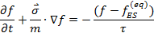
Where the equilibrium ES distribution is given by
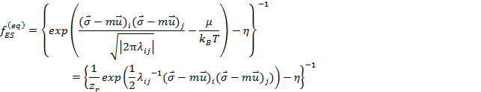
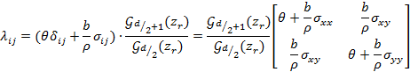

is the pressure tensor, , is fugacity, and is i-direction thermal velocity,, 、、are trace free stress tensor,,,are pressure tensor. When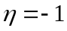one has Fermi-Dirac (FD) statistics, 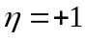Bose-Einstein （BE）, and 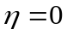Maxwell-Boltzmann （MB）statistics.
3. Solution Method

We first apply the discrete ordinate method to discretize the velocity space and render a set of hyperbolic conservation equation with source term in physical space. Then we implement a class of high resolution shock capturing schemes including TVD and WENO methods. This direct solution methods in phase space for the Boltzmann-BGK type equations have been proven to be very accurate and efficient and can simulate wide range of flow parameters such as Reynolds number, Mach number and Knudsen numbers [4,5]. .

4. Results and Discussion
Once after you have completed your manuscript in Word format, you must create a PDF file. Both Word file and PDF file you prepare should be submitted from ICFD Web Page.
I
Proceedings will be distributed to the conference participants with USB memory sticks. Color figures are acceptable.

4. Concluding remarks
Due date of the paper submission is September 1, 2013.

References
[1] E. A. Uehling and G. E. Uhlenbeck, Phys. Rev. 43, (1933) 552–561.
[2] P.L. Bhatnagar, E. P. Gross & M. Krook, M., Phys. Rev. 94, (1954) 511–525.
[3] W. Lei, J. P Meng, and Yonghao Zhang,Proc. Roy. Soc. A, 468(2012), p. 1799.
[4] J. Y. Yang and J. C. Huang, J. Comput. Phys., 120, (1995) 323–339.
[5] J. Y. Yang,B. P. Muljadi, Z. H. Li and H. X. Zhang, Commun. Comput. Phys. 14, (2013) p. 242-264 .
[6] C. W. Schultz-Rinne, , J. P. Collinsand H. M. Glaz,
SIAM J. Sci. Comput. 14, (1993) 1394–1414.
[7] P. D. Lax and X. D. Liu, SIAM J. Sci. Comput 19, (1995) 319–340.

