Runme!
Coded by Manuel Diaz, f99543083 NTU, IAM, 2012.04.01.
% Exercise 1.a
HWproblem1adIso
% Exercise 1.b
HWproblem1bdIso
% Exercise 2
HWproblem2dIso
% Exercise 3
HWproblem3dIso
% Exercise 4
HWproblem4dIso

Exercise 1.a plots:
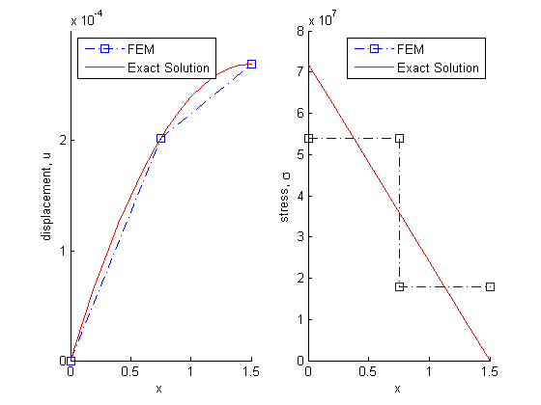

Exercise 1.b plots:
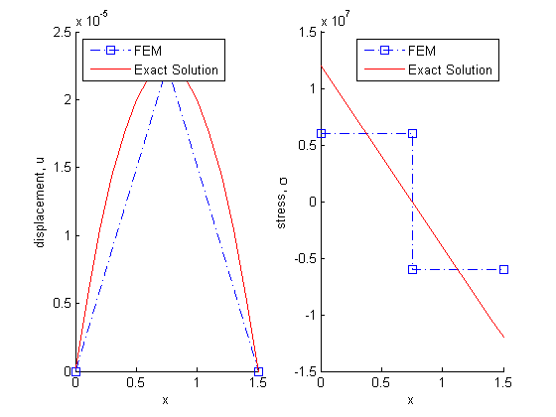

Exercise 2. plots:
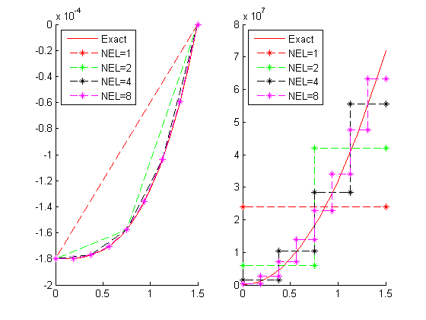

Exercise 4 plots:
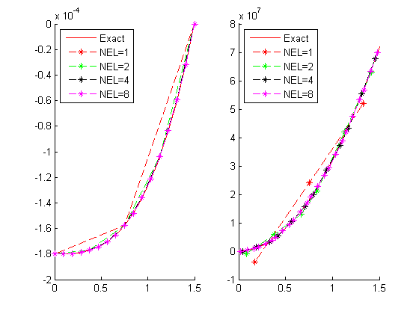

Exercise 4 plots, (Unfinished problem)
