- Features of Potential Energy Surfaces
Potential energy surface (PES) provides energy as a function of the locations of all the atoms in a system:
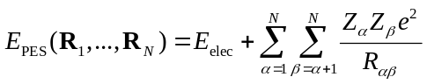
Here R_{i} are the Cartesian positions of all the atoms in space.
- Specifying atomic positions
Cartesian coordinates are the most direct way to specify the locations of atoms in a molecule. For N atoms, there are 3N Cartesian coordinates.

A non-linear molecule with N atoms has 3N − 6 internal degrees of freedom. The other 6 DOFs correspond to translation in the three Cartesian directions and rigid rotation about the three axes. (For linear molecule, becomes 3N − 5 internal degrees of freedom.) These six/five can be specified any way, and codes usually will translate atoms to the center of mass and orient principle rotation axis in z direction. Called “standard orientation.” When reading output, like direction of dipole vector or contributions to molecular orbitals, important to know what orientation it refers to.

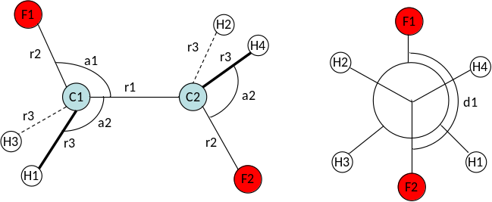
Z-matrix is popular alternative that can often simplify specification and doesn’t have any redundancy. Based on specifying distances between pairs of atoms, angles between 3 atoms, and dihedrals between four atoms. For instance, for 1,2-difluoroethane:

- C1
- C2 C1 r1
- F1 C1 r2 C2 a1
- F2 C2 r2 C1 a1 F1 d1
- H1 C1 r3 C2 a2 F1 d2
- H2 C2 r3 C1 a2 F2 d2
- H3 C1 r3 C2 a2 F1 −d2
- H4 C2 r3 C1 a2 F2 −d2

Here we’ve assumed symmetry in the distances, angles, etc. Wouldn’t have to do that.

With z-matrix in hand, relatively easy to “scan” over coordinates. E.g., here is Gaussian input to calculate energy vs. rotational angle d1 (HF/STO-3G), with all other coordinates fixed at some sensible values.

#N HF/STO-3G SCAN NOSYMMETRY

C2H4F2

0 1
C
C 1 r1
F 2 r2 1 A1
H 2 r3 1 A2 3 D1 0
H 2 r3 1 A2 3 D2 0
F 1 r2 2 A1 3 D3 0
H 1 r3 2 A2 6 D1 0
H 1 r3 2 A2 6 D2 0

r1=1.5386
r2=1.39462
r3=1.11456
D1=120.47127
D2=-120.483 05
A1=109.54214
D3=7.5 23 15.
A2=110.09239

Energy results:
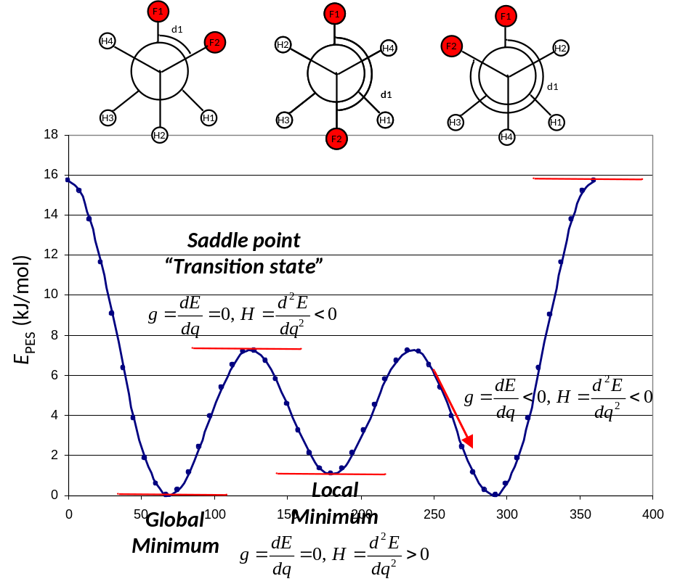

Note 3-fold periodicity as expected for rotation about a C−C single bond. Note too there are some special points:

Minima – places where energy bottom out. More formally, first derivative of energy, or slope, or “gradient” g = 0, and second derivative, or curvature, or “Hessian” H > 0. These are the stable conformations of the molecule. Note that lowest energy in this case is not trans, but rather gauche conformations. Are you surprised?

Saddle point – places where energy maxes out. Physicially, corresponds to “transition states” connecting low-energy conformations. Gradient g = 0, but curvature H < 0.

Classically, the “force” on an object is F = −g, so the gradients are often called the “forces.” Where gradient (slope) is negative, force is positive, and vice versa. Force always pushes system toward nearest minimum. If the potential is harmonic, then the force constant k = H, so the Hessian is also called the “force constant.”

For more than one degree of freedom, have to generalize these ideas. Define the first derivative, or gradient vector g, where q_{i} are the individual degrees of freedom. Also the second derivative, or Hessian, matrix H:

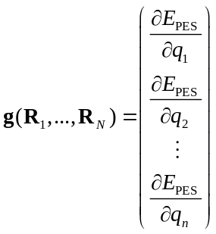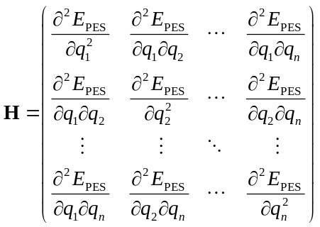

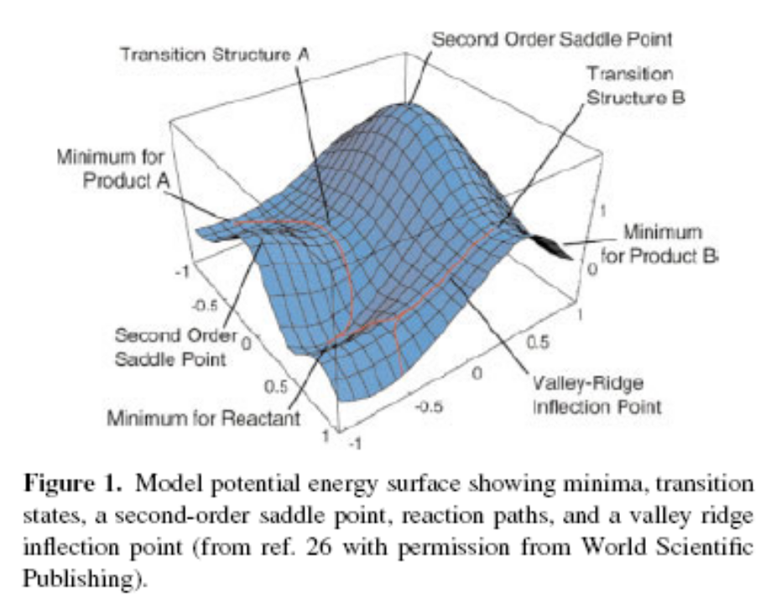
From Schlegel, J. Comp. Chem. 2003, 24, 1514-1527.

Hessian matrix is real and symmetric, can be diagonalized to give eignevalues and eigenvectors. Eigenvectors give “natural” directions along PES (physically, the harmonic vibrational modes), and eigenvalues indicate curvature in that direction.

Minimum on multidimensional PES has gradient vector g = 0 and all positive Hessian eigenvalues.

First order saddle point, or transition state, has g = 0 and one and only one negative Hessian eigenvalues. (Physically, one unique direction that leads downhill in energy.) Always corresponds to lowest energy point connecting two minima.

Minimum energy pathway (MEP) or intrinsic reaction coordinate (IRC) is steepest descent pathway (in mass-weighted coordinates) from saddle point to nearby minima. Path a marble with infinite inertia would follow.

Higher order saddle points have g = 0 and more than one negative Hessian eigenvalue. Can always lead to lower energy first order saddle point. These typically do not have chemical significance.

In computational chemistry/materials science, it is usually our job to identify the critical points (minima and transition states on a PES). In liquids, PES much more flat and lightly corrugated. Statistical mechanics becomes mores important.

Remember that there are multiple PES’s for any atom configuration, corresponding to different electronic states. Sometimes these states can interact, intersect, giving avoided crossings, conical intersections…. Lead to more complicated dynamical behavior.
- Energy gradients and second derivatives
Obviously very helpful to be able to calculate first and second derivatives of E_{PES} with respect to nuclear positions q_{i}.
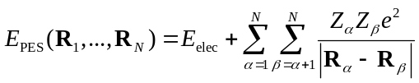
First derivatives could be calculated numerically, by finite difference, but analytical would be more convenient.

Sum is easy to differentiate. First term is tougher:

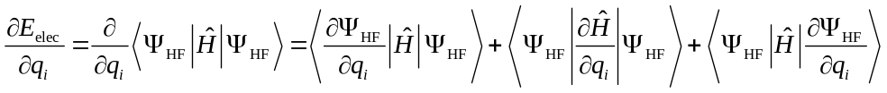

If we had the exact Hartree-Fock wavefunction (HF limit), the Hellmann-Feynman theorem tells us that the first and last terms sum to zero. The middle term would be easy, since the only part of 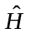that depends on the nuclear positions is the one-electron electron-nucleus attraction piece.

Unfortunately if we use an atom-centered (LCAO) basis set, the Hellmann-Feynman condition is not met, because 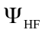 depends on the nuclear positions (the basis functions are “attached” to the atoms and follow them around), so the derivatives of the wavefunction have to be evaluated. These additional basis-dependent contributions to the forces are called “Pulay forces.” (See Peter Pulay, “Analytical Derivative Methods in Quantum Chemistry,” Adv. Chem. Phys: Ab initio Methods in Quantum Chemistry Part 2, 1987, 69, 241-286.)

Evaluating these other terms can be done, but involves differentiating the two-electron integrals, which adds computational expense.

Second-derivatives of energy even more complicated. Can be evaluated analytically, through solution of “Coupled Perturbed Hartree-Fock” equations. More common for correlated methods and DFT to use finite differences.

If E_{PES} is locally harmonic, then a good estimate of the second derivative can be obtained by calculating the first-derivative at some small displacements h away from the point of interest. Typical approach assumes that the point of interest is a minimum, i.e. that g = 0. If not so, Hessian will not be quantitatively correct, but may be qualitatively useful. Of course could relax this requirement, but requires more computational effort.
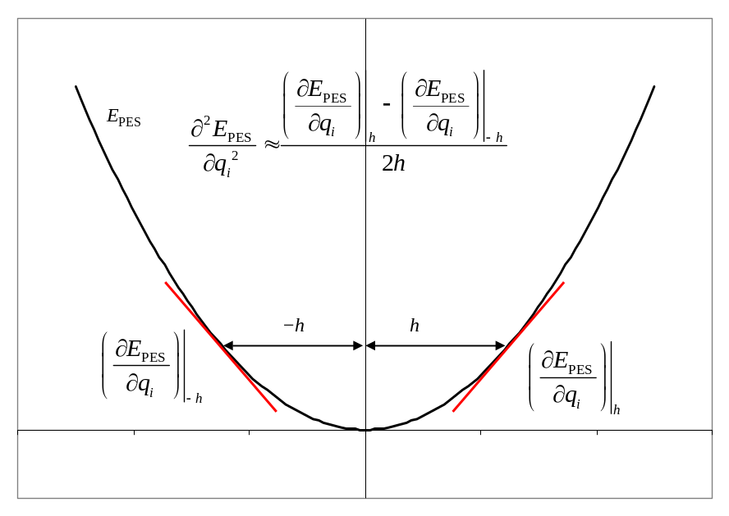
h must be small enough to stay in the harmonic region, but big enough to avoid numerical noise swamping the gradients.

For a molecule with N atoms, to construct complete Hessian 3N × 3N Hessian, have to evaluate gradients 2*3N times for two-sided differencing. Each pair of displacements completes one row. Obviously tends to be quite expensive.

To get better precision and accuracy, could calculate even more than two displacements, and could even fit to a more complicated function than a harmonic potential.
- Optimization algorithms
One of the most common tasks we have is finding the “optimum” geometry of a molecule, which translates into finding a minimum point on E_{PES}. This is a general problem in Numerical Optimization. Sholl and Steckel, Section 3.3, has a nice write-up on general features of optimizations. Also see Schlegel reference from figure above. I’ll give more general comments.

“Energy-only” algorithms search for minima without any gradient/force information. Effectively infer gradients and Hessian from lots of displacements. These tend to be very slow to converge and are only used in specialized situations.

While it costs computationally to calculate gradients analytically, having them on hand vastly increases the speed of optimizations.

Steepest descent: Consider some set of coordinates R for which we have E_{PES} and g. Most straight-forward approach would be to move atoms in direction of –g, i.e. find λ such that coordinates 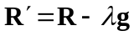have mimimum energy. Called a line-search. Repeat starting from updated R′ until ΔE_{PES} or g is sufficiently small. This general algorithm is called “steepest descent.” While every step lowers the energy, this algorithm tends to converge very slowly near a minimum.

Conjugate gradient: Disadvantage of steepest descent is that it loses information about previous steps. Notion of “conjugate gradient” search is to augment steepest descent with requirement to keep each step orthogonal to some number of previous steps. Generally performs much better than steepest descent, and is often the first choice if far from an equilibrium geometry.

Quasi-Newton Raphson: The two above only use/require information about g. If we also knew something about the second-derivative of the energy, H, that should speed up optimization even further. In one dimension, if function was quadratic, can exactly write
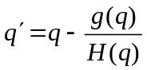
If not quadratic, make Taylor expansion of energy in q up to second-order, arrive at same expression for predicting q′. Apply interatively; in well-behaved cases this algorithm rapidly converges to local minimum.
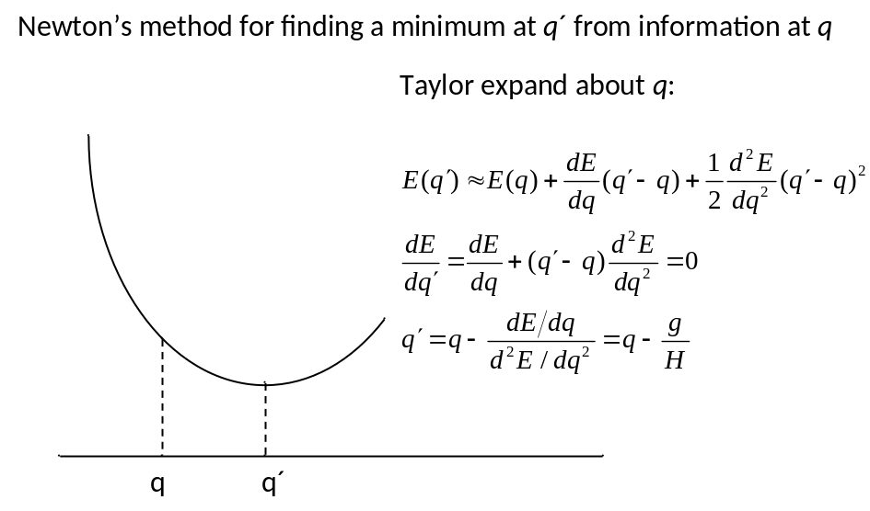
Can generalize approach to multiple dimensions. Make second-order Taylor expansion of energy about R, can show optimal
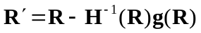

Again can perform line-search in direction R′− R if you want. Apply iteratively. Called Newton-Raphson method. This works really well.

One big, obvious disadvantage is that we need to know the Hessian at each step, and it is expensive to calculate. Fortunately, it is not important to know it very well, so we often start with a guess of the Hessian, and then update the Hessian using information from the gradients at each step. Large variety of formulas to do Hessian updating, like “Murtagh-Sargent” (MS) and “Broyden-Fletcher-Goldfarb-Shanno” (BFGS). Collectively called “quasi-Newton-Raphson.” Generally have to control sizes of steps. Various approaches, including line search, “trust radius,” “rational function optimization.” A variant using the RFO is the default in Gaussian.

Quality of method depends on quality of Hessian. Can calculate or estimate using approximate methods.

Geometry Direct Inversion in the Iterative Subspace (GDIIS). The size of a Newton-Raphson step H⁻¹g gives some estimate of the error in the current position. If we have a series of such steps, can predict the next step by requiring that it minimizes error from the previous ones. Gives next step as linear combination of previous steps. Find set of coefficients c_{i} that minimize the error vector
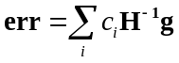
Next step is then:
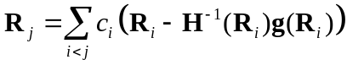
Generally very efficient near minima. Algorithm can misbehave away from minima, possibly even converging to nearby saddle points, so often started with conjugate gradient steps. As mentioned before, similar algorithm is also very powerful for electronic convergence.

Convergence criteria. As with any numerical optimizations, one has to specify a criterion for deciding when a result is converged enough. Stopping criterion can be in terms of differences in energy between subsequent steps, size of steps, or in terms of gradients (maximum, rms) going below some threshold. The last tends to be most robust. Should always be aware of the threshold and if you really care about a result, test against it. To be extra careful, calculate Hessian to be sure you are at a minimum

Additional caveat: all these methods find a minimum, but not necessarily the “best” (or global) minimum. There is no general algorithm to do that for E_{PES}.
- Algorithm for molecular geometry optimizations
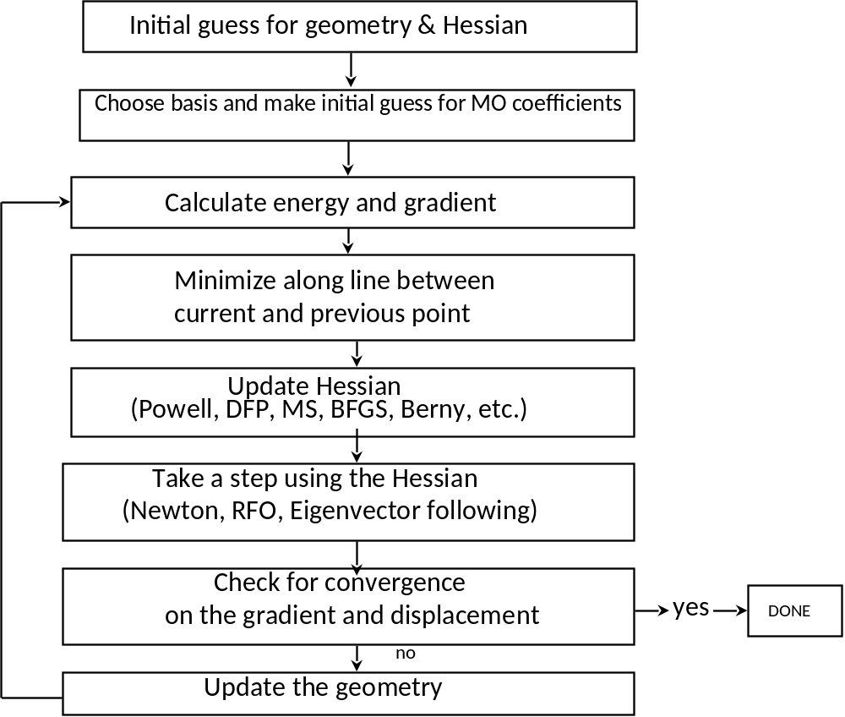

The real expensive part here is electronic structure calculation, so want to make geometry search part as efficient as possible. Example: Let’s go back to C₂H4F₂ molecule in the gauche conformation, do HF/3-21G optimizations.

Steepest Descent: [opt=(steep,cart)] doesn’t converge after 34 steps, E = -275.41842

Quasi-Newton-Raphson [opt=cart] converges after 8 steps, E = -275.41857

GDIIS opt=(gdiis,cart), converges after 6 steps, E = -275.41857

Compare final structures in gaussview.
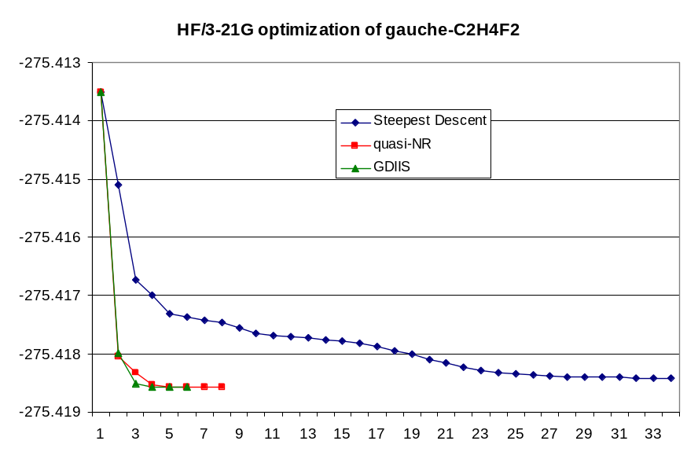
How about trans conformation? E = -275.41989. Slightly lower (3.5 kJ/mol) than gauche. Compare structures.
- Efficient coordinate systems
It is generally easiest to calculate gradients and Hessians in Cartesian coordinates, and even when you draw a molecule on a computer screen, the computer works with a Cartesian representation of the molecule. However, Cartesian coordinates are not necessarily the best coordinates to work in for carrying out an optimization. Multidimensional optimizations work best in coordinate systems in which the internal motions are as decoupled as possible. Consider coordinates q which represent displacement of atoms from equilibrium positions.

Want to choose coordinate system where off-diagonal and higher-order terms are as small as possible. Cartesians typically do not satisfy that. How to choose? Chemical intuition: bonds, angles, bends, …

Idea is to transform back and forth between Cartesian (for energy and gradient evaluations) and a better internal coordinate system, related through some (possibly complicated) coordinate transform.

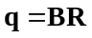

Trick/challenge is to transform gradients and Hessian back and forth between coordinate systems as well.

Cartesian – simplest to implement, consistent performance. Typically only choice in supercell calculations.

Z-matrix – easy to use, typically better performance than Cartesian, easier to estimate initial Hessian. Implemented in most common molecular packages. Has problems with rings or unusual coordination modes. Show example of C₄H₄.

“Natural” internal – linear combinations of internals that match more closely to normal modes of molecules. (Fogarsai, Zhou, Taylor, and Pulay, J. Am. Chem. Soc. 1992, 114, 8191.) Can work very efficiently, especially for ring systems, but are hard to generate automatically.

Redundant internal – produces an over-determined set of internal coordinates, like all bond distance, all angles between bonded atoms, all dihedrals. Construct Hessian guess using some sort of forcefield. Mapping between Cartesians and redundant internals becomes more complicated; transform from redundant to Cartesians is overdetermined and has to be solved iteratively. Works very efficiently for molecules though. Default in Gaussian. (Pulay and Fogarasi, J. Chem. Phys. 1992, 96, 2856.)

For instance, gauche C₂H₄F₂ quasi-NR optimization in redundant internals takes 6 steps, compared to 8 in Cartesians.

Constraints can be applied, like the scan we performed before.

Symmetry imposes a special type of constraint, consequence of fact that forces must belong to total symmetric representation, therefore cannot break symmetry.

Speeds calculation (of all quantities) when it can be imposed, and can often be put to good use. For instance, could do C₂H₄F₂ in eclipsed conformation and optimize. If we are careful to make it symmetrically eclipsed, will converge to the higher energy TS for rotation.

HF/3-21G E = −275.405447, 38 kJ/mol above trans. Can’t apply the same trick for the lower energy TS.
- H-F performance for geometry optimizations
Hartree-Fock generally robust for geometry of systems well-described by H-F model. Errors tend to be systematic and tend towards bonds being too short. Cramer quotes errors of 0.03 Å and 0.015 Å for heavy atom and H atom bond lengths in organics, respectively. Angles also good. What isn’t described well? Transition states, d block, hypervalent compounds, things where electron correlation becomes significant.

CCCDBD is good resource for comparing calculation and experiment.
- Vibrational Frequencies
Once you have found the geometry of a molecule (that is, a minimum on the PES), a very useful thing to do is to evaluate the character of that minimum from the Hessian.

Results relate to vibrational spectroscopy of the molecule.

Consider diatomic molecule AB. Near equilibrium bond distance, potential that the nuclei see is approximately harmonic, so we can write

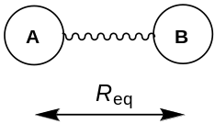
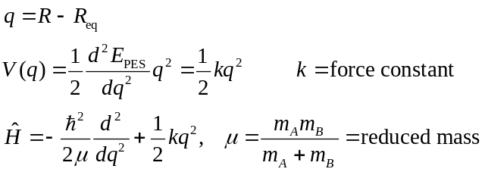

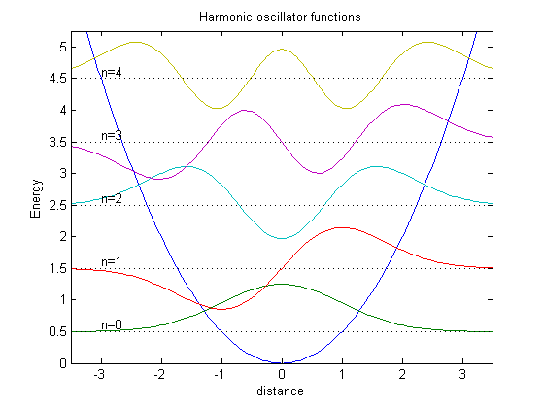
Equation for a harmonic oscillator. Solutions well known:
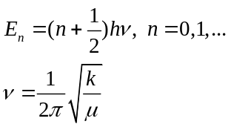

Note it is impossible for molecule to just sit at q = 0. Nuclei are always vibrating about R_{eq}. Gives zero point energy 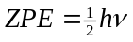.

For a chemical bond, k typically about 500 N m⁻¹,
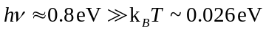
so molecules are typically in lowest energy vibrational state. Spacing between states is 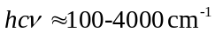, corresponds to vibrational spectrum of molecule.

Absorption selection rules say only jumps between adjacent levels are allowed. Intensity of absorption transitions relates to derivative of dipole moment w.r.t. bond stretching, can be calculated from electronic wavefunction. Intensity of Raman transitions related to derivative of polarizability.

For polyatomics, generalize to
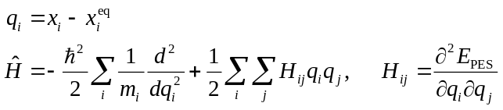
or in mass-weighted coordinates
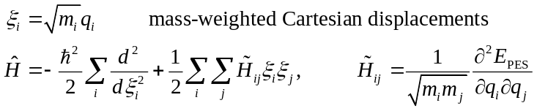
3n-dimensional problem, but by finding eigenvalues κ_{i} and eigenvectors s_{i} of mass-weighted Hessian, can transform into 3n one-dimensional problems:
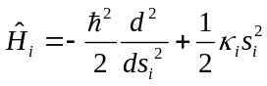
These s are the normal modes of the molecule, and the harmonic normal-mode frequencies 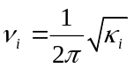.
Do this in 3n Cartesian space, so 6 (or 5) of the normal modes correspond to translations and rotations of the molecule. If calculation is exact, these will have κ_{i} = 0. Numerical errors may make them somewhat non-zero. If necessary, these can be projected out by transforming Hessian to internal and back to Cartesian coordinates.

Example: Gas-phase spectrum of methanol, CH₃OH. First must calculate optimal geometry [HF/6-31G(d)]. Then use geometry to do vibrational frequency calculation, analytically in this case.

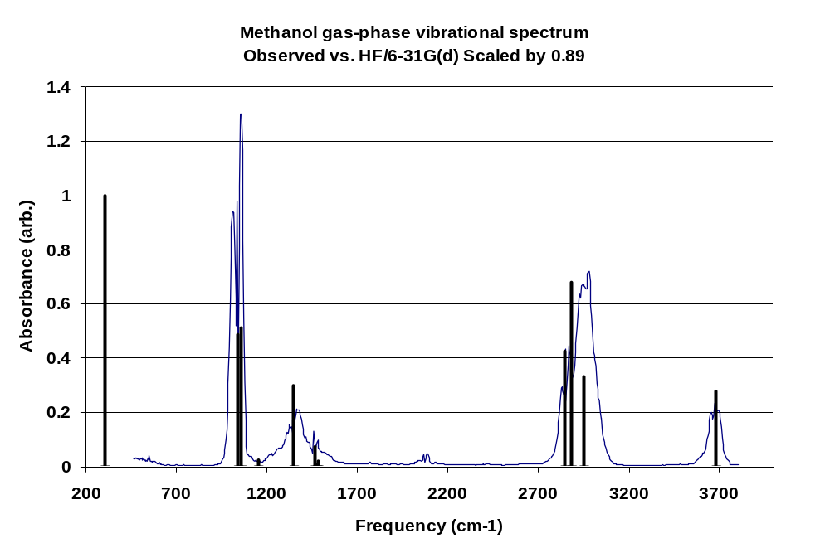
See that the calculated vibrational frequencies systematically overestimate observed frequencies. Two causes: Harmonic approximation not right, tends to broaden PES and decrease spacing between energy levels. On top of that, HF tends to make PES too steep. Can typically be corrected with a scale factor
(see Cramer, Table 9.3 and Scott and Radom, J. Phys. Chem. 1996, 100, 16502):

 | Freq. scale factor | ZPE scale factor
HF/3-21G | 0.9085 | 0.9409
HF/6-31G(d) | 0.8929 | 0.9135
MP2/6-31G(d) | 0.9434 | 0.9676
B3LYP/6-31G(d) | 0.9613 | 0.9804

What if curved downward in direction of one normal mode? The κ_{i} < 0, ν_{i} imaginary. If one and only one imaginary mode (and if g = 0), then you’re at a transition state!
- Transition States
We’ve already seen in C₂F₂H₄ example how to use symmetry to find eclipsed TS. How about the one between gauche and trans?

Coordinate dragging can be used when one degree of freedom dominates reaction coordinate. In C₂H₄F₂, for instance, the F-C-C-F dihedral angle dominates the reaction coordinate for interconverting conformers. Calculate optimal structure holding this coordinate fixed over a series of values.

Gaussian input:
#N HF/3-21G opt=z-matrix nosymmetry

C2H4F2 Coordinate Drag
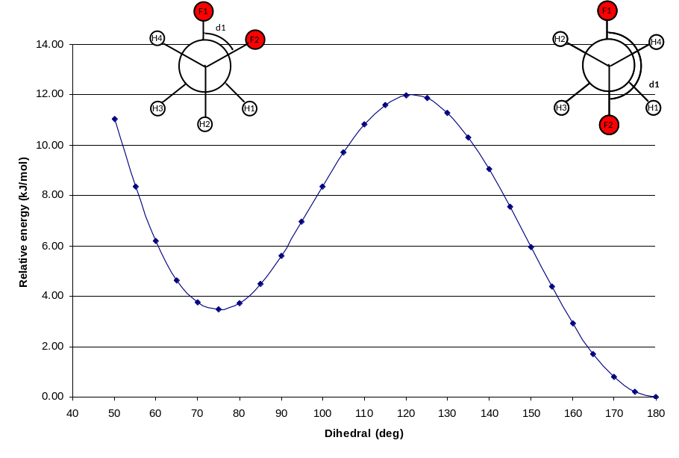
0 1
C
C 1 r1
F 2 r2 1 A1
H 2 r3 1 A2 3 D1 0
H 2 r4 1 A3 3 D2 0
F 1 r2 2 A1 3 D3 0
H 1 r3 2 A2 6 D1 0
H 1 r4 2 A3 6 D2 0

r1=1.5386
r2=1.39462
r3=1.11456
r4=1.12
A1=109.54214
A2=111.
A3=110.
D1=120.
D2=-120.5
D3=50. S 26 5.

Generates 27 points, in increments of 5° about D3. Transition state is at about 120°, like we’d expect. Note from this scan we don’t find the exact transition state, but might be good enough.

HF/3-21G summary:
 | F-C-C-F angle (deg) | E_{rel} (kJ/mol)
trans | 180.0 | 0
gauche | 74.97 | 3.5
H-F eclipsed drag | 120 | 11.97
H-F eclipsed TS | 121.3 | 11.99
F-F eclipsed | 0 | 38

What’s relative populations of trans and gauche? What is relative rate of transition over the two barriers? What about ZPE?

Coordinate dragging can fail when the reaction coordinate is non-linearly related to multiple internal coordinates. Plus, it is relatively expensive, as you have to do a lot of optimizations.

Hessian-based optimization methods (like quasi-NR and GDIIS) generally work more efficiently, assuming you can guess a point reasonably close to the TS and can obtain a good guess for the Hessian with the correct number (one!) of negative eigenvalues. These work like the optimization methods, but lock in on the imaginary mode and search uphill along it while going downhill for the others. The Hessian update scheme has to be modified to accommodate the negative eigenvalue. The choice of coordinate system is even more crucial here than for optimizations.

For example, find TS for rotation about H-F ecliplsed TS. Algorithm:

- Make guess of TS. Use drag geometry at 120°.
- Calculate Hessian and check to be sure there is one imaginary frequency, and that it corresponds to the mode you want.
- Do qNR optimization in redundant internals, reading in calculated Hessian.
- Recalculate Hessian to be sure you are at the right TS.

In this example, converges in two steps. Final dihedral angle and energy just slightly different from drag result.

#P HF/3-21G opt=(ts,calcfc)
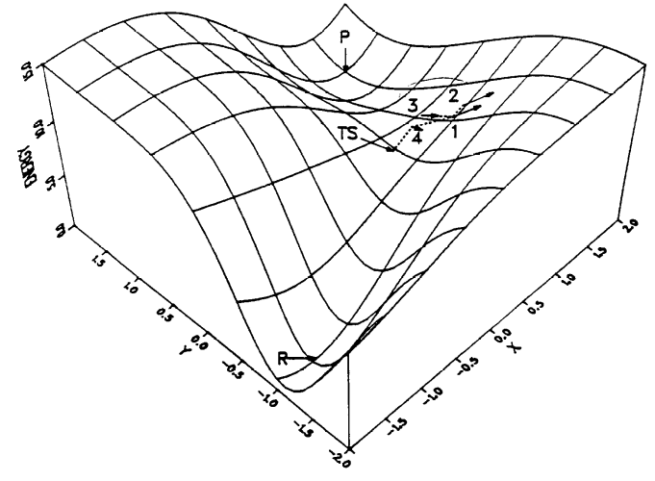
Pictures from Schlegel, illustrating gradient-based TS optimization.
C2H4F2 transition state search

0 1
C
C 1 r1
F 2 r2 1 A1
H 2 r3 1 A2 3 D1 0
H 2 r4 1 A3 3 D2 0
F 1 r2 2 A1 3 D3 0
H 1 r3 2 A2 6 D1 0
H 1 r4 2 A3 6 D2 0

r1 1.52688
r2 1.40634
r3 1.07777
r4 1.07749
A1 109.51296
A2 112.00064
A3 108.18013
D1 119.60395
D2 -119.13814
D3 120.00000

Another example, taken from gas-phase chemistry of NH₃ + NO:

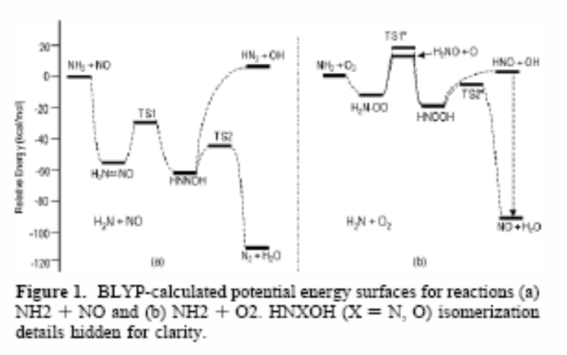

#N HF/6-31G(d) opt=(ts,calcfc)

HNNOH transition state search

0 1
N
N 1 r1
O 2 r2 1 A1
H 1 r3 2 A2 3 D1 0
H 1 r4 2 A3 3 D2 0
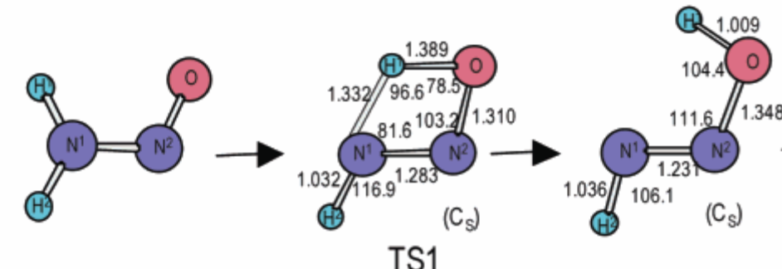
r1 1.28
r2 1.31
r3 1.33
r4 1.03
A1 103.2
A2 92.
A3 105.
D1 0.
D2 180.0

What to do if you don’t have a TS guess structure?

Two-sided methods combine information about the two end-points of an elementary step and use a linear or quadratic interpolation scheme to estimate path between two. Have to be careful that path doesn’t lead to collisions between atoms. By calculating energies along the path, able to come near the maximum, and then use regular searching to find transition state. Might be able to get away with a worse, or maybe even no, Hessian guess. Implemented in Gaussian as “QST2” and “QST3” methods.

What if you don’t know what reaction you are interested in? There are some methods that attempt to search for all passages out of a given basin, but they can be expensive. This is at the forefront of research in the field.
- Intrinsic Reaction Coordinates
In more complicated systems, it can often be difficult to know exactly what minima a particular transition state corresponds to. The intrinsic reaction coordinate (IRC) or minimum energy path (MEP) is steepest descent path from TS towards both basins. Starts from TS, steps forward in direction given by gradient, using second order method. Have to use care in selecting algorithm and step sizes to stay on the path. Can be useful for locating variational transition state…configuration where free energy (rather than energy) is maximized. Example of IRC calculations:

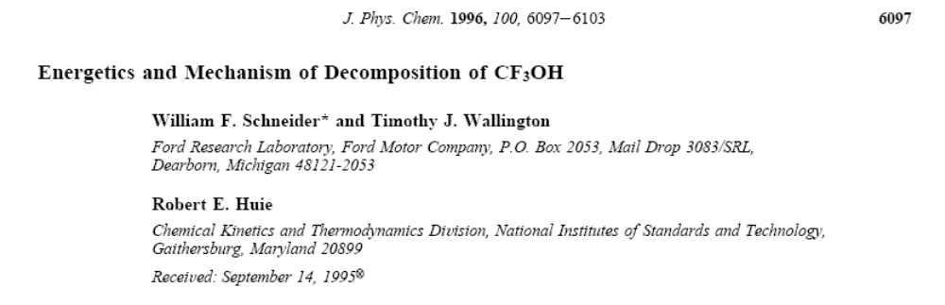
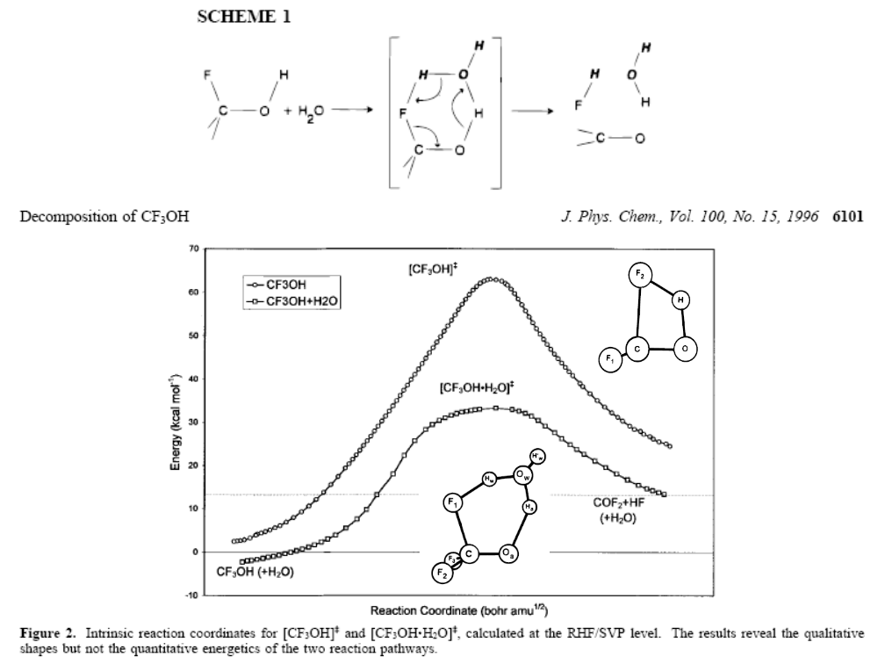

Good resource on this general topic is

David J. Wales, Energy Landscapes, Cambridge University Press: Cambridge (2003).

