- Connection between QM and Thermodynamics
We have focused to this point on the many approaches and details of calculating the internal electronic energy of a single molecule, that is, the energy associated with taking infinitely separated constituent nuclei and electrons at rest and forming a molecule:

2 H⁺ + O⁸⁺ + 10 e⁻ → H₂O E^{elec}

We typically calculate E^{elec} within the Born-Oppenheimer approximation, i.e. within the approximation that the nuclei of the molecule are all fixed in space. We know that even at 0 K molecules have a zero-point vibrational energy (ZPVE), and the 0 K internal energy of a molecule is thus:

E⁰ = E^{elec} + ZPVE

ZPVE can be calculated pretty reliably within the harmonic approximation, according to

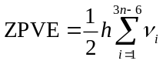

where ν_{i} are the harmonic vibrational frequencies, obtained from a vibrational frequency analysis. E^{elec} is not directly observable; U⁰ in principle is.

E⁰ is the minimum energy a molecule can have. Higher energies are possible by electronic excitation, or vibrational excitation, or due to rotational motion, or translational motion. If we assume that they are separable:
E = E⁰ + E^{elec} + E^{vib} + E^{rot} + E^{trans}

To fully describe microscopic state of a molecule, we would have to specify all these quantities (actually, all the associated quantum numbers).

Macroscopically, though, what we are typically interested in is the “equilibrium” value of internal energy, U (or some other thermodynamic quantity, like S or H or G) at some specified, externally imposed thermodynamic conditions, like temperature T or pressure P or chemical potential µ. Or perhaps we want the derivatives of these quantities, like heat capacity C_{p}.

These equilibrium values are averages over an ensemble of molecules. It is the very large size of macroscopic systems (6 × 10²³ molecules) that make fluctuations from these average values so tiny. The way these averages are constructed is the realm of statistical thermodynamics.

Most important for us is the canonical ensemble, in which the free variables are N, V, and T. We’ll generally choose N to be 1 mole, so we can talk about molar values of quantities.

The relative probability of a molecule being in a particular state E_{i} above E⁰ in the canonical ensemble is given by the Boltzmann factor,
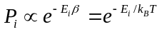
The sum over all the states is the canonical partition function:

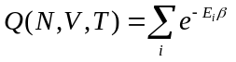
Good news: all thermodynamic quantities can be defined in terms of this function (see table). Bad news: not so easy to calculate for some general collection of molecules, like a liquid, where E_{i} runs over all the states of all the molecules.

The Equations of the Canonical Ensemble (N, V, T independent variables)
NOTE: All energies are referenced to E⁰.
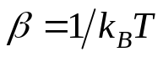 | Full Canonical Ensemble | Distinguishable Particles  (e.g., atoms in a crystal lattice | Indistinguishable Particles  (e.g., molecules in a fluid)
Single particle partition function | 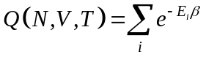 | 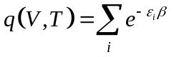
Full partition function |  | 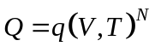 | 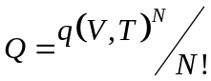
Log partition function | 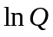 | 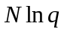 | 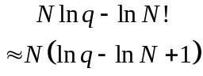
Internal Energy (U) | 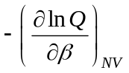 | 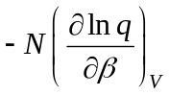
Pressure (P) | 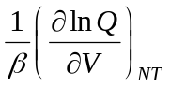 | 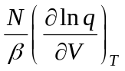
Helmholtz Energy  (A = U − TS) | 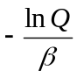 | 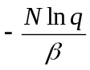 | 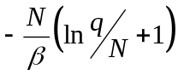
Entropy (S) | 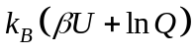 | 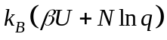 | 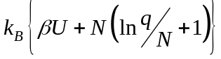
Enthalpy  (H = U + PV) | 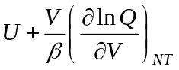 | 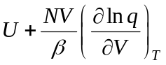
Gibbs Energy  (G = A + PV) | 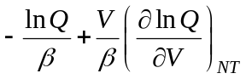 | 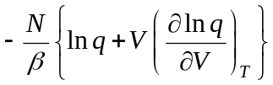 | 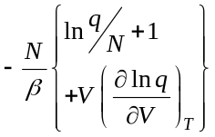
Chemical Potential 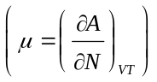 | 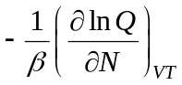 | 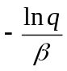 | 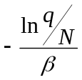

- Ideal Gas Thermodynamics
For a gas of identical molecules, though, the partition function can be (nearly exactly) factored:

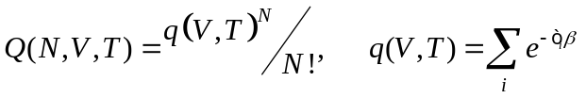
q(V,T) is the molecular partition function, and is calculated by summing over the internal energy states ε_{i} of an individual molecule (starting at E⁰).

Further simplified by factoring into contributions from various (3N) degrees of freedom:

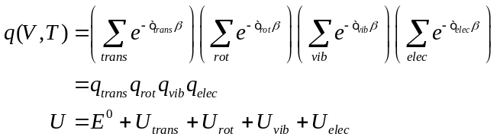

Similarly for other thermodynamic quantities. For example,

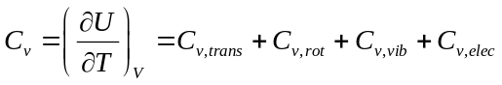
Have to separately calculate contributions from each DOF:

Translational – 3 degrees of freedom. Assume particle-in-a-box.

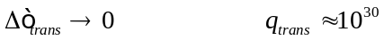

Implies PV = nRT. Note we have to choose a standard pressure/concentration here! Gaussian chooses by default 1 atm as pressure.

Rotational – construct sum for each of 3 rotational degrees of freedom. Assume rigid rotor, means we need moments of inertia from molecular geometry.

Vibrational – construct sum for each of 3N−6 normal modes within harmonic approximation. Means we need vibrational spectrum.

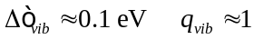

Electronic – sum over excited electronic states. At usual temperatures, only ground state is important.

The Statistical Thermodynamics of an Ideal Gas
All energies referenced to their 0 K values
All thermodynamic quantities expressed on a per mole basis

Translational DOFs– 3-D particle in a box model
Thermal wavelength 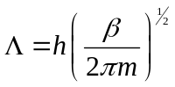
For Λ << L, 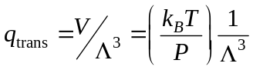 (essentially always true)
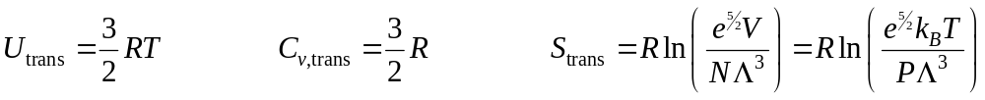
Rotational DOFs– rigid rotor model
Linear molecule – rotational temperature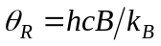
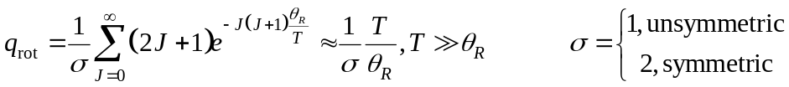

Non-linear molecule – rotational temperatures 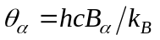
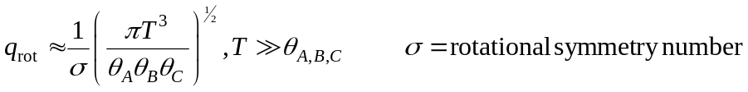
Vibrational DOFs – harmonic oscillator model
Single harmonic mode – vibrational temperature 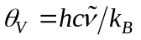
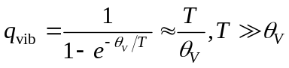(generally must use full form)
Multiple harmonic modes – vibrational temperatures 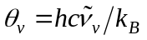
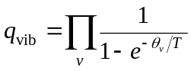
Electronic DOFs
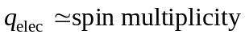

- Gaussian thermochemistry output
Vibrational frequency calculation within Gaussian calculates all these quantities for you. See Section 3 of Ochterski, “Thermochemistry in Gaussian,” for description.
- Reaction thermodynamics
Often interested in changes in thermodynamic quantities accompanying a chemical reaction. Have to calculate differences:

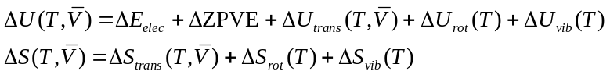

Can do this for any condition you want. If you want a particular standard state (e.g. 273 K, 1 bar), have to choose density/V appropriately.

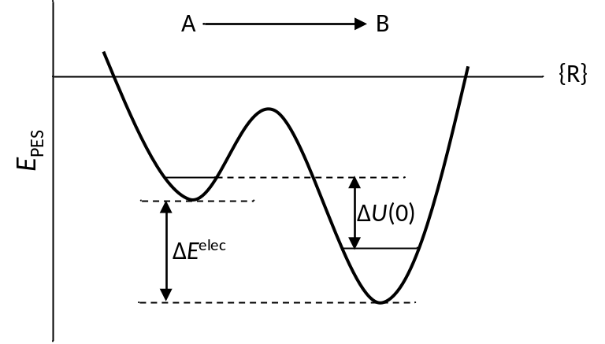

Equilibrium constants, 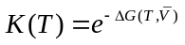. Corresponding concentration units and “standard state” determined by 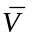.

See Section 4 of Ochterski, “Thermochemistry in Gaussian,” for description.
- Mixing electronic structure and experimental thermochemistry
Sometimes want to relate to some experimental standard, like heat (enthalpy) of formation. Recall that this is an enthalpy relative to elemental species, and these are not always easy to calculate with a particular method. Use a thermodynamic cycle, and combine experimental and calculated quantities as necessary.

Note that 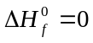for the elements in their most stable state at all temperatures by definition, but that does not mean that the enthalpy of an element is not temperature dependent. Can calculate or measure this quantity depending on convenience.

Same approach can be used for S, G.

Sample thermodynamic cycle for calculating the heat of formation of methane:

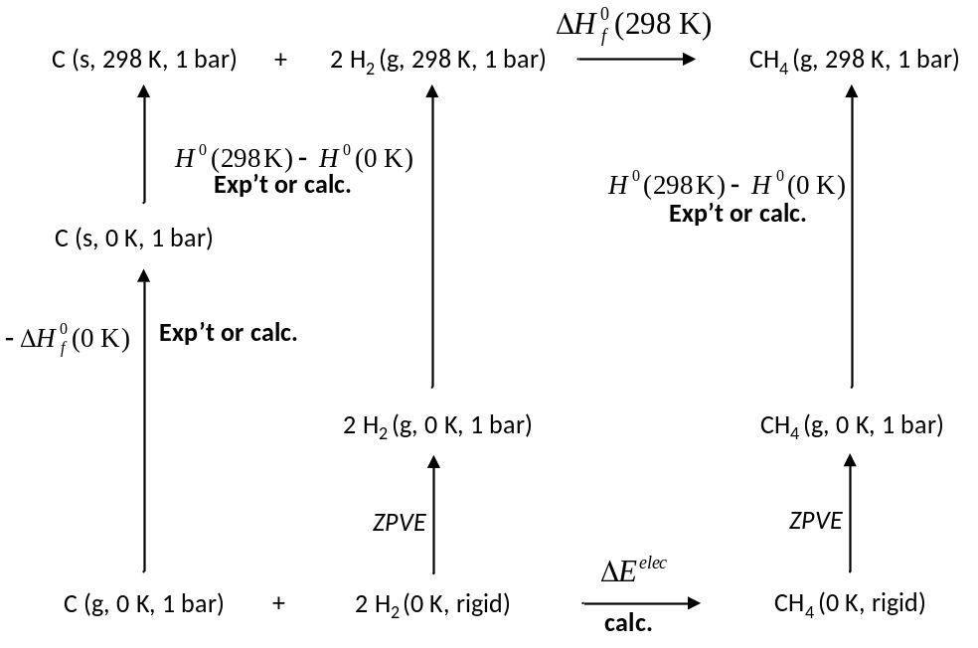
- Isodesmic reactions
Ultimately reliability depends on ability to calculate electronic energy differences, and these can be difficult, especially for reactions that involve significant changes in electronic structure. Isodesmic reaction is a little trick of the trade that takes advantage of fact that correlation errors are often constant for a given bond type. Write unknown compound in terms of reactions that conserve bond types, for example:

CH₄ + CH₂Cl₂ → 2 CHCl₃

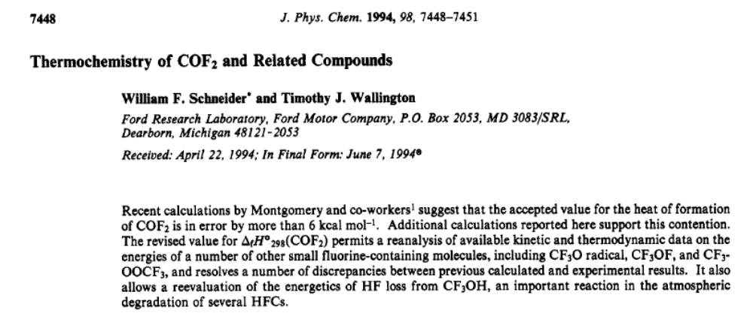

Uses CH₂F₂ + HCHO → CH₄ + COF₂ reaction and known information about first three molecules to calculate thermodynamics of the fourth.
- Reaction Kinetics
Reaction rates more challenging to predict than thermodynamics—the latter is a universal property of a reaction for given conditions, the former depends on the pathway(s) from reactants to products.

Conceive of a reaction as happening in a sequence of “elementary steps.” In general difficult to predict these elementary steps a priori. Given them, though, our task is to calculate the rates of the individual steps.

A + B → products 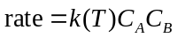

Units?

Conceived of as passage from one well to another. Can be complex dynamical process. Transition state theory is a very useful model that is straightforward to apply from computational results.

TST assumptions (in order of degree of approximation):
- Existence of a PES
- Existence of a “dividing surface” (“point of no return”)
- Existence of a critical “transition state” point on dividing surface
- Existence of a quasi-equilibrium between reactants and transition state
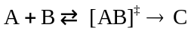
- Harmonic (quadratic) form of the PES near the TS

Equilibrium and harmonic approximations lead to:

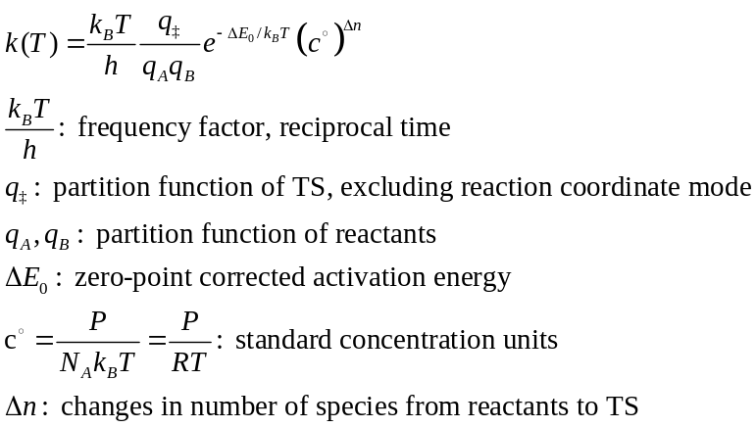

Can equivalently be expressed

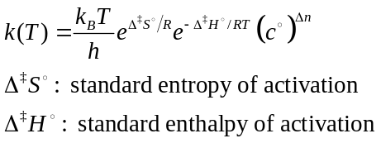

Example: Diels-Alder reaction

H₂C=CHF + H₂C=CH–CH=CH₂ → TS

 |  |  |  | h | 6.6261E-34 | J s
 |  |  |  | NA | 6.0221E+23 | /mol
 |  |  |  | R | 8.31447 | J/mol K
 |  |  |  | kB | 1.3807E-23 | J/K
 |  |  |  | T | 298.15 | K
 |  |  |  | P | 1.00 | atm
 |  | H₂C=CHF | H₂C=CH–CH=CH₂ | TS | Delta (kJ/mol)
 | E^{elec} | -177.82 | -155.99 | -333.77 | 85.8
 | ZPVE | 0.04 | 0.09 | 0.13 | 8.5
 | delta E0 |  |  |  | 94.2
1 | Boltzmann |  |  |  | 3.09E-17
2 | q | 1.59E+11 | 1.92E+12 | 2.07E+14 | 6.7397E-10
3 | kB T/h |  |  |  | 6.21E+12 | s-1
4 | RT/P |  |  |  | 24.465428 | l/mol
4p | kT/P |  |  |  | 4.06E-20 | cm^3
 |  |  | 1*2*3*4: | k(298.15) | 5.09E-25 | l/mol s
 |  |  | 1*2*3*4p: | k(298.15) | 5.25E-33 | cm3/molecule s

Slow…. What would I have to do to calculate at a higher temperature? Or pressure?
- Special kinetics topics
Kinetic isotope effect – partition functions calculated by default for most abundant isotope. Substitution of D for H can significantly impact rate.

Tunneling correction – especially for reaction paths involving light atoms, tunneling through barrier can significantly impact rates. Hard to treat quantitatively; simple models available based on knowing curvature at TS.

Variational transition state theory – what if a reaction doesn’t have an energy barrier? May still have a free energy barrier, place where 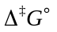is maximized. Found by searching along IRC.

Non-adiabatic dynamics – incorporate effect of multiple electronic states on reaction rate

