Overall algorithm:

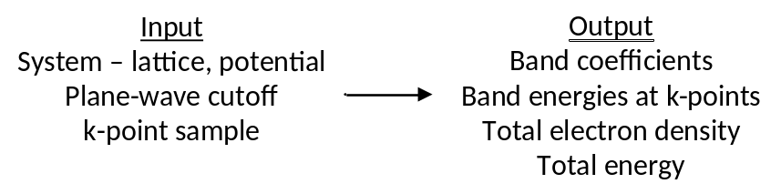
- FCC metal

Late transition metals commonly crystallize in FCC lattice. 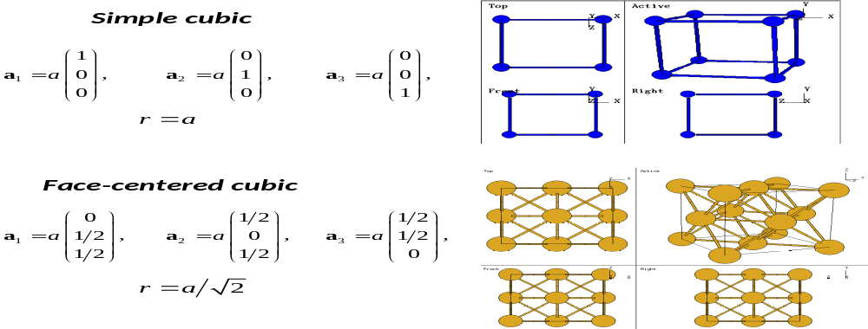
Primitive cell has one atom.
- Energy calculation
POSCAR:
Pure FCC metal
3.9239
0. .5 .5
.5 0 .5
.5 .5 0.
1
Direct
.0000000000000000 .0000000000000000 .0000000000000000

KPOINTS:
10x10x10
0
Monkhorst-Pack
10 10 10
0. 0. 0.

INCAR:
System = Au, FCC
NWRITE = 1
LWAVE = .FALSE. ! write WAVECAR?
LCHARG = .FALSE. ! write CHGCAR?
LVTOT = .FALSE. ! write LOCPOT?

Electronic relaxation
ALGO = Fast ! use fast algorithm for electronic convergence
ISMEAR = 0 ! 0: Gaussian smearing of states near Fermi level
SIGMA = 0.1 ! smearing parameter, eV
PREC = normal
! set FFT mesh, cutoffs
ENCUT = 350 ! set plane-wave cutoff
ISTART = 0 ! start from scratch
EDIFF = 1e-4 ! electronic convergence parameter
ISPIN = 1 ! polarization? 1, no; 2, yes

POTCAR:
Depends on the metal you are doing.

Look at output file

Example of FCC Au, PAW GGA. Note symmetry unique k points do not grow monotonically. Timings scale with number of k points. Also would scale (more severely) with energy cutoff.

 | Unique k points | Free Energy (eV) | Total Energy | Delta | Time (s)
6x6x6 | 28 | -2.841 | -2.837 | 0.004 | 6.0
7x7x7 | 20 | -2.912 | -2.911 | 0.001 | 4.5
8x8x8 | 60 | -2.859 | -2.858 | 0.001 | 12.2
10x10x10 | 110 | -2.858 | -2.857 | 0.001 | 21.6

With Gaussian smearing, look for difference between free energy (finite sigma) and total energy (sigma neglected) to ~0.001 eV/atom. For Au does so at modest k point sizes.
- Lattice constant optimization
Two approaches:
By hand: Calculate energy vs. lattice parameter.

Au, primitive FCC, 8x8x8 mesh (a bit too small):

3.7: 1 F= -.15522197E+01 E0= -.15517255E+01 d E =-.988329E-03
3.8: 1 F= -.23013630E+01 E0= -.23008848E+01 d E =-.956338E-03
3.9: 1 F= -.27777703E+01 E0= -.27773039E+01 d E =-.932702E-03
4.0: 1 F= -.30520956E+01 E0= -.30516339E+01 d E =-.923270E-03
4.1: 1 F= -.31785731E+01 E0= -.31780922E+01 d E =-.961871E-03
4.2: 1 F= -.31986333E+01 E0= -.31976437E+01 d E =-.197911E-02
4.3: 1 F= -.31463591E+01 E0= -.31454782E+01 d E =-.176166E-02
4.4: 1 F= -.30443417E+01 E0= -.30434732E+01 d E =-.173691E-02

Could fit to a quadratic, but Burch-Murnaghan equation of state better choice.

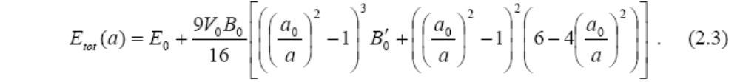
E₀: total energy
a₀: equilibrium lattice constant
V₀: equilibrium volume
B₀: bulk modulus
B₀′:

“murg” program performs this fit. fort.2 input:

8.0 ! lattice guess, bohr
0. .5 .5 ! lattice vectors
.5 0 .5
.5 .5 0.
7 ! number of energies
7.180962136 -0.169108099368 ! lat in bohr, E in Ryd
7.369934823 -0.204123467588
7.558907511 -0.224285895928
7.747880199 -0.233580199912
7.936852887 -0.235017176246
8.125825574 -0.23118316919
8.314798262 -0.22368610907
-3.2

fort.10 output:
Total energy murnaghan fit
the four parameters are E0,B,BI,V0

value of Eo : 2.96474621
value of B : 0.00913914
value of BI : 5.43623555
value of V0 : 122.90870968
value of rms : 0.40775044E-07

Vol Etot Efit residual
7.181 92.574 -0.169108 -0.169052 -0.0561
7.370 100.076 -0.204123 -0.204307 0.1837
7.559 107.973 -0.224286 -0.224187 -0.0991
7.748 116.276 -0.233580 -0.233408 -0.1725
7.937 124.993 -0.235017 -0.235098 0.0808
8.126 134.135 -0.231183 -0.231351 0.1682
8.315 143.713 -0.223686 -0.223581 -0.1051

Bulk modulus (Mbar) : 1.34520849
Bulk derivative : 5.43623555
Equilibri volume (au^3) : 122.90870968
lattice constant (au) : 7.89249321
lattice constant (Ang) : 4.17644695
rws (au) : 3.08435731
rws (Ang) : 1.63214010

energy mininum (Ryd) : -0.23525379
energy mininum (eV) : -3.20079209

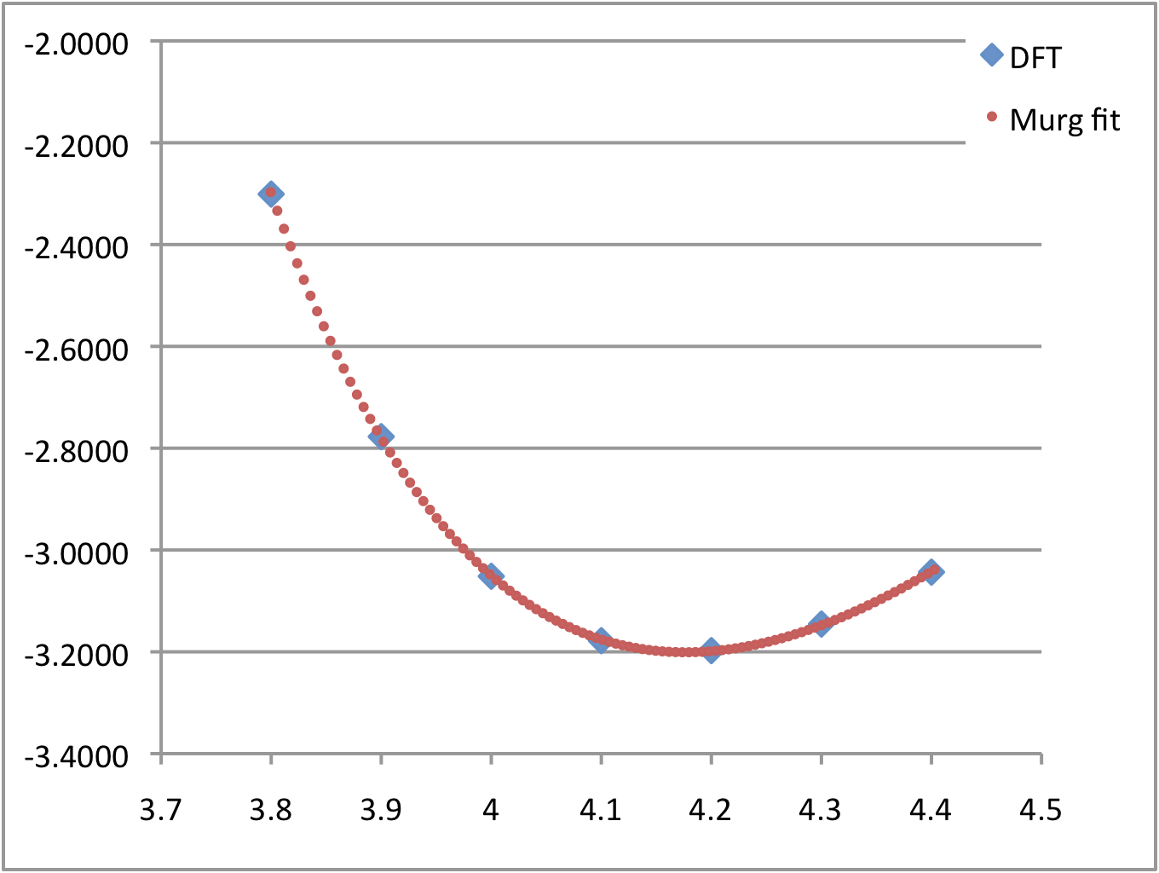

Gives lattice constant (4.176 Å), compare to experiment of 4.078 Å. Typical of GGA to slightly overestimate this.

Since energy of atom within PAW model is ~0, can get cohesive energy directly from minimum energy point, 3.20 eV vs. exp’t of about 3.8 eV, not too bad.

Gradient-based: Calculate “stress tensor” and use to optimize cell. Problem is that basis set size is determined by cell size, through energy cutoff. Can either let basis set size float and fix energy cutoff as cell changes size, or fix basis set size and let cutoff effectively float. Vasp does the latter. Have to apply more carefully, iteratively optimize and calculate final total energy in a single point.

In this case, converges in six steps to give lattice constant of 4.161 Å and energy of -3.18 eV.

Sometimes only choice if cell has multiple internal degrees of freedom.
- Band structure and density of states
Calculation gives band energies and occupations in OUTCAR and total density of states in DOSCAR. Note that absolute band energies are arbitrary; in an infinite solid, there is no vacuum to reference the energy of an electron to! Typically put Fermi level at 0 eV.

(Density and total energy converges faster than band energies; common to converge calculation with some k point mesh, and then use computed density to get band energies along directions of interest non-self-consistently.)

Frequently helpful to decompose bands/DOS into atomic components. Done by projecting onto atom-centered spherical harmonics, either within a sphere of given radius (RWIGS) or with an intelligently selected radius (LORBIT = 11).

PROCAR gives projection of bands, kind of like an orbital population. Example output:
PROCAR lm decomposed
# of k-points: 60 # of bands: 9 # of ions: 1

k-point 1 : 0.06250000 0.06250000 0.06250000 weight = 0.00390625

band 1 # energy -4.18713668 # occ. 2.00000000

ion s py pz px dxy dyz dz2 dxz dx2 tot
1 0.565 0.002 0.002 0.002 0.000 0.000 0.000 0.000 0.000 0.570

band 2 # energy 0.32959685 # occ. 2.00000000

ion s py pz px dxy dyz dz2 dxz dx2 tot
1 0.000 0.000 0.000 0.000 0.306 0.306 0.000 0.306 0.000 0.918

band 3 # energy 0.40770609 # occ. 2.00000000

ion s py pz px dxy dyz dz2 dxz dx2 tot
1 0.000 0.000 0.000 0.000 0.482 0.001 0.001 0.437 0.000 0.922

band 4 # energy 0.40770634 # occ. 2.00000000

ion s py pz px dxy dyz dz2 dxz dx2 tot
1 0.000 0.000 0.000 0.000 0.132 0.612 0.000 0.176 0.001 0.922

band 5 # energy 1.65915418 # occ. 2.00000000

ion s py pz px dxy dyz dz2 dxz dx2 tot
1 0.000 0.000 0.000 0.000 0.000 0.001 0.278 0.000 0.677 0.956

band 6 # energy 1.65915431 # occ. 2.00000000

ion s py pz px dxy dyz dz2 dxz dx2 tot
1 0.000 0.000 0.000 0.000 0.000 0.000 0.677 0.001 0.278 0.956

band 7 # energy 20.13821541 # occ. 0.00000000

ion s py pz px dxy dyz dz2 dxz dx2 tot
1 0.000 0.001 0.001 0.001 0.007 0.007 0.000 0.007 0.000 0.024

band 8 # energy 22.38990576 # occ. 0.00000000

ion s py pz px dxy dyz dz2 dxz dx2 tot
1 0.022 0.073 0.073 0.073 0.008 0.008 0.000 0.008 0.000 0.265

band 9 # energy 23.48253361 # occ. 0.00000000

ion s py pz px dxy dyz dz2 dxz dx2 tot
1 0.000 0.015 0.141 0.086 0.006 0.004 0.005 0.001 0.001 0.259

Note that Au is d¹⁰s¹, yet there are 12(!) electrons here. We must have screwed up! No…other bands (“orbitals”) would have lower occupancies, so that average works out correctly.

DOSCAR gives total density of states summed over k points, and similar type of atomic and lm projection. EMIN, EMAX, and NEDOS in INCAR specify lower and upper energy bounds and total number of points, respectively. File first gives total and integrated DOS, then gives site and angular momentum projection.

FCC Au, 10x10x10: 11 valence electrons, as indicated by where Fermi level crosses integrated DOS. Kind of dull electronic structure.
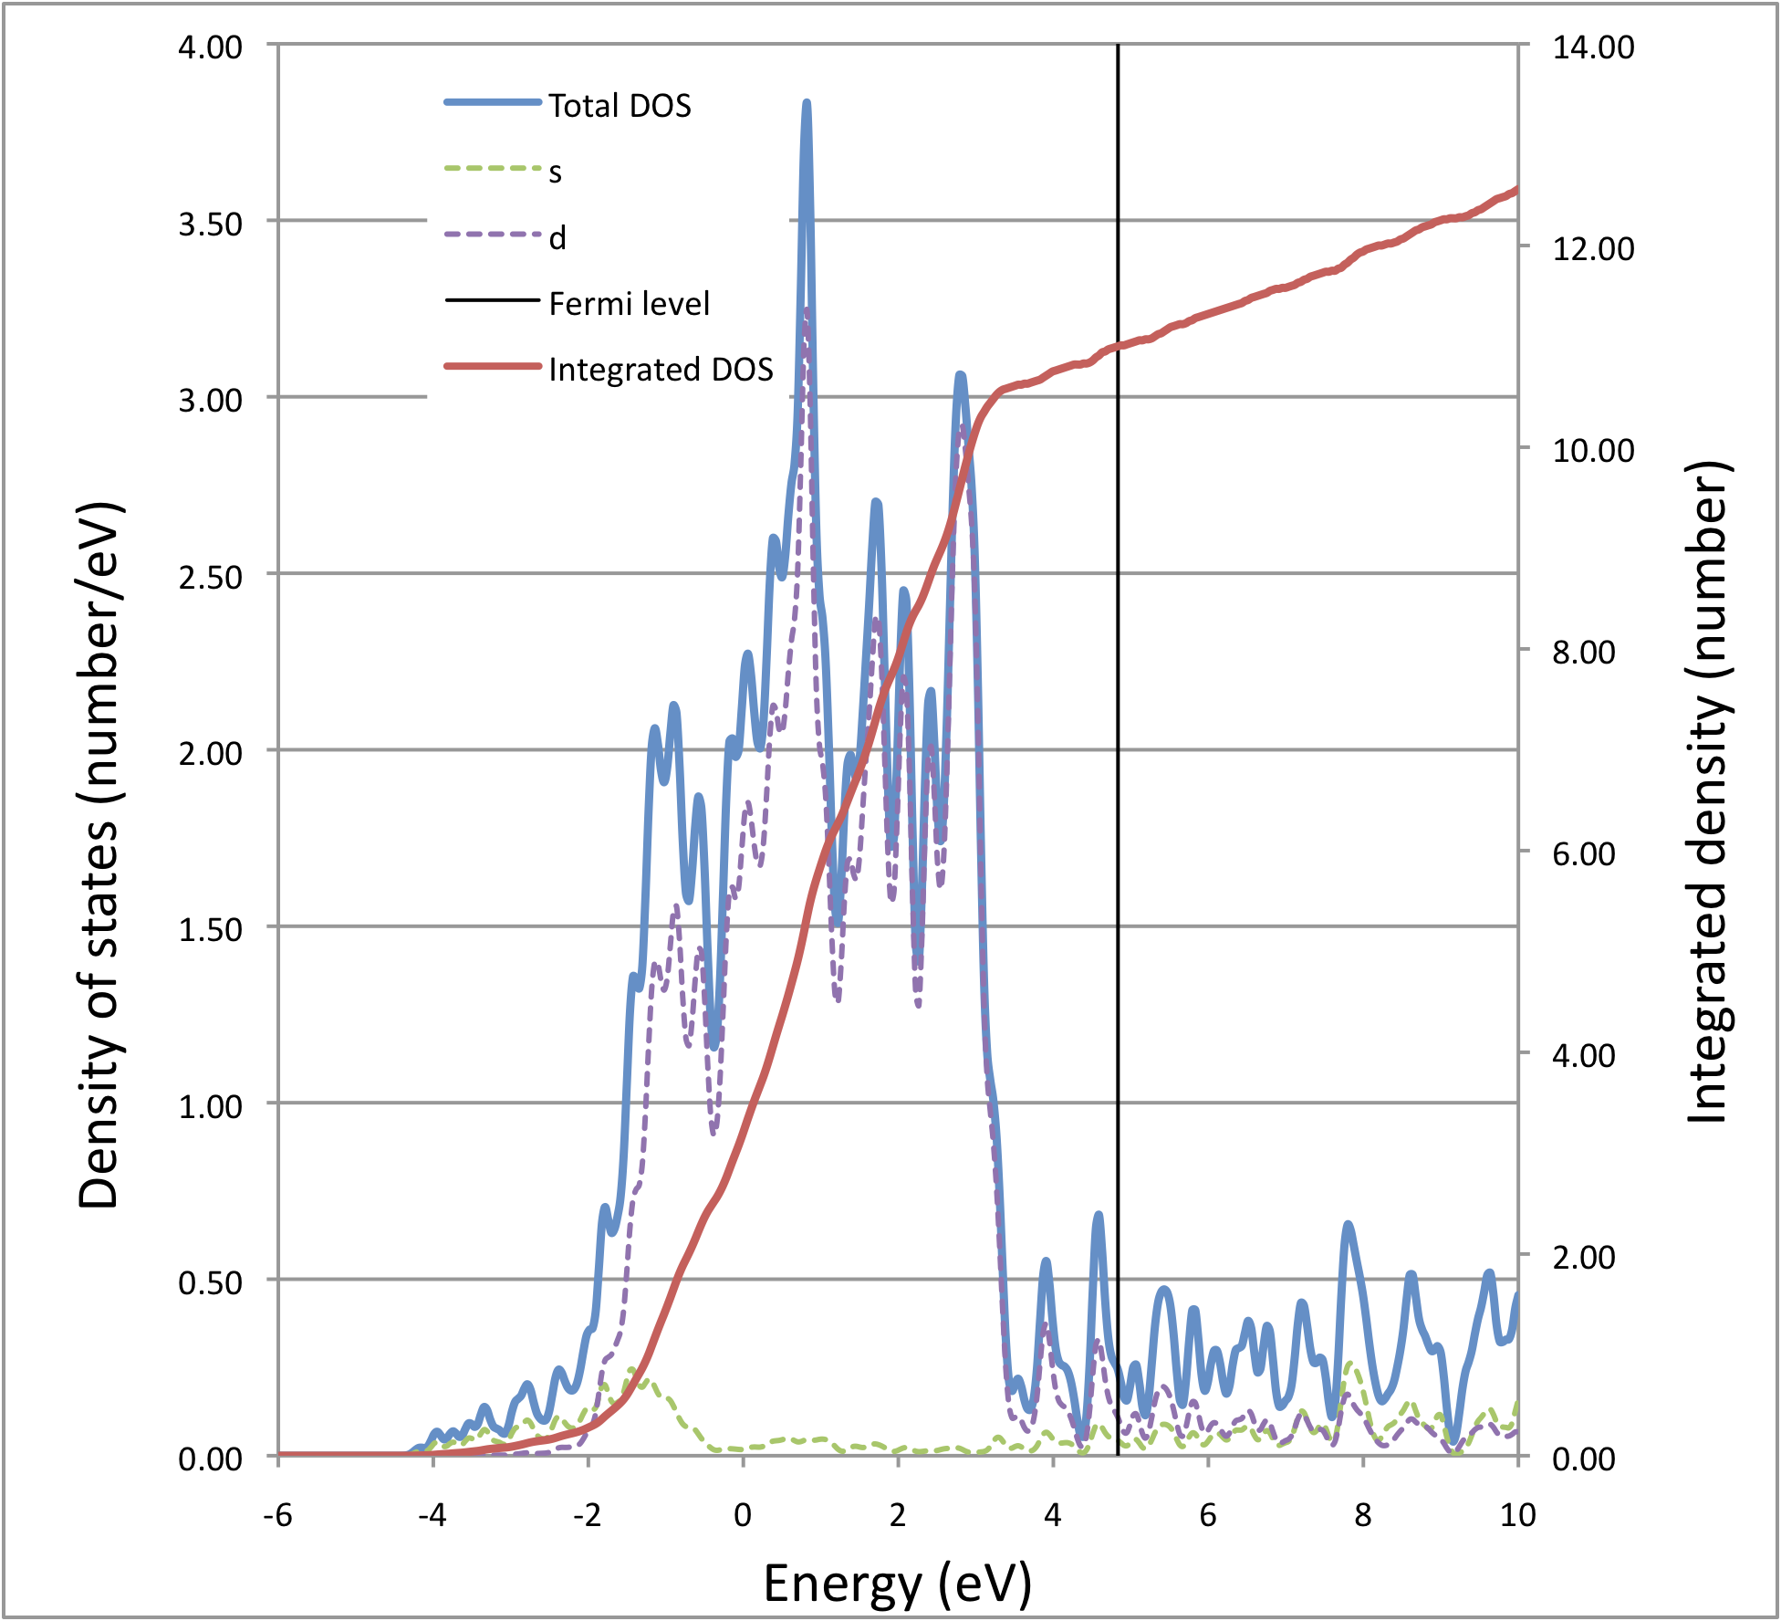
- Supercells and phonon calculations
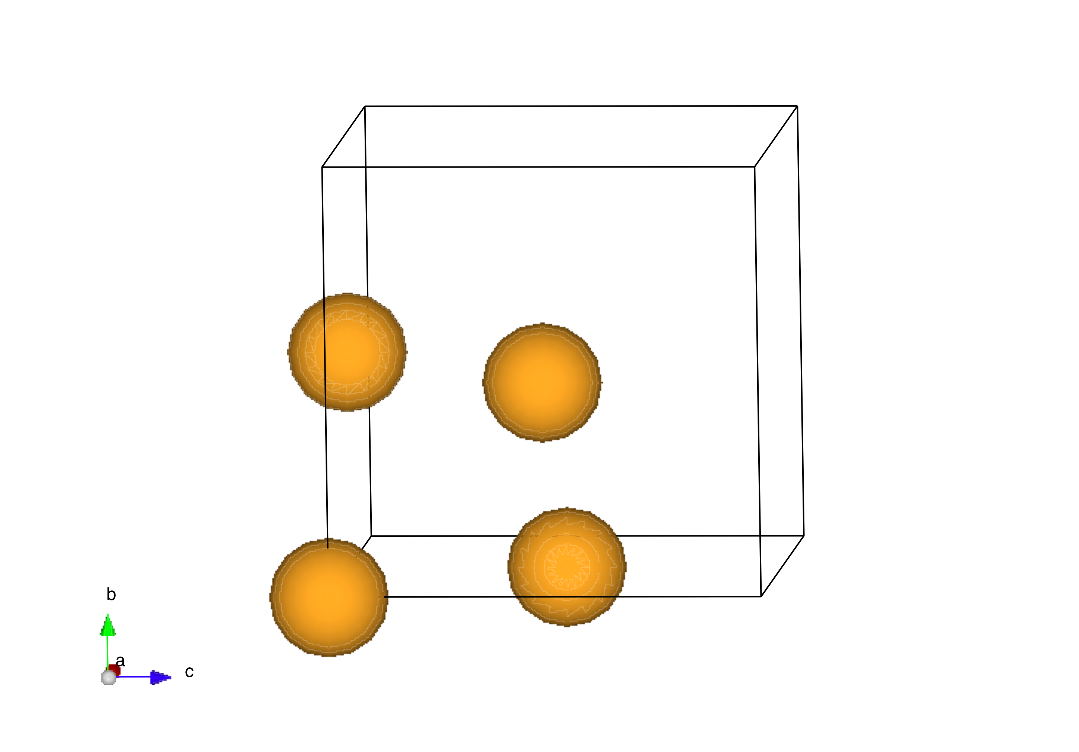
Four atom conventional supercell. Lattice constant becomes 2^0.5 times primitive one, basis becomes four atoms rather than one. Increasing lattice constant, can decrease k points proportionately, eg 8x8x8 becomes 6x6x6.

Pure FCC metal
4.176
1. 0. 0.
0. 1. 0.
0. 0. 1.
4
Direct
.0000000000000000 .0000000000000000 .0000000000000000
.5000000000000000 .5000000000000000 .0000000000000000
.5000000000000000 .0000000000000000 .5000000000000000
.0000000000000000 .5000000000000000 .5000000000000000

10 irreducible k points. Calculation takes longer, energy becomes -12.759/4 = -3.19 eV/atom, same as above. Why bother to do this?

Larger cell, more internal degrees of freedom (remember H chain dimerization), lower symmetry constraints.

Also important for phonon (vibrational frequency) calculations. Bloch’s theorem applies to vibrational modes: any mode in a cell can be propagated with range of wavelengths, picture completely analogous to electronic wavefunctions, k space becomes q space. No simple way, though, to evaluate frequencies at various q. Alternative approach:

  - multiply supercell (larger cell, more modes that are included)
  - “dynamical matrix” in harmonic approximation (like a Hessian)
  - finite difference approximation

Controlled with IBRION and NFREE options. Vasp 4.6 does not take advantage of symmetry in displacement calculations; 5.2 does. Vasp 5.2 also includes linear response method.

INCAR:
System = Au, FCC
NWRITE = 1
LWAVE = .FALSE. ! write WAVECAR?
LCHARG = .TRUE. ! write CHGCAR?
LVTOT = .FALSE. ! write LOCPOT?

Electronic relaxation
ALGO = Fast ! use fast algorithm for electronic convergence
ISMEAR = 0 ! 0: Gaussian smearing of states near Fermi level; -5: tetrahedron + Blochl
SIGMA = 0.1 ! smearing parameter, eV
PREC = normal ! set FFT mesh, cutoffs
ENCUT = 350 ! set plane-wave cutoff
ISTART = 0 ! start from scratch
EDIFF = 1e-4 ! electronic convergence parameter
ISPIN = 1 ! polarization? 1, no; 2, yes
! LORBIT = 11 ! site-projection of DOS

Geometry relaxation
NSW = 10 ! # of steps in optimization (default 0!)
ISIF = 2 ! 0: relax ions, 1,2:relax ions,calc stresses, 3:relax ion+cell
IBRION = 5 ! 1: quasi-NR, 2:CG algorithm for ions, 6:symmetrized phonons
NFREE = 2 ! number of DIIS vectors to save, or number of dynamical matrix displacements
POTIM = 0.35 ! reduce trial step in optimization
EDIFFG = -0.05 ! >0: converge on energy (eV); <0: converge on gradient (eV/Ang)

OUTCAR gives
Eigenvectors and eigenvalues of the dynamical matrix
----------------------------------------------------

1 f = 4.265170 THz 26.798856 2PiTHz 142.270765 cm-1 17.639333 meV
X Y Z dx dy dz
0.000000 0.000000 0.000000 -0.486404 0.115808 0.000000
2.088000 2.088000 0.000000 0.486404 -0.115808 0.000000
2.088000 0.000000 2.088000 0.486404 0.115808 0.000000
0.000000 2.088000 2.088000 -0.486404 -0.115808 0.000000

2 f = 4.265170 THz 26.798856 2PiTHz 142.270765 cm-1 17.639333 meV
X Y Z dx dy dz
0.000000 0.000000 0.000000 0.000000 0.000000 0.500000
2.088000 2.088000 0.000000 0.000000 0.000000 0.500000
2.088000 0.000000 2.088000 0.000000 0.000000 -0.500000
0.000000 2.088000 2.088000 0.000000 0.000000 -0.500000

3 f = 4.265170 THz 26.798856 2PiTHz 142.270765 cm-1 17.639333 meV
X Y Z dx dy dz
0.000000 0.000000 0.000000 0.115808 0.486404 0.000000
2.088000 2.088000 0.000000 -0.115808 -0.486404 0.000000
2.088000 0.000000 2.088000 -0.115808 0.486404 0.000000
0.000000 2.088000 2.088000 0.115808 -0.486404 0.000000

4 f = 2.738963 THz 17.209413 2PiTHz 91.361973 cm-1 11.327445 meV
X Y Z dx dy dz
0.000000 0.000000 0.000000 0.171709 -0.181306 0.196340
2.088000 2.088000 0.000000 0.184840 0.590661 -0.196340
2.088000 0.000000 2.088000 -0.184840 0.181306 -0.126684
0.000000 2.088000 2.088000 -0.171709 -0.590661 0.126684

5 f = 2.738963 THz 17.209413 2PiTHz 91.361973 cm-1 11.327445 meV
X Y Z dx dy dz
0.000000 0.000000 0.000000 0.139045 0.020405 -0.330128
2.088000 2.088000 0.000000 -0.555876 0.249534 0.330128
2.088000 0.000000 2.088000 0.555876 -0.020405 0.000000
0.000000 2.088000 2.088000 -0.139045 -0.249534 0.000000

6 f = 2.738963 THz 17.209413 2PiTHz 91.361973 cm-1 11.327445 meV
X Y Z dx dy dz
0.000000 0.000000 0.000000 0.630812 -0.143663 -0.046407
2.088000 2.088000 0.000000 0.065887 -0.254373 0.046407
2.088000 0.000000 2.088000 -0.065887 0.143663 -0.101179
0.000000 2.088000 2.088000 -0.630812 0.254373 0.101179

7 f = 2.738963 THz 17.209413 2PiTHz 91.361973 cm-1 11.327445 meV
X Y Z dx dy dz
0.000000 0.000000 0.000000 -0.102597 0.149812 -0.152806
2.088000 2.088000 0.000000 0.055759 -0.033029 0.152806
2.088000 0.000000 2.088000 -0.055759 -0.149812 -0.662933
0.000000 2.088000 2.088000 0.102597 0.033029 0.662933

8 f = 2.738963 THz 17.209413 2PiTHz 91.361973 cm-1 11.327445 meV
X Y Z dx dy dz
0.000000 0.000000 0.000000 0.177086 0.535721 0.394746
2.088000 2.088000 0.000000 -0.157676 0.028511 -0.394746
2.088000 0.000000 2.088000 0.157676 -0.535721 -0.012013
0.000000 2.088000 2.088000 -0.177086 -0.028511 0.012013

9 f = 2.738963 THz 17.209413 2PiTHz 91.361973 cm-1 11.327445 meV
X Y Z dx dy dz
0.000000 0.000000 0.000000 -0.106646 -0.369637 0.413688
2.088000 2.088000 0.000000 -0.352880 -0.149143 -0.413688
2.088000 0.000000 2.088000 0.352880 0.369637 -0.184633
0.000000 2.088000 2.088000 0.106646 0.149143 0.184633

10 f/i= 0.000000 THz 0.000001 2PiTHz 0.000003 cm-1 0.000000 meV
X Y Z dx dy dz
0.000000 0.000000 0.000000 -0.048248 -0.127059 -0.481174
2.088000 2.088000 0.000000 -0.048248 -0.127059 -0.481174
2.088000 0.000000 2.088000 -0.048248 -0.127059 -0.481174
0.000000 2.088000 2.088000 -0.048248 -0.127059 -0.481174

11 f/i= 0.000000 THz 0.000001 2PiTHz 0.000003 cm-1 0.000000 meV
X Y Z dx dy dz
0.000000 0.000000 0.000000 0.448013 -0.221585 0.013589
2.088000 2.088000 0.000000 0.448013 -0.221585 0.013589
2.088000 0.000000 2.088000 0.448013 -0.221585 0.013589
0.000000 2.088000 2.088000 0.448013 -0.221585 0.013589

12 f/i= 0.000000 THz 0.000001 2PiTHz 0.000004 cm-1 0.000000 meV
X Y Z dx dy dz
0.000000 0.000000 0.000000 -0.216695 -0.429833 0.135230
2.088000 2.088000 0.000000 -0.216695 -0.429833 0.135230
2.088000 0.000000 2.088000 -0.216695 -0.429833 0.135230
0.000000 2.088000 2.088000 -0.216695 -0.429833 0.135230

Note three zero frequency modes and degeneracies in other modes.
- Bulk reactions
One common application of supercell DFT is to look at the stability of bulk compounds. AuCu system makes a nice example. Consider compounds of form Au_{x}Cu_{1-x} using the FCC supercell above (called the L1₂ and L1₀ structures in the alloy literature, see http://cst-www.nrl.navy.mil/lattice/alloys/aucu.html). Calculate “formation energies” for reactions

x Au (s) + (1-x) Cu (s) → Au_{x}Cu_{1-x}

and plot against x. Use 6x6x6 k points, 350 eV cutoff, PAW potentials, gradient optimization of supercells and atom positions.
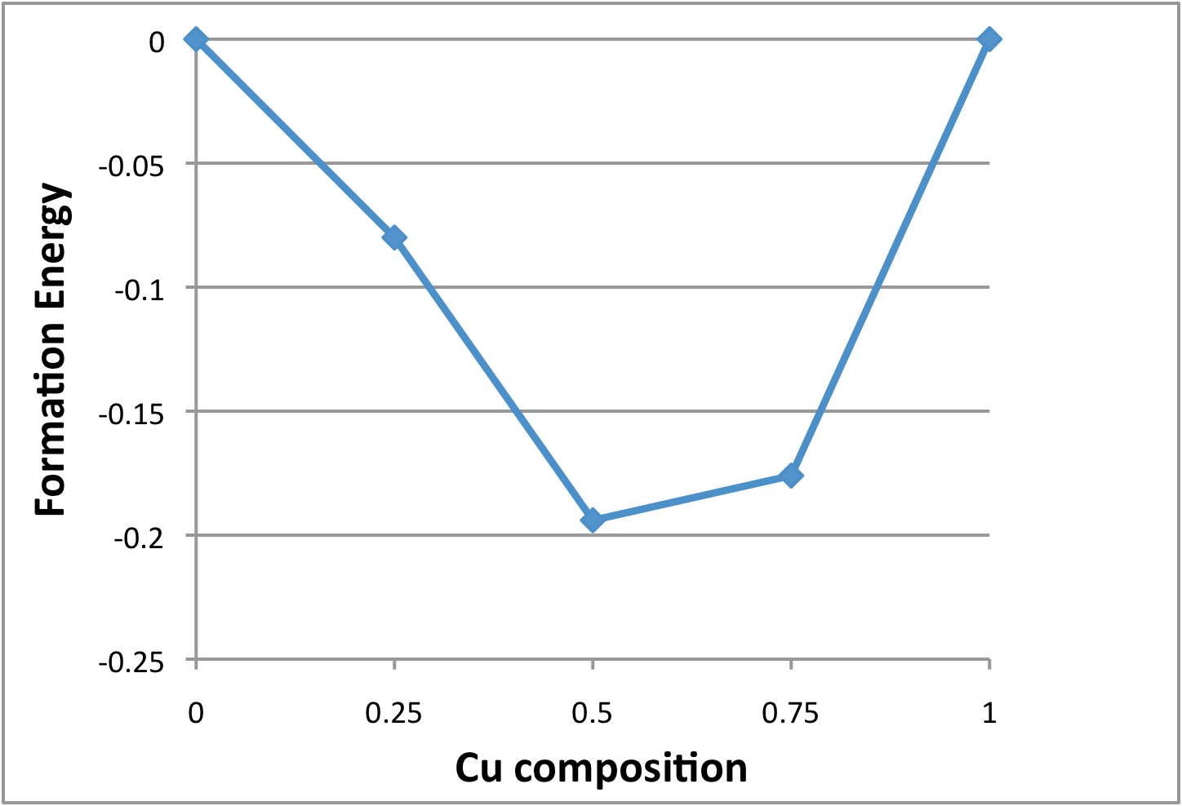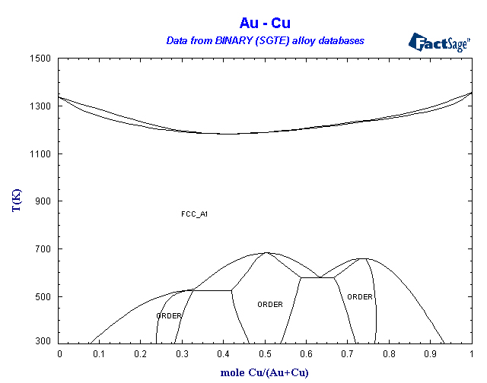

According to this, AuCu and AuCu₃ are stable structures, Au₃Cu is not. Phase diagram shows that this is not correct. Probably a consequence of insufficiently converged computational parameters.
- Other structures
Many, many known crystal structures (see e.g. http://cst-www.nrl.navy.mil/lattice/). Using DFT to calculate bulk structures, stability, phonon and electronic spectra, …, is now a cottage industry.
- Visualization tools that may be helpful:
vmd: http://www.ks.uiuc.edu/Research/vmd/
Vesta: http://www.geocities.jp/kmo_mma/crystal/en/vesta.html
XCrysDen: http://www.xcrysden.org/

