Elastic Band Methods for finding the MEP between two minima on a PES

- Class of methods deriving from the “chain-of-states” method that finds MEP between two minima using the gradient of the PES but not the Hessian
  - Does not require “good” estimate of MEP/TS geometries
- Method:
  - Locate minima on PES
  - Draw a path between them
    - Most common way to do this: linear interpolation
  - Discretize the path into a finite # of points (called “images”)
    - Each geometry is a linear interpolation of the two minima
    - Optimization is performed at each point by analyzing the forces on the geometry. Goal is to converge each image to the same MEP.
- What is the MEP? On the MEP, the forces along the direction parallel to the reaction pathway are finite, but they are 0 in all other directions
F:
rxn coordinate
E
- Complex surfaces contain many reaction pathways and thus many MEPs. We want to make sure we converge all images to the same MEP, so we connect them with a theoretical spring:
I
1
2
3
4
F
x
  - Spring force on each image is: 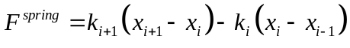
- Since we want to converge to the MEP and not necessarily to a stationary point, we need to project the component of the total force perpendicular to the reaction pathway out of the total force:
  - 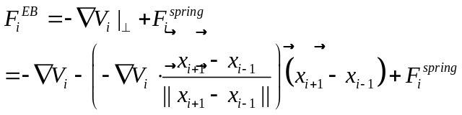
  - This way, the reaction path is updated @ each step (or every 10 steps, or …, depends on program, defaults, user inputs, etc.)
  - Elastic Band method is converged when 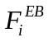 = 0 (or goes below some specified convergence criterion.)
    - If all spring constants are the same, the spring force is minimized when images are equally spaced
    - Perpendicular component of the molecular force zero-ed when image is on the MEP
- Relaxation in the direction perpendicular to the reaction path stretches images over the PES, much like pulling a rubber band over a surface (hence “Elastic Band” Method)
- Nudged Elastic Band method:
  - Removes perpendicular component of spring force:
  - 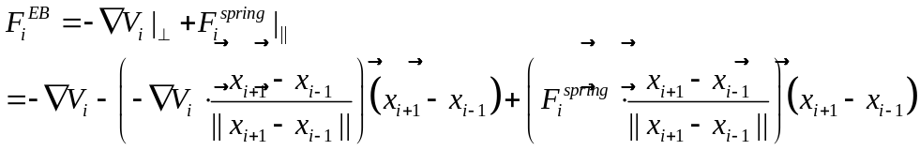
  - This way, spring forces do not interfere with relaxation to MEP
    - Takes away unnatural forces perpendicular to the reaction path
    - This clean version of the EB force brings about an optimization algorithm referred to as “nudging,” hence “Nudged” Elastic Band
- EB methods do not necessarily find the “TS”
  - Sometimes require interpolation between the two highest energy images
- Cure: Climbing Image Elastic Band Methods
  - After a few geometry convergence steps in the EB method, locates image with the highest E
    - This image is now denoted MAX
  - Spring forces are removed from max, CI-NEB force becomes:
    - 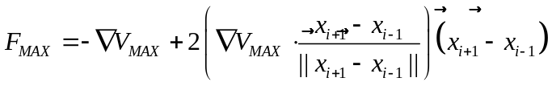
    - MAX moves down toward MEP and up to TS
    - Upward movement denoted “climbing,” hence “Climbing Image”-Nudged Elastic Band

Relevant literature:

- Plain Elastic Band of Elber and Karplus: Chem. Phys. Lett., 139, 1987, 375.
  - No projection of forces: PEB force is a sum of spring and total molecular forces.
- Elastic Band Method of Ulitsky and Elber: J. Chem. Phys. Lett., 92, 1990, 15.
  - Projects out parallel component of molecular force
- Self-Penalizing Walk method of Czerminski and Elber: International Journal of Quantum Chemistry: Quantum Chemistry Symposium 24, 1990, 167.
  - Instead of a spring force uses a repulsive force and an attractive force couple to maintain connection but not allow images to get too close. Projects out parallel component of molecular force.
- Locally-Updated Plains method of Choi and Elber: J. Chem. Phys., 94, 1990, 751.
  - No spring force, i.e. images are not connected. Parallel component of molecular force is projected out.
- Plain Elastic Band method of Gillian and Wilson: J. Chem. Phys., 97, 1992, 3.
  - For molecular dynamics.
- Nudged Elastic Band Method of Jónsson, Mills, and Jacobsen:
  - Projects out parallel component of molecular force and perpendicular component of spring force.
- Improved Tangent Nudged Elastic Band Method of Henkelman and Jónsson: J. Chem. Phys., 113, 2000, 9978.
  - Improves how the reaction path is calculated: 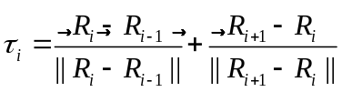
  - Ensures equi-spacing even in regions of large curvature, gets rid of “kinkiness” of path
- Climbing Image Nudged Elastic Band Method of Henkelman, Uberuaga, and Jónsson: J. Chem. Phys., 113, 2000, 9901.
  - Introduces climbing image: spring forces removed from NEB force of image with highest energy so that it can move along the elastic band in search of the maximum. Searches to minimize total molecular force.

