- The Problem of Many Electrons
Helium: next (after hydrogen) simplest atom

In a sense we “know” the answer…(1s)². But is this the “same” 1s as in H? No…nuclear charge and shielding give different wavefunction, different distribution of electrons, different energies.

To model: again nucleus at origin and stationary. Now have to capture dynamics of both electrons.

He atom Schrödinger equation

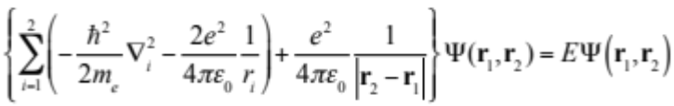

Summation runs over both electrons. First part looks similar to what we had for hydrogen, kinetic energy now of each electron and electrostatic attraction to 2+ nuclear charge. These are called “one-electron” terms and are (relatively!) straightforward to handle as we have for hydrogen. Last is the electron-electron repulsion and is a “two-electron” term. It’s the (many-body) problem.

More generally for n-electron atom in atomic units would write

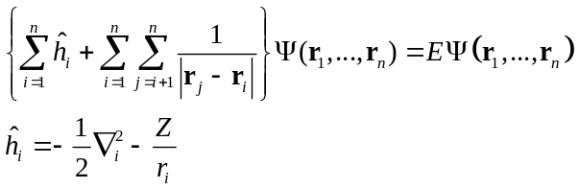

First summation over all electrons, second set goes over all electron pairs. (Note extending to molecule will only involve elaboration of one-electron, h, part to include multiple nuclei.)

Solution(s) are many-dimensional functions of the coordinates of all the electrons. Cannot solve this analytically! Several approaches to obtaining very accurate solutions, such as quantum Monte Carlo. Most common approximate approaches reintroduce single electron “orbitals.” We’ll look at three models.
- The Hartree atom
Simplest approach is to approximate with a “Hartree” product, an approximate separation of variables. We (or Douglas Hartree, 1897-1958) write

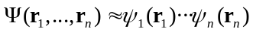

These ψ_{i} are fictitious “atomic (spin) orbitals” that describe separately the motions of the individual electrons. Note this separation is not physical: it says the motions of the two electrons are not correlated, i.e. that the motion of one can be described by considering the other on average, a mean field model.

How to use this?

- Use variational principle. The “best” set of ψ_{i} minimize the expectation value of the energy.
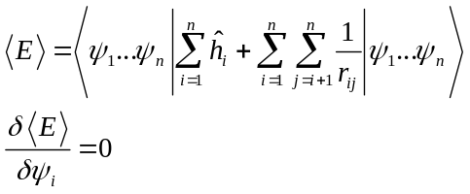
- Use method of Lagrange multipliers to maintain constraint that ψ_{i} are orthonormal.

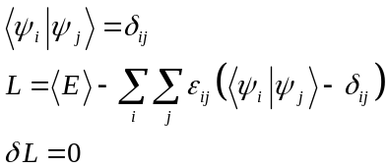

Turn crank, arrive at new set of equations for ψ_{i:}

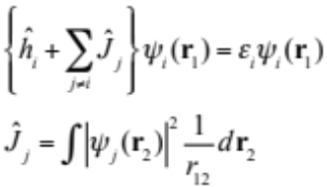 One-electron Hartree equation

Have to solve this for all n electrons of the atom/molecule. are the regular one-electron terms; 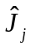 operators represent the Coulomb repulsion between an electron in orbital ψ_{i} and another electron in orbital ψ_{j}. Always a positive quantity.

For an atom, can separate variables using spherical coordinates (and law of cosines) to reduce to 1-D radial equation. Solution gives us the individual electron orbitals

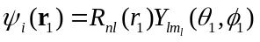

as well as individual electron energies ε_{i}. To avoid double-counting of electron-electron repulsions, have
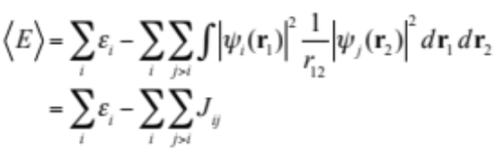
Presents an obvious difficulty…if we don’t know ψ_{j} ahead of time, how to construct Hartree equation to solve this differential equation for ψ_{i}?

Hartree offered a numerical solution in the 1930’s, called the self-consistent field (SCF) approach.

- Guess initial set of ψ_{i} (on a log grid)
- Construct Hartree potential for each orbital i
- Solve differential equations for new ψ_{i}
- Check to see whether new and old are sufficiently close (based on E, ε_{i}, or some other criterion.) If yes, done!
- If no, return to 2 using new ψ_{i} and repeat.

For He, for instance, we’d arrive at a ψ_{1s}(r), and 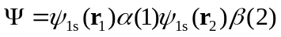

Hartree’s father did this by hand for all the atoms in the 1930’s! Works for some things, like shell structure, but certainly not quantitative. Nonetheless, sets the groundwork for most all approaches that follow.
- Pauli principle and anti-symmetrization
Obvious problem with the Hartree model is that it distinguishes between electrons…each electron gets its own unique and independent spin-orbital. In reality electrons, like all Fermions, are indistinguishable. And we have to pay attention to the fact that electrons have spin.

Pauli principle for Fermions: (fundamental postulate of QM)
“The wavefunction of a multi-particle system must be anti-symmetric to coordinate exchange if the particles are fermions and symmetric to exchange if the particles are bosons.”
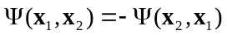

Variable x describes space and spin coordinates of an electron.

Electrons have half-integer spin and are thus fermions. Hartree product doesn’t have this property and isn’t satisfactory. Darn. Construct combination of orbitals (for He):

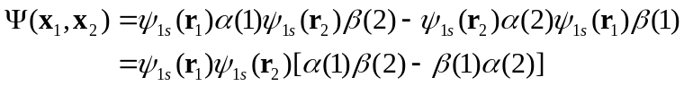

Apparent that exchanging the coordinates of electron 1 and 2 changes the sign on the total wavefunction. Since α and β spins are orthogonal, can pretty easily normalize:

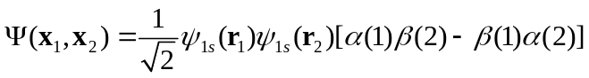

Note it is impossible to construct an antisymmetric wavefunction with both electrons in the same orbital with the same spin. Jibes with chemical intuition:
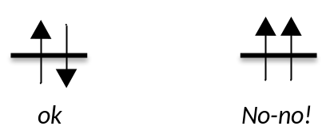
Closed-shell singlet vs. non-sense!
- Slater determinants and exchange
For an arbitrary number of electrons in orbitals, Slater proposed method for generating normalized combinations of spin-orbitals that obey Pauli principle. E.g. for He:

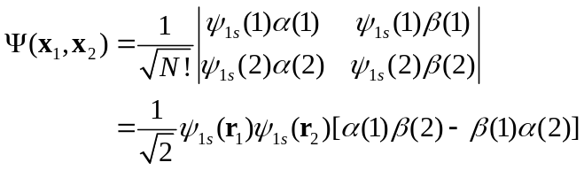
Each spin-orbital gets a column and each electron a row. Expanding determinant gives normalized antisymmetric combination. Rules of determinants guarantee that swapping any two electrons = swapping two rows = change in sign of determinant.

In general
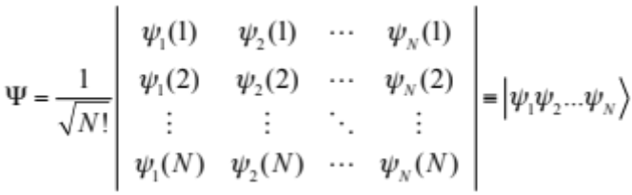

Take two-electrons in two orbitals case. Four possibilities (use bar to represent β spin):

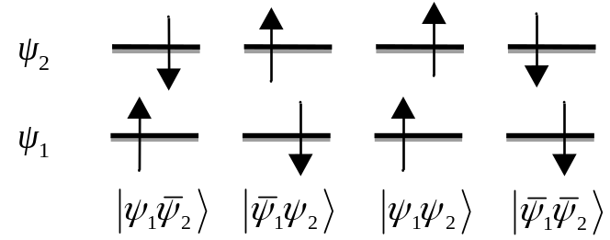

Compare energies of these. One-electron parts all the same. Two-electron parts differ:

Spin-paired combination:

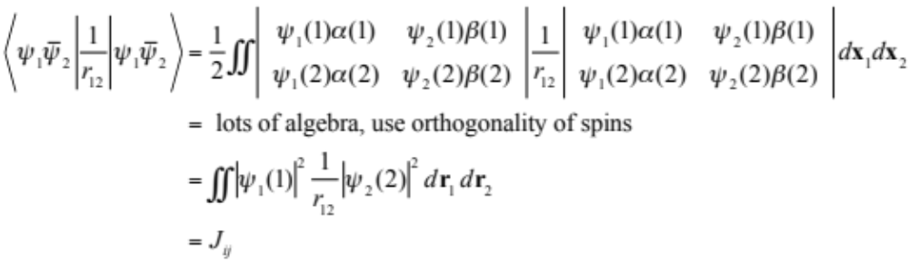

Makes sense…same Hartree electrostatic repulsion between two electrons.

Spin-aligned combination:
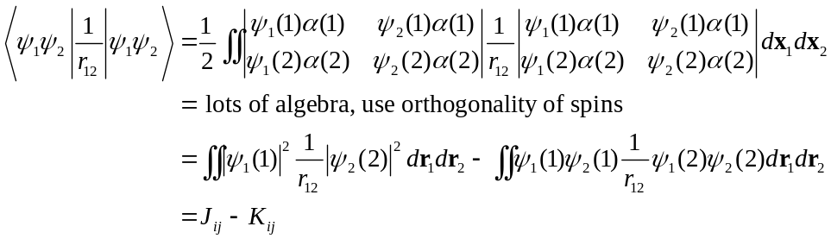

Hmmm….energy is different than Hartree case, repulsion reduced by some amount given by K_{ij} > 0, so-called exchange integral. Note funny form: electrons are “exchanged” between the two orbitals.

Exchange: Embodies notion that like fermions (like electrons of the same spin) intrinsically avoid one another independent of their Coulomb repulsion. Interaction reduced by their inability to get near one another. Creates “exchange hole” around an electron, in which another electron of same spin will not penetrate.

Careful analysis shows that 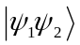 and 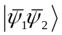 are both eigenfunction of the spin operator 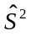 with eigenvalues 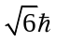. Neither 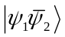 nor 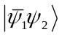 are pure spin functions. Have to “spin-adapt”
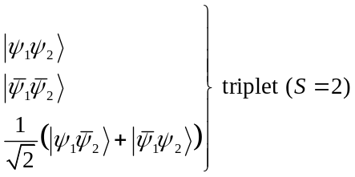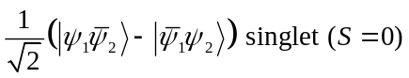

Recall multiplicity = 2S + 1, corresponds to electronic degeneracy of each combination.
- Hartree-Fock equation
Ok, so Slater determinants nicely incorporate adherence to the Pauli principle into the one-electron Hartree orbitals. Let’s use this as our approximation for the “real” wavefunction:

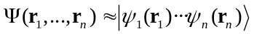

Let’s restrict ourselves, as well, to closed shell singlets, let ψ be spatial orbitals. Same song and dance,

- Use variational principle. The “best” set of ψ_{i} minimize the expectation value of the energy.

- Use method of Lagrange multipliers to maintain constraint that ψ_{i} are orthonormal.

Turn crank, arrive at new set of equations for ψ_{i:}

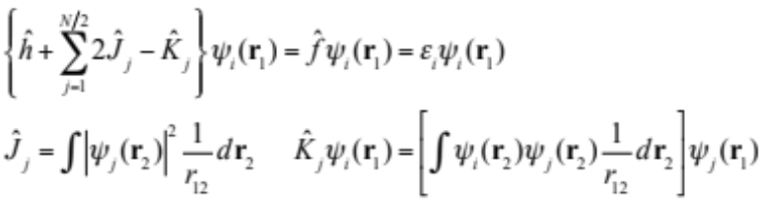

Restricted Hartree-Fock (RHF) equation

One-electron eigenvalue equations, but just like the Hartree equation, they are coupled through the appearance of every occupied orbital in the Fock (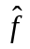) operator. Must be solved self consistently.

Solution gives bunch of atomic/canonical molecular orbitals ψ_{i} and energies ε_{i}.

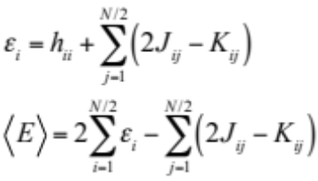

Note equation for ε_{i} is the same for all the occupied and unoccupied orbitals, but index j only runs over occupied orbitals.

What do the terms mean? Define the one-particle charge density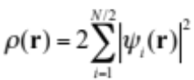 (units charge/unit volume; would multiple by e to get charge in there explicitly):
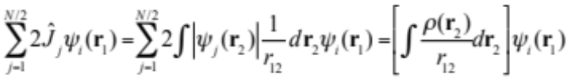

Coulomb repulsion of electron 1 with all electrons (including itself!!). Called Poisson equation.

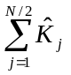as written contains the exchange interaction with all electrons. Includes exchange interaction between and electron and itself, called the “self-interaction” correction.

cannot be written in a simple closed form in terms of ρ(r).

Much better model than Hartree alone, but much harder to solve, especially in the early days of computers. Even today, more work than one often wants to do.
- Hartree-Fock-Slater model
In 1951 Slater introduced an approximation to the Hartree-Fock model that turned out to be prescient of a whole new approach to solving the electronic structure problem, called density functional theory (DFT).

Start from Hartree-Fock equation. Just saw that the Coulomb part can be written:

This is just the same as above, called Poisson equation. (Just to make sure we are following units around, the potential energy is in units energy/charge, eg J/C in SI; it would have an 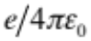in front.)

sum doesn’t as easily simplify, but multiplying and dividing by 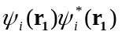 and performing the sum gives
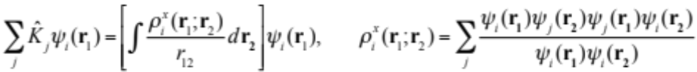

This looks like a density thing too (also has units charge/volume), although it includes a funny orbital dependent “exchange charge density” or “exchange hole.” What are it’s properties?

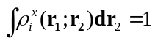: every electron at any position r₁ has an exchange “hole” around it equal to one electron of the same spin as itself

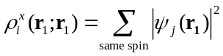: exchange hole totally cancels out all electrons of same spin at the location of an electron.

Thus, the Coulomb repulsion felt by an electron is diminished by an exchange “hole” that follows the electron around, exactly canceling out the charge at its current location. It’s not necessarily spherical and is not the same for all orbitals, but the fact that it has these general properties gives hope that it can be approximated somehow.

What to do, what to do? Hey, how about approximating exchange hole by its value in a homogeneous electron gas of same density at a given point? By dimensional analysis, if hole is spherical and contains one electron of say an α spin, then its radius 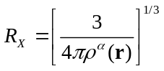. The potential felt by the electron due to this spherical exchange hole is then
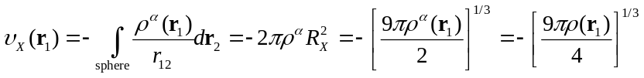
(The last step assumes equal number of spin-up and spin-down electrons.) Actual averaging over all the orbitals gives a result that differs only in the constants:
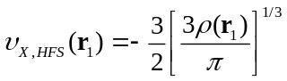
This is the simplest example of a density functional exchange operator, the Hartree-Fock-Slater exchange. Since the exchange potential depends only on the value of the density at a point, it is also an example of the “local density approximation” (LDA). (As an aside, the “right” value of the constants in front is not well-determined, so a scale factor α was put in front, which is origin of the so-called “Xα” method.)

Can now write an approximate Hartree-Fock-Slater equation:

This is much simpler than Hartree-Fock equations, because left-hand side is the same for all electrons, and just involves the total electron density, ρ. Still has to be solved iteratively, using self-consistent field.

Few things to note:
Exchange potential scales with the total number of electrons around: more electrons (like near a nucleus) means a more compact, denser exchange hole, more electron exchange “screening,” a greater decrease in potential energy. Further from nucleus, more diffuse exchange hole, less screening.

Screening is not exact, though; 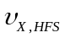does not exactly cancel self-interaction. Clearest in one-electron case: Coulomb and exchange potentials should then exactly cancel, which they evidently do not! HFS energy of an H atom is not exactly −0.5 au!

From a computational point of view, the exchange potential goes from being the hard thing to evaluate to being the easy thing. The Coulomb potential takes more effort to evaluate, and tricks are often implemented to simplify that, like fitting the density to an auxiliary basis set. On the other hand, the 1/3 power makes the exchange potential non-analytic, and solution of the HFS equation (and all DFT methods) involves some form of numerical quadrature.

How does the HFS model do? Pretty darn well, in particular for calculating the structures of things, and it works nicely for things like metals. Not a bad deal! Way to go, Slater!

Another aside: back in the day, the numerical implementations of Xα were very crude and sometimes gave unreasonable results (like linear water!). Slater still sold it very hard, which did not enamor him or all of DFT to the chemical community, although the physics community was far more accepting. For many years DFT was unaccepted by chemists, until solid numerical implementations in codes like Gaussian brought it to the mainstream.
- Numerical implementation
Herman-Skillman code written in the 1960’s to do HFS numerical calculations for atoms. Still popular for modeling core electron spectroscopies. Code only handles singlet spins. Several sources today:

http://hermes.phys.uwm.edu/projects/elecstruct/hermsk/HS.TOC.html:
updated fortran version of original code

http://dcbwww.unibe.ch/groups/schumacher/qc/fda.htm:
version rewritten in C++, plus a Windows version

“Dirac” relativistic atomic code in ADF is a descendant of the Herman-Skillman code

Demonstrate code….compare e.g. mixing, occupations, …
Virial theorem states (for Coulomb potential) that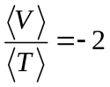. For approximate solutions, useful metric as to quality of results. For approximate solutions, useful metric as to quality of results.

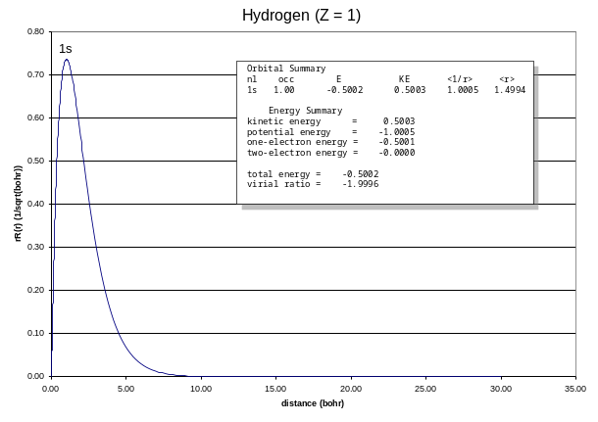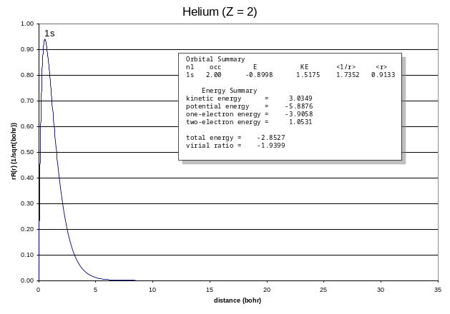
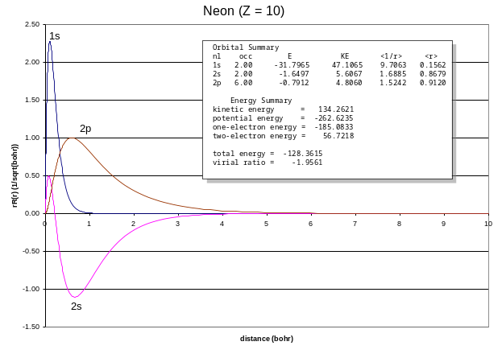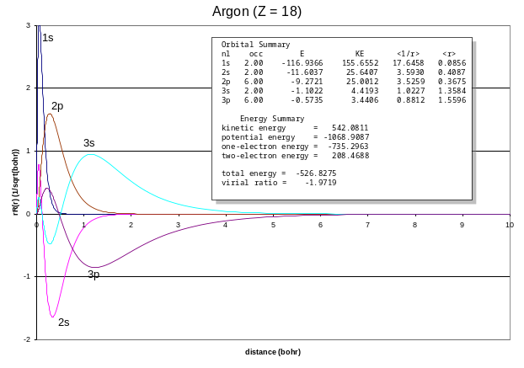
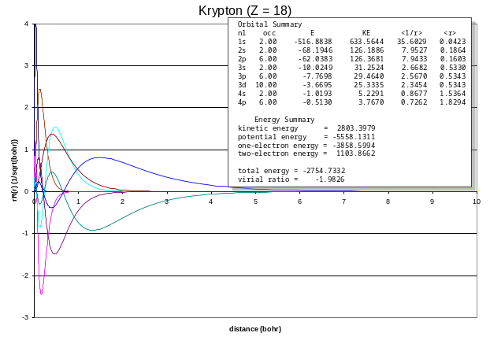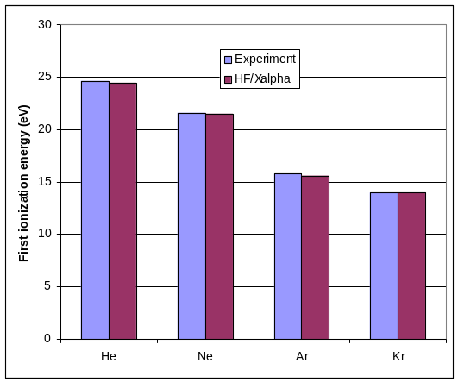

- Comparison of models

Koopman’s theorem: The negative of the energy of an occupied orbital (−ε_{i}) approximates the energy to extract an electron from that orbital, i.e. to ionize the system. The energy of a virtual orbital ε_{i}* approximates the energy to add an additional electron to a system, i.e. the electron affinity. Assumes no relaxation of orbitals. IPs reasonably approximated, EAs not so well.

How’s it do? Check out http://srdata.nist.gov/cccbdb/koopmany1.asp.
- Correlation
Hartree-Fock works very well for some things, like shapes of molecular orbitals, dipoles, predictions of molecular structures and vibrational frequencies of simple molecules. It doesn’t work well when making/breaking bonds, or any system with “weak” electron interactions.

So what is missing in the Hartree-Fock (and Hartree-Fock-Slater) model? The both assume a “mean field,” averaged interaction between an electron and all its companions. The error is called:

Correlation: the instantaneous, dynamical Coulomb interaction between all electrons. Prevents, for instance, electrons of opposite spin from being in the same place at the same time. More expensive to treat than regular Hartree-Fock (except for DFT). Will discuss more later.

Wavefuntion (WFT) based:
Many-body (Møller-Plesset) perturbation theory (MPn)
Coupled Cluster (CC) and Quadratic CI (QCI)
Configuration Interaction (CI)

Density-based
Density Functional Theory (DFT) – LDA, GGA, MetaGGA

Hybrid
Hybrid density functional theory – B3LYP, PBE0

