CSCE 5430 (Fall 2026) — Deliverable 4, Project Phase 2

Lost and Found for Campus — Team Falcons
Waleed Mirza (1194980) · Venkata Sai Anirudh Naidu Mamidi (11908399) · Sai Sathvika Potluri (11813771) · Sai Asritha Thati (11909319)
Source: src/backend, src/frontend · Report: reports/deliverable-4/

1. Requirements
The Phase 2 scope is unchanged from Section 9.2 of the Deliverable 2 requirements document, so the requirements below are that set with the detail the implementation now makes possible. Phase 2 delivers the matching engine, the private claim and resolution workflow, and in-app notifications; messaging, moderation, the map, and analytics stay in Phase 3.
Table 1. Phase 2 requirement set.
ID | Requirement | Implemented in
FR-MATCH-01 | Compare Active Lost with Active Found listings on category, date, location, and public keywords | matchingService.js
FR-MATCH-02 | Score candidates 0–100 on the specified weights and keep the contributing factors | matchingService.js, Match.js
FR-CLM-01 | A verified non-owner claims an Active Found listing with an explanation and two private details | claimController.js, Claim.js
FR-CLM-02 | Retain many pending claims; the owner approves one or rejects a claim | claimController.js
FR-CLM-03 | Approval moves the listing to Pending Return, closes competitors, and permits resolution | claimController.js
FR-COM-01 | Notify on matches, claims, decisions, and resolution; optional email never reverses an action | notificationService.js, Notification.js

1.1 FR-MATCH-01 — Generating suggestions
Creating, editing, or restoring an Active listing compares it with every Active, non-deleted listing of the opposite type. Pairs scoring 65 or more are persisted as Match documents, pairs that no longer qualify are deleted, and all matches are removed when a listing is deleted, resolved, or moved to Pending Return. Because matches are recomputed rather than appended, an edited listing cannot keep a stale suggestion. Only the owner may read them (GET /api/v1/listings/:id/matches, GET /api/v1/matches); anyone else gets 403.

1.2 FR-MATCH-02 — Scoring and explainability
Each match stores its score and the four factors behind it, so the owner sees why a pairing was suggested instead of an opaque number.
Table 2. Match scoring rule (maximum 100 points).
Factor | Rule | Points
Category | Same category (case-insensitive) | 35, else 0
Date | Found date within 1 day of the lost date | 25
 | Within 7 days | 15
 | More than 7 days apart | 0
Location | Same building | 20
 | Same campus zone, different building | 10
Keywords | 3 or more shared public keywords | 20
 | 1 or 2 shared keywords | 10
Only public text is compared: title, description, brand, and color. Private claim evidence is never read by the scorer, so a suggestion can be shown without leaking the answer to a claim. Text is lower-cased, stripped of punctuation and accents, stop-worded, and lightly stemmed so wallet/wallets compare equal; a pair matching on all four factors scores 100.

1.3 FR-CLM-01 — Submitting a claim
A verified non-owner claims an Active Found listing through POST /api/v1/listings/:id/claims with an ownership explanation and at least two private identifying details, such as a serial suffix or an engraved mark. The endpoint rejects an unverified account (403), a missing listing (404), a Lost listing (400), a listing that is not Active (409), the owner (403), an empty explanation or fewer than two details (400), and a duplicate open claim (409). Claims are limited to 30 requests per 15 minutes per client, and the 201 response returns the claim without its private details.

1.4 FR-CLM-02 — Owner decisions
A listing may hold any number of pending claims. The owner reads each claim’s evidence at GET /api/v1/listings/:id/claims and approves one claim or rejects a claim with PATCH /api/v1/claims/:id/decision and a body of {action, decisionNote}. Only the owner may call either endpoint (403), and only a pending claim may be decided (409). Approval is guarded by a conditional update that requires the listing to still be active, so two simultaneous approvals cannot both succeed; the second receives 409.

1.5 FR-CLM-03 — Pending Return and resolution
Approval makes three changes: the chosen claim becomes approved, the listing becomes pending_return, and every competing pending claim becomes closed with the note “Another claim for this listing was approved”. Affected claimants are notified and the listing’s suggestions are removed. After the handoff the owner calls PATCH /api/v1/listings/:id/resolve; resolution requires the owner, a pending_return listing, and an approved claim, then sets the listing to resolved, notifies the claimant, and deletes remaining matches.

1.6 FR-COM-01 — Notifications
The system persists an in-app notification for a potential match, a new claim, a decision, a competing closure, and a resolution. They are listed at GET /api/v1/notifications with an unread count and can be marked read individually or all at once. Each user has an emailNotifications preference (default on); when it is on, the service retries once and records emailStatus (sent, skipped, failed) and emailAttempts. Every call is wrapped so a delivery failure is logged and swallowed: a broken mail server can never roll back a claim, a decision, or a listing change.

1.7 Constraints applied in Phase 2
Table 3. Nonfunctional and interface requirements carried into Phase 2.
ID | Requirement | Satisfied by
NFR-SEC-03 | Validation and rate limits on claims | Field, ownership, and state checks; 30/15 min limiter
NFR-PRIV-01 | No private evidence in public responses or logs | select: false; field stripped from the create response
NFR-TST-01 | Tests cover authorization boundaries | 32 tests in 7 suites, including owner and state guards
IF-UI-03 | Claim review separates public data from evidence | Evidence only in the owner’s review panel
IF-SW-01, IF-COM-02 | Versioned JSON endpoints behind a credential | All Phase 2 routes under /api/v1 behind JWT protect

2. UML Design
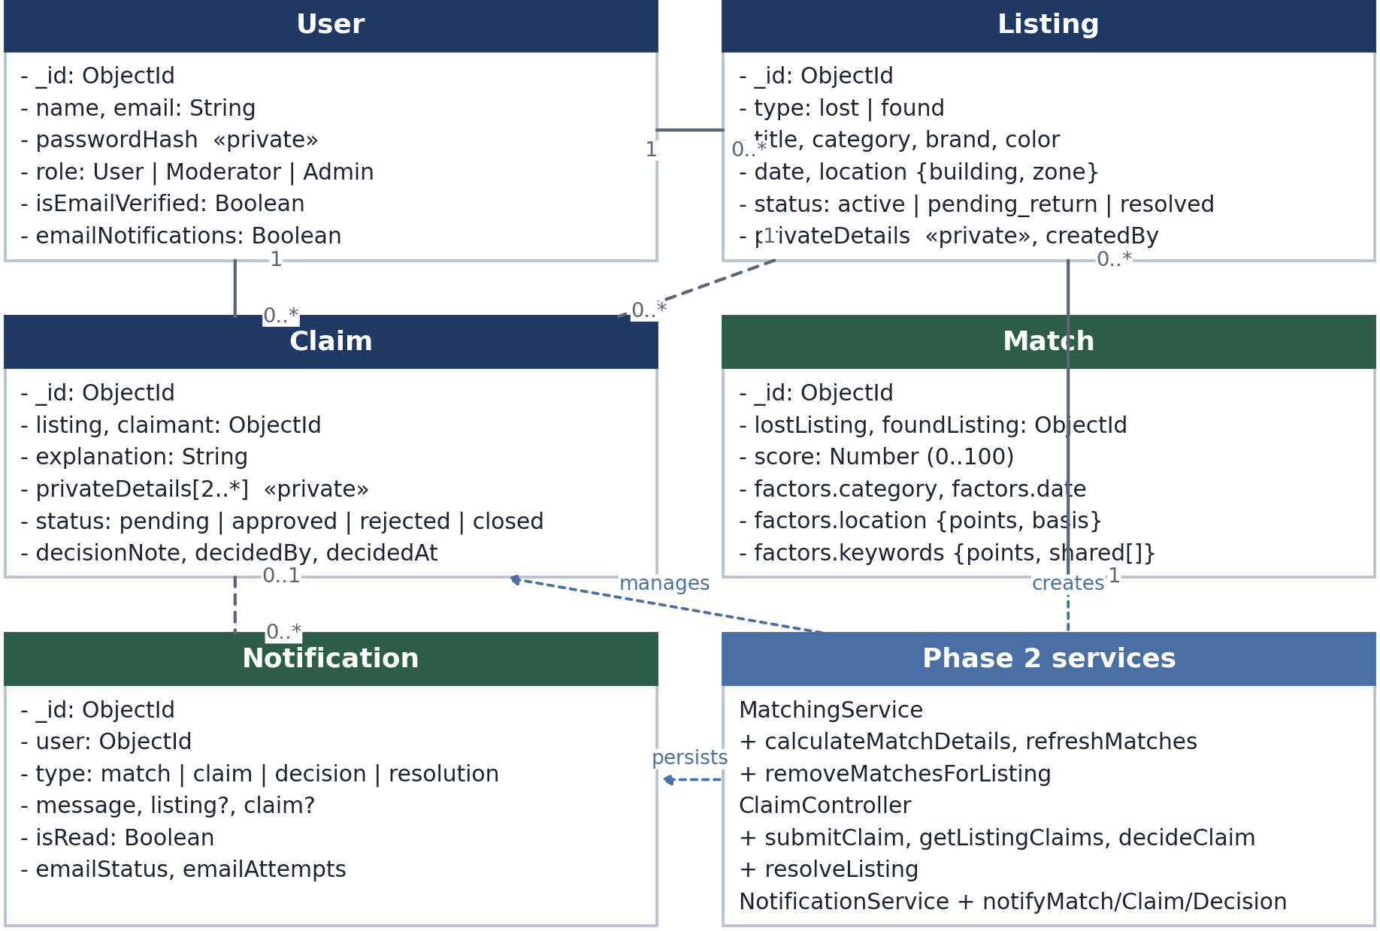
Figure 1. Phase 2 class diagram: domain entities, associations, and service modules.
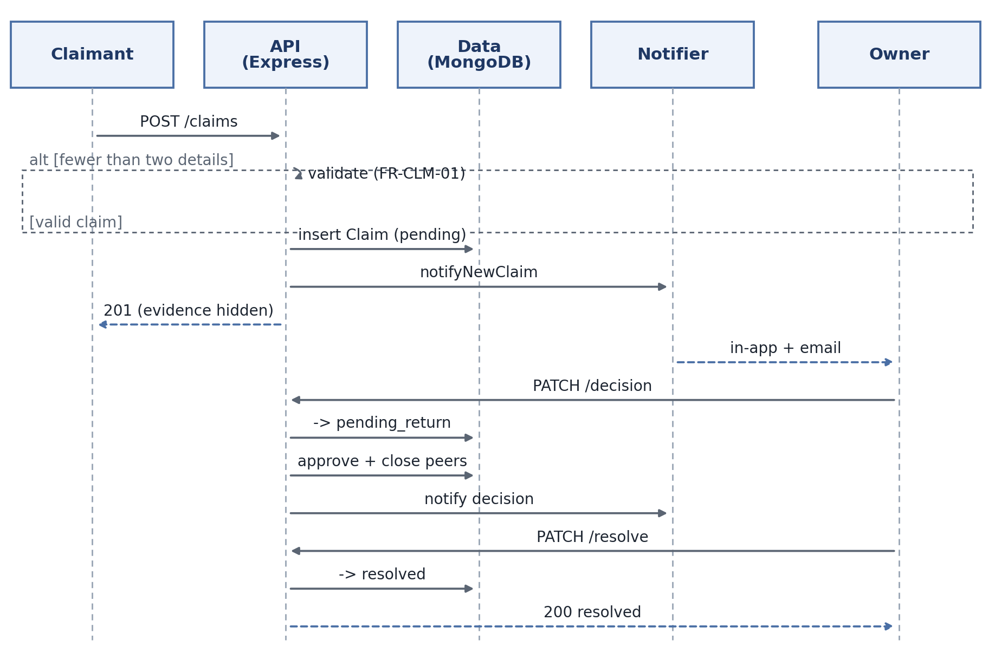
Figure 2. Claim lifecycle: the invalid-evidence branch, owner approval, competing-claim closure, and resolution.
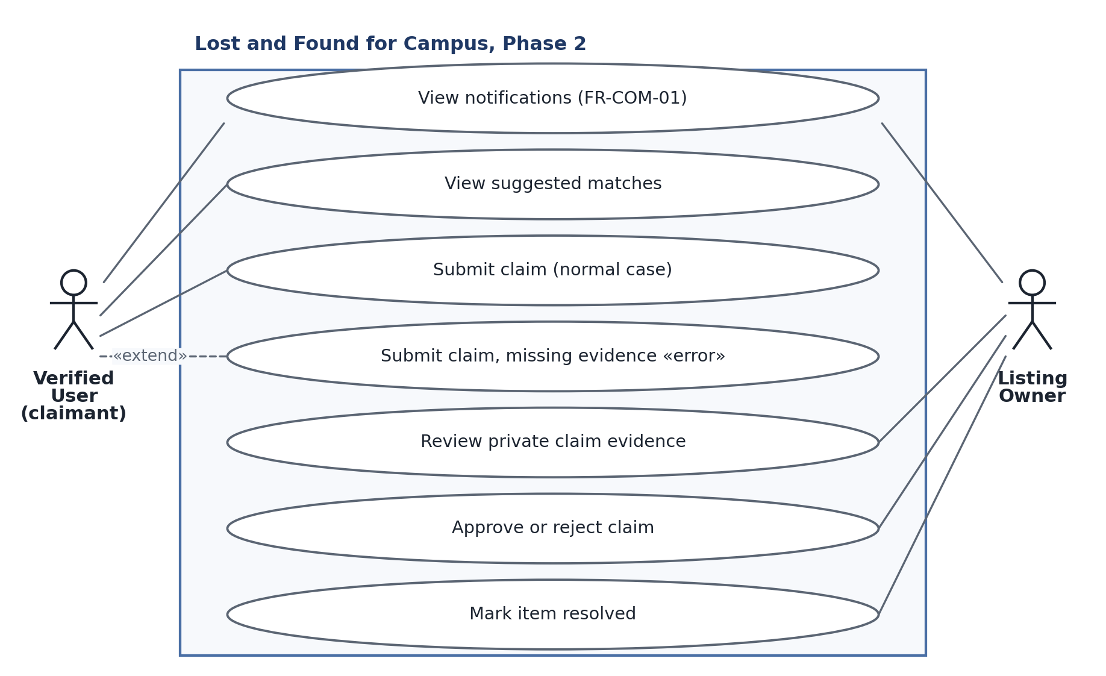
Figure 3. Phase 2 use cases, including the normal claim case and the missing-evidence error case.

2.1 Notes on the diagrams
Class diagram. Match is a persisted, scored association between one Lost and one Found listing and owns the factor breakdown of Table 2. Claim belongs to one listing and one claimant and holds evidence that ordinary queries exclude. Notification optionally references a listing and a claim so a message can be traced to its cause. A user owns zero or more listings, a listing receives zero or more claims, and a listing may appear in many matches. The lower compartment groups the Phase 2 modules rather than modelling them as classes, because they are stateless Express modules; the dotted arrows show which entity each creates or manages.
Sequence diagram. The alt fragment is the error case: with fewer than two details the API returns 400 and no state changes. Otherwise the API persists a pending claim, notifies the owner, and returns 201 without the evidence. The lower half re-checks ownership, claim state, and listing state before moving the listing to pending_return, approving the chosen claim, closing its competitors, notifying everyone affected, and dropping the matches. The last exchange marks the item resolved; dashed arrows are responses, labelled with the status the client receives.
Use case diagram. The verified user views suggestions for their own listings and submits a claim (normal case). The error case is Submit claim with missing evidence, which «extend»s the normal claim because it is the same interaction entered with invalid input. The owner reviews private evidence, approves or rejects a claim, and marks the item resolved, and both actors receive notifications. Because the decision controls sit inside each claim’s evidence panel, an owner cannot decide a claim they have not been shown.

3. Coding and AI Usage Report

3.1 What was generated by AI and what was done by the team
Phase 2 code was drafted with an AI assistant and then reviewed, corrected, and tested by team members. No Phase 2 file was accepted without being run.
Table 4. Authorship by component.
Component | AI-generated | Team work
Claim, Match, Notification models | Schemas, indexes, validators | Field selection, two-detail validator, evidence kept select: false
matchingService.js | Scoring, keyword normalization, refresh routine | Factor audit against FR-MATCH-02, lifecycle wiring, stale-match cleanup
claimController.js | Handlers and validation branches | Atomic approval guard, competing closure, redaction, error isolation
notificationService.js, emailService.js | Persistence, fan-out, retry loop | Preferences, delivery bookkeeping, swallowing failures
Controllers, routes, React views, tests | Scaffolding, layout, fixtures | Ownership checks, /api/v1 mounting, owner-only controls, privacy assertions

3.2 AI usage report
Tools and tasks. Claude (Anthropic, Sonnet family, via claude.ai and an editor agent) and ChatGPT drafted schema and controller scaffolding, the scoring functions, claim-panel React state, test fixtures, and this report’s structure. Every output was reviewed by a team member before it was kept.
Representative prompts. “Implement FR-MATCH-02 exactly as written, and store the factor breakdown with each match.” · “Add an owner-only endpoint returning pending claims with private evidence, and keep the evidence out of the create-claim response and every public payload.” · “Approval must not be racy: only one approval may succeed even if the owner double-clicks.” · “Wrap notification and email failures so a claim action is never rolled back.”
Mistakes the AI produced, and the fixes.
- Matching was implemented but never called. It passed its unit test while no route imported it. Fixed by calling refreshMatchesForListing after create and edit and removeMatchesForListing after delete and resolution.
- Notifications were fabricated in memory. They vanished on restart. Fixed by persisting Notification documents and adding list and read endpoints.
- Email failure reversed successful actions. The paths awaited the mail transport, so an SMTP error returned 500 after the write. Fixed by isolating delivery, retrying once, and never propagating the error.
- Approval was racy. The handler read the listing and then updated it. Fixed with a conditional findOneAndUpdate on status: "active".
- Private evidence leaked and tests shared a database. The create response returned privateDetails, and suites deleted each other’s data. Fixed with select: false, a response field strip, MONGODB_URI_TEST, and maxWorkers: 1.

4. Test Cases
Phase 2 is covered by 32 Jest/Supertest cases in 7 suites, run against a dedicated lost_and_found_test database with one worker.
Table 5. Phase 2 and regression test cases.
# | Test case | Input | Expected result
1 | Strong pair | Same category, 1 day, same building, 3 keywords | Score 100
2 | Claim happy path | Verified non-owner, explanation, 2 details | 201, pending, no privateDetails
3 | Owner cannot claim | Owner claims own listing | 403
4 | Insufficient evidence | One private detail | 400
5 | Duplicate claim | Second pending claim by the same user | 409
6 | Non-Active listing | Listing in pending_return | 409
7 | Evidence owner-only | Owner fetches listing claims | 200, both details present
8 | Approval closes competitors | Two pending claims, approve one | Approved, other closed, listing pending_return
9 | Second decision blocked | Decide an already-decided claim | 409
10 | Resolution requires approval | Resolve with no approved claim | 409
11 | Resolution happy path | Owner resolves after approval | 200, resolved, claimant notified
12 | Notification persisted | Email disabled | Stored, isRead: false, emailStatus: not_requested
13 | SMTP not configured | Email enabled, no SMTP | emailStatus: skipped, action succeeds
14 | Regression: bad date range | dateFrom after dateTo | 400, not an empty page
Result: 7 suites, 32 tests, 32 passing. A live API smoke test exercised match, competing claims, approval, closure, resolution, notifications, and email preference: 27 of 27 checks passed. The frontend passed a production build and a lint run with 0 errors.

5. User Manual (Phase 2 Features)
Suggested matches. Open one of your own listings. The Potential matches panel shows each suggestion’s score and a per-factor breakdown.
Claiming a found item. Open an Active Found listing and select Claim this item. Explain why the item is yours and enter at least two private details, such as a serial suffix; the owner alone sees them. The claim appears under My Claims as Pending. You cannot claim your own or a Lost listing, an inactive item, or the same item twice.
Reviewing claims and resolving. As the owner, open your Found listing. The Claims panel lists each claim with the claimant’s name, explanation, and private evidence. Approve asks for confirmation because it closes every other pending claim; Reject records a decision note. Approval moves the listing to Pending Return; after handing the item over, Mark Resolved makes it Resolved, removes it from search and matches, and notifies the claimant.
Notifications. The bell shows your unread count. Notifications lists every event, newest first; select one to mark it read, or use Mark all read. The Email notifications switch turns email off but keeps in-app notifications; if the mail server is down the notification is still recorded and your action still succeeds.

6. Compilation and Run Instructions
Prerequisites. Node.js 20 or later, Git, and MongoDB 7 (local or Docker) at mongodb://127.0.0.1:27017.
git clone <repository-url>
cd csce5430-falcons-lostandfoundapp
docker run -d --name lostfound-mongo -p 27017:27017 mongo:7
Backend. Copy .env.example to .env and set PORT=5000, MONGODB_URI=mongodb://127.0.0.1:27017/lost_and_found, MONGODB_URI_TEST=mongodb://127.0.0.1:27017/lost_and_found_test, JWT_SECRET, APP_BASE_URL, and CLIENT_ORIGIN (http://localhost:5173). SMTP_* is optional; without it emails are recorded as skipped and in-app notifications still work.
cd src/backend && npm install && cp .env.example .env && npm run dev # API :5000
cd src/frontend && npm install
echo "VITE_API_BASE_URL=http://localhost:5000" > .env && npm run dev # Vite :5173
Verify. curl http://127.0.0.1:5000/api/v1/health must return 200. Create a Found and a Lost listing with the same category, building, and a nearby date; the Lost listing should show a match above 65 points.
Tests. MongoDB must be running and MONGODB_URI_TEST must point at a disposable database; the suite clears its own data and never touches the development database.
cd src/backend && npm test # or: npx jest --runInBand
cd ../frontend && npm run build && npm run lint
Expected: 7 suites, 32 tests passing, a clean production build, and no lint errors.

7. Code Inspection Feedback
The Phase 2 code-inspection session had not taken place when this report was written, so this section does not invent remarks. From the Deliverable 3 inspection. Reviewers asked for clearer separation between public listing data and claim evidence, now enforced in the schema rather than only the interface; for the matching and notification modules to be reachable from real routes instead of unused drafts, now wired into the listing and claim flows; and for tests covering authorization boundaries, which now assert owner/non-owner, verified/unverified, and state-transition failures.
From the Deliverable 2 workshop. The workshop asked for a defined lifecycle (Active, Pending Return, Resolved), a claim step separate from messaging, and a rule that email failure must not break a workflow. All three are in Sections 1.5 and 1.6.
Outstanding. Written feedback from the Phase 2 inspection will be appended here, with the action taken for each remark.

8. Reflection
Phase 2 is the first increment where the project behaves like a product rather than a set of screens. A Lost listing produces scored, explainable suggestions; a stranger can prove ownership without publishing the proof; the owner decides once and only once; and the losing claimants are told why. Storing the factors next to the score cost one small schema and made the feature testable and defensible.
What went well: the requirement text was precise enough to implement literally, so the scoring table, status names, and error codes map one-to-one onto the code and tests. Keeping email failures out of the transactional path removed a class of “the claim succeeded but the user saw an error” bugs.
What could be improved: two modules were written before they were connected, which produced a false sense of progress until a live run showed that no match was ever stored; a feature must be wired to a route the day it is written. Approval needed a second pass to become race-safe, and the frontend still has no automated tests, the largest gap before Phase 3.

9. Member Contribution Table
Table 6. Contribution by member.
Member | Contribution | Overall (%)
Waleed Mirza | Coordinated the phase; authored the requirements, UML notes, AI usage, inspection, and reflection sections; verified the end-to-end chain | 30%
Venkata Sai Anirudh Naidu Mamidi | Implemented the backend models, controllers, routes, matching, notification, and email services | 30%
Sai Sathvika Potluri | Produced the three UML diagrams; reviewed the claim and notification screens; contributed to the user manual | 20%
Sai Asritha Thati | Implemented the frontend; authored the test cases; ran the automated suites and the manual pass | 20%
Total |  | 100%

