实 验 报 告

课程名称 高级Java程序设计
实验项目 Java数据库编程
实验仪器 个人计算机 __

学 院 计算机学院
专 业 计算机科学与技术
班级/学号_____大数据1802/2018010070____________
学生姓名 _____吴梦娇__________
实验日期 2020/4/21
指导教师 徐 莉

实验项目一 Java数据库编程

一．实验目的
- 巩固课堂所学的理论知识，掌握Java数据库应用程序设计的基本方法，提高学生将相关知识和对象描述方法用于分析复杂工程问题、并提出解决方案的能力。
- 理解MVC设计模式，培养学生能够针对特定软件需求，完成可重用软件模块的分析、设计能力。

二．实验要求
- 上机实验前，仔细阅读实验指导书，按照每一个实验任务的具体要求提前完成准备工作，如：查找资料、设计算法、写出全部源程序，做好预习笔记，做到有准备地上机。
- 上机实验课内，积极调试及修改程序。得到正确运行结果后，积极主动要求指导教师验收程序，回答指导教师提出的问题。
- 上机实验课后，学生应根据实验数据及结果，完成实验报告。实验报告是评定实验成绩的重要组成部分。实验报告上传课堂派。

- 实验内容
根据课堂所学案例设计与实现一简单图书管理系统，其主要任务包括：
- 设计图书数据模型
- 设计图书数据访问接口
- 实现图书的数据访问类
- 实现图书的添加、修改、删除和查询功能

- 系统设计（数据库设计，程序架构）
数据库设计
共包括五张表，有书名表，图书存储地点表，图书所属科目表，语言表，每本书的详细信息等等。如下图所示
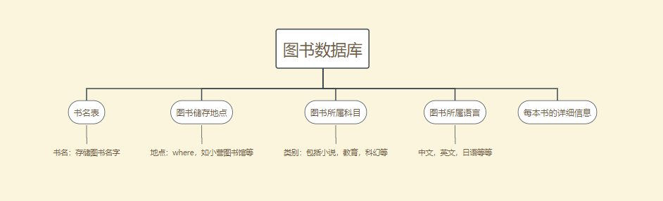
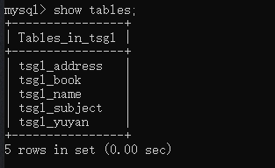
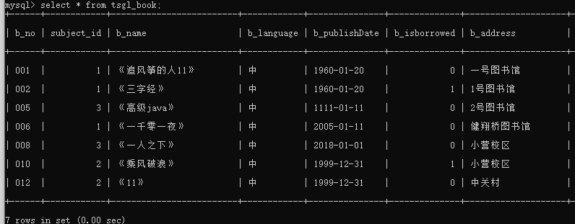
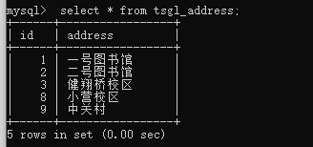
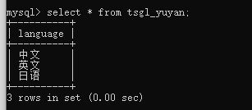
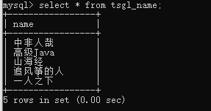

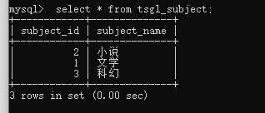

程序架构
程序包括dao包，接口包，检测数据库是否连接包，
实体类包，包含实体类书，科目，用户，语言
页面编写包，包含添加，查找，删除，修改，翻页等操作页面
实现页面包，检测前面编写的页面包是否正确，并运用
等六个包，
具体内容请看下图
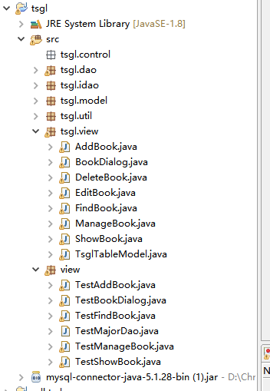

- 测试数据及系统运行结果
- 根据书名查找数据
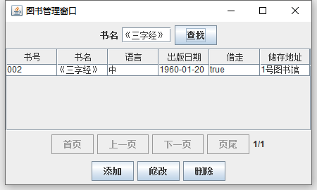
- 实现目录翻页（显示第二页）
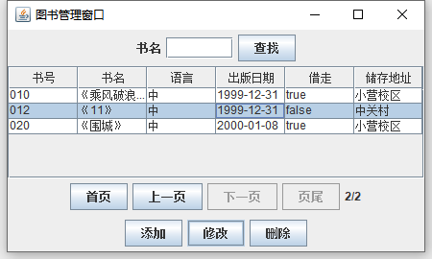
- 添加图书信息
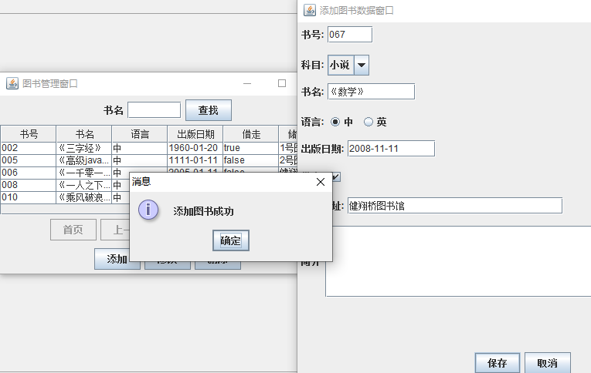
- 修改图书信息（可直接选中目录中的图书，再点击修改）
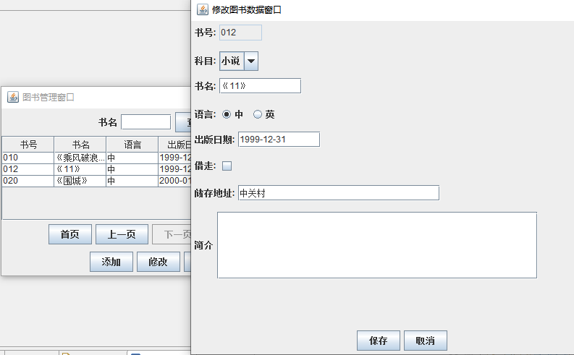
- 删除图书信息（删掉了图书《追风筝的人》
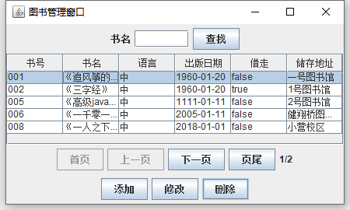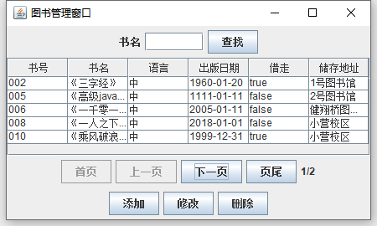
- 调试分析及实验总结
调试分析：
主要是调试过程出现的问题和解决方法
- 数据库连接问题
问题：测试时，显示数据库连接失败。
解决：经检查，发现随着java和eclipse版本不一样，需要自己去官网下载合适的连接驱动，而并非都可以用老师发的实验资料
- 数据表设计问题
问题：不知道怎么设计才使数据合理而且规范的表达图书的信息
解决：学习数据库的范式之后，发现虽然设计一张表比较省事，但不利于图书的修改和删除等问题，所以可以根据唯一书号设计多个表来进行管理
- 程序报错
问题：有很多问题，如找不到合适的主类，类型不适配，方法类编写错误等等
解决：根据程序运行时eclipse的报错一步步进行调试，如有时忘记添加简单方法，就可使eclipse自动添加，类型不适配，就找到源头去修改数据类型等等，一步一步的解决问题，直到红叉号消失，再运行
实验总结：
通过这次利用设计图书管理系统，首先，我掌握了基本的java数据库应用程序设计的基本方法，首先根据需要设计好数据库的各个部分，再通过JDBC API，用Java语言编写程序执行sql语言。
其次，理解了MVC设计模式，将模型与数据处理，即在这里将页面以及其实体类模型分开，有助于管理复杂的应用程序，可以在一个时间内专门关注一个方面。例如，可以在不依赖业务逻辑的情况下专注于视图设计。同时也让应用程序的测试更加容易。

- 附录：系统源程序
说明：将按照包的顺序来粘贴
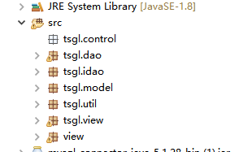

- Tsgl.dao
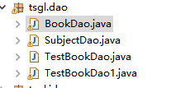
- BookDao.java

import java.sql.Connection;
import java.sql.PreparedStatement;
import java.sql.ResultSet;
import java.util.ArrayList;
import java.util.List;
import tsgl.idao.IBookDao;
import tsgl.model.*;
import tsgl.util.SqlHelper;
public class BookDao implements IBookDao{
private Connection conn=null;
private PreparedStatement ps=null;
private ResultSet rs=null;

@Override
public Book findBook(String bNo){
Book bb=null;
try{
conn=SqlHelper.connect();
String sql="Select a.subject_name,b.* from tsgl_subject a,tsgl_book b where a.subject_id=b.subject_id and b_no=?";
ps=conn.prepareStatement(sql);
ps.setString(1, bNo);
rs=ps.executeQuery();
if(rs.next()){
bb=new Book();
Subject subject=new Subject();
bb.setSubject(subject);
subject.setSubjectId(rs.getInt(3));
subject.setSubjectName(rs.getString(1));
bb.setBookNo(rs.getString(2));
bb.setbName(rs.getString(4));
bb.setbLanguage(rs.getString(5));
bb.setbPublishDate(rs.getDate(6));
bb.setbIsBorrowed(rs.getBoolean(7));
bb.setbAddress(rs.getString(8));
bb.setbResume(rs.getString(9));
bb.setbPic(rs.getBytes(10));
}
}catch(Exception e){

}finally{
SqlHelper.closeResultSet(rs);
SqlHelper.closePreparedStatement(ps);
SqlHelper.closeConnection(conn);
}
return bb;
}

@Override /*实现抽象方法findBooks()；根据姓名分页查询学生*/
public List<Book> findBooks(String bName, Integer pageNo, Integer pageSize){
List<Book> list=new ArrayList<>();
try{
conn=SqlHelper.connect();
String sql="Select a.subject_name,b.* from tsgl_subject a,tsgl_book b where a.subject_id=b.subject_id and b_name like ? ";
sql=sql+ " limit "+ (pageNo-1)* pageSize+","+pageSize;
ps=conn.prepareStatement(sql);
ps.setString(1, "%"+bName+"%");
rs=ps.executeQuery();
Book bb;
while(rs.next()){
bb=new Book();
Subject subject=new Subject();
bb.setSubject(subject);
subject.setSubjectName(rs.getString(1));
bb.setBookNo(rs.getString(2));
subject.setSubjectId(rs.getInt(3));
bb.setbName(rs.getString(4));
bb.setbLanguage(rs.getString(5));
bb.setbPublishDate(rs.getDate(6));
bb.setbIsBorrowed(rs.getBoolean(7));
bb.setbAddress(rs.getString(8));
bb.setbResume(rs.getString(9));
//b.setbPic(rs.getBytes(10));
boolean add = list.add(bb);
}
}catch(Exception e){

}finally{
SqlHelper.closeResultSet(rs);
SqlHelper.closePreparedStatement(ps);
SqlHelper.closeConnection(conn);
}
return list;
}
//根据姓名查询记录总数
@Override
public int findCount(String bName){
int count=0;
try{
conn=SqlHelper.connect();
String sql="Select count(*) as count from tsgl_book where b_name like ?";
ps=conn.prepareStatement(sql);
ps.setString(1, "%"+bName+"%");
rs=ps.executeQuery();
if(rs.next()){
count=rs.getInt(1);
}
}catch(Exception e){

}finally{
SqlHelper.closeResultSet(rs);
SqlHelper.closePreparedStatement(ps);
SqlHelper.closeConnection(conn);
}
return count;
}

@Override
public boolean addBook(Book book){
boolean bln=false;
try{
conn=SqlHelper.connect();
String sql="insert into tsgl_book(b_no,subject_id,b_name,b_language,b_publishDate,b_isborrowed,b_address,b_pic)";
sql=sql + " values (?,?,?,?,?,?,?,?) ";
ps=conn.prepareStatement(sql);
ps.setString(1, book.getBookNo());
ps.setInt(2, book.getSubject().getSubjectId());
ps.setString(3, book.getbName());
ps.setString(4, book.getbLanguage());
ps.setDate(5, book.getbPublishDate());
ps.setBoolean(6,book.getbIsBorrowed());
ps.setString(7, book.getbAddress());
ps.setBytes(8,book.getbPic());
int n=ps.executeUpdate();
return n>0;
}catch(Exception e){
return bln;
}finally{
SqlHelper.closePreparedStatement(ps);
SqlHelper.closeConnection(conn);
}
}

@Override
public boolean deleteBook(String bNo){
boolean bln=false;
try{
conn=SqlHelper.connect();
String sql="delete from tsgl_book where b_no=? ";
ps=conn.prepareStatement(sql);
ps.setString(1, bNo);
int n=ps.executeUpdate();
return n>0;
}catch(Exception e){
return bln;
}finally{
SqlHelper.closePreparedStatement(ps);
SqlHelper.closeConnection(conn);
}
}

@Override
public boolean editBook(Book book){
boolean bln=false;
try{
conn=SqlHelper.connect();
String sql="update tsgl_book set subject_id=?,b_name=?,b_language=?,b_publishDate=?,b_isBorrowed=?,";
sql=sql + "b_address=?,b_pic=? where b_no=? ";
ps=conn.prepareStatement(sql);
ps.setInt(1, book.getSubject().getSubjectId());
ps.setString(2, book.getbName());
ps.setString(3, book.getbLanguage());
ps.setDate(4, book.getbPublishDate());
ps.setBoolean(5,book.getbIsBorrowed());
ps.setString(6, book.getbAddress());
ps.setBytes(7,book.getbPic());
ps.setString(8, book.getBookNo());
int n=ps.executeUpdate();
return n>0;
}catch(Exception e){
System.out.println(e);
return bln;
}finally{
SqlHelper.closePreparedStatement(ps);
SqlHelper.closeConnection(conn);
}
}

- SubjectDao.java
package tsgl.dao;

import java.sql.*;
import java.util.ArrayList;
import tsgl.idao.*;
import java.util.List;
import javax.swing.JOptionPane;
import tsgl.model.Subject;
import tsgl.model.Book;
import tsgl.util.SqlHelper;

public class SubjectDao implements ISubjectDao{
private Connection conn=null;
private PreparedStatement ps=null;
private ResultSet rs=null;
@Override
public boolean addSubject(Subject subject) {
throw new UnsupportedOperationException("Not supported yet."); //To change body of generated methods, choose Tools | Templates.
}

@Override
public boolean deleteSubject(Integer subjectId) {
throw new UnsupportedOperationException("Not supported yet."); //To change body of generated methods, choose Tools | Templates.
}

@Override
public boolean editSubject(Subject subject) {
throw new UnsupportedOperationException("Not supported yet."); //To change body of generated methods, choose Tools | Templates.
}

@Override
public int findCount() {
int count=0;
try{
conn=SqlHelper.connect();
String sql="Select count(*) as count from tsgl_subject ";
ps=conn.prepareStatement(sql);
rs=ps.executeQuery();
if(rs.next()){
count=rs.getInt(1);
}
}catch(Exception e){

}finally{
SqlHelper.closeResultSet(rs);
SqlHelper.closePreparedStatement(ps);
SqlHelper.closeConnection(conn);
}
return count;
}

@Override
public List<Subject> findSubjects() {
List<Subject> list=new ArrayList<>();
try{
conn=SqlHelper.connect();
String sql="Select * from tsgl_subject ";
ps=conn.prepareStatement(sql);
rs=ps.executeQuery();
Subject subject;
while(rs.next()){
subject=new Subject();
subject.setSubjectId(rs.getInt(1));
subject.setSubjectName(rs.getString(2));
boolean add = list.add(subject);
}
}catch(Exception e){
JOptionPane.showMessageDialog(null, "没有瞒住满足条件记录！");
}finally{
SqlHelper.closeResultSet(rs);
SqlHelper.closePreparedStatement(ps);
SqlHelper.closeConnection(conn);
}
return list;
}

@Override
public Subject findSubject(String subjectName) {
Subject subject=null;
try{
conn=SqlHelper.connect();
String sql="Select * from tsgl_subject where subject_name=?";
ps=conn.prepareStatement(sql);
ps.setString(1, subjectName);
rs=ps.executeQuery();
if(rs.next()){
subject=new Subject();
subject.setSubjectId(rs.getInt(1));
subject.setSubjectName(rs.getString(2));
}
}catch(Exception e){

}finally{
SqlHelper.closeResultSet(rs);
SqlHelper.closePreparedStatement(ps);
SqlHelper.closeConnection(conn);
}
return subject;
}
}

- TestBookDao.java
package tsgl.dao;

import java.util.List;
import tsgl.model.Book;
public class TestBookDao {
public static void main(String[] ages){
BookDao bdao=new BookDao();
System.out.println("\n测试findCount(String bName)");
int count=bdao.findCount("");
System.out.println(count+"条记录");

System.out.println("\n测试findBooks(bName, pageNo, pageSize)");
System.out.println("\n测试findBooks('', 1, 3)");
List<Book> list=bdao.findBooks("",1, 3);
for(Book s:list)
System.out.println(s);

System.out.println("\n测试findBooks('', 2, 3)");
list=bdao.findBooks("",2, 3);
for(Book s:list)
System.out.println(s);

System.out.println("\n测试findb(bNo)");
String bNo="001";
Book b=bdao.findBook(bNo);
System.out.println(b);
System.out.println();
}
}

- TestBookDao1.java
package tsgl.dao;

import java.sql.Date;
import java.util.List;
import tsgl.model.Subject;
import tsgl.model.Book;
public class TestBookDao1 {
public static void main(String[] ages){
BookDao bdao=new BookDao();
int count=bdao.findCount("");
Book b=new Book();

System.out.println("\n测试findBooks(bName, pageNo, pageSize)");
List<Book> list=bdao.findBooks("",1, count);
for(Book s:list)
System.out.println(s);

Subject major=new Subject();
major.setSubjectId(1);
major.setSubjectName("语文");
b.setSubject(major);
b.setBookNo("777");
b.setbLanguage("中");
b.setbIsBorrowed(true);
Date date=new Date(95,1,20);
b.setbPublishDate(date);
b.setbAddress("一号图书馆");
System.out.println("\n测试addBook(Book book)");
System.out.println(bdao.addBook(b));

count=bdao.findCount("");
list=bdao.findBooks("",1, count);
for(Book s:list)
System.out.println(s);

System.out.println("\n测试deleteBook(Book book)");
System.out.println(bdao.deleteBook("777"));

count=bdao.findCount("");
list=bdao.findBooks("",1, count);
for(Book s:list)
System.out.println(s);

System.out.println("\n测试findBook(bNo)");
String bNo="001";
b=bdao.findBook(bNo);
System.out.println(b);

System.out.println("\n测试editBook(Book book)");
b.setbAddress("二号图书馆");
System.out.println(bdao.editBook(b));
b=bdao.findBook(bNo);
System.out.println(b);
}
}

- Tsgl.idao

- IBookDao.java
package tsgl.idao;

import java.util.List;
import tsgl.model.Book;
public interface IBookDao {
boolean addBook(Book book);
boolean deleteBook(String bNo);
boolean editBook(Book book);
int findCount(String bName);
Book findBook(String bNo);
List<Book> findBooks(String bName,Integer pageNo,Integer pageSize);
}

- ISubjectDao.java
package tsgl.idao;

import java.util.List;
import tsgl.model.Subject;
public interface ISubjectDao {
boolean addSubject(Subject subject);
boolean deleteSubject(Integer subjectId);
boolean editSubject(Subject subject);
int findCount();//查询满足条件的记录总数
Subject findSubject(String subjectName);
List<Subject> findSubjects();
}

- Tsgl.model
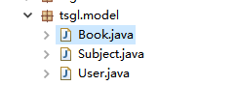
- Book.java
package tsgl.model;

import java.sql.Date;
import java.util.Arrays;
public class Book {
private String bookNo;
private Subject subject;
private String bName;
private String bLanguage;
private String bAddress;
private String bResume;
private Boolean bIsBorrowed;
private byte[] bPic;
private Date bPublishDate;
public String getBookNo() {
return bookNo;
}
public void setBookNo(String bookNo) {
this.bookNo = bookNo;
}
public Subject getSubject() {
return subject;
}
public void setSubject(Subject subject) {
this.subject = subject;
}
public String getbName() {
return bName;
}
public void setbName(String bName) {
this.bName = bName;
}
public String getbLanguage() {
return bLanguage;
}
public void setbLanguage(String bLanguage) {
this.bLanguage = bLanguage;
}
public String getbAddress() {
return bAddress;
}
public void setbAddress(String bAddress) {
this.bAddress = bAddress;
}
public String getbResume() {
return bResume;
}
public void setbResume(String bResume) {
this.bResume = bResume;
}
public Boolean getbIsBorrowed() {
return bIsBorrowed;
}
public void setbIsBorrowed(Boolean bIsBorrowed) {
this.bIsBorrowed = bIsBorrowed;
}
public byte[] getbPic() {
return bPic;
}
public void setbPic(byte[] bPic) {
this.bPic = bPic;
}
public Date getbPublishDate() {
return bPublishDate;
}
public void setbPublishDate(Date bPublishDate) {
this.bPublishDate = bPublishDate;
}
@Override
public String toString() {
return "Book [bookNo=" + bookNo + ", subject=" + subject + ", bName=" + bName + ", bLanguage=" + bLanguage
+ ", bAddress=" + bAddress + ", bResume=" + bResume + ", bIsBorrowed=" + bIsBorrowed + ", bPic="
+ Arrays.toString(bPic) + ", bPublishDate=" + bPublishDate + ", getBookNo()=" + getBookNo()
+ ", getSubject()=" + getSubject() + ", getbName()=" + getbName() + ", getbLanguage()=" + getbLanguage()
+ ", getbAddress()=" + getbAddress() + ", getbResume()=" + getbResume() + ", getbIsBorrowed()="
+ getbIsBorrowed() + ", getbPic()=" + Arrays.toString(getbPic()) + ", getbPublishDate()="
+ getbPublishDate() + ", getClass()=" + getClass() + ", hashCode()=" + hashCode() + ", toString()="
+ super.toString() + "]";
}

}

- Subject.java
package tsgl.model;

import java.util.Objects;

import tsgl.model.Subject;
public class Subject {
private Integer subjectId;
private String subjectName;

public Integer getSubjectId() {
return subjectId;
}

public void setSubjectId(Integer subjectId) {
this.subjectId = subjectId;
}

public String getSubjectName() {
return subjectName;
}

public void setSubjectName(String subjectName) {
this.subjectName = subjectName;
}

@Override
public String toString() {
return "Subject [subjectId=" + subjectId + ", subjectName=" + subjectName + ", getSubjectId()=" + getSubjectId()
+ ", getSubjectName()=" + getSubjectName() + ", hashCode()=" + hashCode() + ", getClass()=" + getClass()
+ ", toString()=" + super.toString() + "]";
}

@Override
public boolean equals(Object obj) {
if (obj instanceof Subject) {
final Subject other = (Subject) obj;
return other.subjectId.equals(this.subjectId);
}
return this==obj;
}

@Override
public int hashCode() {
int hash = 7;
hash=89*hash+Objects.hashCode(this.subjectId);
return hash;
}

}

- User.java
package tsgl.model;

import java.sql.Date;
public class User {
private Integer userId;
private String userName;
private String userPwd;
private Date userDatetime;
public Integer getUserId() {
return userId;
}
public void setUserId(Integer userId) {
this.userId = userId;
}
public String getUserName() {
return userName;
}
public void setUserName(String userName) {
this.userName = userName;
}
public String getUserPwd() {
return userPwd;
}
public void setUserPwd(String userPwd) {
this.userPwd = userPwd;
}
public Date getUserDatetime() {
return userDatetime;
}
public void setUserDatetime(Date userDatetime) {
this.userDatetime = userDatetime;
}
@Override
public String toString() {
return "User [userId=" + userId + ", userName=" + userName + ", userPwd=" + userPwd + ", userDatetime="
+ userDatetime + ", getUserId()=" + getUserId() + ", getUserName()=" + getUserName() + ", getUserPwd()="
+ getUserPwd() + ", getUserDatetime()=" + getUserDatetime() + ", getClass()=" + getClass()
+ ", hashCode()=" + hashCode() + ", toString()=" + super.toString() + "]";
}

}

- Tsgl.util
- SqlHelper
package tsgl.util;

import java.sql.*;
public class SqlHelper {
public static Connection connect(){
try{
Class.forName("com.mysql.jdbc.Driver");
String url = "jdbc:mysql://localhost:3306/tsgl?useUnicode=true&amp;characterEncoding=utf8";
Connection conn=DriverManager.getConnection(url,"root","aa17753466520");
return conn;
}catch(Exception e){
e.printStackTrace();
return null;
}
}

public static void closeResultSet(ResultSet rs){
try{
rs.close();
}catch(Exception e){
e.printStackTrace();
}
}

public static void closePreparedStatement(PreparedStatement ps){
try{
ps.close();
}catch(Exception e){
e.printStackTrace();
}
}
public static void closeConnection(Connection conn){
try{
conn.close();
}catch(Exception e){
e.printStackTrace();
}
}
}

- TestSqlHelper
package tsgl.util;

import java.sql.*;
import javax.swing.JOptionPane;
public class TestSqlHelper {
public static void main(String[] args) {
Connection conn=SqlHelper.connect();
if(conn!=null){
JOptionPane.showMessageDialog(null, "数据库连接成功!");
SqlHelper.closeConnection(conn);
}else{
JOptionPane.showMessageDialog(null, "数据库连接失败!");
}
}
}

- Tsgl.view
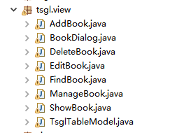
1.package tsgl.view;

- import java.awt.event.*;
- import java.io.File;
- import java.text.ParseException;
- import java.text.SimpleDateFormat;
- import javax.swing.*;
- import javax.swing.filechooser.FileNameExtensionFilter;
- import tsgl.dao.*;
- import tsgl.model.*;
- public class AddBook extends BookDialog implements ActionListener{
- public AddBook(){
- this.setTitle("添加图书数据窗口");
- this.addActionListener();
- }

- private void addActionListener(){
- btnOk.addActionListener(this);
- btnCancel.addActionListener(this);
- }

- @Override
- public void actionPerformed(ActionEvent e) {
- if((e.getSource()).equals(btnOk)) {
- try {
- SubjectDao subjectdao=new SubjectDao();
- Subject subject=subjectdao.findSubject((String)comSubject.getSelectedItem());
- Book b=new Book();
- b.setBookNo(txtNo.getText().trim());
- b.setSubject(subject);
- b.setbName(txtName.getText().trim());
- b.setbLanguage(LanguageM.isSelected()?"中":"英");
- SimpleDateFormat date=new SimpleDateFormat("yyyy-mm-dd");
- b.setbPublishDate(new java.sql.Date(date.parse(txtPublishDate.getText()).getTime()));
- b.setbIsBorrowed(isBorrowed.isSelected());
- b.setbAddress(txtAddress.getText().trim());
- b.setbResume(txtResume.getText());
- BookDao bdao=new BookDao();
- if(bdao.addBook(b)){
- JOptionPane.showMessageDialog(null, "添加图书成功");
- dispose();
- }else{
- JOptionPane.showMessageDialog(null, "添加图书失败");
- txtNo.requestFocus();
- }
- } catch (ParseException ex) {
- JOptionPane.showMessageDialog(null, "保存数据出现异常");
- }
- }else{
- dispose();
- }
- }

- }
2.package tsgl.view;

import java.awt.*;
import java.io.*;
import javax.swing.*;
import tsgl.dao.*;
import tsgl.model.*;
public class BookDialog extends JDialog {
protected String[] head={"书号","科目","书名","语言","出版日期","借走","储存地址"};
protected JLabel[] labHead = new JLabel[7];
protected JComboBox comSubject=new JComboBox();
protected JRadioButton LanguageM=new JRadioButton("中");
protected JRadioButton LanguageF=new JRadioButton("英");
protected JTextField txtNo=new JTextField(5);
protected JTextField txtName=new JTextField(10);
protected JTextField txtPublishDate=new JTextField(10);
protected JTextField txtAddress=new JTextField(25);
protected JCheckBox isBorrowed=new JCheckBox();
protected JTextArea txtResume = new JTextArea();
// protected JPanel panelPic=new JPanel();
protected JButton btnOk=new JButton("保存");
protected JButton btnCancel=new JButton("取消");
protected String filename;
protected Container con;
public BookDialog(){
con=this.getContentPane();
ButtonGroup group=new ButtonGroup();
group.add(LanguageM);
group.add(LanguageF);
LanguageM.setSelected(true);
this.loadSubject();
this.loadLayout();
this.loadResume();
this.loadButtom();
this.setTitle("图书窗口");
setSize(600, 500);//设置大小
setLocation(100, 100);//设置位置
setDefaultCloseOperation(JDialog.DISPOSE_ON_CLOSE); //设置关闭行为
setVisible(true);
}

public final void loadSubject(){
SubjectDao dao=new SubjectDao();
java.util.List<Subject> list=dao.findSubjects();
for(Subject s:list) {
comSubject.addItem(s.getSubjectName());
}
}

public final void loadResume(){
JPanel center=new JPanel(new FlowLayout(FlowLayout.LEFT));
center.add(new JLabel("简介"));
center.add(new JScrollPane(txtResume));
txtResume.setColumns(40);
txtResume.setRows(5);
con.add(center,"Center");
}
public final void loadButtom(){
JPanel bottom=new JPanel();
bottom.add(btnOk);
bottom.add(btnCancel);
con.add(bottom,"South");
}
public final void loadLayout(){

JPanel top=new JPanel(new BorderLayout());
JPanel topRight=new JPanel();

JPanel topLeft=new JPanel(new GridLayout(7,1));
JPanel[] p=new JPanel[7];
for(int i=0;i<7;i++){
labHead[i]= new JLabel(head[i]+":");
p[i]=new JPanel(new FlowLayout(FlowLayout.LEFT));
p[i].add(labHead[i]);
topLeft.add(p[i]);
}
p[0].add(txtNo);
p[1].add(comSubject);
p[2].add(txtName);
p[3].add(LanguageM);
p[3].add(LanguageF);
p[4].add( txtPublishDate);
p[5].add(isBorrowed);
p[6].add(txtAddress);
top.add(topLeft, "Center");
top.add(topRight,"East");
con.add(top,"North");
}

}
3.package tsgl.view;
import java.awt.event.*;
import java.text.ParseException;
import java.text.SimpleDateFormat;
import javax.swing.JOptionPane;
import tsgl.dao.*;
import tsgl.model.*;
public class DeleteBook extends BookDialog implements ActionListener{

public DeleteBook(String bNo){
btnOk.addActionListener(this);
btnCancel.addActionListener(this);
this.setTitle("删除图书数据窗口");

}

@Override
public void actionPerformed(ActionEvent e) {
if((e.getSource()).equals(btnOk)) {
try {
SubjectDao subjectdao=new SubjectDao();
Subject subject=subjectdao.findSubject((String)comSubject.getSelectedItem());
Book b=new Book();
b.setBookNo(txtNo.getText().trim());
//b.setSubject(subject);
//b.setbName(txtName.getText().trim());
// b.setbLanguage(LanguageM.isSelected()?"男":"女");
SimpleDateFormat date=new SimpleDateFormat("yyyy-mm-dd");
b.setbPublishDate(new java.sql.Date(date.parse(txtPublishDate.getText()).getTime()));
// b.setbIsBorrowed(isBorrowed.isSelected());
// b.setbAddress(txtAddress.getText().trim());
// b.setbResume(txtResume.getText());
BookDao bookDao=new BookDao();
boolean A = bookDao.deleteBook(b.getBookNo());
if(A){
JOptionPane.showMessageDialog(null, "删除图书数据成功");
dispose();
}else{
JOptionPane.showMessageDialog(null, "删除图书数据失败");
txtNo.requestFocus();
}
} catch (ParseException ex) {
JOptionPane.showMessageDialog(null, "保存数据出现异常");
}
}else{
dispose();
}
}

}
4.package tsgl.view;

import java.awt.event.*;
import java.text.ParseException;
import java.text.SimpleDateFormat;
import javax.swing.JOptionPane;
import tsgl.dao.*;
import tsgl.model.*;

public class EditBook extends BookDialog implements ActionListener{
public EditBook(String bNo){
btnOk.addActionListener(this);
btnCancel.addActionListener(this);
this.setTitle("修改图书数据窗口");
loadData(bNo);
txtNo.setEditable(false);

}
public final void loadData(String bNo){
BookDao bookDao=new BookDao();
Book b=bookDao.findBook(bNo);
txtNo.setText(b.getBookNo());
comSubject.setSelectedItem(b.getSubject().getSubjectName());
txtName.setText(b.getbName());
LanguageM.setSelected(b.getbLanguage().equals("中"));
txtPublishDate.setText(b.getbPublishDate().toString());
isBorrowed.setSelected(b.getbIsBorrowed());
txtAddress.setText(b.getbAddress());
}
@Override
public void actionPerformed(ActionEvent e) {
if((e.getSource()).equals(btnOk)) {
try {
SubjectDao subjectdao=new SubjectDao();
Subject subject=subjectdao.findSubject((String)comSubject.getSelectedItem());
Book b=new Book();
b.setBookNo(txtNo.getText().trim());
b.setSubject(subject);
b.setbName(txtName.getText().trim());
b.setbLanguage(LanguageM.isSelected()?"中":"英");
SimpleDateFormat date=new SimpleDateFormat("yyyy-mm-dd");
b.setbPublishDate(new java.sql.Date(date.parse(txtPublishDate.getText()).getTime()));
b.setbIsBorrowed(isBorrowed.isSelected());
b.setbAddress(txtAddress.getText().trim());
b.setbResume(txtResume.getText());
BookDao bdao=new BookDao();
if(bdao.editBook(b)){
JOptionPane.showMessageDialog(null, "修改图书数据成功");
dispose();
}else{
JOptionPane.showMessageDialog(null, "修改图书数据失败");
txtNo.requestFocus();
}
} catch (ParseException ex) {
JOptionPane.showMessageDialog(null, "保存数据出现异常");
}
}else{
dispose();
}
}

}
5.package tsgl.view;

import java.awt.*;
import java.awt.event.*;
import javax.swing.*;
import java.util.List;
import tsgl.dao.*;
import tsgl.model.Book;
public class FindBook extends JFrame implements ActionListener{
final static Integer PAGE_SIZE=5;
BookDao bookDao=new BookDao();
JTable table=new JTable();
String[] head={"书号","书名","语言","出版日期","借走","储存地址"};
JTextField txtName=new JTextField(6);
JButton btnFind=new JButton("查找");
JButton btnFirst=new JButton("首页");
JButton btnPrev=new JButton("上一页");
JButton btnNext=new JButton("下一页");
JButton btnLast=new JButton("页尾");
JLabel labPageNo=new JLabel("ssss");
String userName="";
int pageCount=0,pageNo=0;
int count;
JPanel bottom=new JPanel(new BorderLayout());
public FindBook() {
Container con=this.getContentPane();
JPanel top=new JPanel();
top.add(new JLabel("书名")); top.add(txtName); top.add(btnFind);
con.add(top,"North");
con.add(new JScrollPane(table),"Center");
JPanel btn=new JPanel();
btn.add(btnFirst);btn.add(btnPrev);btn.add(btnNext);btn.add(btnLast);
btn.add(labPageNo);
con.add(bottom,"South");
bottom.add(btn,"North");

count=bookDao.findCount(userName);//查询的记录总数
if(count>0){
pageNo=1;
pageCount=count/PAGE_SIZE+(count%PAGE_SIZE>0?1:0);
}
this.setState();
this.loadData(userName,pageNo);//
this.setTitle("查询图书窗口");
this.setSize(450,270);
this.setVisible(true);
this.addActionListener();
}
private void addActionListener(){
//给按钮注册动作监听器
btnFind.addActionListener(this);
btnFirst.addActionListener(this);
btnPrev.addActionListener(this);
btnNext.addActionListener(this);
btnLast.addActionListener(this);
//给表格注册鼠标监听器
table.addMouseListener(new MouseAdapter(){
@Override
public void mouseClicked(MouseEvent e){
int row=table.getSelectedRow();
if(row>=0){
String bNo=table.getValueAt(row, 0).toString();
ShowBook showBook = new ShowBook(bNo);
}
}
});
}
public final void loadData(String bName, int pageNo){
List<Book> list =bookDao.findBooks(bName, pageNo,PAGE_SIZE);
Object[][] data=convert(list);
table.setModel(new TsglTableModel(head,data));
}

private Object[][] convert(List<Book> list){
Object[][] data=new Object[list.size()][6];
int i=0;
for(Book b:list){
data[i][0]=b.getBookNo();
data[i][1]=b.getbName();
data[i][2]=b.getbLanguage();
data[i][3]=b.getbPublishDate();
data[i][4]=b.getbIsBorrowed();
data[i][5]=b.getbAddress();
i++;
}
return data;
}
@Override
public void actionPerformed(ActionEvent e) {
if((e.getSource()).equals(btnFind)) {
userName=txtName.getText().trim();
count=bookDao.findCount(userName);//查询的记录总数
if(count>0){
pageNo=1;
pageCount=count/PAGE_SIZE+(count%PAGE_SIZE>0?1:0);
}else{
pageNo=0;
pageCount=0;
}

}else if((e.getSource()).equals(btnFirst))
pageNo= 1;
else if((e.getSource()).equals(btnLast))
pageNo= pageCount;
else if((e.getSource()).equals(btnNext)&&pageCount>pageNo)
pageNo++;
else if((e.getSource()).equals(btnPrev)&&pageNo>1)
pageNo--;

this.loadData(userName, pageNo);
setState();
}

private void setState() {
labPageNo.setText(pageNo+"/"+pageCount);
if(pageNo==pageCount){
btnLast.setEnabled(false);
btnNext.setEnabled(false);
}else{
btnLast.setEnabled(true);
btnNext.setEnabled(true);
}
if(pageNo<=1){
btnFirst.setEnabled(false);
btnPrev.setEnabled(false);
}else{
btnFirst.setEnabled(true);
btnPrev.setEnabled(true);
}
}
}
6.package tsgl.view;

import java.awt.event.ActionEvent;
import java.awt.event.MouseAdapter;
import java.awt.event.MouseEvent;

import javax.swing.JButton;
import javax.swing.JPanel;

import tsgl.model.Book;
import tsgl.dao.BookDao;
public class ManageBook extends FindBook{
JButton btnAdd=new JButton("添加");
JButton btnEdit=new JButton("修改");
JButton btnDelete=new JButton("删除");
JPanel updata=new JPanel();
String bNo;
public ManageBook(){
updata.add(btnAdd);
updata.add(btnEdit);
updata.add(btnDelete);
bottom.add(updata);
this.setTitle("图书管理窗口");
btnAdd.addActionListener(this);
btnEdit.addActionListener(this);
btnDelete.addActionListener(this);
table.addMouseListener(new MouseAdapter(){
@Override
public void mousePressed(MouseEvent e){
int row=table.getSelectedRow();
if(row>=0){
bNo=table.getValueAt(row, 0).toString();
}
}
});

}
@Override
public void actionPerformed(ActionEvent e) {
super.actionPerformed(e);
if((e.getSource()).equals(btnAdd)){
AddBook add=new AddBook();
}else if((e.getSource()).equals(btnEdit)){
EditBook edit=new EditBook(bNo);

}else if((e.getSource()).equals(btnDelete)){
BookDao book = new BookDao();
book.deleteBook(bNo);
//DeleteBook edit=new DeleteBook(bNo);

}

}
}
7.package tsgl.view;

import java.awt.*;
import javax.swing.*;
import tsgl.dao.*;
import tsgl.model.Book;
public class ShowBook extends JDialog{
String[] head={"书号","科目","书名","语言","出版日期","借走","储存地址"};
JLabel[] labHead = new JLabel[10];
JLabel[] txt=new JLabel[7];
JTextArea txtResume = new JTextArea();

JPanel bottom=new JPanel();
public ShowBook(String bNo) {
Container container=this.getContentPane();

JPanel top=new JPanel(new BorderLayout());
JPanel topLeft=new JPanel(new GridLayout(7,1));
top.add(topLeft, "Center");
container.add(top,"North");

JPanel[] p=new JPanel[7];
for(int i=0;i<7;i++){
labHead[i]= new JLabel(head[i]+":");
txt[i]=new JLabel();
p[i]=new JPanel(new FlowLayout(FlowLayout.LEFT));
p[i].add(labHead[i]);
p[i].add(txt[i]);
topLeft.add(p[i]);
}

JPanel center=new JPanel(new FlowLayout(FlowLayout.LEFT));
center.add(new JLabel("简介"));
center.add(new JScrollPane(txtResume));
container.add(center,"Center");
container.add(bottom,"South");

txtResume.setEditable(false);
txtResume.setColumns(30);
txtResume.setRows(5);

this.loadData(bNo);
this.setTitle("查询图书窗口");
this.setSize(360,360);
this.setVisible(true);
}

public final void loadData(String bNo){
BookDao bookDao=new BookDao();
Book b=bookDao.findBook(bNo);
txt[0].setText(b.getBookNo());
txt[1].setText(b.getSubject().getSubjectName());
txt[2].setText(b.getbName());
txt[3].setText(b.getbLanguage());
txt[4].setText(b.getbPublishDate().toString());
txt[5].setText(b.getbIsBorrowed()?"是":"否");
txt[6].setText(b.getbAddress());
}

}

- View
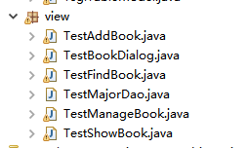
1.TestAddBook.java
package view;

import tsgl.view.AddBook;
public class TestAddBook {
public static void main(String[] args) {
AddBook student = new AddBook();
}
}
2..TestBookDialog.java

package view;

import tsgl.view.BookDialog;
public class TestBookDialog {
public static void main(String[] args) {
BookDialog book = new BookDialog();
}
}
3..TestFindBook.java
package view;

import tsgl.view.FindBook;
public class TestFindBook {
public static void main(String[] args) {
FindBook findBook = new FindBook();

}
}
4..TestMajorDao.java
package view;

import java.util.List;
import tsgl.dao.SubjectDao;
import tsgl.model.Subject;
public class TestMajorDao {
public static void main(String[] args) {
SubjectDao dao=new SubjectDao();
System.out.println("\n测试findSubjects()");
List<Subject> list=dao.findSubjects();
for(Subject s:list)
System.out.println(s);

System.out.println("\n测试findSubject()");
Subject m=dao.findSubject("数学");
System.out.println(m.getSubjectId());
System.out.println(m);

}
}

5..TestManageBook.java
package view;

import tsgl.view.*;
public class TestManageBook {
public static void main(String[] args) {
ManageBook book = new ManageBook();
}
}

6..TestShowBook.java
package view;

import tsgl.view.ShowBook;
public class TestShowBook {
public static void main(String[] args) {
ShowBook showBook = new ShowBook("997");
}

}

