R6 Growing Season Index Calibration

Growing Season Index Live Woody Fuel Moisture Calibration to Sampled Field Data

Brian Maier, 10/19/2022

# Purpose

Calibration of the Growing Season Index (GSI) for Fire Danger Rating Area (FDRA) Special Interest Group (SIG) Remote Automated Weather Stations (RAWS) to sampled fuel moisture data. This effort focuses on GSI calibration to sampled Live Woody fuel moisture in the Great Basin and Columbia Basin FDRA.

# Data

Fuel moisture data from the National Fuel Moisture Database (NFMD) was downloaded via the Wildland Fire Assessment System (WFAS) *Download Fuel Moisture Data* option. Representative sample data sites were associated with FDRA.

Weather files, in FW13 format, were retrieved from Cognos for FDRA SIG stations. Gap filled data was not used in this effort to fill data gaps or append additional historic data. Hourly weather with solar radiation data from Cognos starts in 2014, weather data from 2015-2020 was used for calibration for Oregon and 2015-2021 for Washington. The end years were chosen based on sparse data i.e., not much NFMD data for Oregon in 2021 and not much data before 2020 in Washington.

# Methods

A machine learning approach was utilized, or at the very least a machine was used, to find the optimal combination of GSI inputs to match sampled data. This was accomplished using Python, initially, to iterate through every possible combination of upper and lower GSI inputs within a defined range. Input ranges were informed by prior manual machinations and limited by computing power and iteration time.

Both the Maximum Vapor Pressure Deficit (VPD) and Precipitation Enhanced versions of GSI were tested individually and together for several stations across Oregon and Washington. Results using either or both versions produced lower scores and so precipitation was dropped from the initial GSI calculation and Average VPD was utilized.

After calibrating several stations daylength was also dropped from the process and only VPD and minimum relative humidity were derived from the machine process and the daylength upper limit was used to fine tune, generally to flatten out the tail of the season, by adding typically two to four hours to the default, more hours were required as the latitude increased. This process seemed to produce the best results in this study area.

# Results

Results by FDOP are contained in the following Appendices.

# Appendices

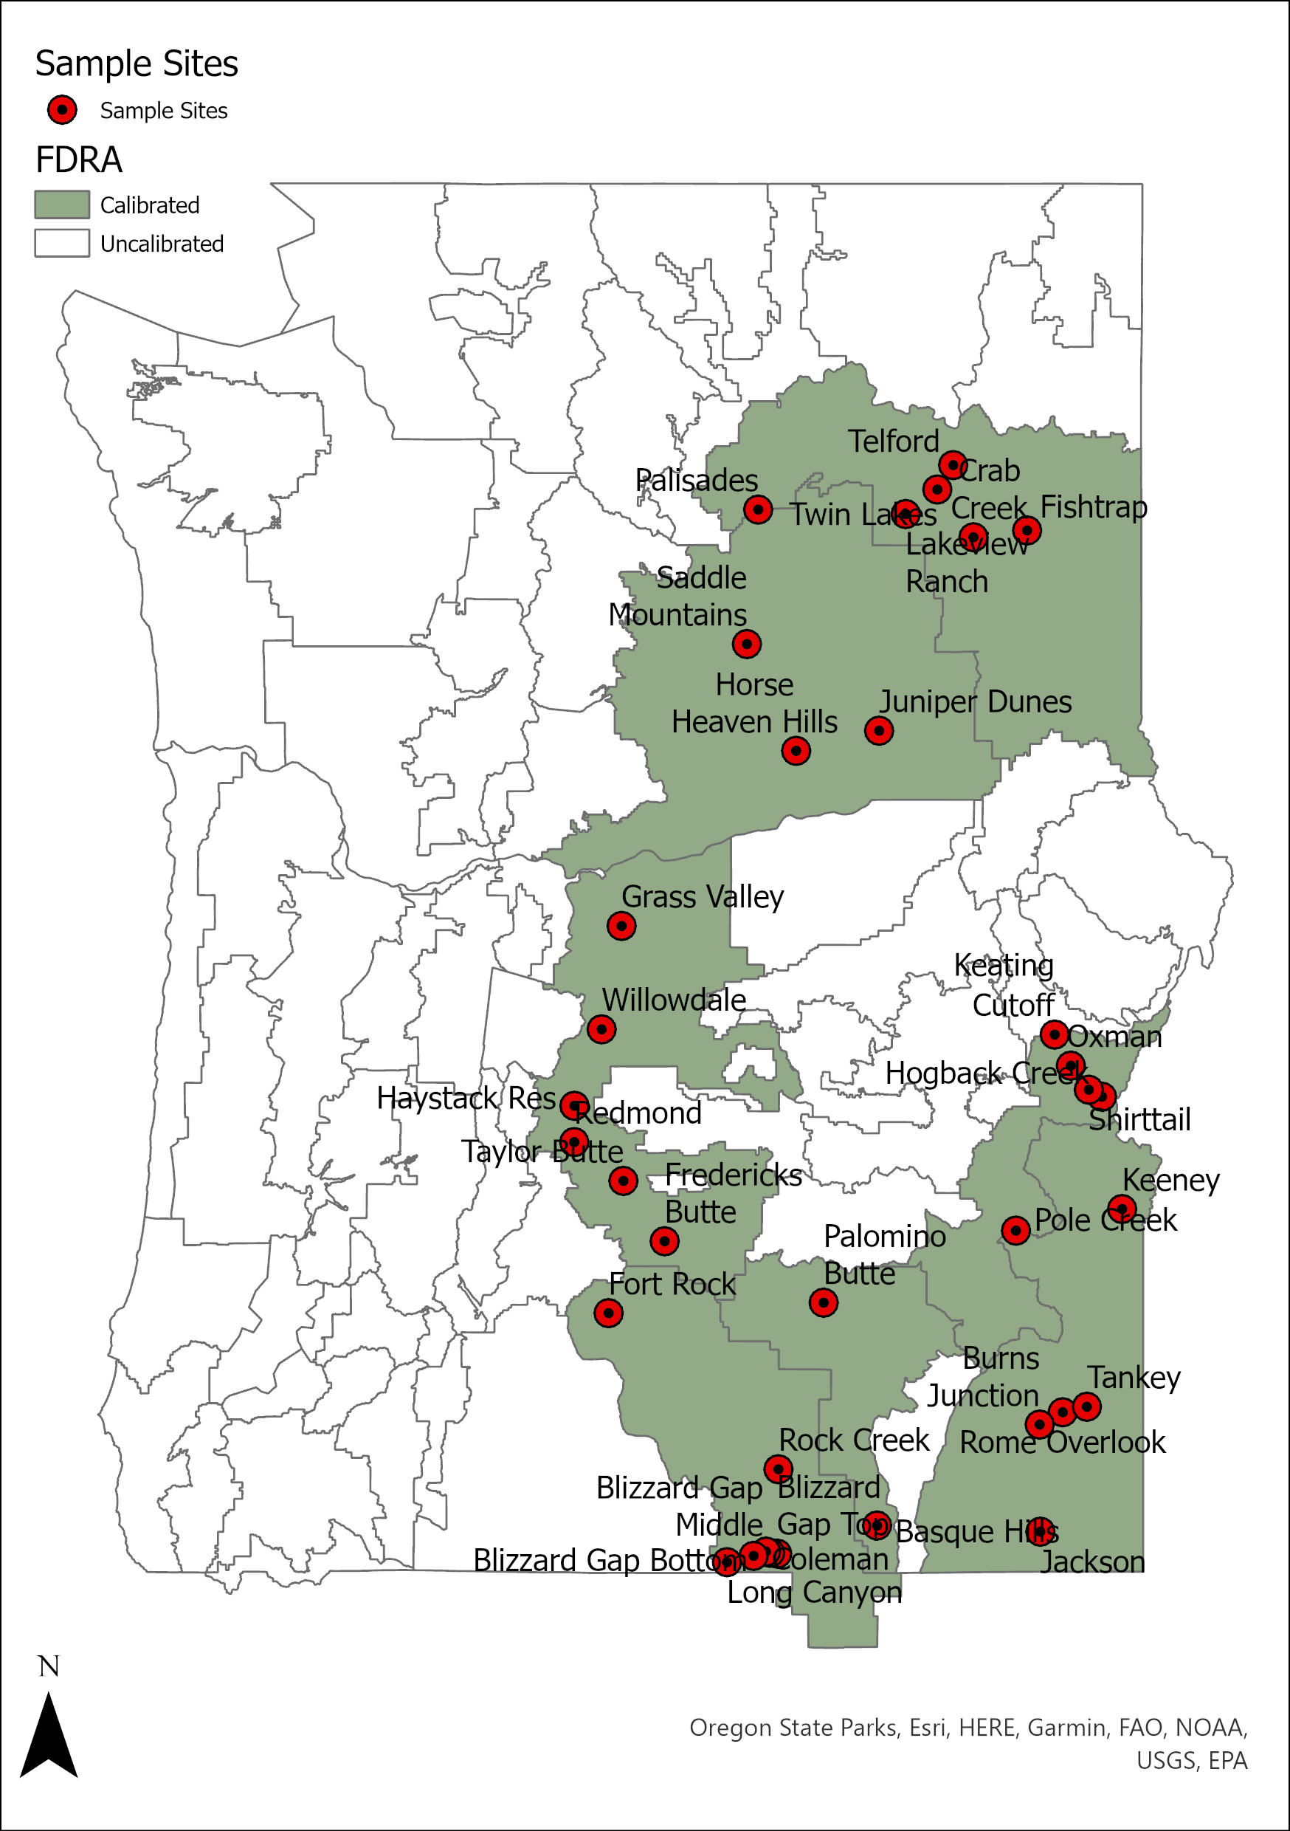

## OR Central Oregon FDOP

### High Desert FDRA

#### Live Woody Adjusted GSI Settings

|  |  |  |  |  |  |  |  |
| --- | --- | --- | --- | --- | --- | --- | --- |
| FDRA | RAWS | TMinLow | TMinUp | VPDAvgLow | VPDAvgUp | DaylLow | DaylUp |
| High Desert | 350915 | -10 | 13 | 1,250 | 2,250 | 36,000 | 50,400 |
| 352107 | -8 | 11 | 1,250 | 2,000 | 36,000 | 50,400 |
| 353428 | -2 | 3 | 750 | 2,750 | 36,000 | 50,400 |

#### GSI Default vs. GSI Adjusted

###### 350915 – North Pole

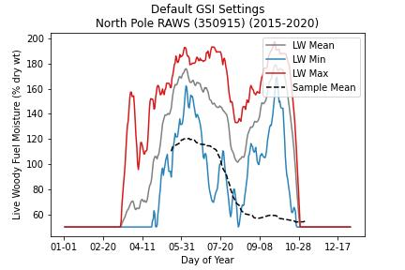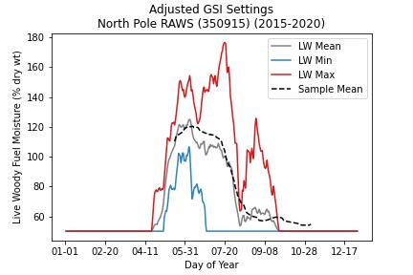

###### 352107 – Haystack

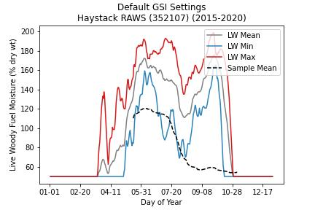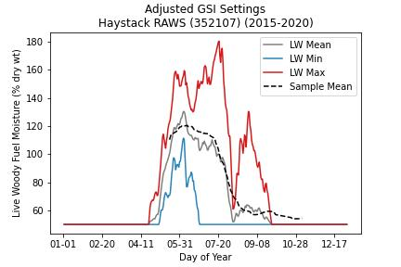

###### 353428 – Browns Well

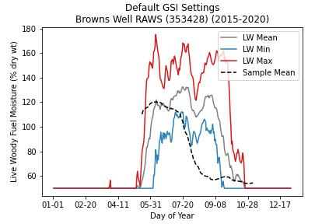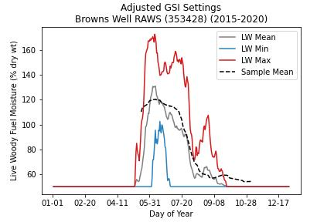

#### Sample Data

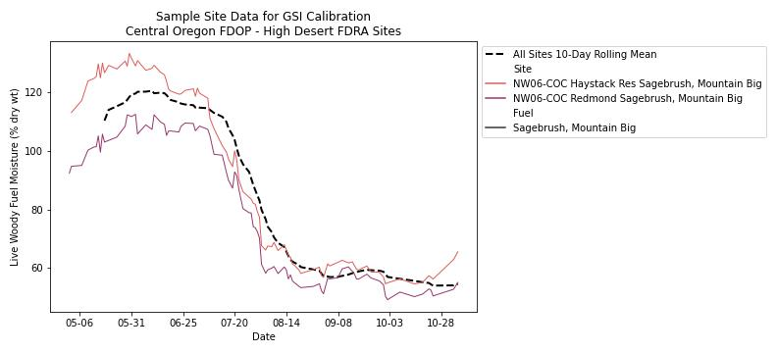

## OR South Central Oregon FDOP

### Desert FDRA

#### Live Woody Adjusted GSI Settings

|  |  |  |  |  |  |  |  |
| --- | --- | --- | --- | --- | --- | --- | --- |
| FDRA | RAWS | TMinLow | TMinUp | VPDAvgLow | VPDAvgUp | DaylLow | DaylUp |
| Desert | 353406 | -20 | 1 | 1,000 | 2,750 | 36,000 | 50,400 |
| 353424 | -14 | 1 | 1,000 | 3,250 | 36,000 | 50,400 |

#### GSI Default vs. GSI Adjusted

###### 353406 – Fort Rock

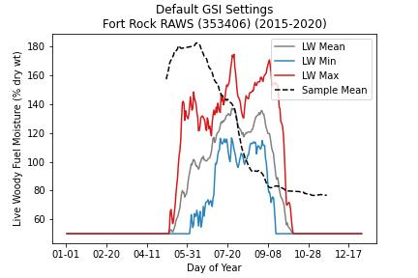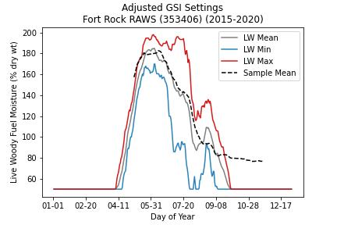

###### 353424 – Rock Creek

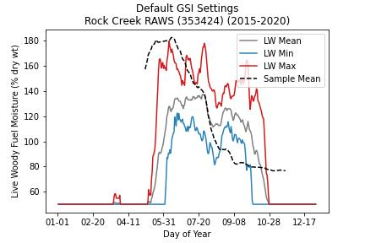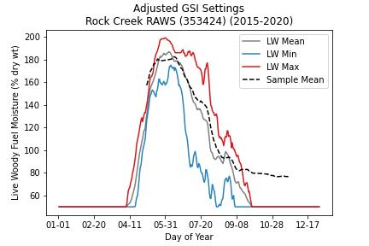

#### Sample Data

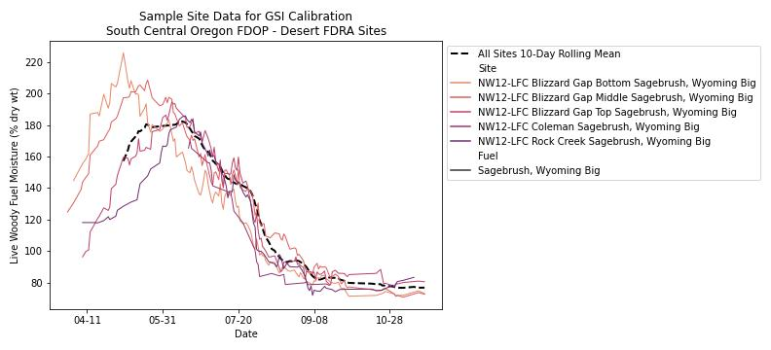

## OR Southeast Oregon FDOP

### Grasslands FDRA

#### Live Woody Adjusted GSI Settings

|  |  |  |  |  |  |  |  |
| --- | --- | --- | --- | --- | --- | --- | --- |
| FDRA | RAWS | TMinLow | TMinUp | VPDAvgLow | VPDAvgUp | DaylLow | DaylUp |
| Grasslands | 353612 | -20 | 1 | 750 | 4,750 | 36,000 | 46,800 |
| 353613 | -20 | 1 | 500 | 4,250 | 36,000 | 46,800 |
| 353614 | -20 | 1 | 500 | 5,000 | 36,000 | 46,800 |
| 353618 | -12 | 1 | 1,000 | 5,000 | 36,000 | 46,800 |

#### GSI Default vs. GSI Adjusted

###### 353612 – Grass Mountain

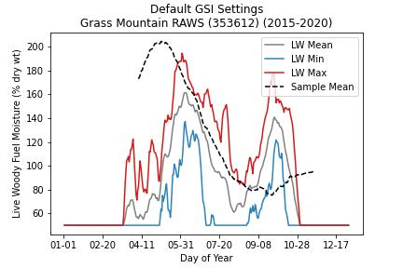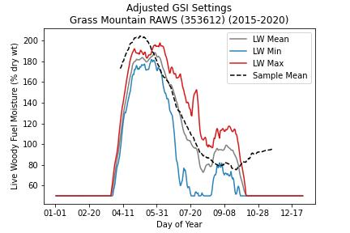

###### 353613 – Kelsey Butte

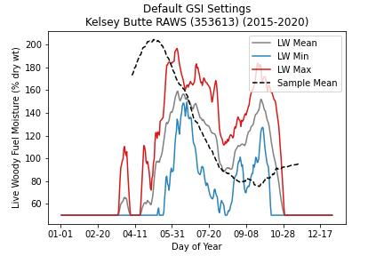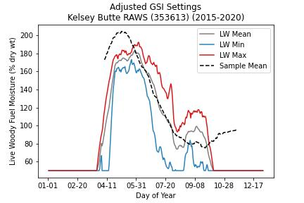

###### 353614 – OwyRid

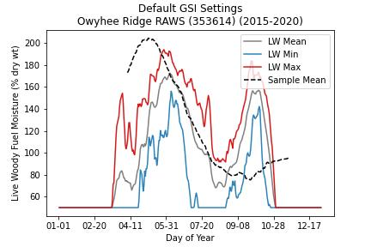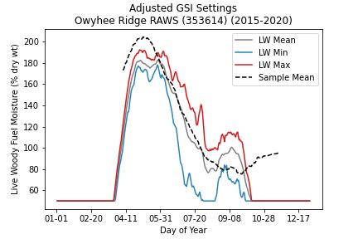

###### 353618 – Alkali Flat

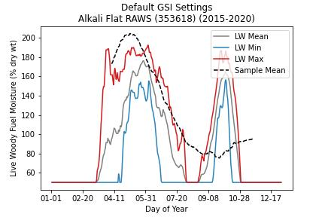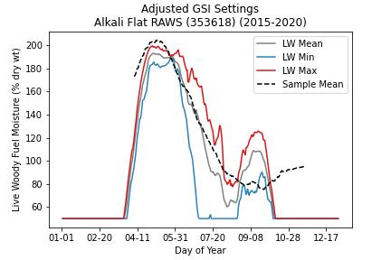

#### Sample Data

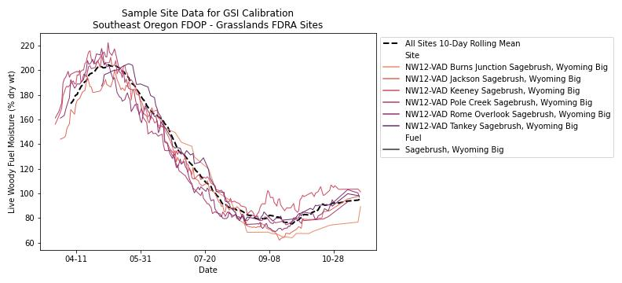

### High Desert FDRA

#### Live Woody Adjusted GSI Settings

|  |  |  |  |  |  |  |  |
| --- | --- | --- | --- | --- | --- | --- | --- |
| FDRA | RAWS | TMinLow | TMinUp | VPDAvgLow | VPDAvgUp | DaylLow | DaylUp |
| Burns High Desert | 353520 | --14 | 7 | 1,750 | 2,750 | 36,000 | 46,800 |
| 353521 | -16 | 7 | 1,000 | 3,750 | 36,000 | 50,400 |
| 353525 | -12 | 1 | 750 | 3,000 | 36,000 | 50,400 |

#### GSI Default vs. GSI Adjusted

###### 353520 – Basque Hills

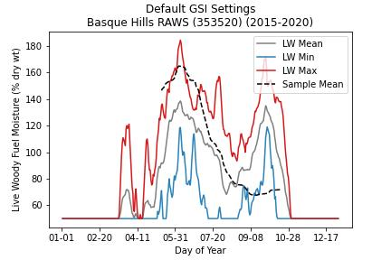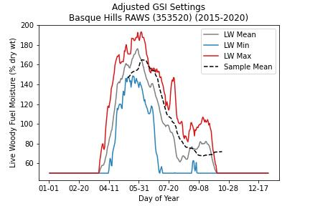

###### 353521 – P Hill

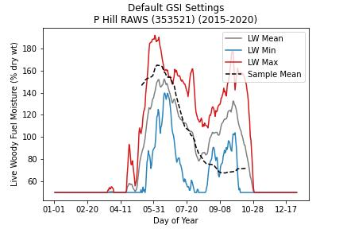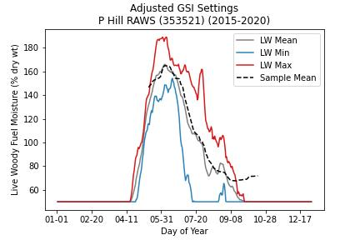

###### 353525 – Foster Flat

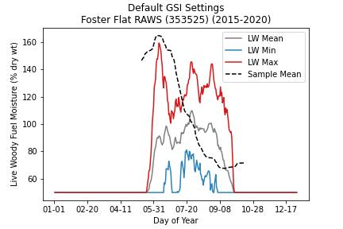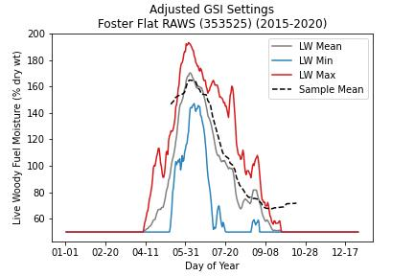

#### Sample Data

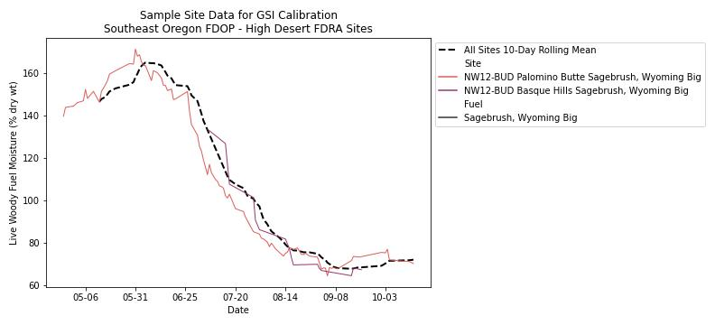

### Juniper FDRA

#### Live Woody Adjusted GSI Settings

|  |  |  |  |  |  |  |  |
| --- | --- | --- | --- | --- | --- | --- | --- |
| FDRA | RAWS | TMinLow | TMinUp | VPDAvgLow | VPDAvgUp | DaylLow | DaylUp |
| Juniper | 353420 | -10 | 1 | 750 | 5,000 | 36,000 | 46,800 |
| 353522 | -20 | 1 | 1,000 | 3,750 | 36,000 | 50,400 |
| 353613 | -20 | 1 | 1,000 | 3,750 | 36,000 | 46,800 |

#### GSI Default vs. GSI Adjusted

###### 352420 – Morgan Mountain

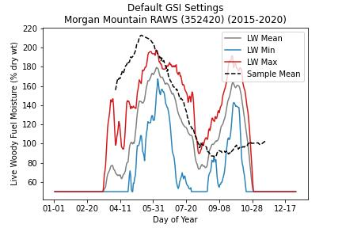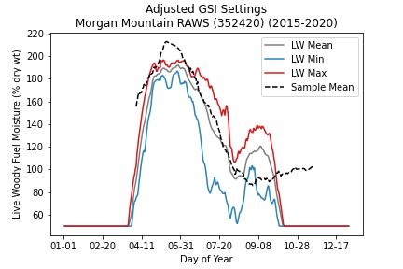

###### 353522 – Bald Mountain

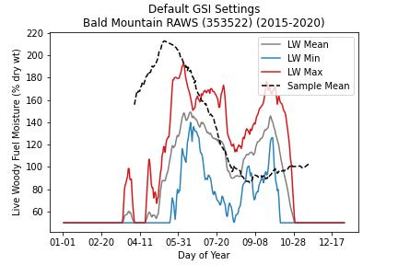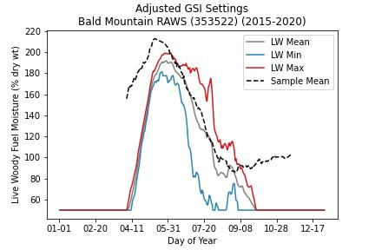

###### 353613 – Kelsey Butte

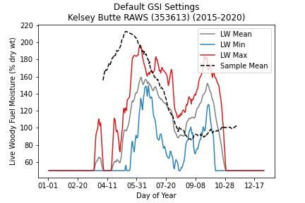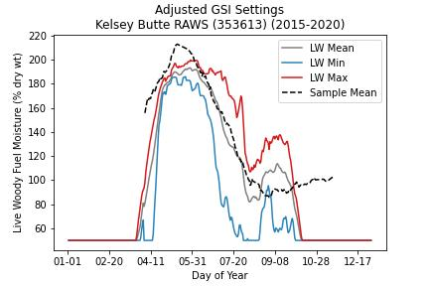

#### Sample Data

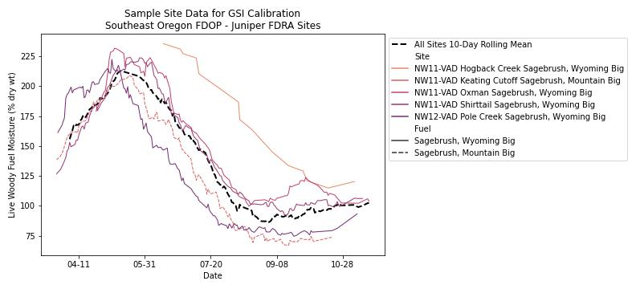

## WA Eastern Washington FDOP

### Upper Basin FDRA

#### Live Woody Adjusted GSI Settings

|  |  |  |  |  |  |  |  |
| --- | --- | --- | --- | --- | --- | --- | --- |
| FDRA | RAWS | TMinLow | TMinUp | VPDAvgLow | VPDAvgUp | DaylLow | DaylUp |
| Lower Basin | 453601 | -20 | 1 | 1,250 | 4,000 | 36,000 | 54,000 |
| 453002 | -20 | 1 | 1,250 | 4,250 | 36,000 | 54,000 |

#### GSI Default vs. GSI Adjusted

###### 453601 – Escure

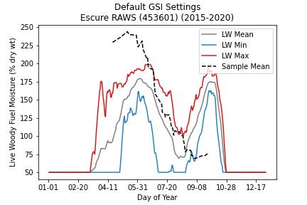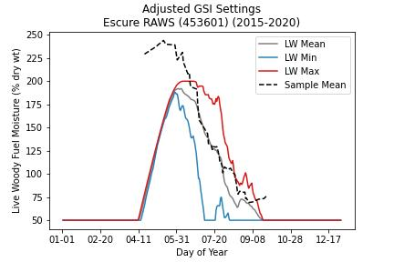

###### 453002 – Spring Canyon

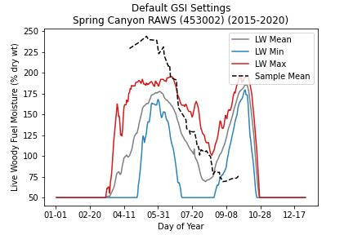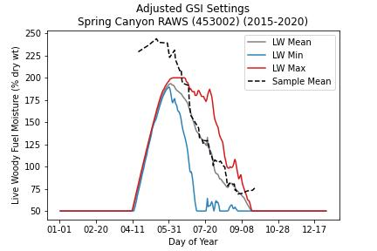

#### Sample Data

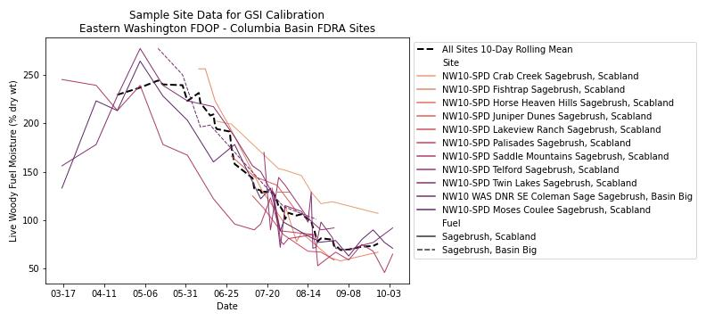

### Lower Basin FDRA

#### Live Woody Adjusted GSI Settings

|  |  |  |  |  |  |  |  |
| --- | --- | --- | --- | --- | --- | --- | --- |
| FDRA | RAWS | TMinLow | TMinUp | VPDAvgLow | VPDAvgUp | DaylLow | DaylUp |
| Lower Basin | 452701 | -20 | 1 | 1,750 | 3,500 | 36,000 | 54,000 |
| 453102 | -20 | 1 | 1,500 | 2,750 | 36,000 | 54,000 |

#### GSI Default vs. GSI Adjusted

###### 452701 – Saddle Mountain

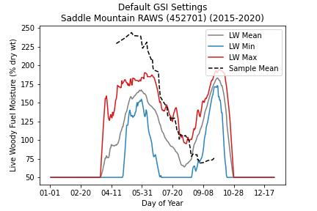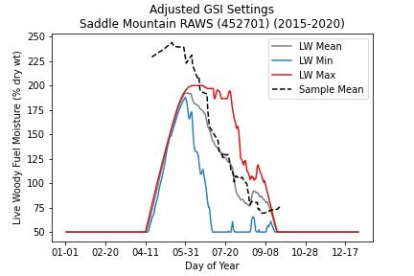

###### 453102 – Columbia NWR

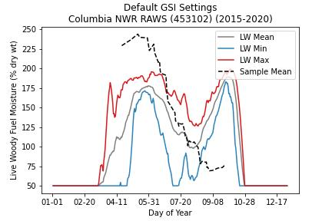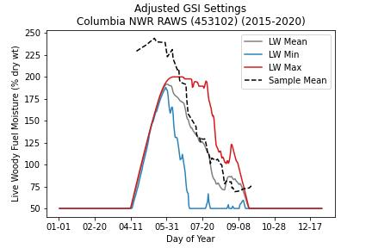

#### Sample Data

