PDF Patcher

PDF Patcher

User Manual (Ver：0.4.2 )

2022年1月4日

Author: W. Jordan

Email: wmjordan@163.com

Table of Contents

1. Software Function Introduction

2. Usage License and Authorization Agreement

3. Software installation and usage environment

3.1. Operating environment

3.2. How to install and run the program

3.3. Uninstallation methods

4. Detailed function introduction

4.1. Program interface

4.2. Processing documents

4.2.1. List of files

4.2.2. Adding files

4.2.3. Adjusting the processing order of files

4.2.4. Deleting file items

4.2.5. Modifying the properties of the output file

4.2.6. Switching patch and rename modes

4.2.7. Output files, information file paths and execution buttons

4.3. "Standalone patch" processing mode

4.3.1. Steps for patch modification documentation

4.3.2. Batch operation output file naming rules

4.4. Advanced patch function (export, import information file) 10

4.4.1. Exporting information files 10

4.4.2. About the "Information document" 10

4.4.3. Importing information files 11

4.4.4. Batch processing method 11

4.4.5. Information file options 12

4.5. PDF document options 14

4.5.1. Page Size 14

4.5.2. Reading method 15

4.5.3. Compression cleanup 16

4.5.4. Document properties 17

4.5.5. Page labels 18

4.5.6. Replace fonts 20

4.6. Renaming processing modes 21

4.7. Merging documents 22

4.7.1. Operation method 22

4.7.2. Known issues 26

4.8. Merge document options 26

4.8.1. Page layout 26

4.8.2. Bookmarks 27

4.9. Automatic bookmark generation 28

4.9.1. Operation steps 29

4.9.2. Title recognition options 30

4.9.3. Text filtering options 30

4.9.4. Advanced filter processing options 31

4.9.5. Other options 32

4.10. Editing bookmark files 32

4.10.1. Overview of operation steps 34

4.10.2. Basic editing functions 34

4.10.3. "Modify" menu function 39

4.10.4. Searching and replacing bookmarked text 40

4.11. Recognizing image text 43

4.11.1. Steps for recognizing image text operations 44

4.11.2. Steps for writing in recognition results 44

4.11.3. Identification options 44

4.11.4. Identify directory pages as simple bookmark files 45

4.12. Extracting images 45

4.12.1. Operation steps 46

4.12.2. Extraction options 46

4.12.3. File naming rules 47

4.13. Extracting pages 47

4.14. Document Structure Probe 48

4.15. Global options 50

4.16. Output information 50

5. Application examples 52

5.1. Cancel the display ratio of bookmarks and page links 52

5.2. Disabling bookmarks in the default expanded state 53

5.2.1. Modify the bookmark open status of multiple PDF files with independent patch function 53

5.2.2. Use the Bookmark Editor to modify the bookmark opening status of a single PDF file 53

5.3. Uniform page size 54

5.4. Adjusting the double-page reading order of vertical documents 55

5.5. Disable the behavior of setting the "fit to page" display when opening a document 55

5.6. Clear pop-up pages when opening a page 56

5.7. Exporting bookmarks in text form 56

5.8. Fixing bookmarks with the Bookmark Editor 57

5.8.1. Fix bookmark text mess 57

5.8.2. Fix bookmarks that fail after renaming PDF files 58

5.8.3. Modifying the target page number of a link 60

5.8.4. Patch the changes back to the PDF document 60

5.9. Adding easy bookmarks 61

5.9.1. Example 1: Using Excel to make a simple bookmark 61

5.9.2. Example 2: Making a simple bookmark with a multi-level table of contents 62

5.9.3. Example 3: Using character recognition to generate simple bookmarks 63

5.10. Automatic generation of navigation bookmarks 64

5.10.1. Observe the documentation 64

5.10.2. Try to generate bookmarks 64

5.10.3. Observing the output and adjusting the title recognition options 65

5.10.4. Modifying the output bookmarks using the Bookmark Editor 68

5.11. Batch delete the first and last page of a document 68

5.12. Batch reverse page order documents 68

5.13. Illustrations, merging documents and retaining original document bookmarks 69

5.13.1. Adding files 69

5.13.2. Reordering files 69

5.13.3. Setting the page layout 69

5.13.4. Keeping bookmarks for source files 70

5.13.5. Generating files 70

5.14. Inserting and merging documents 70

5.14.1. Extracting images and then generating files 71

5.14.2. Merging documents and then sorting them 71

5.14.3. Comparison of the two methods 72

6. XML information file reference 73

6.1. Information file root element 73

6.1.1. Properties 73

6.1.2. Subelements 73

6.2. Units of measure 73

6.3. Document metadata ("Document Information" element) 74

6.3.1. Properties 74

6.3.2. Example 74

6.4. Reader initial settings ("Reader settings" element) 74

6.4.1. Properties 74

6.4.2. Example 75

6.5. Page numbering style ("page numbering style" element) 75

6.5.1. The "style" sub-element 75

6.5.2. Example 76

6.6. Document bookmarks 76

6.6.1. The "bookmark" sub-element 76

6.6.2. Example 77

6.7. Page links 78

6.8. Naming locations 79

6.9. Page Setup 79

6.9.1. The "page" sub-element 79

6.9.2. PDF page boundaries 79

6.9.3. Example 80

7. Simple bookmark file reference 82

7.1. File structure 82

7.2. Document header 82

7.3. Bookmarks content 82

7.3.1. Indentation marks 83

7.3.2. Bookmark text 83

7.3.3. Separators 83

7.3.4. Page 83

7.3.5. Example 83

7.4. Bookmark command 83

7.4.1. Home page number (specify the page number base value) 83

7.4.2. Indentation markup (custom bookmark nesting markup) 84

7.4.3. Open bookmarks (specify default open state) 85

8. Technical support and contact information 86

8.1. Frequently Asked Questions 86

8.1.1. Program initialization failure 86

8.1.2. The file list is automatically emptied and no more files can be added 86

8.1.3. Principle of the lossless image extraction function 86

8.2. Known problems 86

8.3. Contact information 87

# Software Function Introduction

PDF Patcher is a tool for modifying information in PDF files. It has the following functions.

* Modify the document (some functions marked with "*" need to be implemented through the advanced patch modification function).
  + Modify document properties (such as author, subject, keywords, etc.). Support for rewriting document properties by filename.
  + Bookmark Editor: Add, modify or delete PDF bookmarks, set the text color of bookmarks, open or collapse state, jump position after clicking and page scaling and other functions to modify PDF bookmarks.
  + Replace fonts used in a document, or embed fonts into a PDF document that did not originally have fonts embedded.
  + Add or modify links within a page. *
  + Add or change the logical page number of a PDF document.
  + Change the initial settings of the reader (such as display ratio, interface, etc.).
  + Uniform page size, crop or expand page size.
  + Adjusts the page rotation direction. *
  + Deletes XML metadata embedded in a document or page.
  + Removes actions that are performed automatically when a document or page is opened.
  + Remove PDF file copying and printing restrictions.
* Advanced patch modification function (in two steps).
  + Export information files first (export PDF document properties, initial reader status, page number settings, page settings, bookmarks and other information into editable XML files.
  + Import information files to generate new documents: merge the above information files with existing PDF files to generate a new PDF document that has the settings of an XML information file (such as page settings, bookmarks, etc.).
* Make PDF files: By importing a batch of pictures or existing PDF files, generate PDF files containing pictures and existing PDF files with specified page ranges (bookmarks can be attached). This function can also split or merge PDF files and keep the bookmarks of the original file.
* Auto-generate PDF bookmarks: Analyze the text of PDF documents and automatically generate bookmarks.
* Text recognition: Call the optical character recognition engine of Microsoft Office 2003 or 2007 to convert pictures of PDF documents to text. Recognition results can be written to PDF documents.
* Lossless export of images to PDF files.
* Extract the specified pages in the PDF file.
* Rename PDF file names based on PDF document metadata.
* Analyze document structure: View PDF document structure in the form of tree nodes, export pages or document content into XML files, binary files for PDF enthusiasts to analyze and debug.
* Support opening and modifying very large PDF documents over 2G bytes.

# License and Authorization Agreement

The PDF Patching software (hereinafter referred to as the Software) is protected by copyright laws and international treaty provisions and other intellectual property laws and treaties.

The Software is free for end users and you are free to use and distribute it in compliance with this Agreement. By installing, copying or using the Software, you agree to the terms of this Agreement.

If you do not agree to this Agreement, please do not install and use this software.

1. Software: Software refers to the "PDF Patching" software and its updates, product manuals, and related vehicles such as online documentation.
2. You may distribute an unlimited number of complete copies of the Software in any manner you wish, provided that
3. you must provide the full version of the software and must not make any changes to the software or even its installer without permission.
4. You may not charge a fee for this in any way for any reason.
5. You may not attach this software to commercial promotional activities, products, unless you have obtained written permission from the copyright owner.
6. Support: The software will be constantly updated due to the needs of users, and the copyright holder will provide support with various relevant information including user manuals and emails, but the software does not ensure that the support content and functions will not change.
7. Termination: When you do not agree to or breach this Agreement, the Agreement will automatically terminate and you must immediately delete the Software Product.
8. Copyright: You need to be clear that you only have the right to use the software and that the software is protected by copyright laws and international treaty provisions and other intellectual property laws and treaties.
9. Disclaimer: This software and the copyright holder are not responsible for any damage caused by the installation, copying, or use of this software.

# Software installation and usage environment

## Operating Environment

PDF Patching requires that Microsoft .NET Framework 2.0 or higher is installed on the computer in order to run.

## How to install and run the program

PDF Patcher is portable software, the package will be unpacked out, run PDFPatcher.exe file can be.

## Uninstallation method

Delete the directory where the PDF patch is located to complete the uninstallation.

# Detailed Features

## Program Interface

After starting the program, you will see the program interface shown in the figure below.

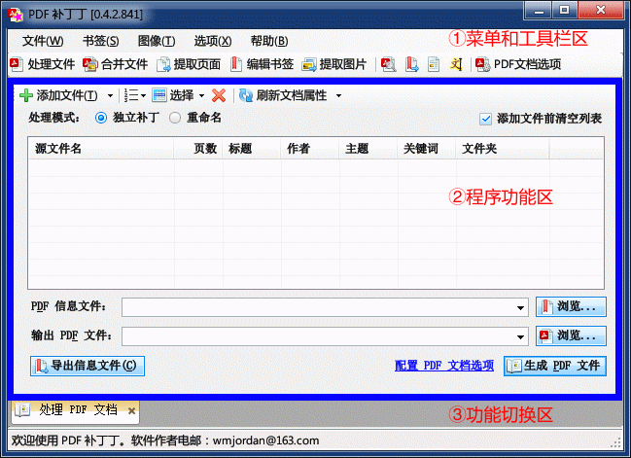

Chart 4 ---1 : PDF Patching program interface

The interface is mainly divided into two parts: the upper part is the menu and toolbar area, and the lower part is the program function area and function switching area.

Clicking on a menu item or toolbar button will open the corresponding function.

Frequently used functions are displayed as icons and function text in the toolbar, while less frequently used functions are displayed as icons. Move the mouse over the toolbar icon and hold it for a few seconds, and the program will pop up the description text of the function corresponding to that button.

Once the function is opened, a tab will be added to the function switch area corresponding to the function.

If you don't need to use the function anymore, you can click the "X" button on the tab to turn off the tab and the corresponding function.

The following section describes each function of the program in turn.

## Processing documents

The interface for processing PDF files function is shown below.

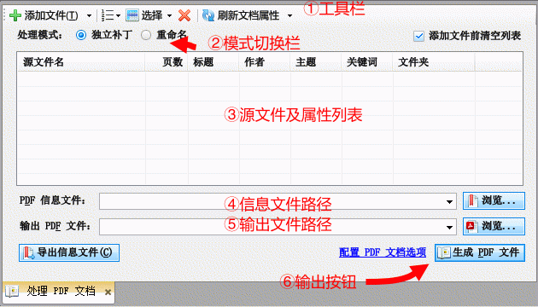

Chart 4 -2 : PDF file processing functions

### File List

In the center of the screen is the "Source Files and File Properties List" (Figure 3 above). This list lists the files and their properties that need to be processed. You can select multiple files at once by holding down the Shift or Ctrl key on your keyboard and clicking on the source file name in the file list with your mouse.

### Add a file

Use the "Add File" button on the toolbar (① above) to add a file to the file list for processing. To the right of the "Add File" button is a small inverted triangle button. Clicking this button will bring up a menu listing the most recently processed PDF files. You can also add files to the file list by clicking the File item on the menu.

In addition, you can select a group of files in Windows Explorer (or other programs' file list box) and then drag and drop file items onto the list with your mouse.

Note: If the "Clear list before adding files" checkbox is checked, the file list will be cleared before adding files and then adding file items. If you need to process a file that will be added to the file list several times, uncheck the checkbox.

Description: When adding a file, if the PDF file itself is encrypted and requires that it can only be opened after entering a password, a pop-up dialog box for entering an authentication will be displayed for entering the password. If you cannot provide the correct password, you will not be able to process the PDF document.

### Adjusting the processing order of files

The program handles the file list files in order from top to bottom.

After selecting a file, drag the selected item with the left mouse button to adjust the processing order of the file.

Use the Sort menu on the toolbar to sort the files. There are two types of sorting: "Sort by numeric and alphabetic order" takes the numbers in the file name into account as numeric values. "Sort by alphabetical order" sorts files according to the alphabetical order of their names.

For example, there are four files in the import list, "1.tif", "2.tif", "10.tif" and "3.tif "10.tif" should come after "3.tif" because the "10" in the file name is larger than the "3" after sorting by number and alphabetical order. should be ranked after "3.tif", so the sorted order is "1.tif", "2.tif", "3.tif " and "10.tif"; if sorted alphabetically, "1" in "10.tif" appears after If sorted alphabetically, "1" appears before "2" and "3" in "10.tif", so the sorted order is "1.tif", "10.tif", "2.tif" and "10.tif". "2.tif" and "3.tif".

You can also sort by the data corresponding to the table header item by clicking on the table header of the file list. The first click performs sequential sorting, and another click performs reverse-order sorting.

### Delete file items

After selecting an item on the file list, click the "x" button to delete the selected item.

### Modify the properties of the output file

Click on the "Title", "Author", "Subject" and "Keywords" columns of the document item in the document list. The list item will enter the editing state. Edit the text of the item to modify the properties of the output file (the properties of the original file will not be changed). This is shown in the figure below.

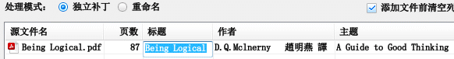

Chart 4 -3 : Modify the properties of the output file

Some PDF files do not use the correct encoding for their document properties, and the document properties will be displayed as garbled. In this case, you can select the PDF file in the file list, and then click the toolbar "Refresh Document Properties" button on the right of the inverted triangle button, in the pop-up menu to select other encoding. As shown in the figure below.

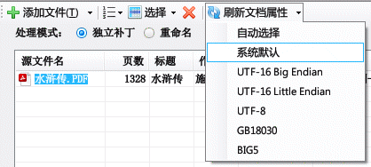

Chart 4 -44 : Decoding document properties using other encoding methods

There are several commonly used encodings, and trying them one by one may lead to choosing the correct encoding that will turn garbled text into readable text.

### Toggle patch and rename mode

Under the toolbar is the "Mode Switching Bar" (Figure ② above), which contains two radio boxes corresponding to two processing methods. By switching the processing mode, the following tasks can be performed (see below).

stand-alone patch: modify the content of PDF documents (modify bookmarks, page links, lift copy restrictions, etc.) to generate new documents.

Rename: View PDF document properties and rename PDF files according to the document properties.

### Output file, information file path and execution button

The "Generate PDF File" button will perform the task corresponding to the selected mode in the mode bar, generating a new PDF file that will be output to the file path corresponding to "Output PDF File" (Figure ⑤ above). Some functions may involve information files for modifying PDF documents. This can be specified at the "PDF Information File" (④ above).

The following section describes the use of each of the two processing methods according to the above.

## "Standalone patch" processing mode

The "standalone patch" mode of the process file function is used to modify each PDF file in the process list.

### Steps for patch modification document

The usual procedure for standalone patch mode is as follows.

1. Select the "Standalone Patch" processing method for "Process PDF documents".
2. Use the "Add" button or drag and drop files to add PDF files to the list of files to be processed.
3. Click the "Configurefileprocessingoptions" link in the upper right corner of the interface (or select "PDF document options" in the function directory tree), specifysettings that need to bechanged in the interface PDFfiles (such as specifying the reader interface, removing restrictions on copying and printing, etc., setting the bookmark status to off, disable bookmarks and page links to change the display ratio, etc.). The modified settings will be applied to the generated PDF file. For details, see4.5 section.
4. Close the Options dialog box, return to the "Process/Produce PDF Files" function, specify the path to the output PDF file (you can insert the output file name containing substitution characters in the text box, see the use of substitution characters for details)4.3.2 (see section).
5. Click the "Generate PDF Files" button. The program will process the PDF files in the file list one by one according to the settings of "PDF Document Options" and generate the corresponding new PDF files to the output location.

### Batch operation output file naming rules

In order to correctly operate batch patch operations with multiple raw files, it is necessary to understand the location and naming rules of the file output after the batch operation. The program has two types of naming rules: default naming rules and substitution naming rules.

#### Default Naming Rules

In the case of multiple files in the file list, the output file name is "output PDF file" specified file name in the directory name + the original file name + ".pdf" suffix.

For example: set the original PDF file selected in the "M:\abc" folder, there are "f1.pdf" and "f2.pdf" two. "Output PDF files" corresponding to the directory "E:\efg", the file name "xyz.pdf" (that is, the path to "E:\efg\xyz.pdf efg\xyz.pdf").

In the batch operation, the program will ignore the filename part of the output path, output files to the "E:\efg" directory, the file name "f1.pdf" and "f2.pdf ". As shown in the table and diagram below.

Tables 4 -11 : Example of batch operation output file name

| Enter the file name | "Output PDF file" location | Actual output file name |
| --- | --- | --- |
| M:\abc\f1.pdf | E:\efg\xyz.pdf | E:\efg\f1.pdf |
| M:\abc\f2.pdf | E:\efg\f2.pdf |

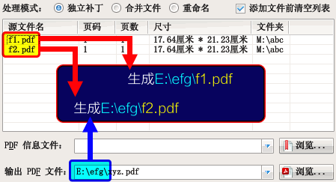

Chart 4 -5 : Files output by default naming convention

#### Naming rules for substitution characters

In the "Export PDF File" combo edit box, click the right mouse button, a context menu will pop up. Click on the menu item to insert substitution characters. When outputting the file, the substitution character of the file name will be replaced with the corresponding content. The interface for inserting substitution is shown in the figure below.

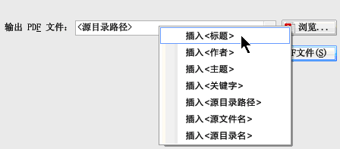

Chart 4 -6 : Insert substitution characters in the output path

The meaning of each substitution character is shown in the following table.

Tables 4 -2 : Meaning of substitution characters

| Alternative character name | Alternative content |
| --- | --- |
| < Title | The "Title" property of the original document |
| < Author | The "Author" property of the original document |
| < Topic | The "Subject" property of the original document |
| < Keyword | The "keyword" attribute of the original document |
| < source directory path | the original PDF file path in addition to the part of the file name (set the path of the source file is "M:\abc\efg\hi.pdf", the replacement character that "M:\abc\efg\") |
| < source file name> | the original PDF file path file name does not contain the extension of the part (set the source file path "M:\abc\efg\hi.pdf", then the alternative character that "hi") |
| < source directory name> | the original PDF file path of the folder name (set the path of the source file is "M:\abc\efg\hi.pdf", the replacement character that "efg") |

Tip: The properties of the source file are listed in the file list.

Examples are given below.

Set the selected original PDF file has "M:\abc\efg\f1.pdf" and "M:\abc\efg\f2.pdf" two.

where the "f1.pdf" file has the following document properties: "title" for "example 1", "author " as "W. Jordan", "keyword" as "example document".

The "f2.pdf" file does not have document properties.

The output path is "< source directory path> < title>", "< source directory path>" means the path part of the original PDF file except for the file name. "< title>" indicates the "title" attribute of the document.

Since the "f2.pdf" document does not contain a "title" attribute, substitution results in an empty file name. In this case, the program will automatically use the filename of the original path as the filename part of the output.

The output is shown in the table below.

Forms 4 -3 : Output file name when the output path contains the substitution "<source directory path> <title>"

| Enter the file name | Document Properties | Output file name |
| --- | --- | --- |
| M:\abc\efg\f1.pdf | title="Example 1"  author="W. Jordan"  keyword="example document" | M:\abc\efg\ Example 1.pdf |
| M:\abc\efg\f2.pdf | No document properties | M:\abc\efg\f2.pdf |

Note: In this example, the output path of the "f2.pdf" file is the same as the original path, so the patch cannot be executed.

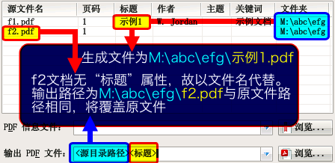

Chart 4 -7 : Output files with alternative naming rules

## Advanced patch function (export, import information files)

The Advanced Patch feature is used to export information from a PDF document into an editable document. This document contains information such as PDF document properties, bookmarks, page links, page sizes, etc. and is called an "information file".

The patch operation is performed in two steps.

Step 1, Export Information File: Export the information in the PDF document into an editableand modifiableXMLinformation file.

Step 2, import the information file: use a text editor to modify the previous step to export XML files, and then specify the information file at the processing of PDF files, click the "Generate PDF File" button to merge the source PDF file and the information file to generate a new PDF file with modified settings.

### Exporting information files

The operation steps are shown below.

1. Select the "Standalone Patch" processing method for "Process PDF documents".
2. Add a PDF file to the file list with the information to be exported.
3. Click the "Browse" button on the right side of "PDF Information File" to specify the location to save the exported information file.
4. Click the "Export Info File" button, the program will export the information in the original PDF file to the corresponding location in the "PDF Info File".

The operation steps are shown in the following figure.

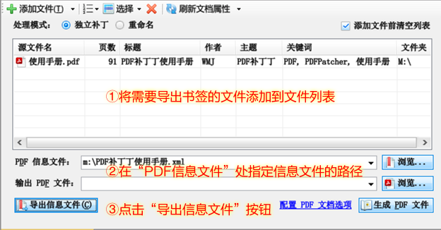

Chart 4 -8 : The process of exporting information files

### About the "Information Document"

There are two types of information files: one is an XMLformatted information file (file name suffixed with "xml") and the other is a simple text file (file name suffixed with "txt").

When exporting information files, the type of information file is determined by the file name suffix. For example, if the information file name is "file.xml", the XML format information file is exported; if the information file name is "file.txt", the simple text bookmark file is exported.

XML information files contain more complete and richer information. It can contain information such as document properties, reader settings, bookmarks, page links, page layout settings, etc. See Chapter6 chapter for an introduction.

Text bookmark files contain only document attributes and bookmark information pointing to the page (see Chapter7 chapter), the amount of information is much less than the XML information file. If the bookmarks of a PDF document are exported to a simple text bookmark file, edited and re-imported into the document, the simple text bookmark contains less information, which may lead to the loss of some information in the bookmarks of the original document (such as the inability to precisely locate the specified position on the page, etc.). Therefore, in general, do not export simple text bookmark files.

### Importing information files

After exporting the information file in the previous step, you can open it with a text editor or XML editor to modify the information inside. After modification, the contents of the information file can be merged with the original PDF file to generate a new PDF file. The operation steps are shown below.

1. Specify the PDF source file and information file as in the previous step.
2. Click the "Browse" button on the right of "Output PDF File" to specify the location of the PDF file after the patch is saved; or you can directly enter the output file path in the corresponding combination box of the output PDF file.
3. Click the "Generate PDF file" button. The program will switch to the output information interface. If the import is successful, the output PDF file will contain the content of the original PDF file, as well as the information attached to the PDF information file.

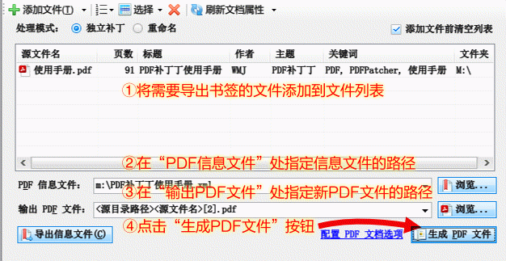

Chart 4 -9 : The process of importing information files

The content of the information file does not necessarily need to be imported into the PDF file, you can specify which content of the information file should be imported at the "Import Options" of the "Information File Options" function.

For details on how to use the message file, see the ApplicationExamples and Message File Reference.

### Batch processing method

If there are multiple original PDF files selected, the information files will be exported to the directory specified in the "PDF Information Files" combo box, and the information file names will be named according to the PDF file names.

For example: the original PDF file selected in the "M:\abc" folder, there are "f1.pdf" and "f2.pdf" two. Click the "PDF information file" on the right side of the "Browse" button, specify the information file in the "M:\efg" directory, the file name is " xyz.xml" (that is, the path to "M:\efg\xyz.xml"). The program will ignore the filename part of the output path in the batch operation, so the actual output information files will be placed in the "M:\efg" directory with the filenames "f1.xml" and "f2.xml ".

Forms 4 -4 : Example of output file name for batch export information file

| Enter the file name | Location of the "PDF information file" | Actual output information file name |
| --- | --- | --- |
| M:\abc\f1.pdf | M:\efg\xyz.xml | M:\efg\f1.xml |
| M:\abc\f2.pdf | M:\efg\f2.xml |

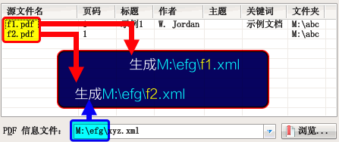

Chart 4 -10 : Naming rules for bulk export of bookmarks

When importing files, the naming rules of information files as above, that is, the program reads "PDF information files" in the directory with the same file name of PDF files as information files for batch processing.

The output files are named as described in4.3.2 determined in the manner described in section

### Information file options

The Info File Options are used to specify the content to be exported and imported in both steps of the Advanced Patch. Select the "Info File Options" command in the program's "Options" menu to bring up the Info File Options dialog box.

#### General export options

The General Export option specifies the content to be exported by the Export Info File feature. The interface is shown below.

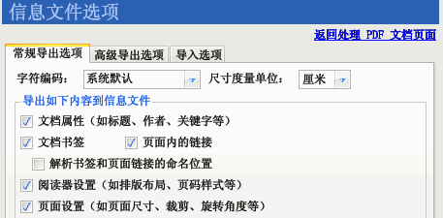

Chart 4 -11 : Information File Options (General Export Options)

Each option is described below.

Character encoding: Specify which encoding to use for exporting information files. The default encoding is GBK, but some PDF files contain some characters that cannot be represented by GBK encoding. In this case, you can try to select "GB18030", "UTF-8" or "UTF-16" from this drop-down box (using the system default, UTF-8 or UTF-16 encoding can be opened and edited directly by Windows Notepad).

Document Properties: Specify whether to export metadata information such as title, author, keywords, subject, etc. of the PDF document.

Document Bookmarks: Specify whether to export the bookmark information within the PDF document. Check this option when you need to modify PDF bookmarks.

Links within pages: Specify whether to export links within the pages of a PDF document. For some PDF documents, clicking on some of these areas can jump to other locations in the document, open new documents or open websites, etc. Choose this option when you need to modify these links.

Resolve the named location of bookmarks and page links: The "named location" in a PDF document is a jump target with a specific name, and the bookmark information is stored independently. If you find that the exported PDF bookmarks or page links cannot be patched to the PDF document, you can try to check this option to convert the named locations of bookmarks and page links to actual locations.

Reader settings: specify whether to export the initial layout (such as single page, single page continuous, double page, etc.), page numbering style (in the PDF reader to see the logical page numbering, such as "I", "II", " III" form of Roman numerals page number, "A", "B", "C" form of alphabetical page number) and other settings.

Size unit: Specify which unit to use to express the PDF document coordinate value. The default in the program is "centimeters".

Tip: The standard unit of measure used in PDF documents is "points". To export accurate positioning information, please select "points" as the unit of measure.

#### Advanced Export Options

Advanced Export Option is an advanced feature provided by PDF Patching for PDF developers. This feature can export the content of PDF pages, processing instructions and other information in the form of XML representation for development reference. The interface is shown below.

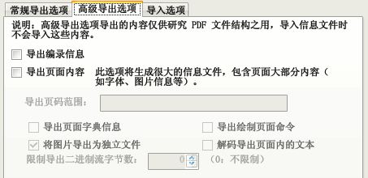

Chart 4 -12 : Information File Options (Advanced Export Options)

Export Catalog Information: When this checkbox is checked, the exported information file will contain the contents of the PDF Catalog dictionary.

Export page content: When this checkbox is checked, the exported information file will contain the dictionary of PDF pages, drawing instructions, etc. for debugging and studying documents.

Page range: Specify to export the content of only some pages. If you do not specify a page range, the contents of all pages are exported.

Check the "Export page dictionary information" checkbox to export the page dictionary information.

Check the Export Draw Page command checkbox to export commands for outputting text, pictures, images, etc. to the page.

Check the "Export images as separate files" checkbox to save the images as separate files without writing to the XML message file.

Check the "Decode text within exported pages" checkbox to decode and extract the text from the document page content stream.

If you only need to analyze the content of the first few bytes of the binary stream, you can enter a value in the "Limit the number of bytes of the exported binary stream" numeric adjustment box, such as "100", which means only the content of the first 100 bytes of the binary stream will be exported.

Note: The XML content exported by the advanced export option is for reference only and will not be written to the PDF document upon import. the binary content in the PDF document will be encoded into the CDATA string in the XML document using the HexBin encoding method.

#### Import Options

The Import option is used to specify the content to be imported in the Advanced Patch function. The interface and the meaning of each option are as follows.

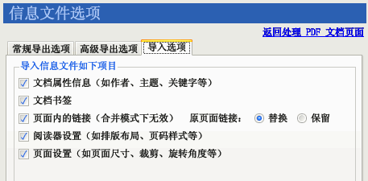

Chart 4 -13 : PDF document option (information file content)

Document attribute information: whether to use the metadata specified in the information file (e.g., author, subject, keywords, etc.).

Document Bookmarks: Whether to use the bookmarks specified in the information file. If this option is unchecked, the bookmarks of the output file will be the same as those of the original PDF file. The bookmark format can be found in the bookmarks section of the information file reference.

Links within pages: Whether to import links to pages contained in the message file. If you select this option, you can replace (select the "Replace" radio box to the right of the "Original page links") or overlay (select the "Keep" radio box) the page links from the information file Page links of the original PDF file.

Reader settings: whether to import the initial state of the reader (such as whether to show bookmarks when opening a document, full screen display, initial page state) and the page numbering method.

Page settings: whether to import the size, crop border, rotation angle and other data of each page.

## PDF document options

PDF document options are used to specify how to modify PDF documents. Clicking the "PDF Document Options" item on the toolbar will open the PDF Document Options dialog box.

The options dialog is divided into tabbed options. The interface is divided into "Page Size", "Reading Style", "Compression Cleanup", "Document Properties", "Page Label" and "Replace Font" tabs. "Page Label" and "Replace Font" tabs, respectively, are described below.

### Page Size

The option can unify the size of the PDF document, or adjust the page border white space, its interface and the meaning of the options are as follows.

Note: The default state of the tabs is shown below. If the settings of the interface are changed, the settings on the interface will prevail when importing information; if the default settings are retained, the information specified in the information file will prevail.

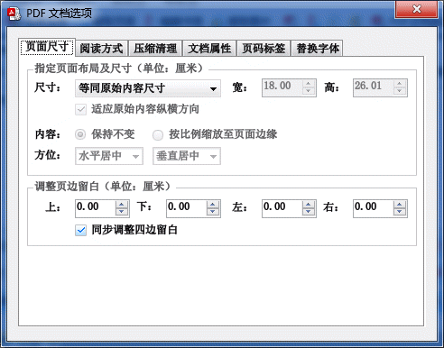

Chart 4 -14 : PDF document options (page size)

Page Size, Width, Height: In this list, you can specify the page size of the output PDF file. After changing the selected items in the "Page Size" list, the specific size will be displayed in the text box corresponding to "Width" and "Height". The final page size is based on the size specified by "Width" and "Height". Even if the page size of the source PDF file is different, the output page will be the same size.

Special page sizes.

"Equal to original content size": does not change the page size of the output PDF document.

"Fixed Page Width Auto Height": freely specify the output PDF document page width, scaling the source PDF page to the specified width in equal proportion.

Position: Specify the alignment of the source PDF page on the new size page.

White space: The space left on all four sides of the page. When the "Adjust white space on all sides synchronously" option is checked, changing any one white space value will change the values of the other three. Uncheck the box to adjust the white space values on each side individually. The value can be a negative number, which is used to reduce the white space on the page.

### Reading Style

The Reading Mode tab is used to specify the interface settings of the reader, and its interface and the meaning of each option are as follows.

Note: The default state of the tabs is shown below. If the settings of the interface are changed, the settings on the interface will prevail when importing information; if the default settings are retained, the information specified in the information file will prevail.

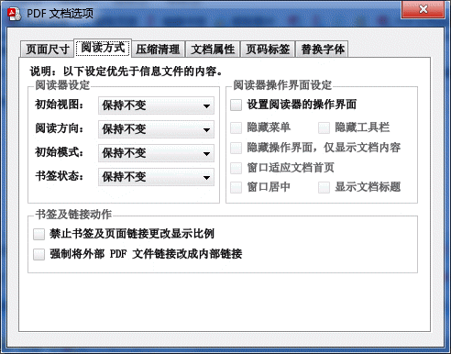

Chart 4 -15 : PDF document options (reading style)

Reader settings: Specify the initial view, reading direction, and initial mode of the reader. When "Leave as is" is selected in the drop-down list, the settings specified in the information file or the original PDF file prevail.

In the case of displaying two pages of vertical text on one screen (such as some ancient books), you can set the reading direction of the document to "right to left" to adapt to the vertical reading style.

The "Bookmark Status" option is used to specify whether to open (expand) or close all bookmarks. When no status is specified, the status specified in the message file or the original PDF file prevails.

Bookmarks and links action: Specify the scaling of bookmarks and links within pages. Some bookmarks or page links will change the current display scale of the reader when clicked, check the "Disable bookmarks and page links from changing display scale" checkbox to remove such behavior, so that the display scale of the reader will be maintained after clicking bookmarks and page links. Some PDF documents, change the file name after the bookmark is invalid, check the "Force external PDF file links to internal links" option, you can repair such bookmarks.

Reader interface settings: Specify the interface when opening PDF files in the PDF Reader. By default, it is not mandatory to change the interface settings of the PDF Reader. To override the interface settings for PDF documents, you can check the "Specify interface settings" checkbox. When this checkbox is selected, the grayed-out disabled checkboxes below will become operational. By setting these checkboxes to be checked, you can specify the interface of the PDF Reader after opening the document.

### Compression Cleaning

This function is used to improve the compression rate of PDF documents, and can clean up some unwanted content. Its interface and options are as follows.

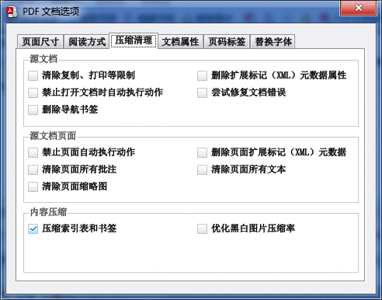

Chart 4 -16 PDF document options (compression cleanup)

Source document processing, source document page processing: for clearing restrictions (such as copying, printing, and other restrictions), automatically executed actions, document annotations, and metadata information.

Description: About Extended Markup (XML) metadata attributes: XML metadata attributes are a kind of annotation information attached to the document, which generally does not affect the reading, and can be removed if not needed.

Try to fix document errors: Normally it is not necessary to select this checkbox. If you have an "invalid operator" error when opening some PDF documents, you can check this box to try to repair the document content.

Clear all text on the page: Do not select this checkbox in general. This option will clear all text content on the page.

Compress index table and bookmarks: When this option is checked, the program will compress the index table and bookmarks of the PDF and other data to minimize the space occupied by the PDF file.

Note: Lower versions or incompatible PDF readers may not be able to open PDF documents with compressed index tables.

Optimize compression of black and white images: When this option is selected, the program will try to compress the black and white images in the PDF document using the JBIG2 algorithm in order to reduce the file space occupied by the images. If the file size cannot be reduced after compression, the original image will remain unchanged. Selecting this option will not reduce the image quality, but may use more processing time.

### Document Properties

The Document Properties tab is used to specify document properties. Normally, you do not need to use this tab to set document properties, just enter the document properties you need to set directly in the document list. This tab is used to set the document properties in bulk. Its interface and the meaning of the options are as follows.

Note: The default state of the tabs is shown below. If the settings of the interface are changed, the settings on the interface will prevail when importing information; if the default settings are retained, the information specified in the information file will prevail.

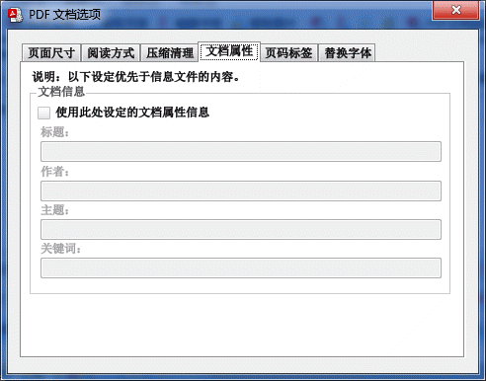

Chart 4 -17 PDF Document Options (Document Properties)

Document Information: Check the "Use document attribute information set here" checkbox to specify the document title, author, subject, keywords, and other attributes.

In the "standalone patch" processing mode, you can right-click on each document properties text box to bring up the Insert "< source file name>" and "< source directory name>" menu commands. " substitution menu commands. "< Source filename>" means to use the filename of the source PDF file as the specified document attribute, and "< Source directory name>" means to use the directory name as the specified attribute. Use this function to easily modify the properties of a PDF file using the PDF file name or directory name.

When rewriting document properties, if the set document property is empty, the corresponding original property of the PDF document is retained. If the attribute is one or more half-space (" "), the original attribute corresponding to the PDF document is deleted.

### Page Label

The page number label of a PDF document is usually displayed on the page flip control of the PDF reader, indicating the logical page number in the document.

The Page Label tab can be used to specify logical page number labels, and its interface and the meaning of each option are as follows.

Note: The default state of the tabs is shown below. If the settings of the interface are changed, the settings on the interface will prevail when importing information; if the default settings are retained, the information specified in the information file will prevail.

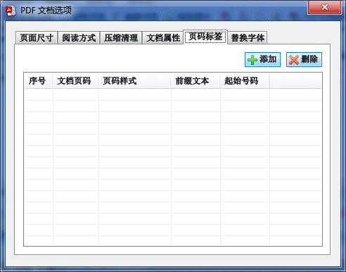

Chart 4 -18 : PDF document options (page labels)

Click the "Add" button to add a new page number label. If you want to modify the page number label, you can directly click the corresponding page number label item in the list box to modify its content. Click the "Delete" button to delete the selected page label.

Document Page Number: indicates the actual page number in the document using this page number tag. In the PDF Reader interface, starting from this page, the pages that follow will display the page number using the set tag.

Page style: the style of page numbering. The default is numeric, in addition, Roman numerals and English letters can be used.

Prefix text: the text before the logical page number tag.

Start number: The number where the logical page numbering label starts, generally kept as 1.

The following figure is an example of the usage of the page number tag.

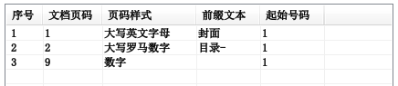

Chart 4 -19 : Example of page number label setting

in the above figure, the first document page number for 1, page style for the "capital letters", prefix text for the "cover", the starting page code for "1", then the first page in the reader of the page number displayed as "Cover A".

The second document page number is 2, the page number style is "uppercase Roman numerals", the prefix text is "directory-", the starting page number is "1", then in the reader from page 2, to page 8 (a total of 7 pages), the page number display as "directory-I", "directory-II", "directory-III"... The page numbers are displayed as "Table of Contents-I", "Table of Contents-II", "Table of Contents-III"... ... "Table of Contents-VII".

The third document page number for 9, page style for the "number", the prefix text is empty, the starting page code for 1, then in the reader from the beginning of page 9 to the last page of the document, the page number displayed as "1", "2 ", "3" ......

### Replace fonts

The settings on the Replace Font tab are used to replace the font of the PDF document with other fonts installed in the system. For some PDF documents without embedded fonts, this function can also achieve the function of embedded fonts. Its interface and the meaning of the options are as follows.

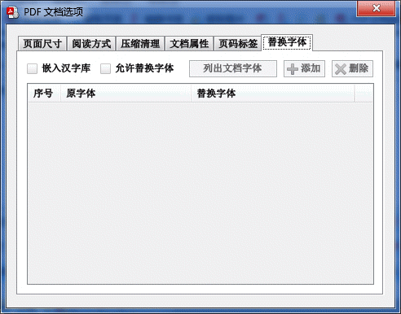

Chart 4 -20 PDF document options (replace fonts)

Embed Chinese Character Library: Check this option to automatically embed the following common font for PDF documents without embedded font: Song, bold, italic, imitation Song, and young round font.

Allow font replacement: Check this option to replace the fonts in the PDF document.

List document fonts: To replace fonts in PDF documents, you first need to know which fonts are used in the document. Click this button, a dialog box will appear. As shown in the figure below.

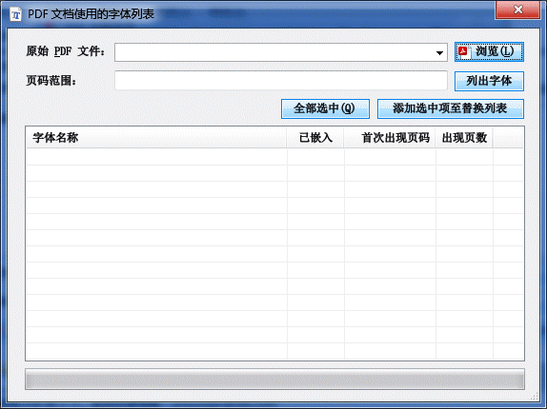

Chart 4 -21 : List document fonts

Click the "Browse" button, select the PDF document where you want to list the fonts, and then click the "List Fonts" button, the fonts used in the document will be listed in the list at the bottom of the dialog box.

Check the checkbox corresponding to the font name, and then click the "Add selected items to the replacement list" button, the selected fonts will be added to the replacement fonts list of PDF document options. Click the "Replace Font" column on the right of the list item to specify the fonts installed in the system.

After the patch operation, the fonts in the "Original Fonts" column will be replaced with the fonts in the "Replacement Fonts" column.

## Rename processing mode

This function is used to view the properties of a PDF document and change the PDF file name based on the document properties.

The operation is similar to the standalone patch processing mode.

Export PDF files to change the naming template of the PDF file. The naming template supports substitution characters, so you can rename PDF files with document attributes such as "title". See the section on Substitution Naming Rules for more information on the use of substitution characters.

Click the "Test" button to preview the renaming result.

Click the "Generate PDF File" button, the source PDF file name will be changed to the name specified in the template according to the renaming template. If the "Keep original file" checkbox is checked, the PDF file before renaming will be kept, otherwise the file will be changed to a new name.

## Merge files

This function can realize the function of making PDF files in many ways, such as making eBooks of scanned books, merging the whole catalog of pictures and PDF files into one PDF file, etc.

The merge function also allows you to extract a specified range of pages from existing PDF files and export them to the generated PDF files, i.e. with the ability to merge or split PDF files.

In the middle of the interface there is a list box called "File List". In the file list, you can mix specified images and PDF files, and insert the images into the pages of PDF files.

Double-click the source PDF file in the list to specify the page number range in the document that is involved in the merge operation. The default page number range is from the first page to the last page. By modifying the page number range, you can achieve the function of splitting and rearranging the pages of PDF files.

In addition, you can specify the properties of the output PDF file when merging PDF files by modifying the settings of mergedocument option.

The interface of this function is shown in the following figure.

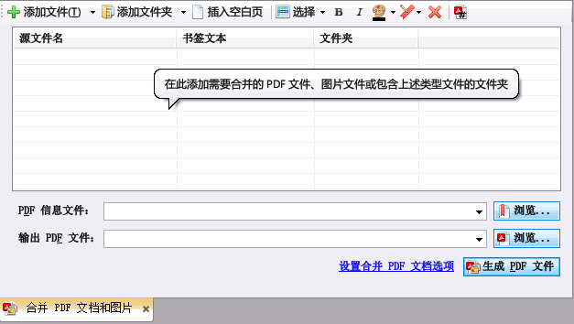

Chart 4 -22 : Merge document function

### Operation method

Use the merge file function to generate PDF documents as follows.

1. Click the "Merge Files" button on the toolbar.
2. Add images (JPEG, PNG, GIF, BMP and TIFF files) or source PDF files to the file list. Each image will become a page of the PDF document, if there are 3 images, the PDF document will have 3 pages; 10 images will make the document 10 pages. If the image file has multiple frames, each frame will be a separate page.
3. To add a blank page, click the "Insert Blank Page" button in the toolbar.
4. Clicking the "Add Folder" button will bring up a dialog box to open the files. Use this dialog box to locate the folder you need to add and click the "Open" button to add all the images or PDF files in that folder to the list (with subfolders of files).
5. If you have added a file or folder that you do not want to merge, you can select the item and then click the "Delete File" button on the toolbar to remove the file or folder from the file list.
6. If you need to bookmark the generated PDF file, you can click the "Browse" button on the right of "PDF Info File" to specify the location of the bookmark file. If the information file is not required, you may not specify it. When no bookmark is specified, the program generates bookmarks for the generated PDF files according to the "Bookmark Text" column in the file list.
7. Click "Output PDF file" on the right side of the "Browse" button to specify the location to save the production PDF file.
8. Click the "Generate PDF file" button.
9. The program will create PDF files and then add images or source PDF files to the pages of the output PDF file one by one in the order of the file list.

Tip: In addition to using the Add File or Folder button, you can also drag and drop files directly from Explorer to the file list.

#### Sort File

After selecting a file item, use the mouse to point and hold the text area where you need to move the file, and then drag the mouse to move the file. Move the mouse over other file items and release the mouse button to make the selected file move to the corresponding location.

PNG" and "Subfolder 2" and drag them to the "Folder 1" bookmark with the mouse. A blue rectangle will be displayed on "Folder 1".

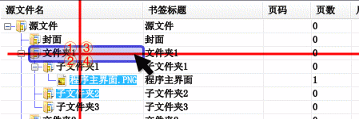

Chart 4 -23 : Sort document items

The blue rectangle has four areas, and there are different ways to move in different areas by releasing the mouse button. Take the picture above as an example.

Release the mouse button on the ① area and the selected file item will move to the front of "Folder 1".

Release the mouse button on the ② area and the selected file item will be moved to the back of "Folder 1".

Releasing the mouse button on the ③ area will move the selected file item to the front of all subitems of "Folder 1".

Releasing the mouse button on the ④ area will move the selected file item to the back of all the sub-items of "Folder 1".

The effect after moving the file items is shown in the following figure for each marker respectively (the two file items that were moved are selected).

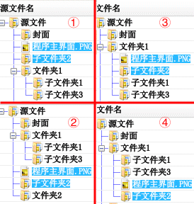

Chart 4 -24 : Effect of moving file items

Note: When dragging a bookmark, press the Esc key on the keyboard to cancel the dragging operation.

#### Set bookmark text and bookmark style

When merging PDF files, you can specify navigation bookmarks, and clicking on them in the reader will jump to the page corresponding to the file.

The bookmark text is set in the "Bookmark text" column of the merged file list. After adding the file to the merged file list, click on the cell in the "Bookmark text" column. The cell will be edited and you can set the corresponding bookmark item for the file by entering text in it.

If the bookmark text is not empty, select the file item, and then click the "B" and "I" buttons on the toolbar to set the bold and italic styles for the bookmark item respectively; click the small inverted triangle button next to the color palette button on the toolbar to set the bookmark item Click the small inverted triangle button next to the palette button on the toolbar to set the text color of the bookmark item.

If the bookmark text content is empty, no bookmark is generated for the item. If the item has sub-items and the sub-item text is not empty, the sub-item still generates the corresponding bookmark.

Description: When adding a file to the merged files list, the program automatically sets its corresponding bookmark text according to the file name. This behavior can be adjusted in the Merge files option.

#### Crop source image options

Double-click the image file in the file list, the "Source Image Processing Options" dialog box will pop up, as shown in the figure below. Use this dialog box to specify when importing pictures to create PDF files, crop the pictures first, and then import them to the document.

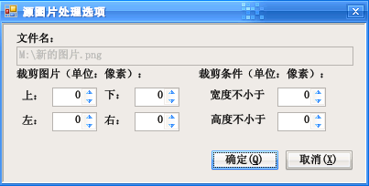

Chart 4 -25 : Source Image Processing Options Dialog

#### Filter source PDF file page options

Double-click the PDF file in the file list, the "Source PDF File Options" dialog box will pop up, as shown in the figure below. Use this dialog box to specify to import only a few pages of the source PDF document, or import only the images inside the PDF document.

The default state of the controls in the Import and Process Source PDF File Images column is disabled. It is only available when the "Import only images from source PDF files" checkbox is checked. The Import Images option is similar to the options for the Extract Images feature, see that section for instructions.

Tip: The page number range supports the reverse order range, such as page number range "10-1", will first insert the source document page 10, then insert page 9, and so on, and finally insert the first page to the output document.

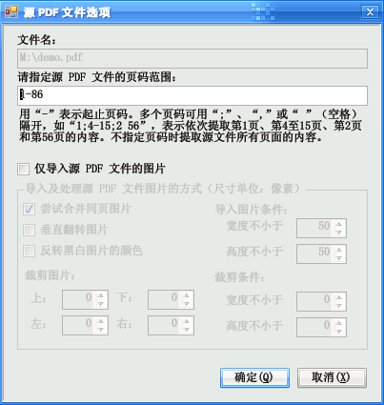

Chart 4 -26 Source PDF file options dialog

### Known Issues

* The size of the imported bookmark should match the size of the selected output file, otherwise the positioning coordinates may not be accurate.
* The document properties and metadata of the source PDF file will not be exported to the generated target file, but can be imported to the output file by specifying the information file, or specifying the document information in the "PDF Document Options".

## Merge Document Options

Merge Document Options is used to specify the options for merging PDF documents generated by the function. Clicking the Merge Document Options item on the toolbar or clicking the Set Merge PDF Document Options link on the interface will open the Merge Document Options dialog box.

The options dialog is divided into tabbed options. The interface is divided into tabs such as "Page Layout", "Reading Style", "Bookmarks", "Document Miscellaneous" and Tabs such as "Page Layout", "Reading Style", "Bookmarks", "Document Miscellaneous" and "Page Label". Among them, "reading", "document miscellaneous" and "page label" content and function of the PDF document options are basically the same, not here to repeat. The following article will introduce the "page layout" and "bookmarks" two tabs.

### Page Layout

"Page Layout" tab interface is shown below, the interface is similar to the PDF document options "Page Size" dialog box, but the following options have been added.

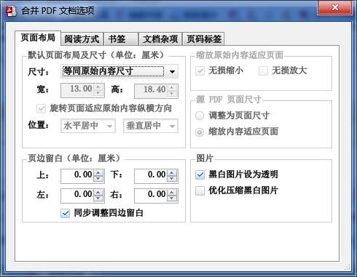

Automatically rotate the page to fit the original content aspect: When this option is checked, if the image aspect is different from the page and the page cannot accommodate the image, the program will automatically rotate the page to better fit the image.

For example, click on the "Size" drop-down list and select the page size as a 16-page page (184 mm wide and 260 mm high), which is a portrait page with less width than height. At this time, the source page size entered is 1024 pixels wide and 768 pixels high, and the image is wider than the height of the horizontal page. If this option is not checked, the horizontal picture is placed directly on the portrait page, which will leave a lot of blank space (left in the figure below)

When this option is checked, the program will automatically set the page layout to landscape, adapting to the orientation of the source image, and then place the content of the source image on the new page (below, right).

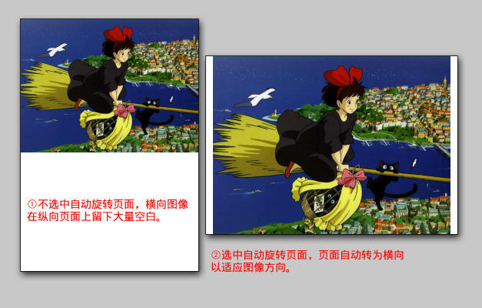

Scale original content to fit page: Specify whether to resize the source image to fit the page size. Check the Lossless Scaling checkbox to scale the original content to fit the page when the page is smaller than the original content size. Check the "Zoom in lossless" checkbox to scale the original content to fit the page when it is smaller than the page size.

Tip: Scaling does not reduce the quality of the image (the operation only uses the PDF built-in scaling command to make the image appear a different size).

Source PDF page resize: Specify whether to change the page zoom ratio of the source PDF file to fit the size of the output document page. By default, if "Resize to Page Size" is selected, the program keeps the original content of the document unchanged, but changes the page size to make it consistent with the size of the page settings. This can expand the blank area of the page in order to add annotations, or to hide unnecessary blank space on the page to facilitate reading. If you select "Scale Content to Page", the page imported from the source PDF file will be stretched to a size suitable for the output document page.

Black and white pictures set to transparent: for only black and white pictures, set them to transparent (in the PDF reader will not be selected and copied the picture).

Optimized compression of black and white images: use the JBIG2 algorithm with high compression rate to compress black and white images.

### Bookmarks

The Bookmarks tab contains options to control the generation of bookmarks for PDF files, with the following interface.

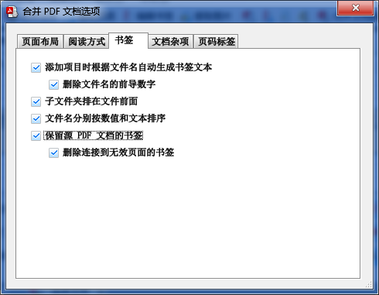

Chart 4 -27 : PDF document options (bookmarks)

Automatically generate bookmark text based on file name when adding items: When this item is checked, a bookmark item is added to the page corresponding to each source file (image or source PDF file), and the text of the bookmark item is the source file name (delete the extension part).

Ignore leading digits of file names: This option is available when the "Automatically generate bookmark text based on file names when adding items" checkbox is selected. When this option is checked, the text of the bookmark item is the part of the source file name after deleting the leading digit. If the file name is empty after deleting the number, no bookmark will be added to the page. For example, the list of files used to generate PDF there are four image files, the file names are: "0001 cover.jpg", "0002 directory.tif", "0003.tif " and "0004 Chapter 1.tif", then there are three bookmarks generated with the names "Cover" (skip to page 1), "Table of Contents" (skip to page 2) (skip to page 2) and "Chapter 1" (skip to page 4).

Subfolders ahead of files: When this option is checked, when adding a folder to the file list, the subfiles contained in the folder will be listed ahead of the files. When this option is unchecked, files are sorted alphabetically by file.

File names are sorted by value and text respectively: When this option is checked, when adding folders to the file list, the files contained in the folder will be sorted by value and text respectively, e.g. the following sequence is sorted by value and text for 1.pdf, 2.pdf and 10.pdf (sorting treats "10" as a value and comes after "pdf), while 1.pdf, 10.pdf and 2.pdf are sorted by text (sorted by "10" as text, in front of "2").

Note: The bookmark text of the file list will not be refreshed after changing the above options. If you want to refresh the bookmark text, you can delete the original added files in the file list, and when you add files to the list again, the bookmark text will be generated according to the new settings.

Keep the bookmarks of the source PDF file: Copy the bookmarks of the source PDF file to the output document after merging. If the pages of the source PDF file are not in the output document, clicking on the bookmarks will not perform any action.

Delete bookmarks linked to invalid pages: This option is valid when the "Keep bookmarks of source PDF files" checkbox is selected. When this option is checked, if the page of the source PDF file is not in the output document, the bookmark pointing to that page will be deleted (if the bookmark contains subbookmarks, the subbookmarks will also be deleted). For example, if the source PDF file has 100 pages, only 1~50 pages will be imported to generate a new PDF file, the bookmark items pointing to the original document page 51~100 will be deleted from the source file.

## Automatic bookmark generation

This feature can be used to automatically generate bookmarks for PDF documents. The principle is: the text of PDF documents have certain formatting rules, so you can follow the rules of the page text, size, fonts used, etc., to filter out the text that meets the rules (often large-print headings), so as to use these texts to generate PDF bookmarks. The interface of this function is shown in the figure below.

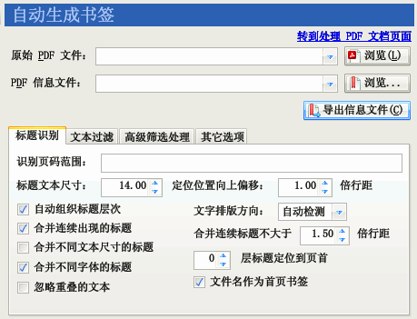

Chart 4 -28 : Automatic bookmark generation function

Note: This function automatically creates bookmarks for PDF documents by analyzing the font size of the text content within the PDF document, and does not perform optical character recognition (OCR) to recognize images as text.

### Operation steps

To use this function to generate a bookmark file of a text PDF, proceed as follows.

1. Select the "Recognize title as bookmark" function.
2. Click the "Browse" button on the right of "Original PDF File" to specify the PDF file that needs to be identified with the title of the bookmark.
3. Click the "Browse" button on the right side of "PDF information file" to specify the information file to be saved for bookmark generation after recognition.
4. Adjust the options if needed (especially "Identify page range").
5. Click the "Export Information File" button. The program will analyze and identify the text in the original PDF file within the specified page number range, extract the text whose size is larger than the value of the "Title Text Size" trim box, organize them into bookmarks, and save them as XML information files. In the process of the program, the log window will output the text identified as the title, level, and its page number.
6. An overview of the output bookmarks can be seen by observing the output of the log window. Often the bookmarks obtained from the first analysis are less than ideal and can be returned to adjust the filtering options, such as resizing the header text to include header text in smaller (or larger) fonts, specifying filter text to screen out unwanted text, adding filters to exclude specific fonts in the advanced filtering processing options, etc.

Tip: You can open the message file output by this function with a text editor, which lists the dimensions of the header text. In addition, you can click on the "Add from message file" button in the "Advanced filtering" option. After clicking this button, the program brings up a dialog box. Use this dialog box to add a header text filter from the output message file.

1. Repeat steps 5 and 6 until a more satisfactory bookmark nesting result is obtained.
2. After completion, go to "Processing, generate PDF documents" function of "independent patch" processing mode, use the aforementioned generated information file to patch PDF files, and view the bookmark effect of the output file. If the effect is not satisfactory, you can manually modify the XML information file and re-patch.

Hint: Detailed application examples can be found in Section5.10 section of this manual.

### Title recognition options

The filtering parameters for the analysis process can be specified in the tabs of this function.

Identify the page range: Specify the page number of the text to be analyzed.

Header text size: Specify that only text with size larger than this value may be extracted as bookmarks.

Positioning position is shifted upward by a number of line spacing: when text is extracted as a bookmark item, clicking on the bookmark item will jump to the corresponding text, but it will be shifted upward by some position, so that the positioned text will not stick to the top of the reader window.

Automatically organize header levels: When this option is checked, the program generates multi-level bookmarks based on the size level of the text.

Merge consecutive occurrences of headings: If both lines of text meet the conditions to constitute a heading, they are treated as one heading (adapted to the occasion when a heading is displayed in two lines).

Merge headers of different sizes in the same line: When the headers have different font sizes, you can check this option to make the text of different sizes merge into one headers.

Merge headings with different fonts: When the headings have different font styles, you can check this option to merge the text with different fonts into one heading.

Ignore overlapping text: Some PDF production procedures will be in the same location slightly staggered a little bit of the output of the same text multiple times, so as to produce the effect of faux bold or shading, which will lead to the appearance of duplicate text. Check this option to allow the program to detect the technical means to ignore the repeated appearance of text in the same location.

Text layout direction: the program can generally automatically detect the layout direction of the text, but due to the limited intelligence of the algorithm, it may infer errors, you can use this option to manually specify the layout direction of the text to improve the accuracy of the program to organize the text layout.

Merge consecutive headings no larger than several times the line spacing: When "Merge consecutive headings" is selected, headings smaller than this specified line spacing will be merged into one heading.

Position several layer headers to the top of the page: By default, bookmarks generated after clicking on the recognition will be positioned where the bookmark is located. When this option is checked, clicking on a bookmark within the specified number of layers will position it to the top of the page instead of where the bookmark is located.

Generate bookmarks for the first page: When this option is checked, a bookmark item will be generated to point to the first page of the document, the text of the bookmark item is the name of the PDF file, in addition, regardless of whether there is text to meet the conditions of the title, no longer generate bookmarks for the first page. Do not check this option, then follow the normal rules for processing.

### Text filtering options

The text filter option specifies a list (one per line) to be used to filter text. Text that matches the specified pattern is ignored. The interface is as follows.

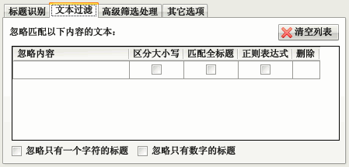

Chart 4 -29 : Text filtering options for the automatic bookmark generation feature

Ignore headings with only one character: Some PDF documents have large sunken first characters, use this option to ignore them. Avoid sunken words being recognized as headings (when this option is checked, do not select the "Merge headings of different sizes in the same line" option, otherwise the sunken words will be merged together with the normal text).

Ignore headers with only numbers: This option is usually available to ignore page numbers.

Fill in the "Ignore Content" column with the text of the title to be ignored. When the PDF text matches the ignored content, the program will not treat it as a bookmark title.

Check the checkbox in the "Case sensitive" column to match ignore content with case sensitive English.

Check the checkbox of the "Match full title" column, the text of the line will be ignored only if the entire line of PDF text and the ignored content are the same length.

Check the checkbox in the "Regular Expression" column to ignore the content as a regular expression.

If you need to delete the entered ignore pattern, click the corresponding button under the "Delete" column or click the "Clear List" button.

### Advanced filtering options

The Advanced Filtering option allows you to specify to ignore text under specific conditions or change the title level of the matching text. The interface is shown below.

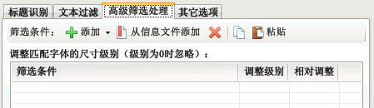

Chart 4 -30 : Advanced filtering options for the automatic bookmark generation feature

The above screen allows you to add filter conditions for filtering the header text. The added filters are listed in a list, and each row is a set of filter conditions and the value of the adjustment level if the conditions are matched. If a paragraph matches a specific group of filters, the level adjustment action is performed. When adjusting the level, if the checkbox corresponding to the "Relative Adjustment" column of the filter condition is checked, the level of the text matching the filter condition will be increased or decreased by the value specified in the "Adjustment Level" column, otherwise the level of the text will be changed to otherwise the level of the text will be changed to the value specified in the "Adjustment level" column.

Hint: When the adjustment level is 0 and the "Relative adjustment" checkbox is unchecked, it means the text matched by the matching condition will be filtered.

If the adjusted value is smaller than the Header Text Size parameter specified in the Header Identification option, the text will be ignored and will not be output to the generated bookmarks. If the value is greater than the value of the Header Text Size option, the text that was ignored by this option will also be output to the generated bookmarks.

There are five buttons on the toolbar: The "Add" button is used to add filters manually, which is generally not used, but the "Add from Info File" button is used to add filters from the information file generated by the first trip processing. The "Delete" button removes the selected filter from the list. The "Copy" and "Paste" buttons can be used to copy and paste filters.

For more information on how to use the advanced filtering options, please refer to the chapter on sample applications.

### Other options

Check the checkbox "Count fonts used for headers after identification", then the fonts used for headers will be listed in the log window after identification.

If the "List ignored fonts" checkbox is selected, the names of fonts that have been ignored by the filtering criteria are also included in the statistics.

If the "Export text location information" checkbox is selected, the exported information file will also contain information about the location of the text within the page.

## Edit bookmark file

This function can edit simple text bookmark documents, XMLmessage files or directly extract bookmarks from PDF documents and save them as message files or add bookmarks to existing PDF documents. The interface of this function is shown in the following figure.

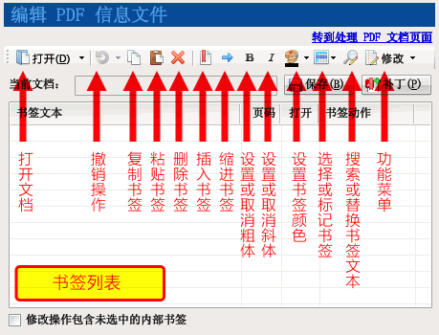

Chart 4 ---31 PDF Bookmark Editor Interface

At the top of the interface are two rows of buttons, with a list of bookmarks displayed in a tree format in the middle. Move the mouse over a button in the toolbar and hold it for a moment, a prompt message will pop up explaining the purpose of the button and displaying the keyboard operation shortcut. The first row of buttons is described in order from left to right as follows.

The "Open" button opens the message file or PDF file that needs to be edited with bookmarks. Clicking on the small triangle next to the button will bring up a menu with a list of recently processed message files or PDF files. Clicking on the menu item will open the bookmark for the corresponding file.

The "Undo" button is used to undo the previous modification and restore the bookmark to its pre-modification state. Click on the small triangle next to the "Undo" button, a menu will pop up, click on the menu item to undo multiple steps at once.

The "Copy" button is used to copy the selected bookmark.

The "Paste" button is used to paste the previously copied bookmark into the specified location.

The "Delete" button deletes the selected bookmark. If the bookmark contains a subbookmark, the subbookmark will also be deleted.

The "Insert Bookmark" button inserts a new bookmark item behind the current bookmark.

The "Indent Bookmark" button sets the selected bookmark as a subbookmark of the previous sibling document.

The "Bold" and "Italic" buttons toggle the bold and italic styles of the bookmark text, respectively.

The "Color" button sets the color of the bookmark text. Clicking on the small triangle next to it will bring up a color picker box where you can choose a predefined color or use the color palette to select the desired color.

Clicking on the "Select or Mark Bookmarks" button will bring up a menu containing the following commands.

Check all: Check all the bookmarks that are visible on the display.

Uncheck all: Uncheck all bookmarks.

Reverse the selection status: select the unselected bookmark and unselect the selected bookmark's selection status.

Mark bookmark: mark the selected bookmark with the specified color for subsequent processing; or unmark the status of the selected bookmark.

Select Marked Bookmarks: Select the bookmarks marked with the "Mark Bookmarks" feature.

Collapse All: Hides all subbookmarks of the bookmark.

Collapse subbookmarks: Hide the subbookmarks of the currently selected bookmark.

Expand All: Expand all subbookmarks of all bookmarks so that all bookmarks are displayed.

Clicking the "Search or Replace Bookmarks Text" button will bring up a dialog box that can be used to search or batch replace the text of selected bookmarks.

Clicking on the "Modify" menu button will bring up a menu with several commonly used modify bookmark commands, clicking on the command will modify the selected bookmark. All modification commands are listed below.

Set the target display: Set the display method to jump to the target location after clicking the bookmark.

Set bookmark default open state: Sets whether the bookmark is open by default in the reader. This command can only be used for bookmarks that contain subbookmarks.

Clear bookmark targeting offset: clearing the horizontal offset will disable changing the horizontal offset position of the reader after clicking on a bookmark; clearing the vertical offset will cause clicking on a bookmark to jump to the top of that page.

Change target page number: Modify the target page number after clicking the bookmark.

Change bookmark text case: Set the English case form of the bookmark text.

Change the target page coordinates: change the target page coordinates after clicking the bookmark, you can set the absolute value or offset modification value.

Merge bookmarks: Combine selected bookmarks into one bookmark, keeping the properties of the top one, and all the selected bookmark text in series as the text of that bookmark.

Forced to set as a link within the document: some bookmarks will open external files after clicking, use this command to force the link to convert the behavior to the current page within the PDF document. Some PDF documents after the name of the bookmark fails, the reason is also due to the use of its bookmarks to point to the page in the way of external documents, in the absence of a name change before, "external documents" file name and PDF file name just the same; when the PDF document renamed, bookmarks point to the "external documents " will be invalid, so it will not be able to open the specified page. Use this function to fix these invalid bookmarks.

Click the "Save" button to save the modified bookmark as a message file.

Clicking the "Patch" button will bring up a dialog box in which you can directly combine the modified bookmarks with the original PDF document to form a new PDF document.

If the "Modify to include unselected internal bookmarks" checkbox is selected, the modification will affect the subbookmarks of the selected bookmark. See the section on editing and modifying subbookmarks for more details.

### Overview of operation steps

The operation of the bookmark editor is briefly described as follows.

Select the "Edit Bookmark File" function.

Click the "Open" button to specify the bookmark file or PDF file to be edited.

After loading the file, the bookmarks will appear in the tree list and can be modified using the toolbar buttons or the menu.

Click the "Save" button to save the bookmark as a message file. (After saving as a message file, you can use the "Import Message File" function of the advanced patching function or merge processing mode to patch the bookmarks to a new document; if you do not need to save the message file, you can skip this step)

Click the "Patch" button, the program will pop up a dialog box to select the location of the output PDF file.  
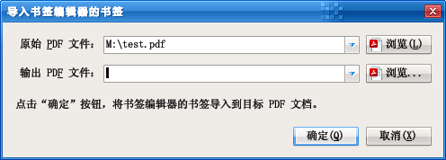

After selecting the target PDF file, click "Confirm" button, the program will copy the original PDF file and generate the target PDF file with bookmarks.

Tip: Hold down the Ctrl key and click the "Save" button to save with a new name. When you open a document as a PDF file, you will always save it with a new name.

### Basic editing functions

After opening the bookmark, you can use the editor interface to modify the style and properties of the bookmark. The basic editing operations are described below.

#### Select Bookmark

Use the mouse to click on the bookmark item, the item color turns back to white, indicating that the bookmark is selected.

Editor commands usually only work on the selected bookmarks. To make editing commands work on internal bookmarks, check the "Modify actions to include unselected internal bookmarks" checkbox.

If you need to select more than one bookmark at the same time, you can hold down the Shift key or Ctrl key of the keyboard, and then click the bookmark you need to select with the mouse (hold down the Shift key and click to select all the bookmarks within a certain range; hold down the Ctrl key and click to select the bookmarks clicked with the mouse one by one; when a bookmark is selected, hold down the Ctrl key and click the bookmark again will cancel its selected status).

Press the Ctrl+A key combination on the keyboard to select all displayed bookmarks.

Note: Pressing the Ctrl+A key combination will not select unexpanded subbookmarks.

#### Expand or collapse bookmarks in the editor

When a bookmark file is opened, the bookmark is collapsed by default. For example, after loading the bookmarks of a document, the bookmark editor is shown in the figure below. As you can see from the figure, there are three top-level bookmarks, click on the bookmark action is to go to the PDF document by the "page" column listed in the page.

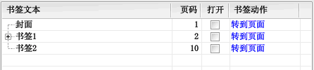

Chart 4 ---32 : The editor interface after loading a PDF bookmark

The bookmark item with the text "Bookmark 1" has a plus sign to the left, indicating that the bookmark contains subbookmarks. When you click on the plus sign, the subbookmarks gathered inside the bookmark will be displayed, and then the plus sign will change to a minus sign. This is shown in the figure below. As you can see from the figure, "Subbookmark 1" also contains subbookmarks, while "Subbookmark 2" and "Subbookmark 3" do not contain subbookmarks.

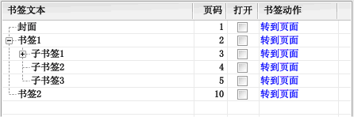

Chart 4 -33 : Expand bookmarks to show their subbookmarks

Clicking on the minus sign to the left of the bookmark text will cause its subbookmarks to collapse back to their pre-expanded state.

#### Move or copy bookmarks

After selecting a bookmark, use the mouse to point and hold the text area where you need to move the bookmark, and then drag the mouse to move the bookmark. Move the mouse over other bookmarks and release the mouse button to move the selected bookmark to the location where you released the mouse.

For example, in the figure below, select the "SunBookmark1" and "SubBookmark2" bookmarks and drag them to the "SubBookmark1" bookmark with the mouse. A blue rectangle will be displayed on "Subbookmark 1".

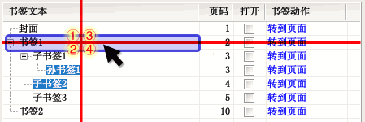

Chart 4 -34 : Move or copy bookmarks

The blue rectangle has four areas, and the mouse is released in different areas to move in different ways. Take the picture above as an example.

Release the mouse on the ① area and the selected bookmark will move to the front of "Bookmark 1".

Release the mouse on the ② area and the selected bookmark will move to the back of "Bookmark 1".

Release the mouse in the ③ area and the selected bookmark will be moved to the front of all subbookmarks of "Bookmark 1".

Release the mouse on the ④ area and the selected bookmark will be moved to the back of all subbookmarks of "Bookmark 1".

The effect after moving the bookmark is shown in the following figure for each marker respectively (the two bookmarks that were moved have been marked with color).

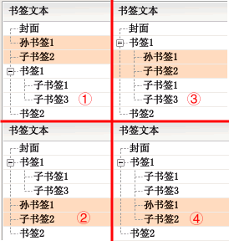

Chart 4 -35 : Effect of moving bookmarks

Note: When dragging a bookmark, press the Esc key on the keyboard to cancel the dragging operation.

While dragging a bookmark and releasing the mouse, press and hold the Ctrl key of the keyboard to copy the bookmark, i.e. the original selected bookmark will remain in the original location and a copy of the selected bookmark will be created in the new location. By holding down the Ctrl and Shift keys on the keyboard and releasing the mouse, the copied bookmark will contain the child bookmarks of the selected bookmark.

#### Modify bookmark text

Method 1: Select the bookmark that needs to be modified, then click the bookmark item again with the mouse (or press the F2 key on the keyboard), the bookmark text will enter the editing state. After finishing editing, press the Enter key (or click other bookmark items with the mouse) to confirm the changes. If you want to cancel the editing operation, you can press the Esc key of the keyboard to exit the editing.

Method 2: Click the text of the corresponding "Action" column of the bookmark, a property box will pop up. Modify the text in the "Bookmark Text" text box in the properties box, and then click the "OK" button to close the dialog box. See the section "Modify Bookmark Properties" for details.

#### Modify bookmark properties

Click the blue text of the bookmark item corresponding to the "Action" column, a property box will pop up. This is shown in the image below.

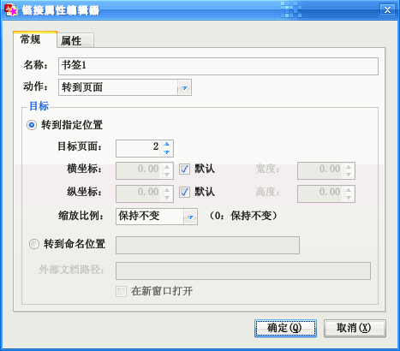

Chart 4 -36 : Link Action Editor

In this property box.

Modify the text of the bookmark by changing the text corresponding to the "Name" text box.

The "Type" drop-down box allows you to select the action that will be performed when the bookmark is clicked.

You can specify the target position of the bookmark in the "Target" group box (usually select the "Go to specified position" radio box). If the horizontal coordinate is "Default", the horizontal offset position will remain the same after clicking on the bookmark. If "Default" is selected for the vertical coordinate, the bookmark will go to the top of the page by default after clicking on it. If the horizontal or vertical coordinate value is 0, the original offset value of the reader will remain unchanged after clicking the bookmark.

Click the "OK" button to close the dialog box and confirm the changes.

Click the "Cancel" button to cancel the operation of modifying the bookmark properties.

#### Set bookmark style

There are two styles of bookmarks: bold and italic, and you can also set the color of the bookmark text. There are corresponding buttons in the toolbar.

Tip: When setting the bookmark text color, if you choose white, the bookmark text will be restored to the default color.

#### Set the default open state of bookmarks

The default open state of the bookmark can be set by modifying the checked state of the checkbox in the "Open" column. When the checkbox is checked, the bookmark is opened in the reader by default (its child bookmarks are displayed), and when the Open checkbox is unchecked, the bookmark is collapsed in the reader by default (the child bookmarks are not visible).

You can change the default opening status of multiple bookmarks using the "Set default opening status of bookmarks" command in the "Modify" menu.

#### Insert Bookmark

Click the "Insert Bookmark" button or press the Insert key on your keyboard to insert a new bookmark item.

Tip: You can also create new bookmarks by copying them by holding down the Ctrl key and dragging and dropping them.

#### Delete bookmark

After selecting a bookmark, click the "Delete" button, or press the Delete key on the keyboard to delete the selected bookmark.

When deleting a bookmark, if the bookmark contains a subbookmark, the subbookmark will also be deleted. To avoid deleting a subbookmark, move the subbookmark out before deleting the bookmark.

#### Edit Modify Subbookmarks

In general, modifying a bookmark will not affect its subbookmarks or the bookmarks contained in the subbookmarks. Pressing the Ctrl+A key combination to select all bookmarks will also not select unexpanded subbookmarks.

If you want to modify the subbookmark, one way is to expand the bookmark so that the subbookmark is displayed, and then select the subbookmark to modify. In the following figure, select "Bookmark 1" and "Sub-bookmark 2" at the same time and prepare to modify the two bookmarks.

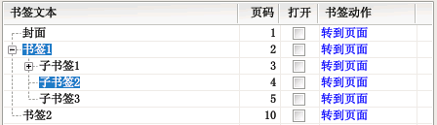

Chart 4 -37 : Select the expanded subbookmark for editing

Another way is to check the "Modify functions on unchecked internal bookmarks" checkbox. When this checkbox is checked, the editor's commands will modify both the selected bookmark and the internal bookmark it contains, regardless of whether the bookmark is expanded or not. This is shown in the figure below.

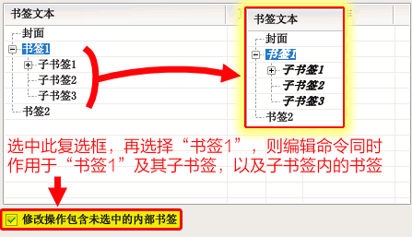

Chart 4 -438 : Check "Modify operation to include unchecked internal bookmarks" to perform changes

Note: If you hold down the Shift key and then click the Bookmark Editor command, the edit command will work on the internal bookmarks of the bookmark, which is equivalent to temporarily selecting the "Modify function to work on unchecked internal bookmarks" checkbox.

#### Indent bookmark level

Click the "→" button on the toolbar or press the Tab key on the keyboard to indent the selected bookmark one level inward.

In addition, you can also change the position of a bookmark by dragging and dropping it (see the previous section "Moving or copying bookmarks").

#### Change bookmark target page

Click the "Page" column of the bookmark list to modify the target page number of the bookmark.

To modify the target page number of multiple bookmarks at once, use the "Change Target Page" command under the "Modify" menu, or press the plus or minus key on the keypad to increase or decrease the page number of the selected bookmark.

In addition, you can also change the target page number of the bookmark by clicking on the link in the "Action" column in the pop-up dialog box.

### "Modify" menu function

The "Modify" menu contains a number of functions designed for editing PDF bookmarks. When using these functions, please note that the "Modify works on unselected internal bookmarks" checkbox is checked. When this checkbox is not checked, the modification function only works on the selected bookmark; when this checkbox is checked, the modification function also works on the bookmark below the selected bookmark. Several functions of this menu have been described in the previous article, the following will introduce the commands not described in the previous article.

#### Change the display of bookmarks

Some bookmarks change the display ratio of the reader when clicked. Generally, this behavior is not desired by readers. To remove the effect of bookmarks on the display ratio, use the "Change how bookmarks are displayed" command to set the display ratio to "Leave as is".

Using this menu command, you can also specify that the bookmark is scaled to a specified ratio after you click it, such as "Fit to page", "Fit to page width", etc.

If you only need to change the display of a particular bookmark, you can also click on the link in the "Actions" column of the bookmark list and select the desired scaling in the pop-up dialog.

#### Clear Coordinate Positioning Offset

Some bookmarks will shift the view of the reader by a certain direction when clicked, you can use this function to clear their effect.

#### Change target page coordinates

This function changes the positioning coordinates after clicking the bookmark and going to the target page. The command interface is shown below.

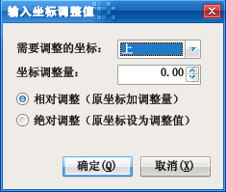

Chart 4 - -39 : "Enter Coordinate Adjustment Values" dialog box

For most bookmarks, you only need to edit the coordinates with the orientation "up". "Relative adjustment" is to increase the amount of coordinate adjustment from the original coordinates (a negative amount means that the original coordinates are reduced). "Absolute adjustment" is to set the amount of coordinate adjustment to the coordinate value.

If you only need to adjust the coordinates of a single bookmark, you can click the link in the "Action" column of the bookmark list and edit the bookmark target coordinates in the pop-up dialog.

#### Merge bookmarks

This function is to merge multiple sibling bookmarks into one bookmark. The text of the merged bookmark is a concatenation of the text of the original selected bookmark.

If the merged bookmark contains subbookmarks, all subbookmarks will become subbookmarks of the merged bookmark.

### Search and replace bookmark text

Another great feature of Bookmark Editor is that you can search and replace bookmark text in batch. Click "Search and replace bookmark text" button, a dialog box will pop up as shown below, you can use this dialog box to complete the task of searching and replacing bookmark text.

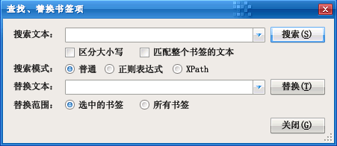

Chart 4 - -40 : "Search and Replace Bookmarked Text" dialog box

In the "Search text" box, you can enter the text to be searched. Click on the triangle button on the right to select the text previously used for the search.

The default search is not case-sensitive, if you need to distinguish, you can select the "Case-sensitive" checkbox.

The default search is a fuzzy search, i.e. as long as the bookmark text partially matches the search text, it is a match. If you select the "Match entire bookmark text" checkbox, the search will only match if the bookmark text exactly matches the search text.

There are three search modes.

The first one is the "normal" mode, which is used to retrieve whether the bookmark text contains the search text or not.

The second is the "regular expression" mode, where the search text is treated as a regular expression, and the bookmark text is considered a match when it matches the expression.

The third one is the "XPath" mode. In this mode, the bookmarks of the bookmark editor are treated as an XML document, each bookmark is a "bookmark" element, and the properties of the bookmark (such as target page, action, etc.) are treated as properties of the XML "bookmark" element. The search text is treated as an XML path expression, and when the bookmark element matches the expression, it is considered a match. The structure of a bookmarked XML document can be found in the section Document Bookmarks for Information Files.

In the "Replace text" box, enter the text to replace the search content. If you use a regular expression search pattern and specify a group match in the search expression, you can replace the matching group with "$1", "$2", etc. in the replacement text.

#### Regular expression search example

The following example illustrates the use of regular expression search with several examples. Set the bookmarks loaded by the Bookmark Editor as shown below.

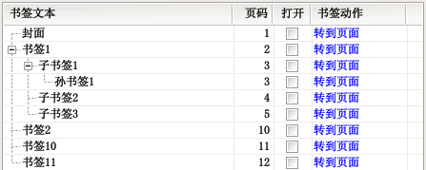

Chart 4 -41 : Example bookmark

Tables 4 -55 : Regular expression search example

| Bookmarks to match | Expressions | Search Results | Description |
| --- | --- | --- | --- |
| Contains any character | . * | All bookmarks | ". " indicates any character; "*" indicates 0 or any number of occurrences of the preceding pattern, ". *" means that any character appears 0 or any number of times |
| Start with "Bookmark" | ^Bookmarks | Bookmark 1, Bookmark 2, Bookmark 10, Bookmark 11 | "^" indicates the beginning of the text |
| Ends with "Bookmark 1" | Bookmarks1$ | Bookmark 1, Sub-bookmark 1, Sun-bookmark 1, Bookmark 11 | "$" indicates the end of the text |
| Include "child" or "grandchild" bookmarks | [Descendants] Bookmark | Sub-bookmark 1, Sub-bookmark 2, Sub-bookmark 3, Bookmark 2 | "[]" means range match, as long as the characters of the matched text match any of the characters in the range, the expression is equivalent to matching "sub bookmark" or "grand bookmark " text |
| Sub-bookmarks|Sun-bookmarks | "|" means "logical or" relationship, this expression means "child bookmark" or "grandchild bookmark" |
| Bookmark text exactly matches "Bookmark 1" or "Subbookmark 1" | ^Sub? Bookmarks1$ | Bookmark 1, Sub-bookmark 1 | "? " indicates that the preceding content does not appear or appears 1 time |
| ^(bookmark1|subbookmark1)$ | "()" means that the contents inside are a set of |
| "Bookmark" followed by a number other than 1 | Bookmarks [2-90] | Sub-bookmark 2, Sub-bookmark 3, Bookmark 2 | "[]" means range matching, "2-9" means matching characters from 2 to 9, followed by "0" to match the character "0 ", which does not contain 1 in this set, so it matches a number that is not 1 |
| "Bookmark" followed by a non-1 character | Bookmarks[^1] | Results as above | "[^]" means filtering range matching, the matched text cannot be any of the characters inside the square brackets, "[^1]" means that it cannot be any character of 1 (may be Chinese characters or punctuation, etc.) |
| Contains two numbers | [0-9]{2} | Bookmark 10, Bookmark 11 | "{2}" means match the previous pattern twice, "[0-9]{2}" means match 2 digits |
| "Bookmark" followed by a number of numbers | ^ bookmarks[0-9]+ | Bookmark 1, Bookmark 2, Bookmark 10, Bookmark 11 | "+" means match the previous pattern at least once, "[0-9]+" means match at least 1 number, and ". +" means match at least 1 arbitrary character |
| ^ bookmarks[0-9]{1,} | "{1,}" means match the previous pattern at least 1 time, equivalent to the "+" sign, and "{2,}" means match the previous pattern at least twice, while "{2,3}" means match 2 or 3 times |

If the search expression uses the parentheses "()" grouping, replace the contents of the grouping with "$1", "$2" and other substitution characters.

For example, if you need to convert the form of "subbookmark 1" and "subbookmark 2" to "1) subbookmark" and "2) subbookmark " to "1)subbookmark" and "2)subbookmark" (by bringing the numbers to the front), you can use the search expression "subbookmark([0-9]+)" to locate the bookmark and capture the numbers with the bracketed group "([0-9]+)", then use "$1) subbookmark" is used as the replacement text, where "$1" represents the replacement of the matching number in parentheses in the search expression.

For example, the numbers and texts of "subbookmark 1", "grandchild bookmark 1", "subbookmark 2", etc. are swapped to "1subbookmark ", "1 SunBookmark", "2 SubBookmark" and so on, you can use the search expression "([ChildSun]Bookmark)([0-9]+)". Use two pairs of brackets to group, the first group matches "child bookmark" or "grandchild bookmark", the second group matches the number after it, and then use "$2$1" as the replacement text to perform the replacement. .

For more on regular expressions, see the tutorials and materials.

#### XML path (XPath) search example

XPath search works by treating the bookmark information file as an XML document and then performing XML path matching on top of it. The bookmarks that match the XML path expression will be selected. Using XML path search can accomplish search tasks that cannot be done with normal search.

Each bookmark is represented in the XML document as a "bookmark" element, and the attributes of the bookmark (such as page number, action, etc.) are represented as XML attributes, and child bookmarks are treated as children of the parent bookmark.

Take the bookmark shown in the illustration of the previous section as an example, and give the number of XML path matches as shown in the table below.

| Bookmarks to match | Expressions | Search Results | Description |
| --- | --- | --- | --- |
| Text for "Bookmark 1" | @text='bookmark1' | Bookmarks 1 | "@text" indicates the text of the bookmark, and the text string to be matched is enclosed in single quotes "'" or double quotes """; the equal sign indicates whether the values of the two sides are equal |
| Target page number range is 5 to 10 | @Pages >= 5 and @Pages <= 10 | Subbookmark 3, Bookmark 2 | "@Page" indicates the target page number of the bookmark, "and" indicates a "logical and" relationship; ">= " means greater than or equal to the relationship, while "<=" means less than or equal to the relationship |
| Style is bold | @style='bold' | No matching bookmarks | "@style" means that the bookmark is bold or italic style; this example does not have the style of bold bookmarks |
| Bookmarks with sub bookmarks | Bookmarks | Bookmark 1, Sub-bookmark 1 | "Bookmark" means check if there is a subbookmark named "Bookmark" |
| Sub-bookmarks with sub-bookmarks inside | Bookmarks/Bookmarks | Bookmarks 1 | The first "bookmark" matches a bookmark with subbookmarks, "/" means one level inwards, the second "bookmark" matches a bookmark with subbookmarks within the above matched bookmark |
| Bookmarks that point to the same page as the upper bookmark | ... /@page = @page | Sun Bookmark 1 | "... /" means the upper bookmark, "... /@page" means to get the "page number" property of the upper bookmark, and the second "@page" is the current bookmark page number; when the page number of the upper bookmark is equal to the current bookmark page number, the equation holds ( The page number of "SunBookmark1" and its upper bookmark "SubBookmark1" point to the page number of 3) |
| Bookmarks with text starting with "Sun bookmark" as a subbookmark | bookmarks[starts-with (@text, 'Sun bookmarks')] | Sub Bookmark 1 | First, "bookmarks" filters the bookmarks with subbookmarks, then "[]" means that the content of these subbookmarks is the judgment condition, if the condition holds, it is considered a match; "starts-with " is a function, when the first argument starts with the second argument, the decision is considered to be valid |
| Text contains "subbookmarks" | contains(@text, 'subbookmark') | Sub-bookmark 1, Sub-bookmark 2, Sub-bookmark 3 | The "contains" function checks whether the first text parameter contains the content of the second text parameter |
| First bookmark within the same class | position() = 1 | Cover, sub bookmark 1, grandson bookmark 1 | The "position" function returns the current position of the bookmark; when calculating only the position, the simplified expression "1" can be used |
| 1 |
| The last bookmark within the same class | last() | Sun bookmark 1, sub bookmark 3, bookmark 2 | The "last" function returns the position of the last sibling bookmark, which is equal to the value returned by the function when it is the last bookmark (this expression is equivalent to "position()=last()") |
| The bookmark whose position is not the last one in the same level of bookmarks | following-sibling::bookmark | Cover, bookmark 1, sub bookmark 1, sub bookmark 2 | "following-sibling::bookmark" means the next bookmark at the same level; the last bookmark in each level does not have the next bookmark at the same level, so this requirement is equivalent to matching the bookmark with the next bookmark at the same level |
| Bookmark with 3 sub bookmarks | count(bookmark)=3 | Bookmarks 1 | The "count" function returns the number of nodes that match the expression in its parentheses |

For more information about XML paths, please refer to the tutorials and materials.

## Recognition of image text

Identify image text function can identify the text of the image within the PDF document into an editable text file, after editing the document, the text can be written into the PDF document as a transparent text layer, so that the image text of the PDF document can be indexed by the search tool.

Note: This feature requires the Document Imaging component of Microsoft Office 2003 or Office 2007 and the corresponding language recognition module to be installed on the machine.

The interface of this function is shown in the following figure.

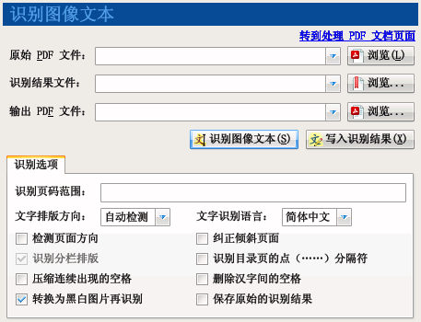

Chart 4 -42 : Recognition of image text functions

### Steps for recognizing image text

1. Select the "Recognize image text" function.
2. Click the "Browse" button on the right of "Original PDF File" to specify the path to the PDF file where the image text needs to be recognized.
3. If you want to save the recognition result as a text file, click the "Browse" button on the right side of "Recognition result file" and specify the location to save the text file. If you do not specify this file path during the recognition process, the program will output the recognition results to the log window.
4. Enter the page number of the image text to be recognized in the "Recognize page range" text box, if not, then all pages of the image will be recognized.
5. Click the "Recognize Image Text" button to start recognition.

Note: If the suffix of the recognition result file is ".xml", the output information file will contain the coordinate information of the recognized text in the page.

### Steps for writing in recognition results

1. Select the "Recognize image text" function.
2. Click the "Browse" button to the right of the "Original PDF file" to specify the path to the PDF file where the recognition result file is generated.
3. Click the "Browse" button on the right side of "Identify Result File" to specify the path of the XML result file to be saved after identification.
4. Click the "Browse" button on the right of "Output PDF file" to specify the path of the PDF file generated after writing the recognition result.
5. Click the "Write recognition result" button to start recognition.

### Identification options

If the text in the original document image is a uniform layout direction (i.e. all horizontal or all vertical), it is recommended to select the corresponding layout method in the "Text Layout Direction" drop-down box.

In the "Text Recognition Language" drop-down box, you can choose the recognition language, the default is Simplified Chinese, in addition, you can choose Traditional Chinese or English.

Note: The recognition of image text function is done by calling the recognition engine of Microsoft Office Document Imaging component to recognize text. Therefore, the corresponding language recognition component must be installed first. If only the Simplified Chinese recognition engine is installed, it is obvious that Traditional Chinese cannot be recognized correctly.

The "Rotation correction" and "Stretch correction" checkboxes allow the recognition engine to try to recognize the rotation direction and tilt angle of the text in the image to improve the recognition. These two options are not selected by default to improve recognition speed.

Check the "Detect page orientation" checkbox to allow the program to automatically identify whether the page is in landscape or portrait orientation.

Check the "Correct skewed pages" checkbox to allow the program to automatically correct skewed pages and improve the recognition rate.

Note: Check the above two options are required to perform more operations, such as recognition results are more satisfactory, no need to select the above two options in order to improve the recognition speed.

When the "Save original recognition results" checkbox is selected, the recognition results output by the Microsoft Office recognition component are saved as is. It is recommended to check this option when you need to write the recognition results to a PDF document. When the checkbox is not selected, the program tries to combine text from the same line in order to extract the recognized text content.

### Identify the directory page as a simple bookmark file

One feature of Image Text Recognition is to recognize scanned PDF document table of contents pages into easy bookmark files for quick PDF bookmark creation.

Microsoft Office's recognition engine does not work very well when recognizing table of contents pages. The recognition engine usually misidentifies the dot (i.e., the consecutive ellipses "......") in the table of contents as a series of periods or the number "0 ", etc. It is recommended to check the "Recognize dot (......) separator for directory pages" checkbox so that the program will try to correct the recognition engine's incorrect results.

In addition, it is recommended to check the "Compress consecutive spaces" checkbox, and then check the "Delete spaces between characters" checkbox if necessary, and uncheck the "Identify columnar typesetting" checkbox ( When the text layout direction is "auto-detect", you cannot switch the selection status of this check box, you need to manually specify the layout direction to switch this check box).

The output text file after recognition can be opened directly with the bookmark editor.

Use the "Change Target Page" function of the Bookmark Editor to fix the correspondence between the table of contents page number and the actual page number.

## Extraction of images

The extract picture function can export pictures of PDF documents to picture files without any loss.

The interface of this function is shown in the following figure.

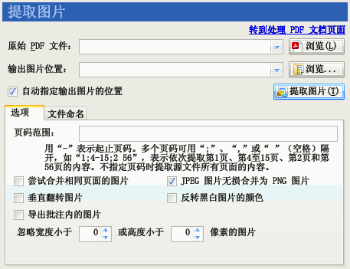

Chart 4 -43 : Extraction of image functions

### Operation Steps

1. Select the "Extract Image" function.
2. Click the "Browse" button on the right side of the "Original PDF File" to specify the PDF file from which you need to extract images.
3. Click the "Browse" button to the right of "Export Location", a directory browse box will pop up. Use this dialog box to select a directory to which the exported images will be stored.
4. Click the "Extract Image" button.
5. The program interface goes to the "Export Information" screen. The program will open the PDF file and export the images in the file to the previously specified directory. At any time during the export process, you can click the "Back" button in the Export Information screen to end the export process.

### Extraction Options

Page Range: Specify to export images with a specific range of page numbers. If you do not specify "Page Range", all images that can be found in the PDF file will be exported.

Try to merge images on the same page: Try to merge images with the same horizontal coordinates, the same width and the same format on the same page into a single image. The reason for providing this function is that some PDF production tools will split a pair of pictures into multiple pieces and write them into PDF files piece by piece. Thus, the extracted images will be fragmented. Using this feature will reunite these fragmented images into one image.

Lossless merge JPEG pictures to PNG pictures: When you select "Try to merge pictures of the same page", if the pictures before merging are JPEG pictures, the pictures will be losslessly merged to PNG pictures.

Flip images vertically: Flip the exported images vertically. Some PDF production tools will flip the picture vertically and then write the PDF file. As a result, the extracted images will be upside down. Use this function to restore the upside-down images back.

Note: If the image is compressed in a lossy format such as JPEG, flipping the image vertically may result in degradation of the quality of the extracted image.

Reverse the color of black and white pictures: reverse the color of pictures that have only two colors. Some PDF production tools will reverse the picture black and white, and then use the PDF rendering instructions to set the drawing colors in the way the colors are reversed when rendering. This will result in extracted images with black and white reversed. Use this function to restore the opposite color back.

Ignore images of specified width or height: Some PDF files contain some very small images. If you don't need to export these images, you can use this option to ignore them.

Export images within annotations: When this option is checked, the images within the annotations are exported. When this option is unchecked, only the images in the PDF body are exported.

### File naming rules

The default name of the extracted image file is the four-digit file name of the page number (mask "0000"), such as "0001.jpg", "0002.tif ", "0010.tif", etc. The file name extension is automatically generated according to the compression method used in the PDF document picture. For example: the picture is JPEG algorithm compression, the extension "jpg"; black and white (using CCITTFax or JBIG2 algorithm compression), the extension "tif"; color or grayscale (using Deflate, etc.) algorithm), the extension is "png".

The part in front of the extracted image file extension can be modified by changing the "File name mask".

If you don't need to fill the number of bits with 0, you can enter the mask "0" or no mask, the program will output the image file name such as "1.jpg", "2.tif", "10.tif", etc. "10.tif", etc.

If you fill in Chinese characters in the mask, the output file name will contain the Chinese character name. For example, the mask "document 000" will generate "document 001.jpg", "document 002.tif" and other image files.

If the invariant part of the file name contains "0", you can enclose the invariant part in half-quotes "". For example, if the mask ""Windows 2008 Reference Book "0"", it will generate "Windows 2008 Reference Book 1.jpg", "Windows 2008 Reference Book 2. png" and so on.

When changing the file mask, the "Examples" tab will demonstrate the naming of image files on pages 1, 2, 3, 11, 12, 13 and 100.

## Extraction page

The Extract Page Content feature allows you to export a specified range of pages of a PDF document into a single PDF file.

The interface of this function is shown in the following figure.

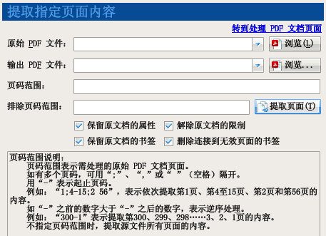

Chart 4 -44 : Extract page function

The extraction of the page is done as shown below.

1. Select the "Extract Page" function.
2. Click the "Browse" button on the right of "Original PDF File" to specify the PDF file from which pages need to be extracted.
3. Click the "Browse" button to the right of "Output Location", a browse box will pop up to save the file. Use this dialog box to specify the location to save the extracted pages after the production of PDF files.
4. If you only need to export content within a specific range of page numbers, you can fill in the page number range in the text box to the right of "Page Number Range". If you do not specify a page range, all pages of the PDF file will be exported.
5. If there are certain page numbers that do not need to be extracted, you can also fill in the "Exclude page range" text box to exclude the page range.
6. Click the "Extract Page" button.
7. The program interface goes to the "Export Information" interface. The program will open the original PDF file and export the specified range of pages to a new PDF file. At any time during the export process, you can click the "Back" button in the Export Information screen to end the export process.

Tip: The page number range supports reverse order range, such as the page number range "10-1", will first insert the source document page 10, then insert page 9, and so on, and finally insert page 1 to the output document. In addition to using this function to export the specified pages of PDF files, you can also use the "MakePDFFile" function to export pages from existing PDF files to generate new PDF files.

## Document Structure Probe

Document Structure Probe provides a tool for PDF developers, enthusiasts, etc. to view and modify the internal structure of PDF documents.

The interface of this function is shown in the following figure.

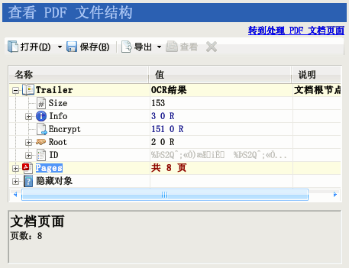

Chart 4 -445 : Document Structure Finder Interface

Operation method.

1. Select the "Document Structure Probe" feature.
2. Click the "Open" button to open the PDF document of interest.

Tip: You can open a PDF document by dragging it from My Computer or Explorer to the function screen.

1. Wait a moment, after the program to open the document, the program to show the internal hierarchy of PDF documents in a tree-type list.
2. The first column of the list is the name of the node. Some nodes (e.g., dictionary, array type nodes) contain internal nodes, which have a plus sign to the left of the node icon. Clicking on the plus sign expands the node to see the contents of the internal node. Some reference nodes to dictionaries or arrays also have a plus sign to the left of their icons. Clicking on the plus sign expands the reference node to see the contents of the target to which it refers.
3. The root node of the document is the Document Cataloging (Trailer) node.
4. For ease of use, the program converts each page of the document into a separate page node, which is displayed independently under the Pages node (which is a virtual node and is actually generated based on the document's internal page tree dictionary).
5. The second column of the list is the value of the node, click the corresponding cell with the mouse to modify its content.
6. Below the list is a note window to explain the meaning of the selected node and its range of values. The program has built-in information on dozens of common PDF nodes for PDF lovers to refer to.
7. Click the "Delete" button to delete the selected node. Some nodes are required to be present in the document and cannot be deleted. When the node is selected, the Delete button will be disabled (shown as a gray button). When a dictionary or array node is deleted, the content node of the dictionary or array is also deleted. When deleting a reference node, only the node is deleted, not the target node to which the node refers.
8. Select the data flow node of the document and press the "Export" button to export the content node to a binary file or a text file for analysis by an external program.
9. Select the image data stream in the document and press the View button, a window will pop up displaying the image of the data stream.
10. Select the text stream in the document and press the View button to view the content of the text stream in the Notes window.
11. After modifying the document, if you want to save the modified document, you can click the "Save" button.

Warning: Before using Document Structure Probe, you should prepare a certain amount of PDF knowledge. If this tool is used improperly and the modified document overwrites the original PDF file, it will probably lead to loss of data and cause irreparable damage.

## Global Options

This option specifies the common way of working for each function of the program.

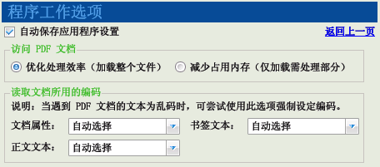

Chart 4 -46 : Global work options for the program

Access PDF documents: Specify the program's policy for reading PDFs. If "Optimize processing efficiency" is selected, the program will try to load the entire PDF file into memory to facilitate more efficient processing. If "Reduce memory consumption" is selected, the program will load only the index table of the PDF to minimize the amount of memory used. If the PDF document is large, you can use this option to avoid the program to load the document and run out of memory.

Read the encoding used in the document: Some PDF documents use non-standard encoding, resulting in not being able to read properly, and exporting the information file as a mess. You can use this option to force to specify the encoding form to read and try to export information in a different encoding form. For details, please refer to Fix Text as Garbled Bookmarks.

## Output Information

The "Log Contents" text box of the interface outputs information about the program's work and the errors encountered. The program will go to this screen when it starts executing tasks.

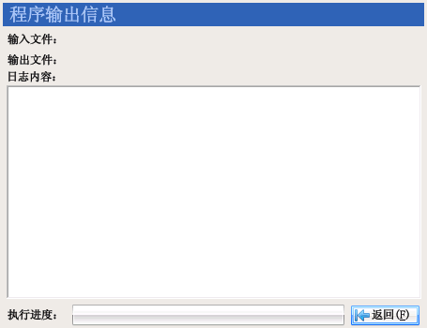

Chart 4 -47 : Output information interface

During the program's operation, clicking the "Back" button will bring up a confirmation dialog box, where clicking the "Yes" button will terminate the program.

After the program has completed its work, clicking the "Back" button will return you to the previous function screen.

Click on an underlined file or directory name in the log window to open the corresponding file or directory.

# Application Examples

In order to better explain the use of PDF Patcher, here are a few examples of the establishment of the situation, the reader can refer to the program to use a better.

## Cancel the display ratio of bookmarks and page links

Task: Some PDF documents bookmarks or page links will change the display ratio of the reader after clicking, for example, the reader would have used 135% of the display ratio, click on the bookmark, the display ratio becomes suitable for the page, the font becomes very small. This has caused inconvenience for readers to read. Using PDF Patching can easily maintain the display ratio of the reader, not to let it freely change and affect the reading.

The operation steps are as follows.

1. Select the "PDF Document Options" feature.
2. Click on the "Reading Style" tab and check the "Disable bookmarks and page links from changing display scale" checkbox.
3. Select the "Standalone Patch" mode of the "Process, Create PDF Documents" function.
4. Add PDF documents to the file list that need to be modified.
5. Specify the path to the output PDF file.
6. Click the "Generate PDF file" button. In the generated new file, clicking on the bookmarks and page links will not change the display ratio of the reader anymore.

The schematic diagram of the processing is shown below.

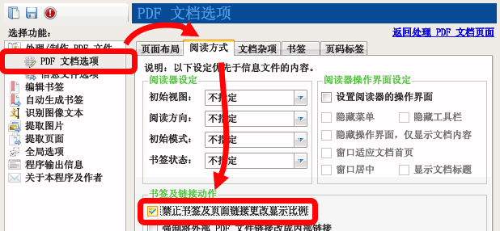

Chart 5 -1 : Patch Steps 1 to 2: Selecting Patch Options

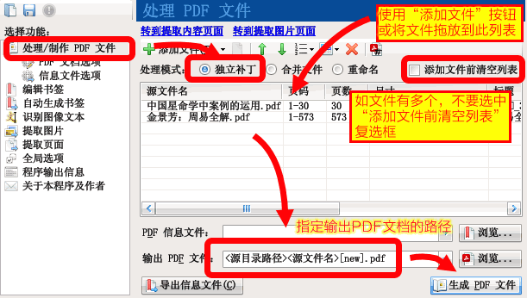

Chart 5 -2 : Patch steps 3 to 6: Select the file to execute the patch

## Close the default expanded bookmark

Task: Some PDF documents have bookmarks for easy reading. However, the number of bookmarks and layers are many, and all in the default expanded state, to flip the scroll bar to find the items needed. Change the default state of bookmarks to close, and then manually open them when reading, which is usually more convenient than opening all bookmarks by default. Use PDF Patcher can batch change the open state of the document bookmarks.

### Use the independent patch function to modify the bookmark opening status of multiple PDF documents

To modify the open status of a bookmark using the standalone patch function, proceed as follows.

1. Select the "PDF Document Options" feature.
2. Click on the "Reading Style" tab, find the "Bookmark Status" drop-down box, and select "Close All".
3. Select the "Standalone Patch" mode of the "Process, Create PDF Documents" function.
4. Add PDF documents to the file list that need to be modified.
5. Specify the path to the output PDF file.
6. Click the "Generate PDF file" button. In the new document generated, the bookmarks are closed.

### Bookmarks Editor to modify a single PDF file with the bookmark open state

Use the Bookmark Editor to modify the opening state of the PDF document bookmark operation steps are as follows.

1. Select the "Edit Bookmark" function.
2. Click the "Open" button to open the PDF file that needs to be modified.
3. Batch select the bookmarks that need to change the open status, and then select the corresponding command in the "Set default open status of bookmarks" submenu under the "Modify" menu.
4. Click the "Patch" button to save the modified PDF file.

Tip: If there are subbookmarks within the selected bookmark, check the "Modify action to include unselected internal bookmarks" checkbox to apply the modification command to the inner bookmark.

Compared with the "standalone patch" feature, this method can make certain bookmarks open by default on demand, but obviously cannot handle PDF files in bulk.

## Uniform page size

Task: a PDF document page size varies, I hope to unify its page size to facilitate reading. The use of PDF Patcher operation steps are as follows.

1. Select the "PDF Document Options" feature.
2. In the "Page Layout" tab, by default, the size drop-down box is "Equal to original content size", you can change it to other defined sizes, such as "A4", "16", etc., or select "Custom", and then enter the appropriate values for "Width" and "Height". You can change it to other defined size, such as "A4", "16", etc., or select "Custom", and then enter appropriate values in "Width" and "Height". Then enter the appropriate values for "width" and "height".
3. Select the "Scale content to fit page" radio box in the "Source PDF page adjustment" group.
4. Return to the "Process, Create PDF Document" function and select "Standalone Patch" mode.
5. Add files that require a uniform page size and specify the output PDF file.
6. Click the "Export PDF file" button.

The options selected for the operation process are shown in the figure below.

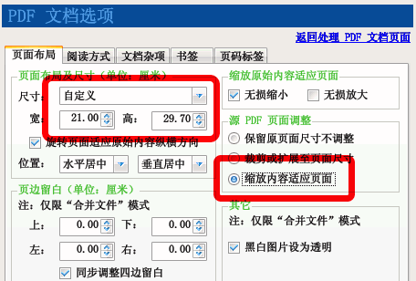

Chart 5 -3 : Patch Steps 2 to 3: Select a uniform size for PDF documents

Tip: The size of the first page of the PDF document is listed on the file list.

## Adjust the double page reading order of vertical documents

Task: Widescreen monitors are popular nowadays, and some larger widescreen monitors can display two pages of documents at a time. Switching to a two-page view will reduce the number of page turns and make it easier to read. But the default reading direction of the double-page display is "left to right" for vertical documents, it is not convenient to read: first from the middle of the page, read the bottom left corner of the page, and then jump to the top right corner of the page to read the next page. As shown in the figure below on the left.

If you can change the reading direction to "right to left", it will be more convenient to read vertical documents: start reading from the top right corner of the page to the bottom left corner after reading two pages, the line of sight does not need to turn. As shown in the figure below right.

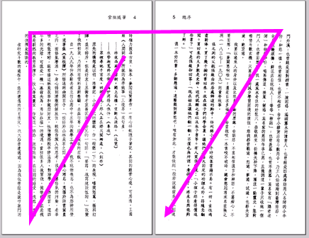　　　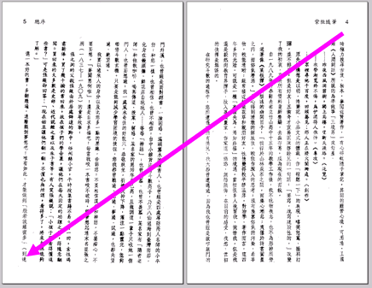

The operation steps are as follows.

1. Select the "PDF Document Options" feature.
2. Click on the "Read by" tab.
3. Select "Right to left" in the "Reading direction" drop-down box.
4. Return to the "Process, Create PDF Document" function and select "Standalone Patch" mode.
5. Add PDF files that need deletion actions.
6. Specify the path to the output PDF file.
7. Click the "Generate PDF Files" button. Use PDF Reader to open the new PDF document generated, switch to the two-page view, you will find that the reading order has been changed to the right to the left.

## Disable the behavior of setting the "fit to page" display when opening a document

Task: Some PDF documents automatically open when the display ratio of the reader is set to "suitable for the page", resulting in the display of too small a font, each time you read the need to manually adjust the display ratio, which is quite inconvenient. PDF Patching can be used to prohibit this behavior of the document.

The operation steps are as follows.

1. Select the "PDF Document Options" feature.
2. Click on the "Miscellaneous Document" tab.
3. Check the "Delete the automatic execution of actions when opening documents" check box.

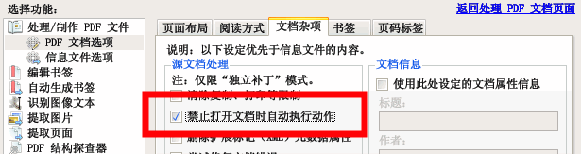

Chart 5 -44 : Select the "Disable automatic execution of actions when opening documents" option

1. Return to the "Process, Create PDF Document" function and select "Standalone Patch" mode.
2. Add PDF files that need deletion actions.
3. Specify the path to the output PDF file.
4. Click the "Generate PDF File" button, the program will read the original PDF file, remove the document's auto-execute action, and output it as a new PDF file.

## Clear pop-up pages when opening a page

Task: A PDF document automatically opens a browser to visit a specific website when reading a page. This is due to the actions performed by the PDF file to open the web page in the page. Using PDF Patcher can remove these actions.

The operation steps are as follows.

1. Select the "PDF Document Options" feature.
2. Click on the "Miscellaneous Document" tab.
3. Check the "Delete automatic actions on pages" checkbox.
4. If there is a web page pop-up when you open the document, you can check the "Remove the automatic execution of actions when opening documents" check box.
5. Return to the "Process, Create PDF Document" function and select "Standalone Patch" mode.
6. Add PDF files that need deletion actions.
7. Specify the path to the output PDF file.
8. Click the "Generate PDF File" button, the program will read the original PDF file, remove the auto-execute action in the page, and output it as a new PDF file.

## Exporting bookmarks in text form

Task: Export the bookmarks of PDF files to a directory in text form.

The operation steps are as follows.

1. Select the "Process/Produce PDF Files" function.
2. Select "Standalone Patch" mode.
3. Add the PDF files that need to be exported to the directory in the file list.
4. In the "PDF information file", specify a text file with the suffix "txt" as the output information file.
5. Click the "Export Info File" button. The exported message file will be a text file.

The operation steps are shown in the figure below.

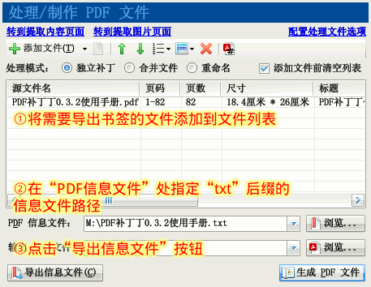

Chart 5 -5 : Export text bookmark information file

## Repairing bookmarks with the Bookmark Editor

Some PDF documents in the production of tools due to limitations, bookmarks do not meet the PDF specification, in the new version of the PDF reader can not be used properly, the usual problems are: bookmark text garbled, PDF files renamed after the bookmark failed, bookmarks point to the target page range is not correct.

Such PDF bookmarking problems can be easily fixed using PDF Patching's Bookmark Editor.

### Fix bookmark text mess

Task: a PDF document bookmarks for the mess, can not read, as shown below.

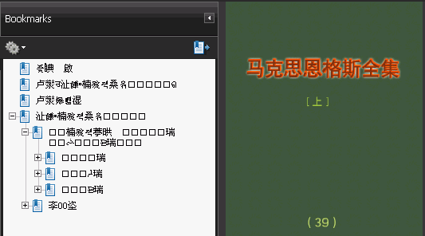

Chart 5 -6 : Messy bookmarks

Use the Bookmark Editor to load the document, found that the bookmark text is also garbled. As shown in the figure below.

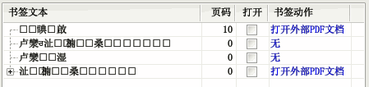

Chart 5 -7 : Garbled bookmarks displayed in the Bookmark Editor

Use the "Read Encoding" in the program's global options to force the encoding used to read the message and then reopen the bookmark.

The operation steps are as follows.

Click on "Global Options" to go to the global settings of the program.

Select the "Read encoding options" tab. Select "UTF-16 Big Endian" in the "Bookmark text encoding". As shown in the figure below.  
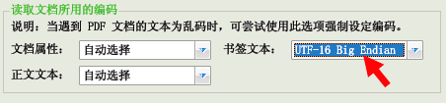

Back to the Bookmark Editor, click the toolbar "Open" button to reload the problematic PDF document. At this point you can see that the bookmark text has been normal (if not properly displayed, return to step 2 to select other encoding, and then repeat this step), as shown in the figure below.  
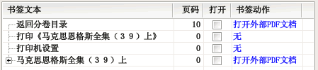

### Fix bookmarks that fail after renaming PDF files

The above PDF document bookmarks seem to have been repaired, but there are still problems. Once the PDF file name is changed, open the document and click on the bookmark will appear "can not open the document j24.pdf" and other errors, as shown in the figure below. Only the PDF file name back to "j24.pdf", bookmarks can work properly.

The reason for this problem is that the PDF document bookmark uses an external link to the specified file name instead of an internal link to the document.

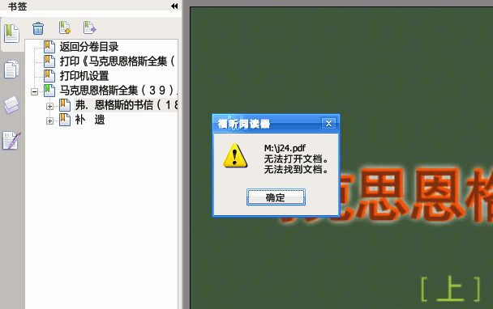

To solve the above problem, Bookmark Editor provides the function of "force external links to internal links". The procedure is as follows.

Open the bookmark with the Bookmark Editor (see the figure in the previous section for the results). In the editor can see that the bookmark action is "Open External PDF Document". Expand the bookmark, found that all bookmarks are actions to open external PDF documents. Click on any of the editor "bookmark action" column "open external PDF document" link, in the pop-up dialog box can be found, the bookmark action points to a named "j24.pdf "of the document. As shown in the figure below.  
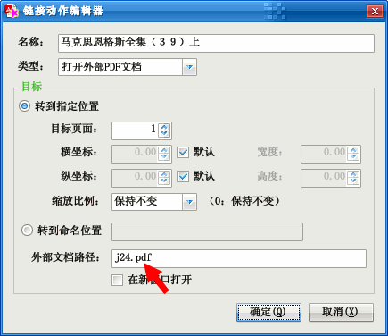

This is the reason why the link fails after the PDF file is renamed. Only when the file name is "j24.pdf", click on the link to jump to its designated page, otherwise, as there is no "j24.pdf" file, the PDF reader will report that the document could not be found error.

Click the "Cancel" button to close the above dialog and return to the Bookmark Editor.

Since all bookmarks have the same problem, you can use the command from the Modify menu to fix it all together. Press Ctrl+A (or select with the mouse) to select all bookmarks and select the "Modify action to include unselected internal bookmarks" checkbox to make the subsequent action work on the subbookmarks hidden inside the bookmark.

Click the "Modify" button and select the "Force in-file link" command in the pop-up menu.

After finishing, you can see from the editor that the bookmark action has changed to "Go to page". As shown in the image below.  
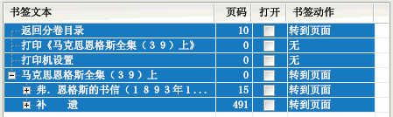

### Modify the target page number of the link

The use of advanced patching features will be bookmarked back to the PDF document can be found, the bookmark points to the target page forward deviated from a page. Should have pointed to the second page, but jumped to the first page; should point to the 16th page, but jumped to the 15th page. Using the Bookmark Editor, you can add one page back to the target page number of all pages. The procedure is as follows.

Open the bookmark with the bookmark editor (the result is shown in the figure in the previous section). From the bookmark editor you can see that the page number of the first valid page "Marx and Engels (39) on" points to 0.

Check the "Include unchecked internal bookmarks in modifications" checkbox to make subsequent modifications work on the subbookmarks hidden inside the bookmark.

Check all the bookmarked items.

Click the "Modify" button, and select the "Add Page" command in the pop-up menu.

After finishing, you can see from the editor that the page numbers have all been increased by 1. As shown in the figure below.  
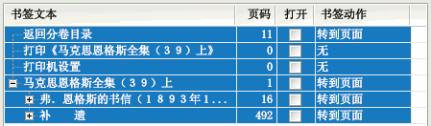

In addition, there is no need to keep the first three bookmark items, you can select them with the mouse and then click the "Delete" button on the toolbar to delete them.

### Patch the changes back to the PDF document

After the above few steps, the bookmark has been successfully repaired. The final step is a combination of bookmarks and the original PDF document, to generate a new document after the repair. Operation steps are as follows.

Click the "Save" button in the editor to save the bookmark as a message file with ".xml" suffix. (If you do not need to save the message file, you can skip this step)

Click the "Patch" button, a dialog box will pop up. The dialog box lists the original PDF file and the output PDF file. Specify the location of the patch output file in the "Output PDF File".

Click the "OK" button, wait a moment, the results of the changes just saved to the generation of new PDF documents to go.

## Add easy bookmarks

### Example 1: Using Excel to make a simple bookmark

On hand is a photocopy of the Huangdi Neijing without any bookmark. From the Internet we can easily find the text of the table of contents of this book. It is copied, with a little processing, into a line of text in a form similar to the following.

The First Treatise on Ancient Heaven and Truth

The Second Treatise on the Four Energies and the Great Spirit

The Third Treatise on Shengqi Tongtian

The Fourth Discourse on the True Discourse of Golden Scarcity

......

Then copy the text to an Excel worksheet, and the text above becomes column A (column 1).

The above table of contents does not have page numbers, therefore, page numbers have to be added in order for the bookmark to jump to the specified page. Photocopies of PDF are usually accompanied by the original book directory. Open the document with a PDF reader, go to the directory page, and then against the page number will be entered into the Excel column B (column 2).

After inputting, there is a gap between the page number in the directory page and the real page number in the PDF file. In this photocopied version of the PDF document, the first chapter appears in the document on page 14. Therefore, in front of the first line of the Excel table insert a line, enter "# Home Page = 14", that the following page number in the first page corresponds to the PDF document on page 14. Excel table looks like the following.

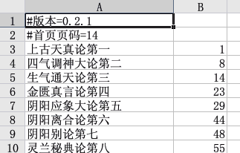

Chart 5 ---8 : Use Excel to create simple bookmarks (the "# version" command in line 1 can be ignored)

After completing the bookmark input, use Excel to save it as a "bookmark.txt" text file (it cannot be saved as an XLS file).

Open PDF Patching. Select the "Standalone Patch" mode of the "Process, Create PDF Documents" function. Add the PDF file of "Huangdi Neijing" to the file list. Select the text file you just saved in the "PDF Information File" section. Select the new PDF file after importing the bookmark file at "Output PDF File".

Tip: Close the Excel program before operation, otherwise the program cannot read the information file.

Click "Generate PDF File" button, the program will merge the simple bookmark and the original file to create a new PDF file.

Note: In addition to using the "standalone patch" function, you can also use the Bookmark Editor to open a simple bookmark file and execute the patch.

Patiently wait for the program to finish processing. Finally, we got a PDF file with bookmarks. As shown in the figure below.

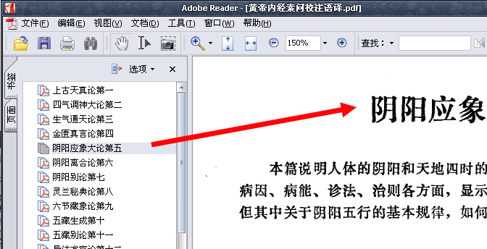

Chart 5 -9 : PDF file with easy bookmarks imported

### Example 2: Making a simple bookmark with a multi-level directory

The previous example explains the general steps to create a simple bookmark, this section describes the creation of a more complex multi-level bookmark.

First, enter the text of the simple bookmark you need to make. The partial table of contents for this example is shown below.

Chapter 1 Overview of Qigong in China 1

I. Brief history of qigong development 1

II. What is "qigong" 3

III. The purpose of practicing gong 5

IV. What are the effects of qigong 7

V. Classification and characteristics of qigong gong methods 9

Qigong for health 11

Diagnostic Qigong 19

......

This table of contents is actually divided into three levels, the first being chapters, the second being sections, and the last being subsections.

Copy the above text into the editing area of a text editor (e.g., AkelPad, PSPad, EditPlus, etc.). Select the above lines from "I. History of Qigong Development" to "Diagnosis of Qigong" and press the "Tab" key on your keyboard. In this way, these lines in front of a tab, it seems to be indented into the appearance of a layer. Then, select the following two lines from "Health Qigong" to "Diagnostic Qigong", and then press the "Tab" key, these two lines are indented into another layer. It becomes the following form.

Chapter 1 Overview of Qigong in China 1

I. Brief history of qigong development 1

II. What is "qigong" 3

III. The purpose of practicing gong 5

IV. What are the effects of qigong 7

V. Classification and characteristics of qigong gong methods 9

Qigong for health 11

Diagnostic Qigong 19

......

Treat the table of contents of the later chapters in a similar way.

open the PDF file to see the first chapter corresponds to the actual page number is the first few pages (this example is the seventh page). Therefore, we inserted a line in front of the first line in the bookmark file, add "# Home Page = 7" command, which became the following form.

#Home Page=7

Chapter 1 Overview of Qigong in China 1

I. Brief history of qigong development 1

......

"# Home Page = 7" instruction that the following page number 1 corresponds to page 7 of the PDF document.

The book still has a table of contents in the front. We can add something more to the bookmark file to include the table of contents in the bookmark. Insert the content before the first line of the bookmark file, which becomes the following form.

Table of Contents 1

#Home Page=7

Chapter 1 Overview of Qigong in China 1

I. Brief history of qigong development 1

......

Although the "directory" and "Chapter 1" page number are 1, but the "directory" corresponds to the first page of the PDF document, and as the second line "# Home page number" specifies the relationship between the page number, "Chapter 1" actually corresponds to the seventh page.

After completion, save the bookmark file as a text file. Then use PDF Patching to import it into the original PDF document, you can generate a PDF file with bookmarks. As shown in the figure below.

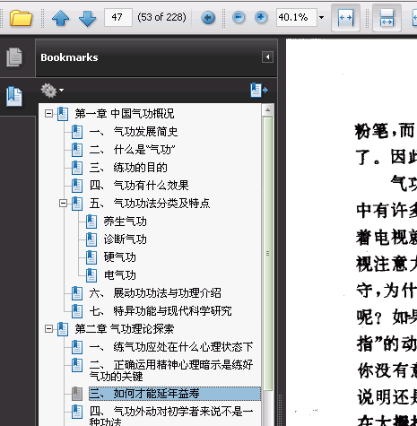

Chart 5 -10 : PDF bookmark with multi-layer table of contents

### Example 3: Using character recognition to generate simple bookmarks

Another way to create simple bookmarks for scanned PDF documents is to use the character recognition function to identify the directory page, using the text of the directory page to generate bookmarks. The basic operation steps are as follows.

1. Open and observe the document in the PDF reader to determine the range of directory pages of the scanned PDF document.
2. to "identify the image text" function, specify the need to identify the PDF file, and select the appropriate processing options (it is recommended to select "identify the directory page point separator", "compression of the continuous appearance of spaces " two options; in order to improve the recognition effect, you can manually specify the "text layout direction" option for horizontal or vertical; if the scanned page is skewed, you can check the "rotation correction" and "stretch correction "(two options).
3. Enter the page number range of the table of contents page in the "Identify page number range" text box.
4. Specify the text file to be output after recognizing the text, and click the "Recognize Image Text" button to try to recognize the directory page.
5. Edit the output text file to fix misidentified characters.
6. Open the text file with Bookmark Editor to make a bookmark file or patch it directly to a PDF document.

## Auto-generated navigation bookmarks

Auto-generated navigation bookmarks is a useful feature. This feature can automatically generate bookmarks for PDF documents, eliminating the inconvenience of manually entering bookmarks. The basic operation steps are as follows.

1. Observe documents and manually analyze document title features.
2. Try to generate bookmarks.
3. Adjust title recognition options and add filtering criteria.
4. Check the output bookmarks in the output log window or bookmark editor, and repeat steps 2 and 3 if you are not satisfied.
5. Use the Bookmark Editor to edit and optimize bookmarks.
6. Generate PDF files.

Note: The auto-generate PDF bookmarks feature can only generate bookmarks for text PDF documents, and cannot handle scanned image PDF documents.

The bookmarks in the PDF electronic version of this reference manual are generated using the automatic bookmark generation function. This section will take this manual as an example to tell the detailed operation steps of automatic bookmark generation.

### Observation Document

The first step in automatically generating bookmarks is to look at the PDF document and understand its typographic features. Observe the text that needs to be bookmarked with what features. To this document, for example, the document title has the following characteristics: ① each title are used in a larger size of bold Song or bold, ② font size with the title level and gradually become smaller. ③ each heading is a separate line. As shown in the following figure.

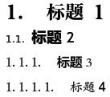

Chart 5 -11 : Title style of this reference manual

### Try to generate bookmarks

As the number of pages of PDF books is often more, it takes some time to deal with a certain amount of time, first of all, use the default settings of the program, try to generate bookmarks for a few more representative pages - with the need to generate bookmarks for the title of the page. Observe whether the titles of these pages can be fully generated bookmarks, and no other text introduced into the body.

This example attempts to generate bookmarks for pages 2 to 20 of the usage document in the default configuration. The options are configured as shown in the following figure.

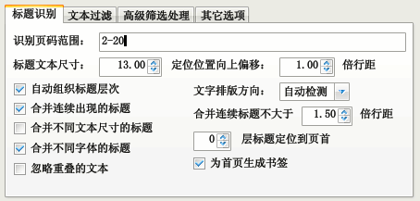

Chart 5 -12 : Use the default configuration to generate bookmarks for pages 2 to 20 of the sample document

Click the "Export Message File" button and the program will generate bookmarks and display the text to the log window as shown below.

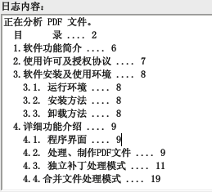

Chart 5 -13 : Bookmark text content of log file output

### Observe the output and adjust the title recognition options

Observing the output of the log window, we can see that according to the default header size, only header 2 can be output, and the text of header 3 and header 4 are not included in the output bookmarks.

In order to export the text of Heading 3 and Heading 4 as bookmarks as well, try to adjust the Heading Identification option, adjust the "Heading Text Size" parameter from the default 13 to a smaller 12, and then click the "Export Info File" button. As shown in the figure below.

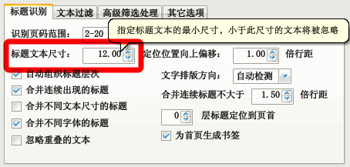

Chart 5 -14 : Adjust title text size parameter to output lower level titles

The output is shown in the figure below.

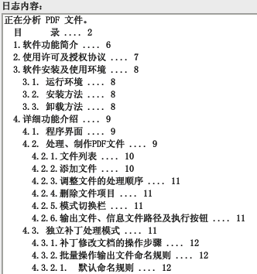

Chart 5 -15 : Text content of bookmark output after resizing title text

As you can see from the text output above, the contents of Heading 3 and Heading 4 have been output to the bookmark.

However, heading 3 and heading 4 have the same font size, so they are output to the bookmark at the same level (see "4.3.2" and "4.3.2.1" in the figure above), which does not reflect the hierarchical relationship between the headings.

To make the output bookmark reflect the hierarchical relationship between Heading 3 and Heading 4, you can add an adjustment item to the "Advanced Filtering" option to adjust the level of Heading 3 so that its level is greater than Heading 4 by doing the following.

Select the "Advanced Filtering" tab.

Since the message file has already been generated, you can click the "Add from message file" button.

Clicking the button will bring up a dialog box that lists the fonts used for document headings and their sizes, as well as the text content in the document where this size font was first used. As shown in the figure below.

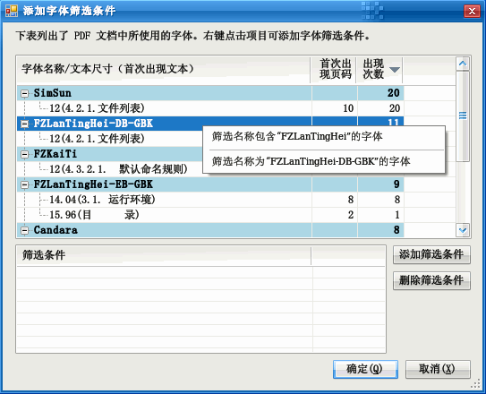

Chart 5 -16 : Add Font Filter Criteria

PDF documents in general, the use of English font names in the dialog box to find the first title 3 (example of "4.2.1 file list") corresponds to the font, as the title of a mixture of two fonts, so there are two places where the title of the text, and the size are 12.00, the first is The first is "SimSun", which the experienced reader will know corresponds to "Song", the font used for the number ("4.2.1") in the text of Heading 3; the following A "FZLanTingHei-DB-GBK" is the font used for the Chinese font ("Document List") in Heading 3. Right-click on the font name, and then select the "Filter fonts with name 'FZLanTingHei-DB-GBK'" menu item in the context menu that pops up.

After clicking the above command, you will see that an item has been added to the "Filter Criteria" list.

Click the "OK" button to close the dialog.

When you return to the "Advanced Filtering" option screen, you can see that a new filter has been added. Select the filtering condition, enter "0.01" in the "Adjustment level" column, and check the corresponding checkbox in the "Relative adjustment" column (the meaning of these two options is to increase the level of text that meets the filtering The meaning of these two options is to increase the level of the text that meets the filtering conditions by 0.01; if you do not check the "Select Adjustment" check box, it means that the level of the matching text is reduced to 0.01). The following figure shows.

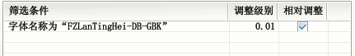

Chart 5 -17 : Increase the level of headings matched by filter criteria

From the previous analysis, we can see that the level of Heading 3 and Heading 4 are the same, and now the level of Heading 3 is increased by 0.01, so Heading 3 will have a higher level than Heading 4, and Heading 4 will be included in the exported bookmarks. Click the "Export Info File" button to re-execute the operation of generating bookmarks.

Looking at the output, it can be seen that heading 3 already contains heading 4. The output is basically satisfactory.

Return to the screen where bookmarks are automatically generated and modify the page range to include all pages to be processed. Then perform the Export Info File operation to generate bookmarks for the entire document.

### Use the Bookmark Editor to modify the output bookmarks

After generating the message file, you can use the Bookmark Editor to modify the text in it to make the bookmark more beautiful. The specific process is omitted here, you can see the content of the previous article. After modifying the bookmarks, you can use the bookmark editor's patch function to generate a new PDF document with bookmarks.

## Batch delete the first and last page of the document

Task: a group of Internet users to get a PDF file, the first and last page of each document are advertisements, want to batch to remove them. Using PDF Patcher operation steps are as follows.

1. Select the "Extract Page" function.
2. Put the original PDF files in the same directory (set the directory as "E:\Original Files"), click the "Browse" button on the right of "Original PDF Files" to go to the above directory Select the batch file.
3. In the "Output PDF file" on the right side of the combined edit box, specify the output location, such as "E:\output file \abc.pdf". The program will copy the original file to the "E:\output file" directory (ignore the output file name "abc.pdf", the program will automatically replace the original file name for the output directory file name).
4. Do not enter anything in the "Page Range" text box, the program handles all pages by default. In the "Exclude page range" text box, enter "1;-1" to exclude page 1 and the penultimate page (a negative number means the page number from the end).
5. Just click the "Extract Page" button.

## Batch reverse page order documents

Task: A network user downloaded a number of PDF documents. The pages in each document are arranged backwards. The first page of the original book in the PDF file into the last page, the end of the book page but in the forefront. If you use the PDF editor to manually adjust the number of pages one by one document, it will take a lot of time. The user tried to use the PDF printer's "reverse-order printing" function to rearrange the pages, but reverse-order printing will reduce the quality of the document, time-consuming even more.

Use PDF Patcher can easily batch adjust the page number order, the operation steps and screenshots are as follows.

1. Select the "Extract Page" function.
2. Click the "Browse" button on the right side of the "Original PDF File", and in the Open File dialog box that pops up, select the PDF document that needs to rearrange the page order (you can select more).
3. At the output PDF file, enter the output path (in this example, it is "M:\"), then right-click the text box, and select "< source file name>" in the pop-up context menu to insert the source file name substitution character, which means output to the output directory by the file name of the original PDF file.
4. In the "page range" text box to fill in the reverse page range: "-1-1" (without quotation marks). The first "-1" means the last page of the document, the middle "-" sign indicates the page number range, and the last "1" means the first page. "-1-1" that is, the last page of the document to the first page (if you need to extract the page from the penultimate page of the document, then enter "-2-1").
5. Click the "Extract Pages" button to return the original PDF file with inverted page numbers to its original state and save it to the output path.

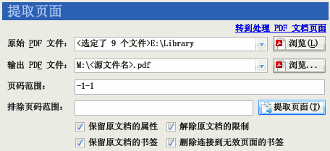

Chart 5 -18 : Reorder Reverse Order Pages

## Illustrate, merge documents and retain original document bookmarks

Task: the "novel (I).pdf" and "novel (II).pdf" merged into a PDF file, and in the merged PDF file in front of the first page insert "cover.jpg " image file. "novel (a)" and "novel (b)" the two PDF files themselves have easy to read bookmarks, I hope the combined PDF document also comes with the original bookmarks to read.

The use of PDF Patcher can complete the above-mentioned task of inserting pictures and merging PDF documents. The operation steps are as follows.

### Add a file

Select the "Merge Files" mode of the "Process, Create PDF Documents" function.

Click the "Add File" button, and locate the "Cover.jpg", "Novel (I).pdf" and "Novel (II).pdf" files in the Open File dialog box that pops up. "pdf" files, select these three files and click "OK" to add them to the file list. If the files are not in the same directory, you can repeat this step several times until all the files you need to process are added to the file list.

Tip: You can drag and drop files from My Computer or Explorer directly into the file list.

### Reorder the files

The files at the top of the list will be inserted into the output PDF file first. If the order is not correct, you can use the "↑" and "↓" buttons on the program interface to adjust the order of the file items.

After finishing the above adjustment, the file list from top to bottom will be: "Cover. jpg", "Novel (top).pdf" and "Novel (bottom).pdf". The "cover" will be the first page of the output file; the "novel (above)" has 2 pages and is on the 2nd and 3rd pages of the output file; the "novel (below)" is on the 4th and 5th pages of the output file. page 4 and 5 of the output file.

### Set page layout

As the above pictures and PDF documents are not the same size. For the sake of aesthetics, you can adjust the page size of the picture, so that the size of the page where the picture is located and the page size of the two PDF documents are the same.

Select the "PDF document options" function. In the "Page Size" drop-down list, find "A4 (21 cm * 29.7 cm)" and check it. At this time, the interface on the right side of the "width", "height" value adjustment box will automatically change to the corresponding value.

Tip: If the required page size is not found in the list box, you can enter it in the "Width" and "Height" adjustment boxes.

### Keep bookmarks of source files

In this example, the source PDF file itself comes with bookmarks. After the merge operation is completed, the program can bring the bookmarks of the source PDF file to the new file as well.

In the Bookmarks Settingstab of PDF File Options, select the "Automatically generate bookmarks when there are no bookmarks in the information file" radio box, and the "Keep bookmarks in the source PDF file" checkbox, and then generate the file.

### Generate files

After finishing the page layout adjustment operation, return to the "Processing PDF documents" function.

Click the "Browse" button to the right of "Export PDF Files" to specify the location of the output PDF file.

Click the "Generate PDF file" button. The program will merge the above three documents into one PDF file.

The example generated by the document in Adobe Reader is shown below (for the convenience of display, manually change the way the document is displayed to "double page continuous").

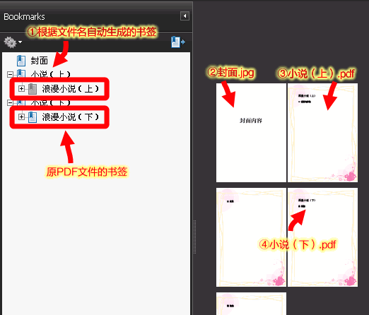

## Insert to merge documents

Task: a network user with a scanner scanned a number of double-sided printed documents, to get two PDF files. One contains the front side of the paper (odd-numbered pages), the other contains the reverse side of the paper (even-numbered pages), and now wants to merge the two PDF files into one PDF file according to the actual front and back side.

There are two ways to use PDF Patching to achieve the above task. The first method is to extract the picture and then generate the document; the second method is to merge two PDF documents into one, and then rearrange the page order. are described below.

### Extracting images and generating files

As a result of scanning the generated PDF document is a full picture of PDF documents, so you can extract all the pictures of the two PDF documents, sorted by file name, and then regenerate a new PDF document. Operation steps are as follows.

1. Select the "Extract Image" function.
2. Select the first PDF file and specify the output directory, such as "C:\Documents\Image".
3. In the specified file mask for "0000A", so that the output file in the form of four digits followed by an "A" word, such as "0001A.tif", "0002A.tif", etc. "0002A.tif" and so on.
4. Click the "Extract Image" button to export the image to the output directory.
5. and then select the second PDF file, do not change the output directory specified above, but change the file mask for "0000B", so that the output file name becomes "0001B.tif", "0002B. tif" form. In this way, the output of the two PDF documents will be stored in the same directory, and the picture file name according to the number of pages and the back of the "A", "B" suffix, you can naturally arrange a good order.
6. Select the "Merge Files" mode of the "Process PDF Documents" function.
7. Add all the image files generated by the above steps to the file list.
8. Use the sort function to sort the image files in the file list so that the order becomes "0001A.tif", "0001B.tif", "0002A.tif" and "0002B.tif", etc.
9. Specify a file name for the generated PDF file.
10. Click the "Generate PDF File" button and the program will combine the images into a PDF file in the order of the file list.

### Merge documents and then sort them

Another method is to merge two PDF documents into one PDF file, and then use the export page function to rearrange the page order. Operation steps are as follows.

1. Select the "Merge Files" mode of the "Process PDF Documents" function.
2. Drag and drop the first PDF file and the second PDF file into the file list, sorting them in order of priority.
3. Specifies the output file location.
4. Then click the "Generate PDF file" button to generate the document.
5. Select the "Extract Page" function.
6. Specify the file you just generated at "Original PDF file".
7. Specifies the output location.
8. Here assume that the two original documents equal number of pages, are 100, then the combined PDF document has 200 pages. After rearranging the pages, the page order should be 1, 101, 2, 102, 3, 103 ......99, 199, 100, 200. Therefore, the "page range" should be specified in the following order: "1; 101;2;102;3;103 (the middle item is omitted here);99;199;100;200".
9. Click the "Extract Pages" button, the program will automatically rearrange the pages of the combined PDF document to generate a new document.

Tip: the method of generating the above page order is very simple, with a spreadsheet program (such as Excel, WPS forms, etc.) automatically fill the way to do two lines of numbers, the first line is 1 to 100; the second line is 101 to 200. two lines of numbers are separated by a grid staggered, and then in the third line with a formula to add up the two lines of numbers (as shown below), you get a staggered column. The contents of the line copied out, is the above page order (from the spreadsheet program copy of the third line of text in the tabs, do not care, the program will automatically ignore).

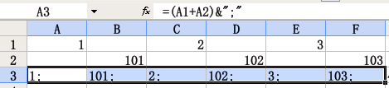

### Comparison of the two methods

The first method is easy and fast, but only for PDF files that are entirely pictures.

The second method is relatively high fidelity, suitable for containing text and pictures of PDF documents, but the operation steps are a little more complicated.

Note: In the second method above, you can actually use the "merge files" mode to rearrange the page numbers. First, merge the two files to create a new file. Empty the file list, add the new file to the file list, double-click the file list item, enter the above form of page number order in the "Page Order" text box in the Properties dialog box, and then generate a new file can also be.

# XML information file reference

The information files used by PDF Patching can be exported from the ExportFileInformation function. Information files are XML files that can be opened and edited using an XML editor or text editor.

## Information file root element

The root element of the information file is "PDF Information".

### Properties

The document root element may contain the following attributes.

The "Program Name" property (fixed): takes the fixed value of "PDFPatcher".

The "Program Version" property (required): indicates the minimum version of the document that can be opened and processed normally by PDF Patching.

"Export Time" property (optional): the date and time of the exported document.

"PDF File Location" property (optional): The path to the original PDF file used to export the information document. The Bookmark Editor uses this property to open the PDF document corresponding to the bookmark.

"Number of Pages" property (optional): the number of pages in the PDF document.

### Sub-element

The root element can contain the following sub-elements. Each child element is optional.

The "Unit ofmeasure" element: indicates the unit of measure of the document size.

The "DocumentInformation" element: contains metadata information about the document.

"Reader Settings" element: indicates the initial settings of the reader.

The "Page Style" element: contains the numbering scheme for the logical page numbers of the document.

"Document bookmark" element: contains the document's navigation bookmark.

The "page link" element: contains the link to the jump within the document page.

"Named Location element: contains the named jump target location within the document.

The "Page Setup" element: contains settings such as page size and rotation angle.

The content of each element is described in detail below.

## Unit of measure

The units of measure for page and position dimensions in the information file are indicated in the "Units of measure" element.

The unit of measure contains the "unit" attribute, which can take the values "centimeter", "millimeter", "inch" and "point". If no "unit of measure" element or "unit" attribute is present, the unit is "point". 1 inch (approximately 2.54 cm) is equal to 72 points.

A "point" is a unit of measure used internally in PDF documents.

## Document metadata ("Document Information" element)

The document's metadata information is represented as a "Document Information" element under the root element.

### Properties

Each attribute is optional. If no attribute is specified for the information file, the corresponding data of the original PDF file is retained.

"PDF Version" property: PDF version number, such as 1.4, 1.5, 1.6, etc.

"Title" property: the title of the PDF document.

"Author" attribute

"Topic" attribute

"Keyword" attribute

The "Create Program" property: indicates the program used to create the PDF document.

"Handler" property: indicates the program that last processed the PDF document.

"Date Created" property: indicates the creation date and time of the PDF document.

"Last Modified Date" property: indicates the date and time when the PDF document was last modified.

When importing information files, title, author, subject and keywords can be imported into the document.

### Example

< Document Information

Create program = "WPS Office Personal Edition"

keywords="PDF, PDFPatcher, User Manual"

author="WMJ"

title = "PDF Patching Manual"

Subject="PDF Patcher"

Created Date="Apr 28, 2010 16:47:50"

Handler="PDFlib 7.0.3 (C++/Win32)" />

## Reader initial settings ("Reader settings" element)

The initial settings of the reader are represented by the "Reader Settings" element under the root element, which specifies the layout of the reader's interface when the document is opened.

### Properties

Each attribute is optional and not all PDF readers support these attributes. If no attributes are specified for the information file, the corresponding data of the original PDF file is retained.

"Page Layout" property: the initial layout of the displayed page, valid values can be: "single page continuous", "single page", "double page continuous ", "double page", "double page continuous first page alone" or "double page first page alone" one of the six. Among them, the "continuous" layout allows readers to display documents across pages, and the double-page layout allows the first page (cover) to be set as a separate page.

"Initial Mode" property: displays the navigation bar (such as page thumbnails, document bookmarks, etc.) displayed when the document is opened, with valid values of "No sidebar", "Show document bookmarks" , "show page thumbnails", "full-screen display", "show optional content group" or "show attachment bar " one of the six. The more commonly used values are "Show document bookmarks" or "Show full screen".

"Hide Toolbar" property: indicates whether to hide the toolbar in the reader interface, valid values are "Yes" or "No" (not all PDF readers support this property).

"Hide Menu" property: indicates whether to hide the menu bar of the reader interface, valid values are "Yes" or "No" (not all PDF readers support this property).

"Show document content only" property: indicates whether to hide the rest of the user interface, valid values are "Yes" or "No" (not all PDF readers support this property).

"Window fits first page of document" property: indicates whether to adjust the reader's window to fit the first page of the document, valid values are "Yes" or "No" (not all PDF readers support this property).

"Window centering" property: valid values are "Yes" or "No" (not all PDF readers support this property).

"Show Document Title" property: indicates whether to display the title of the document in the title bar of the reader window, valid values are "Yes" or "No" (not all PDF readers support (not all PDF readers support this property).

"Reading direction" property (only valid when the page layout is double page): indicates the display mode of two adjacent pages in a double page layout, valid values are "left to right" or "right to left". . If the document is a traditional vertical layout, you can choose "Right to Left".

### Example

Example 1: In the open reader to display the document when the document bookmarks.

< Reader Settings Initial Mode="Show Document Bookmarks" />

Example 2: Using the right-to-left way to read text, the initial page layout is a double-page folio display with continuous scrolling, where the first page of the document is placed separately.

< Reader Settings

Initial mode = "Show document bookmarks"

Reading direction = "right to left"

Page Layout="Double Page Continuous Home Solo" />

## Page Numbering Style ("Page Number Style" element)

The logical page numbering of a PDF document is set under the root element with the "Page Style" element. This element has no attributes.

### The "style" child element

The "Page Style" element contains a series of "style" elements that specify a logical page numbering style starting at a specific page number.

Each style represents a page numbering rule, starting with the page corresponding to the "actual page number" of the document and ending with the page number corresponding to the "actual page number" specified in the next "style".

The "style" element can contain the following attributes.

"Actual Page Number" property (numeric, required): an absolute page number, valid as a value between 1 and the number of pages in the PDF document, indicating that the page style specified by this "Style" element is used from that page onwards.

The "Start Page Number" property (numeric, optional): indicates the starting number of the page numbering style used from the "actual page number", a valid value should be a value between 1 and the end page number of the PDF document. Default starts from 1.

"Page prefix" attribute (optional): a paragraph of text before the page number, such as the page number style for "number", and "page prefix" for "P -", the logical page number seen in the reader is "P-1", "P-2" and so on. No prefix by default.

"Style" attribute (optional): specify the number style used for page numbering, valid values can be "number", "lowercase Roman numerals", " Uppercase Roman numerals", "lowercase English letters" or "uppercase English letters" one of the five. The default is Arabic numerals.

### Example

The following example demonstrates a document with multiple page styles.

The page numbering style for pages 1 to 4 is upper case Roman numerals (I, II, III, IV).

The page numbering style for pages 5 to 25 is a number beginning with P (P1, P2 ......P21).

The page numbers on pages 26 and 27 are in capital letters (A and B).

The page numbers on pages 28 to 21 are lowercase letters (a, b, c, d).

The page numbers from page 32 to the end of the document are Arabic numerals (1, 2, 3 ......).

< Page Style

< style actual-page-number="1" style="upper-case Roman numerals" />

< style actual-page-number="5" prefix-page-number="P" style="number" />

< style actual-page-number="26" style="uppercase alphabet" />

< style actual-page-number="28" style="lower-case alphabet" />

< style actual-page-number="32" style="number" />

</page style

## Document Bookmark

A document bookmark is an interactive element in the PDF Reader. Click on a document bookmark to jump to the specified location in the document, open an external PDF document or execute an external executable file.

PDF document bookmarks are represented by the "Document Bookmarks" element under the root element.

### The "bookmark" sub-element

The bookmark sub-element represents a bookmark in the reader.

The "bookmark" element can contain the following attributes.

"Text" property (required): indicates the text of the bookmark.

"Open by default" property (optional): Indicates whether the bookmark is opened by default. The optional values are "Yes" and "No". The default value is "Yes", which means the bookmark is open by default.

"Style" property (optional): indicates the appearance of the bookmark text, the optional styles are "bold", "italic" and "bold italic " three kinds.

Color property group (optional): indicates the color of the bookmark text. The attribute group with three values of "red", "green" and "blue" represents the three components of RGB, and takes a decimal value between 0 and 1, with 1 being the full value. Thus, the combination of the three attributes "Red="1", "Green="1", and "Blue="1"" represents white. In addition to using numeric colors, you can also use colors named by the .NET Framework and represented by the "color" attribute, such as "color="Red"" for red, "color="Blue" " for blue, "Color="DarkGreen"" for dark green. In addition, you can also use the Web's "#RRGGBB" hexadecimal representation, such as white can be expressed as "color = "#FFFFFF"", red for "color = "#FF0000" " etc.

"Action" property (optional): indicates the action to be performed after clicking the bookmark. The optional actions are "Go to page" (jump to the specified location of the current PDF document), "Open external PDF document" (open an external PDF document and jump to the specified page), "Open URL " and "Start Program" four kinds. The default action is "Go to page". If the bookmark does not have "Action" and "Page" properties, clicking the bookmark will not perform any action.

The "Page Number" property (positive integer): indicates the page to which the bookmark was clicked. Valid when the "Action" property is "Go to page" or "Open external PDF document".

"Home page number" (optional): indicates the offset value of the page number. For example, if "Home Page" is 5 and the page number is 3, then the actual page will be jumped to page 5 + 3-1 = 7.

"Display Method" property (optional): Indicates the display method after jumping to the specified page. It is valid when the "Action" property is "Go to page". The following display methods are available: "Coordinate Scaling" (goes to the specified page coordinates and scales to the specified ratio), "Fit to Page", "Fit to Window", "Fit to Window", "Fit to Window Width", and "Fit to Window". "Fit to window width", "Fit to window height", "Fit to page width", "Fit to page height", and "Fit Area" (scales to the size of the specified rectangular area).

"Named Location property (optional): Indicates a jump to the location of the specified name. The "named location" is specified by the "named location" element of the message file.

The "PDF Name" property (optional): indicates a jump to the location indicated by the PDF document name.

The Coordinate property group (optional, numeric) has "Up", "Left", "Down", "Right" and The five properties "Scale" are used in combination with the "Display" property. As shown in the table below.

| Display method | Coordinates |
| --- | --- |
| Coordinate Scaling | The "left" property specifies the horizontal offset, the "up" property is the vertical offset, and the "scale" property specifies the scaling ratio (optional, 1 indicates 100%). |
| Suitable pages | There should not be any coordinates. |
| Suitable for windows | There should not be any coordinates. |
| Suitable window width | Contains the "up" attribute, which indicates the vertical coordinate after the jump. |
| Suitable window height | Contains the "left" attribute, which indicates the horizontal coordinate after the jump. |
| Suitable page width | Contains the "up" attribute, which indicates the vertical coordinate after the jump. |
| Suitable for page height | Contains the "left" attribute, which indicates the horizontal coordinate after the jump. |
| Suitable area | Contains 4 values of "up", "left", "down" and "right", which indicate the rectangle to be zoomed to after the jump. area after the jump. |

Note: The coordinates are based on the bottom left corner of the page (0,0) as the minimum value. The unit of the coordinate value depends on the document's "unit of measure" element, if it does not exist, the unit of measure is "point". When the value is 0 or "null", it means that the offset value or the scale before the jump is kept unchanged.

The "Named Location", "PDF Name" and Coordinate properties are mutually exclusive and only one of them can be specified.

"External File" property: Indicates that an external file is open. Valid when the "Action" property is "Open external PDF document" or "Launcher".

"URI" attribute: Indicates the URL to open. Valid when the "Action" property is "Open URL".

"New Window property: Indicates whether to open the document in a new window. Valid when the "Action" property is "Open External PDF Document".

The "bookmark" element can contain subordinate "bookmark" elements, indicating a nested relationship between bookmarks.

### Example

The following example indicates that there is only one bookmark in the PDF document.

The text of the bookmark is "ABCDEF", which is displayed in bold. When you click on it, you jump to page 1. Since the unit of measure is centimeter, the horizontal coordinate of the page coordinate is 0, which means the current horizontal position of the reader remains unchanged, and the vertical coordinate is 29.7, which means the page jumps to the first page with the vertical coordinate of 29.7 cm, and the scaling ratio is 0, which means the current display scaling of the reader is not changed.

< Unit of measure Unit="cm" />

< Document Bookmark

< bookmarks text="ABCDEF" style="bold" page="1" display="coordinate zoom" left="0" up="29.7" scale="0" action="go to page" />

< /document bookmark

Tip: It is recommended to change the scaling to 0 to avoid changing the display scaling of the reader for reading when clicking on a bookmark. In addition, you can force the scaling to 0 by specifyingthe option"unscale linkedtargets" when importing information files.

The following example indicates that the "ABC" bookmark contains the "XYZ" bookmark, but not the "DEF" bookmark.

The "ABC" bookmark has a blue color and is closed by default. Since this bookmark has no "Action" and "Page" properties, clicking on it in the reader will not perform any action.

The action of the "XYZ" bookmark is "Go to page", after clicking on it, the display ratio of the reader will be changed to "Fit to width" and it will jump to page 5, with the vertical coordinate 5.24 cm from the bottom of the page. 5.24 cm from the bottom of the page.

"DEF" is an empty bookmark that does not perform any action when clicked.

< Unit of measure Unit="cm" />

< Document Bookmark

< bookmarks text="ABC" color="Blue" open by default="No">

< bookmarks text="XYZ" page="5" display="Fit to width" up="5.24" action="Go to page" />

< /Bookmark

< bookmark text="DEF"/>

< /document bookmark

Note: The last attribute of the "ABC" bookmark is followed by ">", which means the bookmark contains subbookmarks, while the last attribute of the "XYZ" bookmark is followed by "/>" after the last attribute of the "XYZ" bookmark, which means it does not contain subbookmarks. The "</bookmark>" after the "XYZ" bookmark corresponds to the "ABC" bookmark, indicating that the "ABC "DEF" bookmark is not nested within the "ABC" bookmark.

Tip: Before importing the information file, you can force all bookmarks to be closed by specifying "Close All" in the "Reading Style Settings" tab of PDF document options. in the default closed state.

## Page Links

Indicates a link within a PDF document page. This is indicated by the "Page Link" element under the root element.

Each "link" element under the "page link" element represents a link to a page. The link element can contain the following attributes.

The "page" attribute (required, positive integer): indicates the page number of the link.

Coordinate property group (required): there are 4 properties "left", "bottom", "top" and "right", which indicate the rectangular area where the link is located.

"Border" property (optional): contains the value of the border property as a combination of three values.

The "click effect" property: indicates the effect of clicking on the link.

"Text" attribute: indicates the text description of the link.

Color attribute group: indicates the color of the link marker, with the combination of "red", "green" and "blue" attributes of the three primary color components.

The "page link" element may contain the following sub-elements.

Border style: the style of the border, can include "style" property.

For elements named after actions (such as "Go to page", "Open URL", etc.), see the "Action" property of the "Bookmarks" element. attribute of the "bookmark" element. Elements can contain attributes corresponding to actions.

## Name Location

Indicates a location in the PDF document with a specific name.

## Page Setup

The page size, display area and rotation angle can be represented using the Page Setup element.

### The "page" sub-element

The "Page" sub-element represents the settings of the page and contains the following attributes.

The "Page Range" property (required): indicates the absolute page range corresponding to this page setting.

"Page Number Filter" property (optional): used to filter the page number range, the value can be "odd pages" (all odd pages in the page number range) or "even pages" (all even pages in the page number range). (all even pages in the page range).

The "Page Border" property (required): indicates the coordinate position of the page border. The border contains a rectangular area consisting of two pairs of coordinate values. The first pair is the coordinates of the bottom-left corner of the page (0,0), and the second pair is the coordinates of the top-right corner of the page. The unit of measure of the coordinates is determined by the document's "Unitmeasure" element.

The "intercept border" property (required): indicates that those contents of the page border can be displayed. The coordinates of the intercept border must not fall outside the rectangle defined by the page border.

"Cropped Borders" property (optional, see the "PDFPageBorders" section for a diagram)

"Bleed border" property (optional)

"Content border" property (optional)

The "Rotation Angle" property (optional): indicates the direction of page rotation, which must be 0, 90, 180 or 270 degrees. The default is 0 degrees.

### PDF page boundaries

PDF page mainly by the "page border" given by the rectangular range specified. In addition to the interception of other borders and the relationship between the page border is shown below.

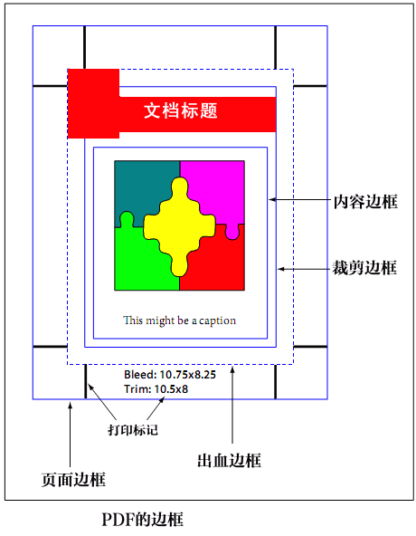

Chart 6 ---1 PDF border diagram

Since the "intercept border" has no specific relationship to any border other than the page border (the intercept border must fall within the page border), it is not drawn in the figure.

In general, only page borders and intercept borders need to be defined.

### Example

The following example represents page sizes from 1 to 517 pages that are 21 cm wide and 29.7 cm high.

< Unit of measure Unit="cm" />

< Page Setup>

< page page range="1-517"

Page border="0 0 21 29.7"

truncate border="0 0 21 29.7" />

</page setup>.

Use the intercept border and page border together to crop the page. The following example represents an even-numbered page from page 1 to 517, and cropping 1 cm of its left content, the actual page width should be 21-1 = 20 cm.

< Unit of measure Unit="cm" />

< Page Setup>

< page page range="1-517" page filter="even-numbered pages"

Page border="0 0 21 29.7"

truncated border="1 0 21 29.7" />

</page setup>.

By changing the page borders you can leave extra space for the original PDF pages that do not have much space. For example, the following example leaves an additional 3 cm of white space at the bottom of the page.

< Unit of measure Unit="cm" />

< Page Setup>

< page page range="1-517"

Page border = "0 -3 21 29.7"

truncated border="0 -3 21 29.7" />

</page setup>.

Different sizes can be specified for different pages. For example, the following examples define different sizes for page 1, and for odd and even pages between pages 2 and 517.

< Unit of measure Unit="cm" />

< Page Setup>

< Page range="1" Rotation angle="90"

Page border="0 0 29.7 21"

truncate border="0 0 29.7 21" />

< page page range="2-517" page filter="even-numbered pages"

Page border="0 0 21 29.7"

truncate border="1 0 22 29.7" />

< page page range="2-517" page filter="odd pages"

Page border="0 0 21 29.7"

truncate border="0 0 21 29.7" />

</page setup>.

# Simple bookmark file reference

Simple bookmark files are mainly used to quickly create PDF bookmarks. If you need more powerful functions, you can use the Convert Bookmark File function to convert it to an XML information file. The format of the simple bookmark file is described below.

Note: If the original bookmarks of the PDF document is exported into a simple text bookmark file, edited and re-imported into the document, due to the amount of information contained in the simple text bookmarks is less, which may lead to the original document bookmarks lost some information (such as the inability to precisely locate the specified location to the page, specify the bookmark text as bold, etc.). Therefore, do not export simple text bookmark files in general.

## File Structure

The simple bookmark file contains two parts: the file header and the bookmark.

## Document header

The file header contains information such as version, title, subject, keywords, author, etc.

"# Version" indicates the version number of the bookmark file and must appear in the first line. The version number should match the version of the PDF Patcher. Do not use this line can also be used, but in the import will prompt the version does not match. Higher versions of the program are generally compatible with lower versions of the bookmark file.

"#Title", "#Subject", "#Keyword" and "#Author" indicate the title of the PDF document attribute's title.

The following code specifies the bookmark file version as 0.2.6 and the corresponding metadata information.

#version=0.2.6

# Title = PDF Patching Manual

# Themes = PDF Patcher

# keywords=PDF, PDFPatcher, Manual

#Author=WMJ

## Bookmarks Contents

Other than this line, the rest is the bookmark content. Each line of body text represents a bookmark. The bookmark consists of four parts as follows.

Indent markers (default is tabs).

Bookmark text.

Separator between text and page number.

Page Code.

### Indent markers

When a bookmark has one more indent mark than the previous bookmark, it means that this bookmark is a sub-level bookmark of the previous bookmark. The text of the first bookmark must not be preceded by any indentation marks.

The default indent marker is tab.

### Bookmark Text

The indent marker string is only valid at the start position, and indent marker characters that appear in the bookmark text will be treated as bookmark text.

### Separator

The separator between text and page number can be more than one of the following characters: tab, half or full space, dot ". ", ellipsis "...", minus sign "-", underscore "_".

### Page

Numbered page numbers in Arabic numerals. The page number can not be followed by anything other than extra space.

Page numbers can be half-angle numbers or full-angle numbers, but not Chinese or Roman numerals.

If the page number section is empty, it indicates a bookmark that does not jump to any position in the document.

### Example

For example, the following defines six bookmarks.

Top bookmarks ........... 1

Secondary bookmark ______ 2

Level 3 Bookmark 3

Another top bookmark

Secondary bookmark 2 ----- 7

Sub-bookmark 3 ...... 56

Note the nesting relationship indicated by the tab indent before the bookmark: top-level bookmarks contain secondary bookmarks, and secondary bookmarks contain tertiary bookmarks.

The separators are different for each bookmark (either one is correct) and the page numbers are 1, 2, 3, 7, 56. the 4th bookmark (another top-level bookmark) has no page number and clicking on that bookmark in the reader will perform no action.

## Bookmark Instructions

### Home page number (specify page number reference value)

In many cases, we see the body of the page number is not the first page in the PDF document to start. Often a number of pages in front of the preface, directory, etc., many pages before the body. And we enter the simple bookmark text, usually to the directory page to enter (as shown in the above multi-level bookmark), therefore, the simple bookmark text in the page number is entered in the directory page, rather than the page number in the PDF document.

In the bookmark content, you can use the "# Home Page" command to specify the following bookmarks that appear, corresponding to the actual page number of the home page.

For example, the following definition of the content of the "body" corresponds to the page number 1, "Chapter 1" corresponds to the page number 2, but as a result of the previous "# Home Page = 39" command, so "body" actually corresponds to the PDF document in the 39th page, "Chapter 1" corresponds to the 40th page.

#Home Page=39

Main article 1

Chapter 1 2

Section 1 3

Chapter 2 14

A simple bookmark file can have more than one "#HomePage" command, each command only affects the correspondence between the bookmark page number and the actual page number that appears after it, and does not affect the bookmark page number in front of it.

For example, the following example has multiple "#HomePage" directives.

#Home Page=1

Cover 1

#Home Page=3

XX Preamble 1

Preface 5

#Home Page=11

Table of Contents 1

#Home Page=39

Main article 1

Chapter 1 2

Section 1 3

Chapter 2 14

### Indent markers (custom bookmark nesting markers)

By default, the program uses tabs as indentation marks, which is convenient when using editors that support tab indentation of content (e.g. AkelPad, EditPlus, PsPad, etc.). However, in some cases it is not convenient to use tabs (e.g. entering a bookmark file in Excel is not good for entering tabs). You can use the "# indent mark" command to specify the indent mark, which is the content after the equal sign.

The following example uses "." as an indent marker.

#Home Page=39

#indent marker=.

Main article 1

. Chapter 1 2

. Section 1 3

. Chapter 2 14

More than one character can be used as an indent marker.

The following example uses ",,," as an indent marker.

#Home Page=39

#indent marker =,,,

Main article 1

Chapter 2

、、、、、、 Section 1 3

Chapter 2 14

Similar to the "#HomePage" command, the "#IndentMark" can appear multiple times in a simple bookmark file and is only valid for the bookmark text that appears after it.

### Open bookmark (specify default open state)

The program sets bookmarks to be closed by default. For a default setting to open a bookmark to show its subbookmarks, use the "#OpenBookmark" command.

The following example specifies that the "Body" bookmark is open and each subsequent bookmark is closed.

#OpenBookmark=Yes

Main article 1

#OpenBookmark=No

Chapter 1 2

Section 1 3

Chapter 2 14

# Technical Support and Contact

## Frequently Asked Questions

### Program initialization failed

Q: When running the program, it prompts: The application failed to initialize properly (0xc00000135). Please click "OK" to terminate the application.

A: This is because you do not have .NET Framework 2.0 or higher installed on your computer (the package is built-in in Windows Vista, Windows 7). Please go to Microsoft website to download and install it. The download URL is.

<http://www.microsoft.com/downloads/details.aspx?displaylang=zh-cn&FamilyID=5b2c0358-915b-4eb5-9b1d-10e506da9d0f>

### The file list is automatically emptied and no more files can be added

Q: Every time I add a file to the file list, it clears the previous files by itself, making it impossible to patch multiple files at once. Is there a way to fix it?

A: You can add multiple files to the file list by unchecking the "Clear list before adding files" checkbox on the interface.

### Principle of lossless image extraction function

Q: Is PDF Patcher extracting pictures using virtual devices to print into pictures?

A: PDF Patcher is through the analysis of PDF documents inside the data, the data will be restored to the picture file without loss.

PDF files in the picture usually have several encoding methods: uncompressed, Deflate, JPEG, JPEG2000, FAX and JBIG2. uncompressed pictures and Deflate encoding can be saved as PNG, JPEG and JPEG2000 will generally save the stream directly out of the picture file, FAX encoding can be restored to TIFF files, JBIG2 encoding will be converted to TIFF files. JBIG2 encoding will be converted to TIFF files. As the picture data is extracted from PDF files, decoded immediately after the direct preservation or lossless compression to save as a picture file, so there will be no secondary compression and other issues that reduce the quality of the picture.

## Known Issues

If you encounter any of the following problems in the course of use, please do not write.

Cannot export, import PDF bookmarks or page links that contain multiple actions or multimedia actions.

Cannot open PDF documents encrypted with Adobe Acrobat X.

## Contact information

If you find any problems during the use of the application, please send an email to: wmjordan at 163 dot com (replace "at" with "@" and "dot" with ". "). In the email, please provide the following information.

The version of PDF Patcher.

Operating system version and revision number.

The conditions and operational steps for reproducing the problem.

Please describe in as much detail as possible the PDF file that is causing the problem. If possible, use the Export Pages feature to export a representative number of pages from the document and send them as attachments with your email.