Abstract—Trying to determine what one can make based on the ingredients at hand is a common situation.
I will create a simple python program that will allow the user to select an image of the available ingredients so that an object detection model can determine what the ingredients are. The list generated can be modified to add ingredients or make other corrections since object detection is not always perfect. Hitting a button will then ask ChatGPT [4] to provide a couple of recipes that can be used.

I. INTRODUCTION
The idea of getting A.I. to provide recipes is not new, nor is the notion of using object detection to identify food. Combining these technologies can help speed up the process of getting recipes since most available sites require you to enter the ingredients by hand.
This project aims to make life a little simpler when you are confounded by the age old question, “What can I make for dinner?"

II. The Recipes from Pictures Program
The object detection model was created using Ultralytics YOLO [1] and a dataset of food ingredients that was available online [2]. The training of the model took multiple hours using a Jetson Thor [5] which is designed for this kind of A.I. training.
Python was used for user interface for this endeavor using these libraries:
- Tkinter for the user interface.
- PIL for image handling.
- IO input and output.
- OS for accessing the system environment.
- Requests for using an API to access ChatGPT.
- JSON for deciphering the ChatGPT results.
- YOLO for accessing the object detection model.

I started the project using Google Colab [6] to get a basic python program to work for this project. I then ported the code to work outside of Google Colab which required a different graphical user interface (GUI) because Colab has a different library it uses for GUIs.
An API Key for ChatGPT [4] is required in order to retrieve the recipe. This API Key can be gotten from https://developers.openai.com/api/docs/quickstart. It is recommended to store this key as an environment variable in order to keep it safe. Otherwise, you can just add it when requested by the program.
The basic structure of the GUI includes:
- A button requesting the user to upload an image.
  - Pressing the button brings up the file selector window.
  - The user selects the desired image of the available ingredients.
- Once an image has been selected, the YOLO model will detect the ingredients in the picture and display the image with the items detected inside boxes with the confidence scores.
- The list of unique ingredients will appear in the “Detected Ingredients” text box.
- The user can edit the list as desired.
- Clicking on the “Ask ChatGPT for Ideas” button will create an API request to the ChatGPT website and wait for the results to be returned.
- If the API Key is found, then ChatGPT will return the A.I. generated recipes for display in the “Results” text box.
- If the API Key is not found, then a new text box and button will appear below the “Results” text box in order for the user to provide a key.
  - Enter the key in the “Enter your OpenAI API Key” text box.
  - Click on the “Get API Key” button.
  - A success or failure message will appear in the “Results” text box.
  - If the key is in the appropriate text box, then clicking on the “Ask ChatGPT for Ideas” button again to get your recipes.
- Clicking on the ‘X’ button at the top right corner of the application will close the application.
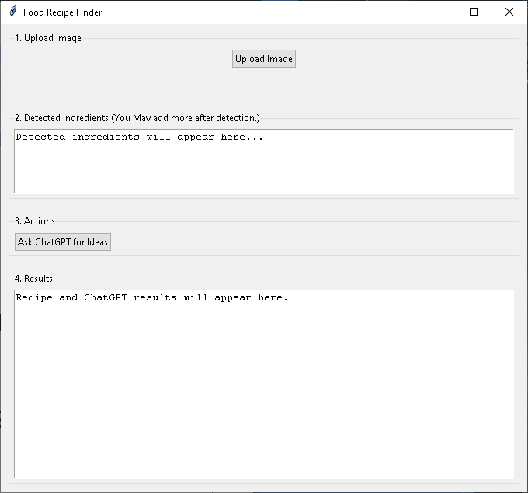
Figure 1: Interface Default Screen
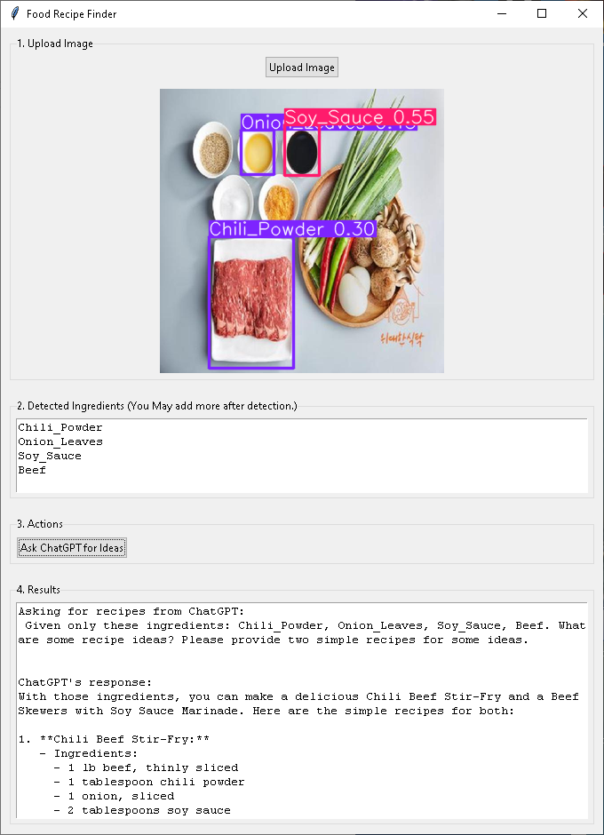
Figure 2: Interface with the Recipe Shown
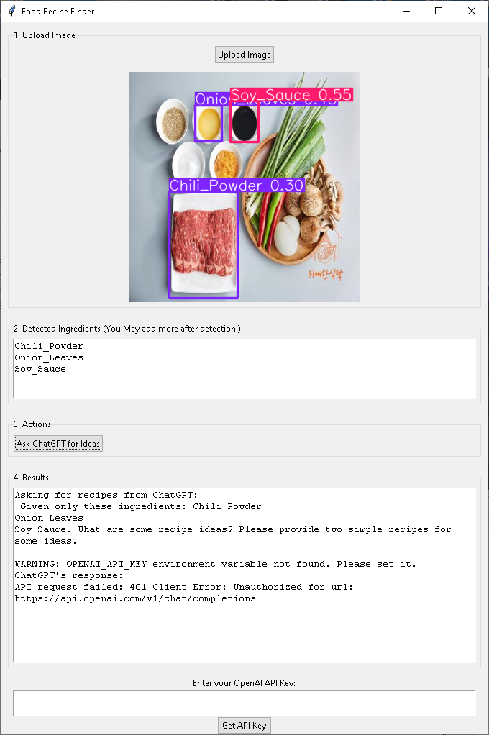
Figure 3: Interface if the API Key was not Found
I also attempted to use the Meal DB website [3] but it only worked in Colab [6]. I disabled the button on the GUI. It can be re-enabled once I get the website API working correctly. That button works just like the ChatGPT button but will return recipes from Meal DB.
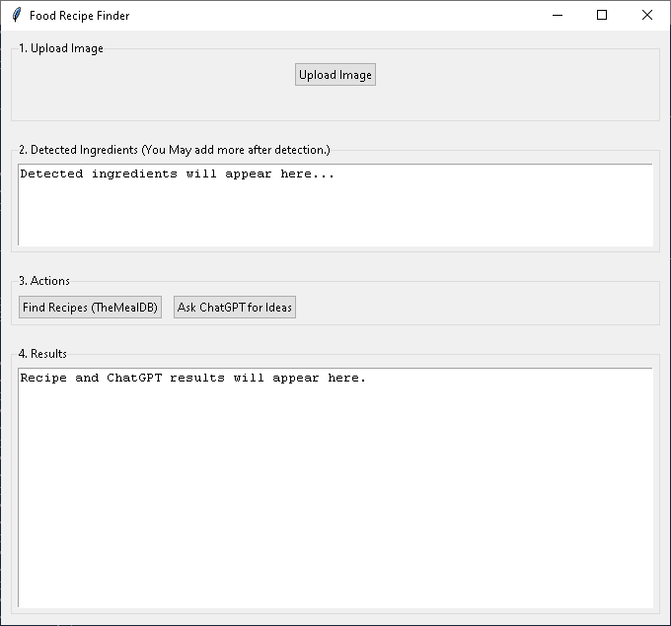
Figure 4: Interface with the MealDB Button Enabled

III. Observations
The most obvious observation is that the object detection model can give erroneous results from a given image. This can be worked around by editing the ingredients list by hand.
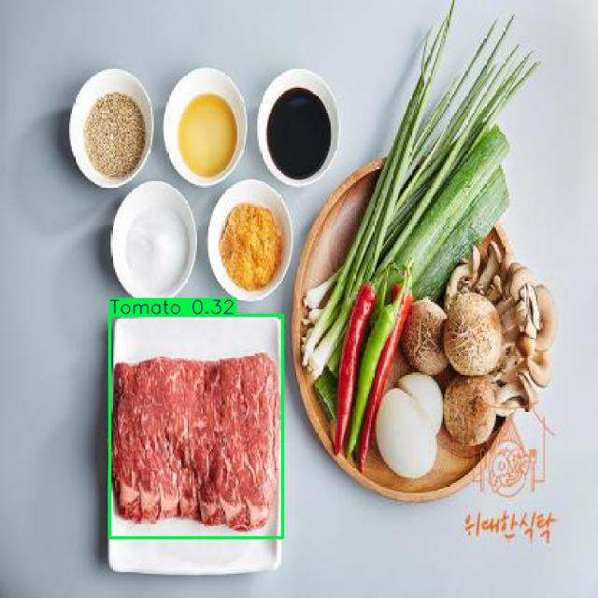
Figure 5: The Beef Tomato
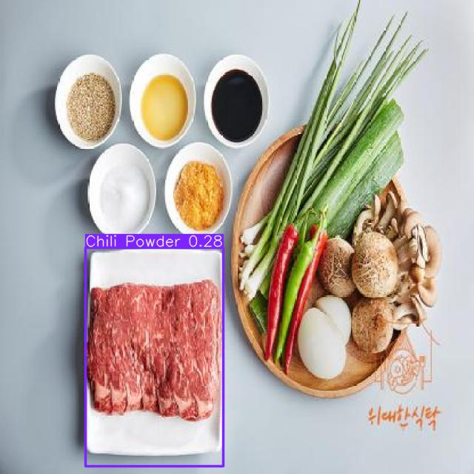
Figure 6: The Chili Powder Beef
Another issue, ChatGPT [4] does not seem to understand the word, “only.” Therefore, the recipes may include ingredients not listed.
Overall, the program works fairly well. The step-by-step design makes it user friendly. It just needs some improvements to be more useful.

IV. Continued Work to be Done
There are many ways this program can be improved:
- Add the ability to use multiple pictures and concatenate the results.
- Develop a better dataset of ingredients.
- Improve the object detection model.
- Add save and print capabilities for the recipes.
- Add the ability to change the number of recipes to be retrieved.
- Add the ability to get specialized recipes based on dietary constraints and meal type.
- Place each recipe in a different tab of a text box.
- Create a specialized LLM for generating recipes.
- Make it into a phone application using the cloud to handle the A.I. portion.

References

[1] https:/platform.ultralytics.com/

[2] https://universe.roboflow.com/food-recipe-ingredient-images-0gnku/food-ingredients-dataset

[3] https://www.themealdb.com/

[4] https://openai.com/

[5] https://www.nvidia.com/en-us/autonomous-machines/embedded-systems/jetson-thor/

[6] https://colab.research.google.com/

