Blogical.Shared.Adapters.Sftp
Documentation

2010-09-21

Table of content
1. Overview 3
2. Sftp/SSH Infrastructure 3
3. BizTalk Adapter Infrastructure 3
4. Blogical.Shared.Adapters.Sftp Infrastructure 4
a. Sequence diagram Receive Adapter 5
b. Sequence diagram Send Adapter 5
5. Misc 6
a. Tips & tricks – Tracing adapter execution 6
b. Tips & Tricks – Dynamic Send Ports 6
c. Left to wish for 6
6. Installation 6
7. Configuration 7
a. Load balancing 7
b. Connections Pool 7
c. Managing Host Keys 8
8. Setting up a simple test environment with Bitvise tools 8
a. Configure a user account 8
b. Install and configure WinSSHD 8
c. Install and configure Tunnelier 9
d. Configure the SFTP Adapter 9

Overview
I’ve developed this adapter for a customer who needed to transfer files independent from any choice of platform. Much concern for security, along with already invested infrastructure, where the main reasons for choosing Sftp before other protocols like Ftps.

The adapter utilizes an open source library for the actual communication with the sftp/ssh server. The library is developed by Tamir Gal. For more information: http://www.tamirgal.com/home/dev.aspx?Item=SharpSsh.

The adapter has implemented a more sophisticated scheduler for setting up the polling interval. Rather than stating this property in milliseconds, you’re able to set a timely, daily, weekly or even a monthly scheduled polling interval. This part of the code comes from the Biztalk Scheduled Task Adapter project that was posted at GotDotNet. However, since GotDotNet no longer exists, I don’t have any reference to this project.

The adapter is also able to send out an “Empty Batch” message, if the receive endpoint didn’t pick up any files. This property is disabled by default.

Finally, you may use this adapter as you like, but please keep me posted for any changes you make. This way my former customer will benefit from sharing this adapter with the open source community.

Sftp/SSH Infrastructure
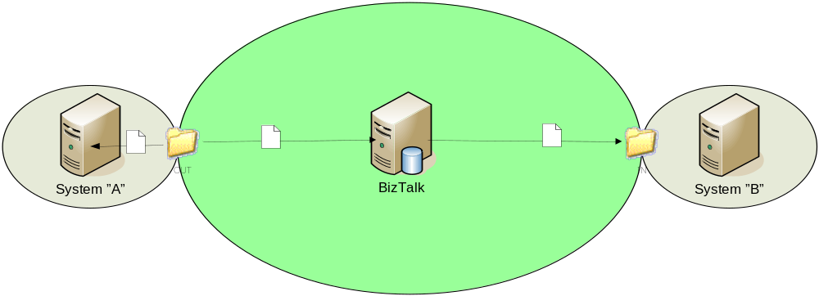

The SSH File Transfer Protocol or sftp, is a platform independent protocol for transforming and manipulating files in a secure manner. Thus Blogical.Shared.Adapters.Sftp is build to receive and send files to and from sftp/ssh servers, in a similar fashion as the native ftp adapter does from ftp servers.

Besides the protocol differences, the main difference lies in that sftp supports a public key authentication infrastructure, and does not send its user name, passwords and content in clear text over the wire.

BizTalk Adapter Infrastructure

BizTalk adapters usually comes with at least two different assemblies. One used for the BizTalk Server 2006 Administration Console to configure the adapter. For this adapter this assembly is named Blogical.Shared.Adapters.Sftp.Management. The other assembly is the actual adapter that will do all the work.
The “runtime” assembly can be divided code and classes supporting either the receiver- or the transmitter endpoint.

The Blogical adapter is built using the Microsoft BizTalk Adapter SDK. The Microsoft.samples.base.adapter project is renamed to Blogical.Shared.Adapters.Common.

Blogical.Shared.Adapters.Sftp Infrastructure

Blogical.Shared.Adapters.Sftp.Management components:
Component | Description
ReceiveLocation.xsd | Schema definition with all Receive location properties. These are the actual properties the user will see in the BizTalk administration console.
TransmitLocation.xsd | Schema definition for all Send port properties
AdapterManagement | Used for administrating and validating all properties.

Blogical.Shared.Adapters.Sftp components
Component | Description
ReceiverProperties.cs | Same properties as defined in the ReceiveLocation.xsd. The class also contains methods for initiating and loading the properties from the xml document.
ReceiverEndPoint.cs | This class contains the methods for triggering and receiving the messages from given destination.
Receiver.cs | Initiating the Receiver EndPoint.
TransmitProperties.cs | Works the same way as the ReceiverProperties class for the Send port.
TransmitEndPoint.cs | Receives the message from the message box, and transmits the message to the destination.
Transmitter.cs | Initiating the Transmitter EndPoint.

Sequence diagram Receive Adapter
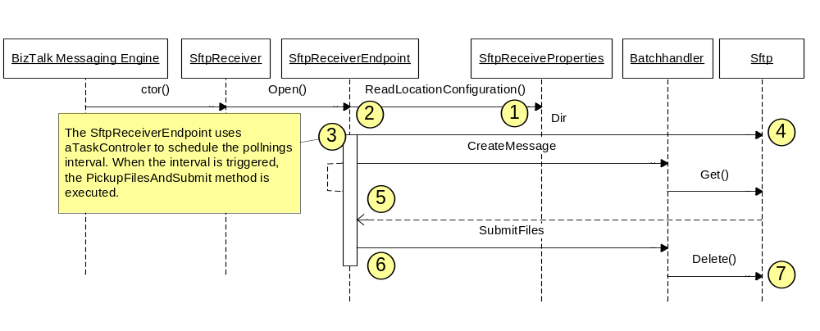
.
- When the BizTalk Messaging Engine starts, all parameters are loaded from the SSO database(1).
- The adapter TaskController initiates to set the polling interval.
- For each time the polling interval is triggered, the PickupFilesAndSubmit method is called (3) (internal call, not shown in the diagram).
- The PickupFilesAndSubmit method starts by getting a list of files to be processed (“LS” command) (4). Setting the UseLoadbalancing is set to “true”, will cause each file to be “checked out” to prevent receive locations running in other hosts to pick up the file.
- If there are files to pick up, a BatchHandler in created. The BatchHandler will create a BizTalk message for each file in the batch. The CreateMessage method (5) will read the entire file to a VirtualStream, before creating the message along with various content properties
- When there are no files left to pick up or the batch has reached maximum number of files in batch or maximum number of bytes, the entire batch is submitted to BizTalk (6).
- If the batch was successfully submitted, files left at the receive location is removed (7).

Sequence diagram Send Adapter
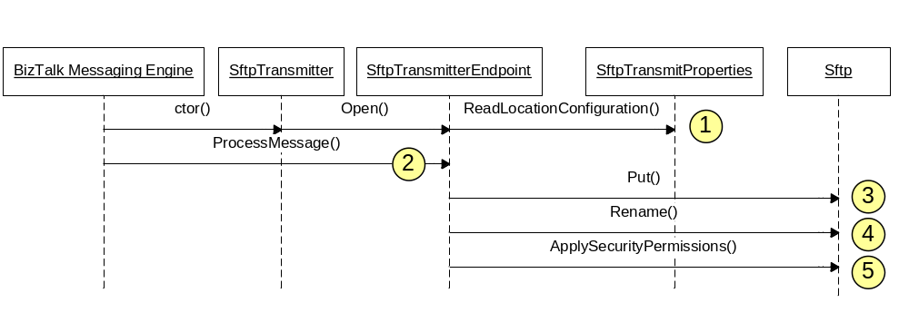
- When the send adapter is called the first time, it will load its configuration(1).
- The send adapter inherits from AsyncTransmitterEndpoint, and exposes the ProcessMessage method which is called from the BizTalk Messaging Engine (2).
- The adapter connects the the sftp/ssh server and writes the file to given path (3).
- If the RemoteTempDir property is set, the file is moved the this location (4).

If the ApplySecurityPermissions is set, the adapter will make chmod call to set default permissions to the file.

Misc

Tips & tricks – Tracing adapter execution
Debugging an adapter can, in many situations, be challenging. One of the better ways is to use a trace tool like DegugTrace from sysInternals (now Microsoft). To make this work you need to:

- Enable the Trace property for the adapter.
- Select “Capture Win32” and “Capture Kernel” in the “Capture” menu in the DebugView application.
- (Optional) set a filter to only capture events from ”[Sftp”. It can also be useful (and gratifying) to use colors for different trace events. That way it’s easy to see the flow.

Another way to capture the trace events is by enabling TraceListener in the BTSSvc.exe.config file. Add the following in the config section:

<system.diagnostics>
<trace autoflush="false" indentsize="4">
<listeners>
<add name="myListener" type="System.Diagnostics.TextWriterTraceListener" initializeData="bLogical.Shared.Adapters.Sftp.log" />
<remove name="Default" />
</listeners>
</trace>
</system.diagnostics>

Tips & Tricks – Dynamic Send Ports
To use the SFTP adapter from your orchestration through a Dynamic Send Port, use something similiar to the below code:

DynamicSendPort(Microsoft.XLANGs.BaseTypes.Address) = "SFTP://server:22/";
MsgOut(BTS.OutboundTransportType) = "SFTP";
MsgOut(Blogical.Shared.Adapters.Sftp.Schemas.host) = "server";
MsgOut(Blogical.Shared.Adapters.Sftp.Schemas.portno) = 22;
MsgOut(Blogical.Shared.Adapters.Sftp.Schemas.user) = "user";
MsgOut(Blogical.Shared.Adapters.Sftp.Schemas.identityfile) = @"c:\mysftpkeyfile.ppk";
MsgOut(Blogical.Shared.Adapters.Sftp.Schemas.remotefile) = "OUT_%SourceFileName%";

For these properties to be available for your choosing you have to add a reference to Blogical.Shared.Adapters.Sftp.Schemas.

Left to wish for

Setting lifetime to Sftp connections.
During the development of this adapter, the concerns have mainly been performance and security. One of the requirements where that the adapter should not be connected for more than five minutes. At the same time, making the actual connection is very time consuming.

This led me to develop a ConnectionPool, which works like a container for a configurable number of sftp connections. If all connetions where in use, the next process is queued in waiting for a connection to be released from the pool.

When a connection is released to the pool, the life time of that connection where checked not to have exceeded the maximum allowed minutes.

At the time we where deploying this adapter to the production environment, we found problems with connections to a specific server. In the eagerness of solving the problem, I changed the handling of the connections life cycle, so it would always disconnect from the server when the connection was released to the pool.

Later we found out that this was not a problem caused by the adapter, but the connection life cycle functionality where not reimplemented.

The 1.3.3 version enabled connections to stay connected when released to the connection pool.

Installation

After you Run the installation program, start up BizTalk Administration Console. Expand the tree view, and right-click the [Adapters] node. Select New->Adapter.
In the “Adapter Properties” dialog, select the “Blogical.Shared.Adapters.Sftp v1” adapter and set the name to “SFTP”.

For eventlogging to be correctly displayed, please run installutil on Blogical.Shared.Adapters.Common.dll. The step is not included in the installer due to changes in installer permission handling for Vista and other operating systems.

Done.

Configuration

Load balancing
The Sftp adapter is developed to work in a load balanced environment, and uses a SQL table to keep track of what files are being processed by witch host.

The first node to pick up a file will "check-out" the file by inserting a row to the SftpWorkingProcess table. When the file is removed from its original location the CheckInFile method in the Blogical.Shared.Adapters.Sftp.DataBaseHelper class is called. This will remove the file entry from the table.

To enable load balancing:
- Create a new database, and run the script below to create the SftpWorkingProcess table.
- Edit the BTSNTSvc.exe.config file (default C:\Program Files\Microsoft BizTalk Server 2006) and add the connection string AT THE END OF THE FILE. Add it at the top of the config file, will cause an error, and the BizTalk host won’t start.

Sample:
<connectionStrings>
<add name=" Blogical.Shared.Adapters.Sftp"
connectionString=" Data Source=localhost;Initial Catalog=Blogical; Integrated Security=SSPI;"
providerName ="System.Data.SqlClient"/>
</connectionStrings>

Change the "Initial Catalog" to whatever you named your database, and make sure the user running your host instance, has sufficient rights to the table.

- Create a new Receive Location (or open an existing one), and enable the UseLoadBalancing property.

Connections Pool

If nessesary, it’s possible to limit the number of sftp connection per server. This will affect ALL receive and send ports connecting to the same host.

To set this property, open the BTSNTSvc.exe.config file (default C:\Program Files\Microsoft BizTalk Server 2006). Add a <Host> element and set the connectionLimit:

<Blogical.Shared.Adapters.Sftp>
<SftpConnectionPool defaultConnectionLimit="60">
<Host hostName="10.102.114.224" connectionLimit="5"/>
<Host hostName="SomeHostName" connectionLimit="5"/>
</SftpConnectionPool>
</Blogical.Shared.Adapters.Sftp>

hostName = the IP Address or server name. Has to correlate to the [SSH Host] property in adapter configuration.
connectionLimit = maximum number of sftp connections
defaultConnectionLimit = the default maximum number of sftp connections

Important! If the section above does not already exists in the BTSNTS.exe.config, you need to add the section below at the top of the config file.

<configSections>
<section name="Blogical.Shared.Adapters.Sftp"
type="Blogical.Shared.Adapters.Common.XmlSerializerSectionHandler, Blogical.Shared.Adapters.Common, Version=1.0.2.0, Culture=neutral, PublicKeyToken=d2417434632efeea" />
</configSections>

Using HTTP Proxy
The bLogical Sftp adapter supports connection through HTTP Proxy. In order to connect through a proxy there are some additional receive- and send port properties you need to set.
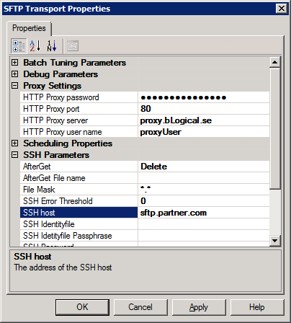

You will still need to set the appropriate SSH parameters such as SSH Host, User name and Remote path. These parameters will be sent to the proxy server, which in turn will act as “man-in-the-middle” and connect to the SSH server using the parameters provided by the adapter.

Proxy Parameters | Description
HTTP Proxy server | The URI to the HTTP Proxy server
HTTP Proxy port | The port on which the HTTP proxy is running on; by default 80.
HTTP Proxy user name | The username used for proxy authentication.
HTTP Proxy password | The password used for proxy authentication.

Managing Host Keys

Every time the adapter connects to a host, it will receive a HostKey from the server. After the HostKey is received it is checked against the key received from prior connections, to ensure the host to be the same. If it’s not the same the connection will fail and an exception will be thrown:
"HostKey does not match previously retrieved HostKey."

When the host is called for the first time, the new HostKey is added automaticly.

The HostKey is saved in the SftpHostFiles.config file witch can be found at ”\Local Settings\Application Data\IsolatedStorage\” for the user that runs the BizTalk host instance.

Enterprise Single Sign-On (SSO)
The adapter supports SSO Affiliate Application which allows storing user name and password in the SSO database. This might be preferred when SFTP accounts are reused for several ports.

BizTalk Server comes with the SSO Administration and SSO Client Utility, both are installed separately. However, these tools are a bit complicated to use, why I’d recommend using Richard Seroters BizTalk SSO Configuration Data Storage Tool, which is real easy to manage.

Regardless of tooling, it’s important the names of the properties to set are UserName and Password, since those are the properties the adapter are going to look for.
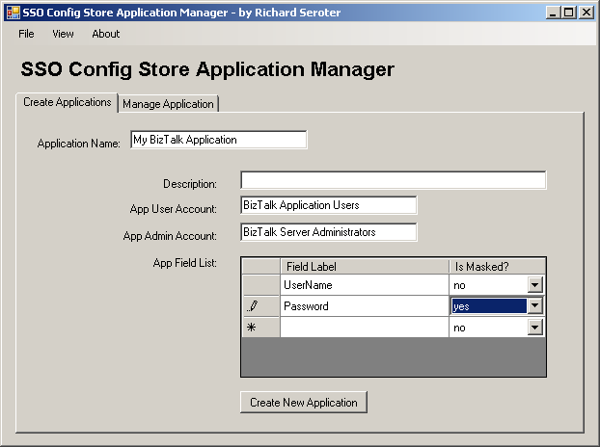

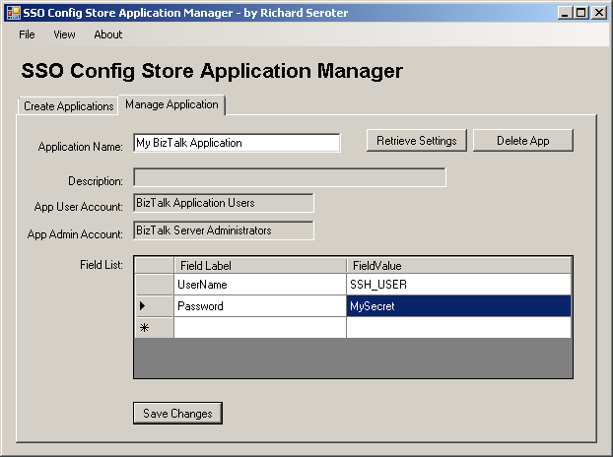

Setting up a simple test environment with Bitvise tools

Configure a user account
Create a local user account. You will use this when configuring WinSSHD, and when connecting through Tunnelier and the SFTP Adapter. Let’s call it SFTPUser. Remember the password.

Install and configure WinSSHD
WinSSHD is a SFTP (etc) server that allows you to connect to retrieve and put files to try out the functionality of the SFTP Adapter.

Install with default settings. Create a new user called SFTPUser. You do this by accessing the Windows Accounts option through navigating to it by Edit Settings – Access Control – Windows Account – Add. All values are at their defaults except username which is set to the name of the user create earlier, SFTPUser.

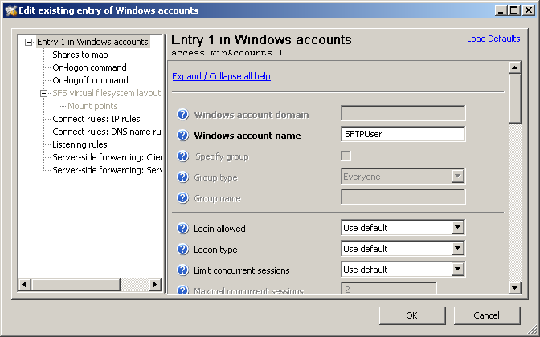

Optional steps are to point the root folder of the user to a specific folder on your disk. You do this by changing the SFS Virtual filesystem layout and the Mount points, as seen below:

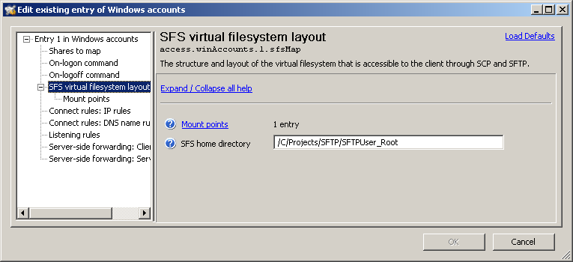

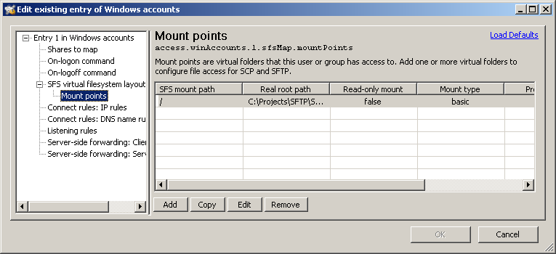

Install and configure Tunnelier
Tunnelier is a SFTP Client and can be used to verify the connection before connecting with the SFTP Adapter.
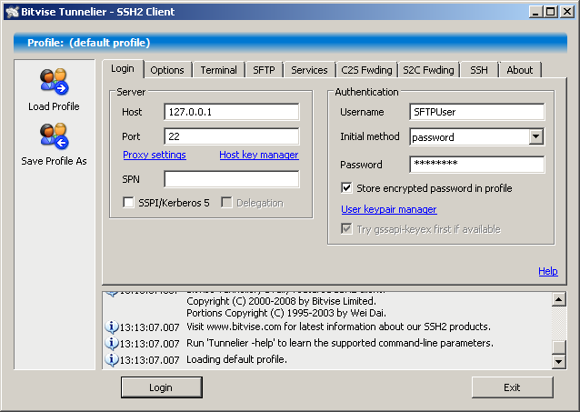

Set Host to 127.0.0.1, that is point it to the localhost, or wherever you decided to install WinSSHD. Set Username to the user created, SFTPUser. Set Initial method to password and set the Password accordingly. Verify the connection.

Configure the SFTP Adapter
Configure SSH User to the user created earlier, SFTPUser. Configure SSH Password accordingly. See below. SSH Remote path and SSH Remote temp path are optional put highly advisable to set to a specific folder created for the purpose of the SFTP adapter.

On the Receive Port, enable a timely schedule of for example every 60 seconds. On the Send Port, on the ports Advanced Transport options, lower the retry count to 0 so you will be able to get fast feedback (Note: dev environment only!). Optional at this point is to change the SSH Remote file name and Turning on Trace.

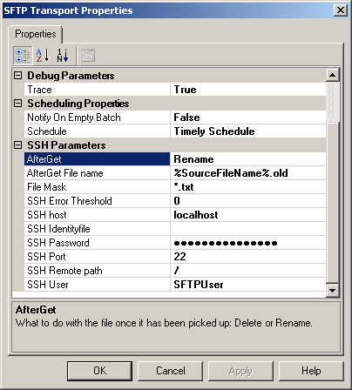  Figure 1 Receive Port | 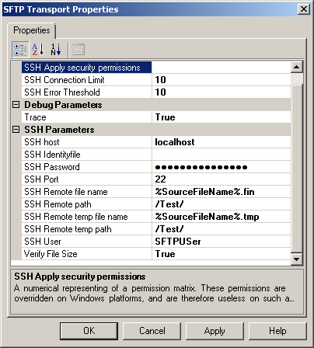  Figure 2 Send Port

