13.1 MATLAB Tutorial 7

Introduction to Computational Science:
Modeling and Simulation for the Sciences, 2nd Edition
Angela B. Shiflet and George W. Shiflet
Wofford College
© 2014 by Princeton University Press
Introduction
We recommend that you work through this tutorial with a copy of MATLAB, answering all Quick Review Questions. MATLAB is available from MathWorks, Inc. (http://www.mathworks.com/).
The prerequisites to this tutorial are MATLAB Tutorials 1-6. For those starting their use of MATLAB with Chapter 13, refer instead to Alternative Tutorial 7, MATLABTutorial7Alt.m, which has no prerequisite. Tutorial 7 prepares you to use MATLAB to complete projects for this chapter. The tutorial introduces the following functions and concepts: dot, matrix addition and multiplication, any, all, eig, unique, sortrows, and union. The module also gives examples along with Quick Review Questions for you to do with MATLAB. Execute all input cells to view the results of the examples.

Matrix Operations for Modules 13.2-13.4
When two matrices have the same size, we can perform the + or .* operation. The resulting matrix has the same size and each element of the result is the sum or product, respectively, of corresponding elements of the two operands. The following gives examples of these operators:

matA = [3 6 5; -2 0 3];
matB = [4 -1 0; 7 8 3];
matA + matB
matA .* matB

As the results show, adding element by element, the sum matA + matB = 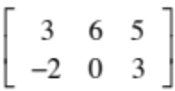 + 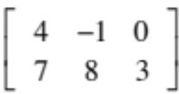 is 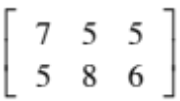. Similarly, multiplying element-by-element for matA .* matB, we obtain 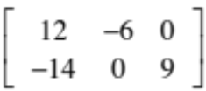.
For vectors that have the same number of elements, we can perform the dot product, which returns a number, the sum of the product of corresponding elements. The MATLAB function dot performs this operation on vectors. Thus, the following command returns the dot product of [2 7 -1] and [5 3 4], which is 2 · 5 + 7 · 3 + -1 · 4 = 10 + 21 -4 = 27:

dot([2 7 -1], [5 3 4])

The matrix-times-vector or matrix product operator is *. Consider vector vecCol = 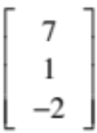, which the following command creates:

vecCol = [7; 1; -2];

The product of matA and vecCol, matA * vecCol, produces a 2-by-1 column vector, 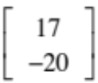. With matC = 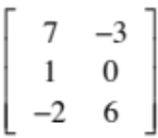, the following is an example of matrix multiplication, producing the result 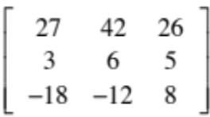 :

matC = [7 -3; 1 0; -2 6];
matC * matA
Quick Review Question 1 Start a new Script. In opening comments, have "MATLAB Tutorial 7 Answers" and your name. Save the file under the name MATLABTutorial7Ans.m. In the file, preface this and all subsequent Quick Review Questions with a comment that has "%% QRQ" and the question number, such as follows:

%% QRQ 1 a

a. Generate a 4-by-2 matrix mA, where the i-j element is the sum of i and j. Thus, after forming mA, mA(3, 2) should be 5, which is 3 + 2.
b. Generate a 4-by-2 matrix mO of all ones.
c. Give matrix sum of mA and mO.
d. Define a vector u with elements 2 and 7.
e. Define a vector v with elements 5 and 3.
f. Give dot product of u and v.
g. Generate a 2-by-3 matrix mB, where the i-j element is the difference of i and j, i - j.
h. Give the matrix product of mA and mB.

We can take the matrix product of a square matrix by itself, which accomplishes the matrix power operation. For example, suppose mS is defined as follows:

mS = [8 4 6; 7 7 1; 4 6 2];

The matrix product of mS with itself, mS * mS, is the 3 × 3 matrix 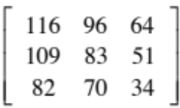. We generate the same result by squaring mS with mS ^ 2. For element-by-element operations, we employ .* and .^.
Quick Review Question 2
a. Generate a 3 × 3 matrix mC, where the i-j element is 2i - j.
b. Calculate the matrix power of mC with power 5.
c. Show that the calculation of the matrix product of mC with itself five times has the same value as the answer to Part b.

To test if all elements of a matrix or vector satisfy a condition, we employ the command all. Similarly, to test if any of these elements satisfy a condition, we use any. Thus, the answer to the following segment is 1, representing true:

b = [3 5 2];
all(b == b)

Moreover, because 5 > 4, the following command returns 1, or true:

any(b > 4)
Eigenvalues and Eigenvectors for Modules 13.3-13.4
For square matrix M, the constant λ is an eigenvalue and v is an eigenvector if multiplication of the constant by the vector accomplishes the same results as multiplying the matrix by the vector, that is, the following equality holds:
Mv = λv
The dominant eigenvalue for a matrix is the largest eigenvalue for that matrix. The MATLAB function eig returns a vector containing the eigenvalues for a square matrix argument, as the following illustrates:

mat = [0 3 6; 0.1 0 0; 0 0.4 0];
lambdaValues = eig(mat)

MATLAB returns the following vector of eigenvalues:

0.7796 + 0.0000i
-0.3898 + 0.3948i
-0.3898 - 0.3948i

In this case, two of the eigenvalues are complex numbers, and the dominant eigenvalue is the first element of lambda, 0.7796. (0.0000i is 0.) To obtain the corresponding eigenvectors, too, we store the results in a vector of two variables, as follows:

[vecLst lambdaLst] = eig(mat)

MATLAB returns the following:

vecLst =

0.9898 + 0.0000i -0.9762 + 0.0000i -0.9762 + 0.0000i
0.1270 + 0.0000i 0.1236 + 0.1252i 0.1236 - 0.1252i
0.0651 + 0.0000i 0.0016 - 0.1268i 0.0016 + 0.1268i

lambdaLst =

0.7796 + 0.0000i 0.0000 + 0.0000i 0.0000 + 0.0000i
0.0000 + 0.0000i -0.3898 + 0.3948i 0.0000 + 0.0000i
0.0000 + 0.0000i 0.0000 + 0.0000i -0.3898 - 0.3948i

The eigenvalues are on the diagonal, from top left to bottom right, of lambdaLst, 0.7796, -0.3898 + 0.3948i, -0.3898 - 0.3948i. The corresponding eigenvectors are in the columns of vecLst. Thus, the corresponding eigenvector, (0.9898, 0.1270, 0.0651), of the dominant eigenvalue is the first column of vecLst, ignoring 0.0000i. The following illustrates that the matrix-vector product of mat and this vector equals the dominant eigenvalue times the vector.

lambda = lambdaLst(1)
v = vecLst(:, 1)
mat * v
lambda * v
Each of the products returns the column vector 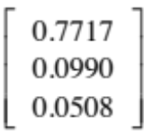.
Quick Review Question 3
a. Define the matrix mD as 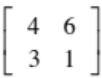.
b. Return a list of eigenvalues of mD without calculating eigenvectors.
c. Calculate a list of eigenvalues and eigenvectors of mD, and store the results in variables lLst and vLst, respectively.
d. Verify that the matrix-vector product of mD and the dominant eigenvalue equals the product of that eigenvalue and the corresponding eigenvector.
Additional Commands Used in Module 13.5
In this section, we consider several MATLAB commands that are used in the file associated with Module 13.5.
As execution of the following shows, the MATLAB command unique with a list argument returns a list with the same elements but without duplicates and in ascending order, in this case [1 4 5]. The function does not change the argument, lst.

lst = [1, 5, 5, 4, 1, 5];
unique(lst)
lst

The function union returns the sorted union of two list arguments with no duplicates and with the elements in ascending order. Thus, output of the following is the list [1 3 4 5 7 8]:

lst1 = [1 5 5 4 1 5];
lst2 = [4 8 7 8 3];
union(lst1, lst2)

Using the command sortrows, we can sort rows of a matrix in ascending or descending order based on a particular column. Consider the matrix 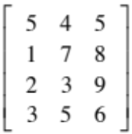, which we define as follows:

triples = [5 4 5; 1 7 8; 2 3 9; 3 5 6];

To sort in ascending order, based on the values in the second column, 2 appears as an additional argument, as follows:

sortrows(triples, 2)

The sorted output, with the second column elements in ascending order, is as follows:

ans =

2 3 9
5 4 5
3 5 6
1 7 8

With a negative second argument, the sort is in descending order. Consider the following command:

sortrows(triples, -2)

The results reveal a sorting on the second column in descending (reverse) order:

ans =

1 7 8
3 5 6
5 4 5
2 3 9
Quick Review Question 4
a. Define a list (matrix), lst1, of a five numbers, where each element is a random integer between 0 and 2.
b. Using unique and an assignment statement, eliminate the duplicate pairs in lst1. Display lst1after the unique command.
c. Form another list, lst2, of 5 numbers, where each element is a random integer between 10 and 12. Assign the union of lst1 and lst2 to lst3.
d. Define a list, dup1, of a five ordered pairs of numbers, where the first element in each pair is a random integer between 0 and 2 and the second element is a random integer between 10 and 12. Write a command to return dup1, sorted by the first elements from highest to lowest.

