8.1 MATLAB Tutorial 3
Introduction to Computational Science:
Modeling and Simulation for the Sciences, 2nd Edition
Angela B. Shiflet and George W. Shiflet
Wofford College
© 2014 by Princeton University Press
Introduction
We recommend that you work through this tutorial with a copy of MATLAB, answering all Quick Review Questions. MATLAB is available from MathWorks, Inc. (http://www.mathworks.com/).
The prerequisites to this tutorial are "MATLAB Tutorial 1" and "MATLAB Tutorial 2." Tutorial 3 prepares you to use MATLAB for material in this and subsequent chapters. The tutorial introduces the following functions and concepts: array operations, transpose; additional graphics options, such as for equal axes, plotting area, line width, and line style; fitting; rule substitutions; reading data files; and logarithms.
Array Operations
Arrays are essential to MATLAB, and we can perform operations on entire arrays. To perform addition, subtraction, multiplication, or division of a scalar (number) by every element in an array, we use the usual operator of +, -, *, or /, respectively. For example, consider the following vector:

vec = [4:0.3:5.2]

vec =

4.0000 4.3000 4.6000 4.9000 5.2000

The following input statements (in red) perform the same operation on every element of vec, returning the appropriate output array (in blue) without changing the value of vec:

vec + 10
14.0000 14.3000 14.6000 14.9000 15.2000

vec - 5
-1.0000 -0.7000 -0.4000 -0.1000 0.2000

vec * 10
40 43 46 49 52

vec / 10
0.4000 0.4300 0.4600 0.4900 0.5200

To change the value of vec, we must assign the result of an operation to vec, such as follows:

vec = vec * 10
vec =

40 43 46 49 52

As the following Quick Review Question illustrates, we can also apply other functions, such as the square root function (sqrt), that operate on a single number to every element of an array.
Quick Review Question 1 Start a new Script. In opening comments, have "MATLAB Tutorial 3 Answers" and your name. Save the file under the name MATLABTutorial3Ans.m. In the file, preface this and all subsequent Quick Review Questions with a comment that has "%% QRQ" and the question number, such as follows, so that we can employ Run Section:

%% QRQ 1 a

a. With one assignment statement, make ar a 2-by-4 array of all zeros.
b. With one assignment statement, make the first row of ar be the sequence of positive integers 1, 3, 5, 7.
c. Return the product of 3 by every element of ar without changing ar.
d. Return the square root of every element of ar without changing ar.
e. Add 2 to every element of ar, changing the value of ar.

If two arrays have the same dimensions, we can perform operations that combine corresponding elements. Addition and subtraction use the typical operators of + and -, respectively. However, the array multiplication, division, and exponentiation operators, with the operations performed element-by-element on corresponding elements, include a period to be .*, ./, and .^, respectively. The following statements illustrate these operations using vec and another five-element vector:

vec = [40 43 46 49 52];
vec2 = [3 -1 0 8 1];
vec .* vec2
120 -43 0 392 52

vec2 ./ vec
0.0750 -0.0233 0 0.1633 0.0192

vec2 .^ 2
9 1 0 64 1

Besides performing the same operation on every element of an array, some functions combine the values in an array. For example, the function sum returns the sum of all the elements in an array. Thus, with vec2 being [3, -1, 0, 8, 1], the following command returns 3 + -1 + 0 + 8 + 1 = 11:

sum(vec2)

In the case of a two-dimensional array, sum returns a vector with the sum of each column. Thus, to obtain the sum of an entire two-dimensional array, we can take the sum of the sum of the array.
Quick Review Question 2
a. With one assignment statement, make br a 2-by-4 array of all zeros.
b. With one assignment statement, make the first column of br contain ones.
c. Make the first row, third element of br be 5.
d. Display ar.
e. Without changing either array, obtain the sum of ar and br.
f. Return an array where corresponding elements of ar and br are multiplied.
g. Define a function sqr to square a parameter. The function should work for numeric and array arguments.
h. Using sqr from Part g, return an array with every element of ar squared.
i. Give a command to return the sum of the squares of the elements of ar.
Transpose
In Module 8.3 on "Empirical Models," we deal with some examples where the first and second coordinates of data points are in separate lists that need be in one array of ordered pairs with one pair per row. For example, suppose for an hour a scientist measures amounts (in milligrams) of residues from a chemical reaction every 12 minutes, or 0.2 hours. The following command assigns to tlst the list of times, [0, 0.2, 0.4, 0.6, 0.8, 1.]:

tlst = [0:0.2:1];

The following rlst is a list of residue measurements:

rlst = [0.00 0.05 0.16 0.23 0.55 1.00];

The following expression on the input line produces output of a rectangular array of two rows and six columns:

[tlst; rlst]

ans =

Columns 1 through 5

0 0.2000 0.4000 0.6000 0.8000
0 0.0500 0.1600 0.2300 0.5500

Column 6

1.0000
1.0000

Thus, the array is as follows:

0.0 0.2 0.4 0.6 0.8 1.0
0.00 0.05 0.16 0.23 0.55 1.0

The first row consists of the times, while the second stores the measured residues. To generate a list of ordered pairs of corresponding times and residues, we take the transpose of [tlst; rlst]. Without changing the original array, the transpose, which MATLAB indicates with a trailing apostrophe ('), returns an array with the rows and columns swapped. Thus, the following statement assigns the list of ordered pairs to trans:

trans = [tlst; rlst]'

The output value of trans is as follows:

0 0
0.2000 0.0500
0.4000 0.1600
0.6000 0.2300
0.8000 0.5500
1.0000 1.0000

Definition. The transpose of a matrix (rectangular array) is a matrix with the rows and columns exchanged from the original matrix.
Quick Review Question 3 Write a statement to generate a list xLst of x-values, which are positive integers from 1 through 9. Using one assignment statement, have gLst store the corresponding values of 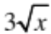. Write commands to assign to pairsLst the array of ordered pairs with one ordered pair per row.
Additional Graphics Options
In "MATLAB Tutorial 1," we covered basic graphing of a function with plot. In this tutorial, we discuss some additional features that are helpful in producing meaningful scientific visualizations.
The aspect ratio of a graphics is its width divided by its height. For example, if a graphics is 6 cm wide and 3 cm high, then its aspect ratio is 6/3 = 2; and if the dimensions are reversed, the aspect ratio is 3/6 = 1/2. MATLAB decides the aspect ratio that it considers best for each graph. To designate that a unit length on one axis is the same as on the other, we employ the option axis equal. Such specifications can be helpful for visualization of a graphics without distortion. To revert to MATLAB's choice of aspect ratio, we designate axis auto.

Definition The aspect ratio of a graphics is its width divided by its height.

Although we specify the part of the domain to graph, MATLAB decides on an appropriate part of the range unless we override the software's decision with another property, axis. The designation axis([a b c d]) specifies the horizontal portion as being from a to b and the vertical portion from c to d. The following plot of f(x) = x² with domain from -2 to 3, range from 0 to 9 (axis([-2 3 0 9]), the same proportions (axis equal) on both axes, and the axes labeled (xlabel and ylabel) results in the graph of Figure 1:

clear('f');
f = @(x) x .* x;

x = -2:0.1:3;
plot(x, f(x))
axis equal
axis([-2 3 0 9])
xlabel('x')
ylabel('y')

Figure 1 Graph of x² with equal units on each axis and specified plot region
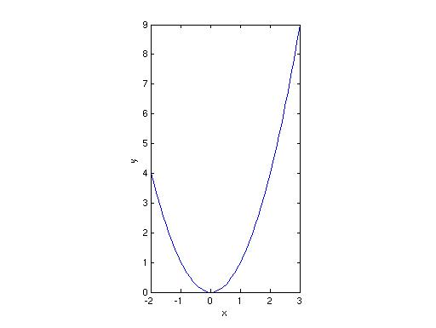
Quick Review Question 4
a. Graph y = ln(x²) from 0.1 to 6 without any properties except axes labels.
b. Specify that the graph should be shown from 0 to 6 on the x-axis and from –2 to 4 on the y-axis.
c. Specify that a unit on one axis should be the same length as a unit on the other axis. Observe the impact of each option on the graph.

Frequently for comparisons, we wish to show more than one plot in the same figure. To do so, we can alternate sequences of values independent and dependent variables as arguments in the plot command. The following segment defines g and plots f and g in the same graphics (Figure 2):

clear('g');
g = @(x) f(x) + 1;
plot(x, f(x), x, g(x))

Figure 2 Graph of f(x) = x² and g(x) = f(x) + 1
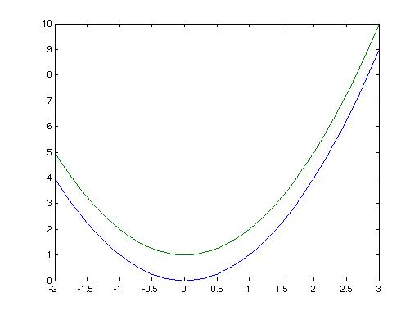

In such situations, to differentiate clearly between the two graphs, MATLAB shows them with different colors for display on a monitor or color printer. Alternatively, we can employ assorted thicknesses or dashing for a black-and-white printer. After the sequences for each graph, we can indicate the color in a string, such as 'k' for black in the following:

x = -3:0.1:3;
plot(x, f(x), 'k', x, g(x), 'k')

Quick Review Question 5 For the above plot, omitting the axis designations, include the function 3x + 2 in green.

To distinguish graphs on a black-and-white printer, we can indicate a color of black with the string 'k' and in the same string a style of dashed with '--', dotted with '.', or dash-dotted with '-.'. The following example in black-and-white, which Figure 3 pictures, has no extra specifications for the graph of f so that it appears as a solid curve and indicates that the graph of g should be dashed.

plot(x, f(x), 'k', x, g(x), '--k')

Figure 3 Plot from Figure 2 with g being dashed
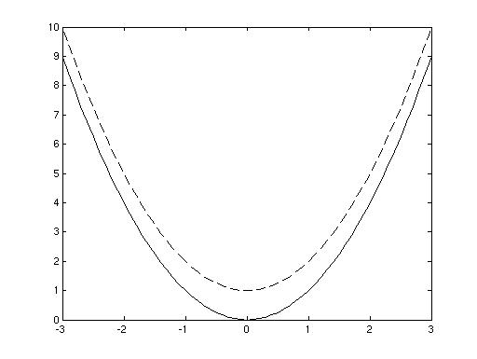
Quick Review Question 6 For the functions f, g, and 3x + 2 from Quick Review Question 5, have the graphs display on one figure in black-and-white with f being dashed, g being dotted, and 3x + 2 being dash-dotted.

Alternatively, we can designate the thickness using the property 'LineWidth'. The value is in number of points, where 1 point = 1/72 inch and the default is 0.5 points. The following command indicates to plot f with a line of thickness value 3, which is 3/72 inch = 1/24 inch:

plot(x, f(x), 'k', 'LineWidth', 3)

However, a plot command designates the line width for the entire figure, not just a graph of one function. In the next section, we indicate how to have separate line widths for different functions.
Showing Several Graphics Together
To have two functions on the same graph while specifying properties, such as LineWidth, we graph one function and issue the command hold on, which adds subsequent plots to the figure instead of replacing them. Additions continue until execution of the command hold off. Figure 4 displays the final result of the following command sequence with the function g thicker than f and both in black:

plot(x, f(x), 'k', 'LineWidth', 3)
hold on
plot(x, g(x), 'k', 'LineWidth', 6)
hold off

Figure 4 Plot from Figure 2 with g thicker than f
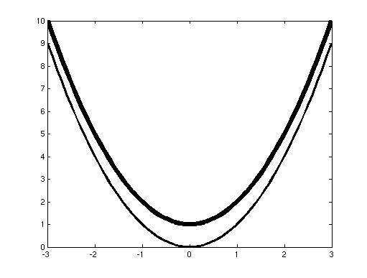
Quick Review Question 7 For the functions f, g, and 3x + 2 from Quick Review Question 5, have the graphs display on one figure in black-and-white with progressively thicker lines.

Similarly, several times in the module on "Empirical Models," we need to display a plot of data points and a plot of a function in the same graphics. To do so, we generate the first graphics, indicate hold on, and then display the second graphics. For example, the following segment defines a list of point coordinates, displays the points with plot as in Figure 5a, and indicates hold on:

xCoords = [-3, 2, -1, 4, 0];
yCoords = [20, 20, -10, 30, 0];
plot(xCoords, yCoords, 'o','MarkerSize', 10, 'MarkerFaceColor', 'k')
xlabel('x')
ylabel('y')
hold on

The next segment plots a cubic polynomial in the same figure (Figure 5b), illustrating that the cubic somewhat captures the trend of the data:

x = -3:0.1:5;
plot(x, -3 + 9*x + 3*x.*x – x.^3, 'k')
hold off

Figure 5a plot of data points | Figure 5b plot of cubic with Figure 5a
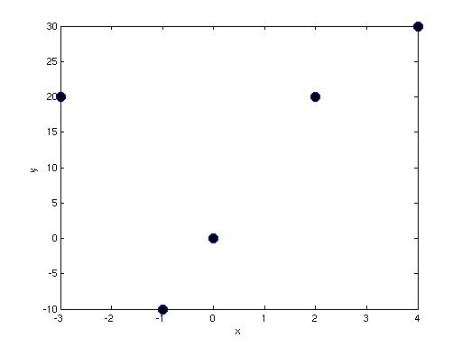 | 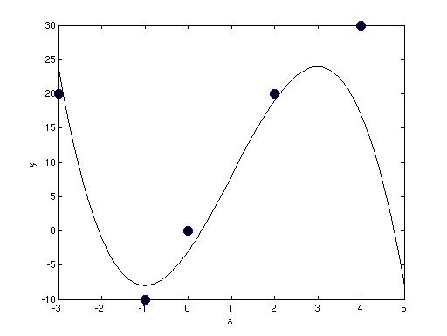
Fit
In Module 8.3 on "Empirical Models," we investigate discovering functions that capture the trend of data. To do so, we employ the MATLAB functions polyfit and polyval. The form of a call to polyfit is as follows:

polyfit(x-coordinates, y-coordinates, n)

For nonnegative integer n, MATLAB returns coefficients (a_{n}, …, a₁, a₀) of the n-th degree polynomial a_{n}x^{n} + …+ a₁x + a₀ that "best" fits the data points with coordinates in x-coordinates and y-coordinates. For example, the following command fits a cubic polynomial to the set of points { (-3, 20), (2, 20), (-1, -10), (4, 30), (0, 0) } above:

xCoords = [-3 2 -1 4 0];
yCoords = [20 20 -10 30 0];
fitCubic = polyfit(xCoords, yCoords, 3)

MATLAB returns the following list (fitCubic) of cubic polynomial coefficients:

-0.8205 3.0439 9.0617 -2.6682

Thus, the cubic that "best" fits the data is -0.8205x³ + 3.0439x² + 9.0617x - 2.6682. The MATLAB function polyval evaluates such a polynomial at an array of values. In the following segment, we assign to x a sequence of values; evaluate the polynomial with coefficients in fitCubic at these values, storing the results in polyValues; and plot the cubic through points with x-coordinates in x and y-coordinates in polyValues:

x = -3:0.1:4;
polyValues = polyval(fitCubic, x);
plot(x, polyValues)

After plotting these points, we show together the graphics of the points (Figure 5a) and the cubic to obtain Figure 6.
Figure 6 Graphics of data points and fitted cubic
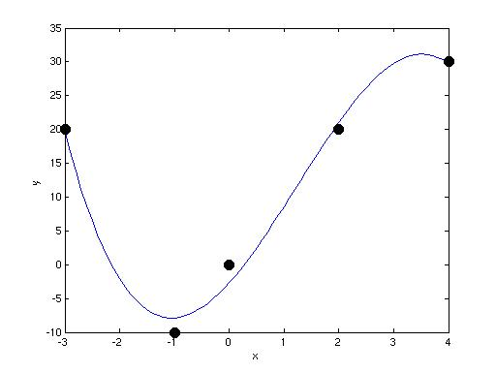
Quick Review Question 8
a. Plot the points in the set { (0.4, 0.16), (0.6, 0.23), (0.8, 0.55), (1.0, 1.0) }. Have the points be green with size 8.
b. Give the command to have curveFit store the coefficients of the line to fit "best" the data. Recall that the general equation of a line is mx + b, which is a polynomial of degree 1.
c. Plot the line from Part b on the same figure as that of Part a.
d. Fit a quadratic, a₂x² + a₁x + a₀, to the data.
e. Add a plot of this quadratic to the figure.
f. No longer have hold on active.

The function polyfit gives the least-squares fit to a list of data. In Module 8.3 on "Empirical Models," we explain least-squares fit and its utility in working with data.
Rules
MATLAB's transformation rules or substitutions enable us to change expressions from one form to another. The function subs, which has the following general form, substitutes value for term every place term occurs in expr:

subs(expr, term, value)

For example, suppose z and x are symbols, and fitData is 23 + 751 * z. The following sequence replaces z with x^{3.9} in the expression fitData:

syms z x
fitData = 23 + 751 * z
subs(fitData, z, x.^3.9)

To define a function f equal to the result, we use the following command:

f = @(x) subs(23 + 751 * z, z, x.^3.9)

Thus, we are defining f(x) as 23 + 751x^{3.9}. We can plot the function from 0 to 4 as follows:

vals = 0:0.1:4;
plot(vals, f(vals))

Quick Review Question 9 Declare x, y, u, and v to be symbols. Then, perform two substitutions to return an expression replacing u with 2^{x} and v with ln(y).

u + 7*v

Remember that the natural logarithm function in MATLAB is log.
Reading from a File
Files can store huge amounts of data and simplify input. Links to data files for various projects appear on the textbook's website. For example, Module 8.3 on "Empirical Models" uses the file DanWoodEM.dat, which appears in Table 1, and several much larger files, all with rectangular arrays of tab-delimited data.
Table 1 DanWoodEM.dat

1.309 2.138
1.471 3.421
1.490 3.597
1.565 4.340
1.611 4.882
1.680 5.660

The MATLAB function load can read such a file of numbers into an array. One form of the command is as follows:

load('FileName.dat')

The file name appears in apostrophes with an extension of .dat or .txt. Unless assigned to a variable, the data is stored in a variable with the name of the file, FileName.
For example, the file DanWoodEM.dat consists of two columns of data for y- and x-values. To read the data into an array of points with the coordinates of each point on a line and to store the resulting table in the variable pts, we employ the following command:

pts = load('DanWoodEM.dat')

The command returns the following array:

pts =

1.3090 2.1380
1.4710 3.4210
1.4900 3.5970
1.5650 4.3400
1.6110 4.8820
1.6800 5.6600

The data file must be in the path of where MATLAB looks, or we must specify the full path name of the file. We can add a path to the list of MATLAB paths from the File menu by selecting Set Path..., clicking Add Folder..., and navigating to the appropriate directory.
As an alternative to setting the path and using load, from the File menu we select Import Data.... The Import Wizard displays the data and leads us through importing the data. For space delimited numeric data in a rectangular array configuration, we press Next and then Finish.
Quick Review Question 10 Read the data of BoxBODEM.dat, which is available on the text's website, into an array, lst.
Logarithms
See the section on "Logarithmic Functions" from Module 8.2 on "Function Tutorial" for a discussion of logarithms.

In MATLAB, the common logarithm of n is log10(n). Thus, the following call to the function returns 3:

log10(1000)

The natural logarithm of n is log(n) in MATLAB. Thus, log(50.0) returns 3.9120 because e ^{3.9120} is 50.0.
Quick Review Question 11
a. Plot e^{x} and ln x from 0 to 3 on the same graph.
b. Evaluate log₁₀ 7.

