11.2 Agents of Interaction: Steering a Dangerous Course

## *NetLogo* Quick Review Questions

*Introduction to Computational Science:*

*Modeling and Simulation for the Sciences, 2nd Edition*

Angela B. Shiflet and George W. Shiflet

Wofford College

© 2014 by Princeton University Press

Agent-Based Modeling

**Quick Review Question 1** Indicate to which each of the following applies, cellular automaton (CA) simulations, agent-based (AB) simulations, or both:

**a.** Autonomous, decision-making entity has a state and behaviors

**b.** Grid cell has state and transition rules specify next state

**c.** Relationship with neighbors determines next state

**d.** Can use grid

**e.** For each time step, iteration is over each grid cell

**f.** For each time step, iteration is over each autonomous, decision-making entity

**g.** Local interactions can cause global change

***Compose all the following answers in NetLogo*:**

Model Environment

**Quick Review Question 2** Write the*WHEN-CREATING-NEW-AGENT* function for initialization of a *Farm* agent.

Agents and Their States

**Quick Review Question 3** Write the*WHEN-CREATING-NEW-AGENT* function for initialization of a *Cattle* agent and the associated *countSIRM* function.

Agent Behaviors

**Quick Review Question 4** Write cattle *WHILE-RUNNING* function, which is the cattle scheduler function.

**Quick Review Question 5** Write cattle *sir* function.

**Quick Review Question 6** Write cattle *sirSlaughterhouse* function.

**Quick Review Question 7** Write cattle *inFarm* function.

**Quick Review Question 8** Write cattle *farm2Sale* function.

**Quick Review Question 9** Write cattle *inSaleBarn1* function.

**Quick Review Question 10** Write cattle *moveInSalebarn* function.

**Quick Review Question 11** Write cattle *inStocker* function.

**Quick Review Question 12** Write cattle *inFeedlot* function.

Model Refinement

**Quick Review Question 13** Write the *SimulationDriver*'s *WHILE-RUNNING* function.

**Quick Review Question 14** Write cattle *initI* function.

Answers to Quick Review Questions

**1. a.** AB **b.** CA **c.** both **d.** both

**e.** CA **f.** AB **g.** both

**2.**

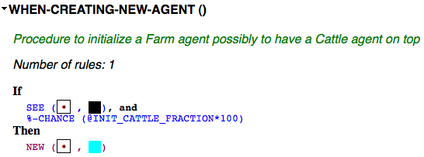

**3.**

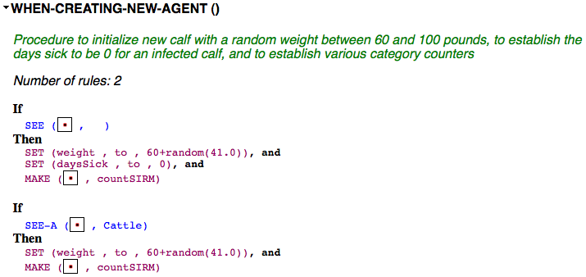

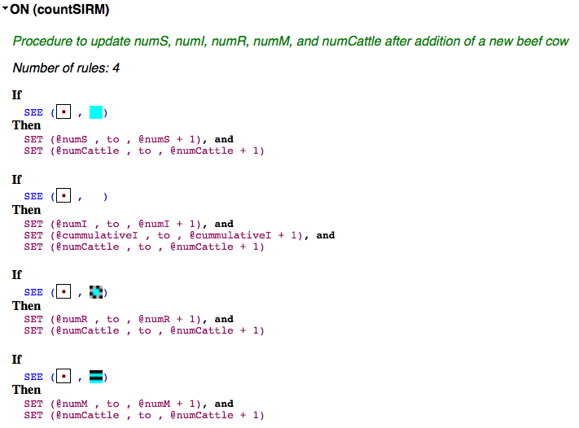

**4.**

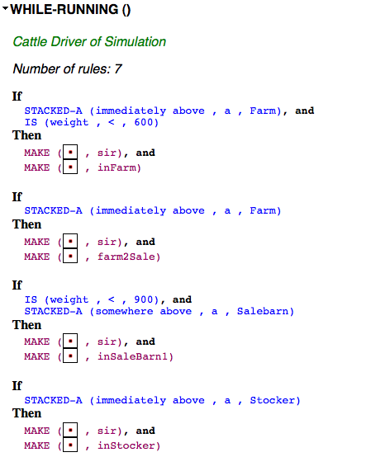

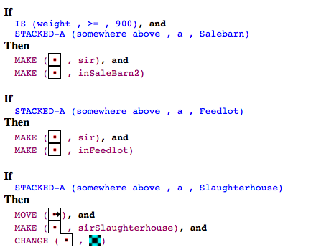

**5.**

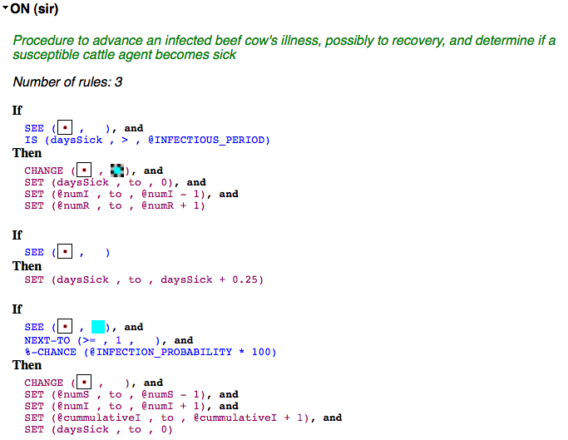

**6.**

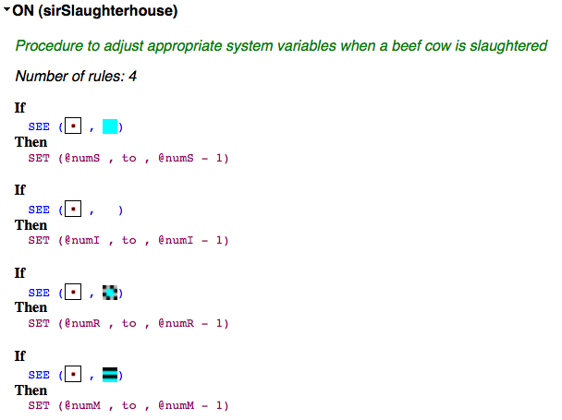

**7.**

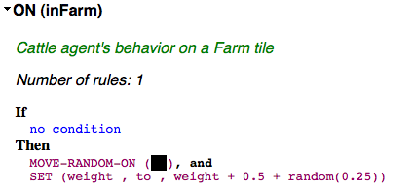

**8.**

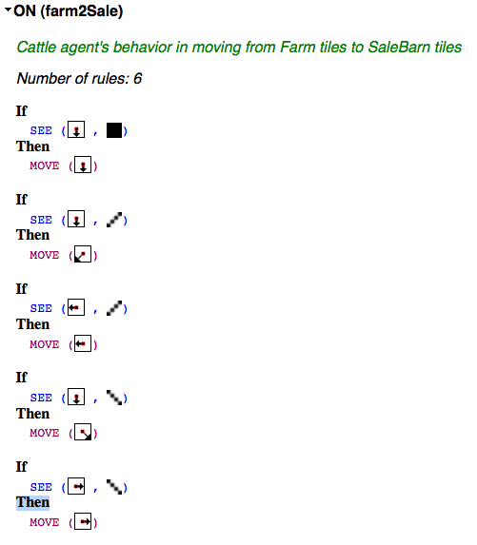

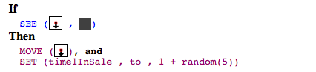

**9.**

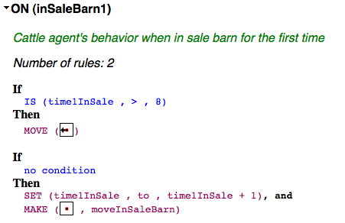

**10.**

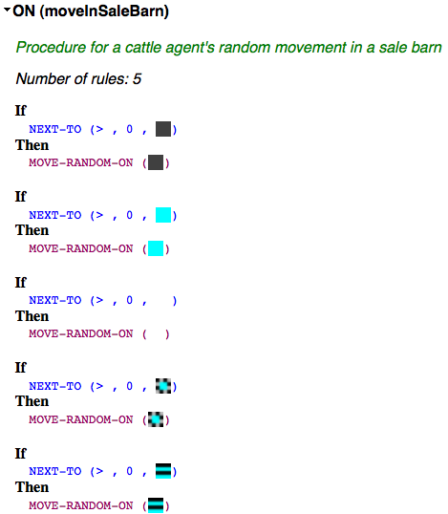

**11.**

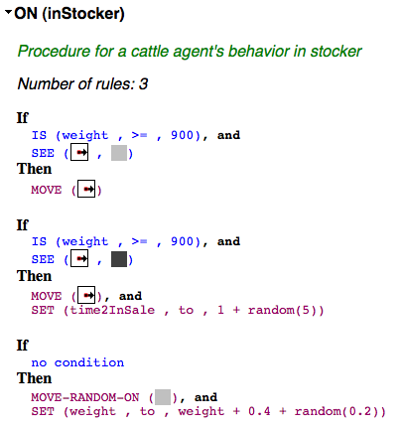

**12.**

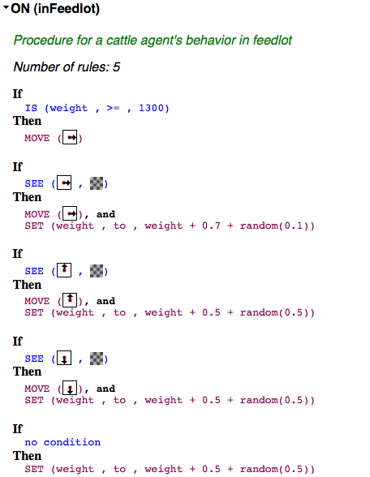

**13.**

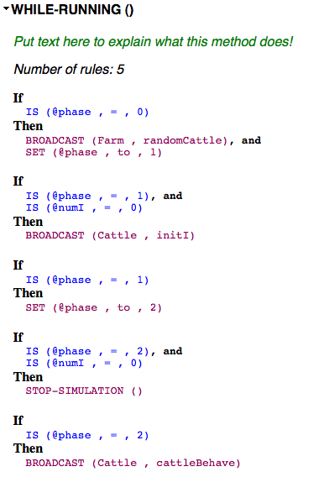

**14.**

