Learn Tables

William Murrah

September 29, 2017

# Introduction

This report uses the Iris data to learn about tables in R Markdown.

|  |  |  |  |  |  |
| --- | --- | --- | --- | --- | --- |
|  | Sepal.Length | Sepal.Width | Petal.Length | Petal.Width | Species |
| **1** | 5.1 | 3.5 | 1.4 | 0.2 | setosa |
| **2** | 4.9 | 3 | 1.4 | 0.2 | setosa |
| **3** | 4.7 | 3.2 | 1.3 | 0.2 | setosa |
| **4** | 4.6 | 3.1 | 1.5 | 0.2 | setosa |
| **5** | 5 | 3.6 | 1.4 | 0.2 | setosa |
| **6** | 5.4 | 3.9 | 1.7 | 0.4 | setosa |
| **...** | ... | ... | ... | ... | NA |
| **145** | 6.7 | 3.3 | 5.7 | 2.5 | virginica |
| **146** | 6.7 | 3 | 5.2 | 2.3 | virginica |
| **147** | 6.3 | 2.5 | 5 | 1.9 | virginica |
| **148** | 6.5 | 3 | 5.2 | 2 | virginica |
| **149** | 6.2 | 3.4 | 5.4 | 2.3 | virginica |
| **150** | 5.9 | 3 | 5.1 | 1.8 | virginica |

ggplot(iris, aes(x = Species, y = Sepal.Length)) + geom_boxplot() +  
 ggtitle("Boxplot of Cool Variables")

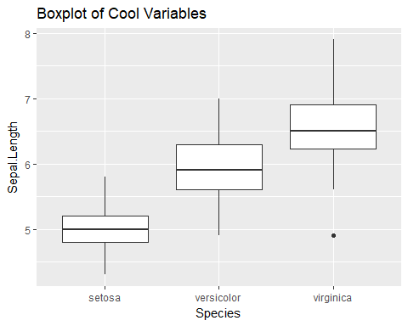

pander(describe(iris[ ,-5], fast = T), caption = "Numeric Variables")

Numeric Variables

|  |  |  |  |  |  |  |  |  |
| --- | --- | --- | --- | --- | --- | --- | --- | --- |
|  | vars | n | mean | sd | min | max | range | se |
| **Sepal.Length** | 1 | 150 | 5.843 | 0.8281 | 4.3 | 7.9 | 3.6 | 0.06761 |
| **Sepal.Width** | 2 | 150 | 3.057 | 0.4359 | 2 | 4.4 | 2.4 | 0.03559 |
| **Petal.Length** | 3 | 150 | 3.758 | 1.765 | 1 | 6.9 | 5.9 | 0.1441 |
| **Petal.Width** | 4 | 150 | 1.199 | 0.7622 | 0.1 | 2.5 | 2.4 | 0.06224 |

pander(table(iris$Species), caption = "Categorical Variable")

Categorical Variable

|  |  |  |
| --- | --- | --- |
| setosa | versicolor | virginica |
| 50 | 50 | 50 |