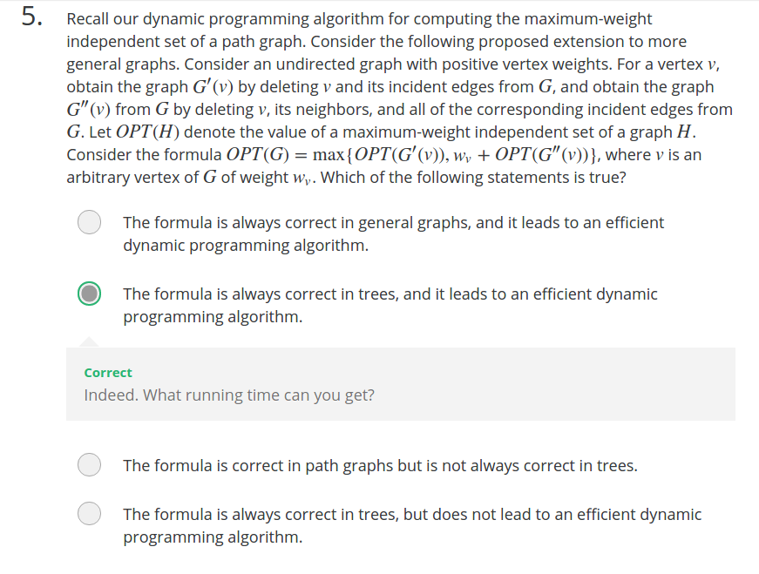
If On = On-2 + wn
O(n-1) = O(n-2). Which means w(n-1) is not used in two consecutive subproblems,

then O(n+1) = max(O(n), O(n-1)+w(n+1), the two subproblems do not rely on w(n-1) eithter.
O(n+2) = max(O(n+1), O(n)+w(n+2))
