README.AvXML-1.0RC1-schema

Synopsis

This README file gives a general description of the AvXML schemas, how it can be used to encode and decode OPMET (OPerational METeorological) data for aviation (namely METAR/SPECI, TAF and SIGMET) and validation of the products against the format and other constraints described by the schemas.

Content

I. Description of Terms
II. Location and Structure of AvXML Schemas
III. Creation of XML Instances
IV. Validation of XML Instances against AvXML Schemas
V. Known Issues
VI. Feedback

Description of Terms

The following terms are used throughout the document:

GML | Geography Markup Language, XML grammar defined by the Open Geospatial Consortium (OGC). Currently, AvXML model and schemas are based on the GML 3.2.1 specifications.
UML | Unified Modeling Language which is used to model WMO Logical Data Model METCE and ICAO Logical Data Model IWXXM.
XML | Extensible Markup Language defined by the World Wide Web Consortium (W3C). Currently, AvXML schemas are based on the XML 1.0 specifications.
XML Document | Document adhering to the XML standard.
XML Instance | XML document adhering to an XML schema.
XML Namespace | Used for providing uniquely named elements and attributes in an XML document.
XML Schema | An XML-based language used to create other XML-based language and data models. In this document, it refers to those specifying the structure that XML documents must adhere to and the type of content that each element can hold. XML Schemas are represented as XSD (XML Schema Definition) documents in AvXML.

Location and Structure of AvXML Schemas

There are two main packages in the AvXML, viz the WMO METCE (Modèle pour l'Échange des informations sur le Temps, le Climat et l'Eau) and the ICAO IWXXM (ICAO Weather Information Exchange Model). Each of these packages contains sub-packages. For AvXML version 1.0RC1, both packages are co-located at the WMO website http://schema.wmo.int with the following directory structure:

http://schema.wmo.int | /wmo | /met-basic | /aeronauticalMeteorology.xsd  /cloud.xsd  /cloudAeronautical.xsd  /mass.xsd  /meteorologicalBasicTypes.xsd  /meteorology.xsd  /moisture.xsd  /momentum.xsd  /oceanography.xsd  /physicalAtmosphericProperties.xsd  /physicalAtmosphericPropertiesAeronautical.xsd  /physicalProperties.xsd  /runwaySurfaceProperties.xsd  /shortWaveRadiation.xsd  /surfaceProperties.xsd  /temperature.xsd
http://schema.wmo.int | /wmo | /opm | /observableProperty.xsd  /opm.xsd
http://schema.wmo.int | /wmo | /metce | /metce.xsd  /observationTypes.xsd  /phenomena.xsd  /procedure.xsd  /qualifiers.xsd
(same as above) | /icao | /saf | /saf.xsd
(same as above) | /icao | /iwxxm | /common.xsd  /dataTypes.xsd  /iwxxm.xsd  /metarSpeci.xsd  /sigmet.xsd  /taf.xsd

A compressed zip file AvXML-1.0RC1-schema.zip containing the above is also available on the WMO WIS-WIKI. These XSD files are generated by semi-automatic processes from their respective models in UML with manual addition of embedded schematrons. For descriptions of the elements and attributes of individual XSD files one should refer to the documentation of the UML models which should also reside on the WMO WIS-WIKI.

Creation of XML Instances

A preliminary test suggested that a number of XML editors are able to create XML Instances with AvXML schemas. These include Liquid XML Studio, NetBeans and <oXygen/> XML Editor. The list, however, is not exhaustive so users are advised to check their own XML editors using AvXML schemas in first place. Please refer to individual software manual on how to create XML instances with XML schemas.

To facilitate automatic and/or offline generation of XML instances, a XML-Java binding ‘AvXML-1.0RC1.jar’ is also available for download at the WMO WIS-WIKI. Created with XMLBeans, one can access instances of the AvXML schemas through JavaBeans-style accessors. See documentation of XMLBeans for details. A sample program using the XML-Java binding and the respective XML instance generated are shown in Appendices A and B.

For descriptions of the elements and attributes one should refer to the documentation of the UML models on the WMO WIS-WIKI

Validation of XML Instances against AvXML Schemas

Appendix C shows the process of validating an XML instance with AvXML schemas using <oXygen/> XML Editor. Please be advised that the location of AvXML schemas has to be explicitly specified so as to tell the XML Editor the place to obtain the embedded schematrons for validation.

Known Issues

Certain constraints as shown in the UML models have not been implemented. They will be handled in subsequent releases of AvXML schemas.

Feedback

Comments are welcomed on issues with implementing the AvXML version 1.0RC1 to create XML instances representing OPMET reports, viz METAR/SPECI, TAF and SIGMET. They should be sent to cbs-tt-avxml@wmo.int. Please start the subject line of your comment with the text [1.0RC1-feedback].

metar-A3-1.java

/*

Sample program for the generation of metar-A3-1.xml

The following libraries are required:

AvXML-1.0RC1
============
AvXML-1.0RC1-XML-Java_binding.jar

XMLBeans
========
jsr173_1.0_api.jar
resolver.jar
saxon9.jar
saxon9-dom.jar
xbean.jar
xbean_xpath.jar
xmlbeans-qname.jar
xmlpublic.jar

*/

package app;

import java.io.File;
import java.io.IOException;
import java.math.BigInteger;
import java.text.SimpleDateFormat;
import java.util.ArrayList;
import java.util.Arrays;
import java.util.Date;
import java.util.HashMap;
import java.util.List;
import java.util.TimeZone;

import javax.xml.namespace.QName;

import net.opengis.gml.x32.DirectPositionType;
import net.opengis.gml.x32.FeaturePropertyType;
import net.opengis.gml.x32.PointType;
import net.opengis.gml.x32.ReferenceType;
import net.opengis.gml.x32.TimeInstantPropertyType;
import net.opengis.gml.x32.TimeInstantType;
import net.opengis.gml.x32.TimePeriodType;
import net.opengis.gml.x32.TimePositionType;
import net.opengis.om.x20.OMObservationPropertyType;
import net.opengis.om.x20.OMObservationType;
import net.opengis.om.x20.OMProcessPropertyType;
import net.opengis.om.x20.TimeObjectPropertyType;
import net.opengis.samplingSpatial.x20.SFSpatialSamplingFeatureType;
import net.opengis.samplingSpatial.x20.ShapeType;

import org.apache.xmlbeans.XmlCursor;
import org.apache.xmlbeans.XmlError;
import org.apache.xmlbeans.XmlObject;
import org.apache.xmlbeans.XmlOptions;

import xint.icao.iwxxm.x10RC1.AerodromeHorizontalVisibilityPropertyType;
import xint.icao.iwxxm.x10RC1.AerodromeHorizontalVisibilityType;
import xint.icao.iwxxm.x10RC1.AerodromeObservedCloudsPropertyType;
import xint.icao.iwxxm.x10RC1.AerodromeObservedCloudsType;
import xint.icao.iwxxm.x10RC1.AerodromeSurfaceWindPropertyType;
import xint.icao.iwxxm.x10RC1.AerodromeSurfaceWindType;
import xint.icao.iwxxm.x10RC1.CloudLayerPropertyType;
import xint.icao.iwxxm.x10RC1.CloudLayerType;
import xint.icao.iwxxm.x10RC1.METARDocument;
import xint.icao.iwxxm.x10RC1.METARType;
import xint.icao.iwxxm.x10RC1.MeteorologicalAerodromeObservationRecordType;
import xint.icao.iwxxm.x10RC1.MeteorologicalAerodromeReportStatusType;
import xint.icao.iwxxm.x10RC1.MeteorologicalAerodromeTrendForecastRecordType;
import xint.wmo.data.def.metBasic.x10RC1.AerodromeForecastWeatherType;
import xint.wmo.data.def.metBasic.x10RC1.AerodromePresentWeatherType;
import xint.wmo.data.def.metBasic.x10RC1.AirTemperatureType;
import xint.wmo.data.def.metBasic.x10RC1.AltimeterSettingType;
import xint.wmo.data.def.metBasic.x10RC1.CloudAmountReportedAtAerodromeType;
import xint.wmo.data.def.metBasic.x10RC1.CloudBaseHeightType;
import xint.wmo.data.def.metBasic.x10RC1.DewPointTemperatureType;
import xint.wmo.data.def.metBasic.x10RC1.PrevailingVisibilityType;
import xint.wmo.data.def.metBasic.x10RC1.WindDirectionType;
import xint.wmo.data.def.metBasic.x10RC1.WindSpeedType;

/**
* @author Keith To
*
*/
public class METAR_example {

public static String XML_FILE_PATH = "xml/metar-A3-1.xml";
public static final String XML_SCHEMA_LOCATION = "http://schemas.wmo.int/iwxxm/1.0RC1 ./iwxxm.xsd http://schemas.wmo.int/metce/1.0RC1 ./metce.xsd";

public static final String NS_GML = "http://www.opengis.net/gml/3.2";
public static final String NS_MET_BASIC = "http://data.wmo.int/def/met-basic/1.0RC1";
public static final String NS_OPM = "http://data.wmo.int/def/opm/1.0RC1";
public static final String NS_METCE = "http://data.wmo.int/def/metce/1.0RC1";
public static final String NS_SAF = "http://icao.int/saf/1.0RC1";
public static final String NS_IWXXM = "http://icao.int/iwxxm/1.0RC1";
public static final String NS_XS = "http://www.w3.org/2001/XMLSchema";
public static final String NS_SAMS = "http://www.opengis.net/samplingSpatial/2.0";
public static final String NS_SAM = "http://www.opengis.net/sampling/2.0";

private static XmlCursor cursor = null;

private static String report_datetime = "";
private static String feature_of_interest_id = "";

/**
* The main function
*
* @param args
*/
public static void main(String[] args) {

Date data_time = new Date();
report_datetime = convert_datetime_format( data_time, "yyyy-MM-dd'T'HH:mm:ssZ" );

create_xml_instance();

}

private static String date_to_yyyymmddhhiiss( String input_date ) {

String yyyy = input_date.substring( 0, 4);
String mm = input_date.substring( 5, 7);
String dd = input_date.substring( 8, 10);
String hh = input_date.substring(11, 13);
String ii = input_date.substring(14, 16);
String ss = input_date.substring(17, 19);

String yyyymmddhhiiss = yyyy + mm + dd + hh + ii + ss;

return yyyymmddhhiiss;
}

private static String convert_datetime_format( Date tar_date, String date_format ){

SimpleDateFormat sdf = new SimpleDateFormat( date_format );
sdf.setTimeZone( TimeZone.getTimeZone( "UTC" ) );

String formated_date = sdf.format( tar_date );

//////////////////////////////////////////////////////////
// Before: 2012-07-23T02:33:09+0000
// After: 2012-07-23T02:33:09+00:00
char last_char = date_format.charAt( date_format.length() - 1 );

if( last_char == 'Z' )
{
formated_date = formated_date.substring( 0, formated_date.length() - 2 ) + ':' + formated_date.substring( formated_date.length() - 2, formated_date.length() );
}
//////////////////////////////////////////////////////////

return formated_date;
}

private static void create_xml_instance()
{

//================================================================
// METAR
METARDocument metar_doc = METARDocument.Factory.newInstance();

METARType metar_type = metar_doc.addNewMETAR();

metar_type.setId("Metar_001");

//================================================================
// MeteorologicalAerodromeReportStatus
metar_type.setStatus( MeteorologicalAerodromeReportStatusType.NORMAL );
metar_type.setAutomatedStation(false);

//================================================================
// observation
OMObservationPropertyType Observation = metar_type.addNewObservation();

OMObservationType MeteorologicalAerodromeObservation = Observation.addNewOMObservation();

MeteorologicalAerodromeObservation.setId( "obs-yudo-20120822163000" );

ReferenceType meteorologicalAerodromeObservationType = MeteorologicalAerodromeObservation.addNewType();

meteorologicalAerodromeObservationType.setHref("http://data.wmo.int/def/49/MeteorologicalAerodromeObservation");
meteorologicalAerodromeObservationType.setTitle("Aerodrome Observation");

//================================================================
// phenomenonTime
TimeObjectPropertyType phenomenonTime = MeteorologicalAerodromeObservation.addNewPhenomenonTime();
TimeInstantType phenomenonTimeInstant = TimeInstantType.Factory.newInstance();
String timeInstant_id = "time-instant-" + date_to_yyyymmddhhiiss( "2012-08-22T16:30:00+00:00" );

phenomenonTimeInstant.setFrame(phenomenonTimeInstant.getFrame());
TimePositionType phenomenonTimePosition = phenomenonTimeInstant.addNewTimePosition();

phenomenonTimePosition.setFrame(phenomenonTimePosition.getFrame());
phenomenonTimePosition.setStringValue( "2012-08-22T16:30:00+00:00" );

cursor = phenomenonTime.newCursor();
cursor.toNextToken();
cursor.beginElement("TimeInstant", NS_GML);
cursor.insertAttributeWithValue(new QName(NS_GML, "id"), timeInstant_id);

XmlCursor placedCursor2 = phenomenonTimeInstant.newCursor();
placedCursor2.copyXmlContents(cursor);

//================================================================
// resultTime
TimeInstantPropertyType resultTime = MeteorologicalAerodromeObservation.addNewResultTime();
TimeInstantType resultTimeInstant = resultTime.addNewTimeInstant();
timeInstant_id = "time-instant-" + date_to_yyyymmddhhiiss( report_datetime );
resultTimeInstant.setId( timeInstant_id );

resultTimeInstant.setFrame(resultTimeInstant.getFrame());
TimePositionType resultTimePosition = resultTimeInstant.addNewTimePosition();

resultTimePosition.setFrame(resultTimePosition.getFrame());
resultTimePosition.setStringValue( report_datetime );

//================================================================
// procedure
OMProcessPropertyType procedure = MeteorologicalAerodromeObservation.addNewProcedure();
procedure.setHref("http://data.wmo.int/def/process/AutomatedMETARObservation");
procedure.setTitle("Automated METAR");

//================================================================
// observedProperty
ReferenceType observedProperty = MeteorologicalAerodromeObservation.addNewObservedProperty();
observedProperty.setHref("http://icao.int/property/AerodromeWeather-obs");
observedProperty.setTitle("METAR observation properties");

//================================================================
// result
XmlObject result2 = MeteorologicalAerodromeObservation.addNewResult();

cursor = result2.newCursor();
cursor.toNextToken();
cursor.beginElement("MeteorologicalAerodromeObservationRecord", NS_IWXXM);
cursor.insertAttributeWithValue(new QName(NS_GML, "id"), "ObservationRecord_001");
cursor.insertAttributeWithValue(new QName("", "ceilingAndVisibilityOK"), "false");

MeteorologicalAerodromeObservationRecordType MeteorologicalAerodromeObservationRecord = MeteorologicalAerodromeObservationRecordType.Factory.newInstance();

//================================================================
// airTemperature
AirTemperatureType airTemperature = MeteorologicalAerodromeObservationRecord.addNewAirTemperature();
airTemperature.setDoubleValue( 17 );
airTemperature.setUom("http://opengis.net/def/uom/UCUM/0/C");

//================================================================
// dewpointTemperature
DewPointTemperatureType dewpointTemperature = MeteorologicalAerodromeObservationRecord.addNewDewpointTemperature();
dewpointTemperature.setDoubleValue( 16 );
dewpointTemperature.setUom("http://opengis.net/def/uom/UCUM/0/C");

//================================================================
// qnh
AltimeterSettingType qnh = MeteorologicalAerodromeObservationRecord.addNewQnh();
qnh.setDoubleValue( 1018 );
qnh.setUom("http://opengis.net/def/uom/UCUM/0/hPa");

//================================================================
// surfaceWind
AerodromeSurfaceWindPropertyType surfaceWind = MeteorologicalAerodromeObservationRecord.addNewSurfaceWind();
AerodromeSurfaceWindType AerodromeSurfaceWind = surfaceWind.addNewAerodromeSurfaceWind();

AerodromeSurfaceWind.setVariableDirection(false);

WindSpeedType windSpeed = AerodromeSurfaceWind.addNewWindSpeed();
windSpeed.setDoubleValue( 4 );
windSpeed.setUom( "http://opengis.net/def/uom/UCUM/0/m/s" );

WindDirectionType meanWindDirection = AerodromeSurfaceWind.addNewMeanWindDirection();
meanWindDirection.setDoubleValue( 240 );
meanWindDirection.setUom( "http://opengis.net/def/uom/UCUM/0/deg" );

//================================================================
// visibility
AerodromeHorizontalVisibilityPropertyType visibility = MeteorologicalAerodromeObservationRecord.addNewVisibility();

AerodromeHorizontalVisibilityType AerodromeHorizontalVisibility = visibility.addNewAerodromeHorizontalVisibility();
PrevailingVisibilityType prevailingVisibility = AerodromeHorizontalVisibility.addNewPrevailingVisibility();

prevailingVisibility.setDoubleValue( 600 );
prevailingVisibility.setUom( "http://opengis.net/def/uom/UCUM/0/m" );

//================================================================
// presentWeather
AerodromePresentWeatherType presentWeather = MeteorologicalAerodromeObservationRecord.addNewPresentWeather();
XmlCursor presentWeatherCursor = presentWeather.type.getAnnotation().getApplicationInformation()[0].newCursor();
presentWeatherCursor.toChild(NS_XS, "vocabulary");
String presentWeatherHref = presentWeatherCursor.getTextValue();

presentWeather.setHref(presentWeatherHref + "/" + "DZ");
presentWeather.setTitle("Drizzle");

//================================================================
// presentWeather
AerodromePresentWeatherType presentWeather2 = MeteorologicalAerodromeObservationRecord.addNewPresentWeather();
presentWeatherCursor = presentWeather2.type.getAnnotation().getApplicationInformation()[0].newCursor();
presentWeatherCursor.toChild(NS_XS, "vocabulary");
presentWeatherHref = presentWeatherCursor.getTextValue();

presentWeather2.setHref(presentWeatherHref + "/" + "FG");
presentWeather2.setTitle("Fog");

//================================================================
// cloud
AerodromeObservedCloudsPropertyType cloud = MeteorologicalAerodromeObservationRecord.addNewCloud();
AerodromeObservedCloudsType AerodromeObservedClouds = cloud.addNewAerodromeObservedClouds();

//================================================================
// layer
CloudLayerPropertyType layer = AerodromeObservedClouds.addNewLayer();
CloudLayerType CloudLayer = layer.addNewCloudLayer();

// amount
CloudAmountReportedAtAerodromeType cloudAmount = CloudLayer.addNewAmount();
XmlCursor cloudAmountCursor = cloudAmount.type.getAnnotation().getApplicationInformation()[0].newCursor();
cloudAmountCursor.toChild(NS_XS, "vocabulary");
String cloudAmountHref = cloudAmountCursor.getTextValue();
cloudAmount.setHref(cloudAmountHref + "/" + "2");
cloudAmount.setTitle("Scattered");

// base
CloudBaseHeightType base = CloudLayer.addNewBase();
base.setDoubleValue(1000);
base.setUom("http://opengis.net/def/uom/UCUM/0/ft");

//================================================================
// layer
layer = AerodromeObservedClouds.addNewLayer();
CloudLayer = layer.addNewCloudLayer();

// amount
cloudAmount = CloudLayer.addNewAmount();
cloudAmountCursor = cloudAmount.type.getAnnotation().getApplicationInformation()[0].newCursor();
cloudAmountCursor.toChild(NS_XS, "vocabulary");
cloudAmountHref = cloudAmountCursor.getTextValue();
cloudAmount.setHref(cloudAmountHref + "/" + "4");
cloudAmount.setTitle("Overcast");

// base
base = CloudLayer.addNewBase();
base.setDoubleValue(2000);
base.setUom("http://opengis.net/def/uom/UCUM/0/ft");

XmlCursor polygonCursor = MeteorologicalAerodromeObservationRecord.newCursor();
polygonCursor.copyXmlContents(cursor);

//================================================================
// featureOfInterest3
FeaturePropertyType featureOfInterest3 = MeteorologicalAerodromeObservation.addNewFeatureOfInterest();
featureOfInterest3 = fill_feature_of_interest(featureOfInterest3);

//================================================================
// MeteorologicalAerodromeTrendForecast
OMObservationPropertyType trend_forecast = metar_type.addNewTrendForecast();

OMObservationType MeteorologicalAerodromeTrendForecast = trend_forecast.addNewOMObservation();

MeteorologicalAerodromeTrendForecast.setId("trend-fcst-1-yudo");

ReferenceType type = MeteorologicalAerodromeTrendForecast.addNewType();

type.setHref("http://data.wmo.int/def/49/observationType/MeteorologicalAerodromeTrendForecast");
type.setTitle("Aerodrome Trend Forecast");

//================================================================
// phenomenonTime
TimeObjectPropertyType fcst_phenomenonTime = MeteorologicalAerodromeTrendForecast.addNewPhenomenonTime();
TimePeriodType phenomenonTimePeriodInstant = TimePeriodType.Factory.newInstance();

TimePositionType BeginPosition = phenomenonTimePeriodInstant.addNewBeginPosition();
BeginPosition.setStringValue("2012-08-22T16:30:00+00:00");

TimePositionType EndPosition = phenomenonTimePeriodInstant.addNewEndPosition();
EndPosition.setStringValue("2012-08-22T17:00:00+00:00");

XmlCursor cursor2 = fcst_phenomenonTime.newCursor();
cursor2.toNextToken();
cursor2.beginElement("TimePeriod", NS_GML);
cursor2.insertAttributeWithValue(new QName(NS_GML, "id"), "time-period-20120822163000-20120822170000");

XmlCursor placedCursor3 = phenomenonTimePeriodInstant.newCursor();
placedCursor3.copyXmlContents(cursor2);

//================================================================
// resultTime
TimeInstantPropertyType fcst_resultTime = MeteorologicalAerodromeTrendForecast.addNewResultTime();

TimeInstantType fcst_resultTimeInstant = fcst_resultTime.addNewTimeInstant();
timeInstant_id = "fcst-time-instant1-" + date_to_yyyymmddhhiiss( report_datetime );
fcst_resultTimeInstant.setId( timeInstant_id );

fcst_resultTimeInstant.setFrame(fcst_resultTimeInstant.getFrame());
TimePositionType fcst_resultTimePosition = fcst_resultTimeInstant.addNewTimePosition();

fcst_resultTimePosition.setFrame(fcst_resultTimePosition.getFrame());
fcst_resultTimePosition.setStringValue( report_datetime );

//================================================================
// procedure
OMProcessPropertyType fcst_procedure = MeteorologicalAerodromeTrendForecast.addNewProcedure();
fcst_procedure.setHref("http://data.wmo.int/def/process/HumanGeneratedTrendForecast");
fcst_procedure.setTitle("Human-generated trend forecast");

//================================================================
// observedProperty
ReferenceType fcst_observedProperty = MeteorologicalAerodromeTrendForecast.addNewObservedProperty();
fcst_observedProperty.setHref("http://icao.int/property/AerodromeWeather-trend-fcst");
fcst_observedProperty.setTitle("METAR trend forecast properties");

//================================================================
// result
XmlObject trend_forecast_result2 = MeteorologicalAerodromeTrendForecast.addNewResult();

cursor = trend_forecast_result2.newCursor();
cursor.toNextToken();
cursor.beginElement("MeteorologicalAerodromeTrendForecastRecord", NS_IWXXM);
cursor.insertAttributeWithValue(new QName(NS_GML, "id"), "trend-fcst-record1-YUDO");

MeteorologicalAerodromeTrendForecastRecordType MeteorologicalAerodromeTrendForecastRecord = MeteorologicalAerodromeTrendForecastRecordType.Factory.newInstance();

cursor.insertAttributeWithValue(new QName("", "ceilingAndVisibilityOK"), "false");
cursor.insertAttributeWithValue(new QName("", "changeIndicator"), "BECOMING");

//================================================================
// visibility
PrevailingVisibilityType trend_forecast_visibility = MeteorologicalAerodromeTrendForecastRecord.addNewPrevailingHorizontalVisibility();
trend_forecast_visibility.setDoubleValue(800);
trend_forecast_visibility.setUom("http://opengis.net/def/uom/UCUM/0/m");

//================================================================
// weather
AerodromeForecastWeatherType trend_forecast_presentWeather = MeteorologicalAerodromeTrendForecastRecord.addNewForecastWeather();
XmlCursor forecastWeatherCursor = trend_forecast_presentWeather.type.getAnnotation().getApplicationInformation()[0].newCursor();
forecastWeatherCursor.toChild(NS_XS, "vocabulary");
String forecastWeatherHref = forecastWeatherCursor.getTextValue();

trend_forecast_presentWeather.setHref(forecastWeatherHref + "/" + "FG");
trend_forecast_presentWeather.setTitle("Fog");

polygonCursor = MeteorologicalAerodromeTrendForecastRecord.newCursor();
polygonCursor.copyXmlContents(cursor);

//================================================================
// featureOfInterest3
featureOfInterest3 = MeteorologicalAerodromeTrendForecast.addNewFeatureOfInterest();
featureOfInterest3 = fill_feature_of_interest(featureOfInterest3);

//================================================================
// MeteorologicalAerodromeTrendForecast
trend_forecast = metar_type.addNewTrendForecast();

MeteorologicalAerodromeTrendForecast = trend_forecast.addNewOMObservation();

MeteorologicalAerodromeTrendForecast.setId("trend-fcst-2-yudo");

type = MeteorologicalAerodromeTrendForecast.addNewType();

type.setHref("http://data.wmo.int/def/49/observationType/MeteorologicalAerodromeTrendForecast");
type.setTitle("Aerodrome Trend Forecast");

//================================================================
// phenomenonTime
fcst_phenomenonTime = MeteorologicalAerodromeTrendForecast.addNewPhenomenonTime();
phenomenonTimePeriodInstant = TimePeriodType.Factory.newInstance();

BeginPosition = phenomenonTimePeriodInstant.addNewBeginPosition();
BeginPosition.setStringValue("2012-08-22T18:00:00+00:00");

EndPosition = phenomenonTimePeriodInstant.addNewEndPosition();
EndPosition.setStringValue("2012-08-22T19:00:00+00:00");

cursor2 = fcst_phenomenonTime.newCursor();
cursor2.toNextToken();
cursor2.beginElement("TimePeriod", NS_GML);
cursor2.insertAttributeWithValue(new QName(NS_GML, "id"), "time-period-20120822180000-20120822190000");

placedCursor3 = phenomenonTimePeriodInstant.newCursor();
placedCursor3.copyXmlContents(cursor2);

//================================================================
// resultTime
fcst_resultTime = MeteorologicalAerodromeTrendForecast.addNewResultTime();

fcst_resultTimeInstant = fcst_resultTime.addNewTimeInstant();
timeInstant_id = "fcst-time-instant2-" + date_to_yyyymmddhhiiss( report_datetime );
fcst_resultTimeInstant.setId( timeInstant_id );

fcst_resultTimeInstant.setFrame(fcst_resultTimeInstant.getFrame());
fcst_resultTimePosition = fcst_resultTimeInstant.addNewTimePosition();

fcst_resultTimePosition.setFrame(fcst_resultTimePosition.getFrame());
fcst_resultTimePosition.setStringValue( report_datetime );

//================================================================
// procedure
fcst_procedure = MeteorologicalAerodromeTrendForecast.addNewProcedure();
fcst_procedure.setHref("http://data.wmo.int/def/process/HumanGeneratedTrendForecast");
fcst_procedure.setTitle("Human-generated trend forecast");

//================================================================
// observedProperty
fcst_observedProperty = MeteorologicalAerodromeTrendForecast.addNewObservedProperty();
fcst_observedProperty.setHref("http://icao.int/property/AerodromeWeather-trend-fcst");
fcst_observedProperty.setTitle("METAR trend forecast properties");

//================================================================
// result
trend_forecast_result2 = MeteorologicalAerodromeTrendForecast.addNewResult();

cursor = trend_forecast_result2.newCursor();
cursor.toNextToken();
cursor.beginElement("MeteorologicalAerodromeTrendForecastRecord", NS_IWXXM);
cursor.insertAttributeWithValue(new QName(NS_GML, "id"), "trend-fcst-record2-YUDO");

MeteorologicalAerodromeTrendForecastRecord = MeteorologicalAerodromeTrendForecastRecordType.Factory.newInstance();

cursor.insertAttributeWithValue(new QName("", "ceilingAndVisibilityOK"), "false");
cursor.insertAttributeWithValue(new QName("", "changeIndicator"), "BECOMING");

//================================================================
// visibility
trend_forecast_visibility = MeteorologicalAerodromeTrendForecastRecord.addNewPrevailingHorizontalVisibility();
trend_forecast_visibility.setDoubleValue(10);
trend_forecast_visibility.setUom("http://opengis.net/def/uom/UCUM/0/km");

//================================================================
// weather
trend_forecast_presentWeather = MeteorologicalAerodromeTrendForecastRecord.addNewForecastWeather();
trend_forecast_presentWeather.setNilReason("http://data.wmo.int/def/nil-reason/nothingOfOperationalSignificance");

polygonCursor = MeteorologicalAerodromeTrendForecastRecord.newCursor();
polygonCursor.copyXmlContents(cursor);

//================================================================
// featureOfInterest3
featureOfInterest3 = MeteorologicalAerodromeTrendForecast.addNewFeatureOfInterest();
featureOfInterest3 = fill_feature_of_interest(featureOfInterest3);

add_schema_location(metar_doc, XML_SCHEMA_LOCATION);
validate_xml_instance( metar_doc );
write_xml_file(metar_doc, XML_FILE_PATH);

}

public static void write_xml_file( XmlObject doc_object, String target_file_path ){

File xml_file = new File( target_file_path );

HashMap NamespaceMap = new HashMap();
NamespaceMap.put("http://www.opengis.net/om/2.0", "om");
NamespaceMap.put(NS_GML, "gml");
NamespaceMap.put(NS_MET_BASIC, "");
NamespaceMap.put(NS_OPM, "");
NamespaceMap.put(NS_METCE, "metce");
NamespaceMap.put(NS_SAF, "saf");
NamespaceMap.put(NS_IWXXM, "");
NamespaceMap.put(NS_XS, "");
NamespaceMap.put(NS_SAMS, "sams");
NamespaceMap.put(NS_SAM, "sam");

XmlOptions xml_options = new XmlOptions();
xml_options.setSavePrettyPrint();
xml_options.setSaveSuggestedPrefixes(NamespaceMap);
xml_options.setSaveAggressiveNamespaces();
xml_options.setUseDefaultNamespace();

try {
doc_object.save(xml_file, xml_options);
} catch (IOException e) {
e.printStackTrace();
}
}

public static boolean validate_xml_instance( XmlObject xml_doc_object ){
boolean is_xml_valid = false;

// A collection instance to hold validation error messages.
ArrayList validation_messages = new ArrayList();

// Validate the XML, collecting messages.
is_xml_valid = xml_doc_object.validate(
new XmlOptions().setErrorListener(validation_messages));

// If the XML isn't valid, print the messages.
if (!is_xml_valid)
{
System.out.println("\nInvalid XML: ");
for (int i = 0; i < validation_messages.size(); i++)
{
XmlError error = (XmlError) validation_messages.get(i);
System.out.println(error.getMessage());
System.out.println(error.getObjectLocation());
}
}
return is_xml_valid;
}

/**
* add schema location to the xml doc object
*
* @param xml_doc_object the xml doc object
* @param schema_location the schema location
*/
public static void add_schema_location( XmlObject xml_doc_object, String schema_location ){

XmlCursor cursor = xml_doc_object.newCursor();

if(cursor.toFirstChild()){
cursor.setAttributeText(new QName("http://www.w3.org/2001/XMLSchema-instance", "schemaLocation"), schema_location);
}

}

private static FeaturePropertyType fill_feature_of_interest( FeaturePropertyType featureOfInterest3 )
{
if( feature_of_interest_id.compareTo("") == 0 )
{
SFSpatialSamplingFeatureType SFSpatialSamplingFeature = SFSpatialSamplingFeatureType.Factory.newInstance();

feature_of_interest_id = "SFSpatialSamplingFeature_001";

SFSpatialSamplingFeature.setId(feature_of_interest_id);
ReferenceType SFSpatialSamplingFeatureType = SFSpatialSamplingFeature.addNewType();
SFSpatialSamplingFeatureType.setHref("http://www.opengis.net/def/samplingFeatureType/OGC-OM/2.0/SF_SamplingPoint");
SFSpatialSamplingFeatureType.setTitle("SF_SamplingPoint");

FeaturePropertyType sampledFeature = SFSpatialSamplingFeature.addNewSampledFeature();
sampledFeature.setHref("http://icao.int/id/aerodrome/YUDO");
sampledFeature.setTitle("Fake Airport");

ShapeType shape = SFSpatialSamplingFeature.addNewShape();

PointType point = PointType.Factory.newInstance();
point.setId("Point_001");
DirectPositionType pos = point.addNewPos();

pos.setStringValue("0.00 0.00");

List<String> latlon = Arrays.asList("Lat", "Lon");
pos.setAxisLabels(latlon);
pos.setSrsName("http://www.opengis.net/def/crs/EPSG/0/4326");
pos.setSrsDimension(new BigInteger("2"));

XmlCursor cursor2 = shape.newCursor();
cursor2.toNextToken();
cursor2.beginElement("Point", NS_GML);
cursor2.insertAttributeWithValue(new QName(NS_GML, "id"), "Point_001");

XmlCursor placedCursor2 = point.newCursor();
placedCursor2.getObject().xmlText();
placedCursor2.copyXmlContents(cursor2);
cursor2.dispose();
placedCursor2.dispose();

XmlCursor cursor = featureOfInterest3.newCursor();
cursor.toNextToken();
cursor.beginElement("SF_SpatialSamplingFeature", NS_SAMS);
cursor.insertAttributeWithValue(new QName(NS_GML, "id"), feature_of_interest_id);

XmlCursor polygonCursor = SFSpatialSamplingFeature.newCursor();
polygonCursor.copyXmlContents(cursor);

cursor.dispose();
polygonCursor.dispose();
}
else
{
featureOfInterest3.setHref( "#" + feature_of_interest_id );
}

return featureOfInterest3;
}

}

metar-A3-1.xml

<?xml version="1.0" encoding="UTF-8"?>
<METAR gml:id="Metar_001" status="NORMAL" automatedStation="false" xsi:schemaLocation="http://schemas.wmo.int/iwxxm/1.0RC1 ./iwxxm.xsd http://schemas.wmo.int/metce/1.0RC1 ./metce.xsd" xmlns="http://icao.int/iwxxm/1.0RC1" xmlns:gml="http://www.opengis.net/gml/3.2" xmlns:xsi="http://www.w3.org/2001/XMLSchema-instance" xmlns:om="http://www.opengis.net/om/2.0" xmlns:xlin="http://www.w3.org/1999/xlink" xmlns:sams="http://www.opengis.net/samplingSpatial/2.0" xmlns:sam="http://www.opengis.net/sampling/2.0">
<observation>
<om:OM_Observation gml:id="obs-yudo-20120822163000">
<om:type xlin:href="http://data.wmo.int/def/49/MeteorologicalAerodromeObservation" xlin:title="Aerodrome Observation"/>
<om:phenomenonTime>
<gml:TimeInstant gml:id="time-instant-20120822163000">
<gml:timePosition frame="#ISO-8601">2012-08-22T16:30:00+00:00</gml:timePosition>
</gml:TimeInstant>
</om:phenomenonTime>
<om:resultTime>
<gml:TimeInstant gml:id="time-instant-20121206085813" frame="#ISO-8601">
<gml:timePosition frame="#ISO-8601">2012-12-06T08:58:13+00:00</gml:timePosition>
</gml:TimeInstant>
</om:resultTime>
<om:procedure xlin:href="http://data.wmo.int/def/process/AutomatedMETARObservation" xlin:title="Automated METAR"/>
<om:observedProperty xlin:href="http://icao.int/property/AerodromeWeather-obs" xlin:title="METAR observation properties"/>
<om:featureOfInterest>
<sams:SF_SpatialSamplingFeature gml:id="SFSpatialSamplingFeature_001">
<sam:type xlin:href="http://www.opengis.net/def/samplingFeatureType/OGC-OM/2.0/SF_SamplingPoint" xlin:title="SF_SamplingPoint"/>
<sam:sampledFeature xlin:href="http://icao.int/id/aerodrome/YUDO" xlin:title="Fake Airport"/>
<sams:shape>
<gml:Point gml:id="Point_001">
<gml:pos axisLabels="Lat Lon" srsName="http://www.opengis.net/def/crs/EPSG/0/4326" srsDimension="2">0.00 0.00</gml:pos>
</gml:Point>
</sams:shape>
</sams:SF_SpatialSamplingFeature>
</om:featureOfInterest>
<om:result>
<MeteorologicalAerodromeObservationRecord gml:id="ObservationRecord_001" ceilingAndVisibilityOK="false">
<airTemperature uom="http://opengis.net/def/uom/UCUM/0/C">17.0</airTemperature>
<dewpointTemperature uom="http://opengis.net/def/uom/UCUM/0/C">16.0</dewpointTemperature>
<qnh uom="http://opengis.net/def/uom/UCUM/0/hPa">1018.0</qnh>
<surfaceWind>
<AerodromeSurfaceWind variableDirection="false">
<meanWindDirection uom="http://opengis.net/def/uom/UCUM/0/deg">240.0</meanWindDirection>
<windSpeed uom="http://opengis.net/def/uom/UCUM/0/m/s">4.0</windSpeed>
</AerodromeSurfaceWind>
</surfaceWind>
<presentWeather xlin:href="http://data.wmo.int/def/49-2/AerodromePresentWeather/DZ" xlin:title="Drizzle"/>
<presentWeather xlin:href="http://data.wmo.int/def/49-2/AerodromePresentWeather/FG" xlin:title="Fog"/>
<visibility>
<AerodromeHorizontalVisibility>
<prevailingVisibility uom="http://opengis.net/def/uom/UCUM/0/m">600.0</prevailingVisibility>
</AerodromeHorizontalVisibility>
</visibility>
<cloud>
<AerodromeObservedClouds>
<layer>
<CloudLayer>
<amount xlin:href="http://data.wmo.int/def/49-2/CloudAmountReportedAtAerodrome/2" xlin:title="Scattered"/>
<base uom="http://opengis.net/def/uom/UCUM/0/ft">1000.0</base>
</CloudLayer>
</layer>
<layer>
<CloudLayer>
<amount xlin:href="http://data.wmo.int/def/49-2/CloudAmountReportedAtAerodrome/4" xlin:title="Overcast"/>
<base uom="http://opengis.net/def/uom/UCUM/0/ft">2000.0</base>
</CloudLayer>
</layer>
</AerodromeObservedClouds>
</cloud>
</MeteorologicalAerodromeObservationRecord>
</om:result>
</om:OM_Observation>
</observation>
<trendForecast>
<om:OM_Observation gml:id="trend-fcst-1-yudo">
<om:type xlin:href="http://data.wmo.int/def/49/observationType/MeteorologicalAerodromeTrendForecast" xlin:title="Aerodrome Trend Forecast"/>
<om:phenomenonTime>
<gml:TimePeriod gml:id="time-period-20120822163000-20120822170000">
<gml:beginPosition>2012-08-22T16:30:00+00:00</gml:beginPosition>
<gml:endPosition>2012-08-22T17:00:00+00:00</gml:endPosition>
</gml:TimePeriod>
</om:phenomenonTime>
<om:resultTime>
<gml:TimeInstant gml:id="fcst-time-instant1-20121206085813" frame="#ISO-8601">
<gml:timePosition frame="#ISO-8601">2012-12-06T08:58:13+00:00</gml:timePosition>
</gml:TimeInstant>
</om:resultTime>
<om:procedure xlin:href="http://data.wmo.int/def/process/HumanGeneratedTrendForecast" xlin:title="Human-generated trend forecast"/>
<om:observedProperty xlin:href="http://icao.int/property/AerodromeWeather-trend-fcst" xlin:title="METAR trend forecast properties"/>
<om:featureOfInterest xlin:href="#SFSpatialSamplingFeature_001"/>
<om:result>
<MeteorologicalAerodromeTrendForecastRecord gml:id="trend-fcst-record1-YUDO" ceilingAndVisibilityOK="false" changeIndicator="BECOMING">
<prevailingHorizontalVisibility uom="http://opengis.net/def/uom/UCUM/0/m">800.0</prevailingHorizontalVisibility>
<forecastWeather xlin:href="http://data.wmo.int/def/49-2/AerodromeForecastWeather/FG" xlin:title="Fog"/>
</MeteorologicalAerodromeTrendForecastRecord>
</om:result>
</om:OM_Observation>
</trendForecast>
<trendForecast>
<om:OM_Observation gml:id="trend-fcst-2-yudo">
<om:type xlin:href="http://data.wmo.int/def/49/observationType/MeteorologicalAerodromeTrendForecast" xlin:title="Aerodrome Trend Forecast"/>
<om:phenomenonTime>
<gml:TimePeriod gml:id="time-period-20120822180000-20120822190000">
<gml:beginPosition>2012-08-22T18:00:00+00:00</gml:beginPosition>
<gml:endPosition>2012-08-22T19:00:00+00:00</gml:endPosition>
</gml:TimePeriod>
</om:phenomenonTime>
<om:resultTime>
<gml:TimeInstant gml:id="fcst-time-instant2-20121206085813" frame="#ISO-8601">
<gml:timePosition frame="#ISO-8601">2012-12-06T08:58:13+00:00</gml:timePosition>
</gml:TimeInstant>
</om:resultTime>
<om:procedure xlin:href="http://data.wmo.int/def/process/HumanGeneratedTrendForecast" xlin:title="Human-generated trend forecast"/>
<om:observedProperty xlin:href="http://icao.int/property/AerodromeWeather-trend-fcst" xlin:title="METAR trend forecast properties"/>
<om:featureOfInterest xlin:href="#SFSpatialSamplingFeature_001"/>
<om:result>
<MeteorologicalAerodromeTrendForecastRecord gml:id="trend-fcst-record2-YUDO" ceilingAndVisibilityOK="false" changeIndicator="BECOMING">
<prevailingHorizontalVisibility uom="http://opengis.net/def/uom/UCUM/0/km">10.0</prevailingHorizontalVisibility>
<forecastWeather nilReason="http://data.wmo.int/def/nil-reason/nothingOfOperationalSignificance"/>
</MeteorologicalAerodromeTrendForecastRecord>
</om:result>
</om:OM_Observation>
</trendForecast>
</METAR>

Validating an XML instance against AvXML schemas with <oXygen/> XML Editor

Step 1: Open XML instance for validation

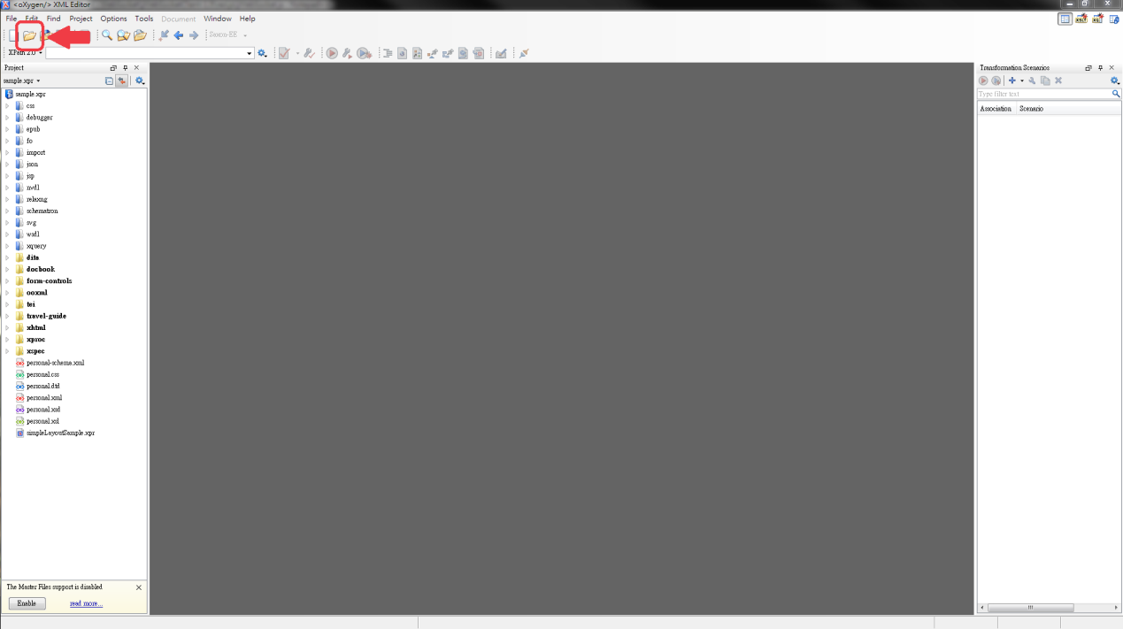

Step 2: Click on the Validate button to expose the pull down menu

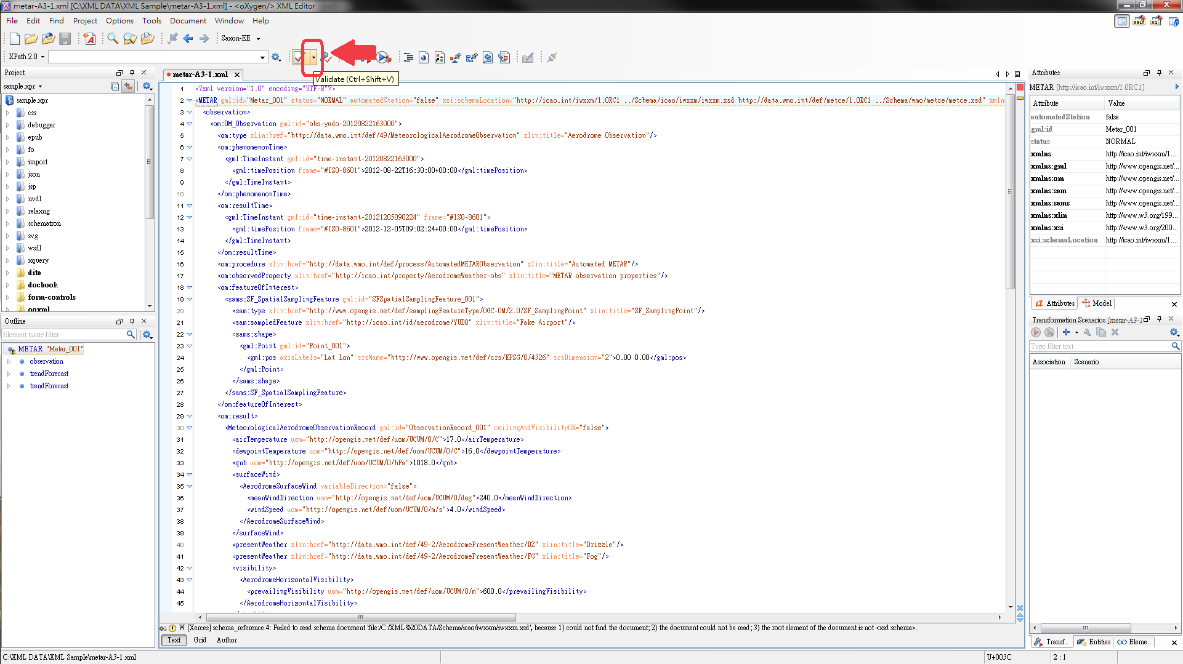

Step 3: Click on the ‘Validate with…’ option and enter the location of the AvXML schema. Tick the ‘Embedded schematron rules’ checkbox.

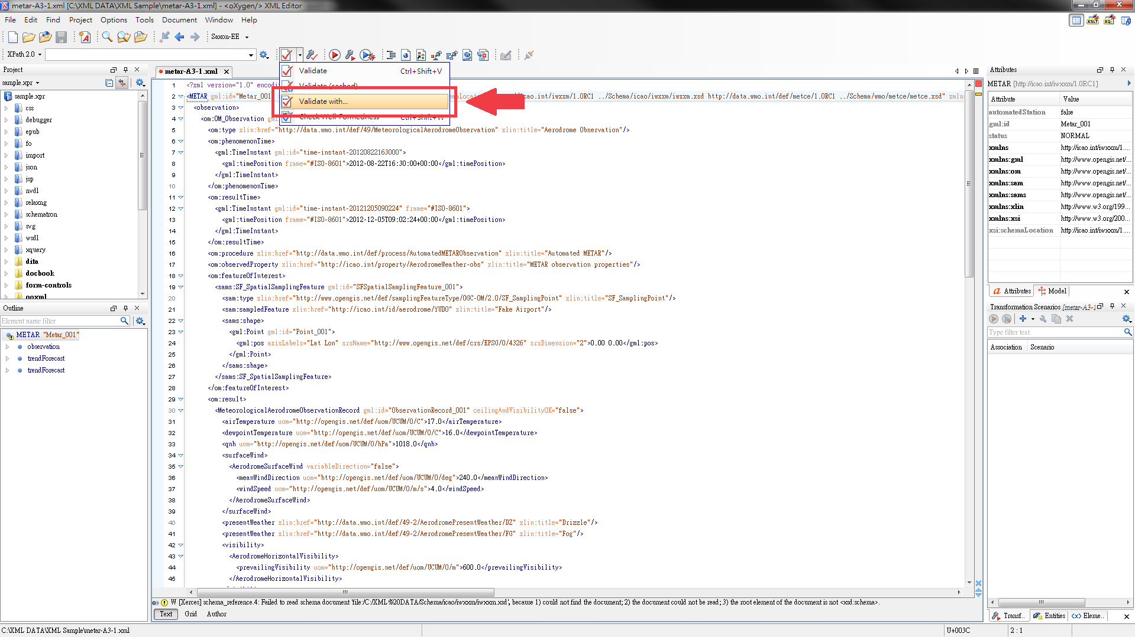

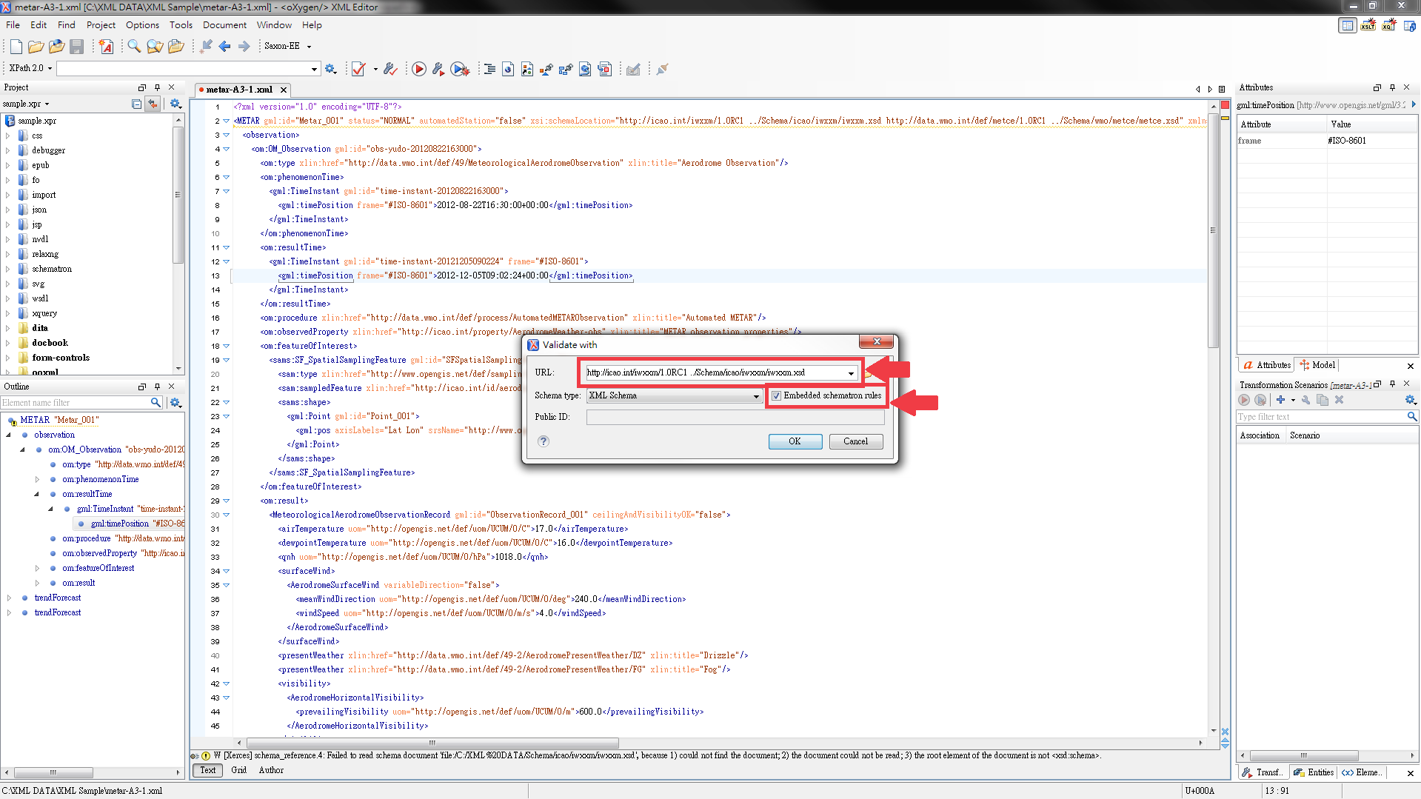

Step 4: Get the validation result at the bottom bar

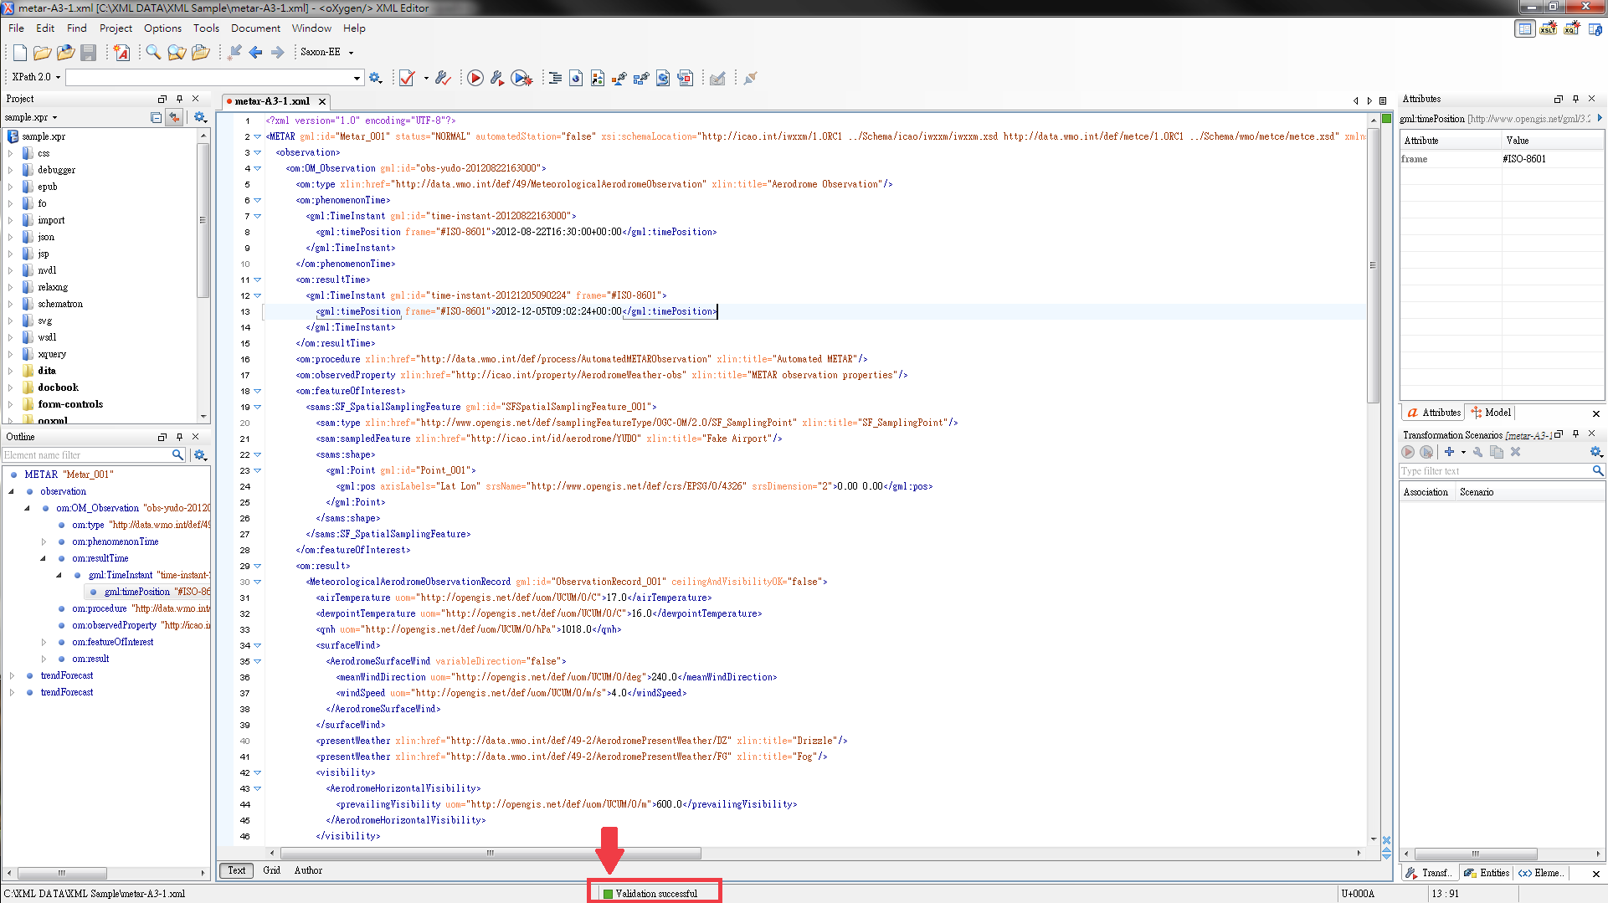

http://www.wmo.int/pages/prog/www/WIS/wiswiki/tiki-index.php?page=METCE-1.0RC1&structure=WIS+up
www.liquid-technologies.com
netbeans.org
www.oxygenxml.com
xmlbeans.apache.org

