README.AvXML-1.0RC2-schema

Synopsis

This README file gives a general description of the AvXML schemas, how it can be used to encode and decode OPMET (OPerational METeorological) data for aviation (namely METAR/SPECI, TAF and SIGMET) and validation of the products against the format and other constraints described by the schemas.

Content

I. Description of Terms
II. Location and Structure of AvXML Schemas
III. Creation of XML Instances
IV. Validation of XML Instances against AvXML Schemas
V. Known Issues
VI. Feedback

Description of Terms

The following terms are used throughout the document:

GML | Geography Markup Language, XML grammar defined by the Open Geospatial Consortium (OGC). Currently, AvXML model and schemas are based on the GML 3.2.1 specifications.
UML | Unified Modeling Language which is used to model WMO Logical Data Model METCE and ICAO Logical Data Model IWXXM.
XML | Extensible Markup Language defined by the World Wide Web Consortium (W3C). Currently, AvXML schemas are based on the XML 1.0 specifications.
XML Document | Document adhering to the XML standard.
XML Instance | XML document adhering to an XML schema.
XML Namespace | Used for providing uniquely named elements and attributes in an XML document.
XML Schema | An XML-based language used to create other XML-based language and data models. In this document, it refers to those specifying the structure that XML documents must adhere to and the type of content that each element can hold. XML Schemas are represented as XSD (XML Schema Definition) documents in AvXML.

Location and Structure of AvXML Schemas

There are two main packages in the AvXML, viz the WMO METCE (Modèle pour l'Échange des informations sur le Temps, le Climat et l'Eau) and the ICAO IWXXM (ICAO Weather Information Exchange Model). Each of these packages contains sub-packages. For AvXML version 1.0RC1, both packages are co-located at the WMO website http://schema.wmo.int with the following directory structure:

http://schema.wmo.int | /wmo | /opm/1.0RC2 | /observable-property.xsd  /opm.xsd
http://schema.wmo.int | /wmo | /metce/1.0RC2 | /metce.xsd  /observation-types.xsd  /phenomena.xsd  /procedure.xsd
http://schema.wmo.int | /wmo | /rule/1.0RC2 | /metce.sch  /opm.sch
(same as above) | /icao | /saf/1.0RC2 | /dataTypes.xsd  /features.xsd  /measures.xsd  /saf.xsd
(same as above) | /icao | /iwxxm/1.0RC2 | /common.xsd  /iwxxm.xsd  /metarSpeci.xsd  /sigmet.xsd  /taf.xsd
(same as above) | /icao | /rule/1.0RC2 | /iwxxm.sch  /saf.sch

These XSD files are generated by semi-automatic processes from their respective models in UML with manual addition of embedded schematrons. The schematrons are also distributed as separate files to facilitate execution with certain validators. For descriptions of the elements and attributes of individual XSD files one should refer to the documentation of the UML models which should also reside on the WMO WIS-WIKI. A compressed zip file AvXML-1.0RC2-schema.zip containing the above is also available on the WMO WIS-WIKI.

Creation of XML Instances

A preliminary test suggested that a number of XML editors are able to create XML Instances with AvXML schemas. These include Liquid XML Studio, NetBeans and <oXygen/> XML Editor. The list, however, is not exhaustive so users are advised to check their own XML editors using AvXML schemas in first place. Please refer to individual software manual on how to create XML instances with XML schemas.

To facilitate automatic and/or offline generation of XML instances, a XML-Java binding ‘AvXML-1.0RC2.jar’ is also available for download at the WMO WIS-WIKI. Created with XMLBeans, one can access instances of the AvXML schemas through JavaBeans-style accessors. See documentation of XMLBeans for details. A sample program using the XML-Java binding and the respective XML instance generated are shown in Appendices A and B.

For descriptions of the elements and attributes one should refer to the documentation of the UML models on the WMO WIS-WIKI

Validation of XML Instances against AvXML Schemas

Appendix C shows the process of validating an XML instance with AvXML schemas using <oXygen/> XML Editor. Please be advised that the location of AvXML schemas has to be explicitly specified so as to tell the XML Editor the place to obtain the embedded schematrons for validation.

Known Issues

Certain constraints as shown in the UML models have not been implemented. They will be handled in subsequent releases of AvXML schemas.

Feedback

Comments are welcomed on issues with implementing the AvXML version 1.0RC2 to create XML instances representing OPMET reports, viz METAR/SPECI, TAF and SIGMET. They should be sent to cbs-tt-avxml@wmo.int. Please start the subject line of your comment with the text [1.0RC2-feedback].

METAR.java (example metar-A3-1)

/*

Sample program for the generation of metar-A3-1.xml

The following libraries are required:

AvXML-1.0RC2
============
AvXML-1.0RC2-XML-Java_binding.jar

XMLBeans
========
jsr173_1.0_api.jar
resolver.jar
saxon9.jar
saxon9-dom.jar
xbean.jar
xbean_xpath.jar
xmlbeans-qname.jar
xmlpublic.jar

*/

package app;

import java.math.BigInteger;
import java.util.HashMap;
import java.util.Map;

import javax.xml.namespace.QName;

import net.opengis.gml.x32.AbstractFeatureType;
import net.opengis.gml.x32.AbstractGeometryType;
import net.opengis.gml.x32.AbstractTimeObjectType;
import net.opengis.gml.x32.AngleType;
import net.opengis.gml.x32.CodeType;
import net.opengis.gml.x32.CodeWithAuthorityType;
import net.opengis.gml.x32.DirectPositionType;
import net.opengis.gml.x32.FeaturePropertyType;
import net.opengis.gml.x32.LengthType;
import net.opengis.gml.x32.MeasureType;
import net.opengis.gml.x32.PointPropertyType;
import net.opengis.gml.x32.PointType;
import net.opengis.gml.x32.ReferenceType;
import net.opengis.gml.x32.SpeedType;
import net.opengis.gml.x32.StringOrRefType;
import net.opengis.gml.x32.TimeInstantPropertyType;
import net.opengis.gml.x32.TimeInstantType;
import net.opengis.gml.x32.TimePeriodType;
import net.opengis.gml.x32.TimePositionType;
import net.opengis.om.x20.OMObservationPropertyType;
import net.opengis.om.x20.OMObservationType;
import net.opengis.om.x20.OMProcessPropertyType;
import net.opengis.om.x20.TimeObjectPropertyType;
import net.opengis.samplingSpatial.x20.SFSpatialSamplingFeatureType;
import net.opengis.samplingSpatial.x20.ShapeType;

import org.apache.xmlbeans.XmlCursor;
import org.apache.xmlbeans.XmlObject;

import xint.icao.iwxxm.x10RC2.AerodromeForecastWeatherType;
import xint.icao.iwxxm.x10RC2.AerodromeHorizontalVisibilityPropertyType;
import xint.icao.iwxxm.x10RC2.AerodromeHorizontalVisibilityType;
import xint.icao.iwxxm.x10RC2.AerodromeObservedCloudsPropertyType;
import xint.icao.iwxxm.x10RC2.AerodromeObservedCloudsType;
import xint.icao.iwxxm.x10RC2.AerodromePresentWeatherType;
import xint.icao.iwxxm.x10RC2.AerodromeRunwayVisualRangePropertyType;
import xint.icao.iwxxm.x10RC2.AerodromeRunwayVisualRangeType;
import xint.icao.iwxxm.x10RC2.AerodromeSurfaceWindPropertyType;
import xint.icao.iwxxm.x10RC2.AerodromeSurfaceWindType;
import xint.icao.iwxxm.x10RC2.CloudAmountReportedAtAerodromeType;
import xint.icao.iwxxm.x10RC2.CloudLayerPropertyType;
import xint.icao.iwxxm.x10RC2.CloudLayerType;
import xint.icao.iwxxm.x10RC2.ForecastChangeIndicatorType;
import xint.icao.iwxxm.x10RC2.METARDocument;
import xint.icao.iwxxm.x10RC2.METARType;
import xint.icao.iwxxm.x10RC2.MeteorologicalAerodromeObservationRecordDocument;
import xint.icao.iwxxm.x10RC2.MeteorologicalAerodromeObservationRecordType;
import xint.icao.iwxxm.x10RC2.MeteorologicalAerodromeReportStatusType;
import xint.icao.iwxxm.x10RC2.MeteorologicalAerodromeTrendForecastRecordDocument;
import xint.icao.iwxxm.x10RC2.MeteorologicalAerodromeTrendForecastRecordType;
import xint.icao.iwxxm.x10RC2.VisualRangeTendencyType;
import xint.icao.saf.x10RC2.AerodromePropertyType;
import xint.icao.saf.x10RC2.AerodromeType;
import xint.icao.saf.x10RC2.CodeAirportHeliportDesignatorTypeType;
import xint.icao.saf.x10RC2.CodeICAOTypeType;
import xint.icao.saf.x10RC2.DistanceWithNilReasonType;
import xint.icao.saf.x10RC2.RunwayDirectionPropertyType;
import xint.icao.saf.x10RC2.RunwayDirectionType;
import xint.icao.saf.x10RC2.RunwayPropertyType;
import xint.icao.saf.x10RC2.RunwayType;
import xint.icao.saf.x10RC2.TextDesignatorTypeType;
import xint.wmo.def.metce.x2013.ProcessDocument;
import xint.wmo.def.metce.x2013.ProcessType;

import common.XMLHelper;

public class METAR {

public static final String XML_FILE_PATH = "xml/METAR.xml";
public static final String XML_SCHEMA_LOCATION = "http://icao.int/iwxxm/1.0RC2 http://schemas.wmo.int/iwxxm/1.0RC2/iwxxm.xsd
http://def.wmo.int/metce/2013 http://schemas.wmo.int/metce/1.0RC2/metce.xsd";

public static final String NS_GML = "http://www.opengis.net/gml/3.2";
public static final String NS_OM = "http://www.opengis.net/om/2.0";
public static final String NS_XLINK = "http://www.w3.org/1999/xlink";
public static final String NS_SAM = "http://www.opengis.net/sampling/2.0";
public static final String NS_SAMS = "http://www.opengis.net/samplingSpatial/2.0";
public static final String NS_OPM = "http://def.wmo.int/opm/2013";
public static final String NS_METCE = "http://def.wmo.int/metce/2013";
public static final String NS_SAF = "http://icao.int/saf/1.0RC2";
public static final String NS_IWXXM = "http://icao.int/iwxxm/1.0RC2";

/**
* The main function
*
* @param args
*/
public static void main(String[] args) {
create_xml_instance();
}

/**
* create the xml instance
*/
public static void create_xml_instance(){

// declare namespace map ===========================================================================
Map<String, String> nsMap = new HashMap<String, String>();
nsMap.put(NS_GML, "gml");
nsMap.put(NS_OM, "om");
nsMap.put(NS_XLINK, "xlink");
nsMap.put(NS_SAM, "sam");
nsMap.put(NS_SAMS, "sams");
nsMap.put(NS_OPM, "opm");
nsMap.put(NS_METCE, "metce");
nsMap.put(NS_SAF, "saf");
nsMap.put(NS_IWXXM, "iwxxm");

// iwxxm:METAR ===========================================================================
METARDocument metar_doc = METARDocument.Factory.newInstance();
METARType metar_type = metar_doc.addNewMETAR();
metar_type.setId("metar-YUDO-20120822163000Z");
metar_type.setStatus(MeteorologicalAerodromeReportStatusType.NORMAL);
metar_type.setAutomatedStation(false);

// iwxxm:observation ===========================================================================
OMObservationPropertyType iwxxm_observation = metar_type.addNewObservation();
OMObservationType om_OM_Observation = iwxxm_observation.addNewOMObservation();
om_OM_Observation.setId("obs-03839-20120824T12Z");

// om:type ===========================================================================
ReferenceType om_type = om_OM_Observation.addNewType();
om_type.setHref("http://codes.wmo.int/49-2/observation-type/IWXXM/1.0/MeteorologicalAerodromeObservation");
om_type.setTitle("Aerodrome Observation");

// om:phenomenonTime ===========================================================================
TimeObjectPropertyType om_phenomenonTime = om_OM_Observation.addNewPhenomenonTime();
AbstractTimeObjectType gml_AbstractTimeObject = om_phenomenonTime.addNewAbstractTimeObject();
TimeInstantType gml_TimeInstant = (TimeInstantType)gml_AbstractTimeObject.substitute(new QName(NS_GML, "TimeInstant"), TimeInstantType.type);
gml_TimeInstant.setId("ti-201208221630Z");
TimePositionType gml_timePosition = gml_TimeInstant.addNewTimePosition();
gml_timePosition.setStringValue("2012-08-22T16:30:00Z");

// om:resultTime ===========================================================================
TimeInstantPropertyType om_resultTime = om_OM_Observation.addNewResultTime();
TimeInstantType gml_TimeInstant2 = om_resultTime.addNewTimeInstant();
gml_TimeInstant2.setId("ti-201208221640Z");
TimePositionType gml_timePosition2 = gml_TimeInstant2.addNewTimePosition();
gml_timePosition2.setStringValue("2012-08-22T16:40:00Z");

// om:procedure ===========================================================================
OMProcessPropertyType om_procedure = om_OM_Observation.addNewProcedure();
ProcessDocument Process_doc = ProcessDocument.Factory.newInstance();
ProcessType metce_Process = Process_doc.addNewProcess();
metce_Process.setId("p-49-2-metar");
StringOrRefType gml_description = metce_Process.addNewDescription();
gml_description.setStringValue("WMO No. 49 Volume 2 Meteorological Service for International Air Navigation APPENDIX 3 TECHNICAL SPECIFICATIONS RELATED TO METEOROLOGICAL OBSERVATIONS AND REPORTS");

// hook metce:Process to om:procedure ===========================================================================
XmlCursor om_procedure_cursor = om_procedure.newCursor();
XmlCursor Process_doc_cursor = Process_doc.newCursor();
om_procedure_cursor.toEndToken();
Process_doc_cursor.toStartDoc();
Process_doc_cursor.moveXmlContents(om_procedure_cursor);
Process_doc_cursor.dispose();
om_procedure_cursor.dispose();

// om:observedProperty ===========================================================================
ReferenceType om_observedProperty = om_OM_Observation.addNewObservedProperty();
om_observedProperty.setHref("http://codes.wmo.int/observableProperty/metarSpeci/observation");
om_observedProperty.setTitle("Observed properties for METAR and SPECI (Meteorological Aerodrome Reports)");

// om:featureOfInterest ===========================================================================
FeaturePropertyType om_featureOfInterest = om_OM_Observation.addNewFeatureOfInterest();
AbstractFeatureType gml_AbstractFeature = om_featureOfInterest.addNewAbstractFeature();

// sams:SF_SpatialSamplingFeature ===========================================================================
SFSpatialSamplingFeatureType sams_SF_SpatialSamplingFeature = (SFSpatialSamplingFeatureType) gml_AbstractFeature.substitute(new QName(NS_SAMS, "SF_SpatialSamplingFeature"), SFSpatialSamplingFeatureType.type);
sams_SF_SpatialSamplingFeature.setId("sampling-point-03839");

// sam:type ===========================================================================
ReferenceType sam_type = sams_SF_SpatialSamplingFeature.addNewType();
sam_type.setHref("http://www.opengis.net/def/samplingFeatureType/OGC-OM/2.0/SF_SamplingPoint");
sam_type.setTitle("SF_SamplingPoint");

// sam:sampledFeature ===========================================================================
FeaturePropertyType sam_sampledFeature = sams_SF_SpatialSamplingFeature.addNewSampledFeature();
AbstractFeatureType gml_AbstractFeature2 = sam_sampledFeature.addNewAbstractFeature();

// saf:Aerodrome ===========================================================================
AerodromeType saf_Aerodrome = (AerodromeType) gml_AbstractFeature2.substitute(new QName(NS_SAF, "Aerodrome"), AerodromeType.type);
saf_Aerodrome.setId("uuid.dd062d88-3e64-4a5d-bebd-89476db9ebea");
CodeWithAuthorityType gml_identifier = saf_Aerodrome.addNewIdentifier();
gml_identifier.setCodeSpace("urn:uuid:");
gml_identifier.setStringValue("dd062d88-3e64-4a5d-bebd-89476db9ebea");
CodeAirportHeliportDesignatorTypeType saf_designator = saf_Aerodrome.addNewDesignator();
saf_designator.setStringValue("YUDO");
CodeType saf_name = saf_Aerodrome.addNewName();
saf_name.setStringValue("DONLON/INTERNATIONAL");
CodeICAOTypeType saf_locationIndicatorICAO = saf_Aerodrome.addNewLocationIndicatorICAO();
saf_locationIndicatorICAO.setStringValue("YUDO");
PointPropertyType saf_ARP = saf_Aerodrome.addNewARP();
PointType gml_Point = saf_ARP.addNewPoint();
gml_Point.setId("pt52284-32035");
gml_Point.setSrsName("http://www.opengis.net/def/crs/EPSG/0/4326");
DirectPositionType gml_pos = gml_Point.addNewPos();
gml_pos.setStringValue("12.34 -12.34");
ShapeType sams_shape = sams_SF_SpatialSamplingFeature.addNewShape();
AbstractGeometryType gml_AbstractGeometry = sams_shape.addNewAbstractGeometry();
PointType gml_Point2 = (PointType) gml_AbstractGeometry.substitute(new QName(NS_GML, "Point"), PointType.type);
gml_Point2.setId("point-5225-3201");
gml_Point2.setSrsDimension(new BigInteger("2"));
gml_Point2.setSrsName("http://www.opengis.net/def/crs/EPSG/0/4326");
DirectPositionType gml_pos2 = gml_Point2.addNewPos();
gml_pos2.setStringValue("12.34 -12.34");

// om:result ===========================================================================
XmlObject om_result = om_OM_Observation.addNewResult();
MeteorologicalAerodromeObservationRecordDocument MeteorologicalAerodromeObservationRecord_doc = MeteorologicalAerodromeObservationRecordDocument.Factory.newInstance();

// iwxxm:MeteorologicalAerodromeObservationRecord ===========================================================================
MeteorologicalAerodromeObservationRecordType iwxxm_MeteorologicalAerodromObservationRecordType = MeteorologicalAerodromeObservationRecord_doc.addNewMeteorologicalAerodromeObservationRecord();
iwxxm_MeteorologicalAerodromObservationRecordType.setId("or1");
iwxxm_MeteorologicalAerodromObservationRecordType.setCloudAndVisibilityOK(false);

// iwxxm:airTemperature ===========================================================================
MeasureType iwxxm_airTemperature = iwxxm_MeteorologicalAerodromObservationRecordType.addNewAirTemperature();
iwxxm_airTemperature.setUom("Cel");
iwxxm_airTemperature.setStringValue("17.0");

// iwxxm:dewpointTemperature ===========================================================================
MeasureType iwxxm_dewpointTemperature = iwxxm_MeteorologicalAerodromObservationRecordType.addNewDewpointTemperature();
iwxxm_dewpointTemperature.setUom("Cel");
iwxxm_dewpointTemperature.setStringValue("16.0");

// iwxxm:qnh ===========================================================================
MeasureType iwxxm_qnh = iwxxm_MeteorologicalAerodromObservationRecordType.addNewQnh();
iwxxm_qnh.setUom("hPa");
iwxxm_qnh.setStringValue("1018");

// iwxxm:surfaceWind ===========================================================================
AerodromeSurfaceWindPropertyType iwxxm_surfaceWind = iwxxm_MeteorologicalAerodromObservationRecordType.addNewSurfaceWind();
AerodromeSurfaceWindType iwxxm_AerodromeSurfaceWind = iwxxm_surfaceWind.addNewAerodromeSurfaceWind();
iwxxm_AerodromeSurfaceWind.setVariableDirection(false);
AngleType iwxxm_meanWindDirection = iwxxm_AerodromeSurfaceWind.addNewMeanWindDirection();
iwxxm_meanWindDirection.setUom("deg");
iwxxm_meanWindDirection.setStringValue("240");
SpeedType iwxxm_meanWindSpeed = iwxxm_AerodromeSurfaceWind.addNewMeanWindSpeed();
iwxxm_meanWindSpeed.setUom("m/s");
iwxxm_meanWindSpeed.setStringValue("4.0");

// iwxxm:visibility ===========================================================================
AerodromeHorizontalVisibilityPropertyType iwxxm_visibility = iwxxm_MeteorologicalAerodromObservationRecordType.addNewVisibility();
AerodromeHorizontalVisibilityType iwxxm_AerodromeHorizontalVisibility = iwxxm_visibility.addNewAerodromeHorizontalVisibility();
LengthType iwxxm_prevailingVisibility = iwxxm_AerodromeHorizontalVisibility.addNewPrevailingVisibility();
iwxxm_prevailingVisibility.setUom("m");
iwxxm_prevailingVisibility.setStringValue("600");

// iwxxm:rvr ===========================================================================
AerodromeRunwayVisualRangePropertyType iwxxm_rvr = iwxxm_MeteorologicalAerodromObservationRecordType.addNewRvr();
AerodromeRunwayVisualRangeType iwxxm_AerodromeRunwayVisualRange = iwxxm_rvr.addNewAerodromeRunwayVisualRange();
iwxxm_AerodromeRunwayVisualRange.setPastTendency(VisualRangeTendencyType.UPWARD);
RunwayDirectionPropertyType iwxxm_runway = iwxxm_AerodromeRunwayVisualRange.addNewRunway();
RunwayDirectionType saf_RunwayDirection = iwxxm_runway.addNewRunwayDirection();
saf_RunwayDirection.setId("uuid.b1947d80-b7f7-11e2-9e96-0800200c9a66");
CodeWithAuthorityType gml_identifier2 = saf_RunwayDirection.addNewIdentifier();
gml_identifier2.setCodeSpace("urn:uuid:");
gml_identifier2.setStringValue("b1947d80-b7f7-11e2-9e96-0800200c9a66");
TextDesignatorTypeType saf_designator2 = saf_RunwayDirection.addNewDesignator();
saf_designator2.setStringValue("12");
AngleType saf_trueBearing = saf_RunwayDirection.addNewTrueBearing();
saf_trueBearing.setUom("deg");
saf_trueBearing.setStringValue("118.23");
LengthType saf_elevationTDZ = saf_RunwayDirection.addNewElevationTDZ();
saf_elevationTDZ.setUom("m");
saf_elevationTDZ.setStringValue("20.5");
RunwayPropertyType saf_usedRunway = saf_RunwayDirection.addNewUsedRunway();
RunwayType saf_Runway = saf_usedRunway.addNewRunway();
saf_Runway.setId("uuid.2f864fc0-b7f8-11e2-9e96-0800200c9a66");
CodeWithAuthorityType gml_identifier3 = saf_Runway.addNewIdentifier();
gml_identifier3.setCodeSpace("urn:uuid:");
gml_identifier3.setStringValue("2f864fc0-b7f8-11e2-9e96-0800200c9a66");
TextDesignatorTypeType saf_designator3 = saf_Runway.addNewDesignator();
saf_designator3.setStringValue("12/30");
AerodromePropertyType saf_associatedAirportHeliport = saf_Runway.addNewAssociatedAirportHeliport();
saf_associatedAirportHeliport.setHref("#uuid.dd062d88-3e64-4a5d-bebd-89476db9ebea");
LengthType iwxxm_meanRVR = iwxxm_AerodromeRunwayVisualRange.addNewMeanRVR();
iwxxm_meanRVR.setUom("m");
iwxxm_meanRVR.setStringValue("1000");

// iwxxm:presentWeather ===========================================================================
AerodromePresentWeatherType iwxxm_presentWeather = iwxxm_MeteorologicalAerodromObservationRecordType.addNewPresentWeather();
iwxxm_presentWeather.setHref("http://codes.wmo.int/306/4678/DZ");
iwxxm_presentWeather.setTitle("Moderate Drizzle");

AerodromePresentWeatherType iwxxm_presentWeather2 = iwxxm_MeteorologicalAerodromObservationRecordType.addNewPresentWeather();
iwxxm_presentWeather2.setHref("http://codes.wmo.int/306/4678/FG");
iwxxm_presentWeather2.setTitle("Fog");

// iwxxm:cloud ===========================================================================
AerodromeObservedCloudsPropertyType iwxxm_cloud = iwxxm_MeteorologicalAerodromObservationRecordType.addNewCloud();
AerodromeObservedCloudsType iwxxm_AerodromeObservedClouds = iwxxm_cloud.addNewAerodromeObservedClouds();
CloudLayerPropertyType iwxxm_layer = iwxxm_AerodromeObservedClouds.addNewLayer();
CloudLayerType iwxxm_CloudLayer = iwxxm_layer.addNewCloudLayer();
CloudAmountReportedAtAerodromeType iwxxm_amount = iwxxm_CloudLayer.addNewAmount();
iwxxm_amount.setHref("http://codes.wmo.int/bufr4/codeflag/0-20-008/2");
iwxxm_amount.setTitle("Scattered");
DistanceWithNilReasonType iwxxm_base = iwxxm_CloudLayer.addNewBase();
iwxxm_base.setUom("ft");
iwxxm_base.setStringValue("1000");

CloudLayerPropertyType iwxxm_layer2 = iwxxm_AerodromeObservedClouds.addNewLayer();
CloudLayerType iwxxm_CloudLayer2 = iwxxm_layer2.addNewCloudLayer();
CloudAmountReportedAtAerodromeType iwxxm_amount2 = iwxxm_CloudLayer2.addNewAmount();
iwxxm_amount2.setHref("http://codes.wmo.int/bufr4/codeflag/0-20-008/4");
iwxxm_amount2.setTitle("Overcast");
DistanceWithNilReasonType iwxxm_base2 = iwxxm_CloudLayer2.addNewBase();
iwxxm_base2.setUom("ft");
iwxxm_base2.setStringValue("2000");

// anyType handling ===========================================================================
XmlCursor om_result_cursor = om_result.newCursor();
XmlCursor MeteorologicalAerodromeObservationRecord_doc_cursor = MeteorologicalAerodromeObservationRecord_doc.newCursor();
om_result_cursor.toEndToken();
MeteorologicalAerodromeObservationRecord_doc_cursor.toStartDoc();
MeteorologicalAerodromeObservationRecord_doc_cursor.moveXmlContents(om_result_cursor);
MeteorologicalAerodromeObservationRecord_doc_cursor.dispose();
om_result_cursor.dispose();

// iwxxm:trendForecast ===========================================================================
OMObservationPropertyType iwxxm_trendForecast = metar_type.addNewTrendForecast();
OMObservationType om_OM_Observation2 = iwxxm_trendForecast.addNewOMObservation();
om_OM_Observation2.setId("trend-fcst-1");

// om:type ===========================================================================
ReferenceType om_type2 = om_OM_Observation2.addNewType();
om_type2.setHref("http://codes.wmo.int/49-2/observation-type/IWXXM/1.0/MeteorologicalAerodromeTrendForecast");
om_type2.setTitle("Aerodrome Trend Forecast");

// om:phenomenonTime ===========================================================================
TimeObjectPropertyType om_phenomenonTime2 = om_OM_Observation2.addNewPhenomenonTime();
AbstractTimeObjectType gml_AbstractTimeObject2 = om_phenomenonTime2.addNewAbstractTimeObject();
TimePeriodType gml_TimePeriod = (TimePeriodType)gml_AbstractTimeObject2.substitute(new QName(NS_GML, "TimePeriod"), TimePeriodType.type);
gml_TimePeriod.setId("tp-201208221630Z-201208221700Z");
TimePositionType gml_beginPosition = gml_TimePeriod.addNewBeginPosition();
gml_beginPosition.setStringValue("2012-08-22T16:30:00Z");
TimePositionType gml_endPosition = gml_TimePeriod.addNewEndPosition();
gml_endPosition.setStringValue("2012-08-22T17:00:00Z");

// om:resultTime ===========================================================================
TimeInstantPropertyType om_resultTime2 = om_OM_Observation2.addNewResultTime();
om_resultTime2.setHref("#ti-201208221640Z");

// om:procedure ===========================================================================
OMProcessPropertyType om_procedure2 = om_OM_Observation2.addNewProcedure();
om_procedure2.setHref("#p-49-2-metar");
om_procedure2.setTitle("WMO 49-2 METAR procedure");

// om:observedProperty ===========================================================================
ReferenceType om_observedProperty2 = om_OM_Observation2.addNewObservedProperty();
om_observedProperty2.setHref("http://codes.wmo.int/49-2/observable-property/MeteorologicalAerodromeTrendForecast");
om_observedProperty2.setTitle("METAR trend forecast properties");

// om:featureOfInterest ===========================================================================
FeaturePropertyType om_featureOfInterest2 = om_OM_Observation2.addNewFeatureOfInterest();
om_featureOfInterest2.setHref("#sampling-point-03839");

// om:result ===========================================================================
XmlObject om_result2 = om_OM_Observation2.addNewResult();
MeteorologicalAerodromeTrendForecastRecordDocument MeteorologicalAerodromeTrendForecastRecord_doc = MeteorologicalAerodromeTrendForecastRecordDocument.Factory.newInstance();

// iwxxm:MeteorologicalAerodromeTrendForcastRecord ===========================================================================
MeteorologicalAerodromeTrendForecastRecordType iwxxm_MeteorologicalAerodromeTrendForecastRecord = MeteorologicalAerodromeTrendForecastRecord_doc.addNewMeteorologicalAerodromeTrendForecastRecord();
iwxxm_MeteorologicalAerodromeTrendForecastRecord.setId("trend-fcst-record-03839-201208221630Z-201208221700Z");
iwxxm_MeteorologicalAerodromeTrendForecastRecord.setChangeIndicator(ForecastChangeIndicatorType.BECOMING);
iwxxm_MeteorologicalAerodromeTrendForecastRecord.setCloudAndVisibilityOK(false);

// iwxxm:prevailingHorizontalVisibility ===========================================================================
LengthType iwxxm_prevailingHorizontalVisibility = iwxxm_MeteorologicalAerodromeTrendForecastRecord.addNewPrevailingHorizontalVisibility();
iwxxm_prevailingHorizontalVisibility.setUom("m");
iwxxm_prevailingHorizontalVisibility.setStringValue("800");

// iwxxm:forecastWeather ===========================================================================
AerodromeForecastWeatherType iwxxm_forecastWeather = iwxxm_MeteorologicalAerodromeTrendForecastRecord.addNewForecastWeather();
iwxxm_forecastWeather.setHref("http://codes.wmo.int/306/4678/FG");
iwxxm_forecastWeather.setTitle("Fog");

// anyType handling ===========================================================================
XmlCursor om_result_cursor2 = om_result2.newCursor();
XmlCursor MeteorologicalAerodromeTrendForecastRecord_doc_cursor = MeteorologicalAerodromeTrendForecastRecord_doc.newCursor();
om_result_cursor2.toEndToken();
MeteorologicalAerodromeTrendForecastRecord_doc_cursor.toStartDoc();
MeteorologicalAerodromeTrendForecastRecord_doc_cursor.moveXmlContents(om_result_cursor2);
MeteorologicalAerodromeTrendForecastRecord_doc_cursor.dispose();
om_result_cursor2.dispose();

// iwxxm:trendForecast ===========================================================================
OMObservationPropertyType iwxxm_trendForecast2 = metar_type.addNewTrendForecast();
OMObservationType om_OM_Observation3 = iwxxm_trendForecast2.addNewOMObservation();
om_OM_Observation3.setId("trend-fcst-2");

// om:type ===========================================================================
ReferenceType om_type3 = om_OM_Observation3.addNewType();
om_type3.setHref("http://codes.wmo.int/49-2/observation-type/IWXXM/1.0/MeteorologicalAerodromeTrendForecast");
om_type3.setTitle("Aerodrome Trend Forecast");

// om:phenomenonTime ===========================================================================
TimeObjectPropertyType om_phenomenonTime3 = om_OM_Observation3.addNewPhenomenonTime();
AbstractTimeObjectType gml_AbstractTimeObject3 = om_phenomenonTime3.addNewAbstractTimeObject();
TimePeriodType gml_TimePeriod2 = (TimePeriodType)gml_AbstractTimeObject3.substitute(new QName(NS_GML, "TimePeriod"), TimePeriodType.type);
gml_TimePeriod2.setId("tp-201208221800Z-201208221900Z");
TimePositionType gml_beginPosition2 = gml_TimePeriod2.addNewBeginPosition();
gml_beginPosition2.setStringValue("2012-08-22T18:00:00Z");
TimePositionType gml_endPosition2 = gml_TimePeriod2.addNewEndPosition();
gml_endPosition2.setStringValue("2012-08-22T19:00:00Z");

// om:resultTime ===========================================================================
TimeInstantPropertyType om_resultTime3 = om_OM_Observation3.addNewResultTime();
om_resultTime3.setHref("#ti-201208221640Z");

// om:procedure ===========================================================================
OMProcessPropertyType om_procedure3 = om_OM_Observation3.addNewProcedure();
om_procedure3.setHref("#p-49-2-metar");
om_procedure3.setTitle("WMO 49-2 METAR procedure");

// om:observedProperty ===========================================================================
ReferenceType om_observedProperty3 = om_OM_Observation3.addNewObservedProperty();
om_observedProperty3.setHref("http://codes.wmo.int/49-2/observable-property/MeteorologicalAerodromeTrendForecast");
om_observedProperty3.setTitle("METAR trend forecast properties");

// om:featureOfInterest ===========================================================================
FeaturePropertyType om_featureOfInterest3 = om_OM_Observation3.addNewFeatureOfInterest();
om_featureOfInterest3.setHref("#sampling-point-03839");

// om:result ===========================================================================
XmlObject om_result3 = om_OM_Observation3.addNewResult();
MeteorologicalAerodromeTrendForecastRecordDocument MeteorologicalAerodromeTrendForecastRecord_doc2 = MeteorologicalAerodromeTrendForecastRecordDocument.Factory.newInstance();

// iwxxm:MeteorologicalAerodromeTrendForcastRecord ===========================================================================
MeteorologicalAerodromeTrendForecastRecordType iwxxm_MeteorologicalAerodromeTrendForecastRecord2 = MeteorologicalAerodromeTrendForecastRecord_doc2.addNewMeteorologicalAerodromeTrendForecastRecord();
iwxxm_MeteorologicalAerodromeTrendForecastRecord2.setId("trend-fcst-record-03839-201208221800Z-201208221900Z");
iwxxm_MeteorologicalAerodromeTrendForecastRecord2.setChangeIndicator(ForecastChangeIndicatorType.BECOMING);
iwxxm_MeteorologicalAerodromeTrendForecastRecord2.setCloudAndVisibilityOK(false);

// iwxxm:prevailingHorizontalVisibility ===========================================================================
LengthType iwxxm_prevailingHorizontalVisibility2 = iwxxm_MeteorologicalAerodromeTrendForecastRecord2.addNewPrevailingHorizontalVisibility();
iwxxm_prevailingHorizontalVisibility2.setUom("km");
iwxxm_prevailingHorizontalVisibility2.setStringValue("10");

// iwxxm:forecastWeather ===========================================================================
AerodromeForecastWeatherType iwxxm_forecastWeather2 = iwxxm_MeteorologicalAerodromeTrendForecastRecord2.addNewForecastWeather();
iwxxm_forecastWeather2.setNilReason("http://codes.wmo.int/common/nil/nothingOfOperationalSignificance");

// anyType handling ===========================================================================
XmlCursor om_result_cursor3 = om_result3.newCursor();
XmlCursor MeteorologicalAerodromeTrendForecastRecord_doc_cursor2 = MeteorologicalAerodromeTrendForecastRecord_doc2.newCursor();
om_result_cursor3.toEndToken();
MeteorologicalAerodromeTrendForecastRecord_doc_cursor2.toStartDoc();
MeteorologicalAerodromeTrendForecastRecord_doc_cursor2.moveXmlContents(om_result_cursor3);
MeteorologicalAerodromeTrendForecastRecord_doc_cursor2.dispose();
om_result_cursor3.dispose();

// output ===========================================================================
XMLHelper.add_schema_location(metar_doc, XML_SCHEMA_LOCATION);
XMLHelper.validate_xml_instance( metar_doc );
XMLHelper.write_xml_file(nsMap, metar_doc, XML_FILE_PATH);
}
}

XMLHelper.java

package common;

import java.io.File;
import java.io.IOException;
import java.util.ArrayList;
import java.util.Map;

import javax.xml.namespace.QName;

import org.apache.xmlbeans.XmlCursor;
import org.apache.xmlbeans.XmlError;
import org.apache.xmlbeans.XmlObject;
import org.apache.xmlbeans.XmlOptions;

public class XMLHelper {

public static void write_xml_file(Map nsMap, XmlObject doc_object, String target_file_path ){

File xml_file = new File( target_file_path );

XmlOptions xml_options = new XmlOptions();
xml_options.setSavePrettyPrint();
xml_options.setSaveSuggestedPrefixes(nsMap);
xml_options.setUseDefaultNamespace();
xml_options.setSaveNamespacesFirst();
xml_options.setSaveAggressiveNamespaces();

try {
doc_object.save(xml_file, xml_options);
} catch (IOException e) {
e.printStackTrace();
}
}

public static boolean validate_xml_instance( XmlObject xml_doc_object ){
boolean is_xml_valid = false;

// A collection instance to hold validation error messages.
ArrayList validation_messages = new ArrayList();

// Validate the XML, collecting messages.
is_xml_valid = xml_doc_object.validate(
new XmlOptions().setErrorListener(validation_messages));

// If the XML isn't valid, print the messages.
if (!is_xml_valid)
{
System.out.println("\nInvalid XML: ");
for (int i = 0; i < validation_messages.size(); i++)
{
XmlError error = (XmlError) validation_messages.get(i);
System.out.println(error.getMessage());
System.out.println(error.getObjectLocation());
}
}
return is_xml_valid;
}

public static void add_schema_location( XmlObject xml_doc_object, String schema_location ){

XmlCursor cursor = xml_doc_object.newCursor();

if(cursor.toFirstChild()){
cursor.setAttributeText(new QName("http://www.w3.org/2001/XMLSchema-instance", "schemaLocation"), schema_location);
}
}
}
metar-A3-1.xml
<?xml version="1.0" encoding="UTF-8"?>
<iwxxm:METAR xmlns:iwxxm="http://icao.int/iwxxm/1.0RC2" xmlns:gml="http://www.opengis.net/gml/3.2" xmlns:xsi="http://www.w3.org/2001/XMLSchema-instance" xmlns:om="http://www.opengis.net/om/2.0" xmlns:xlink="http://www.w3.org/1999/xlink" xmlns:metce="http://def.wmo.int/metce/2013" xmlns:sams="http://www.opengis.net/samplingSpatial/2.0" xmlns:sam="http://www.opengis.net/sampling/2.0" xmlns:saf="http://icao.int/saf/1.0RC2" gml:id="metar-YUDO-20120822163000Z" status="NORMAL" automatedStation="false" xsi:schemaLocation="http://icao.int/iwxxm/1.0RC2 http://schemas.wmo.int/iwxxm/1.0RC2/iwxxm.xsd http://def.wmo.int/metce/2013 http://schemas.wmo.int/metce/1.0RC2/metce.xsd">
<iwxxm:observation>
<om:OM_Observation gml:id="obs-03839-20120824T12Z">
<om:type xlink:href="http://codes.wmo.int/49-2/observation-type/IWXXM/1.0/MeteorologicalAerodromeObservation" xlink:title="Aerodrome Observation"/>
<om:phenomenonTime>
<gml:TimeInstant gml:id="ti-201208221630Z">
<gml:timePosition>2012-08-22T16:30:00Z</gml:timePosition>
</gml:TimeInstant>
</om:phenomenonTime>
<om:resultTime>
<gml:TimeInstant gml:id="ti-201208221640Z">
<gml:timePosition>2012-08-22T16:40:00Z</gml:timePosition>
</gml:TimeInstant>
</om:resultTime>
<om:procedure>
<metce:Process gml:id="p-49-2-metar">
<gml:description>WMO No. 49 Volume 2 Meteorological Service for International Air Navigation APPENDIX 3 TECHNICAL SPECIFICATIONS RELATED TO METEOROLOGICAL OBSERVATIONS AND REPORTS</gml:description>
</metce:Process>
</om:procedure>
<om:observedProperty xlink:href="http://codes.wmo.int/observableProperty/metarSpeci/observation" xlink:title="Observed properties for METAR and SPECI (Meteorological Aerodrome Reports)"/>
<om:featureOfInterest>
<sams:SF_SpatialSamplingFeature gml:id="sampling-point-03839">
<sam:type xlink:href="http://www.opengis.net/def/samplingFeatureType/OGC-OM/2.0/SF_SamplingPoint" xlink:title="SF_SamplingPoint"/>
<sam:sampledFeature>
<saf:Aerodrome gml:id="uuid.dd062d88-3e64-4a5d-bebd-89476db9ebea">
<gml:identifier codeSpace="urn:uuid:">dd062d88-3e64-4a5d-bebd-89476db9ebea</gml:identifier>
<gml:name>DONLON/INTERNATIONAL</gml:name>
<saf:designator>YUDO</saf:designator>
<saf:locationIndicatorICAO>YUDO</saf:locationIndicatorICAO>
<saf:ARP>
<gml:Point gml:id="pt52284-32035" srsName="http://www.opengis.net/def/crs/EPSG/0/4326">
<gml:pos>12.34 -12.34</gml:pos>
</gml:Point>
</saf:ARP>
</saf:Aerodrome>
</sam:sampledFeature>
<sams:shape>
<gml:Point gml:id="point-5225-3201" srsDimension="2" srsName="http://www.opengis.net/def/crs/EPSG/0/4326">
<gml:pos>12.34 -12.34</gml:pos>
</gml:Point>
</sams:shape>
</sams:SF_SpatialSamplingFeature>
</om:featureOfInterest>
<om:result>
<iwxxm:MeteorologicalAerodromeObservationRecord gml:id="or1" cloudAndVisibilityOK="false">
<iwxxm:airTemperature uom="Cel">17.0</iwxxm:airTemperature>
<iwxxm:dewpointTemperature uom="Cel">16.0</iwxxm:dewpointTemperature>
<iwxxm:qnh uom="hPa">1018</iwxxm:qnh>
<iwxxm:surfaceWind>
<iwxxm:AerodromeSurfaceWind variableDirection="false">
<iwxxm:meanWindDirection uom="deg">240</iwxxm:meanWindDirection>
<iwxxm:meanWindSpeed uom="m/s">4.0</iwxxm:meanWindSpeed>
</iwxxm:AerodromeSurfaceWind>
</iwxxm:surfaceWind>
<iwxxm:visibility>
<iwxxm:AerodromeHorizontalVisibility>
<iwxxm:prevailingVisibility uom="m">600</iwxxm:prevailingVisibility>
</iwxxm:AerodromeHorizontalVisibility>
</iwxxm:visibility>
<iwxxm:rvr>
<iwxxm:AerodromeRunwayVisualRange pastTendency="UPWARD">
<iwxxm:runway>
<saf:RunwayDirection gml:id="uuid.b1947d80-b7f7-11e2-9e96-0800200c9a66">
<gml:identifier codeSpace="urn:uuid:">b1947d80-b7f7-11e2-9e96-0800200c9a66</gml:identifier>
<saf:designator>12</saf:designator>
<saf:trueBearing uom="deg">118.23</saf:trueBearing>
<saf:elevationTDZ uom="m">20.5</saf:elevationTDZ>
<saf:usedRunway>
<saf:Runway gml:id="uuid.2f864fc0-b7f8-11e2-9e96-0800200c9a66">
<gml:identifier codeSpace="urn:uuid:">2f864fc0-b7f8-11e2-9e96-0800200c9a66</gml:identifier>
<saf:designator>12/30</saf:designator>
<saf:associatedAirportHeliport xlink:href="#uuid.dd062d88-3e64-4a5d-bebd-89476db9ebea"/>
</saf:Runway>
</saf:usedRunway>
</saf:RunwayDirection>
</iwxxm:runway>
<iwxxm:meanRVR uom="m">1000</iwxxm:meanRVR>
</iwxxm:AerodromeRunwayVisualRange>
</iwxxm:rvr>
<iwxxm:presentWeather xlink:href="http://codes.wmo.int/306/4678/DZ" xlink:title="Moderate Drizzle"/>
<iwxxm:presentWeather xlink:href="http://codes.wmo.int/306/4678/FG" xlink:title="Fog"/>
<iwxxm:cloud>
<iwxxm:AerodromeObservedClouds>
<iwxxm:layer>
<iwxxm:CloudLayer>
<iwxxm:amount xlink:href="http://codes.wmo.int/bufr4/codeflag/0-20-008/2" xlink:title="Scattered"/>
<iwxxm:base uom="ft">1000</iwxxm:base>
</iwxxm:CloudLayer>
</iwxxm:layer>
<iwxxm:layer>
<iwxxm:CloudLayer>
<iwxxm:amount xlink:href="http://codes.wmo.int/bufr4/codeflag/0-20-008/4" xlink:title="Overcast"/>
<iwxxm:base uom="ft">2000</iwxxm:base>
</iwxxm:CloudLayer>
</iwxxm:layer>
</iwxxm:AerodromeObservedClouds>
</iwxxm:cloud>
</iwxxm:MeteorologicalAerodromeObservationRecord>
</om:result>
</om:OM_Observation>
</iwxxm:observation>
<iwxxm:trendForecast>
<om:OM_Observation gml:id="trend-fcst-1">
<om:type xlink:href="http://codes.wmo.int/49-2/observation-type/IWXXM/1.0/MeteorologicalAerodromeTrendForecast" xlink:title="Aerodrome Trend Forecast"/>
<om:phenomenonTime>
<gml:TimePeriod gml:id="tp-201208221630Z-201208221700Z">
<gml:beginPosition>2012-08-22T16:30:00Z</gml:beginPosition>
<gml:endPosition>2012-08-22T17:00:00Z</gml:endPosition>
</gml:TimePeriod>
</om:phenomenonTime>
<om:resultTime xlink:href="#ti-201208221640Z"/>
<om:procedure xlink:href="#p-49-2-metar" xlink:title="WMO 49-2 METAR procedure"/>
<om:observedProperty xlink:href="http://codes.wmo.int/49-2/observable-property/MeteorologicalAerodromeTrendForecast" xlink:title="METAR trend forecast properties"/>
<om:featureOfInterest xlink:href="#sampling-point-03839"/>
<om:result>
<iwxxm:MeteorologicalAerodromeTrendForecastRecord gml:id="trend-fcst-record-03839-201208221630Z-201208221700Z" changeIndicator="BECOMING" cloudAndVisibilityOK="false">
<iwxxm:prevailingHorizontalVisibility uom="m">800</iwxxm:prevailingHorizontalVisibility>
<iwxxm:forecastWeather xlink:href="http://codes.wmo.int/306/4678/FG" xlink:title="Fog"/>
</iwxxm:MeteorologicalAerodromeTrendForecastRecord>
</om:result>
</om:OM_Observation>
</iwxxm:trendForecast>
<iwxxm:trendForecast>
<om:OM_Observation gml:id="trend-fcst-2">
<om:type xlink:href="http://codes.wmo.int/49-2/observation-type/IWXXM/1.0/MeteorologicalAerodromeTrendForecast" xlink:title="Aerodrome Trend Forecast"/>
<om:phenomenonTime>
<gml:TimePeriod gml:id="tp-201208221800Z-201208221900Z">
<gml:beginPosition>2012-08-22T18:00:00Z</gml:beginPosition>
<gml:endPosition>2012-08-22T19:00:00Z</gml:endPosition>
</gml:TimePeriod>
</om:phenomenonTime>
<om:resultTime xlink:href="#ti-201208221640Z"/>
<om:procedure xlink:href="#p-49-2-metar" xlink:title="WMO 49-2 METAR procedure"/>
<om:observedProperty xlink:href="http://codes.wmo.int/49-2/observable-property/MeteorologicalAerodromeTrendForecast" xlink:title="METAR trend forecast properties"/>
<om:featureOfInterest xlink:href="#sampling-point-03839"/>
<om:result>
<iwxxm:MeteorologicalAerodromeTrendForecastRecord gml:id="trend-fcst-record-03839-201208221800Z-201208221900Z" changeIndicator="BECOMING" cloudAndVisibilityOK="false">
<iwxxm:prevailingHorizontalVisibility uom="km">10</iwxxm:prevailingHorizontalVisibility>
<iwxxm:forecastWeather nilReason="http://codes.wmo.int/common/nil/nothingOfOperationalSignificance"/>
</iwxxm:MeteorologicalAerodromeTrendForecastRecord>
</om:result>
</om:OM_Observation>
</iwxxm:trendForecast>
</iwxxm:METAR>
Validating an XML instance against AvXML schemas with <oXygen/> XML Editor

Step 1: Open XML instance for validation

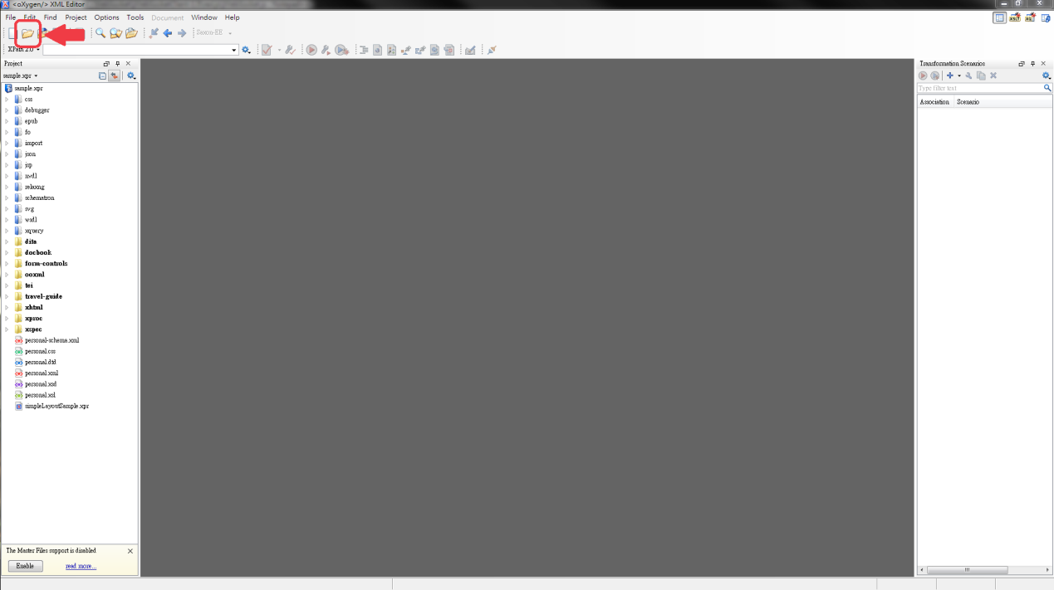

Step 2: Click on the Validate button to expose the pull down menu

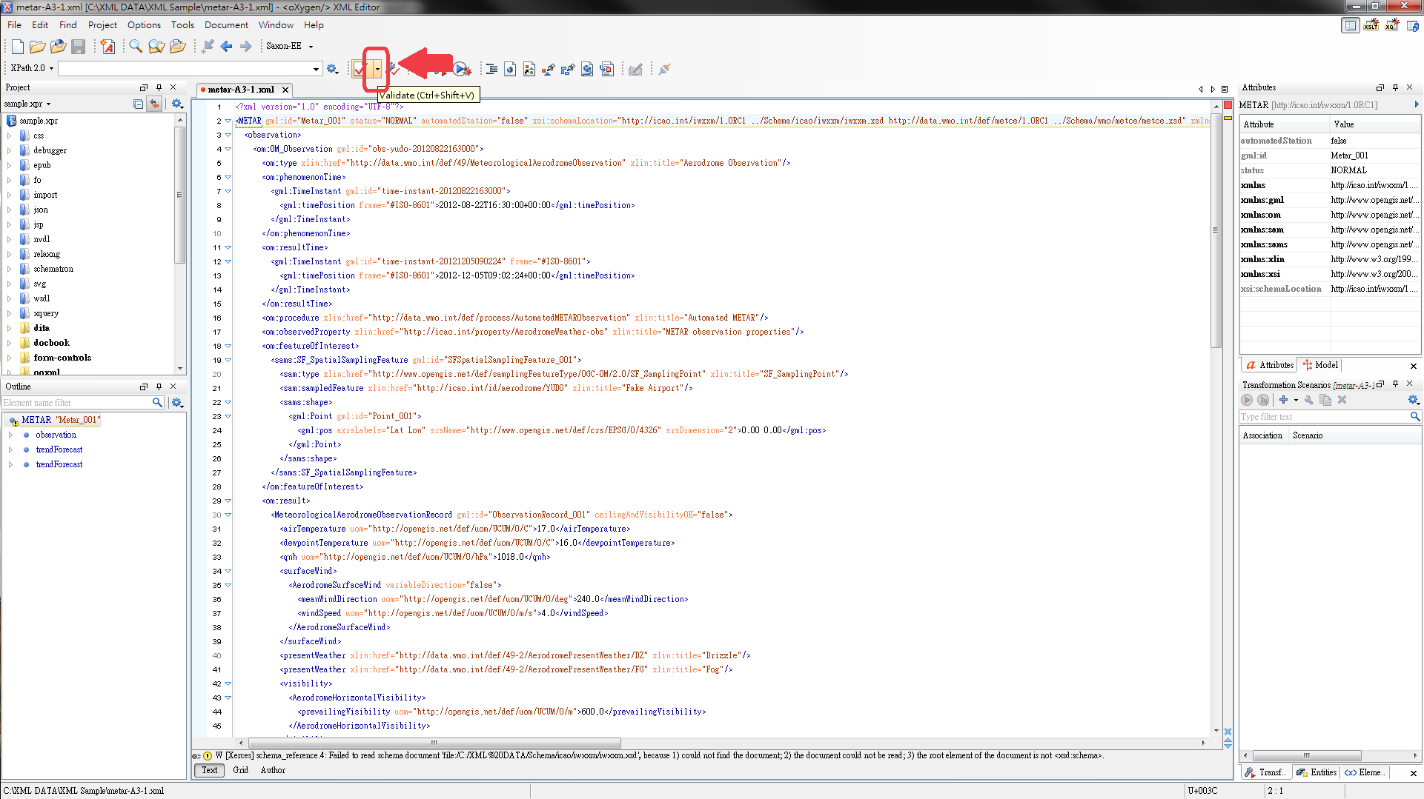

Step 3: Click on the ‘Validate with…’ option and enter the location of the AvXML schema. Tick the ‘Embedded schematron rules’ checkbox.

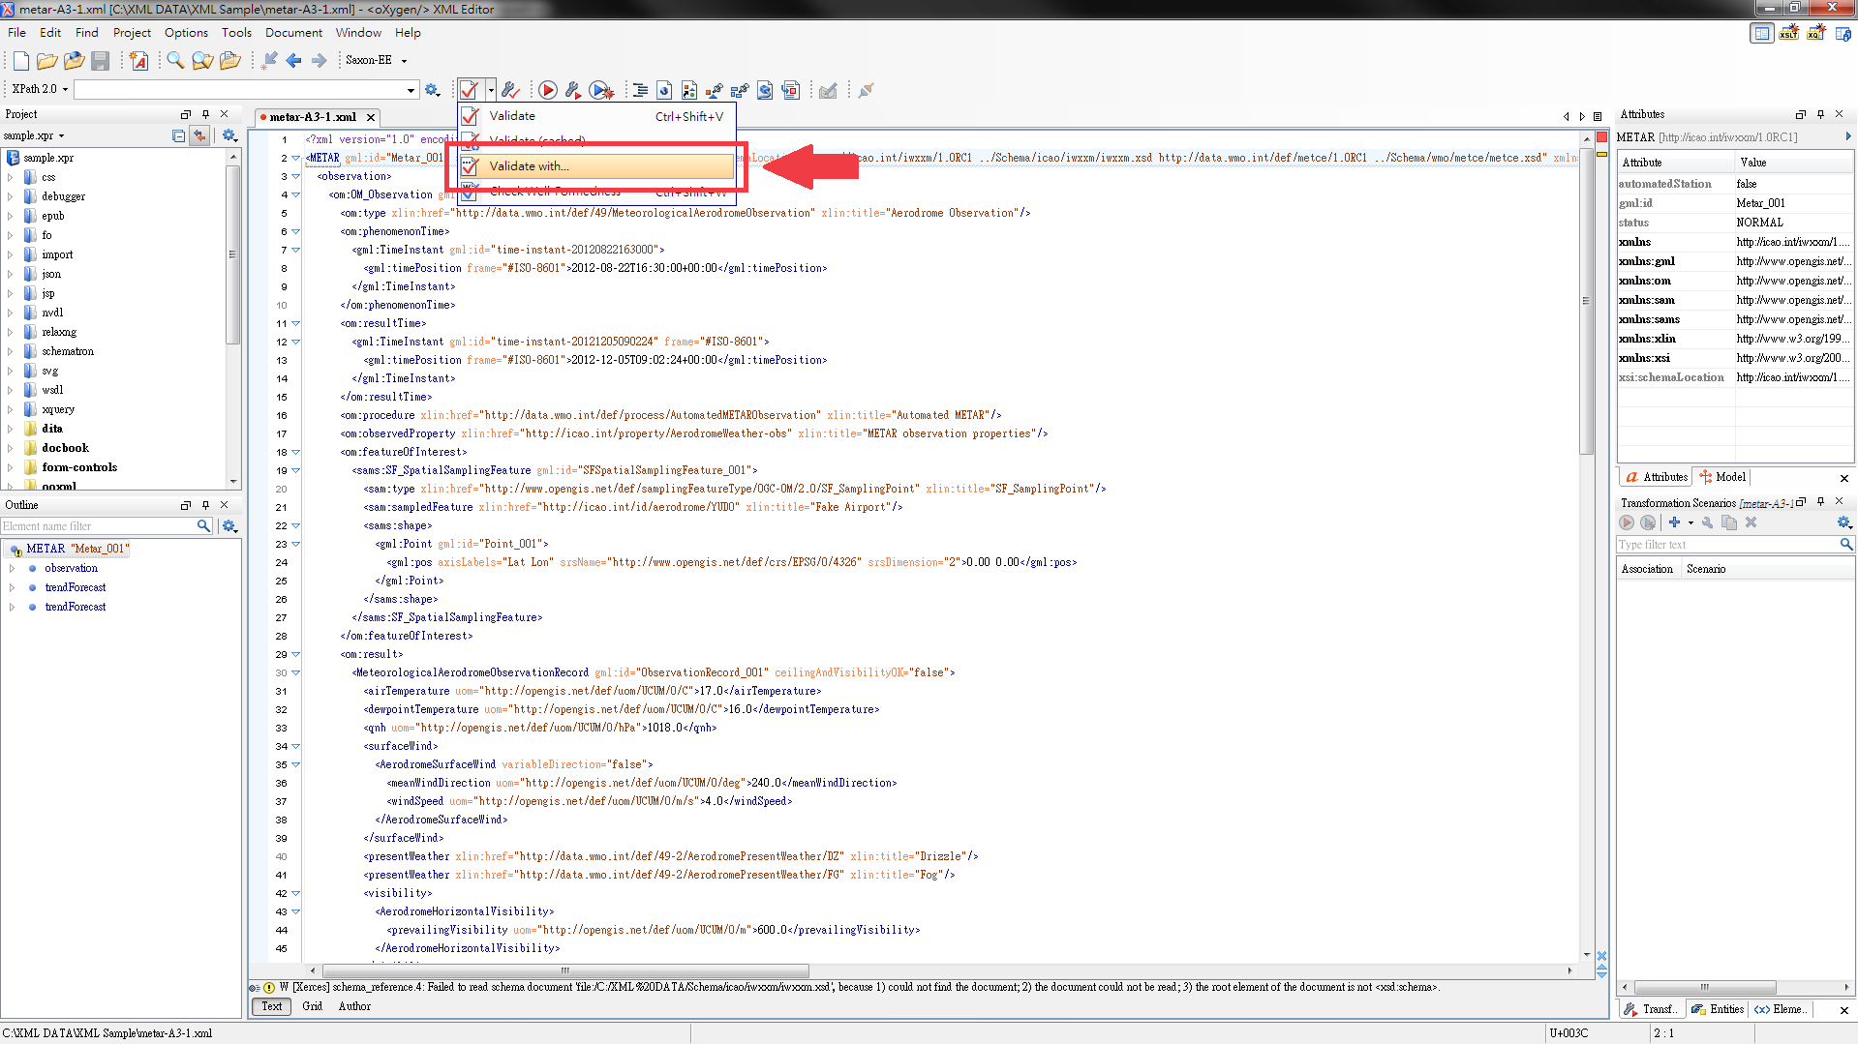

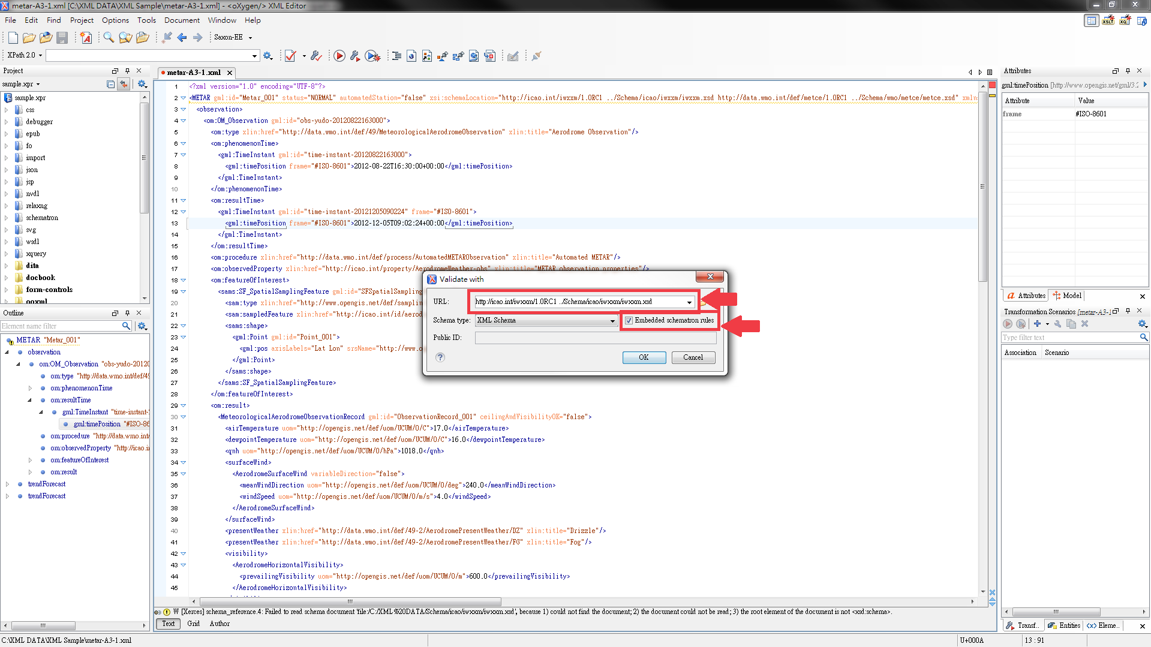

Step 4: Get the validation result at the bottom bar

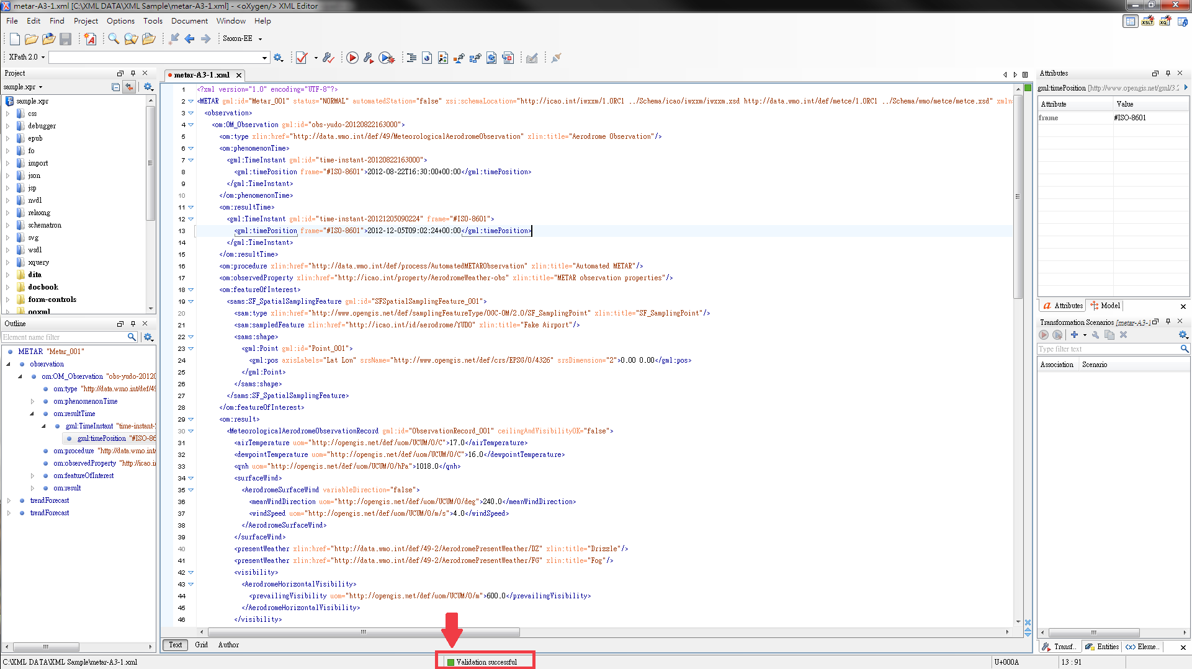

http://www.wmo.int/pages/prog/www/WIS/wiswiki/tiki-index.php?page=METCE-1.0RC2&structure=WIS+up
www.liquid-technologies.com
netbeans.org
www.oxygenxml.com
xmlbeans.apache.org

