WMO Met Data Exchange Interoperability Experiment

2025-02-18

|  |
| --- |
|  |
| **World Meteorological Organization** |
| Date: 2025-02-18 |
| Version: 0.1 |
| Document status: DRAFT |
| Document location: <https://wmo-im.github.io/metdx-ie/metdx-ie/metdx-ie-DRAFT.html> |
| Standing Committee on Information Management and Technology (SC-IMT)[1] |
| Commission for Observation, Infrastructure and Information Systems (INFCOM)[2] |
| Copyright © 2025 World Meteorological Organization (WMO) |

# Abstract

The subject of this Report is the results of testing and experimentation of current data exchange interoperability trends. Interoperability testing is coordinated by the WMO Study Group on Future Data Infrastructures (SG-FIT) subgroup on WMO Met Data Exchange Interoperability. The results of this report will support recommendations on future state data exchange standards guidance and techical regulations at WMO.

# Executive summary

TODO

# Scope

This report presents the testing framework put forth as part of the work of the subgroup. This report also discussses the results and presents a set of conclusions and recommendations.

# Terms and definitions

This document uses the terms defined in [OGC Policy Directive 49](https://portal.ogc.org/public_ogc/directives/directives.php), which is based on the ISO/IEC Directives, Part 2, Rules for the structure and drafting of International Standards. In particular, the word “shall” (not “must”) is the verb form used to indicate a requirement to be strictly followed to conform to this Standard and OGC documents do not use the equivalent phrases in the ISO/IEC Directives, Part 2.

This document also uses terms defined in the OGC Standard for Modular specifications ([OGC 08-131r3](https://portal.opengeospatial.org/files/?artifact_id=34762)), also known as the 'ModSpec'. The definitions of terms such as standard, specification, requirement, and conformance test are provided in the ModSpec.

## Abbreviated terms

API

Application Programming Interface

FAIR

Findable, Accessible, Interoperable, Reusable

FEMDI

European National Meteorological and Hydrological Services

HTTP

Hypertext Transfer Protocol

HTTPS

Hypertext Transfer Protocol Secure

JSON

JavaScript Object Notation

OGC

Open Geospatial Consortium

MQTT

Message Queuing Telemetry Transport

RODEO

The provision of open access to public meteorological data and development of shared federated data infrastructure for the development of information products and services

STAC

SpatioTemporal Asset Catalog

WIS

WMO Information System

WMO

World Meteorological Organization

# References

* Manual on the WMO Information System, Volume II - WMO Information System 2.0 [3]
* Guide to the WMO Information System Volume II - WMO Information System 2.0 [4]
* Provisions for the Transition from the WMO Information System (WIS) 1.0 and Global Telecommunication System to WIS 2.0 [5]

# High level architecture

The focus of testing is to evaluate functionality of various APIs and encodings to assess and evaluate for future data exchange guidance and technical regulation.

## Core work threads

Core threads of work include:

### Discrete sampling of NWP data and observations

TODO

### Interfaces and encodings for cloud optimized data discovery and access

TODO

### Encodings for big multidimensional data

TODO

### Visualization of weather/climate/water products

TODO

### AI-driven search

TODO

### Exploitation of data via custom processing workflows

TODO

### Data usage insights, weblogs for Global Caches and Global Discovery Catalogues

TODO

## Standards

The rest of this section describes the standards implemented during or in support of the interoperability experiment.

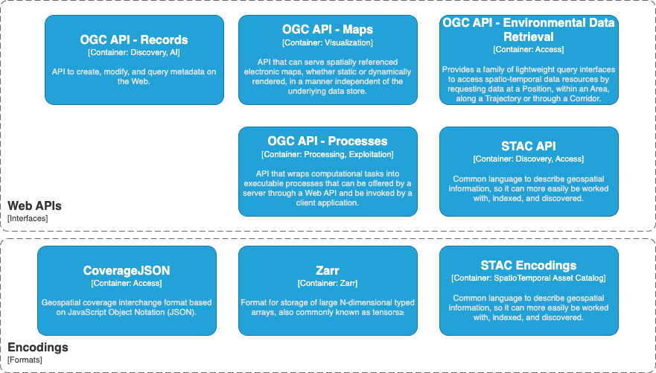

High Level Overview of Standards used

### Web APIs

### OGC API - Environmental Data Retrieval

An Environmental Data Retrieval (EDR) API [6] provides a family of lightweight interfaces to access Environmental Data resources. Each resource addressed by an EDR API maps to a defined query pattern. This specification identifies resources, captures compliance classes, and specifies requirements which are applicable to OGC Environmental Data Retrieval API’s. This specification addresses two fundamental operations; discovery and query. Discovery operations allow the API to be interrogated to determine its capabilities and retrieve information (metadata) about this distribution of a resource. This includes the API definition of the server as well as metadata about the Environmental Data resources provided by the server. Query operations allow Environmental Data resources to be retrieved from the underlying data store based upon simple selection criteria, defined by this standard and selected by the client.

The OGC API - Environmental Data Retrieval Standard provides a family of lightweight query interfaces to access spatio-temporal data resources by requesting data at a Position, within an Area, along a Trajectory or through a Corridor.

The OGC API - Environmental Data Retrieval - Part 2: Publish-Subscribe Workflow Standard provides recommendations on applying Publish-Subscribe (PubSub) architectural patterns to implementations of one or more OGC API Standards in order to support Event Driven applications.

### OGC API - Maps

The OGC API - Maps [7] Standard describes an API that can serve spatially referenced electronic maps, whether static or dynamically rendered, in a manner independent of the underlying data store. OGC API - Maps describes the discovery and query operations of an API that provides access to electronic maps in a manner independent of the underlying data store. The query operations allow dynamically rendered maps to be retrieved from the underlying data store based upon simple selection criteria, defined by the client.

### OGC API - Records

OGC API - Records [8] is a multi-part draft specification that offers the capability to create, modify, and query metadata on the Web. The draft specification enables the discovery of geospatial resources by standardizing the way collections of descriptive information about the resources (metadata) are exposed. The draft specification also enables the discovery and sharing of related resources that may be referenced from geospatial resources or their metadata by standardizing the way all kinds of records are exposed and managed. Part 1 will cover read-only access to records and simple query capabilities. Additional capabilities that address specific needs will be specified in additional parts. Capabilities for richer queries or to create, update or delete records will be specified in additional parts.

### OGC API - Processes

The OGC API - Processes [9] standard supports the wrapping of computational tasks into executable processes that can be offered by a server through a Web API and be invoked by a client application. The standard specifies a processing interface to communicate over a RESTful protocol using JavaScript Object Notation (JSON) encodings. Typically, these processes execute well-defined algorithms that ingest vector and/or coverage data to produce new datasets.

### STAC API

The SpatioTemporal Asset Catalog (STAC) [10] specification provides a common structure for describing and cataloging spatiotemporal assets.

The STAC API [11] provides a RESTful endpoint that enables search of STAC Items, specified in OpenAPI, following OGC API - Features and OGC API - Records.

### Encodings

### CoverageJSON

CoverageJSON [12] defines a format for publishing spatiotemporal data to the Web. CoverageJSON supports the efficient transfer from big data stores of useful quantities of data to lightweight clients, such as browsers and mobile applications.

### Zarr

Zarr [13] is a community project to develop specifications and software for storage of large N-dimensional typed arrays, also commonly known as tensors. A particular focus of Zarr is to provide support for storage using distributed systems like cloud object stores, and to enable efficient I/O for parallel computing applications.

GeoZarr [14] to provide a geospatial extension to the Zarr specification. Zarr specifies a protocol and format used for storing Zarr arrays, while the present extension defines conventions and recommendations for storing multidimensional georeferenced grid of geospatial observations (including rasters).

### STAC encodings

The SpatioTemporal Asset Catalog (STAC) [15] specification provides a common structure for describing and cataloging spatiotemporal assets.

A spatiotemporal asset is any file that represents information about the earth captured in a certain space and time.

The STAC Specification consists of 4 semi-independent specifications. Each can be used alone, but they work best in concert with one another.

* STAC Item [16] is the core atomic unit, representing a single spatiotemporal asset as a GeoJSON feature plus datetime and links.
* STAC Catalog [17] is a simple, flexible JSON file of links that provides a structure to organize and browse STAC Items. A series of best practices helps make recommendations for creating real world STAC Catalogs.
* STAC Collection [18] is an extension of the STAC Catalog with additional information such as the extents, license, keywords, providers, etc that describe STAC Items that fall within the Collection.

# Results

TODO

# Discussion

TODO

# Conclusions

TODO

# Future work

TODO

# Revision history

| Date | Release | Author | Primary clauses modified | Description |
| --- | --- | --- | --- | --- |
| 2025-01-24 | 0.1 | Kralidis | all | initial version |

# Bibliography

1. <https://community.wmo.int/governance/commission-membership/commission-observation-infrastructures-and-information-systems-infcom/commission-infrastructure-officers/infcom-management-group/standing-committee-information-management-and-technology-sc-imt>
2. <https://community.wmo.int/governance/commission-membership/infcom>
3. <https://library.wmo.int/idurl/4/68731>
4. <https://library.wmo.int/idurl/4/69130>
5. <https://library.wmo.int/idurl/4/69050>
6. <https://ogcapi.ogc.org/edr>
7. <https://ogcapi.ogc.org/maps>
8. <https://ogcapi.ogc.org/records>
9. <https://ogcapi.ogc.org/processes>
10. <https://stacspec.org>
11. <https://github.com/radiantearth/stac-api-spec>
12. <https://www.ogc.org/publications/standard/coveragejson>
13. <https://zarr.dev>
14. <https://github.com/zarr-developers/geozarr-spec>
15. <https://stacspec.org>
16. <https://github.com/radiantearth/stac-spec/blob/master/item-spec/item-spec.md>
17. <https://github.com/radiantearth/stac-spec/blob/master/catalog-spec/catalog-spec.md>
18. <https://github.com/radiantearth/stac-spec/blob/master/collection-spec/collection-spec.md>