Draft guidance on transition from GTS to WIS2
2023-12-10

World Meteorological Organization
Date: 2023-09-26
Version: 2.0.0alpha1
Document location: https://community.wmo.int/wis2-transition-guide
Standing Committee on Information Management and Technology (SC-IMT)
Commission for Observation, Infrastructure and Information Systems (INFCOM)
Copyright © 2023 World Meteorological Organization (WMO)

Preamble

Purpose
The purpose of this document is to provide technical guidance and additional information for members to transition from GTS to WIS2, in implementing the practices, procedures, and specifications defined in the Manual on WIS (WMO No. 1060), Vol II.

Audience
This draft guidance document is provided primarily for GTS data producers, data consumers, and service providers.

Status of this document
This draft guidance is as an informal document. The content will be updated, modified and improved throughout the WIS2 transition phase as detailed specifications and procedures are validated through testing. The information provided herein will be consolidated into a new version of the Guide to WIS (WMO No. 1061) upon completion of the pilot phase. (TODO: validate)

Introduction
The WMO Information System 2.0 (WIS2) will be implemented according to the schedule provided in Figure 1. A one-year pilot phase will start at the end of 2022, with several countries collaborating in building the WIS2 infrastructure. Each Country will have a different role in the WIS2 framework and will implement a specific component.
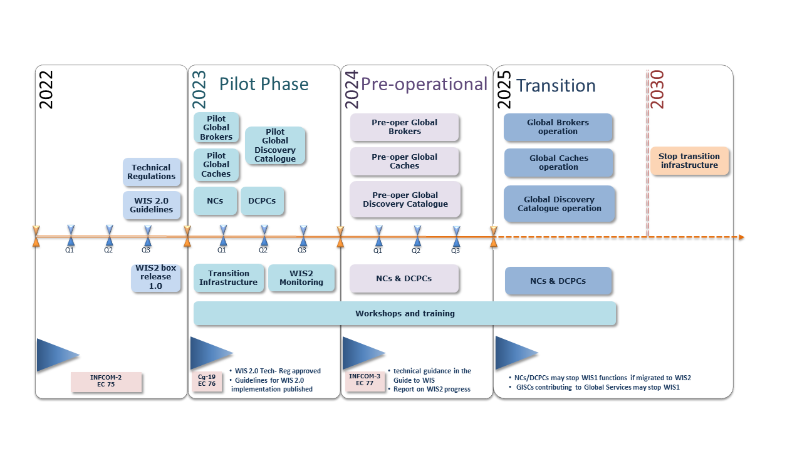
WIS2 implementation timeline
According to the WIS2 implementation plan (see figure 1), the Global Telecommunication System (GTS) will be decommissioned by 2030, and National Meteorological and Hydrological Services NMHSs will use the WIS2 platform for data exchange. During the transition period, there will be a mix of centres operating WIS2 and WIS/GTS. Some of them will be running both data-sharing frameworks simultaneously, with the difficulties associated with maintaining two operational systems for the same purpose. Therefore, a transition plan will be developed during the pilot phase, taking into account the time necessary for Members to migrate to the new systems and reducing, at the minimum, the time of parallel operation of both systems for a Member.

Principles
The following principles are appropriate for the transition:
Principle1: Each NMHS will be able to make the migration during the agreed period 2025-2030:
- Considering the fact that not all centres have the same skills and facilities, and the operational aspects of WIS and the risks involved in a big-bang approach, the WIS node implementation would not be fully implemented at the same time
Principle 2: No GTS data loss during the transition:
- During the pilot phase, and in coordination with the regional associations and GISCs, WIS2 infrastructure will be established in order to avoid data loss during the transition. The aim of this infrastructure is to ensure that data sent on the GTS can be received by a site having migrated on WIS2, and data, previously sent on the GTS, sent on WIS2 can be received by a site still on the GTS
Principle 3: Each Centre will decide when decommissioning the WIS1 and GTS:
- Decommissioning WIS1 services, as well as GTS ones, will be the decision of each NC/DCPC/GISC when they will consider that their and their user’s migration is completed
- After migration to WIS2, It is not required to run an MSS to receive or send data from Centres not having made the transition. The Centre will decide when and if they want to stop their Message Switching System MSS. They can also stop the data dissemination to GTS
Principle 4: New data (eg. GBON, Climate, Hydrology, Cryosphere) will be exchanged solely on WIS2:
- WIS2 is designed to to enable the WMO Unified Data Policy, and to support the WMO Global Basic Observing Network. The new data will be available on WIS2. A centre not having made the migration to WIS2 will not receive the new data. This data will not have a GTS headers TTAAii and will not be exchanged over the GTS

GTS to WIS2 Gateway
The Executive Council, with resolution 34 (EC-76), endorsed the WMO Information System 2 (WIS2) implementation plan and recognized the importance of establishing a pilot phase to develop the WIS2 infrastructure and begin testing it in order to be ready for a preoperational phase in 2024, and then for the transition starting on 2025. According to the WIS2 implementation plan, the Global Telecommunication System (GTS) will be decommissioned by 2030, and National Meteorological and Hydrological Services NMHSs will use the WIS2 platform for data exchange.
During the transition period, in order to avoid some WIS centres being forced to run both data-sharing frameworks simultaneously WIS2 and GTS, with the challenges associated with maintaining two operational systems for the same purpose, a gateway from GTS to WIS2 is designed, taking into account the time required for Members to migrate to the new systems and minimizing the time a member has to operate both systems in parallel.

Purpose
The purpose of the GTS to WIS2 gateway is to enable members who have migrated to WIS2 and have stopped their GTS systems to continue receiving GTS data from WIS2. This gateway also enables users who are not connected to GTS to access GTS data, during the transition phase, from WIS2.

GTS to WIS2 Gateway provider
The gateway will be provided by Germany’s Deutscher Wetterdienst (DWD). The Japanese Meteorological Agency (JMA) may provide a second gateway for increased sustainability and resilience.

Technical requirements
- GTS headers SHALL be used in the WIS2 Topic Hierarchy (WTH)
- The TH for GTS data on the Global Cache (GC) SHALL be as follows:
  - cache/a/wis2/xxg/gts_to_wis2_GC-name/TTAAii
  - e.g for DWD: cache/a/wis2/xxg/gts_to_wis2_dwd/TTAAii

WIS2 to GTS Gateway
The Executive Council, with resolution 34 (EC-76), endorsed the WMO Information System 2.0 (WIS2) implementation plan and recognized the importance of establishing a pilot phase to develop the WIS2 infrastructure and begin testing it in order to be ready for a preoperational phase in 2024, and then for the transition starting on 2025. According to the WIS2 implementation plan, the Global Telecommunication System (GTS) will be decommissioned by 2030, and National Meteorological and Hydrological Services (NMHSs) will use the WIS2 platform for data exchange.
During the transition period, in order to avoid some WIS centres being forced to run both data sharing frameworks simultaneously for WIS2 and GTS, with the challenges associated with maintaining two operational systems for the same purpose, a gateway from WIS2 to GTS will be designed during the WIS2 pilot phase, taking into account the time required for Members to migrate to the new systems and minimizing the time a member has to operate both systems in parallel.

Purpose
The purpose of this gateway is to enable GTS members who have not yet migrated to WIS2 to continue to receive GTS data from GTS members who have migrated to WIS2 and stopped their GTS systems.
Note: Only data that have been already published in GTS are concerned by this gateway, New data will be available only on WIS2.

WIS2 to GTS Gateway provider
The gateway will be provided by the Regional Telecommunication Hubs (RTH)

Technical requirements
To enable the Gateway, providers to do the mapping from WIS2 to GTS, and data providers shall include in the WIS2 Notification Message (WNM) a GTS property as follows:
"properties": {
…
"gts": {
"ttaaii": "FTAE31",
"cccc": "whatever"
}

Management of the WIS1 Catalogue
With the start of the pre-operational phase of WIS2, GISCs do no longer need to maintain and provide their own WIS1 Catalogue. In order to be able to decommission their copies of the Catalogue, GISCs SHALL liaise with their users and with centers in their AoR and point them to the WIS Portals of the WIS Catalogue Authorities, namely GISC Seoul and GISC Offenbach. GISC Seoul and GISC Offenbach will continue to provide WIS1 discovery metadata and the WIS1 Catalogue until the transition from GTS and WIS1 to WIS2 is advanced. ET-W2AT together with ET-OM propose to INFCOM the final date when the WIS1 Catalogue can be decomissioned in due time.

Management of Metadata
With the start of the pre-operational phase updates to WIS1 discovery metadata should be limited to important changes. Important changes are limited to: * updates to the points of contact * updates to the data formats / encoding * updates to the contents of the data Editoral changes or other updates to the discovery metadata for changes that do not affect data users will not be possible after the start of the pre-operational phase.
When GISCs decide to decomission and turn off their WIS1 catalogue and services they should arrange with GISC Offenbach and GISC Seoul how discovery metadata can be maintained. Also they should inform GISC Offenbach and GISC Seoul when their OAI interfaces become unavailable. GISCs may decide to continue to host their discovery metadata catalogue and their WIS1 services for the time being. In this case they should ensure the functioning of their respective OAI interfaces.
New discovery metadata should not be added to the WIS1 Catalogue any more. Instead new data should only be added in WCMP2 to the Global Discovery Catalogue for WIS2.

Global Discovery Catalogue
Users of the WIS1 discovery metadata catalogue should be informed by GISCs about the availability of WIS2 discovery metadata in the Global Discovery Catalogue. GISCs should provide guidance and asist their users in accessing and working with the WIS2 catalogue. With the start of the operational phase of WIS2, the Global Discovery Catalogues become the authoritative source for discovery metadata in WIS while the WIS1 catalogue will be terminated.

References

Normative
- WMO: Manual on WIS (WMO No. 1060), Vol II. WIS 2.0
- WMO: WMO Core Metadata Profile version 2 (WCMP2)
- WMO: WIS2 Topic Hierarchy (WTH)
- WMO: WIS2 Notification Message (WNM) format
- WMO: WIS2 Metric Hierarchy (WMH)

Informative
- WMO: WMO Information System 2.0 Strategy (WMO No. 1213)
- WMO: WMO Guidelines on Emerging Data Issues (WMO No. 1239)

https://community.wmo.int/governance/commission-membership/commission-observation-infrastructures-and-information-systems-infcom/commission-infrastructure-officers/infcom-management-group/standing-committee-information-management-and-technology-sc-imt
https://community.wmo.int/governance/commission-membership/infcom
https://wmo-im.github.io/wcmp2
https://github.com/wmo-im/wis2-topic-hierarchy
https://wmo-im.github.io/wis2-notification-message
https://github.com/wmo-im/wis2-metric-hierarchy
https://library.wmo.int/index.php?lvl=notice_display&id=20422
https://library.wmo.int/index.php?lvl=notice_display&id=21644

