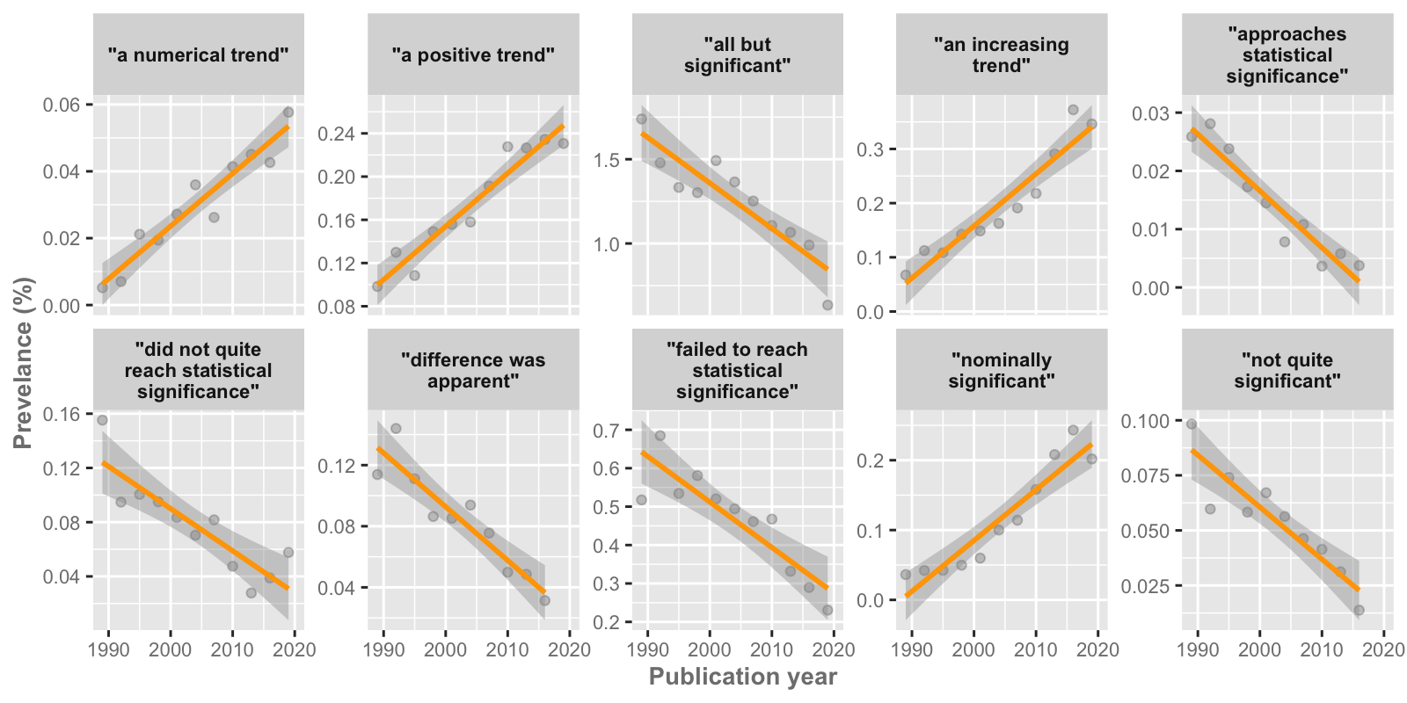

**Fig 3**. Temporal plots for phrases with ‘decisive’ evidence (i.e., Bayes factors > 100) for temporal change. Prevalence estimates are shown as dots, together with the linear regression model fit and corresponding uncertainty.