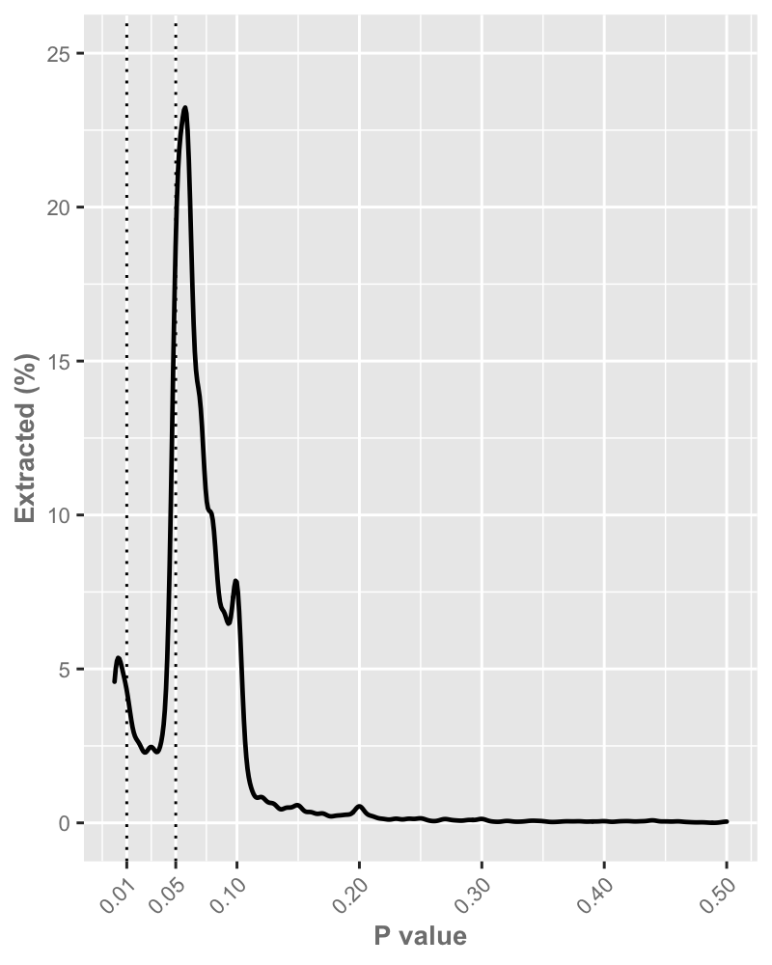

**Fig 4**. Density plot of the 11,926 manually extracted P values.