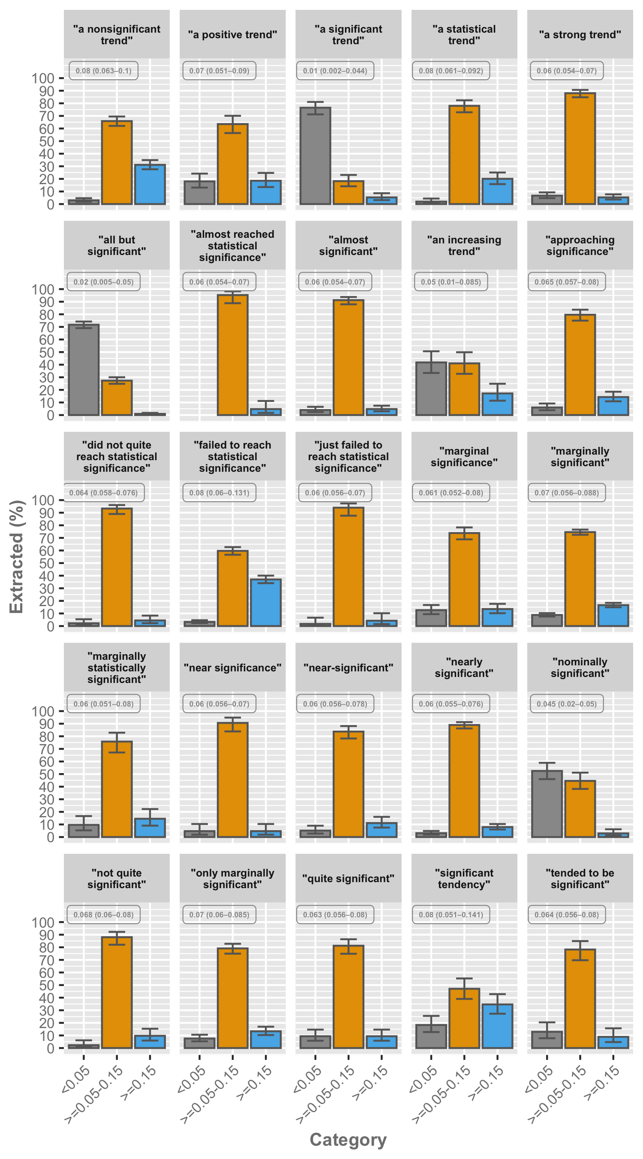

**Fig 5**. Category percentages for the twenty most frequent phrases describing non-significant results, with at least 100 manually extracted P values. Error bars represent the 95% confidence interval. The associated median P value (with the 25% and 75% quantiles) is presented in the upper left corner of each phrase.