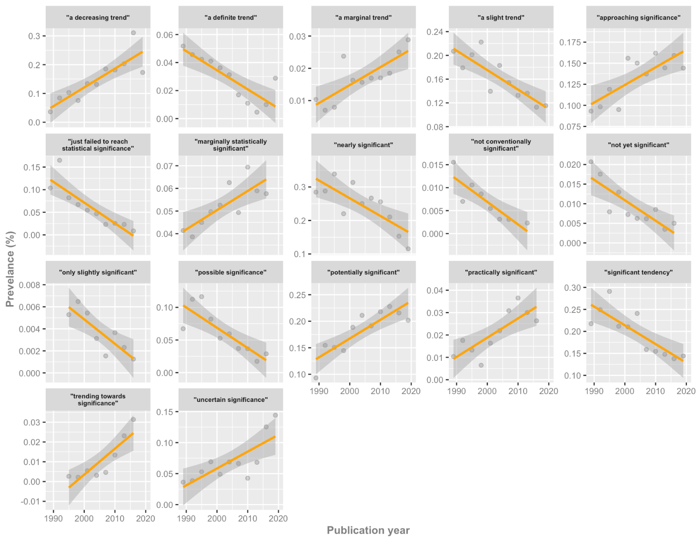

**Fig S1**. Temporal plots for phrases with ‘strong’ evidence (i.e., Bayes factors between 10–100) for temporal change. Prevalence estimates are shown as dots, together with the linear regression model fit and 95% confidence interval.