**Figures**

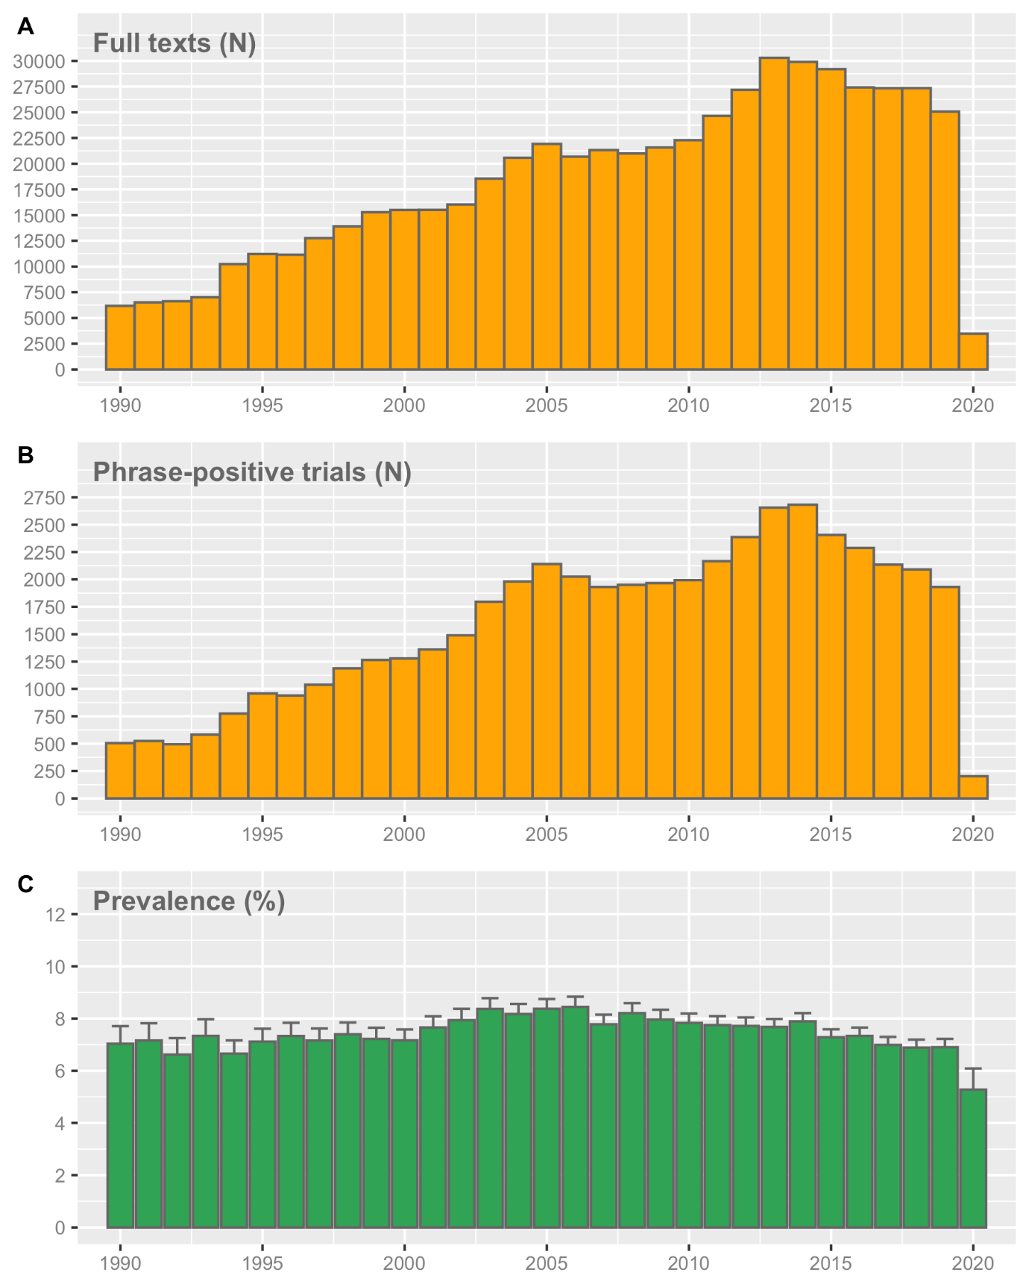

**Figure 1**. The number of analysed full texts (A), number of phrase-positive RCTs (B) and the corresponding prevalence (C) over time. Error bars represent the proportional 95% confidence interval.