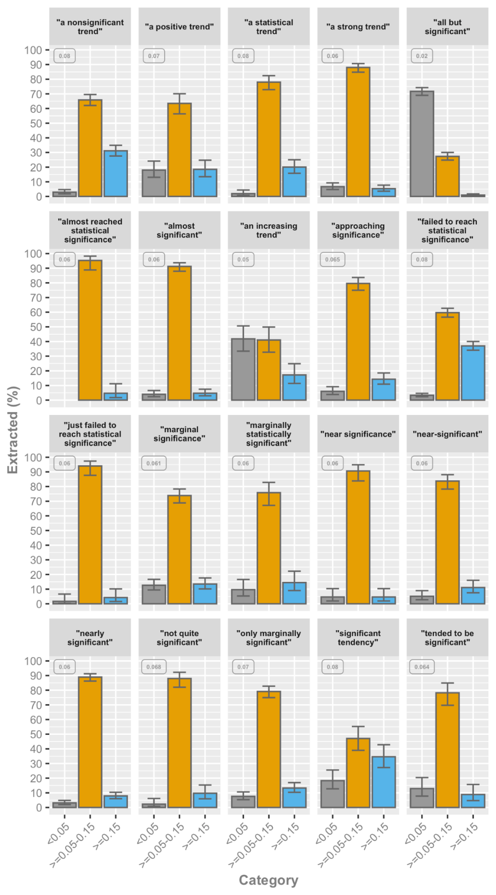

**Figure 4**. Category percentages for the twenty most frequent phrases describing non-significant results, with at least 100 manually extracted P values. Error bars represent the proportional 95% confidence interval. The associated median P value is presented in the upper left corner of each phrase.