PROJECT WALKTHROUGH · SESSION 1

Healthcare Analytics with dbt and SQL Server
Building a raw → staging → silver → gold data warehouse, step by step

A learning guide to everything built in the dbt_session_001 project: the data, the decisions, the folder structure, the problems we hit and how we solved them.

Item | Value
Project | dbt_session_001 (repository dbt_S1, branch S1)
Database | healthcare_dbt_dw on SQL Server 2019 (host SQLLAB)
Toolchain | dbt-core 1.12.6 · dbt-sqlserver 1.12.2 · Python 3.12 · ODBC Driver 18
Dataset | encounters_100k.csv: 50,000 hospital encounters × 93 columns
Author | Waleed Mouhammed
Date | 6 November 2026

Contents
1. Introduction 4
1.1 Purpose of this document 4
1.2 The project at a glance 4
1.3 The dataset 5
2. Core concepts 5
2.1 What dbt is, and what it is not 5
2.2 The medallion architecture 6
2.3 dbt vocabulary used in this document 6
3. Environment and setup 7
3.1 Python virtual environment 7
3.2 Creating the dbt project and connecting to SQL Server 7
3.3 Version control and .gitignore 8
4. Folder structure 8
4.1 Purpose of each part 9
5. Step 1 - Bronze: loading the raw data 10
5.1 Design decision: land everything as text 10
5.2 Choosing a loading method - and why the first ones failed 10
5.3 The Python loader notebook 11
5.4 Validating the load 12
6. Step 2 - Declaring the source 12
7. Step 3 - Staging: cleaning and typing 13
7.1 The job of the staging layer 13
7.2 Choosing data types 13
7.3 Naming conventions 14
7.4 Materialization 14
7.5 Staging tests (176) 14
7.6 A custom generic test: expression_is_true 15
7.7 The 18 business rules 15
8. Why a silver layer? 16
8.1 The problem with one wide table 16
8.2 What silver adds 17
9. Step 4 - Silver: the star schema 17
9.1 Design 17
9.2 Models 18
9.3 Two modelling decisions driven by the data 19
9.4 Derived fields 19
9.5 Generating dim_date without a recursive CTE 19
9.6 Where silver is stored: custom schemas 20
9.7 Silver tests (72) 20
10. Step 5 - Gold: business marts 21
10.1 Purpose 21
10.2 The six marts 21
10.3 Design principles and techniques 22
10.4 Gold tests (74) 23
10.5 First insights from the marts 23
11. Testing strategy across the layers 23
11.1 Severity policy 24
11.2 Investigating a failing test 24
12. How to run the project 25
13. Git history 25
14. Data issues and lessons learned 26
14.1 Habits that paid off 26
15. Suggested next steps 26
Appendix A. Glossary 27

1. Introduction

1.1 Purpose of this document
This document records, in teaching detail, everything that was built in the first working session of the project. It is written so that someone who has never used dbt can follow the reasoning behind each step, not just the steps themselves. Every chapter explains three things:
- What was built: the files, tables and tests.
- Why it was built that way: the design principle or the data fact that drove the decision.
- What went wrong along the way, and the lesson worth remembering.
Read it front to back the first time. Afterwards, chapters 4 (folder structure), 12 (how to run) and the glossary work well as a reference.

1.2 The project at a glance
We took a single CSV file of hospital encounters and turned it into a tested, layered analytics warehouse on SQL Server. The result is four layers of tables, each with a clear job:
Layer | Where it lives | What it contains | Built by
Bronze (raw) | schema raw | 1 table, raw.encounters: the file exactly as delivered (all text) | Python notebook
Staging | schema dev | 1 model, stg_encounters: clean, typed, consistently named | dbt
Silver | schema dev_silver | 7 dimensions + 3 facts: a star schema of the business | dbt
Gold | schema dev_gold | 6 marts: aggregated answers to business questions | dbt

Across these layers the project runs 349 automated data tests. The latest build finished with 0 errors and 1 deliberate warning (a real data-quality issue explained in chapter 7).
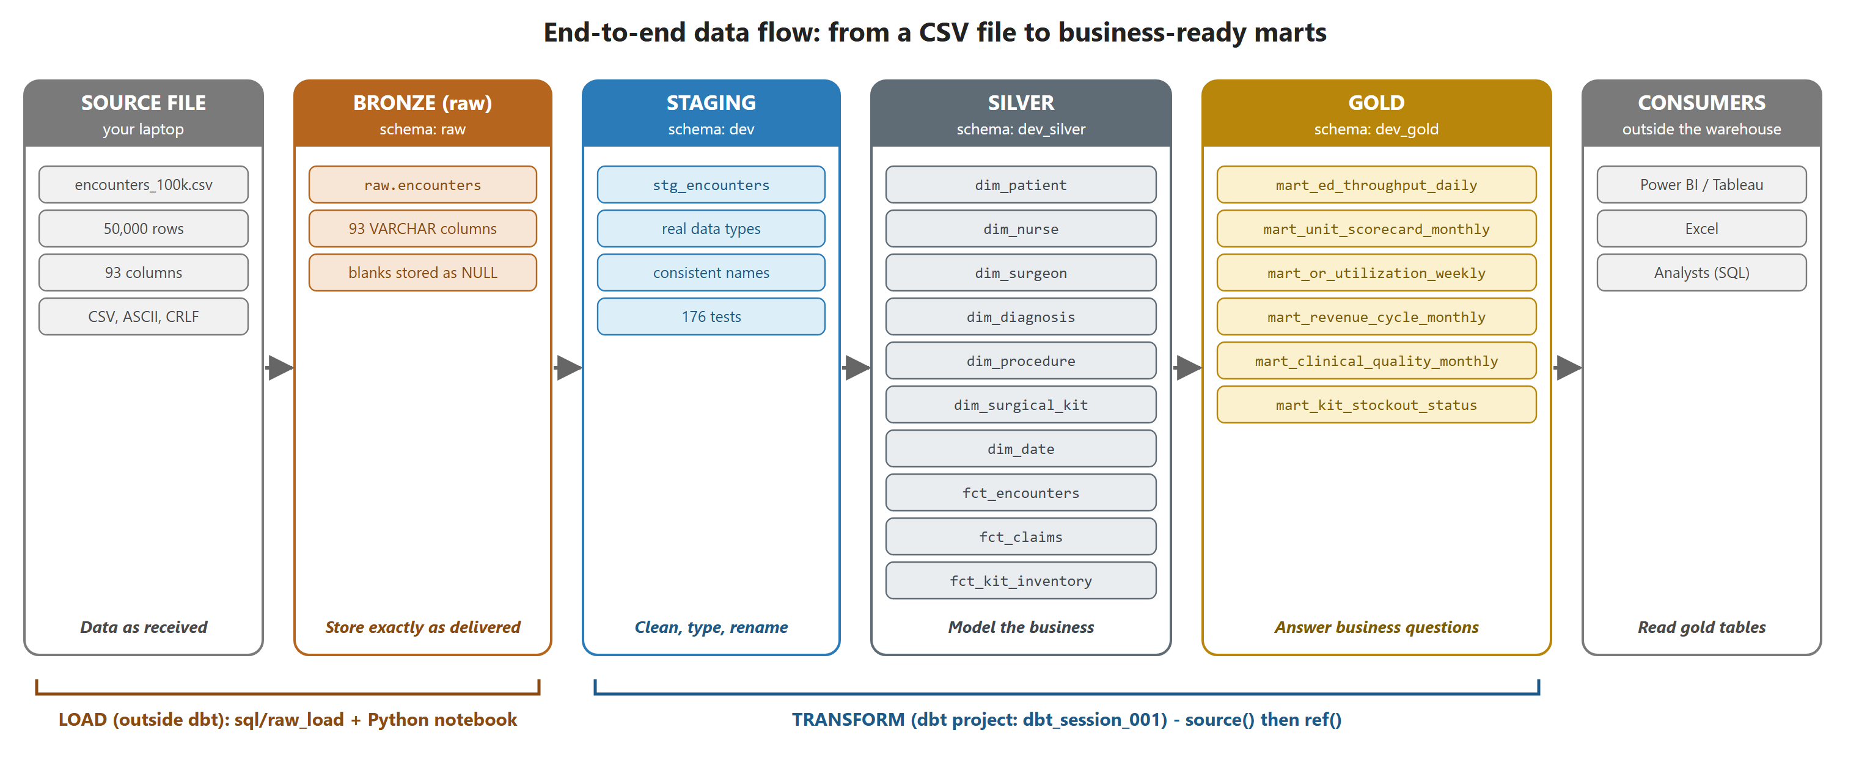
Figure 1. End-to-end data flow. Loading happens outside dbt; every transformation after the raw table is a dbt model.

1.3 The dataset
The source file encounters_100k.csv is a synthetic but realistic hospital extract. Despite its name, it contains 50,000 rows, not 100,000. Each row is one hospital encounter (one patient stay) and the 93 columns mix many subjects into a single wide table:
Subject area | Example columns
Patient demographics | patient_id, birth_year, age, sex, race_ethnicity, state
Diagnosis & comorbidities | icd10_code, diagnosis_display, diagnosis_category, severity_index, has_diabetes
Vitals & labs | sbp_mmhg, heart_rate_bpm, spo2_pct, hba1c_pct, glucose_mg_dl, creatinine_mg_dl
Patient flow & beds | triage_timestamp, admit_timestamp, bed_request_time, bed_assign_time, los_days
Operating room | cpt_code, procedure_display, or_start, or_end, actual_or_minutes
Patient safety | safety_incident_flag, incident_type, incident_severity
Claims & billing | claim_id, payer, submitted_charge_usd, allowed_amount_usd, fraud flags
Nurse & surgeon staffing | nurse_emp_id, nurse_role, burnout scores (MBI), shift_hours, surgeon_specialty
Patient experience | 8 CAHPS survey scores (nurse communication, cleanliness, quietness, ...)
Surgical kit inventory | surgical_kit_id, kit_current_stock, kit_reorder_point, days_of_supply
Quality measures | hedis_hba1c_tested, hedis_hba1c_poor_control, himss_emram_stage

Facts about the file that mattered later:
- Plain ASCII text, Windows line endings (CRLF), no byte-order mark, about 32 MB.
- 26,629 values contain a comma inside quotes, for example "Incision and drainage, complex". Any loader that does not understand quoted CSV will split these values into extra columns.
- Three columns are mostly empty by design: incident_type, incident_severity and pdsa_cycle_id (47,569 blanks each, because most encounters have no safety incident).
- Every patient appears exactly once, so in this data a patient and an encounter are one-to-one.

2. Core concepts

2.1 What dbt is, and what it is not
dbt (data build tool) is the "T" in ELT. It does not move data between systems. It assumes the data is already inside the warehouse, and it runs SQL SELECT statements there to turn raw tables into clean, modelled tables. You write each transformation as a .sql file containing one SELECT; dbt wraps it in the right CREATE TABLE or CREATE VIEW statement, works out the build order, and runs tests against the results.
Concept: ELT means Extract, Load, Transform. We extracted and loaded the CSV ourselves (with Python); dbt only does the Transform part. That is why the raw-loading scripts live outside the dbt project, in sql/raw_load/.
Two Jinja functions make dbt work. Every model in this project uses one of them:
Function | Points to | Used in | Why it matters
source('raw', 'encounters') | A table dbt did not build (declared in _sources.yml) | stg_encounters.sql | Documents and tests the entry point of the data
ref('stg_encounters') | Another dbt model | Every silver and gold model | dbt reads these calls to build the dependency graph (DAG) and the build order

2.2 The medallion architecture
The project follows the widely used medallion pattern: data flows through layers that become progressively cleaner and closer to how the business thinks. dbt's own documentation uses different names for the same idea, so both vocabularies are worth knowing:
Medallion name | dbt name | In this project | Question the layer answers
Bronze | sources / raw | raw.encounters | Did we receive the data intact?
Silver (part 1) | staging | stg_encounters | Is every value correct and properly typed?
Silver (part 2) | intermediate / core | dim_* and fct_* tables | What are the business entities and how do they relate?
Gold | marts | mart_* tables | How is the business performing?

Concept: A rule of thumb used throughout the project: if a calculation will be used by two or more reports, it belongs in silver; if it exists for one dashboard or one team, it belongs in gold. For example, door_to_admit_minutes is defined once in silver; "median door-to-admit by unit by day" lives in gold.

2.3 dbt vocabulary used in this document
Term | Meaning
Model | A .sql file with one SELECT. dbt turns it into a table or view with the same name.
Materialization | How a model is stored: view, table, incremental, ephemeral. All models here are tables.
Source | A table that exists before dbt runs (here: raw.encounters), declared in YAML.
Profile / target | Connection settings (profiles.yml). The target dev points at schema dev.
Generic test | A reusable, parameterised test applied in YAML (unique, not_null, accepted_values, relationships, or custom ones).
Singular test | A one-off .sql file in tests/ that returns the rows that break a rule. Zero rows = pass.
Severity | error (fails the run) or warn (reported, run continues).
DAG | Directed acyclic graph: the dependency graph dbt builds from ref() and source().
Grain | What one row of a table represents (one encounter, one nurse, one unit per month ...).
dbt build | Runs models and their tests in dependency order; a failing test stops downstream models.

3. Environment and setup

3.1 Python virtual environment
All Python packages, including dbt itself, are installed in a project-local virtual environment .venv-dbt-s1, so the project never depends on whatever happens to be installed globally. requirements.txt pins exact versions so the environment can be recreated:
PowerShell - recreate the environment
python -m venv .venv-dbt-s1
.venv-dbt-s1\Scripts\activate
pip install -r requirements.txt

Package | Version | Role
dbt-core | 1.12.6 | The dbt engine
dbt-sqlserver | 1.12.2 | Adapter that teaches dbt to speak T-SQL
pyodbc | 5.4.0 | ODBC driver bridge (used by dbt-sqlserver and by our loader notebook)
pandas | 3.1.1 | Reads the CSV in the loader notebook

Watch out: requirements.txt was produced in PowerShell with pip freeze > requirements.txt, which writes UTF-16. pip can still read it, but git treats it as a binary file and cannot show its diffs. Re-save it as UTF-8 (for example pip freeze | Out-File -Encoding utf8 requirements.txt).

3.2 Creating the dbt project and connecting to SQL Server
The project skeleton was created with dbt init dbt_session_001. The connection lives in profiles.yml, which sits inside the project folder and is deliberately not committed to git:
dbt_session_001/profiles.yml
dbt_session_001:
target: dev
outputs:
dev:
type: sqlserver
driver: ODBC Driver 18 for SQL Server
server: "{{ env_var('DBT_SQLSERVER_HOST') }}"
port: 1433
database: healthcare_dbt_dw
schema: dev
user: "{{ env_var('DBT_SQLSERVER_USER') }}"
password: "{{ env_var('DBT_SQLSERVER_PASSWORD') }}"
encrypt: true
trust_cert: true
threads: 4

- No secrets in files. Host, user and password come from environment variables through env_var(). Even if profiles.yml were shared, it would reveal nothing.
- trust_cert: true is needed because the server uses a self-signed TLS certificate.
- schema: dev is the target schema. Models without a custom schema land here, and custom schemas are prefixed with it (chapter 9.6).
dbt debug checks the configuration and opens a test connection. It was run ten times while setting up; the last runs passed every check. One early failure is a useful lesson:
Lesson learned: dbt debug --target local failed with "The profile does not have a target named 'local'". The --target flag must name an output that exists in profiles.yml (here only dev).

3.3 Version control and .gitignore
The repository root dbt_S1 is a git repository with branches main, S1, S2 and S3; all work so far is on S1. Two .gitignore files keep generated, private and bulky files out of git:
Ignored | Why
.venv-dbt-s1/ | Thousands of installed package files; recreate from requirements.txt instead
profiles.yml, .user.yml | Connection settings and a per-user dbt id
*.csv | Data files are large and may be sensitive; data belongs in the database, not in git
logs/, *.log | Run logs change on every command
target/, dbt_packages/ | Compiled SQL and downloaded packages, regenerated by dbt

Lesson learned: Adding a file to .gitignore does not stop git tracking a file it already tracks. logs/dbt.log had been committed by mistake; it was removed from tracking (while keeping it on disk) with git rm --cached logs/dbt.log.

4. Folder structure
Figure 2 shows every meaningful file and folder, colour-coded by the layer it belongs to. The table after it explains the purpose of each part in more depth.
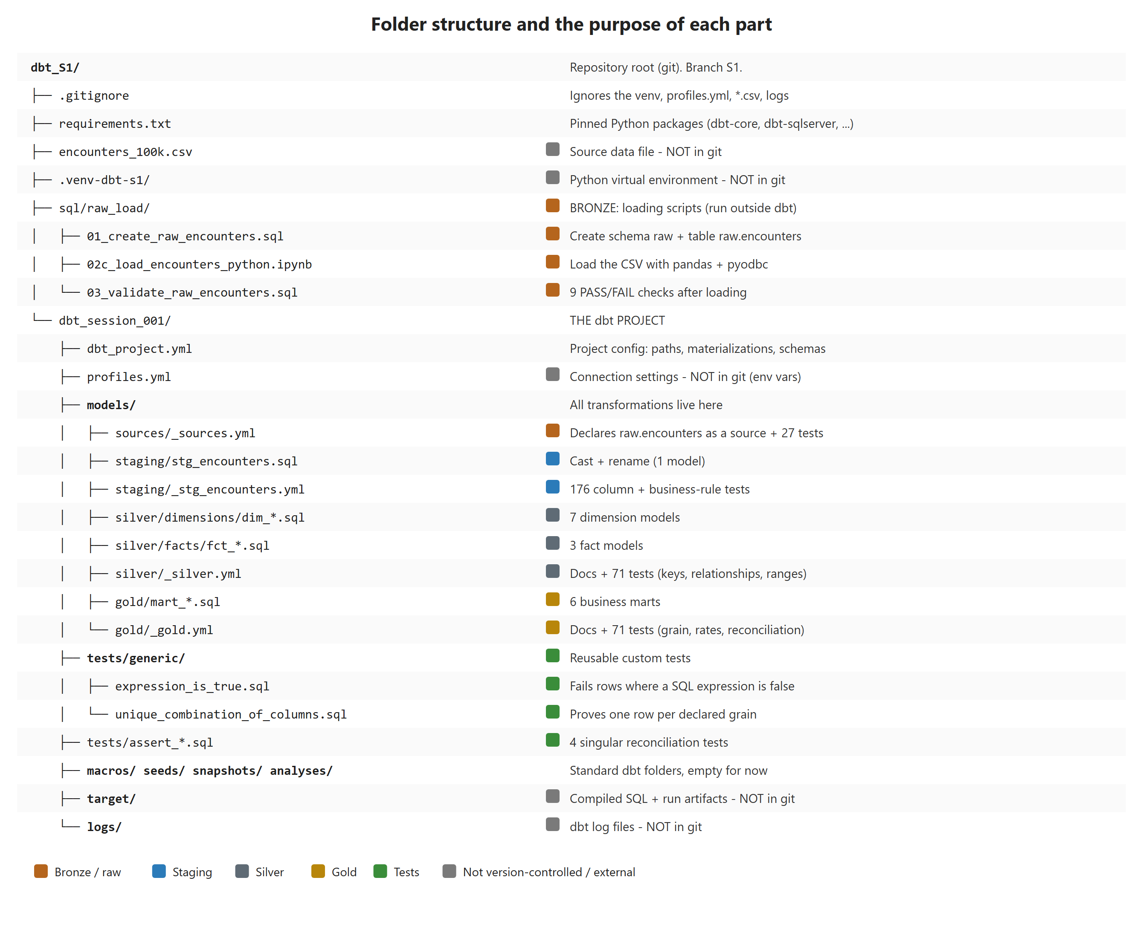
Figure 2. Repository layout and the purpose of each part.

4.1 Purpose of each part
Path | Purpose | Notes
sql/raw_load/ | Bronze: create and fill raw.encounters | Runs outside dbt; executed once per load
dbt_project.yml | The project's main configuration | Folder paths, and per-folder materialization and schema
models/sources/ | Declares tables dbt did not build | One file: _sources.yml (raw.encounters)
models/staging/ | One model per source table: cast + rename | No joins, no aggregations
models/silver/dimensions/ | One table per business entity | dim_patient, dim_nurse, dim_date, ...
models/silver/facts/ | One table per business event | fct_encounters, fct_claims, fct_kit_inventory
models/gold/ | Aggregated, business-ready marts | One mart per grain and audience
_*.yml files | Documentation + tests for the models beside them | Underscore prefix sorts them to the top of the folder
tests/generic/ | Custom reusable tests | expression_is_true, unique_combination_of_columns
tests/assert_*.sql | Singular tests | Reconcile row counts and totals between layers
macros/, seeds/, snapshots/, analyses/ | Standard dbt folders | Empty in this session
target/ | Compiled SQL and run artifacts | Useful for debugging: open the compiled SQL of a failing test

Tip: Naming conventions used everywhere: stg_ = staging, dim_ = dimension, fct_ = fact, mart_ = gold mart, _<name>.yml = properties file. Consistent prefixes let you select whole groups at once, e.g. dbt build --select models/silver.

5. Step 1 - Bronze: loading the raw data

5.1 Design decision: land everything as text
The raw table raw.encounters has the same 93 columns as the CSV, and every column is VARCHAR. This is deliberate:
- The load can never fail because one value does not fit a data type (a stray letter in a number column, an unusual date format ...).
- The raw layer stays an exact, auditable copy of what was delivered.
- Type conversion happens later in dbt, where it is version-controlled and tested.
Column sizes were chosen by profiling the file first: numeric and date columns got VARCHAR(30), short text VARCHAR(50), and longer text VARCHAR(255), always with headroom over the longest value found (58 characters, in diagnosis_display).
sql/raw_load/01_create_raw_encounters.sql (excerpt)
IF SCHEMA_ID(N'raw') IS NULL
EXEC (N'CREATE SCHEMA raw AUTHORIZATION dbo;');
GO
DROP TABLE IF EXISTS raw.encounters;
GO
CREATE TABLE raw.encounters
(
[patient_id] VARCHAR(50) NULL,
[birth_year] VARCHAR(30) NULL,
...
[diagnosis_display] VARCHAR(255) NULL,
... -- 93 columns in total
);

5.2 Choosing a loading method - and why the first ones failed
Loading the CSV took several attempts. Each failure taught something about how SQL Server works, so they are documented here:
Method | Outcome | Root cause
BULK INSERT (T-SQL) | Failed: Msg 4861, operating system error 3 | BULK INSERT runs on the server and reads the server's disk; the file was on the laptop
bcp (command line) | Not used | bcp does not parse quoted CSV, so the 26,629 quoted commas would break rows
SQL Server Import and Export Wizard | Abandoned: hard to get working smoothly | Needs a text qualifier of " and column widths above the default 50; many manual settings
Python: pandas + pyodbc | Worked: 50,000 rows loaded | Reads the file locally and sends rows over the connection

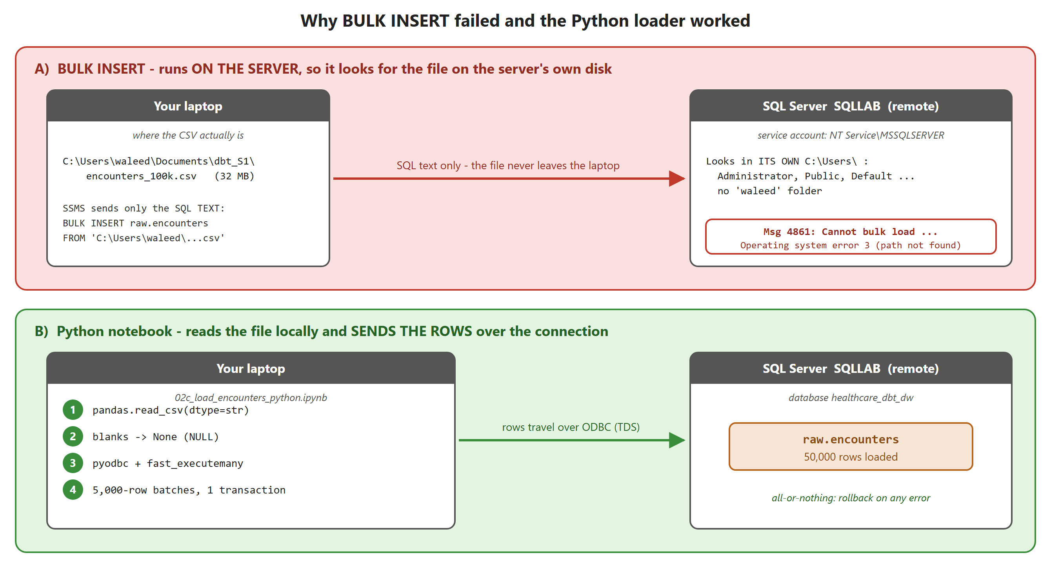
Figure 3. BULK INSERT asks the server to open a path on its own disk; the Python loader carries the rows across the network itself.
Lesson learned: Server-side bulk loaders (BULK INSERT, OPENROWSET) can only read files the SQL Server service account can see: the server's own disks or a network share it can reach. With a remote server, either copy the file onto the server first, or use a client-side tool that sends the rows over the connection.

5.3 The Python loader notebook
sql/raw_load/02c_load_encounters_python.ipynb uses only pandas and pyodbc, which were already installed with dbt. Its key steps:
02c_load_encounters_python.ipynb (key cells)
df = pd.read_csv(CSV_PATH, dtype=str, keep_default_na=False, na_values=[""])

conn = pyodbc.connect(
"DRIVER={ODBC Driver 18 for SQL Server};"
f"SERVER={os.environ['DBT_SQLSERVER_HOST']},1433;DATABASE=healthcare_dbt_dw;"
f"UID={os.environ['DBT_SQLSERVER_USER']};PWD={os.environ['DBT_SQLSERVER_PASSWORD']};"
"Encrypt=yes;TrustServerCertificate=yes;", autocommit=False)
cursor = conn.cursor()
cursor.fast_executemany = True # send rows in bulk

rows = df.astype(object).where(df.notna(), None).values.tolist() # NaN -> None (NULL)
try:
cursor.execute("TRUNCATE TABLE [raw].[encounters]") # re-runnable
for i in range(0, len(rows), 5000):
cursor.executemany(insert_sql, rows[i:i + 5000])
conn.commit()
except Exception:
conn.rollback() # all or nothing
raise

Detail | Why
dtype=str | Read every column as text, matching the all-VARCHAR raw table
keep_default_na=False, na_values=[''] | Only truly empty cells become NULL. By default pandas would also turn text like "NA" or "None" into NULL
NaN -> None | pyodbc sends Python None as SQL NULL; NaN would fail
fast_executemany | Sends parameter arrays in bulk instead of one round trip per row
TRUNCATE + one transaction | Re-running the notebook never duplicates data, and a failure leaves the table unchanged
Credentials from env vars | The same variables dbt uses, so nothing secret is stored in the notebook

5.4 Validating the load
sql/raw_load/03_validate_raw_encounters.sql compares the loaded table with values computed directly from the CSV. Every check must print PASS:
Check | Expected
Row count | 50,000
Distinct encounter_id / claim_id | 50,000 each
diagnosis_display / procedure_display values containing a comma | 16,507 / 10,122 (quoted values kept whole)
Values still wrapped in quote characters | 0
Blank incident_type | 47,569
Sum of submitted_charge_usd | 1,514,284,448.09
Last column contains only 5/6/7 | catches a stray carriage return left by the wrong row terminator

6. Step 2 - Declaring the source
models/sources/_sources.yml tells dbt that raw.encounters exists and was built by something else. This gives three benefits: models can refer to it with source(), it appears in the lineage graph and documentation, and it can be tested before anything is built on top of it.
models/sources/_sources.yml (excerpt)
version: 2
sources:
- name: raw
database: healthcare_dbt_dw
schema: raw
loader: python (pandas + pyodbc) - sql/raw_load/02c_load_encounters_python.ipynb
tables:
- name: encounters
description: One row per hospital encounter (50,000 rows) ...
columns:
- name: encounter_id
description: Primary key. UUID of the hospital encounter.
data_tests:
- unique
- not_null
- name: sex
data_tests:
- accepted_values:
arguments:
values: ['male', 'female']
- name: has_diabetes
data_tests: &flag_0_1 # YAML anchor: define once ...
- accepted_values:
arguments:
values: ['0', '1']
- name: has_hypertension
data_tests: *flag_0_1 # ... reuse many times

- All 93 columns are documented, grouped by subject, so dbt docs becomes a usable data dictionary.
- 27 tests: unique and not_null on the keys, 0/1 checks on 11 flag columns, and allowed-value lists taken from the actual data for categorical columns.
- Severity: broken keys and flags are errors; an unexpected category (a new payer, say) is only a warning, because new categories are normal in real data.
- dbt 1.10+ syntax: tests go under data_tests: and their parameters under arguments:. The older style still works but prints deprecation warnings.
Note: Source freshness checks (loaded_at_field) were not configured because the raw table has no load timestamp. Adding a _loaded_at column in the Python loader would make them possible.

7. Step 3 - Staging: cleaning and typing

7.1 The job of the staging layer
stg_encounters is the only model that reads from the source. It does exactly two things: cast every column to its real data type and apply consistent names. It deliberately does no joins, no filtering and no business calculations. Keeping it one-to-one with the source makes it a stable buffer: if the CSV layout ever changes, only this model needs to change.
models/staging/stg_encounters.sql (pattern)
with

source as (
select * from {{ source('raw', 'encounters') }}
),

renamed as (
select
cast(encounter_id as varchar(36)) as encounter_id,
cast(birth_year as smallint) as birth_year,
cast(state as char(2)) as patient_state,
cast(severity_index as decimal(4, 3)) as severity_index,
cast(has_diabetes as bit) as has_diabetes,
cast(admit_timestamp as datetime2(0)) as admitted_at,
cast(readmission_30d_flag as bit) as is_readmitted_30d,
cast(submitted_charge_usd as decimal(12, 2)) as submitted_charge_usd,
... -- 93 columns in total
from source
)

select * from renamed

This source → renamed → final select layout of named CTEs is the standard dbt style: every step has a name, and the final line shows what the model returns.

7.2 Choosing data types
Every numeric column was profiled (minimum, maximum, number of decimal places) before choosing its type:
Kind of column | SQL Server type | Examples
0/1 flags (11 columns) | bit | has_diabetes, is_readmitted_30d, is_fraud_upcoding
Timestamps (7) | datetime2(0) | triaged_at, admitted_at, or_started_at, discharged_at
Calendar date | date | kit_expiration_date
Money | decimal(12,2) | submitted_charge_usd, allowed_amount_usd
Measurements and scores | decimal, sized per column | sbp_mmhg decimal(5,1), drg_weight decimal(6,4)
Counts and small integers | smallint / tinyint | age, los_days, himss_emram_stage
Codes and identifiers | varchar / char | cpt_code, npi_billing, icd10_code, patient_state

Concept: Codes stay text even when they look like numbers. CPT codes, NPI numbers and ICD-10 codes are identifiers, not quantities: nobody adds two NPI numbers together, leading zeros must be preserved, and NPI values (10 digits) do not even fit in an int.
Concept: cast was chosen over try_cast on purpose. If a bad value ever reaches the raw table, cast makes the build fail loudly; try_cast would silently turn it into NULL and hide the problem.

7.3 Naming conventions
Raw name | Staging name | Rule
admit_timestamp, triage_timestamp, ... | admitted_at, triaged_at, ... | Timestamps end in _at
or_start, or_end | or_started_at, or_ended_at | Timestamps end in _at
readmission_30d_flag | is_readmitted_30d | Booleans start with is_ or has_
safety_incident_flag | has_safety_incident | Booleans start with is_ or has_
fraud_upcoding_flag (and 2 others) | is_fraud_upcoding, ... | Booleans start with is_ or has_
state | patient_state | Avoid ambiguous / reserved words

7.4 Materialization
Staging is materialized as a table. Instead of putting a config() call in each model, the setting is applied to the whole folder in dbt_project.yml, so every future staging model inherits it:
dbt_session_001/dbt_project.yml
models:
dbt_session_001:
staging:
+materialized: table

7.5 Staging tests (176)
models/staging/_stg_encounters.yml holds the most thorough tests in the project, because staging is where every value first gets its real type:
- unique + not_null on the keys encounter_id and claim_id.
- not_null on every column except the three that are blank by design.
- accepted_values for 11 categorical columns.
- Range checks: percentages 0-100, scores 0-1, CAHPS 1-5, burnout 0-6, money ≥ 0, plausible vitals and labs.
- Format checks: PAT-, CLM-, NRS-, SRG- prefixes; NPI exactly 10 digits; state letters only.
- 18 business rules across columns, listed in section 7.7.

7.6 A custom generic test: expression_is_true
dbt's four built-in tests (unique, not_null, accepted_values, relationships) cannot express a rule such as "admission happens before discharge". The popular dbt_utils package has one, but instead of adding a dependency we wrote our own in a few lines:
tests/generic/expression_is_true.sql
{% test expression_is_true(model, expression, column_name=None) %}

select *
from {{ model }}
where not ({% if column_name %}{{ column_name }} {% endif %}{{ expression }})

{% endtest %}

A test passes when its query returns zero rows. This one returns every row where the expression is false. It can be used at model level (a rule across columns) or at column level (the column name is placed in front of the expression):
Using it in YAML
models:
- name: stg_encounters
data_tests:
- expression_is_true: # model level
name: assert_admission_before_discharge
arguments:
expression: "admitted_at < discharged_at"
columns:
- name: age
data_tests:
- expression_is_true: # column level -> "age between 0 and 120"
arguments:
expression: "between 0 and 120"

Note: Rows where the expression evaluates to NULL do not fail this test (NOT NULL is still NULL in SQL). That is intentional: missing values are the job of not_null tests.

7.7 The 18 business rules
Every rule was first checked against the data with a SQL query. Rules that turned out not to hold (for example a guessed days-of-supply formula, or "nurse home unit = patient unit") were dropped rather than added as permanently failing tests.
Area | Rule
Patient timeline | triaged_at ≤ admitted_at ≤ bed_requested_at ≤ bed_assigned_at; admitted_at < discharged_at
Operating room | or_started_at < or_ended_at; or_started_at ≥ admitted_at; or_ended_at ≤ discharged_at (warn)
Derived values | actual_or_minutes = minutes between OR start and end; los_days within 1 day of the real stay; age consistent with birth_year
Billing | allowed ≤ submitted charge; patient responsibility ≤ allowed
Safety | incident type and severity are filled if and only if has_safety_incident = 1
HEDIS diabetes care | HbA1c tested only for diabetics; poor control ⇔ tested and HbA1c > 9%
Inventory | stockout flag ⇔ stock ≤ reorder point; 4-week demand = 4 × weekly volume; kit not expired at surgery

Watch out: Real data issue found: 237 encounters have the operating-room end time after the discharge time. All of them are one-day stays where the surgery starts after the recorded discharge (83 minutes later on average). The test assert_or_ends_before_discharge is set to severity: warn, so the problem stays visible on every run without blocking the build. In silver these rows are kept and flagged (has_timeline_conflict = 1) rather than deleted.

8. Why a silver layer?
After staging, every value is correct and typed. A natural question is: what is left to do? The answer is that staging makes the data correct, while silver makes it useful: it models the business entities and their relationships.

8.1 The problem with one wide table
stg_encounters describes about eight different things at different grains in a single row. Profiling showed how much information is repeated:
Entity | Distinct | Rows per entity | Stable across its rows?
Nurses | 5,000 | ~10 | Role, unit, tenure, FTE, burnout: yes. Shift hours, overtime, turnover risk: no
Surgeons | 3,000 | ~16 | Specialty: yes
Surgical kits | 14 | ~3,571 | Name, cost, lead time, reorder point: yes. Stock and expiry: no
Diagnoses (ICD-10) | 15 | ~3,300 | Code → description → category: yes
Procedures (CPT) | 14 | ~3,500 | Code → description → kit: yes
Patients | 50,000 | 1 | One encounter per patient

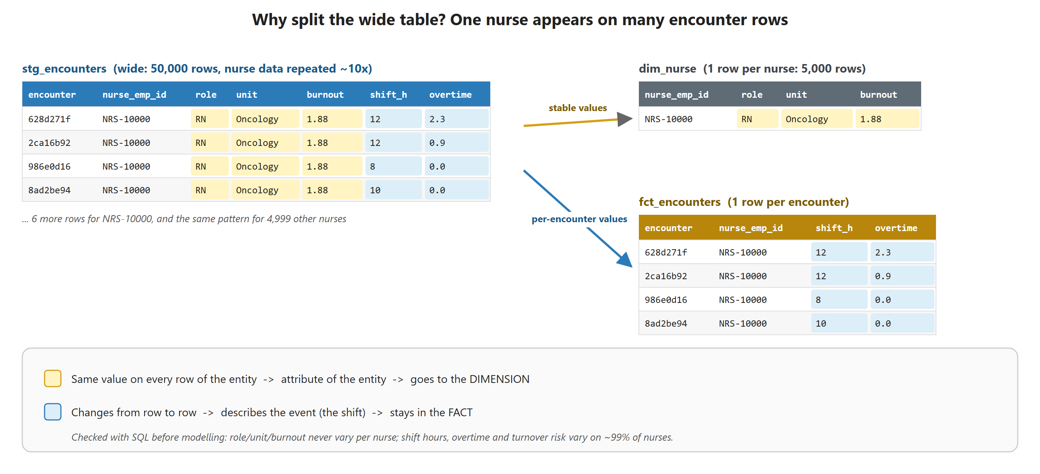
Figure 4. Stable values move to a dimension (stored once); values that change per encounter stay in the fact. Real rows from the data.

8.2 What silver adds
- Split by grain. One table per entity, so a nurse's details are stored once, not ten times. Mixing different grains is the classic cause of wrong totals, for example summing kit stock across encounters.
- Define derived business fields once. Wait times, length of stay in hours, fraud flag counts: calculated in one place, so two dashboards can never disagree about "average wait time".
- Decide how to handle data issues. Staging tests detect problems; silver decides what to do (here: flag the 237 conflicting rows instead of hiding them).
- Integrate sources (future). When an HR system or a real claims feed arrives, silver is where sources are joined on shared keys.
Concept: Why not do this in staging or gold? Staging must stay one-to-one with the source so that source changes are absorbed in one place. Gold is purpose-built per audience; putting shared logic there duplicates it across marts, and the copies drift apart.

9. Step 4 - Silver: the star schema

9.1 Design
Silver is a star schema: fact tables record business events with numeric measures, and point to dimension tables that describe the who, what and when. Natural keys (nurse_emp_id, cpt_code, ...) were already clean and unique, so no surrogate keys were generated.
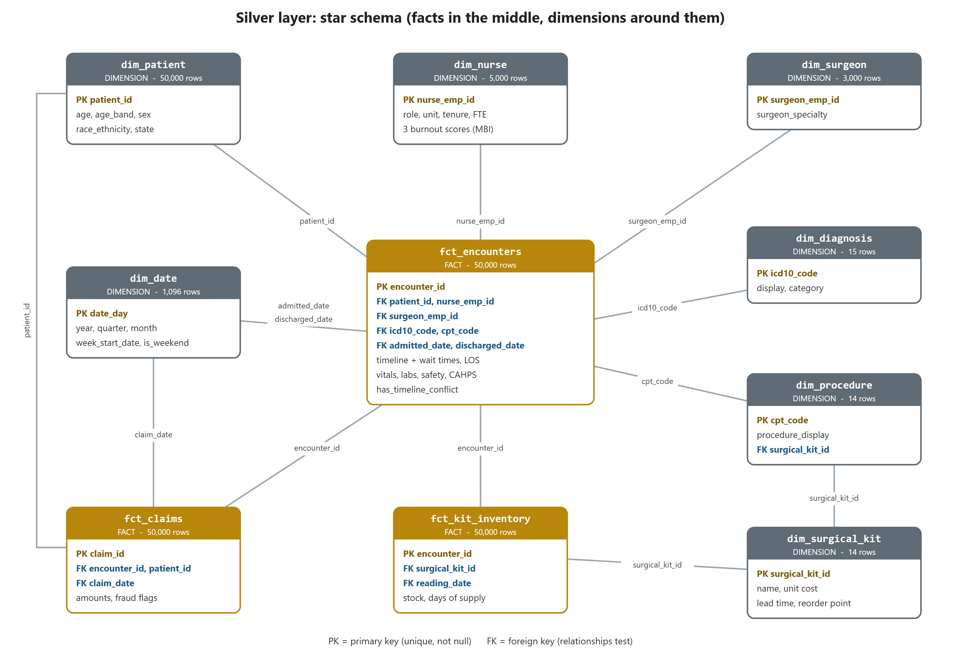
Figure 5. Silver star schema. Gold boxes are facts, grey boxes are dimensions; line labels are the joining keys.

9.2 Models
Model | Grain | Rows | Contents
dim_patient | patient | 50,000 | birth year, age, age band, sex, race/ethnicity, state
dim_nurse | nurse | 5,000 | role, home unit, tenure, FTE, 3 burnout scores
dim_surgeon | surgeon | 3,000 | specialty
dim_diagnosis | ICD-10 code | 15 | description, category
dim_procedure | CPT code | 14 | description, the surgical kit it uses
dim_surgical_kit | kit | 14 | name, unit cost, lead time, reorder point
dim_date | calendar day | 1,096 | 2024-01-01 to 2026-12-31: year, quarter, month, week start, weekday, weekend flag
fct_encounters | encounter | 50,000 | timeline, wait times, clinical state, safety, CAHPS, HEDIS, nurse shift context
fct_claims | claim | 50,000 | payer, amounts, payer-paid, ratio, fraud flags
fct_kit_inventory | stock reading | 50,000 | stock at surgery time, weekly volume, days of supply, stockout risk

Dimensions are built with select distinct from staging. If an attribute were not truly stable per entity, distinct would produce two rows for the same key, and the unique test on the key would fail. The test therefore guards the modelling assumption.
models/silver/dimensions/dim_nurse.sql
-- One row per nurse. Only attributes that are stable per nurse belong here.
with encounters as (
select * from {{ ref('stg_encounters') }}
)
select distinct
nurse_emp_id, nurse_role, nurse_unit, nurse_tenure_years, nurse_fte,
burnout_exhaustion_mbi, burnout_cynicism_mbi, burnout_personal_accomplishment_mbi
from encounters

9.3 Two modelling decisions driven by the data
Lesson learned: Shift-level fields belong to the fact, not the nurse. The original plan put turnover risk in dim_nurse. A check showed turnover_risk_index, shift_hours, patients_per_nurse_ratio and overtime_hours differ between encounters for 99% of nurses. They describe the shift, so they live in fct_encounters. Always verify that an attribute is stable before putting it in a dimension.
Lesson learned: Kit stock is not a daily snapshot. On 5,113 of 5,128 kit-days the stock value differs between surgeries on the same day. fct_kit_inventory therefore has one row per reading (per surgery), and gold takes the latest reading when it needs a kit's current status.

9.4 Derived fields
Model | Field | Definition
fct_encounters | door_to_admit_minutes | minutes from triage to admission
fct_encounters | bed_boarding_minutes | minutes from bed request to bed assignment
fct_encounters | los_hours | exact length of stay in hours (los_days is a rounded day count)
fct_encounters | cahps_composite_score | average of the 8 CAHPS scores
fct_encounters | has_timeline_conflict | 1 when the OR ends after discharge (the 237 known rows)
fct_claims | payer_paid_usd | allowed amount − patient responsibility
fct_claims | allowed_to_submitted_ratio | allowed ÷ submitted
fct_claims | fraud_flag_count, has_any_fraud_flag | number of fraud flags (0-3), and any flag at all
dim_patient | age_band | 18-34, 35-49, 50-64, 65-79, 80+

No new clinical thresholds were invented (for example a cut-off for "high burnout"). Such definitions are business decisions and should come from the people who will use them.

9.5 Generating dim_date without a recursive CTE
SQL Server limits recursive CTEs to 100 levels unless OPTION (MAXRECURSION ...) is added, and that option is not allowed inside the view that dbt-sqlserver creates while building a table. The date dimension is therefore generated from a cross join of digits, which produces the numbers 0-9999 without recursion:
models/silver/dimensions/dim_date.sql (excerpt)
digits as (
select v from (values (0),(1),(2),(3),(4),(5),(6),(7),(8),(9)) as d(v)
),
numbers as ( -- 0 .. 9999
select ones.v + tens.v*10 + hundreds.v*100 + thousands.v*1000 as n
from digits ones cross join digits tens
cross join digits hundreds cross join digits thousands
),
days as (
select dateadd(day, n, cast('2024-01-01' as date)) as date_day
from numbers
where n <= datediff(day, '2024-01-01', '2026-12-31')
)

Tip: The weekday is computed as datediff(day, '1900-01-01', date_day) % 7, because 1900-01-01 was a Monday. Unlike DATEPART(weekday, ...), this does not depend on the server's DATEFIRST or language settings.

9.6 Where silver is stored: custom schemas
Silver and gold are configured with a custom schema in dbt_project.yml. By default dbt combines the target schema and the custom schema, so +schema: silver with target schema dev produces dev_silver. A future prod target would produce prod_silver, so environments never collide.
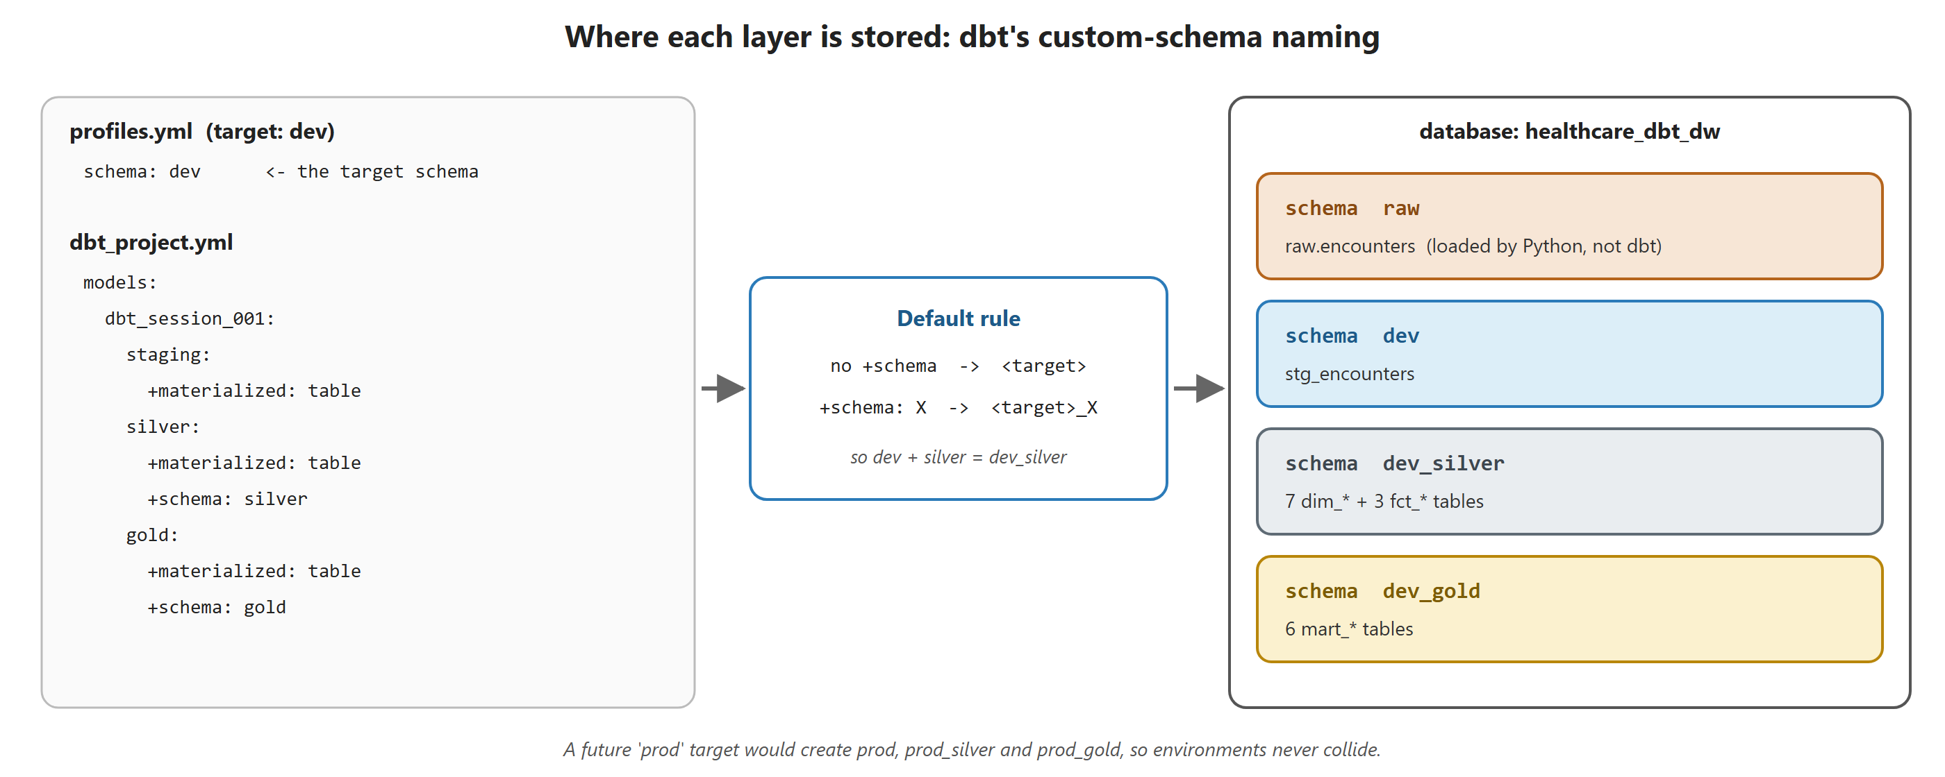
Figure 6. How configuration in profiles.yml and dbt_project.yml decides the schema each layer lands in.

9.7 Silver tests (72)
Test | Count | What it guarantees
unique (keys) | 11 | One row per declared grain; catches unstable 'distinct' dimensions
not_null | 35 | Keys, foreign keys and derived fields are always filled
relationships | 15 | Every foreign key in a fact exists in its dimension: no orphans
expression_is_true | 9 | Derived fields are in valid ranges (wait times ≥ 0, ratio 0-1, ...)
accepted_values | 1 | age_band has only its 5 defined values
singular: row counts | 1 | Each fact has exactly as many rows as stg_encounters

A relationships (foreign-key) test in _silver.yml
- name: nurse_emp_id
data_tests:
- not_null
- relationships:
arguments: {to: ref('dim_nurse'), field: nurse_emp_id}

Concept: Test where the logic is introduced. Silver does not repeat staging's value checks; it tests what silver itself introduces: new grains (unique), new keys between tables (relationships) and new derived fields (ranges and row counts).

10. Step 5 - Gold: business marts

10.1 Purpose
Silver records what happened: one row per encounter, claim or nurse. Gold shows how the business is doing: one row per unit per day, per payer per month, per kit right now, with KPIs already calculated and named in business language, ready for a dashboard.
Two conventions exist for where facts and dimensions go. In dbt's default convention they are gold; in the medallion convention used here they are silver and gold holds only aggregated marts. Both are valid; what matters is the principle: reusable pieces lower, purpose-built pieces higher.

10.2 The six marts
Mart | Grain | Rows | Audience | Key metrics
mart_ed_throughput_daily | admission day × unit | 3,650 | ED / operations | encounters, avg and median door-to-admit and bed boarding minutes, bed occupancy, weekend flag
mart_unit_scorecard_monthly | month × unit | 120 | unit managers, nursing | patient-days, incidents per 1,000 patient-days, readmission rate, 8 CAHPS scores, staffing, nurse burnout
mart_or_utilization_weekly | week × specialty | 265 | surgical services | cases, surgeons, total/avg/median OR minutes, turnover, OR hours per surgeon
mart_revenue_cycle_monthly | claim month × payer | 91 | finance, compliance | submitted, allowed, patient share, payer paid, allowed ratio, case mix index, fraud rates
mart_clinical_quality_monthly | month × diagnosis category | 96 | quality team | readmission rate, severity, LOS, HbA1c testing and poor-control rates
mart_kit_stockout_status | kit (latest reading) | 14 | supply chain | stock vs reorder point, days of supply vs lead time, stock value, days to expiry

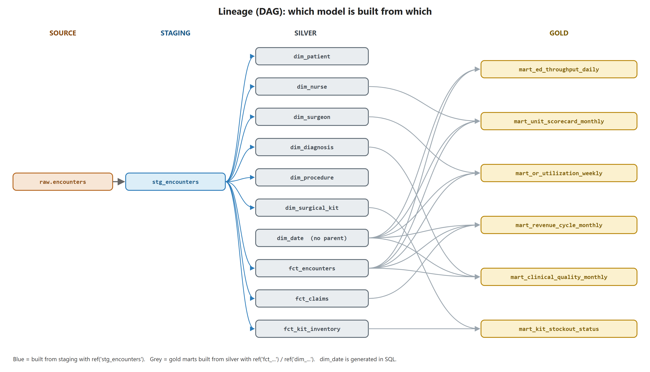
Figure 7. Lineage graph of all 17 models. dbt derives this automatically from the ref() calls and uses it to decide the build order.

10.3 Design principles and techniques

Rates are stored with their numerator and denominator
Every rate column comes with the counts it was calculated from (for example readmissions_30d, encounters and readmission_rate_30d). A dashboard that rolls months up into a year must add the counts and divide again. Averaging monthly rates gives the wrong answer when months have different volumes.

Units: where the care happened
A nurse's home unit matches the patient's unit in only 10% of encounters (nurses float between units). Unit-level metrics therefore use unit_assigned, the unit where the patient was cared for.

Burnout averaged over people, not encounters
In the unit scorecard, workload metrics (patients per nurse, overtime) are averaged over encounters, but burnout is a property of a person. It is averaged over the distinct nurses who worked in the unit that month, so a nurse who had 20 encounters does not count 20 times.

Medians in SQL Server
SQL Server offers PERCENTILE_CONT only as a window function. The marts compute the median per row with OVER (PARTITION BY ...), then collapse it with MAX() in the GROUP BY step:
mart_ed_throughput_daily.sql (excerpt)
with_medians as (
select admitted_date, unit_assigned, door_to_admit_minutes,
percentile_cont(0.5) within group (order by door_to_admit_minutes)
over (partition by admitted_date, unit_assigned) as median_door_to_admit_minutes
from encounters
)
select admitted_date, unit_assigned,
cast(avg(door_to_admit_minutes * 1.0) as decimal(8, 1)) as avg_door_to_admit_minutes,
cast(max(median_door_to_admit_minutes) as decimal(8, 1)) as median_door_to_admit_minutes
from with_medians
group by admitted_date, unit_assigned

Watch out: In SQL Server, AVG() of an integer column returns an integer (AVG of 1 and 2 is 1). Every average in the marts multiplies by 1.0 or casts to decimal first.

Partial periods are flagged
All admissions fall in 2024, but 447 patients were discharged in January 2025. Revenue is reported by claim (discharge) month, the usual finance convention, so January 2025 contains only those 447 claims instead of the usual ~4,200. The column is_partial_month = 1 marks it, so nobody mistakes it for a revenue collapse.

Thresholds
A standard "% of patients boarding longer than 4 hours" metric was considered and dropped: no patient in the data boarded longer than 4 hours, so it would always be 0. The only threshold used is HbA1c > 9%, which is the official HEDIS definition.

10.4 Gold tests (74)
A second custom generic test proves that each mart has exactly one row per declared grain:
tests/generic/unique_combination_of_columns.sql
{% test unique_combination_of_columns(model, combination_of_columns) %}
select {{ combination_of_columns | join(', ') }}, count(*) as duplicate_rows
from {{ model }}
group by {{ combination_of_columns | join(', ') }}
having count(*) > 1
{% endtest %}

- Grain: unique_combination_of_columns on every mart, e.g. (admission_month, unit_name).
- Ranges: every rate between 0 and 1, CAHPS 1-5, burnout 0-6, money ≥ 0.
- Internal consistency: incidents by severity add up to total incidents; payer paid = allowed − patient share; flagged dollars ≤ submitted dollars; HbA1c poor control ≤ tested.
- Reconciliation (3 singular tests): encounter counts in four marts each add up to exactly 50,000; revenue totals equal fct_claims to the cent; the kit mart has a row for every kit.

10.5 First insights from the marts
Area | Finding
Supply chain | 3 kits will run out before the next delivery can arrive. The worst, SKU-ORIF-FEM-KIT, has 0.9 days of supply against a 10-day supplier lead time.
Patient safety | Med-Surg B has the highest incident rate: 17.6 incidents per 1,000 patient-days.
Clinical quality | Pulmonary patients have the worst HbA1c poor-control rate (31%) and the highest 30-day readmission rate (18%).
Revenue cycle | Payers allow about 64% of submitted charges; about 7% of claims carry at least one fraud flag.
Patient flow | Average door-to-admit time is 52 minutes and average bed boarding 95 minutes.

11. Testing strategy across the layers
Tests are spread across layers according to one principle: test where the logic is introduced, and do not re-test what an earlier layer already guarantees.
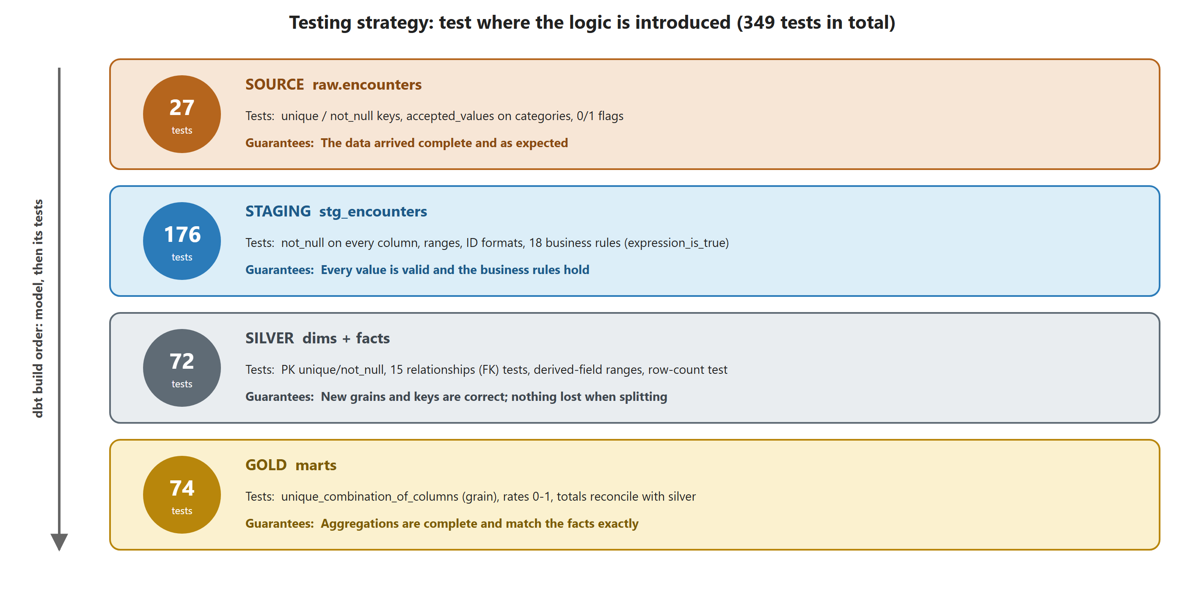
Figure 8. What each layer's tests check and what they guarantee.
Where defined | Tests
models/sources/_sources.yml | 27
models/staging/_stg_encounters.yml | 176
models/silver/_silver.yml + 1 singular test | 72
models/gold/_gold.yml + 3 singular tests | 74
Total | 349

11.1 Severity policy
Severity | Used for | Effect
error | Keys, NULLs, broken business rules, hard limits (percent 0-100), reconciliation | Fails the run; downstream models are skipped
warn | New category values, clinically unusual vitals or labs, the known OR timeline issue | Reported in the output; the run continues

11.2 Investigating a failing test
- Read the test name in the dbt output, e.g. assert_or_ends_before_discharge.
- Open the compiled SQL under target/compiled/dbt_session_001/... (the path is printed with the failure).
- Run that SQL in SSMS: it returns exactly the rows that break the rule.
- Decide: fix the data upstream, fix the model, correct a wrong rule, or downgrade to warn with a documented reason.

12. How to run the project
Run these from the dbt_session_001 folder with the virtual environment active and the three DBT_SQLSERVER_* environment variables set.
Command | What it does
dbt debug | Checks configuration and tests the database connection
dbt parse | Validates all SQL and YAML without touching the database
dbt build | Builds every model and runs every test, in dependency order
dbt build --select stg_encounters | Builds one model and runs its tests
dbt build --select +models/gold | Gold plus everything upstream of it (the + means 'and its parents')
dbt build --select models/silver+ | Silver plus everything downstream of it
dbt test --select source:raw | Runs only the 27 source tests
dbt ls --resource-type test --select models/silver | Lists the tests that would run, without running them
dbt docs generate then dbt docs serve | Builds and opens a browsable documentation site with the lineage graph

Tip: Re-loading the raw data: run 01_create_raw_encounters.sql (only if the table structure changed), then the notebook (it truncates and reloads in one transaction), then 03_validate_raw_encounters.sql, then dbt build.

13. Git history
The work is committed on branch S1, one logical step per commit:
Commit | Content
f0e7206 | Initiating the dbt project (dbt init skeleton)
a7a312c | Preparing for the source stage (.gitignore, stop tracking logs)
2849c92 | Raw-loading scripts: create table, Python loader, validation
d335ff0 | Sources file, staging model, staging materialization
d2fef81 | Add staging tests for encounters
dbca55f | Add silver layer: star schema
38de622 | Add gold layer: 6 business marts

Practices worth keeping:
- One logical change per commit, and the project should build at every commit.
- Run git diff --cached --stat before every commit to see exactly what will be committed.
- When one file holds changes for two commits (dbt_project.yml had both the silver and gold blocks), stage only part of it: in VS Code select the lines and choose Stage Selected Ranges, or use git add -p.
- The repository has no remote yet; adding one (e.g. GitHub) gives a backup and enables pull requests.

14. Data issues and lessons learned
Issue | How it was found | How it was handled
File named 100k contains 50,000 rows | Row count during profiling | Documented; all checks use 50,000
26,629 values with commas inside quotes | Profiling the CSV | Loader must understand quoted CSV; ruled out bcp
BULK INSERT could not see the file | Msg 4861 from the server | Switched to a client-side Python loader
237 encounters with surgery after discharge | Business-rule test in staging | Warn-level test + has_timeline_conflict flag in silver
Nurse shift fields vary per encounter | Stability check before modelling | Moved from dim_nurse to fct_encounters
Kit stock is not a daily snapshot | Stock varied within the same kit-day | One row per reading; gold uses latest reading
Nurses float between units (90%) | Unit match check before gold | Unit metrics use the unit where care happened
January 2025 is a partial month | Date-range check before gold | is_partial_month flag in the revenue mart
requirements.txt saved as UTF-16 | git shows it as binary | Re-save as UTF-8 (to do)

14.1 Habits that paid off
- Profile before you design. Every type, range, rule and grain decision was based on a query against the real data, not on assumptions.
- Plan, then build. Silver and gold were each planned and approved before any code was written.
- Verify after you build. Every layer was reconciled against the one before it (row counts, totals).
- Flag, don't delete. Suspicious rows were kept and marked, so analysts can decide how to treat them.
- Fail loudly. cast instead of try_cast, error-severity tests on keys, and all-or-nothing loading.

15. Suggested next steps
Area | Next step | Benefit
Testing | dbt unit tests for age_band, is_weekend, fraud_flag_count and has_timeline_conflict boundaries | Proves the logic is correct, not just plausible
Testing | Reconcile silver amounts with staging; check dim_date has no gaps | Catches silent data loss
Raw layer | Add a _loaded_at column in the loader and configure source freshness | Alerts when data stops arriving
Gold | Model contracts and exposures for the dashboards that use each mart | Protects consumers from breaking changes
Docs | dbt docs generate / serve | A browsable data dictionary and lineage graph
Engineering | Re-save requirements.txt as UTF-8; add a git remote; consider CI running dbt build | Reproducibility and safety

Appendix A. Glossary
Term | Definition
CAHPS | Consumer Assessment of Healthcare Providers and Systems: standard patient-experience surveys (1-5 scale here).
Case mix index | Average DRG relative weight of a set of claims; higher means more complex, costlier cases.
CPT | Current Procedural Terminology: codes for medical procedures.
DRG weight | Relative cost weight of a Diagnosis-Related Group used for hospital payment.
Fact / dimension | Fact: an event with measures (an encounter, a claim). Dimension: descriptive context (a nurse, a date).
Grain | What exactly one row of a table represents.
HEDIS | Healthcare Effectiveness Data and Information Set: standard quality measures. Here: HbA1c testing and poor control (> 9%) for diabetics.
HIMSS EMRAM | A 0-7 scale of how advanced a hospital's electronic medical record adoption is.
ICD-10 | International Classification of Diseases, 10th revision: diagnosis codes.
LOS | Length of stay.
MBI | Maslach Burnout Inventory: emotional exhaustion, cynicism and personal accomplishment scores (0-6).
NPI | National Provider Identifier: a 10-digit US provider id.
PDC | Proportion of days covered: a medication adherence measure (0-1).
PDSA | Plan-Do-Study-Act: a quality-improvement cycle.
Star schema | A model with fact tables in the centre joined to surrounding dimension tables.
Upcoding / unbundling | Billing fraud patterns: coding a more expensive service than delivered / billing parts of a bundled procedure separately.

