Integrating the symbolic regression (SR) discrepancy model into the original fib Model Code 2020 formulation (Equation (11)) substantially improves crack width estimates for Dataset 1, which is based on the service bending moment. The selected SR model has a complexity of 16 and reached a coefficient of determination (R²) of 0.63 on the test set when predicting the discrepancy between experimental and code-predicted crack widths. The correction term is given by Equation (X) and is added to the code prediction according to Equation (X+1):
$Δw_{SR} = 0.0485 |(w_{caldas} − w_{nbr1})(|d_{p}| + sin(1752.71 f_{y}) − f_{t})|$ (X)
$w_{num} = w_{MC2020} + Δw_{SR}$ (X+1)
where all input variables are standardized by z-score using the mean and standard deviation of the training set. The correction depends on the difference between the crack widths predicted by Caldas (1997), w_{caldas}, and by NBR 6118 for stabilized cracking, w_{nbr1}; on the distance from the centroid of the tensile reinforcement to the concrete surface, d_{p}; on the steel yield strength, f_{y}; and on the concrete tensile strength, f_{t}.
Applied to the complete dataset (n = 341), the corrected model raises the R² between predicted and experimental crack widths from 0.42 to 0.83 and reduces the root mean square error from 0.087 mm to 0.047 mm (Table X and Figure X). The mean of w_{num}/w_{exp} increases from 0.86 to 1.02, which removes the systematic underestimation of the original formulation, and its standard deviation decreases from 0.25 to 0.19 (coefficient of variation from 0.29 to 0.19). The improvement is largest for crack openings above 0.4 mm (30 specimens), where the mean ratio rises from 0.69 to 0.93 and the mean bias falls from −0.178 mm to −0.038 mm.
Kolmogorov–Smirnov goodness-of-fit tests at the 5% significance level reject the normal distribution for the error of the corrected model (p = 0.019), but do not reject the log-normal (p = 0.16) or Student-t (p = 0.29) distributions. The log-normal distribution is adopted to describe the model uncertainty because it is defined only for positive values, as is the ratio w_{num}/w_{exp}, and because it also provided the best fit for the original formulation (p = 0.81). Additional details on the SR modeling of the fib Model Code 2020 formulation are provided in the Supplementary Material.
Table X. Performance of the original and SR-corrected fib Model Code 2020 formulations for Dataset 1.
Metric | fib MC2020 | fib MC2020 + SR
R² | 0.42 | 0.83
RMSE (mm) | 0.087 | 0.047
Mean bias, w_num − w_exp (mm) | −0.047 | 0.001
Mean of w_num/w_exp | 0.86 | 1.02
Standard deviation of w_num/w_exp | 0.25 | 0.19
Coefficient of variation of w_num/w_exp | 0.29 | 0.19
Mean of w_num/w_exp, w_exp > 0.4 mm (n = 30) | 0.69 | 0.93
Mean bias, w_exp > 0.4 mm (mm) | −0.178 | −0.038
KS p-value, normal | 0.20 | 0.019*
KS p-value, Student-t | 0.26 | 0.29
KS p-value, log-normal | 0.81 | 0.16
* Null hypothesis rejected at the 5% significance level.
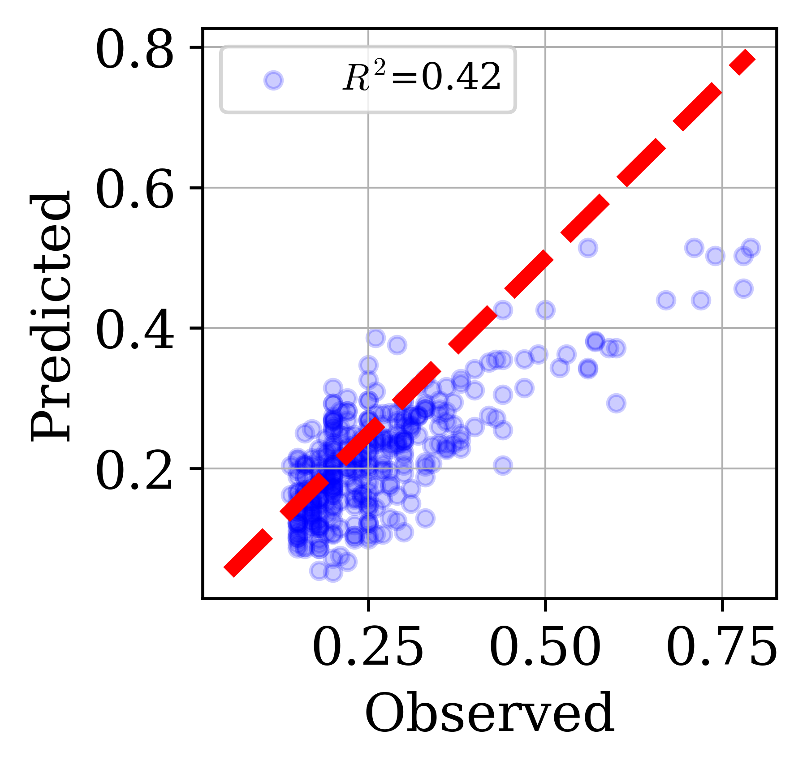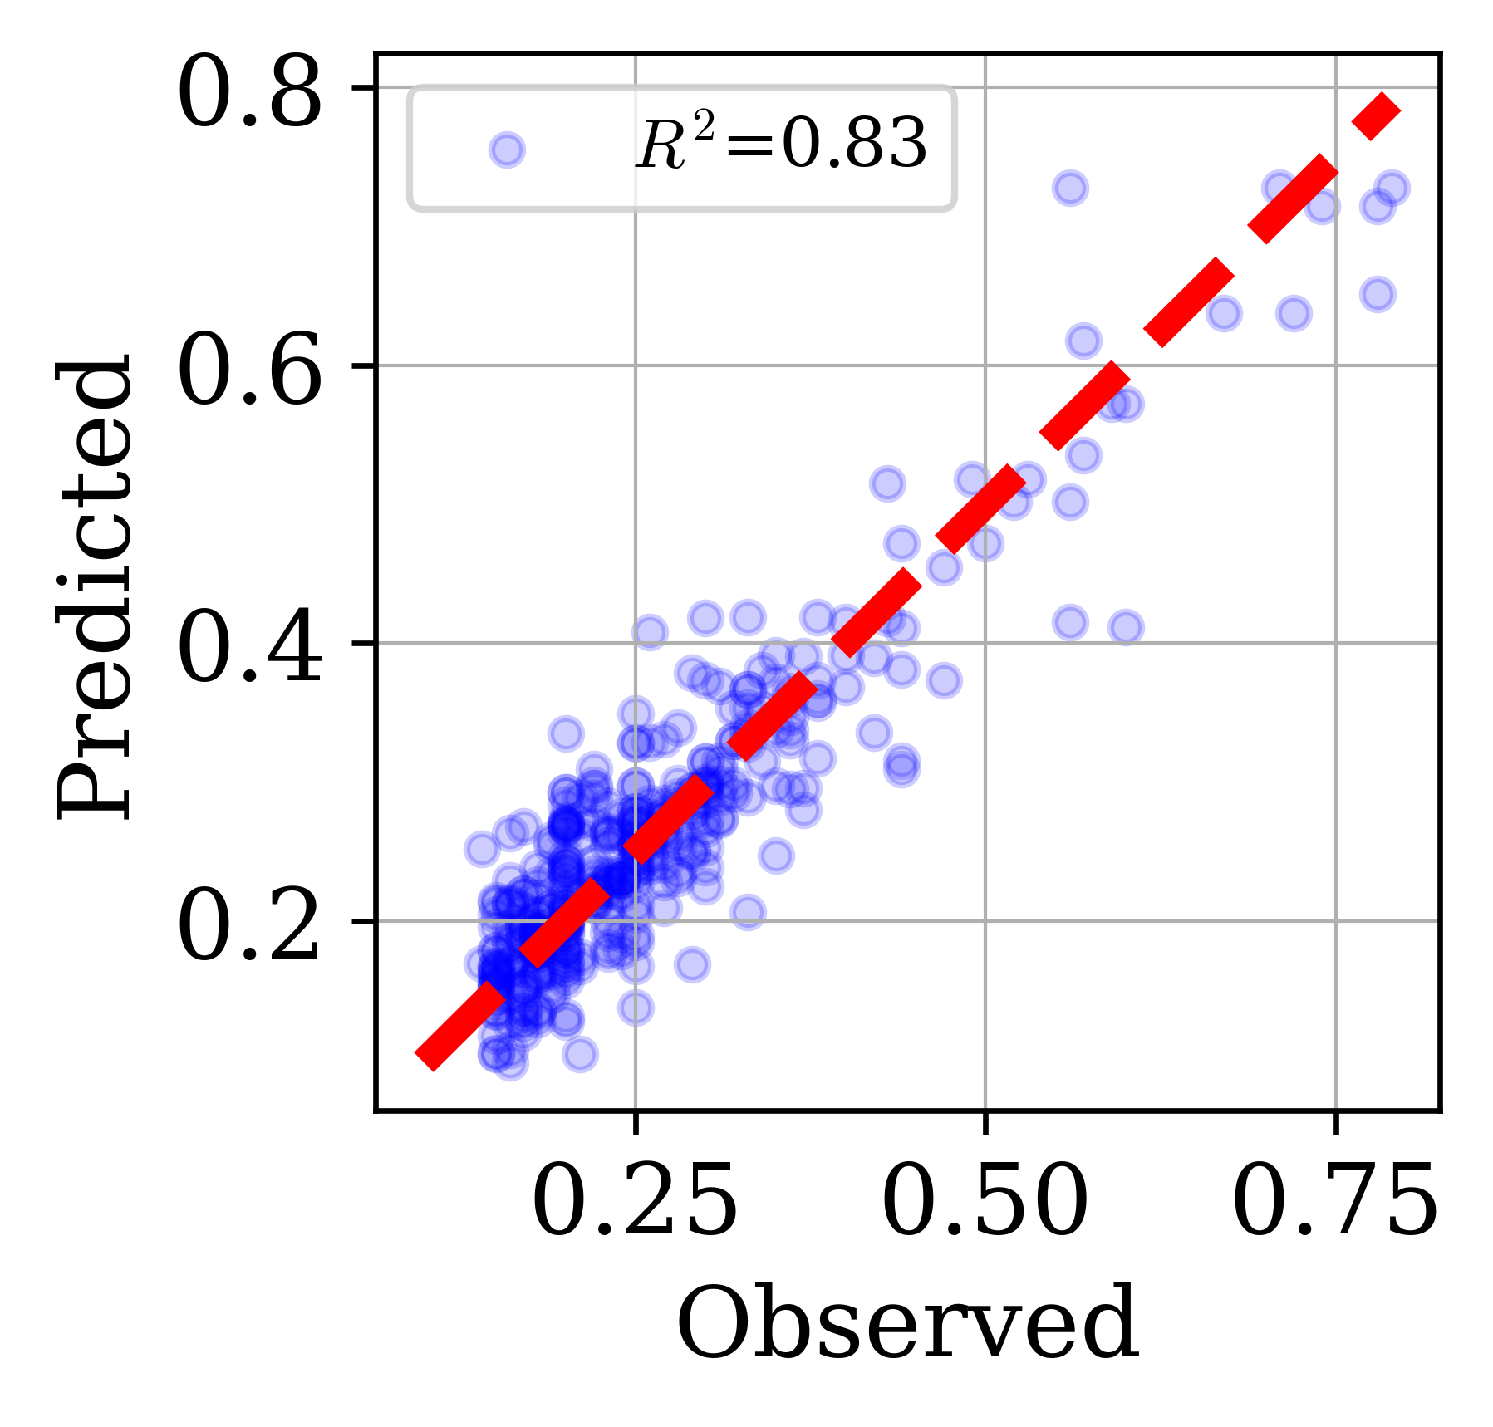
(a) (b)
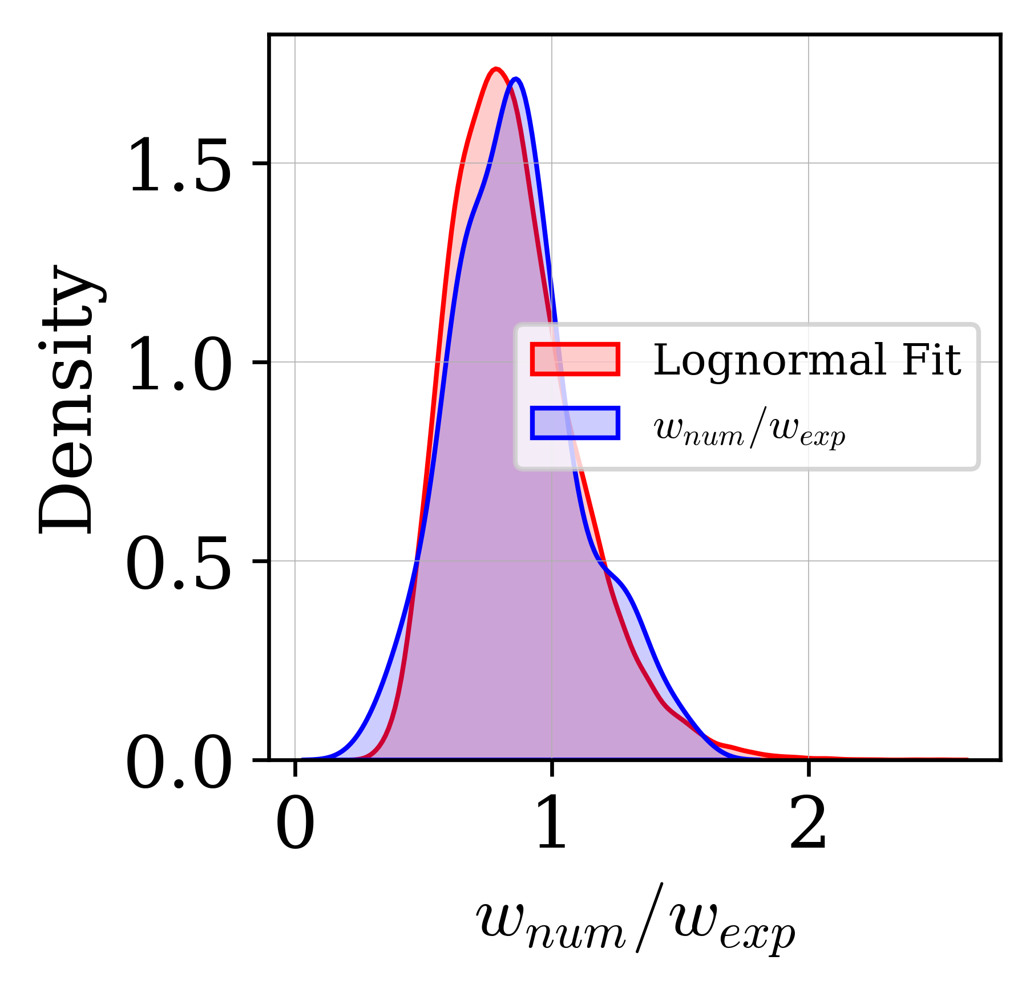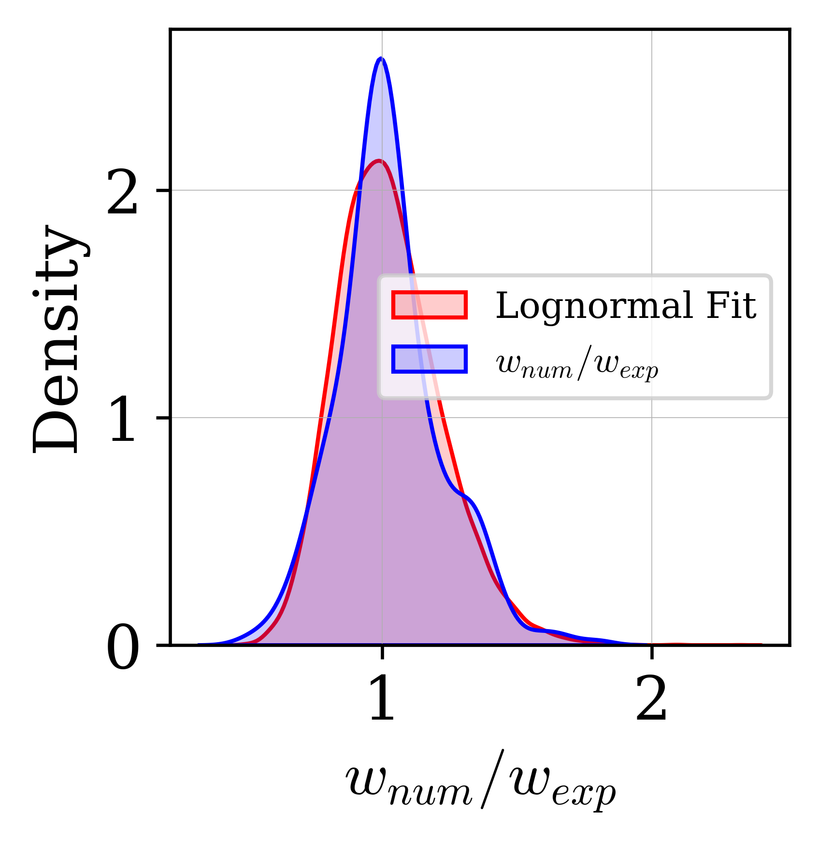
(c) (d)
Figure X. Predicted versus observed crack widths for (a) the original fib Model Code 2020 and (b) the SR-corrected model; distribution of w_num/w_exp and fitted log-normal distribution for (c) the original and (d) the SR-corrected model.

