Enriching the fib Model Code 2020 Formula with Variable Tension-Stiffening
Two discrepancy-enriched formulations were evaluated. In both, an SR discrepancy function Δw_{SR}, trained on the difference between experimental and predicted crack widths, is added to a reference model, w_{num} = w_{ref} + Δw_{SR}. All inputs of Δw_{SR} are standardized by z-score using the mean and standard deviation of the training set. Table 11 summarizes the selected functions and the resulting model error over the 341 specimens.
Table 11. SR discrepancy functions and summary statistics of the model error w_{num}/w_{exp} for the original and discrepancy-enriched formulas (n = 341). Comp.: equation complexity; SD: standard deviation; n/a: not applicable; D1, D2: Dataset 1, Dataset 2.
Model | Comp. | Score | R² | RMSE (mm) | Mean | SD | Mean (w_exp > 0.4 mm)
fib MC2020 (Eq. 11) | n/a | n/a | 0.42 | 0.087 | 0.86 | 0.25 | 0.69
fib MC2020 + SR, D1 (Eq. 27) | 16 | 0.11 | 0.83 | 0.047 | 1.02 | 0.19 | 0.93
Proposal 1 (Eq. 17) | n/a | n/a | 0.39 | 0.090 | 1.05 | 0.37 | 0.86
Proposal 1 + SR, D1 (Eq. 28) | 15 | 0.07 | 0.82 | 0.049 | 1.06 | 0.19 | 0.93
Proposal 1 + SR, D2 (Eq. 29) | 18 | 0.08 | 0.82 | 0.049 | 1.05 | 0.20 | 0.93

In the first approach, the reference is the original fib Model Code 2020 formula (Equation (11)) and the function is trained on Dataset 1, which is based on the bending moment. The selected function (Equation (27)) has a complexity of 16, a score of 0.11, and R² of 0.58 in training and 0.63 in validation. It combines the crack widths predicted by Caldas (1997), w_{caldas}, and by NBR 6118 for stabilized cracking, w_{nbr1}, with the distance from the reinforcement centroid to the tension face, d_{p}, the steel yield strength, f_{y}, and the concrete tensile strength, f_{t}.
$Δw_{SR} = 0.0485 |(w_{caldas} − w_{nbr1})(|d_{p}| + sin(1752.71 f_{y}) − f_{t})|$ (27)
The correction raises R² from 0.42 to 0.83 and reduces the RMSE from 0.087 mm to 0.047 mm (Figure 6). The mean of w_{num}/w_{exp} moves from 0.86 to 1.02, which removes the systematic underestimation of the original formula, and its standard deviation decreases from 0.25 to 0.19. The gain is largest for crack widths above 0.4 mm (30 specimens), where the mean ratio rises from 0.69 to 0.93 and the mean bias falls from −0.178 mm to −0.038 mm.
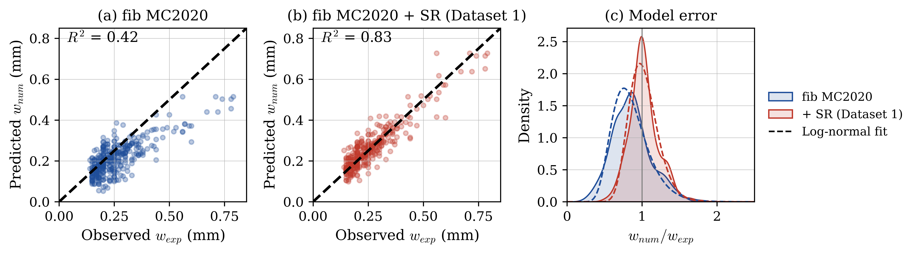
Figure 6. Predicted versus measured crack widths for (a) the fib Model Code 2020 formula and (b) the formula enriched with the discrepancy function obtained from Dataset 1; (c) distribution of w_{num}/w_{exp} (shaded area: empirical kernel density; dashed line: fitted log-normal distribution).
In the second approach, the reference is Proposal 1, which incorporates variable tension stiffening (Equation (17)). For Dataset 1, the discrepancy function (Equation (28)) has a complexity of 15, a score of 0.07, and R² of 0.68 in training and 0.77 in validation. For Dataset 2, Equation (29) has a complexity of 18, a score of 0.08, and R² of 0.69 in training and 0.77 in validation. In these equations, w_{β}, w_{ec}, and w_{yuan} are the estimates from Fields and Bischoff (2004), Eurocode 2, and the slip model of Yuan et al. (2025), and c is the concrete cover.
$Δw_{SR} = 0.0517 [(M_{s} + b_{w} e^{sin(w_{ec})}) cos(e^{d_{p}}) − w_{β}]$ (28)
$Δw_{SR} = [0.0756 w_{yuan} − 0.1039 w_{ec} − 0.1039 (σ_{sts} − w_{caldas}) cos(f_{t})] cos(sin(c))$ (29)
Both functions reach the same validation accuracy, but Equation (28) is more compact. It retains the bending moment, M_{s}, and the beam width, b_{w}, which enter the steel stress through the cracked-section mechanics of Equation (14), so the correction captures the load level and the geometric scale effect across the cross-sections in the dataset. Equation (29) instead depends on the steel stress reduced by tension stiffening, σ_{sts}, a calculated variable. Quantities measured directly in the element tests, such as the bending moment, therefore yield an equally accurate but simpler correction than calculated quantities such as the cracked-section steel stress.
The enriched formulas sharply reduce the dispersion of Proposal 1 (Table 11 and Figure 7). The standard deviation of w_{num}/w_{exp} falls from 0.37 to 0.19 (Dataset 1) and 0.20 (Dataset 2), and R² rises from 0.39 to 0.82 for both. The predictions cluster tightly around the 1:1 line, also above 0.4 mm, where the mean ratio rises from 0.86 to 0.93 and the mean bias falls from −0.086 mm to −0.039 mm. This is critical for serviceability and durability assessments.
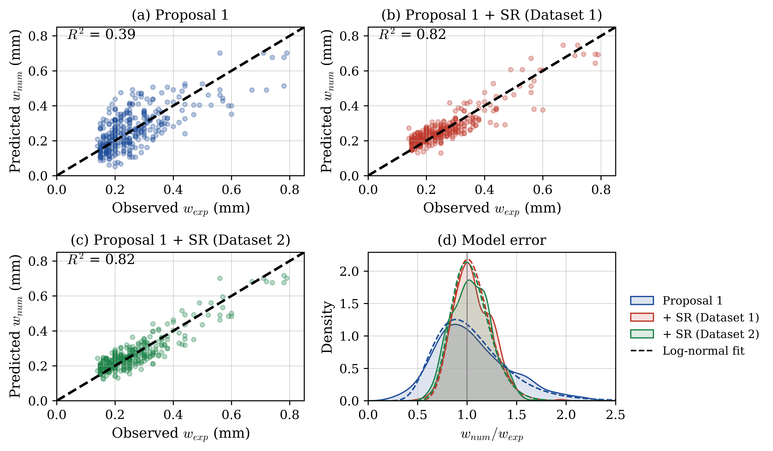
Figure 7. Predicted versus measured crack widths for (a) the Proposal 1 formula and the formulas enriched with the discrepancy functions obtained from (b) Dataset 1 and (c) Dataset 2; (d) distribution of w_{num}/w_{exp} (shaded areas: empirical kernel density; dashed lines: fitted log-normal distributions).
The probability distribution of the model error was assessed with the Kolmogorov-Smirnov test at the 5% significance level. Figures 6(c) and 7(d) compare the empirical distribution of w_{num}/w_{exp}, estimated by kernel density (shaded areas), with the log-normal distribution fitted by the method of moments, that is, with the same mean and standard deviation as the data (dashed lines). The log-normal distribution is not rejected for any of the five models (p = 0.16 to 0.81) and returns the highest p-value in four of them. The exception is the enriched fib Model Code 2020 formula, for which the Student-t distribution fits slightly better (p = 0.29 versus 0.16) and the normal distribution is rejected (p = 0.02). The normal and Student-t distributions are also rejected for Proposal 1 alone (p = 0.005 and 0.03). The log-normal distribution is therefore adopted to represent the model uncertainty of all formulations; it is also defined only for positive values, as is the ratio w_{num}/w_{exp}.

