01. Sept. 2019

Master Data

Before myWMS can be taken fully into operation, it must be provided with appropriate master data. This master data is the basis for the procedures.
They may only be modified by users with the role 'Admin '.
For the data input and maintenance the customer is responsible and he adapts it to his individual requirements.

Contents
1 Setting up master data 2
2 Program Master Data 2
2.1 Roles 2
2.2 Clients 2
2.3 User 4
2.4 System Properties 4
2.5 Sequences 5
2.6 Jasper Reports 6
3 Store Master Data 7
3.1 Zones 7
3.2 Location Clusters 8
3.3 Functional Areas 9
3.4 Working Areas & Positions 10
3.5 Unit Load Types 11
3.6 Storage Location Types 12
3.7 Capacities 13
3.8 Storage Locations 14
3.9 Fixed Location Assignment 19
4 Material Master Data 20
4.1 Item Units 20
4.2 Item Data 20
4.3 Packaging Units 22
4.4 EAN-Codes 22
4.5 Bills of Material 23
5 Strategies 24
5.1 Storage Strategy 24
5.2 Order Strategy 25

Setting up master data
To set up the master data please go one by one. Between the various master data there are dependencies that have to be observed and entered. First read in this document about what is required. Then, define master data in the given order.

Program Master Data

Roles
The permissions of myWMS are controlled by a role concept. Within this concept the permissions are granted to a role. And the role is assigned to a user. And a user may have one or more assigned roles. If one of the assigned roles has a permission, this permission is granted to the user.
The permission system of myWMS basic application is static. The program decides which permission is granted to which role.
Here a list of the permission – role assignment. A detailed list is store with the other parts of the documentation (LOSRollen.ods)

Rolename | Assigned to | Permission
Admin | System administrator | All
Inventory | Clerk | Operation of stock changing actions
Operator | Operator | Goods-In / Goods-Out / Transportation / ...
Foreman | Advisor | Advanced permissions of the operative actions
Clearing |  | Control clearings

Special permissions in myWMS Rich-Client:
Admin
Entityexplorer (BOEditor)
CRUD Operations on the selected entity with the buttons Create, Edit and Delete in the detail-area of the dialog.

Clients
The functionality of clients is implemented in terms of ‘One Warehouse with several customers’.
The system client (operator of the warehouse) has all permissions. He is able to handle all data of all clients.

The ordinary client (customer) is only allowed to operate with ‘his’ data. The private data of a client is for example material, storage locations, stock units and delivery orders.
The client functionality can be used on several ways.
a) Only one system client
With this configuration the client functionality is not available. But the overhead is not given. The client is hidden in several dialogues.
b) One system client and several other clients
The material and stock units of the clients can be separated. The operation of warehouse processes can be done by every operator.
Optionally the physical storage can be separated by assigning the storage location to a single client.
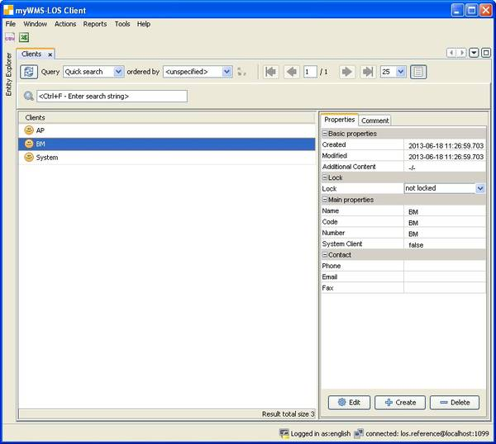
Description of the fields:
Number: Number of the client. This field is shown in dependent entities.
Name: Name of the client.
Code: Code of the client.
Status: State of the client. Possible values are Active and Inactive.
Phone, Email, Fax: Address data. Just for info.

User
myWMS is handling system access with a user account. In order to access the data of the system or launch any actions, an identification is necessary. Currently, the authentication with user name and password is provided.
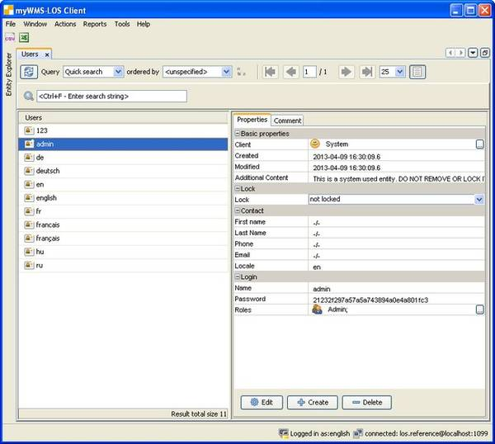
Description of the fields:
First Name, Last Name, Email, Phone: Address of the user. Just for info.
Locale: Language code used in the presentation of the program interface.
Name: The login name. This value is entered to log into the system.
Password: The password of the user. The presentation of password is encrypted. When editing the entity the password can be entered as normal characters. It will be encrypted when saving the entity.
Roles: The roles which are assigned to the user.
Lock: The lock indicator of the user.

System Properties
With the system properties, certain features of myWMS can be configured. System properties are client- and context-related. That means that a property can be set separately for a client or for a workstation. The usage of the client- or context-dependency is defined by the individual implementation of each property. Properties which are not in the group of ‘UI’ or ‘NB’ will normally not support context-dependency because they are per se not dedicated to to a workstation.
Example. The default value for the goods receipt location is stored in a system property. So at the terminal on ramp 1 this gate is shown, whilst on the terminal at ramp 2 the other gate is shown. The context is given to the application with the URL parameter “workstation”.
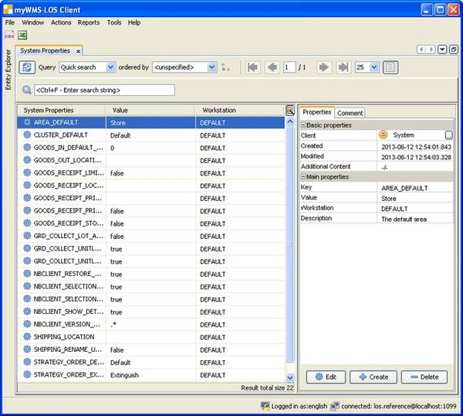
Description of the fields:
Client: The system parameter is assigned to a client. System parameters of the system client are also available for other clients.
Key: The key of the parameter. This may be extended by the fields client and workstation.
Context: The context or workstation to which the property is related. In case that no entry exists for a requested context, the empty context will be used.
Value: The value of the property.
Group: An optional field to group the properties. Just for info
Description: An optional descriptive text.

Sequences
myWMS generates automatically keys out of the sequences.
In a sequence a counter is incremented until reaching a maximal value. Out of this counter the sequence number is generated. The appearance of the sequence number is formatted by the format description.
The description of the sequence has to ensure that the formatted numbers will be unique.
The format is calculated by the standard java String format method. The current counter of the sequence and the current date are valid parameters for the format instruction. Parameter 1 (%1) is the counter of the sequence (datatype Long). Parameter 2 (52) is the current date (datatype Date).
The sequence ends with the reaching of the end value. It has to be reactivated manually. Here it has to be ensured, that newly generated numbers will be unique.
Description of the fields:
Name: The name of the sequence.
Current Counter: The last used counter.
Max Counter: The maximal valid number of the sequence.
Format: Statement to format the number.

Jasper Reports
To generate printed forms or labels myWMS uses Jasper-Reports. This is an open source tool to generate reports.
With this tool it is possible to generate individual designed documents.
The report generator combines the given data and a layout to a printable document. The data provides myWMS. The layout can be individual designed. A default layout is provided for each document of the application. This will automatically activated if there is no layout defined for the requested document.
There are graphical tools available to design the layouts. For example iReport oder ‚Jaspersoft® Studio‘.
The layout is stored in the database. For each client an individual layout can be deposited. The layout of the system client is used as default if no client specific layout is stored.
To create customized layouts the reports should be called one time. With this call the entry with the default layout is created. This default-layout can be downloaded within the edit-window. The default layout defines the available fields and parameters of the report. On this base custom changes can be processed.
Note! The report definition depends on the used version of Jasper Reports. As a compiler 'Java' must be given. Sub-reports, or other methods that cause an ambiguous layout are not supported.
To activate the new layout it can be uploaded and saved in the dialog. On saving the compiler is called to translate the layout. Are there errors in the layout the compiler will give error messages. In detail they are logged to the servers log-file.
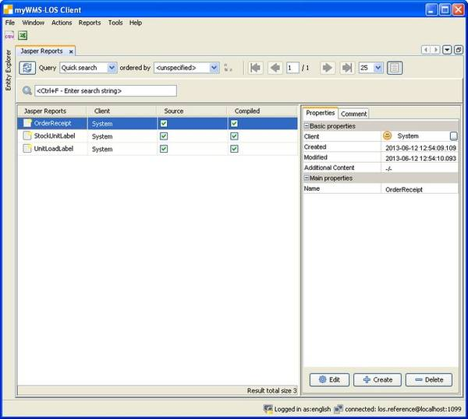
Description of the fields:
Client: The report is assigned to a client. Reports of the system client are also available for other clients.
Name: The name of the report. This is clearly related to the field client.

Description of the actions:
Load JRXML file: Load a layout file into the application.
Save JRXML file: Save a layout as local file.
Compile: Call the compiler to check the layout.

Store Master Data

Zones
With zones special requirements of storage are modeled. The zone references both the storage location and the material. When searching for a location during storage process this assignment is taken into account. Only a location in the appropriate zone will be proposed.
This classification can be used for:
- ABC classification
- Dangerous goods
- Cooled products
- ...
Example:
The store is divided into A-B-and C-zone.
First define the zones. You can then assign these zones to location master data and item data on setup or provide the zones with the import files.
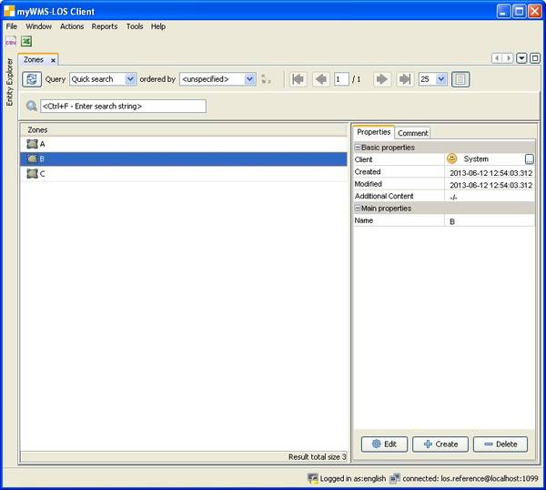
Description of the fields:
Name: The unique name.
Overflow Zone: The zone is linked to other zones. When searching storage locations an unsuccessful search can optional be continued in the overflow zones.

Location Clusters
Location cluster help in the spatial organization of the storage. It combines storage places with the same (spatial) properties. In the work areas then will be directed only to the location cluster.
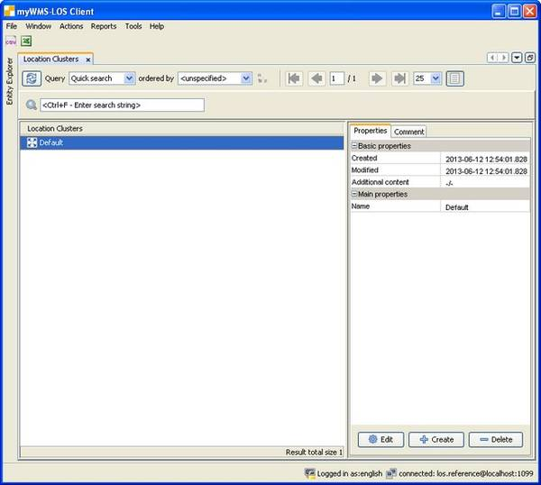

Functional Areas
The predefined functional areas form a logical layout of the warehouse.
Each storage location must be assigned to a functional area.
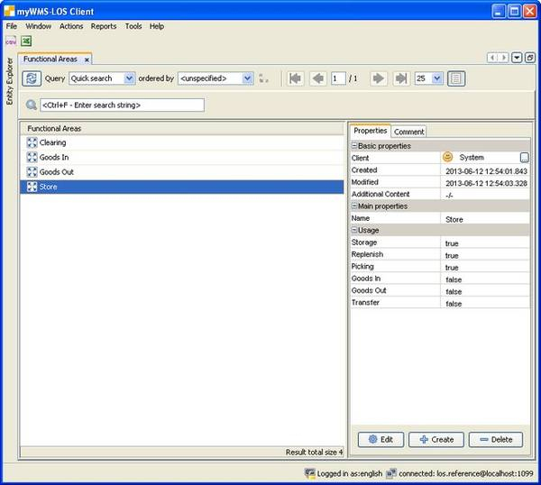
Description of the fields:
Name: A unique identifier.
Stock: Complete unit loads can be stored and rearranged.
Replenish: The material is available for replenishment.
Picking: The material is made ​​available for the picking.
Goods in: Use for goods in.
Goods out: Use for goods out.
Transfer: transfer locations

Working Areas & Positions
The working areas determine where myWMS automatically searches for assignable orders. For Example orders in a forklift control system. To each working area belongs a list of storage groups.
Dispatchable orders must be based on storage areas with the respective groups. Since the working areas are based on the storage groups, all storage areas must be assigned to groups. Orders that refer to places without storage group can not be processed.
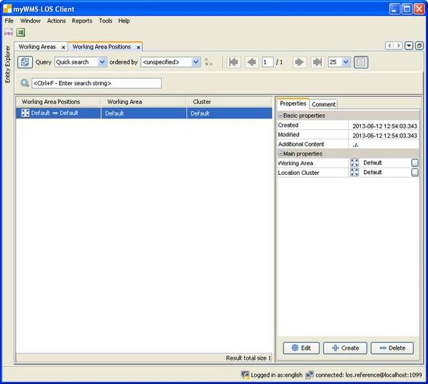

Unit Load Types
Each unit load is assigned to a unit load type. The unit load type describes the general characteristics of the unit load, such as dimensions or weight.
These types are used to control the occupancy of storage locations.
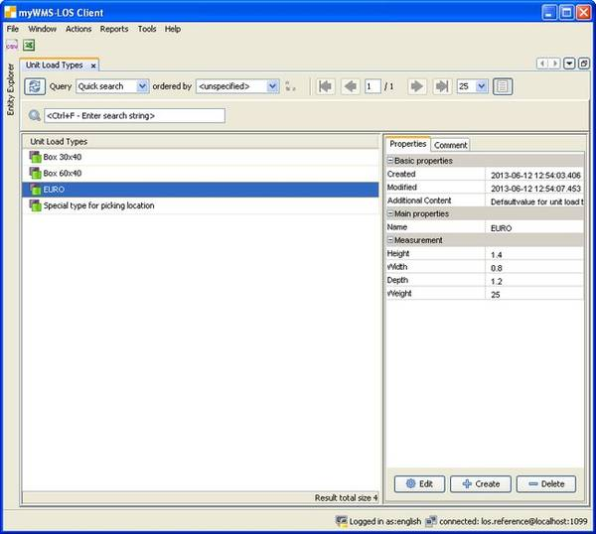
Description of the fields:
Name: A unique key.
Aggregate Stocks: Equal stocks units will be combined on a unit load with this type to one single stock unit. On equal stock units all qualifying characteristics like item data or lot are matching.
Calculate Weight: The weight will be calculated on the basis of item data and stock unit data. This should be disabled on unit load types with only logical meaning on performance reasons.
Height, width, depth: Dimensions. Just for info.
Weight: The weight of the unit load.
Lifting Capacity: The weight that can be put into one nit load of this type. This value is only for info. It is not checked in the standard processes.

Storage Location Types
Each storage location is assigned to a storage location type. The storage location type describe the different physical storage locations.
By the type the strategies determine how the storage location is occupied.
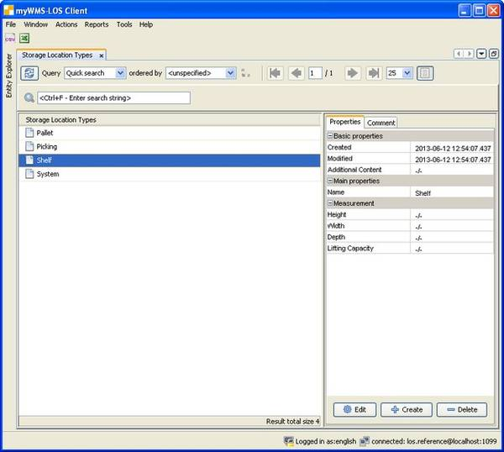
Description of the fields:
Name: A unique key.
Height, width, depth: Dimensions. Just for info.
Lifting Capacity: The maximum allowable weight.

Capacities
Capacity constraints are rules that control the allocation of the storage locations. For this, the unit load type is set in conjunction with the location type.
In the dialog, you give rules, how much percentage one unit loads of a certain type allocates a storage location of a certain type.
If there are no constraints on a storage location, all unit loads are allowed to be put on this location. This is used to handle system locations or handover locations.
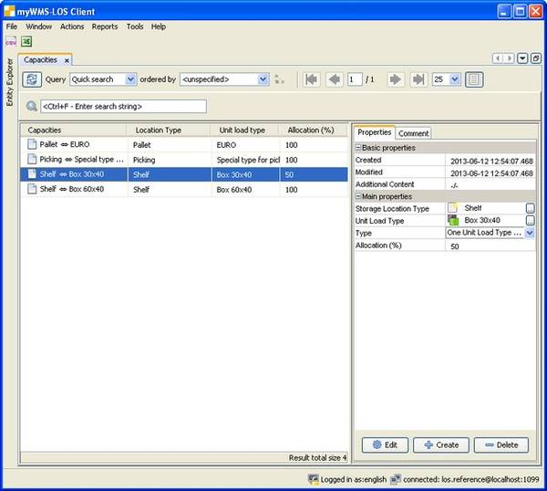
Description of the fields:
Storage Location Type: The type of the storage location
Unit Load Type: The type of the unit load
Type: The method for storage location allocation
- One unit load type. On the storage location only one type of unit loads is allowed
- Mixed unit load types. On the storage location various types of unit loads are allowed
Allocation: Percentage. Proportion of the storage location which is occupied by a unit load.
Orderindex: This value can be used by the storage strategy to sort possible variations of storage locations.

Storage Locations
In this dialog, all storage locations of the warehouse are defined.
Before starting with the definition of storage location, it is useful to think about the labels.
The manually or via forklift operated warehouse consists of shelves that are typically backside joined together. Each shelf is accessible from a lane that branches off from the center aisle. Each shelf is made of storage compartments in the horizontal and vertical directions. The area between two shelve uprights is known as the field. All storage locations have certain dimensions and are for the single depth intake of unit loads (eg Euro pallets) designed.
On the traverses per each storage location a label is placed, on which the storage location name is encoded as a bar code and in plain text and possibly a check digit.
The name of the storage location should be easy to recognize visually. It has to be entered or scanned to identify the location. If it is scanned per barcode, the code should be as compact as possible.
Another issue is the sorting of the picking orders. They are sorted by the location names! Should picking use simultaneously locations on the left and right, the naming must be different than if first all left and than all right locations are used.
A logically clear and easily recognizable subdivision is important in any case.

Example: A4-021-3
A4 = Rack or Aisle
02 = Field in Rack
1 = Location in field
3 = Level
The storage location A4-021-3 is the fourth rack in hall A, there in the second field the first location in the third level.
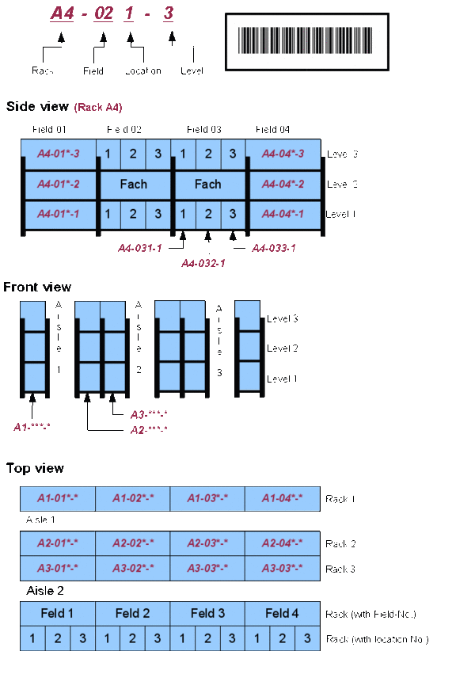

Import of storage locations
With the menu item 'File – import – Rack & Locations' you can import XML files in Microsoft Excel 2003 XML format.
A template is store with the other parts of the documentation (lagerplatz_de.xml).

Procedure:
1. Download the template
2. Open the template in Microsoft Excel, OpenOffice Calc, LibreOffice Calc or a XML editor
3. Edit the file (a row for each storage location) and save/export it (in Microsoft Excel 2003 XML format!)
4. Import of this file

Structure of the file:
Halle | Gasse | Regal | Fach | Ebene | Festplatzartikel | Fachtyp | Bereich | Mandant
X |  | 3 | 011 | 1 |  | Palette | Lager | System

The headers of the table have to be this keywords. Please do not translate them.
Description of the fields:
Halle (Hall): The hall area (A-Z)
Gasse (Aisle): The aisle that the rack is served by (1...)
Regal (Rack): The number of the rack (1...)
Ebene (Level): The level of the storage location (1...)
Fach (Field): The field of the storage location within the level
Festplatzartikel (Fixed Item): The given number is interpreted as an item data number. This one is fix assigned to the storage location.
Fachtyp (Location type): An existing storage location type
Mandant (Client): The client that owns the storage location. Mostly it is the system client.

The example above will create the following storage location:
X3-011-1
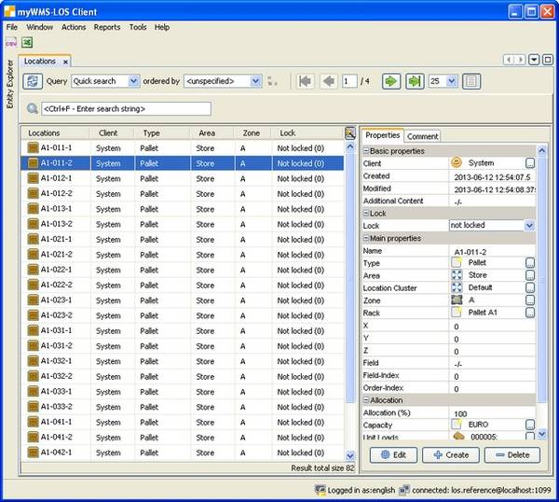
Description of the fields:
Client: Is the storage location assigned to a client (except system client), only stocks of that client are stored in the storage location. Storage locations of the system client can be placed with material of each client.
Lock: The lock indicator of the storage location.
Name: A unique identifier.
Location Type: The type of storage location.
Area: The functional area that is associated with the storage location.
Location Cluster: The location cluster of the client
Zone: The zone (ABC-Class) to that the storage location is assigned.
Rack: The rack, which is associated with the storage location.
X, Y, Z: Integer positions of the storage location.
Field: The field in which the storage location is located. Required for overcrowding.
Field Index: Position within a field.
Order Index: Integer value. After this field, picking routes are sorted.
Allocation (%): Percentage of the storage location, which is occupied or reserved for allocation.
Capacity: The assignment rule currently in use. This value is automatically set for access and release of the storage location of the system. Do not change this value in the master data maintenance.
Unit loads: A list of unit loads available in the storage location.
Last Stocktaking: The date on which the storage location was last counted in inventory.

Description of functions:
Lock Entity: The data set is provided with a selectable block indicator.
Release Reservations: Existing reservations / allocations are removed from the storage location.
The storage area is therefore no longer in use and is available for new storage. If material is still on the storage location, this can lead to unexpected behavior.
Create stocktaking order: For the storage location an inventory counting is created.

Fixed Location Assignment
With the fixed location assignment, storage locations are designated to certain materials.
These settings for example are required for the establishment of dedicated picking locations.
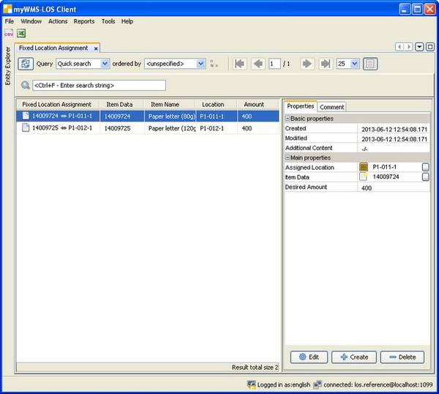
Description of the fields:
Location: The affected storage location.
Item Data: The assigned item.
Min. Amount: Replenish orders can be created for locations with less than the minimum amount.
Max. Amount: The amount that should be reached with a replenishment.
Max. Pick Amount: The maximal amount for one picking positions. For picking positions with more amount it is tried to find stock on other locations.

Material Master Data

Item Units
Each item is assigned to a standard unit of measure. These units are stored here as master data.

Item Data
In the item data definitions the various items are defined.
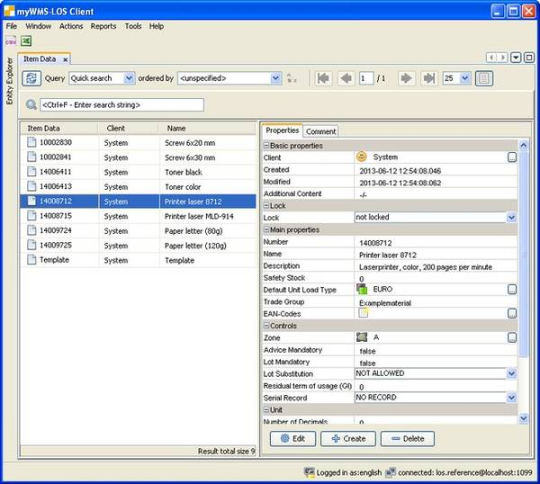
Description of the fields:
Client: Only the specified client (and the system client) have access to this product. All stocks of the article are created for this client.
Number: The unique item number.
Name: A short description.
Description: A long description.
Default Unit Load Type: This unit load type is used in several goods receipt and stocktaking processes as default value for new stock creation.
Trade Group: For special deployment.
EAN-Codes: A List of additional identifiers. (see EAN-Codes).
Zone: The default zone of the item. Is used is storage location search.
Advice Mandatory: For special deployment.
Lot Mandatory: A Flag that directs, whether a lot is mandatory for this item.
Serial Record: Regulates, whether or when a serialnumber has to be captured for a stock.
Shelf life: The minimal remaining term of the item on goods receipt.
Item Unit: The unit of measure.
Number of Decimals: The number of decimals displayed for the amounts of the item.
Height, Width, Depth: The dimensions of the item.
Weight: The weight of the item.

Attention! Not all fields of the item data are evaluated by myWMS in the current processes. Which property is used at which process, is determined by the particular application process. The item master data offer the possibility to store this information.

Import of item data
With the menu item 'File – import – Item Data' you can import XML files in Microsoft Excel 2003 XML format.
A template is store with the other parts of the documentation (artikel_de.xml).

Procedure:
1. Download the template
2. Open the template in Microsoft Excel, OpenOffice Calc, LibreOffice Calc or a XML editor
3. Edit the file (a row for each storage location) and save it (in Microsoft Excel 2003 XML format!)
4. Import of this file

Structure of the file:
Mandant | Nummer | Name | Beschreibung | LHM-Typ | Chargenpflicht | Einheit
System | 21740001 | Artikel 21740001 | Beschreibung des Artikels 21740001 | EURO | JA | Stk

The headers of the table have to be this keywords. Please do not translate them.

Description of the fields:
Mandant (Client): The Client of the item
Nummer (Number): The number of the item
Name (Name): The name of the item
Beschreibung (Description): The description of the item
LHM-Type (Unit load type): The default unit load type of the item
Chargenpflicht (Lot mandatory): The flag for mandatory lot. (YES / NO)
Einheit (Unit): The unit of measure

Packaging Units
The amount of each stock unit is handled in the base unit of the item data. As additional attribute it is possible to add a packaging unit.
The packaging units are defined as master data for each item date separately. It is possible to have different packaging unit for one item data. But the stock unit can have only one packaging.
Description of the fields:
Name: A unique identifier (unique for each item data).
Item Data: The affected item data.
Amount: The amount of base units which are stored in one packaging unit.
Height, Width, Depth: The dimensions of one packaging

EAN-Codes
In addition to the part number, there are other identifiers. This can for example be EAN- or UPC-codes. It can also be custom codes of the manufacturer of the goods. These additional item numbers must clearly refer to one item. It is not possible to have one additional number referring to several items.
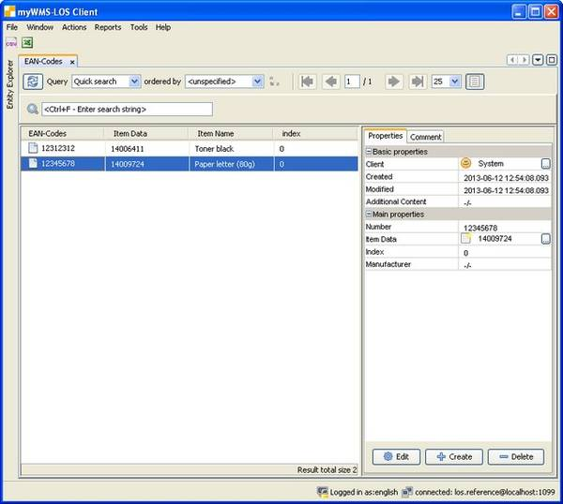
Description of the fields:
Number: A unique identifier.
Item Data: The affected item data.
Manufacturer: The manufacturer of the item. Just for info.
Packaging Unit: The optional packaging unit.

Bills of Material
In this list items will be combined into one bill.
One item is the master. To this master any number of items can be assigned.
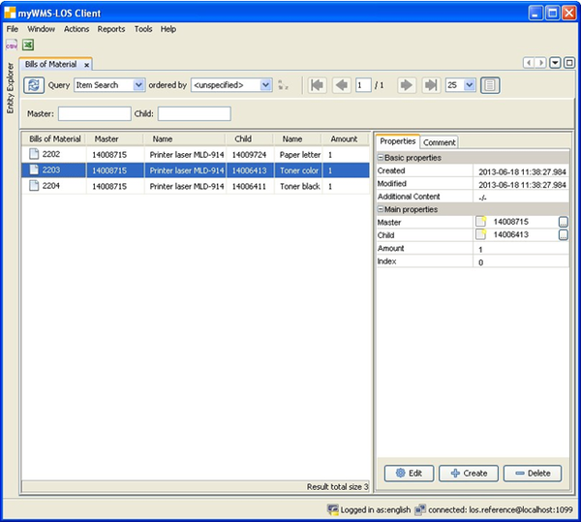
Description of the fields:
Master: The master item data.
Child: The child item data.
Amount: The amount of childs that are required.
Index: Sorting the list.

Strategies

Storage Strategy
Searching for a storing locations with the help of a storage strategy.
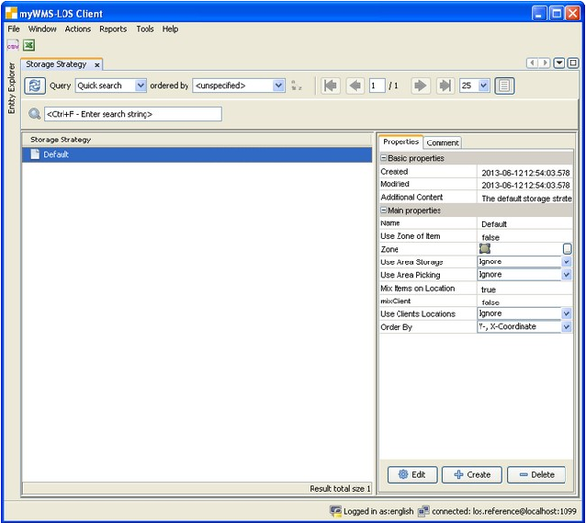
Description of the fields:
Name: A unique identifier.
Manual Search: The strategy will search nothing.
Mix Item on Location: On a storage location several item data may be mixed.
Mix Clients on Location: On a storage location several clients may be mixed.
Only Clients Location: Use only storage locations which are assigned to the client.
Near Picking Location: Find a storage location in the near of a fix assigned picking location. The search is looking for a location within the rack of the fixed location. The distance is calculated by the X-coordinate.
Zone: Only storage locations in the specified zone.
Order by: Various options for sorting the storage locations.

Order Strategy
With the help of strategies for stock removal settings for outbound orders are made. These relate to the selection of outsourced resources as well as the implementation of removal orders.
In general, the stock selection is done strictly according to FIFO. However, there are switches that rank higher other criteria.
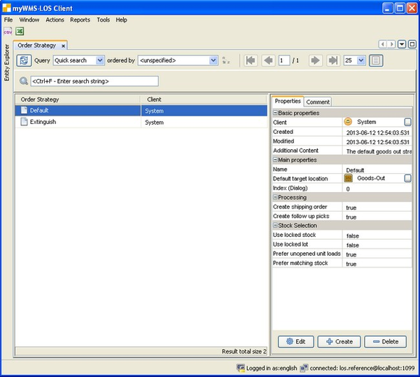
Description of the fields:
Name: A unique identifier.
Index Dialog: Controls the display in the selection list for manual order creation. (less than 0 will not displayed)
Processing:
Default target location: A target location for the order. It can be overwritten within the processing dialogues.
Create follow up picks: When amount is missing in picking, the system automatically tries to find replacement material.
Create shipping order: After finish of picking, a shipping order for is automatically generated.
Separate Order Types: A picking position can be a partial removal or the removal of a complete unopened unit load. Normally all picks for a delivery order are put into one single picking order. With this option it is possible to create separate picking orders for both types.
Stock selection:
Use locked stock: Use stock units, which are blocked.
Use locked lot: Use lots, that are blocked.
Prefer matching stock: Is a stock unit / unit load exactly matching a position, it will be accepted before FIFO.
Prefer unopened unit loads: Can an unopened unit load be fully used, it will be accepted before FIFO.
Only complete unit loads: Only unopened unit load are used. This overrides FIFO.
This setting may cause amount differences. It will be search as much unit loads until at least the requested amount is reached.
A unit load is marked as opened as soon as an amount is changed on the unit load.

