01. Sept. 2019

The Graphical User Interface

Contents
1 General Structure 2
2 The Entity Explorer 2
3 The Menu Bar 2
4 The Query Dialogue 2
5 Basic techniques 3
5.1 Working with Lists 3
5.2 The Search Bar 4
5.3 Sorting 6
5.4 Paging 6
5.5 The table area 7
5.6 The detailled area 7
5.7 The use of the combination fields (three points) 8
5.8 Button "Edit" 8
5.9 Button "Create" 8
5.10 Button "Delete" 8
6 Configuration 9
6.1 System parameters 9
6.2 Setting up the network parameters 9

General Structure
After starting myWMS you see the following graphical user interface (GUI):
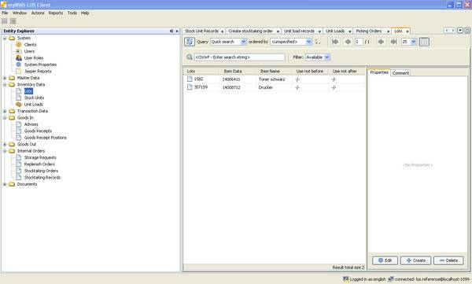

The Entity Explorer
On the left hand you will find the entity explorer which provides a fast access to the data of the myWMS.
The data is summarized under a folder structure like 'Inventory Data' under which you will have access to the regarding inventory data. For example unit load, lot or stock unit. Make a double click on an entry and a new window appears with an overview of the data sets in the working area.
Information about the individual record types can be found in the chapter data.

The Menu Bar
The menu bar consists of different menus with submenus or menu items. Find more details about the special menu item in the appropriate program description.

The Query Dialogue
The area in the middle of the application is called the query dialogue where you have access to manipulate data and do most of the working stuff. It contains different lists, dialogues and views. Multiple windows are shown and are separated in a tab view. Click and hold one tab to place it to the point of the screen where you want it to appear. It is possible to arrange them above or next to each other or completely separated from the application window in an own window. For example if you have two monitors in use.

Basic techniques

Working with Lists
There are several points in the program where data is listed as a table. The following example is about unit loads and used to describe the general functionalities.
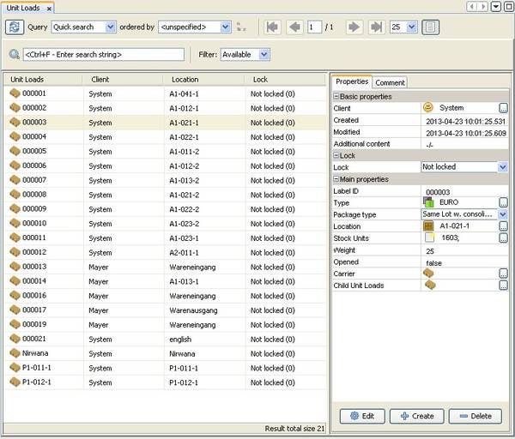
The table view always consists of three areas: in the middle there is the list or table itself showing any found data set. If there is one data entry selected the values are shown on the right side in the detail view area. At the top of the list is the search bar which provides the possibility to make queries and filter functionalities.
Different views and releases can be assigned in the processing to some users of the myWMS. After the registration, on the lower right side of the myWMS is announced who is registered ("Registered as") and with which network the user is connected ("Connected with").

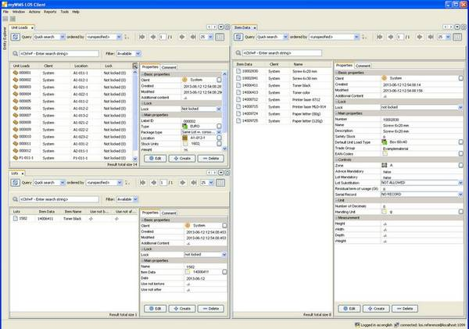

The Search Bar
The search bar allows you to specify which records you want to appear in the table area. You can specify a sorting for the records or search for data sets. On the left hand you see the button (two arrows) to update the tab. After each change, you should click this button to make sure that your view corresponds to the current storage.
A drop-down box offers the search function as a selection to look for a specific record in the table area. The standard search feature includes a 'Quick Search' field, a field to 'Search by Pattern' and a view where you can search for 'Everything'.
Selection: "Quick Search"
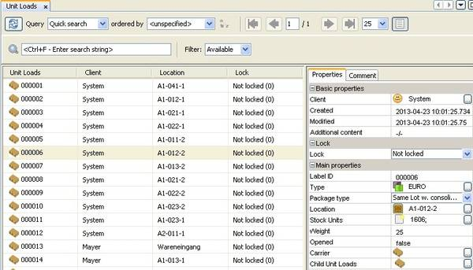
By selection the Quick search a new bar with a text box opens below where you can enter a word or a single character you want to search for in the first column of the table area. The data sets are filtered by the conditions typed in and shown after pressing the enter key. It is possible to sort the data alphabetically after clicking in the head of the specific column. An arrow appears showing if the sorting is ascending or descending.

Selection: "Search by Pattern"
The selection Search by Pattern let a window appear in which more precise values can be entered.
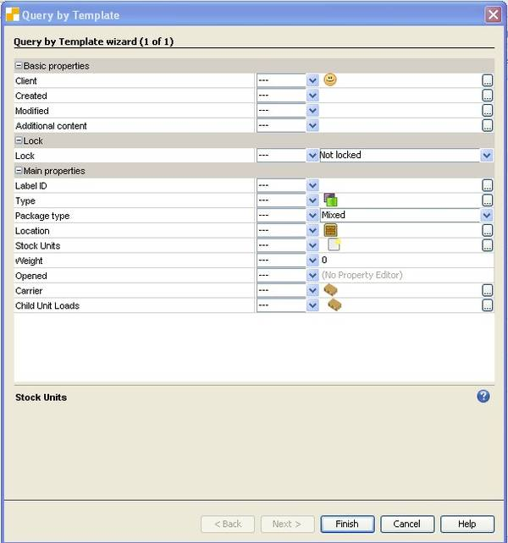
You can specify search parameters for each attribute by using a drop-down box. For example you can choose whether a value should match the expression, does not match or should be larger than or should be smaller than. Type in the expression by clicking on the three points or by selecting an item from the drop-down field.
You leave the Search by Pattern view by clicking the finish-button, with clicking the cancel-button you will exit without proceeding a search order.
In order to see the full data set you have to enter "all" into the choice box "Search".

Selection "All"
All records of a table will be displayed.

Sorting
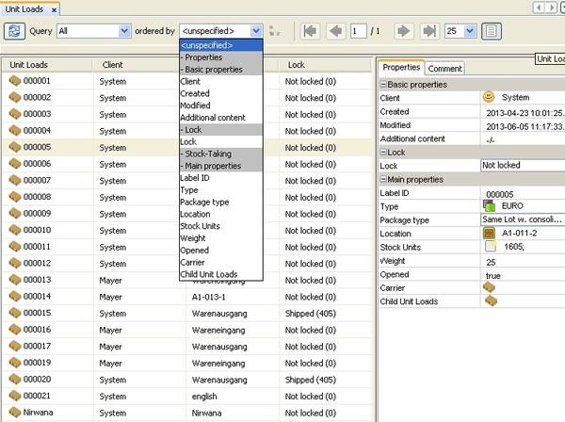
The choice box "Ordered by" offers a selection of methods how the data sets should be ordered. The choice box shows all attributes which can be used for sorting.
By clicking on the icon "A<->Z" one can initiate an alphabetical sorting upward (A>Z) or downward (Z>A). In the individual columns of the table area it is also possible to sort upwards and downwards by clicking on the title of the columns. An arrow indicates then if the sorting is upwards or downwards.

Paging
One can go through the pages of the data sets by clicking on the arrows on the right side of the search bar. It is possible to click back- and forward from page to page as well as to jump from the first to the last page. The notification shows on which side one is. For example it can show 1/3 that means that one is on the first side of three pages in total.
Within the choice box one can choose how many data sets per page should be shown. The presetting arranges for showing 25 records per page.

The table area
In the table area all the matching data sets are listed.
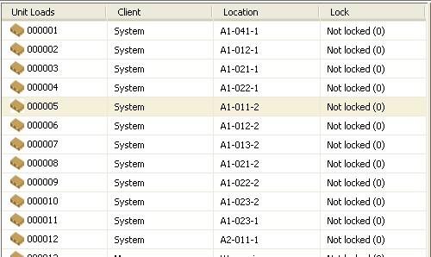
The data set is shown in an alphabetical order up- and downwards by clicking on the title of the second or third column. This only affects the displayed data s An arrow indicates then if the listing is executed up- or downwards. The searchbar offers search functions for the first column.
In the table area below the records on the right side, myWMS shows how many records exists resulting from the searching in the search bar.

The detailed area
The defined characteristics of the selected data set from the table area are to be find in the detailed area. The characteristics and their indication configurable in accordance with their specifications.
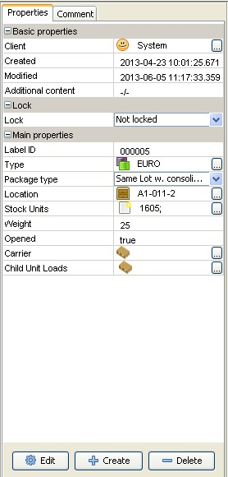
Groups of characteristics are summed up under a title with a colored background. There is an icon "(+/-)" at the beginning of every title that shows the subitems with the relevant title completely (+) or with the reduced (-) one.
More detailed information of the characteristics related to the particular objects can be found in the myWMS. They can be shown in a separate window after clicking on on the combination field (three points).

The use of the combination fields (three points)
The entering of a characteristic related to a record can be typed in in multiple ways. On the one hand the combination field offers the possibility to open a list by clicking on the three points. In this list the desired characteristic can be chosen and added by clicking on it. The window that opens after clicking on the three points shows the normal overview of all existing characteristics. Furthermore character string can be typed directly into the text box as well. With the help of a autocomplete all the characteristics are shown that contains any of the signs or character strings. By entering the space into the text box all characteristics are shown that are available for these value. In the upper part of the detailed area that has a gray background one can find describing information for every selected field.
There are three buttons below: "Edit", "Create", "Cancel"

Button "Edit"
A separated window will be opened by clicking on "Edit". This window shows the detailed area of the record chosen from the table area. Here all characteristics of the data set can be changed.
After clicking on "Finish" the window closes and all changes are saved.
"Cancel" closes the window without saving the changes.

Button "Create"
A mask opens by clicking on "Create". In this mask it is possible to create a new data set.
One can see all the characteristics that have to be indicated for the data set in question. Those can be entered with the help of the combination field (three points) just like in the detailed section. The combo boxes can be used (three points) in order to choose the desired object originating from a list with all objects that belong to the listing related to this selection.
After clicking on "Finish" the window closes with the saved entries. The Button "Cancel" closes the window without the creation of a new record.

Button "Delete"
By clicking on the "Delete" you can delete the selected record in the table section.
myWMS asks before the final commitment whether the system should really delete the record or not.
"OK" deletes the record finally. The button "Cancel" stops the procedure without cancellation of the record.

Configuration

System parameters
The behavior of the layout can be customized by system parameters.
The following system parameters are defined.
NBCLIENT_RESTORE_TABS: Opened tabs will be restored the next time the program is started.
NBCLIENT_SELECTION_ON_START: Dialogues of the entity explorer, select data automatically at startup.
NBCLIENT_SELECTION_UNLIMITED: Allow unlimited selection.
NBCLIENT_VERSION_MATCHER: Regular expression for version control of rich clients. "*." means all versions.

Setting up the network parameters
The setting of network parameter takes place in the 'context.properties' and appserver.properties files.
You can find this file in the unzipped zip distribution of the rich client application. It is located in the directory los_reference/los_reference/config/settings/.
In a customized rich client application replace 'los_reference' with the appropriate project name.
In the file, the access to the server application is set on the entry 'java.naming.provider.url'. For a local installation, the entry is:
java.naming.provider.url=http-remoting://localhost:8080

Caution! The server name must be resolvable on the network. It can not only work with IP addresses. The JBoss RMI connection checks the name resolution and allows access only if this can be carried out successfully.
In a pinch, the host name can be set statically in the hosts file.
When working with NAT is a corresponding configuration of JBoss/Wildfly is necessary.

