01. Sept. 2019

Outbound Processes

The outbound process is divided into several types of orders.
- Delivery orders. The delivery order shows the outbound process from the customer perspective. In the delivery order is defined which material should be delivered to which customer.
- Picking orders. The picking order shows the outbound process from the warehouse view. In the picking order is defined which material should be taken from which storage location.
- Shipping orders. The shipping order shows the outbound process from the carriers view. In the shipping order is defined which packets should be forwarded.
These types are generally independent from each other. A Picking order or Shipping order can for example be done without a delivery order. The generation of a shipping is optional and can be deactivated in the order strategy.
The standard process starts with a delivery order. This is entered via interfaces or manual in a dialogue of the application. Based on this delivery order and the related strategy, one or more picking order will be generated. After processing the picking orders all packets will be combined in a shipping order.

Contents
1 Ordering from stock 2
2 Assemble Picking Order 3
2.1 Automatic creation of Picking Order 3
2.2 Manually create Picking Order 3
3 Picking 4
3.1 Mobile Dialog 4
4 Shipping 7
4.1 Mobile Dialog 7
4.2 Configuration 8
5 Data 8
5.1 Prders + Positions 8
5.2 Picking Orders + Positions 10
5.3 Picking Unit Loads 11
5.4 Shipping Orders + Positions 12

Ordering from stock
The first step of outbound processes is to create orders. These can be automatically transferred via an interface of an ERP system or can be entered manually.
To manually create a stock order to open the menu item 'Window – Create Order'.
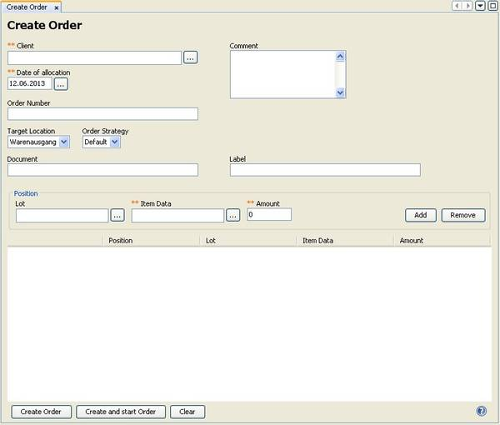
Description of the fields:
Client: Selection of the client whose goods are to be delivered.
Order Number: Enter a reference number for your order here. For example it can be a reference to an ERP system. It will be recorded as ‘External No.’.
Target Location: Refers to the assembly location or goods out gate, on which the goods are to be provided.
Order Strategy: Select the strategy to process the order.
Document: Here you can add a particular document to the shipping documents by specifying the URL of a network resource.
Label: As the indication of a document, a special shipping labels can be provided as a network resource.
Item List: Use the item list to specify the lines of the order.
Lot: Selection of the lot.
Item data: Selection of the item data.
Amount: Specify the desired amount

Description of functions:
Create Order: After all items of the order are entered, the order will be generated.
Create and Start Order: After all items of the order are entered, the order will be generated and a picking order will be calculated with the automatic settings.

Assemble Picking Order
Once an order has been written, it is possible to generate picking automatically. Alternatively, it is also possible to create the picking manually.

Automatic creation of Picking Order
While receiving order from web service interface these are processed automatically, i.e. picking orders are generated. That is at least in the standard implementations of myWMS.
It can also be started later when entering the further order data by specifying additional parameters. Even so, several customer orders can be combined into one picking order.
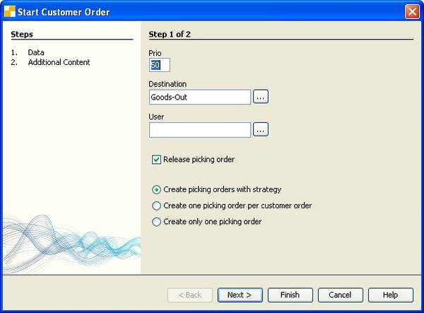
Description of the fields:
Priority: The priority of the picking order.
Target location: The target location of the picking order.
User: Is a user is specified here, the picking order will be reserved for this user.
Release picking order: Picking orders are released directly for editing.
Combine Customer Orders: If this option is activated, the selected delivery orders will be mixed up in a picking order. Attention! With this option the picking order is loosing it’s connection to the delivery order. Status or amount-information will not be transported back to the delivery order.

Manually create Picking Order
For manual assembled picking orders open the menu item 'Window – treat order'.
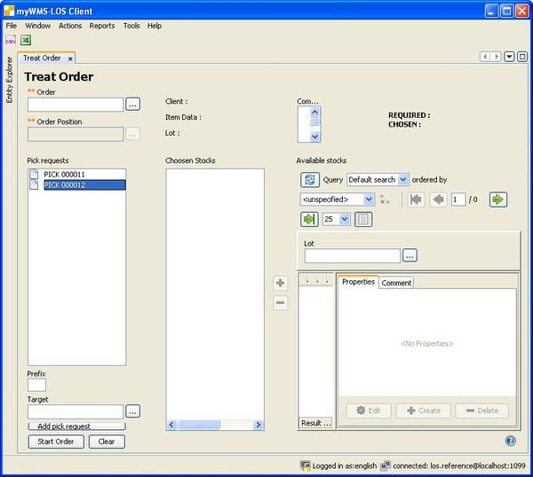
Description of the terms used in the dialog:
Order: Select the order to be picked. You'll only get pre-filtered orders, for which the manual assembly was provided. The associated client is automatically given by myWMS on the right.
Position: First select an order. myWMS will provide only the positions of the selected client. The item data, the lot and the amount information are displayed on the right. The available stock items are listed, showing lot, unit load, storage location and the available amount.
Prefix: To identify the picking order in the further processes, you can precede characters to the picking order.
After selection of the picking position or stock unit, you can select or deselect the stock units from which the ordered items should be picked.

Description of functions:
Start Order: Are all picking orders and positions processed, this action will start them.

Picking
In logistics the process of putting together a customer order or a production order from different goods out of a whole assortment is called: Picking. A picker puts therefore the customer production order together in a warehouse system.
With this dialog you can work on the on the picking order.

Mobile Dialog
After login on the mobile application, select the function 'Picking'.
Here you get a list with all picking orders to select from, that have not been finished. Choose the one you want to process.
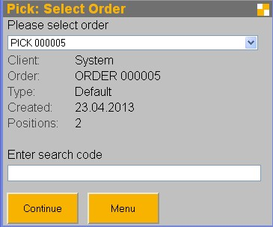
For the selected picking order, you will be guided optimal to the locations.
First you have to identify the unit load from which will be picked.
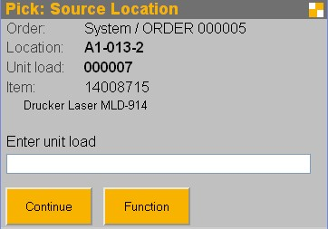
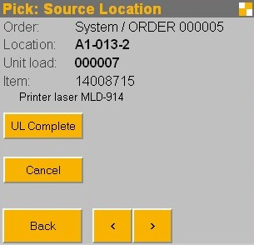
The button 'Function' displays additional functions.
Previous, Next: Navigating in the positions of the picking order.
Unit Load Complete: The target unit load is full. You will be prompted to change the unit load
For the remaining positions, a new picking order will be created.
Cancel: Cancel the processing of picking. This function is only active as long as no picking has been posted.

In this mask the picker confirms the pick.
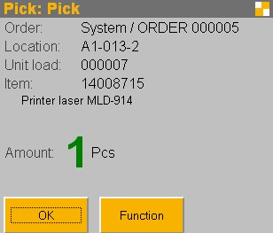
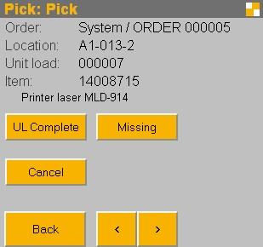
The button 'Function' displays additional functions.
Previous, Next: Navigating in the positions of the picking order.
Unit Load Complete: The target unit load is full. You will be prompted to change the unit load.
For the remaining positions, a new picking order is created.
Cancel: Cancel the processing of picking. This function is only active as long as no withdrawal has been posted.
Missing: Select this function if there is not enough material.
You will then be prompted to enter the picked amount.

After all items have been processed, the user is asked to bring them to the target location.
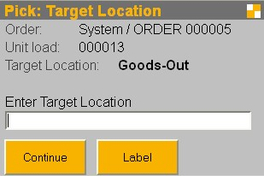
After scanning the target location the picking is finished.
Using the function 'Label', a label for the picking unit load can be read, generated or printed.
With scanning the printer, the label can be printed on this printer.
Note! In the configuration of the server must be ensured that the content of the scanned code printer is the name of a suitable printer. The default print format is PDF.
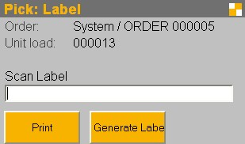
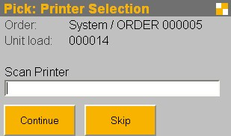

Special procedures:
If there are items with serial number handling, the picker is asked to enter the picked serial number.
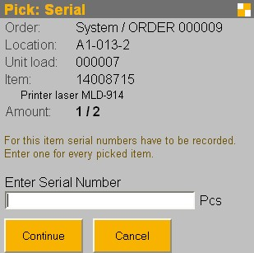
Complete Unit Loads:
With the complete unit load picking a complete pallet will be taken. The difference is that this will not move amounts into a picking cart. The unit load will be taken as a whole.
After confirming such a position the user is asked to bring the unit load directly to the target location.

Shipping
Accordingly, whether it is an internal, such as for production, or external picking, shipping of the picked goods is done or not. You get a list of all unfinished shipping orders to choose from. Choose from this list the shipping order that should be processed.

Mobile Dialog
After logging on to the mobile application, select the function 'Shipping'.

Here you get a list of all unfinished shipping orders to choose from. Choose from this list of the shipping order that should be processed.
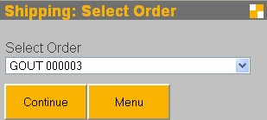
In the title bar is indicated how many unit loads belong to the shipping order and how many you have already scanned.
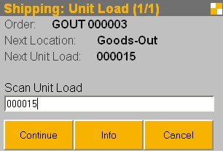

In this screen there is always displayed a unit load belonging to the shipping order. It is not imperative that you work through the unit loads in the proposed order. You can use any unit load, belonging to the shipping order. If you scan a unit load, which is not part of the shipping order, an appropriate error message will be displayed.
This screen is displayed again until all unit loads were scanned.

The function 'Info' will always bring more information about the current shipping order.
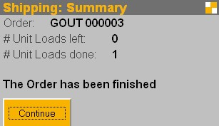
After finishing all unit loads of the shipping order, a conclusion screen is shown.

Configuration
System Properties
SHIPPING_RENAME_UNITLOAD: Unit loads are renamed during shipping. This is necessary if unit load is to be reused.
SHIPPING_LOCATION: Unit loads which are ready for shipping are transferred to this (logical) storage location. If no value is specified, no transfer.

Data

Orders + Positions
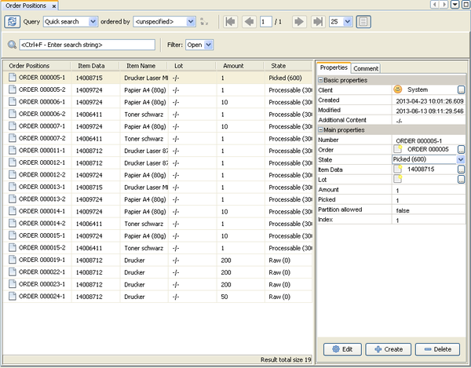
Description of functions:
Start: Starts the calculation of picking
Finish: The order will be completed in the current state of processing. No posting of material is initiated by this function.
Remove: The order is deleted.
Print documents: Start printing the documents of the order. It can be specified which documents are to be issued on which printers. Alternatively the documents can be stored.

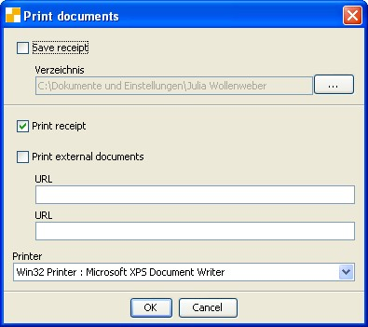
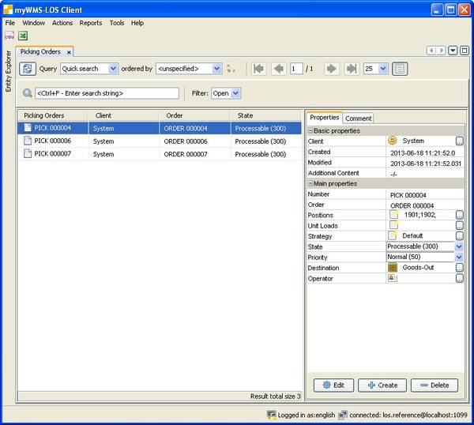

Picking Orders + Positions
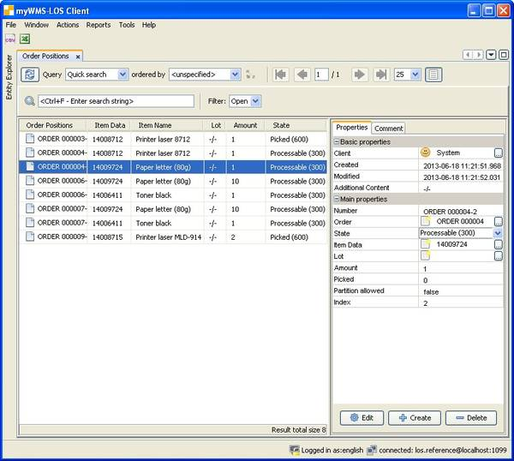
Description of functions:
Halt/Release: Stopping of picking is only possible as long as it is not reserved or in progress. Paused orders do not appear in selection lists of the handsets.
Finish: The order will be completed in the current state of processing. No posting of material is initiated by this function.
Remove: The order is deleted.
Change Properties: Some parameters can be changed for a picking order.
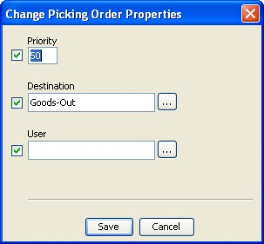
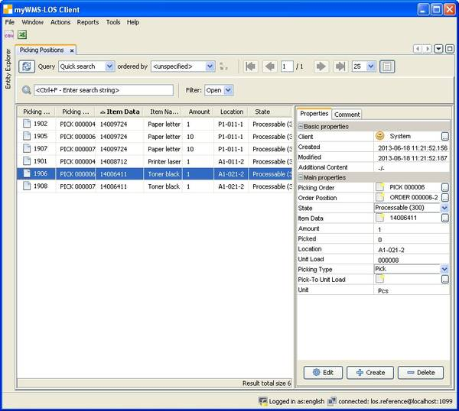

Picking Unit Loads
Picking unit loads or picking carts are unit loads that are used in the picking or packing processes.

Description of the functions:
Finish: The order will be completed in the current state of processing. No posting of material is initiated by this function.
Create shipping order: Manually creating a shipping order for the picking unit load. This is only possible if there is no shipping order for the picking unit load and it's not done yet.
Print Packlist: Start the print of the packlist. The printer can be selected. It is possible to store the list as a file.

Shipping Orders + Positions
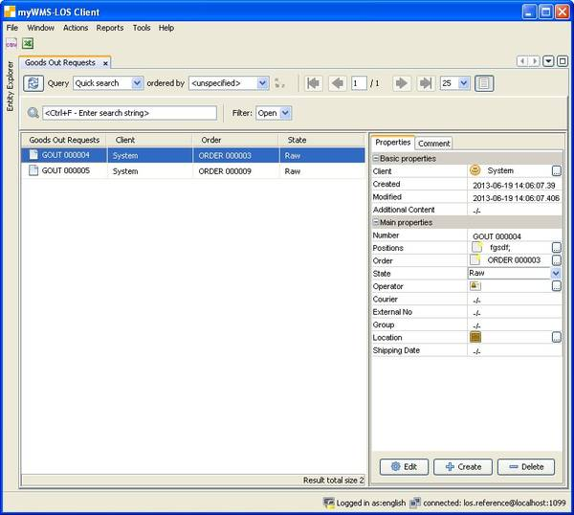
Description of functions:
Confirm: The shipping order will be completely receipt to the default values.
Finish: The order will be completed in the current state of processing. No posting of material is initiated by this function.
Remove: The order is deleted.
