01. Sept. 2019

Internal Processes

Contents
1 Info 2
2 Replenishment 2
2.1 Request replenishment mobile 2
2.2 Request replenishment stationary 3
2.3 Replenishment processing 3
3 Stocktaking 4
3.1 Forms of stocktaking 4
3.2 Procedure 4
3.3 Create Counting Orders 5
3.4 Process Counting order 6
3.5 Confirm Counting Order 8
4 Transfer Unit Load 8
5 Transfer to Carrier 9
6 Transfer Stock Unit 10
7 Change Amount 10
8 Lot lock, unlock 11

Info
The mobile information dialogues displays current information about stock units.
Scan a barcode and the system shows what it knows about it. Based on the input the system searches for storage locations, unit loads and item data.
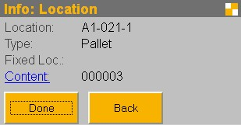
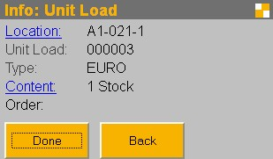
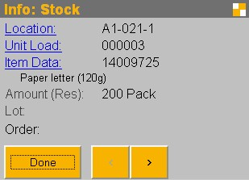
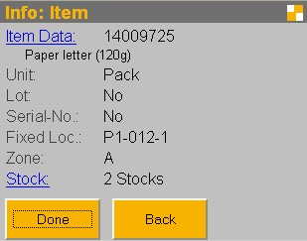
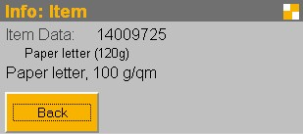
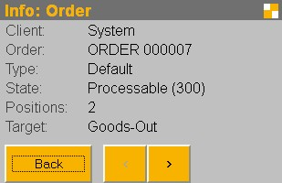

Replenishment
The replenishment is the transport of goods within the warehouse or location to provide the resources at strategic locations in the optimal amount. By a manual input, you have the opportunity to order new material. The processing is performed with the picking process.
The automatic replenishment ensures that appropriate configured storage locations are refilled when the amount is fallen below the minimum amount. The generation of replenish orders is started as in action within the application.
The dialog is located in the menu 'Actions – Replenish Pick Locations'.
Configuration of the storage locations:
- The storage location must be a fixed assigned picking location.
- The attribute 'Max.-Amount' of the fixed location assignment shows the amount, that should be there after refill.
- After the amount is below the ‘Min.- Amount’, a replenishment order may be generated.

Request replenishment mobile
After login on the mobile application, select the option 'Replenish Request'.
First you have to identify the storage location to search for replenishment.
Subsequently, the location is checked and you will see the associated item. You have now the opportunity to enter an amount. if you specify a value, the system tries to request the amount you entered. If you leave the field blank, the system tries to request the amount that is required to refill the location as indicated in the master data.
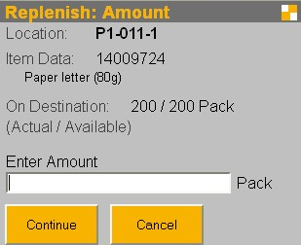
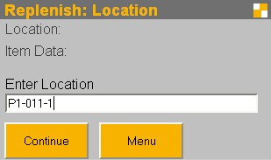

Request replenishment stationary
With the menu item 'Actions / Replenish Pick Locations' myWMS will check all fix assigned picking locations.
Is somewhere the amount below the minimum amount, a replenish order for this location will be generated.

Replenishment processing
After logging on to the mobile application, select the menu item 'Replenish Process'.
First you need to select the order to be processed. You will then be guided to the storage location, where the material has to be taken from. Scan the unit load from which the material will be picked.
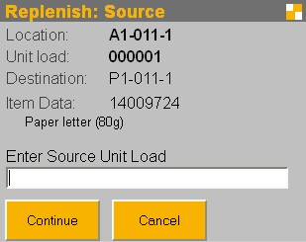
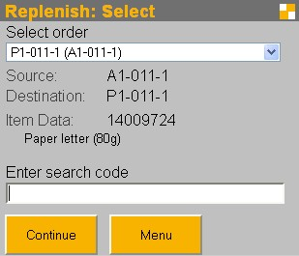
Now pick the material from the source location. You can decide whether the complete unit load or a partial amount is taken. For your support, the current amount at the target location, the amount that may be currently added on the target location and what amount has been requested for, will be displayed.
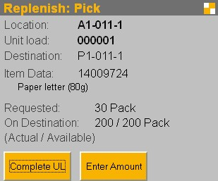
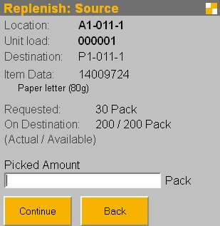

Then the material is added to the material on the target location. Confirm this by scanning the label of the target location.
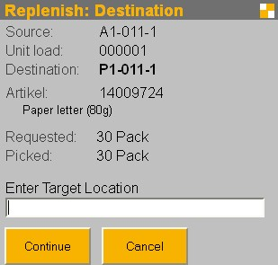

Stocktaking
The module stocktaking of myWMS is used to perform physical inventory counts. In general, it is storage location related. That is, the counting unit is the storage location. A storage location has always to be counted completely.

Forms of stocktaking
The module supports various forms of stocktaking.
Initial: With the initial stocktaking new material is introduced to myWMS. This is mainly the introduction of the warehouse management. But it can also be used to collect new stocks that are not collected through the normal receiving.
Annual: The annual stocktaking will examine the available storage locations on a reference completely.
Permanent: In the permanent stocktaking, all locations are counted during a period and all movements are recorded in a log.
The advantage is that
a) not everything has to be counted on an appointed date and
b) the counting can take place if it means little effort (empty space counting)

Procedure
The procedure for the various forms of stocktaking is very similar.
Create counting orders: First create counting orders for storage locations. For this you can use different criteria. Depending on the shape of the current planned job, appropriate criteria such as: clients, areas, locations, items, last counting date, ... can be entered.
Process counting orders: The processing of the counting orders is done with mobile terminals. With the help of a handheld devices, the unit loads and stocks are checked directly to the storage locations.
Confirm counting orders: If there were differences in mobile counting, these orders appear in the mask with an appropriate indicator. Here it is decided whether the count is so accepted, or the storage location should be counted again.

Create Counting Orders
Start the dialogue in the menu folder 'Tools – Stocktaking – Create Stocktaking Orders'.
Counting orders are created with different criteria. Orders are generated for locations where all the provided criteria meet. Should one criteria not be used, it can be disabled with the option button.
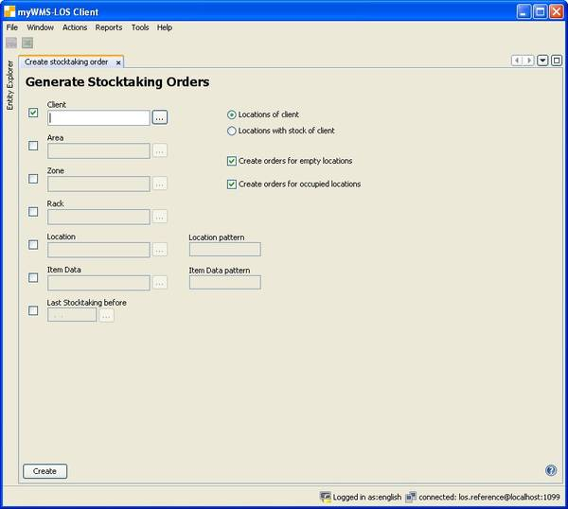
Description of the terms used in the dialog:
Client: Only locations are used, which are dedicated to the specified client.
Area: Only locations are used, which are in the specified area.
Zone: Only locations are used, which are in the specified zone.
Location: Only the specified location is used.
Location pattern: Give a pattern for the names of the locations, which should be counted.
The pattern is evaluated as a SQL LIKE operation (% = any character, ? = one character)
Item Data: All locations are used, where this item data is known to be.
Here you can use the pattern as well.
Last Stocktaking before: Only locations are used, which have not been counted after the specified date.
Create orders for empty locations: Here you can decide, whether locations should be counted that are known as empty.
Create order for occupied locations: Here you can decide, whether locations should be counted that are known as occupied.

Process Counting order
To process the counting orders, use the mobile devices.
Only locations can be counted which have open counting orders. The selection of the orders is done manually.
Process flow:
After login on the mobile application, select the option 'Stocktaking'.
In a multi-client system, you will be prompted to enter a client.
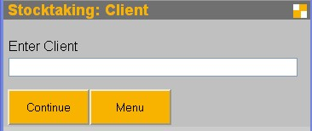
With this input the following process is limited to the entered client. You will only get locations which are owned by the chosen client. All entered stocks will be dedicated to this client.
Then the counted location has to be entered.
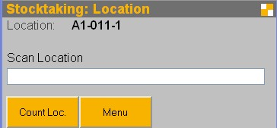
A stocktaking counting always relates to a complete location. Are there any errors, the complete location has to be counted again.
Enter one unit load on the location.
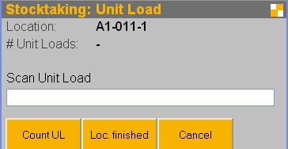
Are there one or more unit loads on the storage location, identify them by scanning and select the function 'Count UL'. Then you can enter the stock units on the unit load.
When selecting the function 'Loc. finished', the counting of the storage location is closed. If no unit loads have been entered, the location is marked as empty.
Enter now the amount of the item on the unit load.
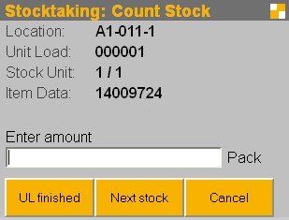
Now you can finish the counting of the unit load or can select the next item in case of a mixed unit load.

Special procedures:
Acquisition of a new unit load.
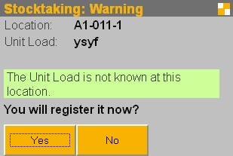
This inquiry is made if an unknown unit load is detected. In this case, the unit load will be captured newly.

Detection of a new unit load type
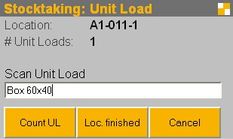
or a newly captured unit load first the appropriate unit load type must be specified.

Capture of the item data of the unit load
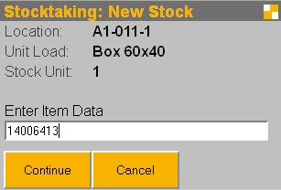
The item data is registered by input of the number or an alternative number (EAN-Codes).
The input of lots and serial numbers is only requested for item data which require these fields.

Confirm Counting Order
Orders with a correct counted amount are confirmed automatically. Other orders have to be controlled. The processing of differences is done in the rich client application.
In case, that there are any differences, these records are displayed in the state ‘Counted’. Here has to decided whether it will be accepted or the counting should be repeated.
As long as the orders stay in the state ‘Counted’ the location is locked. Only after confirming or canceling the order, the location is unlocked.
With the generation of a repeated counting of the location, the original order gets the state ‘Canceled’ and a new order is generated. With the comparation of the orders it is possible to have a look to the different counting.

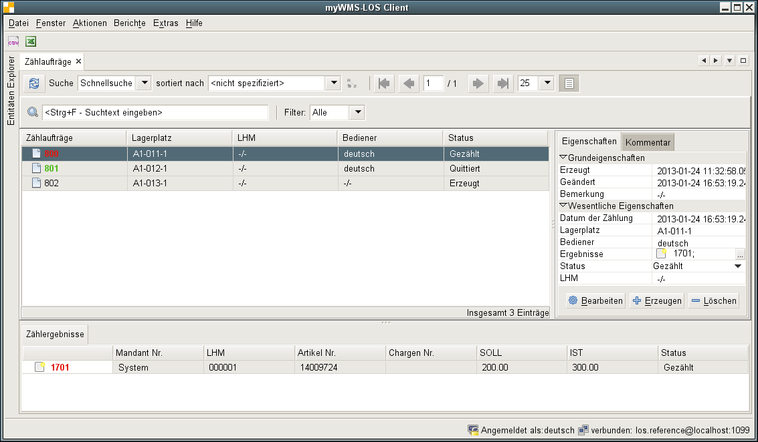
Special functions:
Function 'Recount': For the selected locations, new counting orders are generated.
Function 'Accept count': The selected orders are confirmed. All necessary postings are done.
Function 'Remove order': The selected orders are removed. They are not confirmed. Locks are removed.

Transfer Unit Load
Transferring a unit load to a different storage location.
Start the dialogue in the menu item 'Actions / Transfer Unit Load'.
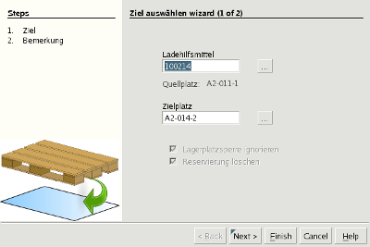
Description of the fields:
Unit Load: The unit load to be relocated.
Destination Location: The location where the unit load should be placed.
Ignore lock of location: The lock of the storage location is ignored.
Remove Reservation: The reservation for a unit load is canceled. For example due to a placed order of goods.

Transfer to Carrier
Transferring a unit load onto a carrier unit load.
Start the dialogue in the menu item 'Actions / Transfer to Carrier'.
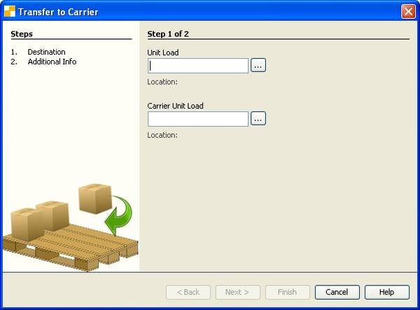
Description of the fields:
Unit Load: The unit load to be transferred.
Carrier Unit Load: The carrier, to which the unit load is transferred.

Transfer Stock Unit
This window usually helps to "Clean up" the stock. One stock unit can be placed to another unit load.
Start the dialogue in the menu item 'Actions / Transfer Stock Unit'.
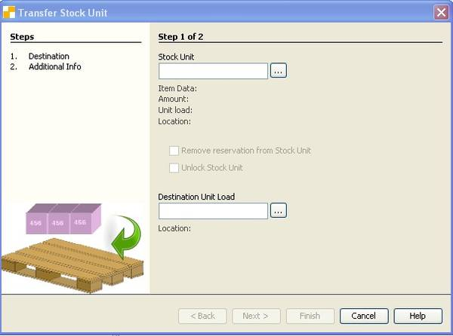
Description of the fields:
Stock unit: Enter the stock unit to be relocated.
Remove reservation from stock unit: The reservation of the stock unit is removed for example due to a placed order of goods.
Unlock stock unit: The lock of the stock unit is removed for example due the validity of a lot.
Destination unit load: The unit load on which the stock unit will be placed.

Change Amount
Changing the amount and packaging unit of a stock unit.
Start the dialogue in the menu item 'Actions / Change Amount'.
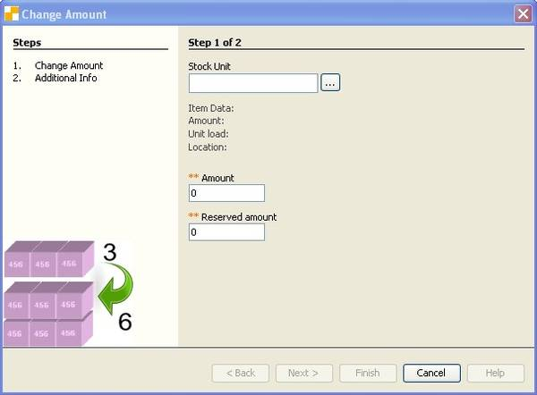
Description of the fields:
Stock unit: Choose the stock unit that has to be changed.
Amount: Enter the new amount of stock unit.
Reserved amount: The system indicates automatically how much of the stock is reserved.
Packaging Unit: The Packaging unit of the stock unit. It can be changed here.

Lot lock, unlock
The menu item 'Actions / Change Amount' causes to examine all lots to determine whether the 'Use not after'-date is exceeded or the 'Use not before'-date is reached.
Lots which reached their valid-to date are locked with an indicator for Lot exceed (202).
Lots that have so far be locked with an indicator for Lot not valid (203) and have reached their valid-from-date will be unlocked.

