01. Sept. 2019

Inventory Data

In the inventory data you will find the current stocks. The stock unit, item amounts unit loads and their location assignment is displayed.
This information is changed with every movement in the warehouse.

Contents
1 Lots 2
2 Stock Units 2
3 Unit Loads 4

Lots
In the lots, additional information to the (production) lot of a stock units is stored. Not every item must have a lot.
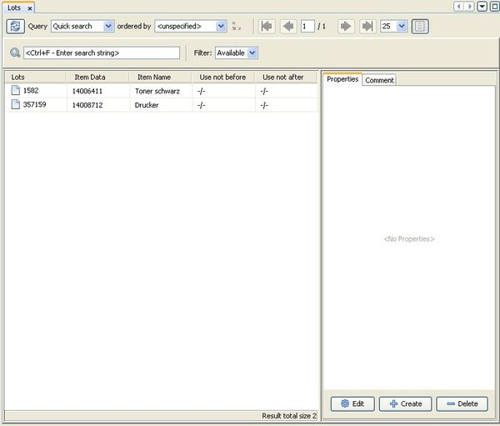
Description of the fields:
Lock: The lock indicator of the lot.
Name: The name of the lot.
Item Data: The number of the item, which is connected to the lot.
Date: The date of the lot.
Use not before: The first date, when the material will be valid
Use not after: The last date, until the material is valid. It is used as best-before date

Description of the functions:
Extinguish lot: In the context menu of the lot you will get the function 'Extinguish Lot'.
With this function, an extinguish order will be generated for all stock units of every selected lot. An extinguish order creates a picking order for all available stock units of the selected lot.
Other parameters for the preparation and processing of extinguish orders can be set via the order strategy. The settings for the stock selection will be ignored, since all available are selected.

Stock Units
A stock unit shows an amount of an item on one unit load or storage location. Thereby all single peaces of the stock unit have identical qualities and are replaceable.
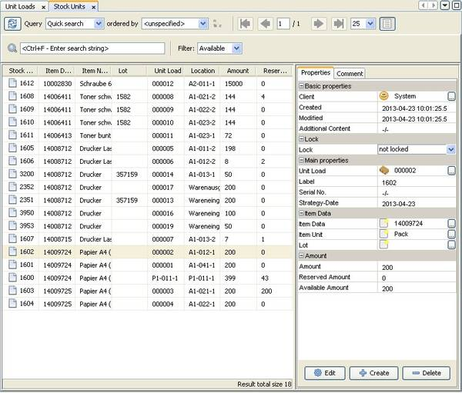
Description of the fields:
Client: The client owns the stock unit.
Lock: The lock indicator of the stock unit.
State: The state of the stock unit shows whether it is goods-receipt, on-stock or picked material.
Unit Load: The unit load or load carrier on which the stock unit is placed.
Location: The name of the storage location where the stock unit or unit load is placed.
Serial-No: The serial number (if available).
Strategy-Date: Based on this date the FIFO is performed. This panel is usually filled with the creation date of the stock unit. For unit loads with a lot the ‘best-before’ of this lot is used.
Item Data: The number of the item data of the stock unit.
Item Unit: The unit of measure.
Lot: The name of the lot (if available).
Amount: The current amount of the stock unit.
Reserved Amount: The current reserved amount of the stock unit. A reservation is done for picking orders.
Available Amount: The amount that is available, taking into account the reservation.
Packaging Unit: The packaging unit that has been assigned to this stock unit.

Description of the functions:
Lock entity: The record is provided with a selectable block indicator. Thus it is no longer available at stock.
Send to nirwana (delete): The stock unit will be deleted. If the unit load gets empty, it will be deleted too.

Change Amount: Directs to the dialog where the current amount can be adjusted. See documentation of the internal processes.
Transfer Stock Unit: Directs to the dialog where the stock unit can be moved to a different unit load. See documentation of the internal processes.

Unit Loads
On the unit load or load carrier the stock units are placed. myWMS administers every stock unit on a unit load.
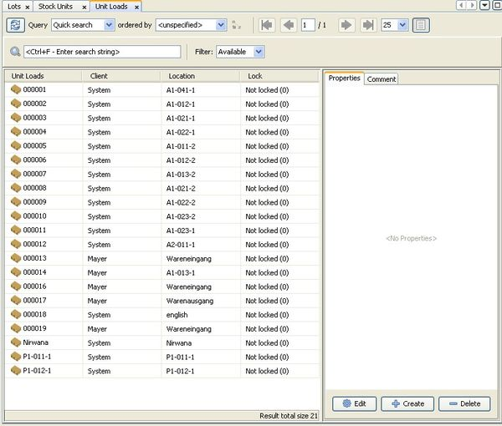
Detailed description of the terms used in the dialog:
Client: The client owns the stock unit.
Lock: The lock indicator of the unit load.
ID, Label: A unique identifier or barcode of the unit load.
Type: The type of the unit load.
State: The state of the stock unit shows whether it is goods-receipt, on-stock or picked material.
Location: The storage location, where the unit load is currently placed.
Weight: The weight of the unit loads. If an explicitly weighed weight is present, this will be displayed. Otherwise, the calculated weight.
Opened: This flag is set when an increase or deduction has been made on a unit load. Unopened unit loads can be accounted for in the retrieval strategies.
Carrier: The carrier is said if the current unit load is on a carrying unit load.
Child unit loads: When the current unit load is a carrier here is the list of the unit loads thereon.

Description of the functions:
Lock entity: The record is provided with a selectable block indicator. Thus it is no longer available on stock.
Send to nirwana (delete): The unit load will be deleted. All stock units on the unit load will be deleted too.
Transfer Unit Load: Directs to the dialog where the unit load can be moved to a different storage location. See documentation of the internal processes.

