01. Sept. 2019

Journals

Every movement in the warehouse is stored to the journals. They document every performed action.
These journals cannot be changed. So they are able to proof certain activities.

Contents
1 Stock Unit Records 2

Stock Unit Records
Every stock changing operation is written to this journal.
With this journal it is possible to show every change of a stock unit.
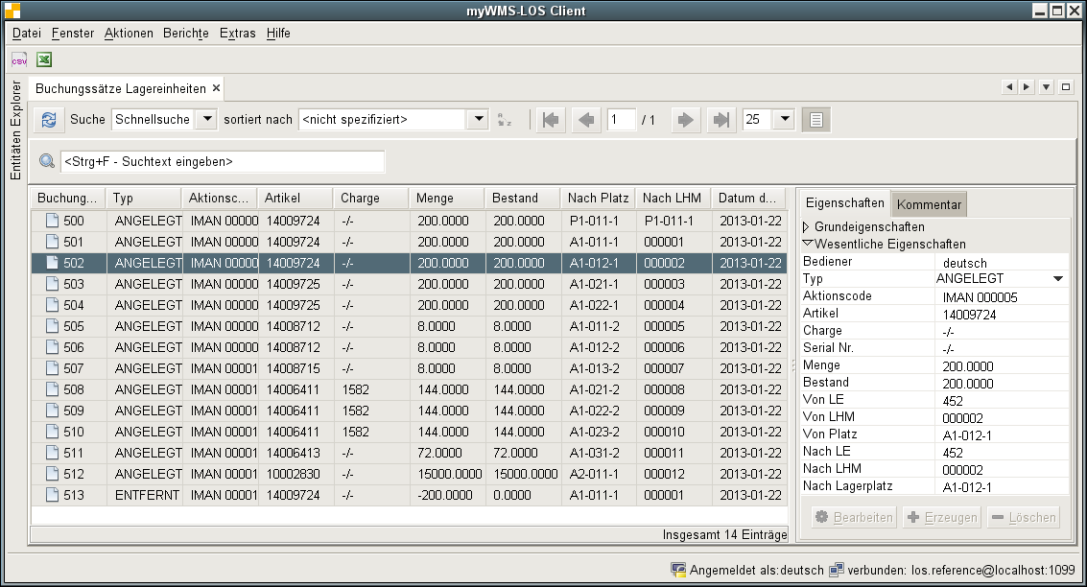
Description of the fields:
Client: The client who owns the stock unit or unit load of the transaction.
Operator: The name of the user, who has done the operation.
Type: There are different types defined:
CREATED: A new stock or unit load has been created.
CHANGED: The amount of the stock unit has been changed.
TRANSFERRED: A unit load has been moved to a new storage location or stock has been moved to a different unit load.
COUNTED: A stock unit, unit load or storage location has been counted.
Activity Code: All movements are provided with an activity code which indicates which process has initiated the movement. The activity code itself is given by the processes involved.
Item Data: The number of the item data of the stock unit.
Lot: The name of the lot (if available).
Serial-No: The serial-No of the stock (if available).
Amount: The changed / registered amount.
Stock: The amount of the stock after the operation.
From Unit Load: The unit load, where the operation comes from (label).
To Unit Load: The unit load, where the operation goes to.
From Location: The storage location, where the operation comes from.
To Location: The storage location, where the operation goes to.
Unit Load Type: The type of the unit load

